
Department of Information Technology

Course: Web Programming Lab | Academic Year: 2021 - 22
Course Code: DJ19ITL405 | Semester: IV

CO: Develop web applications

Experiment 1:

Objective: HTML
- Create a class timetable using HTML.
- Create a registration form using HTML.
- Create a web page using HTML5 tags.

Theory: Explain the different HTML elements used to implement class timetable, registration form, web page using HTML5 tags.

Implementation:
- Create a class timetable for Sem (IV) IT.
- Create a registration form using both HTML and HTML5 elements.
- Create a web page using HTML5 Semantic elements

<html>

<head>
<TITLE>
This is the title
</TITLE>
</head>

<BODY>
<table style="width:100%" border>
<tr>
<th>No.</th>
<th>Period</th>
<th>Monday</th>
<th>Tuesday</th>
<th>Wednesday</th>
<th>Thursday</th>
<th>Friday</th>
<th>Saturday</th>
<tr align="center">
<td align="center">1</td>
<td>7:00-8:00</td>
<td>MATHS(NA)(10)</td>
<td>CN(RS)(10)</td>
<td> </td>
<td> </td>
<td> FLAT(PG) </td>
<td> </td>
</tr>
<tr align="center">
<td>2</td>
<td>8:00-9:00</td>
<td>CN(RS)(10)</td>
<td>FLAT(PG)(10)</td>
<td> </td>
<td> </td>
<td>DAA(MM)(10)</td>
<td> </td>
</tr>
<tr align="center">
<td>3</td>
<td>9:00-9:30</td>
<td bgcolor = "#696969"> </td>
<td bgcolor = "#696969"> </td>
<td> </td>
<td> </td>
<td> </td>
<td> </td>
</tr>
<tr align="center">
<td>4</td>
<td>9:30-10:00</td>
<td rowspan="2">UHV(T)(MD)(45)</td>
<td rowspan="3">CN(CB)(CPG)</td>
<td> </td>
<td> </td>
<td rowspan="3">DAA(MM)(4<sup>th</sup>)</td>
<td> </td>
</tr>
<tr align="center">
<td>5</td>
<td>10:00-10:30</td>
<td rowspan="3">PY(SD)(SPM)</td>
<td> </td>
<td rowspan="2">UHV(RK)(26)</td>
</tr>
<tr align="center">
<td>6</td>
<td>10:30-11:30</td>
<td>MATHS(T)(NA)(45)</td>
<td> </td>
</tr>
<tr align="center">
<td>7</td>
<td>11:30-12:00</td>
<td>FLAT(PG)(B1)(T)(MPMC)</td>
<td>DAA(MM)(31)</td>
<td> </td>
<td bgcolor = "#696969"> </td>
<td rowspan="2">DAA(MM)(31)</td>
</tr>
<tr align="center">
<td>8</td>
<td>12:00-12:30</td>
<td > </td>
<td></td>
<td bgcolor = "#696969"></td>
<td> </td>
<td rowspan="2">WP(VS)(31)</td>
</tr>
<tr align="center">
<td>9</td>
<td>12:30-1:00</td>
<td> </td>
<td> </td>
<td rowspan="2">MATHS(NA)(C3)</td>
<td> </td>
<td>FLAT(PG)(31)</td>
</tr>
<tr align="center">
<td>10</td>
<td>1:00-1:30</td>
<td> </td>
<td> </td>
<td rowspan="2">CN(RS)(51)</td>
<td rowspan="2">MATHS(NA)(31)</td>
<td bgcolor = "#696969"></td>
</tr>
<tr align="center">
<td>11</td>
<td>1:30-2:00</td>
<td> </td>
<td> </td>
<td rowspan="2">UHV(RK)(C3)</td>
<td>WP(NR)(31)</td>
</tr>
<tr align="center">
<td>12</td>
<td>2:00-2:30</td>
<td> </td>
<td > </td>
<td bgcolor = "#696969"> </td>
<td > </td>
<td> </td>
</tr>
<tr align="center">
<td>13</td>
<td>2:30-3:30</td>
<td> </td>
<td> </td>
<td>WP(NR)(C3)</td>
<td rowspan="2">WP(NR)(MPMC)</td>
<td> </td>
<td> </td>
</tr>
<tr align="center">
<td>14</td>
<td>3:30-4:30</td>
<td> </td>
<td> </td>
<td>IPD</td>
<td> </td>
<td> </td>
</tr>
<tr align="center">
<td>15</td>
<td>4:30-5:30</td>
<td> </td>
<td> </td>
<td> </td>
<td> </td>
<td> </td>
<td> </td>
</tr>

</BODY>

</html>

Department of Information Technology
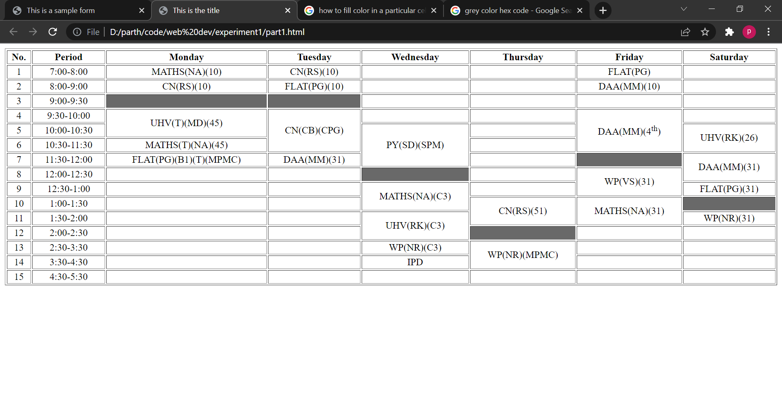

Course: Web Programming Lab | Academic Year: 2021 - 22
Course Code: DJ19ITL405 | Semester: IV

Experiment 2:

b) Create a registration form using HTML.

<html>

<head>
<title>
This is a sample form
</title>
</head>

<body align="center" >
<form action = "registered.html">
<h1> APPLICATION FOR INTERNSHIP </h1>

<br><br>
<b>
<label for="fname">First name:</label>
<input type="text" id="fname" name="fname" value="" required>

<br><br>

<label for="lname">Last name:</label>
<input type="text" id="lname" name="lname" value="" required>

<br><br>

<label for="email">Email Address:</label>
<input type="email" id="mail" name="email" value="" required>

<br><br>

<label for="phoneNumber">Phone Number:</label>
<input type="number" id="number" name="number" value="" required>

<br><br>

<label for="gnder">Gender:</label>
<select name="gnder" id="gnder">
<option value="m">male</option>
<option value="f">Female</option>
<option value="t">Transgender</option>
</select>

<br><br>
<label for="DOB">Date of Birth:</label>
<input type="date" value="2022-03-17" required>

<br><br>

Address
<br>
<textarea rows="4" cols="50"> </textarea>

<br><br>

<labe for = "resume">Upload your resume </labe>
<input type = "file" name = "file1" accept = "pdf/*">

<br><br>

<input type ="checkbox" name = "cbox">I agree to company's policy and t & c

<br> <br>

<input type = "submit">
</form>
</b>
<body>

</html>
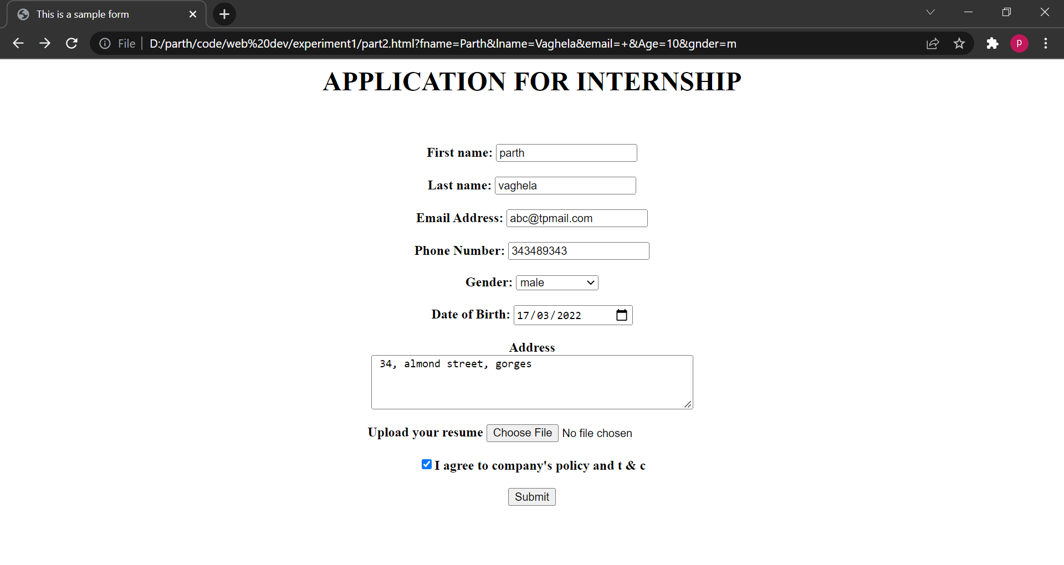

CO: Develop web applications

Objective: CSS
- Design a web page using External or Embedded Style Sheet.

Theory: Explain different tags used to include internal and external style sheet in HTML, also explainthe cascading order.

Implementation:
Apply Internal and external style sheet to any web page

Code:

HTML Code:

c) Create a web page using html 5 elements
#HTML CODE :
<!DOCTYPE html>
<html lang="en">

<head>
<meta charset="UTF-8">
<meta http-equiv="X-UA-Compatible" content="IE=edge">
<meta name="viewport" content="width=device-width, initial-scale=1.0">
<title>Parth's Personal Site</title>
<link rel="stylesheet" href="styles.css">

</head>

<body>

<table cellspacing="30">
<tr>
<td> <img src="parth.png" alt="Parth's Profile Picture" height="200"></td>
<td>
<h1>PARTH VAGHELA</h1>
<p align="center">
<i>Second year <strong><a href="https://en.wikipedia.org/wiki/Information_technology">Information
Technology</a></strong> student
<br>
at
<br>
D.J. Sanghvi College of Engineering </i>
</p>
</td>
</tr>
</table>

<hr>

<h3>Areas of study</h3>
<ul>
<li>Competitive programming</li>
<ul>
</ul>
<li>Operating system</li>
<ul>
<li>process scheduling</li>
<ol type="i" start="3">
<li>sjf</li>
<li>srtf</li>
<li>round robin</li>
</ol>
<li>memory management</li>
<li>process synchronization and deadlock</li>
<li>file system</li>
</ul>
<li>DBMS</li>
<ul>
<li>relational model</li>
<li>transaction</li>
<li>normal forms</li>
</ul>
<li>Computer Networks</li>
<ul>
<li>Ye meri expertise nahi hain I'm out</li>
</ul>

</ul>

<hr>
<h3>Skills</h3>
<table cellspacing="10">
<tr>
<td>
<table>
<tr>
<td>C</td>
<td>⭐⭐⭐⭐⭐</td>
</tr>
<tr>
<td>C++ </td>
<td>⭐⭐⭐</td>
</tr>
</table>
</td>
<td>
<table>
<tr>
<td>Java </td>
<td>⭐⭐⭐</td>
</tr>
<tr>
<td>Python </td>
<td>⭐⭐</td>
</tr>
</table>
</td>
</tr>
</table>

<hr>

<h3>Hobbies</h3>
<ul>
<li>Sketching</li>
<li>Gaming</li>
<li>Singing</li>
<li>Typing <br><img src="https://data.typeracer.com/misc/badge?user=parthvaghela"></li>
</ul>

<hr>

<h3>Education</h3>
<table>
<thead>
<tr align="center">
<th colspan="2">Year</th>
<th>Institution</th>
</tr>
</thead>
<tbody>
<tr align="center">
<td>2007</td>
<td>2018</td>
<td>SVP School</td>
</tr>
<tr align="center">
<td>2018</td>
<td>2020</td>
<td>T.P. Bhatia College of Science</td>
</tr>
<tr align="center">
<td>2020</td>
<td>2024</td>
<td>D.J. Sanghvi College of Engineering</td>
</tr>
</tbody>
</table>

<hr>

<p><a href="contact-me.html"><strong>
<h3>Contact me...</h3>
</strong></a></p>

</body>

</html>

#CSS CODE :
body {
background-color: #380155;
background-repeat: no-repeat;
background-attachment: fixed;

}

hr {
width : 5%;
border:#dca9ff;
border-style: dotted, none, none;
/* border-top-style : dotted; */
border-width : 0.3em;
}

h3, h1{
color: #c58bf7;
}

p , li, table, label{
color: #df74eb;
}

a {
color: #dca9ff;
}
OUTPUT :
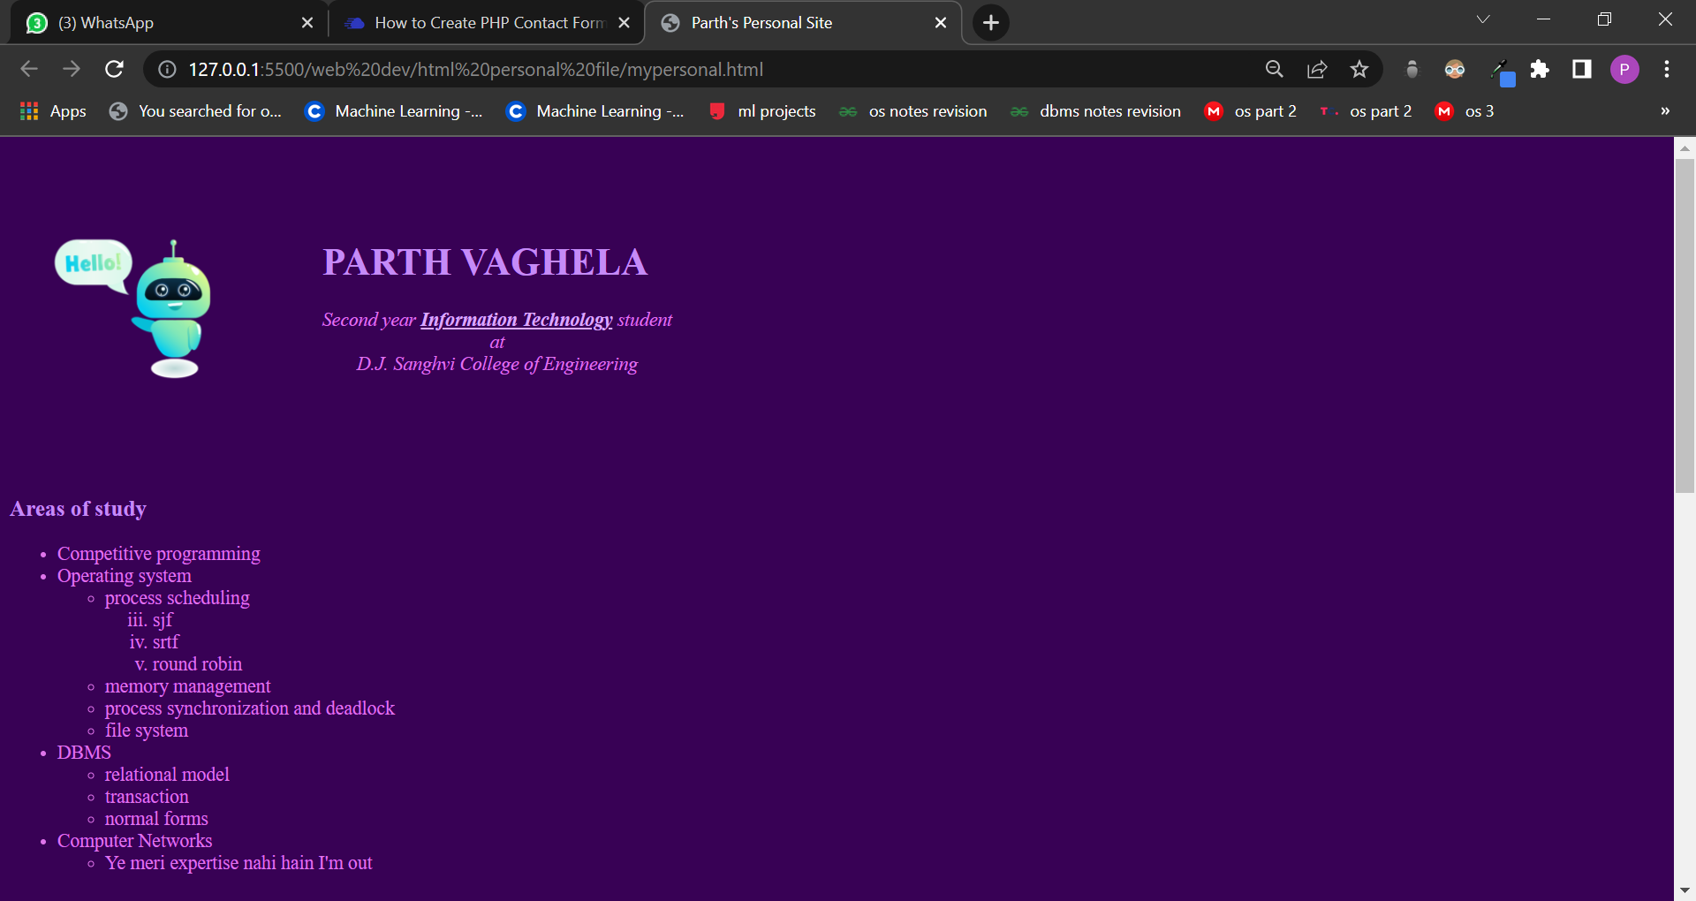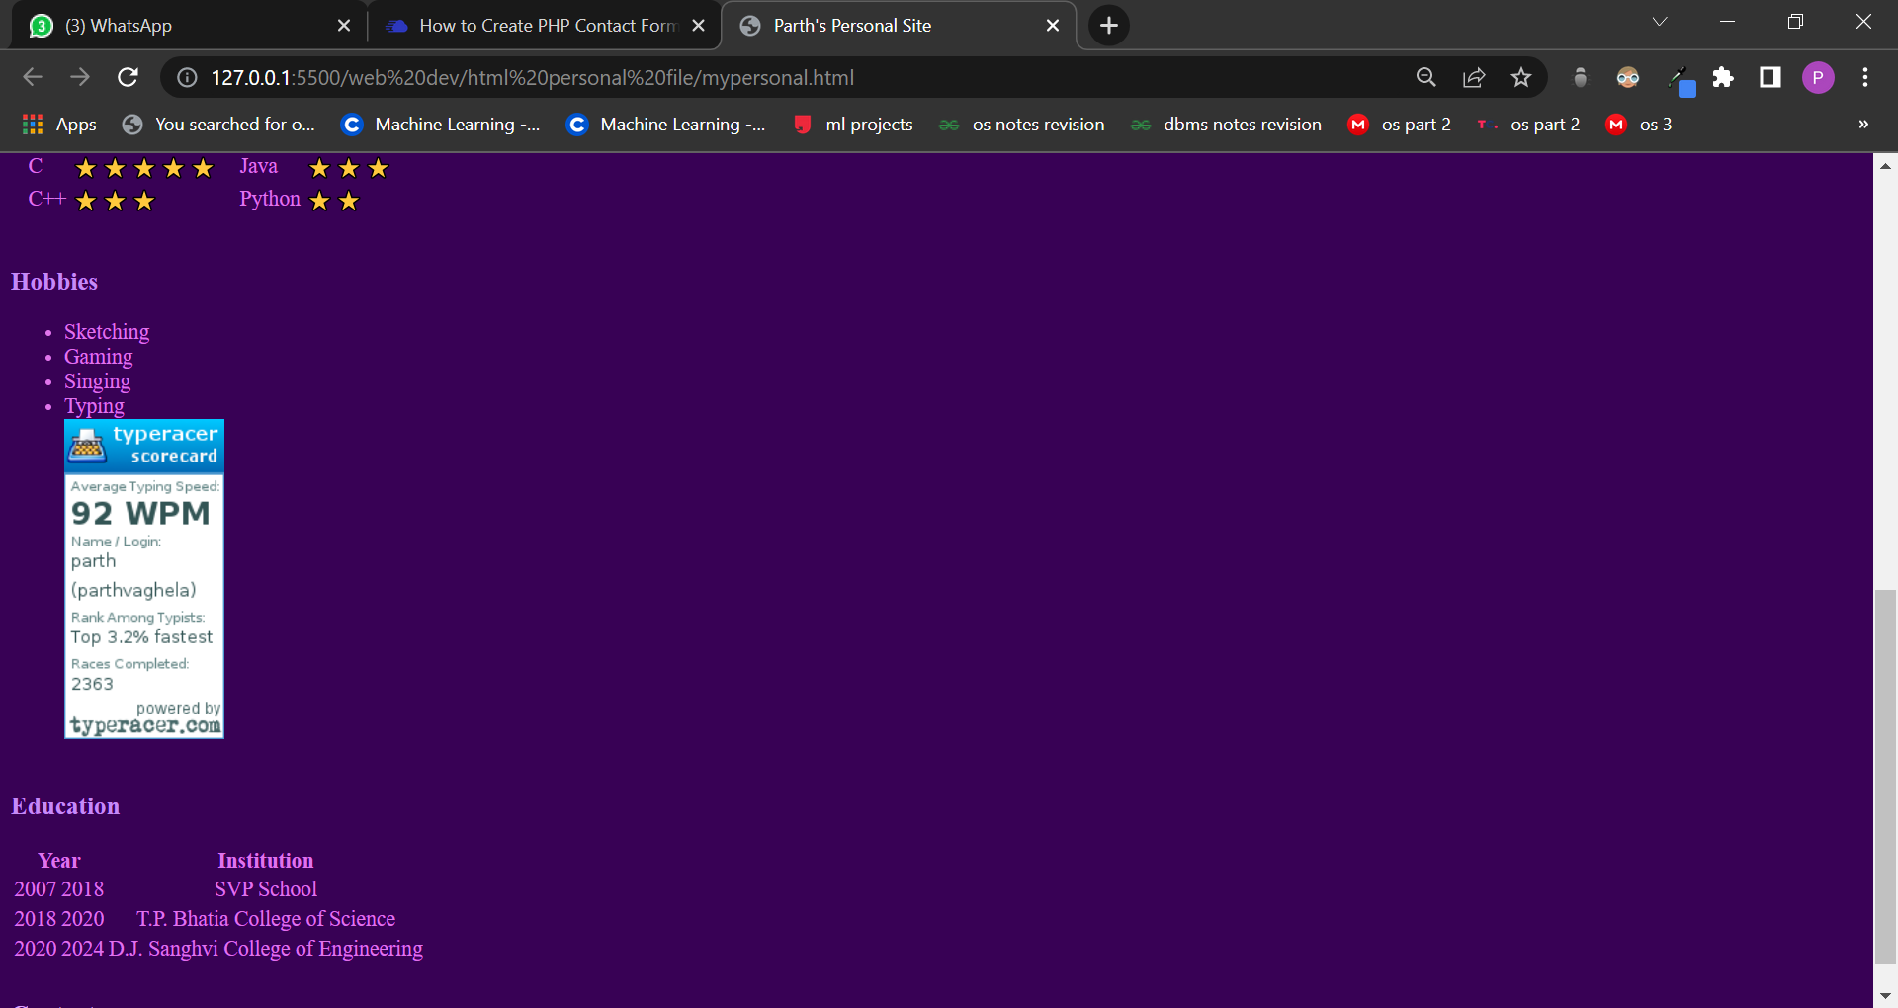

Department of Information Technology

Course: Web Programming Lab Academic Year: 2021 - 22

CO: Develop web applications

Experiment 3
Course Code: DJ19ITL405 Semester: IV

Objective: CSS3
  - Design a responsive web page using media queries and CSS3.
  - Design a web page using Bootstrap.
  - Design the admission form using Bootstrap.

Theory: Explain responsive web page and different tags used to design responsive web page usingmedia query, and using Bootstrap.

Implementation:
- Design a responsive web page using media query
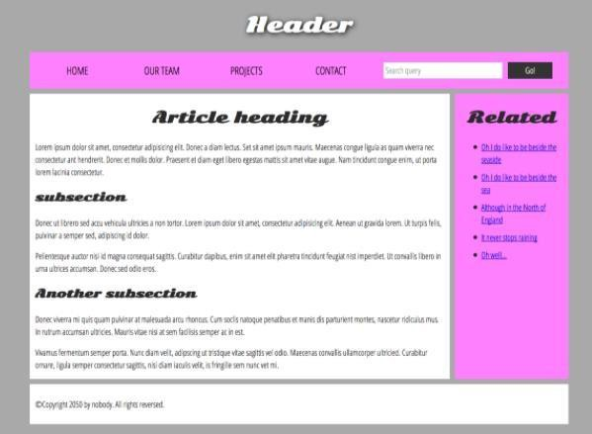

- Design above web page also using Bootstrap.
- Design a responsive admission form using Bootstrap.

Code:
HTML Code:
<!DOCTYPE HTML>
<head>
<meta charset="utf-8">

<title>Example title>
<link href="https://fonts.googleapis.com/css?family=Open+Sans+Condensed:300|Sonsie+One" rel="stylesheet" type="text/css">
<link rel="stylesheet" href="style.css">

</head>
<body>
<header>
<h1>Header</h1>

<nav>
<ul>
<li><a href="#">Home</a></li>
<li><a href="#">Our team</a></li>
<li><a href="#">Projects</a></li>
<li><a href="#">Contact</a></li>
</ul>

<form>
<input type="search" name="q" placeholder="Search query">
<input type="submit" value="Go!">
</form>
</nav>
</header>

<main>

<article>
<h2>Article heading</h2>

<p>Lorem ipsum dolor sit amet, consectetur adipisicing elit. Donec a diam lectus. Set sit amet ipsum mauris. Maecenas congue ligula as quam viverra nec consectetur ant hendrerit. Donec et mollis dolor. Praesent et diam eget libero egestas mattis sit amet vitae augue. Nam tincidunt congue enim, ut porta lorem lacinia consectetur.</p>

<h3>subsection</h3>

<p>Donec ut librero sed accu vehicula ultricies a non tortor. Lorem ipsum dolor sit amet, consectetur adipisicing elit. Aenean ut gravida lorem. Ut turpis felis, pulvinar a semper sed, adipiscing id dolor.</p>

<p>Pelientesque auctor nisi id magna consequat sagittis. Curabitur dapibus, enim sit amet elit pharetra tincidunt feugiat nist imperdiet. Ut convallis libero in urna ultrices accumsan. Donec sed odio eros.</p>

<h3>Another subsection</h3>

<p>Donec viverra mi quis quam pulvinar at malesuada arcu rhoncus. Cum soclis natoque penatibus et manis dis parturient montes, nascetur ridiculus mus. In rutrum accumsan ultricies. Mauris vitae nisi at sem facilisis semper ac in est.</p>

<p>Vivamus fermentum semper porta. Nunc diam velit, adipscing ut tristique vitae sagittis vel odio. Maecenas convallis ullamcorper ultricied. Curabitur ornare, ligula semper consectetur sagittis, nisi diam iaculis velit, is fringille sem nunc vet mi.</p>
</article>

<aside>
<h2>Related</h2>

<ul>
<li><a href="#">Oh I do like to be beside the seaside</a></li>
<li><a href="#">Oh I do like to be beside the sea</a></li>
<li><a href="#">Although in the North of England</a></li>
<li><a href="#">It never stops raining</a></li>
<li><a href="#">Oh well...</a></li>
</ul>
</aside>

</main>

<footer>
<p>©Copyright 2050 by nobody. All rights reversed.</p>
</footer>

</body>

CSS :

html, body {
margin: 0;
padding: 0;
}

html {
font-size: 10px;
background-color: #a9a9a9;
}

body {
width: 70%;
margin: 0 auto;
}

h1, h2, h3 {
font-family: 'Sonsie One', cursive;
color: #2a2a2a;
}

p, input, li {
font-family: 'Open Sans Condensed', sans-serif;
color: #2a2a2a;
}

h1 {
font-size: 4rem;
text-align: center;
color: white;
text-shadow: 2px 2px 10px black;
}

h2 {
font-size: 3rem;
text-align: center;
}

h3 {
font-size: 2.2rem;
}

p, li {
font-size: 1.6rem;
line-height: 1.5;
}

header {
margin-bottom: 10px;
}

nav, article, aside, footer {
background-color: white;
padding: 1%;
}

nav {
height: 50px;
background-color: ff80ff;
display: flex;
}

nav ul {
padding: 0;
list-style-type: none;
flex: 2;
display: flex;
}

nav li {
display: inline;
text-align: center;
flex: 1;
}

nav a {
display: inline-block;
font-size: 2rem;
text-transform: uppercase;
text-decoration: none;
color: black;
}

nav form {
flex: 1;
display: flex;
align-items: center;
height: 100%;
padding: 0 2em;
}

input {
font-size: 1.6rem;
height: 32px;
}

input[type="search"] {
flex: 3;
}

input[type="submit"] {
flex: 1;
margin-left: 1rem;
background: #333;
border: 0;
color: white;
}

main {
display: flex;
}

article {
flex: 4;
}

aside {
flex: 1;
margin-left: 10px;
background-color: #ff80ff;
}

aside li {
padding-bottom: 10px;
}

footer {
margin-top: 10px;
}

Screenshot:

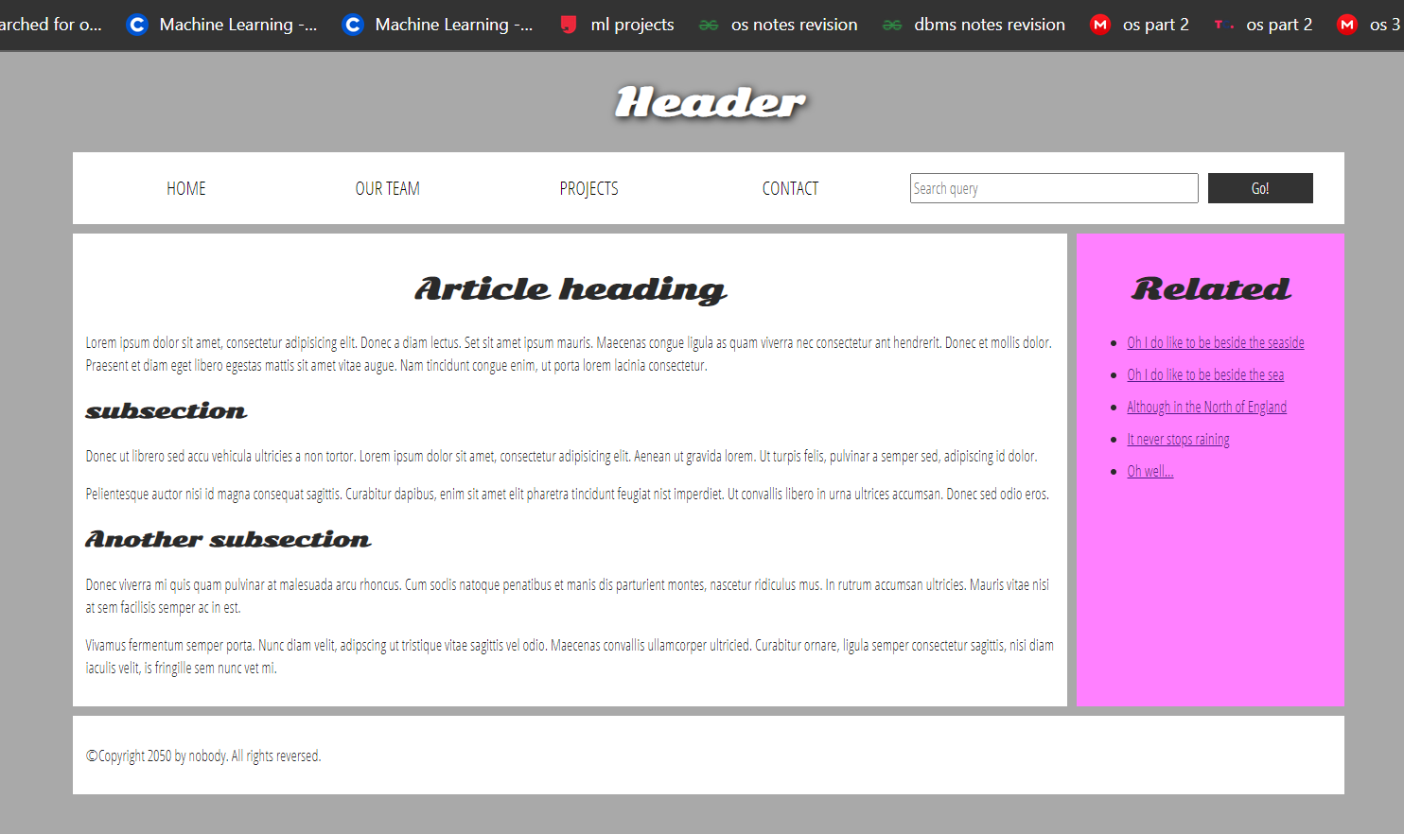

Course: Web Programming Lab | Academic Year: 2021 - 22
Course Code: DJ19ITL405 | Semester: IV

CO: Develop web applications

Experiment 4

Objective: JavaScript
- Programs based on objects in JavaScript.
- Program to design a calculator using JavaScript.

Theory: Explain various objects used and different tags used to implement above two programs

Implementation:

Programs based on objects in JavaScript
  - Collect information from the user and store in a variable for later user.
    - Create a basic page in html.
    - Using a prompt box, prompt the user to supply his or her name.
    - Save the name in a variable.
    - Then, using a document.write() statement, use the information stored in variablesto display Hello username! in big, bold letters, i.e. surrounded by
<h1> tags. username should, of course, be what the user actually typed into the prompt box.
    - Using the same variable, also display Hello username! in an alert message on thesame page.
  - Display the following items in the page using only one or more document.write() statements:
    - Information about the web browser that the user is viewing this page with(hint: use the navigator.appName property).
    - The height and width of the user's monitor, i.e.
the resolution(hint: use window.screen.availHeight and window.screen.availWidth)
    - The date that the page was created or last modified (hint: use the document.lastModifiedproperty).

  - String Manipulation(First read inbuilt methods of string object)

Create a function ucFirst(str) which returns str with uppercased first character. Display theresult using alert box. (Hint : Use CharAt)
For example: ucFirst(john) == “John”

PART A:
Code :
<!DOCTYPE html>
<html lang="en">

<head>
<meta charset="UTF-8">
<meta http-equiv="X-UA-Compatible" content="IE=edge">
<meta name="viewport" content="width=device-width, initial-scale=1.0">
<title>lab4</title>
</head>

<body>
</body>
<script>
// Part 1
let Name = prompt("Enter your Name: ");
alert('Hello ' + Name);
document.write("<h1> Hello " + Name + "</h1>")

// Part 2
document.write("<p>Browser: " + navigator.appName + "</p>");
document.write("<p>Height: " + window.screen.availHeight + "</p>");
document.write("<p>Width: " + window.screen.availWidth + "</p>");
document.write("<p>Width: " + window.screen.availWidth + "</p>");
document.write("<p>LastModified: " + document.lastModified + "</p>");

// Part 3
function UcFirst(name) {
let start = name.charAt(0);
start = first.toUpperCase();
return start + name.slice(1);
}

document.write(UcFirst("parTH"));
</script>

</html>

OUTPUT :
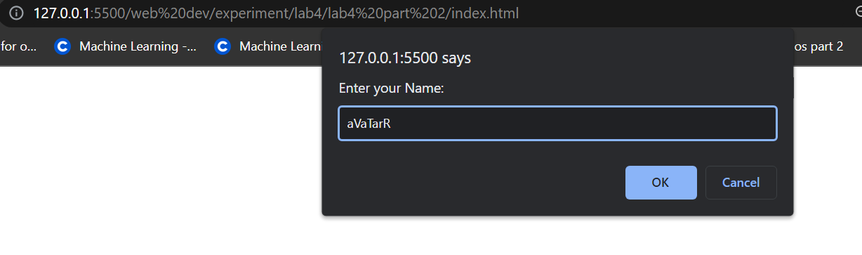
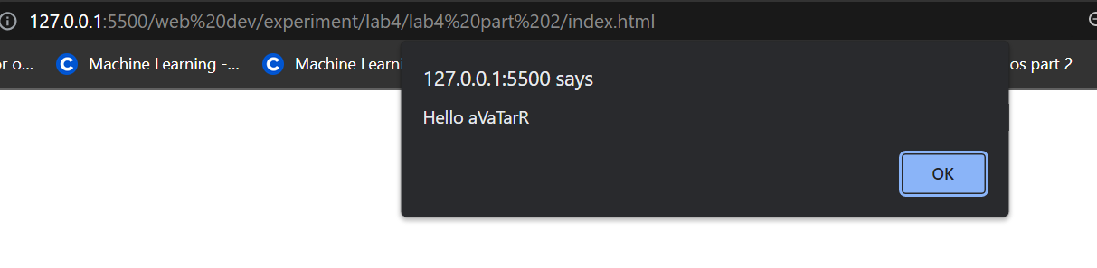
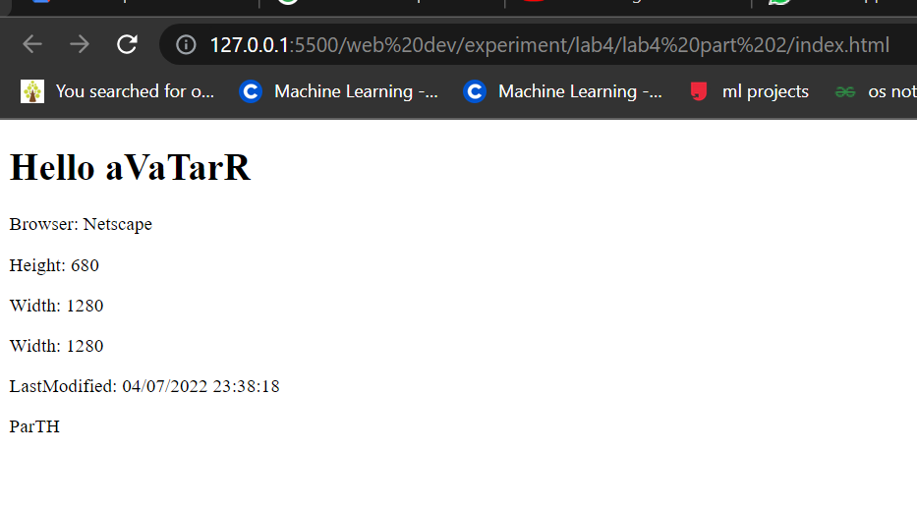

PART 2: Create a Calculator
SOURCE CODE :
HTML :
<!DOCTYPE html>
<head>
<title>Calculator</title>
<link rel="stylesheet" href="styles.css">
</head>
<body>
<div class="calculator">
<input type="text" class="display" disabled>
<div class="keys">
<div class="row">
<button value="7">7</button>
<button value="8">8</button>
<button value="9">9</button>
<button value="C" class="operator" style = " border-radius: 30%;">C</button>
</div>
<div class="row">
<button value="4">4</button>
<button value="5">5</button>
<button value="6">6</button>
<button value="-" class="operator">-</button>
</div>
<div class="row">
<button value="1">1</button>
<button value="2">2</button>
<button value="3">3</button>
<button value="*" class="operator">*</button>
</div>
<div class="row">
<button value="+" class="operator">+</button>
<button value="0">0</button>
<button value="/" class="operator">/</button>
<button value="=" class="operator">=</button>
</div>
</div>
</div>
<script src="code.js"></script>
</body>

</html>

CSS :
* {
padding: 0;
margin: 0;
}
body {
width: 100vw;
height: 100vh;
overflow: hidden;
display: flex;
justify-content: center;
align-items: center;
background-color: #dad9;
font-family: sans-serif;
}
.calculator {
padding-left: 10px;
padding-right: 10px;
padding-top : 30px;
width: 300px;
padding-bottom: 0px;
border-radius: 15px;
background-color: #E6BA95;
box-shadow: -2px 0px 12px 2px #A97155;
}
.display {
box-shadow: -2px 0px 12px 2px #BE8C63;
margin-bottom : 20px;
border-radius: 15px;
width: 100%;
height: 100px;
border: none;
box-sizing: border-box;
padding: 10px;
font-size: 2rem;
background-color: #FAFDD6;
-webkit-text-stroke: 2px #A97155;
font-family: arial; color: #E6BA95;
text-align: right;
border-top-left-radius: 7px;
border-top-right-radius: 7px;
}
.row {
display: flex;
justify-content: space-between;
}
button {
width: 50px;
height: 50px;
border-radius: 50%;
border: none;
outline: none;
font-size: 2rem;
background-color: #A2B38B;
color: #E4E9BE;
margin: 10px;
}
button:hover {
cursor: pointer;
background-color :#E4E9BE;
color : #A2B38B;
}

.operator {
background-color: #A97155;
color: white;
}

.operator:hover {
cursor : pointer;
background-color: white;
color : #A97155;
}

JAVASCRIPT :
const buttons = document.querySelectorAll('button');
const display = document.querySelector('.display');
buttons.forEach(function(button) {
button.addEventListener('click', calculate);
});
function calculate(event) {
const clickedButtonValue = event.target.value;
if (clickedButtonValue === '=') {

if (display.value !== '')
{
display.value = eval(display.value);
}
} else if (clickedButtonValue === 'C')
{
display.value = '';
} else {
display.value += clickedButtonValue;
}
}

OUTPUT :
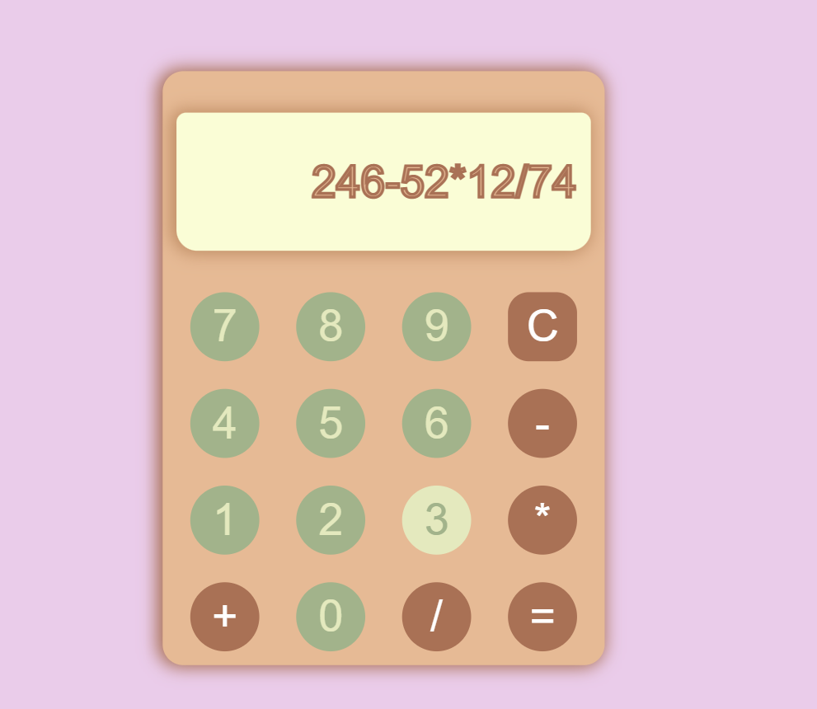

Department of Information Technology
Course: Web Programming Lab | Academic Year: 2021 - 22
Course Code: DJ19ITL405 | Semester: IV

Experiment 5
CO: Validate web applications for conformance to latest W3C markup

Aim: JavaScript
- Programs based on form validation.

Objective: Explain form validation and code used to validate various fields.

Implementation:
  - Create a form shown below.
  - When clicking on “Submit Form” button, it will call the function validateForm(). This function will check whether the inserted data is correct or not. If any of the inserted data is not in proper format, it will display the alert box specifying the error. If all inserted data are in correct format it will display alert box “Your data has been validated!!!!”

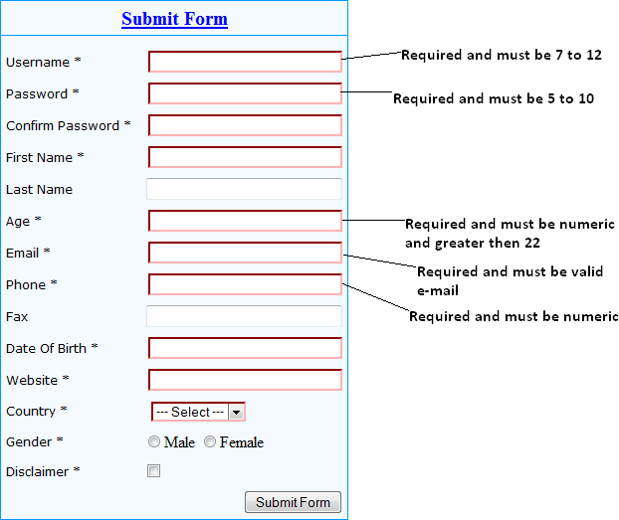

Department of Information Technology

CODE :

HTML :

<!DOCTYPE html>
<html lang="en">
<head>
<meta charset="UTF-8">
<meta http-equiv="X-UA-Compatible" content="IE=edge">
<meta name="viewport" content="width=device-width, initial-scale=1.0">
<title>experiment 5</title>
</head>
<body>
<div class = "main-container">
<div class = "upper-block">
<h3>Submit Form</h3>
</div>
<div class = "lower-block">
<form id = "submit-form">
<label for = "username" >Username*
<input type = "text" id = "username" autofocus required>
</label>
<br>
<label for = "Password">Password*
<input type = "password" id = "Password" required>
</label>
<br>
<label for = "confirm-pass">Confirm Password*
<input type = "password" id = "confirm-pass" required>
</label>
<br>
<label for = "fname">First Name
<input type = "text" id = "fname" required>
</label>
<br>
<label for = "lname">Last name
<input type = "text" id = "lname">
</label>
<br>
<label for = "age">Age*
<input type = "text" id = "age" required>
</label>
<br>
<label for = "email">Email*
<input type = "email" id = "Email" required pattern =".+@gmail/.com">
</label>
<br>
<label for = "Phone">Phone*
<input type = "text" id = "Phone" required>
</label>
<br>
<label for = "Fax">Fax
<input type = "text" id = "Fax">
</label>
<br>
<label for = "DOB">Date Of Birth*
<input type = "text" id = "DOB" required>
</label>
<br>
<label for = "Website">Website*
<input type = "text" id = "Website" required>
</label>
<br>
<datalist id = "country-list">
<option>India</option>
<option>America</option>
</datalist>
<label for = "Country" >Country*
<select name = "countree" id = "Country" required>
<option value = "india">India</option>
<option value = "america">American</option>
<option value = "spain">Spain</option>
<option value = "france">France</option>
</select>
</label>
<br>
<label for = "Gender">Gender*
<label for = "Male">Male
<input type = "radio" name = "gender" value = "male" id = "Male" checked>
</label>
<label for = "Female">Female
<input type = "radio" name = "gender" value = "female" id = "Female">
</label>
</label>
<br>
<label for = "tandc">
<input type = "checkbox" id = "tandc" name = "checkbox" value = "yes" checked>
I Agree To Company's Terms and Conditions
</label>
<br>
<button form = "submit-form"onclick = "validate()">Submit</button>
</form>
</div>
</div>
<script src = "valid.js"></script>
</body>
</html>

JAVASCRIPT

function validate(){
var uname = document.getElementById("username").value;
user_length = uname.length;

if(user_length < 7 || user_length > 12)
{
alert("username should be 7 to 12 character long")
document.getElementById("username").value = "";
}

var pass = document.getElementById("Password").value;
pass_length = pass.length;

if(pass_length < 5 || pass_length > 10)
{
alert("password should be greater than 5 and less than 10")
document.getElementById("password").value = "";
}

var pass2 = document.getElementById("confirm-pass");
if(pass !== pass2)
{
alert("Entered password doesn't match previous password");
document.getElementById("confirm-pass").value = "";
}

var age = document.getElementById("age").value;
fname_length = first_name.length;

if(!NaN(age))
{
alert("The entered value should be a number");
document.getElementById("age").value = "";
}

var num_age = parseInt(age);
if(num_age < 22 || num_age < 0)
{
alert("Age should be greater than or equal to 22");
document.getElementsByTagNameNS("age").value = "";
}

var pnum = document.getElementById("age").value;
fname_length = first_name.length;

if(!NaN(age))
{
alert("The entered value should be a number");
document.getElementById("age").value = "";
}

}
OUTPUT :
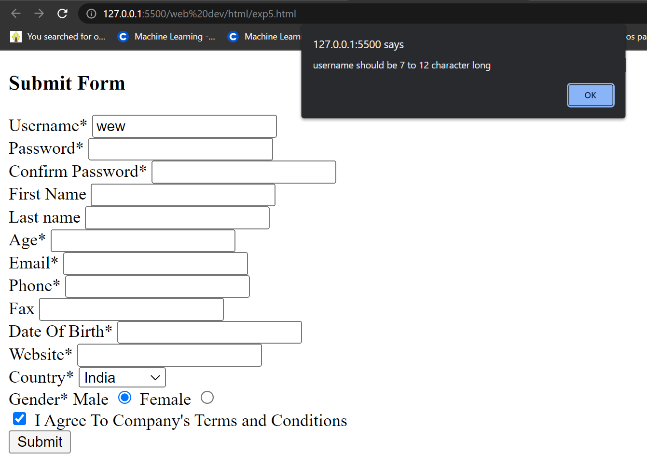

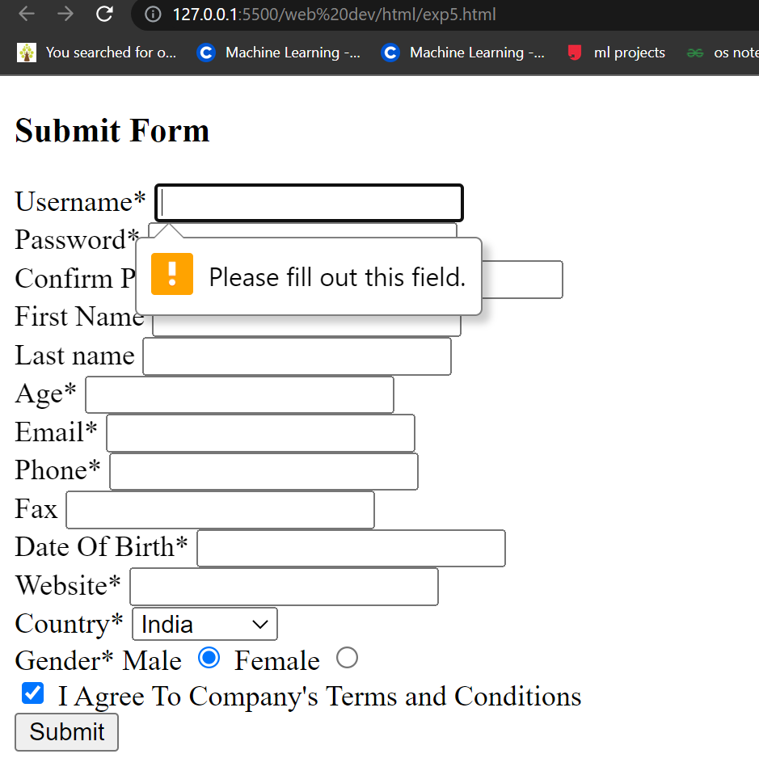
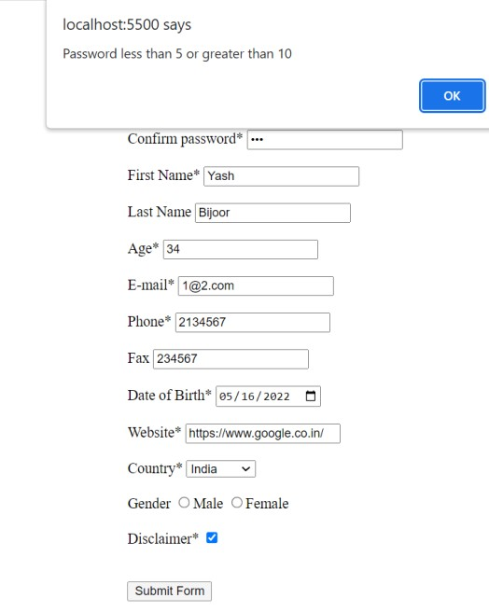
Department of Information Technology

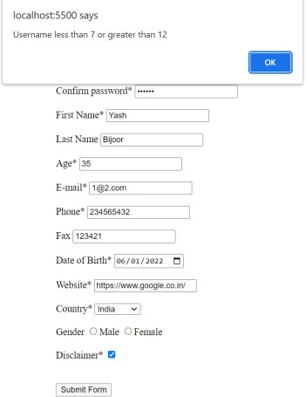

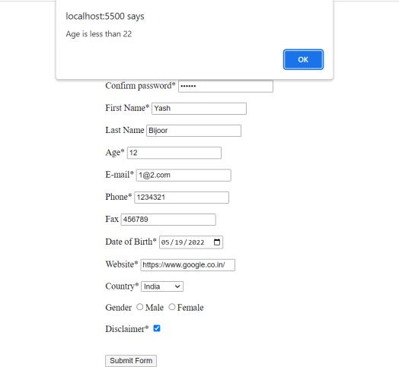

Department of Information Technology

Course: Web Programming Lab | Academic Year: 2021 - 22
Course Code: DJ19ITL405 | Semester: IV
Experiment 6

CO: Develop web applications

Objective: React JS
a) Create an application using React.

Theory: Explain code used to implement react application

Implementation:
Design a react app to convert the temperature from Celsius to Fahrenheit and vice versa.

Code:

import React, { Component } from 'react';

class App extends Component {
constructor(props) {
super(props);
this.state = {
posts: []
}
}

componentDidMount() {
const url = "https://jsonplaceholder.typicode.com/posts";
fetch(url)
.then(response => response.json())
.then(json => this.setState({ posts: json }))
}

render() {
const { posts } = this.state;
return (
<div className="container">
<div class="jumbotron">
<h1 class="display-4">Blog posts</h1>
</div>
{posts.map((post) => (
<div className="card" key={post.id}>
<div className="card-header">
#{post.id} {post.title}
</div>
<div className="card-body">
<p className="card-text">{post.body}</p>
</div>
</div>
))}
</div>
);
}
}
export default App;

#data
[
{
"userId": 1,
"id": 1,
"title": "sunt aut facere repellat provident occaecati excepturi optio reprehenderit",
"body": "quia et suscipit\nsuscipit recusandae consequuntur expedita et cum\nreprehenderit molestiae ut ut quas totam\nnostrum rerum est autem sunt rem eveniet architecto"
},
{
"userId": 1,
"id": 2,
"title": "qui est esse",
"body": "est rerum tempore vitae\nsequi sint nihil reprehenderit dolor beatae ea dolores neque\nfugiat blanditiis voluptate porro vel nihil molestiae ut reiciendis\nqui aperiam non debitis possimus qui neque nisi nulla"
},
{
"userId": 1,
"id": 3,
"title": "ea molestias quasi exercitationem repellat qui ipsa sit aut",
"body": "et iusto sed quo iure\nvoluptatem occaecati omnis eligendi aut ad\nvoluptatem doloribus vel accusantium quis pariatur\nmolestiae porro eius odio et labore et velit aut"
},
...
]

#css

.app {
padding: 10px;
}

.app .jumbotron {
text-align: center;
}

.app .card {
margin-bottom: 10px;
}

.app .card-header {
color: white;
font-weight: bold;
}
Department of Information Technology

Screenshots:

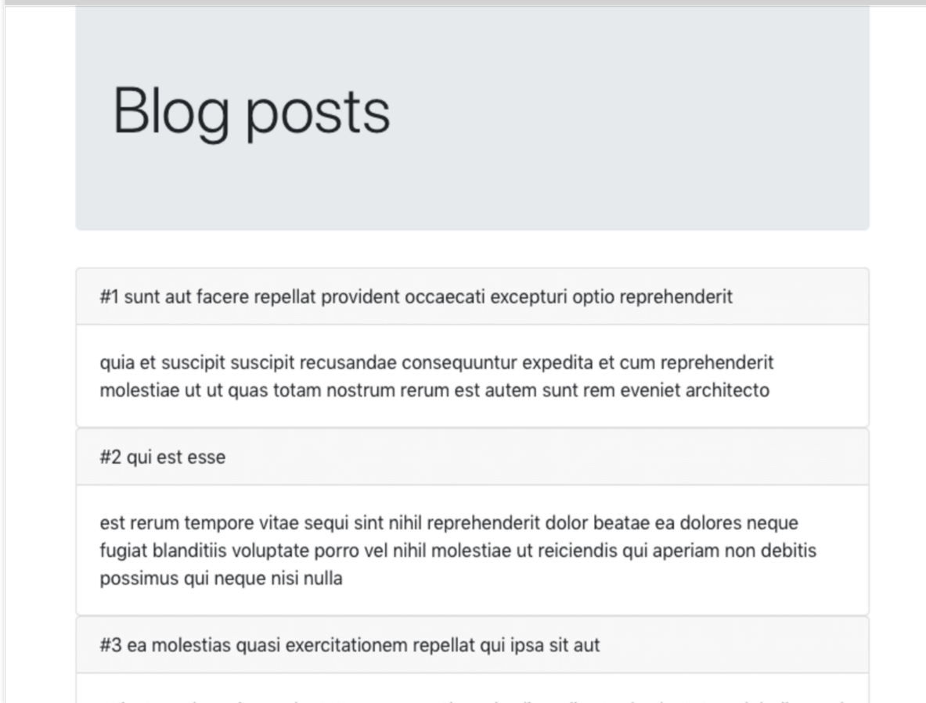
Department of Information Technology
Course: Web Programming Lab | Academic Year: 2021 - 22
Course Code: DJ19ITL405 | Semester: IV

Experiment 7
Objective:
- Installation and configuration of XAMPP/ WAMP Server.
- Programs based on built-in functions in PHP.

Theory: Explain various functions used to implement PHP programs.

Implementation:

- b) Programs based on built-in functions in PHP

  - Write a PHP script to generate simple random password from a given stringSample
String: '1234567890ABCDEFGHIJKLMNOPQRSTUVWXYZabcefghijklmnopqrstuvwxyz 'Note: Password length may be 6, 7, 8 etc. Use str_shuffle() function.

  - Write a PHP script to insert a string at the specified position in a given string.Original String: 'The brown fox' Insert 'quick' between 'The' and 'brown'.
Expected Output: 'The quick brown fox'Hint: Use substr_replace() function.

  - Write a PHP script to remove backslashes and clean up data retrieved from a databaseor from an HTML form
Hint: Use stripcslashes() function.

  - Write a PHP script to submit the form data using post method. Display the datasubmitted on page demo.php

  - Write a PHP script to check the connectivity to the database in conection.php. Useconnection.php in the file insert.html.
Hint: Use include

Code:

<?php
// Q1
$String = "1234567890ABCDEFGHIJKLMNOPQRSTUVWXYZ";
$newString = str_shuffle($String);
$randInt = rand(6,15);
if($randInt>=6){
echo substr($newString,0,$randInt)."\n";
}
// Q2
$original="The Brown Fox";
$Insert = "quick";
$Position=4;
$newStr = substr_replace($original,$Insert.' ',$Position,0);
echo $newStr."\n";
?>

Department of Information Technology
Course: Web Programming Lab | Academic Year: 2021 - 22
Course Code: DJ19ITL405 | Semester: IV

Experiment 8 Objective: Implement PHP – MySQL database connectivity.
Theory: Explain various functions and command used for PHP and MYSQL database
connectivity.Implementation:
- Create a login form that allow only authenticated user to access the registration form
- Create a registration form and perform insert, update, delete and select operation on it.

Code: db.php:

<? php
$con = mysqli_connect("localhost", "root", "", "LoginSystem");

// To check if a connection has been established if (mysqli_connect_errno())
{
echo "Failed to connect to MySQL: " . mysqli_connect_error();
}
?>

auth.session.php:

<? php session_start();
if (!isset($_SESSION["username"]))
{
header("Location: login.php"); exit();
}
?>

dashboard.php:
<? php
include ("auth_session.php");
?>
<!DOCTYPE html>
<html>
<head>
<meta charset="utf-8">
<title>Dashboard - Client area</title>
<link rel="stylesheet" href="style.css" />
</head>
<body>
<div class="form">
<p>Hey, <? php echo $_SESSION['username']; ?>!</p>
<p>You are now user dashboard page.</p>
<p>
<a href="logout.php">Logout</a>
</p>
</div>
</body>
</html>

login.php:
<!DOCTYPE html>
<html>

<head>
<meta charset="utf-8" />
<title>Login</title>
<link rel="stylesheet" href="style.css" />
</head>

<body>
<? php
require ('db.php'); session_start();
{
$username = stripslashes($_REQUEST['username']);
$username = mysqli_real_escape_string($con, $username);
$password = stripslashes($_REQUEST['password']);
$password = mysqli_real_escape_string($con, $password);

$query = "SELECT * FROM `users` WHERE username='$username' AND password='" . md5($password) . "'";
$result = mysqli_query($con, $query) or die(mysql_error());
$rows = mysqli_num_rows($result); if ($rows == 1)
{
$_SESSION['username'] = $username;
}
else
{
echo "<div class='form'>
<h3>Incorrect Username/password.</h3><br/>
<p class='link'>Click here to <a href='login.php'>Login</a> again.</p>
</div>";
}
}
else
{
?>
<form class="form" method="post" name="login">
<h1 class="login-title">Login</h1>
<input type="text" class="login-input" name="username" placeholder="Username" autofocus="true" />
<input type="password" class="login-input" name="password" placeholder="Password" />
<input type="submit" value="Login" name="submit" class="login button" />
<p class="link"><a href="registration.php">New Registration</a></p>
</form>
<? php
}
?>
</body>

Department of Information Technology
registration.php:

<!DOCTYPE html>
<html>
<head>
<meta charset="utf-8" />
<title>Login</title>
<link rel="stylesheet" href="style.css" />
</head>

<body>
<? php
require ('db.php'); session_start();
{
$username = stripslashes($_REQUEST['username']);
$username = mysqli_real_escape_string($con, $username);
$password = stripslashes($_REQUEST['password']);
$password = mysqli_real_escape_string($con, $password);
$query = "SELECT * FROM `users` WHERE username='$username' AND password='" . md5($password) . "'";
$result = mysqli_query($con, $query) or die(mysql_error());
$rows = mysqli_num_rows($result);
if ($rows == 1)
{
$_SESSION['username'] = $username;
}
else
{
echo “<div class='form’>
<h3>Required fields are missing.</h3><br/>
<p class='link'>Click here to <a href='registration.php'>registration</a> again.</p>
</div>"
}
else
{
?>
<form class="form" method="post" name="login">
<h1 class="login-title">Login</h1>
<input type="text" class="login-input" name="username" placeholder="Username" autofocus="true" />
<input type="password" class="login-input" name="password" placeholder="Password" />
<input type="submit" value="Login" name="submit" class="login button" />
<p class="link"><a href="registration.php">New Registration</a></p>
</form>
<? php
}
?>
</body>

</html>

Department of Information Technology

Screenshots:

