CONTACT BOOK
Python Project report

Piyush kumar singh 25BAI11043
Department of Computer Science Engineering (AI & ML)
Vellore Institute of Technology
Bhopal, Madhya Pradesh
piyush.25bai11043@vitbhopal.ac.in
25th November 2025

Abstract: this is simple Contact book management project which is to manage record of contact list using basic python programming. And it performs basic File Input output operations like add contact, search contact, Update contact , delete contact. And save this data to the text file contacts.txt.

Introduction

A Contact book management project a tool designed to maintain contact information in an organized way. In daily life, remembering contacts manually or writing it notebooks, phone notes, or scattered text files and forgetting becomes difficult to find when needed. This project provides a simple command-line window that stores contact details such as name, phone and email using Python Programming..

Objective
The main objectives of this project are:
- Manage contact data
- Understanding input output operations using Python
- Store data permanently in a text file
- Provide a simple and user-friendly menu-driven interface
- Reduce manual workload in handling contact records
- To create a small and easy-to-use digital tool for storing contact details.
- To help users quickly search for a contact when needed.
- To make it possible to update information without having to rewrite everything.
- To allow removal of old or unwanted contact entries.
- To provide a clean, beginner-friendly menu system.
- To follow modular coding practices using Python functions.
- To ensure contacts remain saved across multiple uses of the program.

Implementation
The system works in a step-by-step process:
- The program displays a menu with different options
- The user chooses an operation (e.g., Add contact)
- The system performs the selected operation
- Contact information is stored in the text file contacts.txt
- File handling is used to read, write, update, or delete contacts
- The system continues to run until the user exits

Functional requirement

. Add Contact -> Users can enter a name, phone number, and email. The details are saved in a structured format in a text file.
. Search Contact -> Users can search by name or phone number. The search is case-insensitive and shows matching results.
. List All Contacts ->Displays all saved contacts in a neat and readable format. If no contacts exist, the user is informed.
. Update Contact -> Users can update any part of a contact. They can also keep existing values by leaving inputs blank.
.Delete Contact -> Allows removal of a specific contact. If the name doesn’t exist, the system informs the user.
. Exit -> Closes the application safely.

Non Functional requirement

.Usability -> The system should be simple, clear, and easy for anyone to use.

.Reliability -> Data must be saved correctly and consistently, without errors.

. Maintainability -> The code should be modular, making it easy to add new features in the future.

.Performance -> The application should run quickly and not require much system memory.

. Portability -> The program should run on any operating system that supports Python.

System architecture

The system follows a simple, modular architecture:
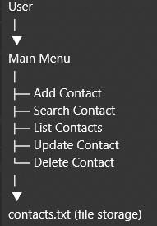

Workflow diagram

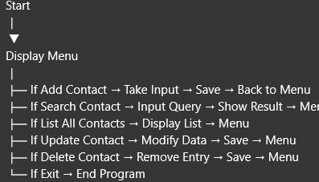

Working

- Main Menu
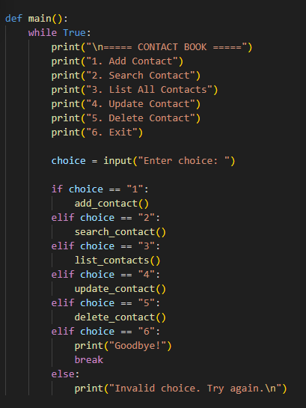
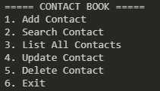

- Add new contacts to contact book
  - This adds new contacts
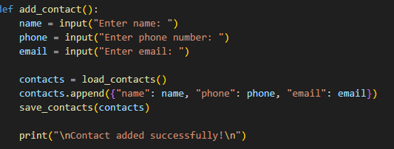
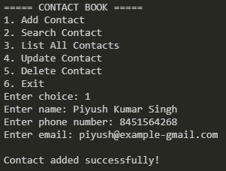

- Search for contacts
  - This Function Search for contact
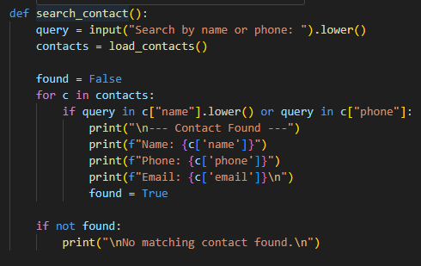

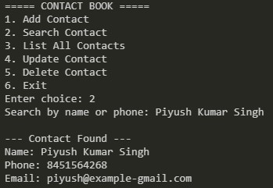

- List all contacts
  - This function lists the contacts
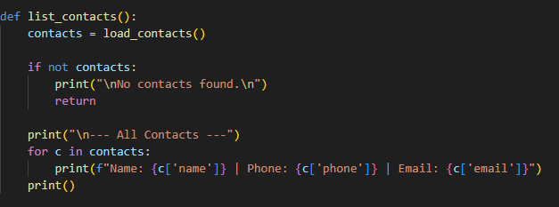
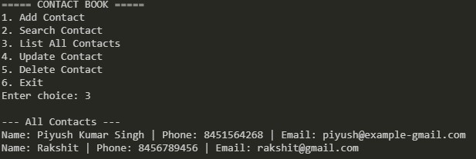

Update contact record
  - This function update the record of contact
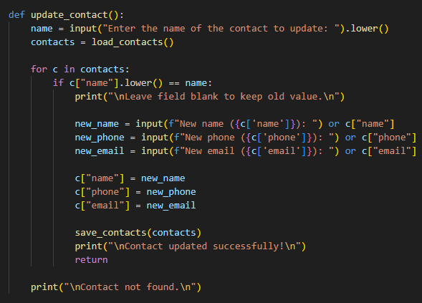

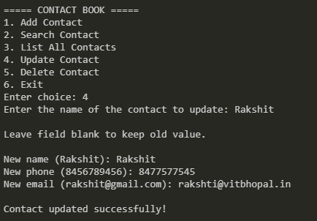

Delete contact record
  - This function delete the record of contact
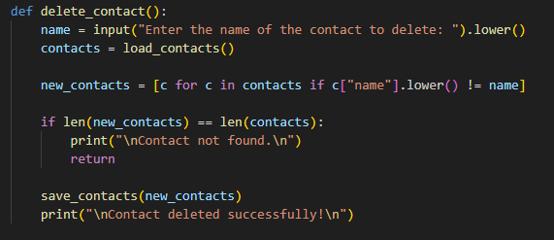
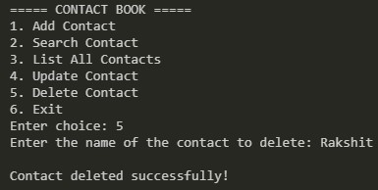

Implementation Details

The application is built using Python 3 and uses:
Basic input/output functions
Lists and dictionaries to store contact information temporarily
The os module to check for file existence
File reading/writing for persistent storage
A loop-based menu system to manage user actions
All core features are implemented inside individual functions such as:
add_contact()
search_contact()
update_contact()
delete_contact()
list_contacts()
load_contacts()
save_contacts()
This modular approach makes the system easy to understand and modify.

Code Summary (High-Level)
Contacts are stored in contacts.txt in the format:
Name|Phone|Email
load_contacts() reads the file and loads contacts into a list.
save_contacts() writes updated contacts to the file.
Each menu option is mapped to a specific function.
The main() function controls overall execution.

Testing
The application was manually tested using various cases:
Test Cases
Adding multiple contacts
Searching existing and non-existing contacts
Updating fields partially and fully
Deleting contacts
Listing contacts when file is empty
Verifying file persistence after restarting the program
All features worked as expected, and no major issues were encountered.

Challenges Faced
Ensuring that updates didn’t overwrite unchanged data.
Maintaining correct formatting when reading/writing the text file.
Handling cases where a user tries to update or delete a non-existing contact.
Avoiding duplicate entries during accidental repeat additions.

Learnings & Key Takeaways
Through this project, the following concepts were strengthened:
Python file handling
Modular programming
Data storage techniques
Designing menu-driven systems
Debugging errors and validating user input
This project also helped build confidence in structuring programs cleanly.

Future Enhancements

Add data validation for correct email and phone formats.
Add separate categories for contacts (personal, academic, professional).
Integrate with a database for more secure storage.
Add GUI support using Tkinter or create a web-based version.
Export contacts to CSV/Excel formats.

FlowChart
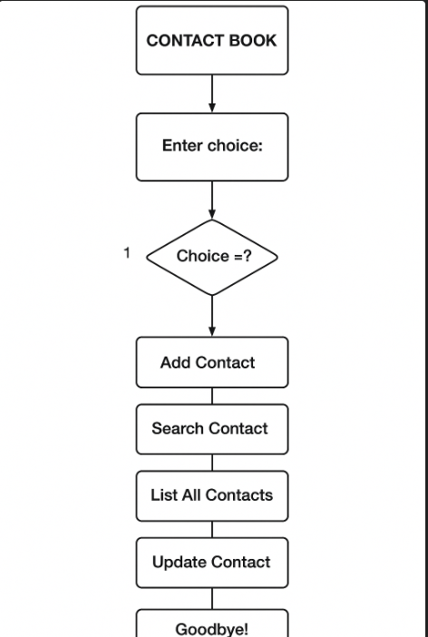

Conclusions

The Contact Book Application successfully provides a simple and effective solution for storing and managing contact information. It meets all the functional requirements and demonstrates practical implementation of Python basics. The system is easy to use, well-structured, and can be expanded with more advanced features in the future.

Reference
- Python Documentation
- Class Notes
- Online Tutorials
- VITyarthi Project Instructions PDF

