# Powerful Writer.

# Powerful Words.

We believe in the power of words. Collaborate with teammates in real time. Create elegant, inspiring documents for free.

## Write across devices.

Maya Angelou wrote in hotel rooms. Sir Walter Scott wrote a famous poem on horseback. Whatever your process, whichever device you prefer, Writer is there when inspiration strikes.



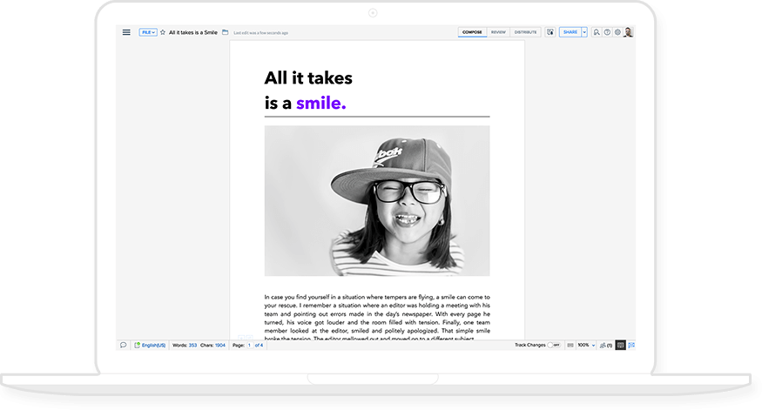

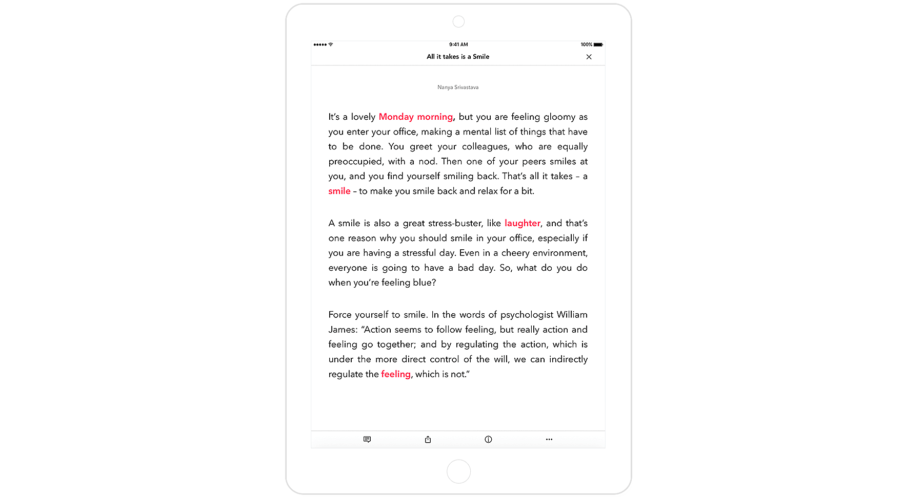

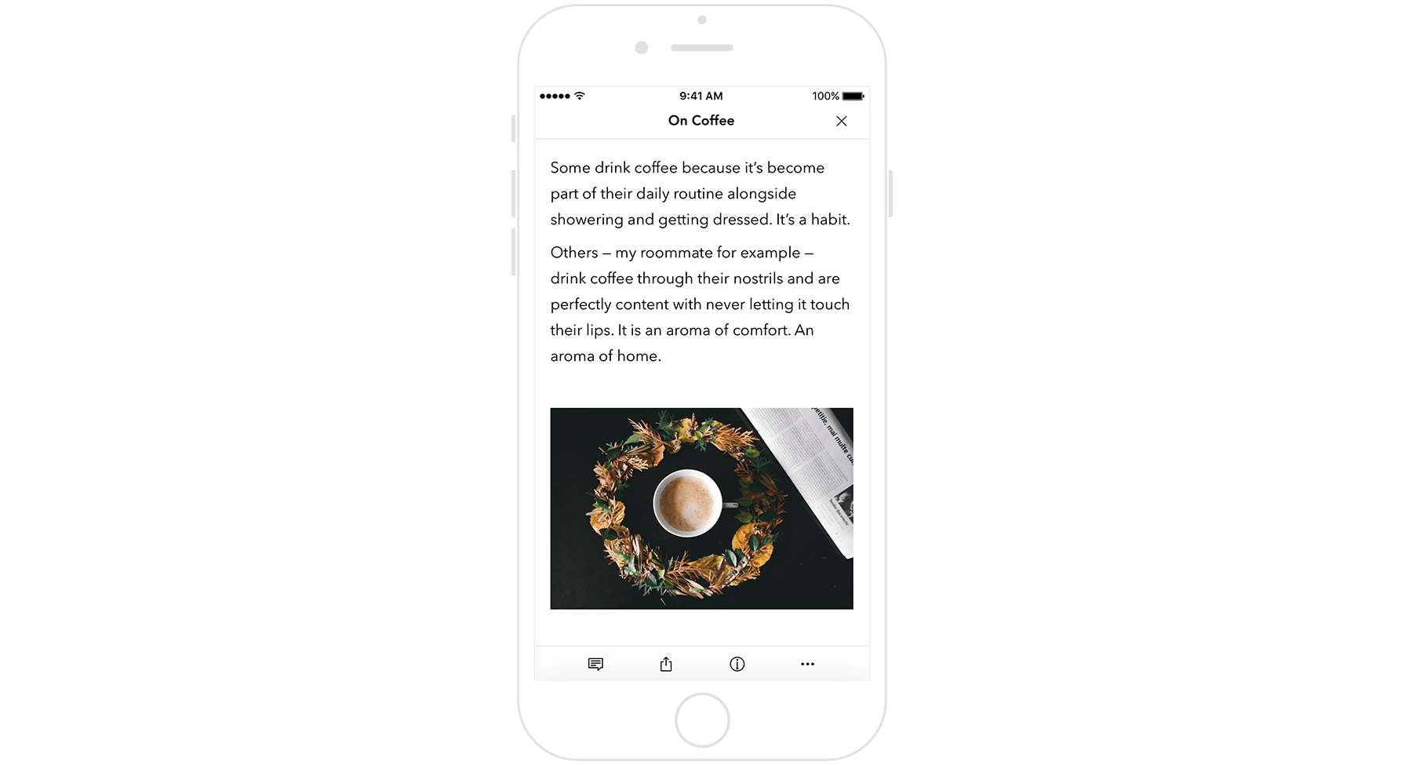

## A crisp, clean space.

A blank page is clean, simple, and distraction-free. It's the space for you to inspire and influence; to persuade, describe, and explain. We've strived to re-create the blank page across your devices by keeping menus to a minimum and making tools available when you need them.

## And other features you'll love!

Zia, the writing assistant

Contextual grammar, readability and style suggestions.

Review & approval

Feedback and change-tracking tools to speed up your review process.

WordPress integration

Collaborate on content and post it directly to your WordPress or Blogger pages.

Powerful tools for work

Document automation and sign collection capabilities along with Zoho CRM integration.