OS : Rocky Linux 8
1. Create 20 files with .txt extensions and rename the first 5 files to .yml extension
# script has been created for the task1. executing the `sh filecreaterename.sh` command to complete the task
#/bin/bash
# switching to specific directory to create a files.
cd /home/devopskvk
#creating the 20 .txt files using looping
for (( i=1 ; i<=20 ; i++ ))
do
touch text$i.txt
done
echo "The new files are created "
#renaming the first 5 .txt file to .yml extension
for (( i=1 ; i<=5 ; i++ ))
do
mv text$i.txt text$i.yml
done
echo "The first 5 files are renamed "

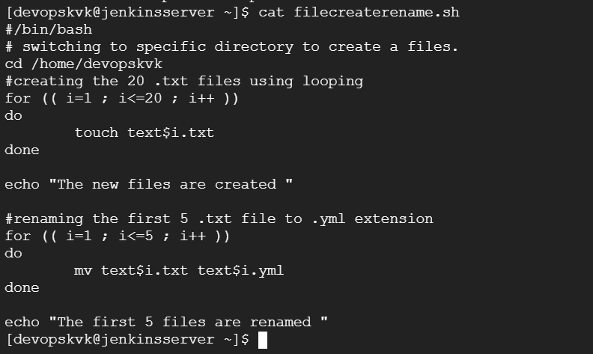
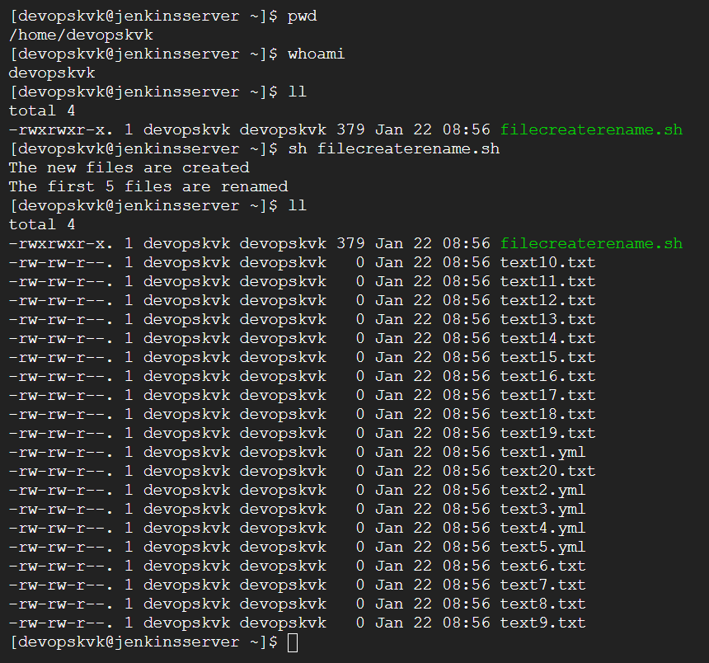

2. Print the latest created top 5 files among the total no of files"

# the command will print the task 2 requirement.
ls -ltr | tail -n 5
or
ls -ltr | tail 5


Or
