**CSCI 620/Section 03/Mior, Introduction to Big Data, Spring 2215 Assignment 7 – Item set mining**

**Submitted by – Prakhar Gupta(pg9349)**

**Ans1**

(refer to query.sql)

**Ans2**

(refer to query.sql)

**Ans3**

(refer to query.sql)

**Ans4**

(refer to query.sql)

**Ans5**

(refer to q5.py and q5_2.sql)

Number of itemsets in each levels is given below. There were 6 levels. For 7th level the number of itemsets is zero hence the code halts.

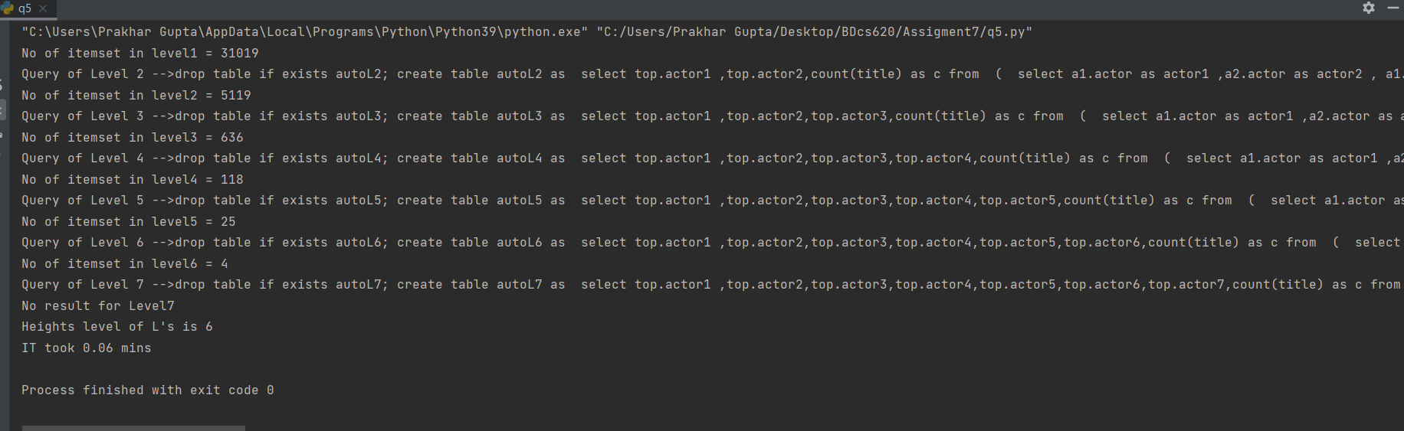

*(Some initial counts may differ as I have loaded most recent IMDB data)*

*(Also the level tables have prefix auto to differentiate them from the ones which were created in question 2 to 4)*

Level 1 item sets = 31019

Level 2 item sets = 5119

Level 3 item sets = 636

Level 4 item sets=118

Level 5 item sets=25

Level 6 item sets=4

Level 7 item sets=0

For level 6 there were 4 item sets:

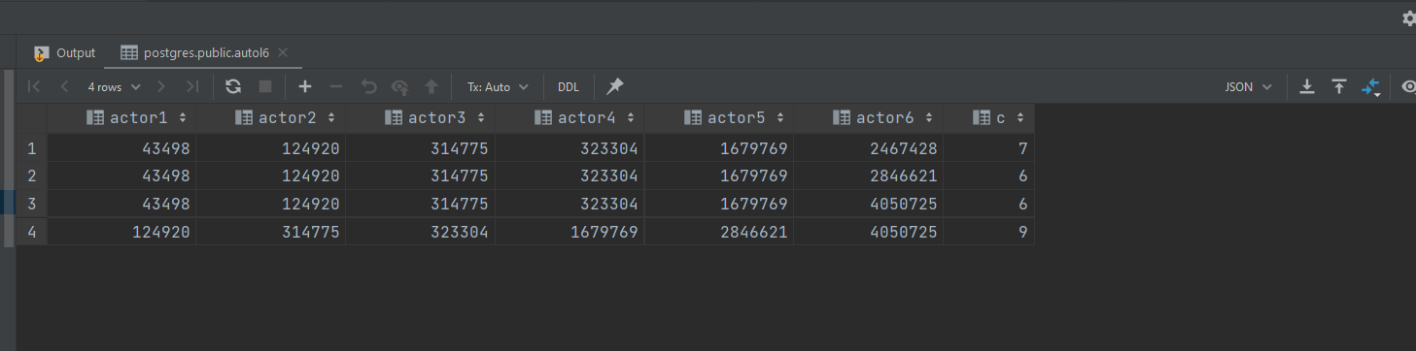

The name of these actors are-

