**CSCI 620/Section 03/Mior, Introduction to Big Data, Spring 2215 Assignment 9 – Distributed System**

**Submitted by – Prakhar Gupta(pg9349)**

**Results of 10 rows**

Query 1

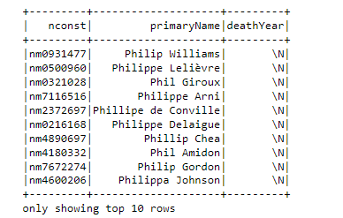

Query 2

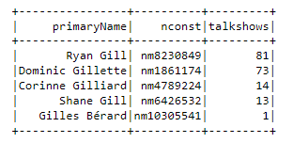

Query 3

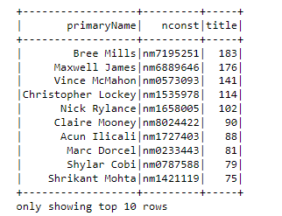

Query 4



**Runtimes for all results**

Query1 Runtime 244.11

Query2 Runtime 54.01

Query3 Runtime 114.73

Query4 Runtime 47.620