**Software development methodology**

**Q.1**

**Given case study:**

**Objective:**

Online Project Management system is a tool help in managing projects within an organization. This system will help employees, project managers, Delivery managers and stakeholders to update about executions of projects going on in this organization. All beneficiaries will be able to manage resources, time effectively.

**Q.2**

Added to local repo srs.txt

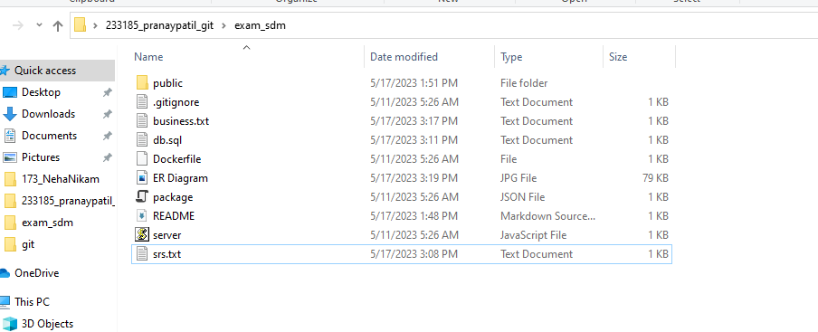

**Q.3**

Added to git repo business.txt



**Q.4**

Added to git repo ER diagram

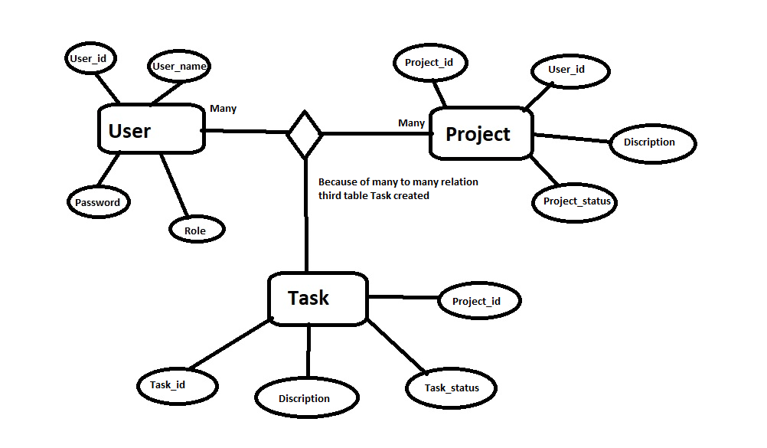



**Q.5**

Added to git repo db.sql



**Q.6**

**Creating git repo**

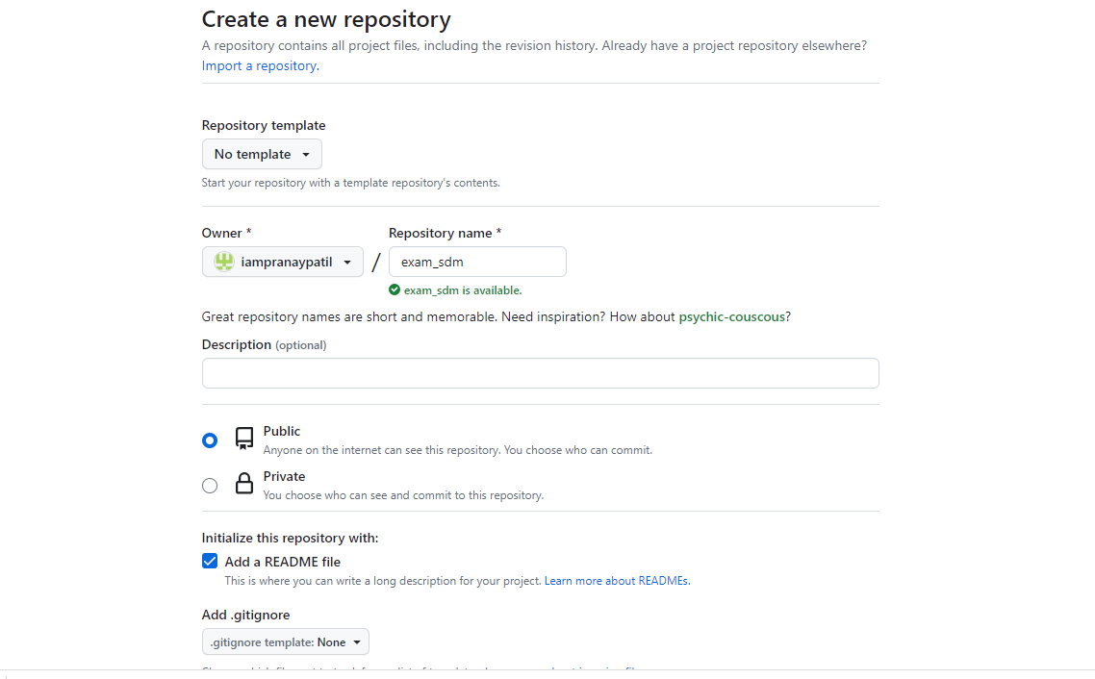

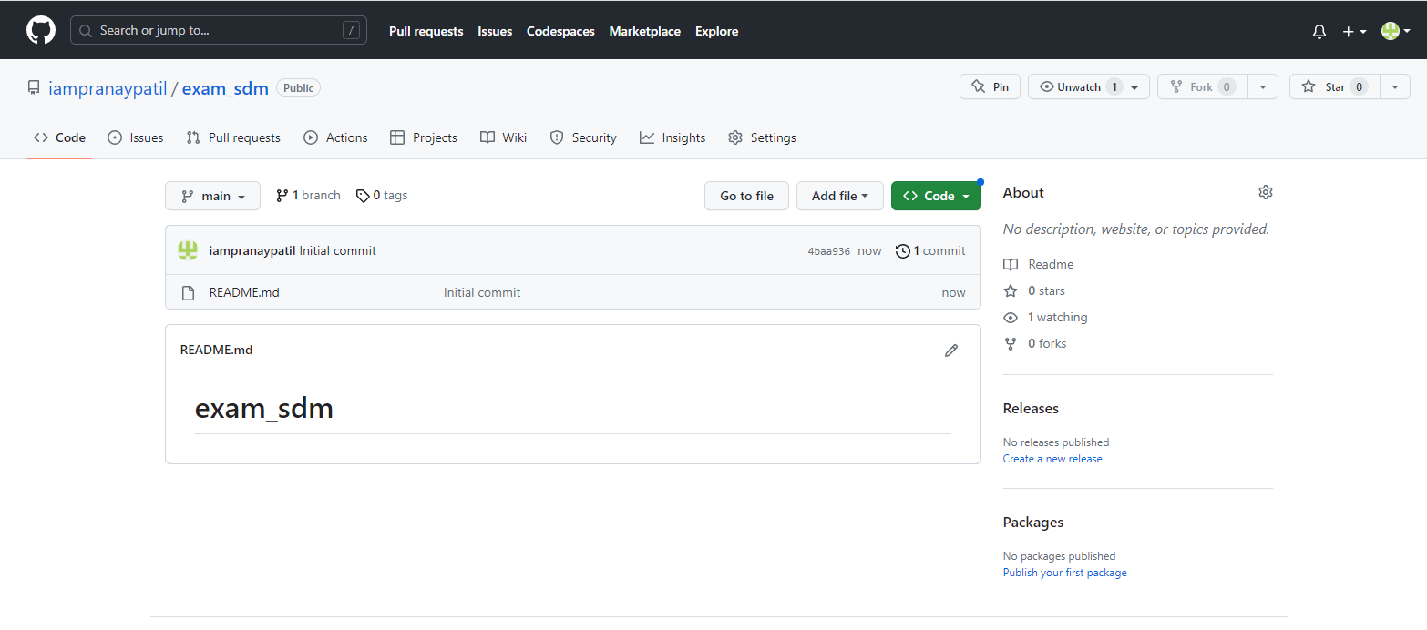

**Q.7**

**Clone**

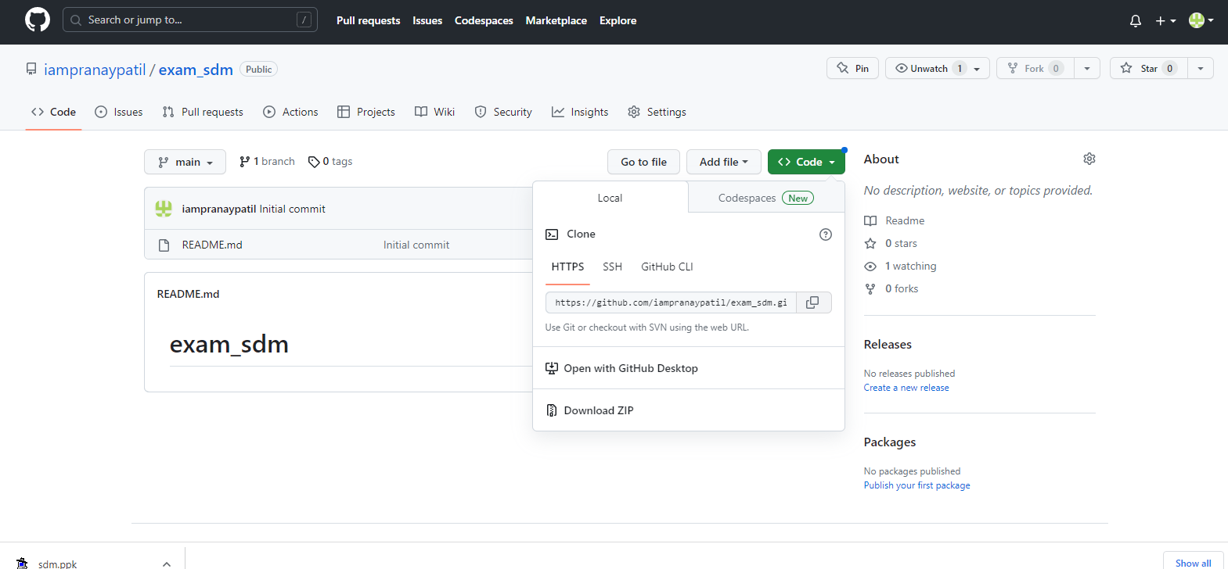

**In local repo**

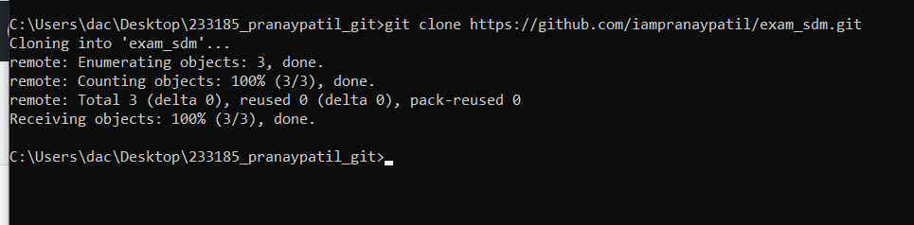

**Q.8**

**Copied to git srs,business,ER,sql**



**CMD**

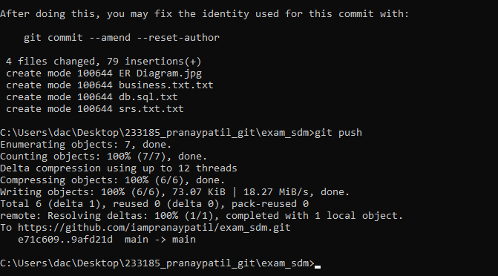

**To git repo**

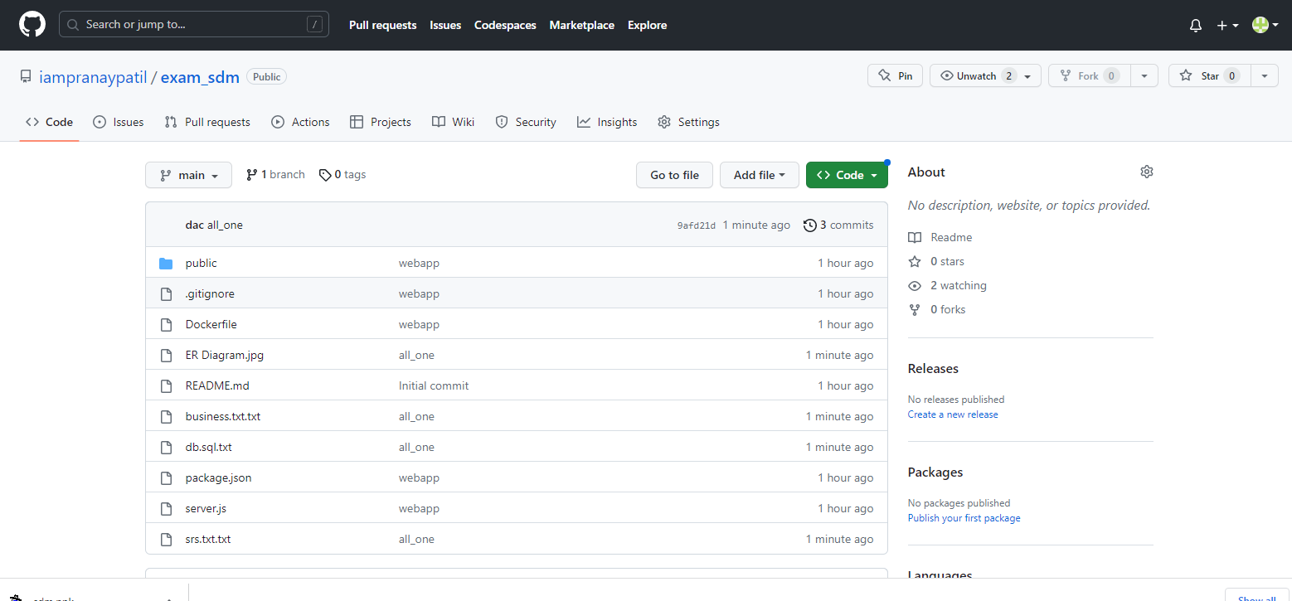

**Q.9**

**Copying webapp code into local repo**

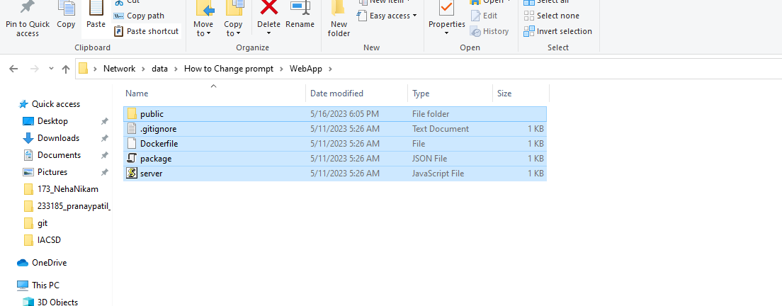

**Local repo**

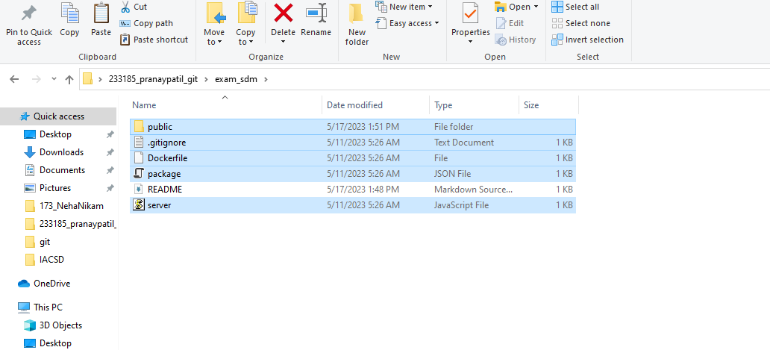

**Q.10**

**Deploying all resources to github repo**

**Git commands**

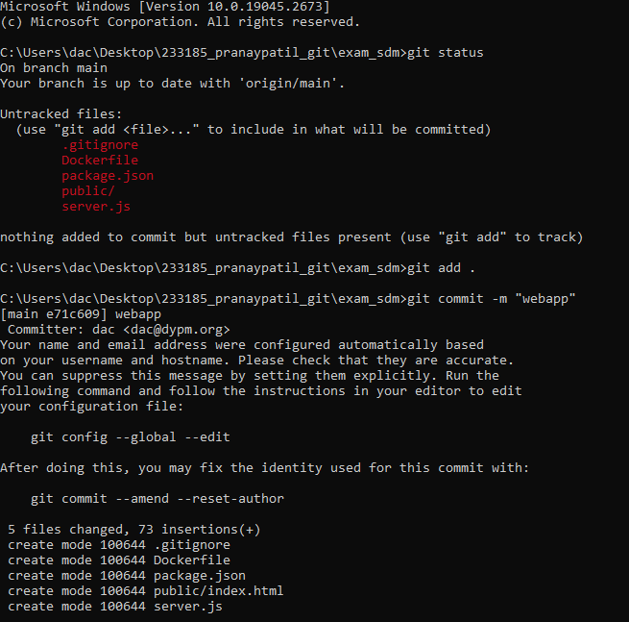

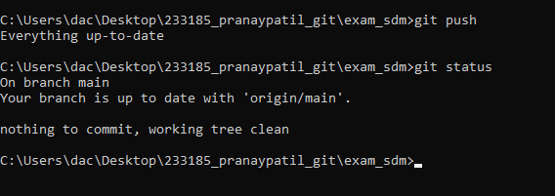

**In github repo**

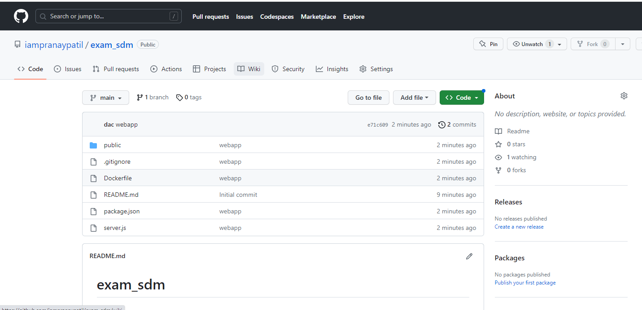

**Q.11**

**Keep githubrepo for deploying to aws**

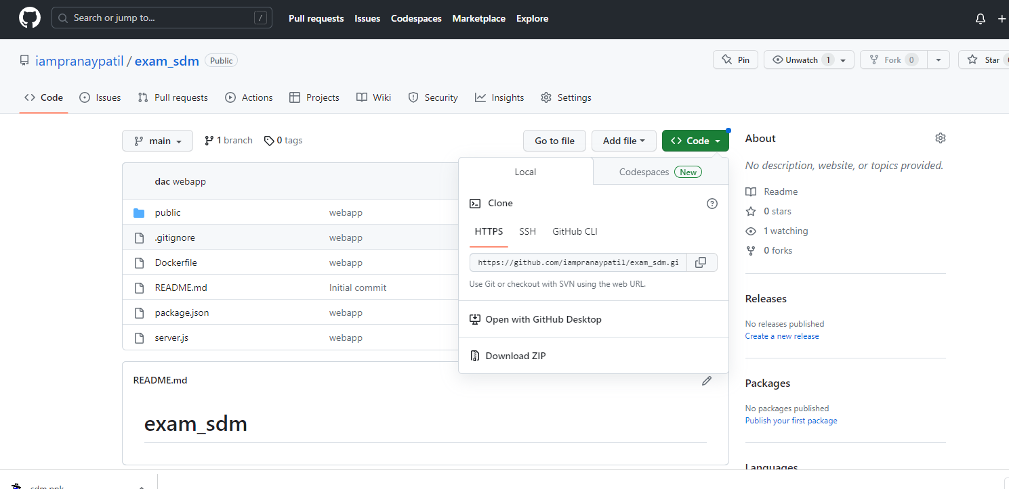

**Q.12**

**Aws-ubuntu virtualserver**

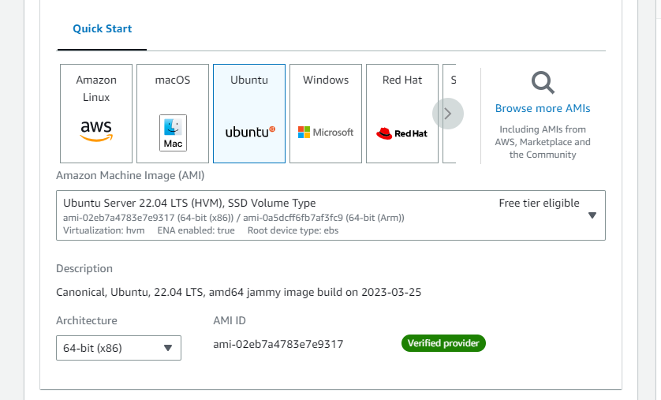

t2.micro machine

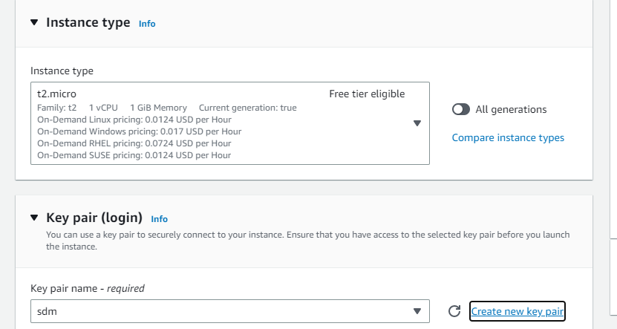

**Instance created**

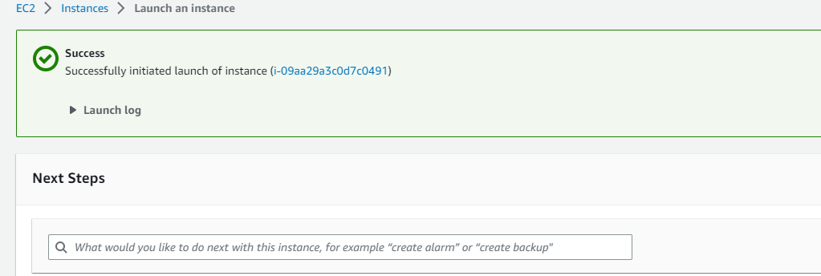

**Q13.**

**Putty connection**

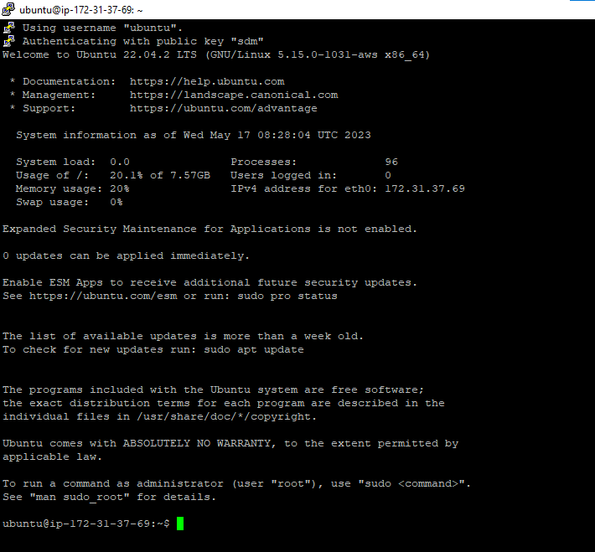

**Q.14**

**Installing docker**

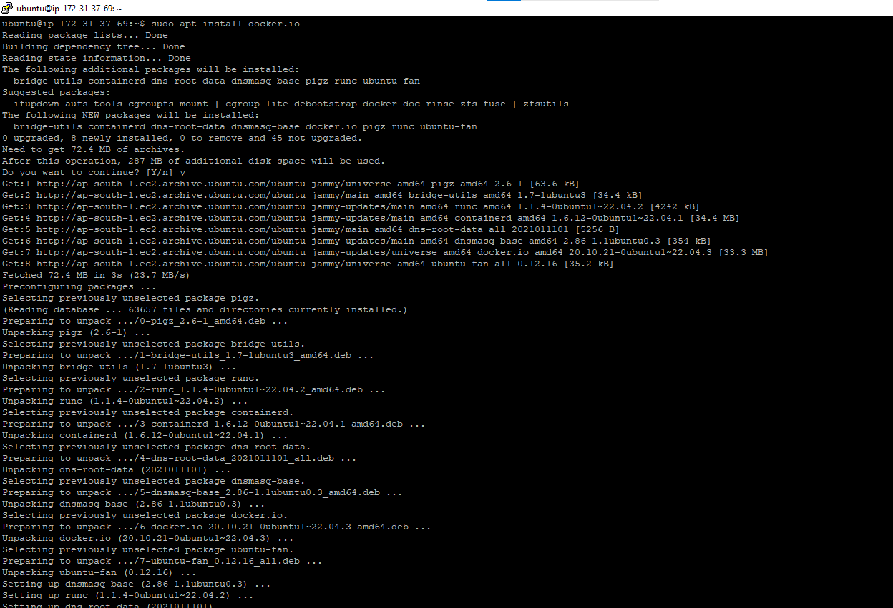

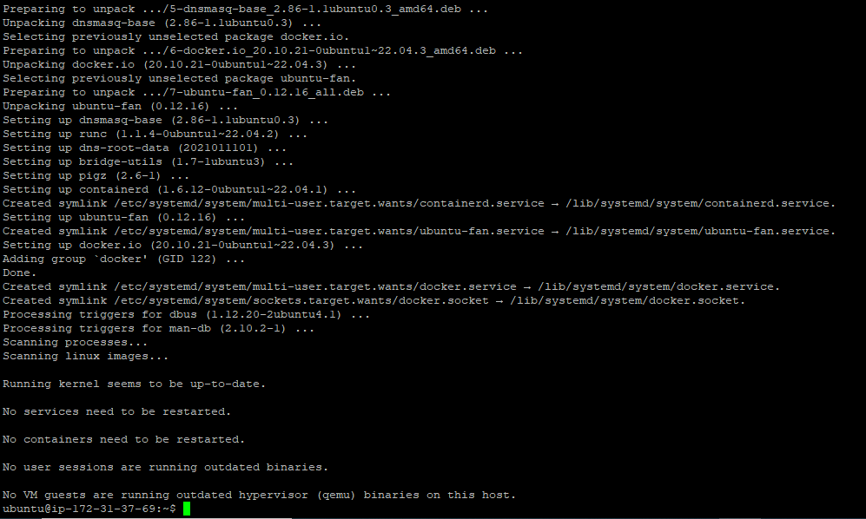

**Q.15**

**Git clone to virtual server**

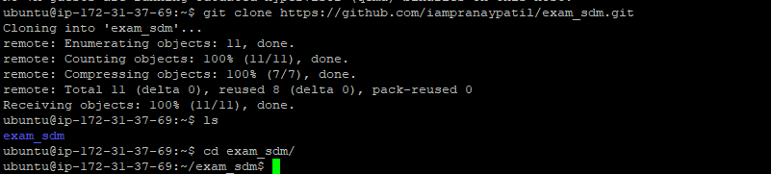

**Q.16**

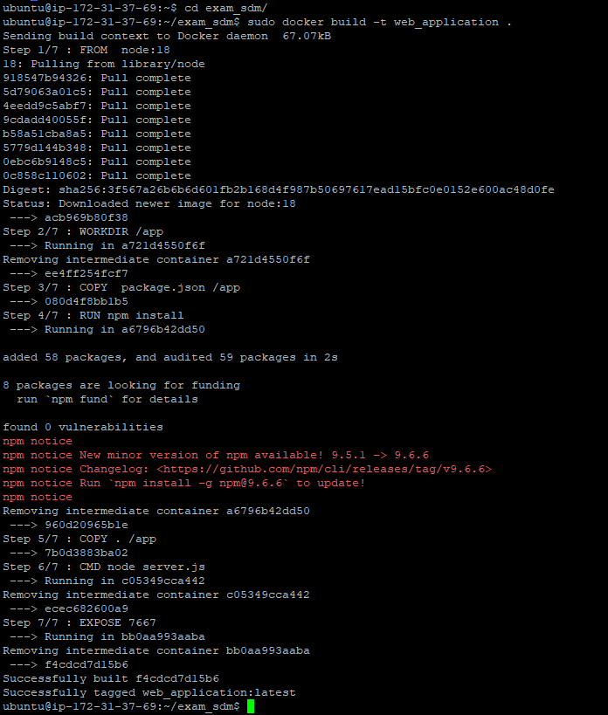

**Q.17**

**Docker downloaded and created**

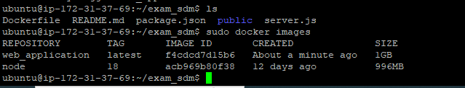

**Q.18**

Configure firewall setting for accept request from anywhere

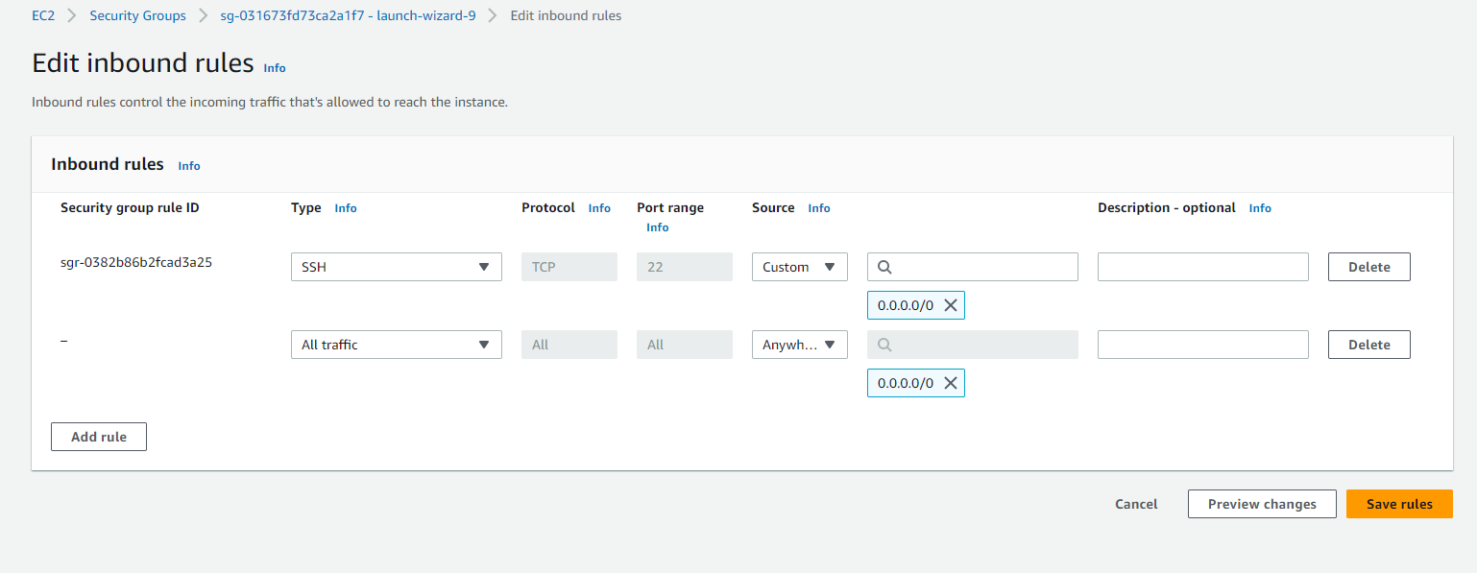

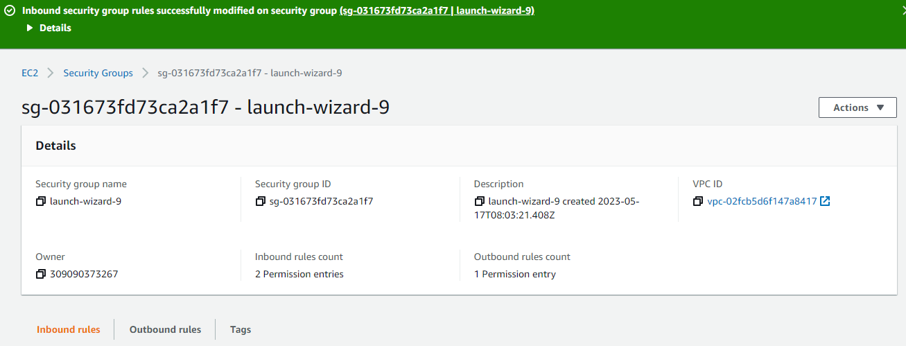

Q.19

Running docker file and deploying to web server



On web site

