**Assignment-3**

By:

Prasad Thondamuthur Vasanth

Poly ID: 0529494

Initial screen of APP is as below.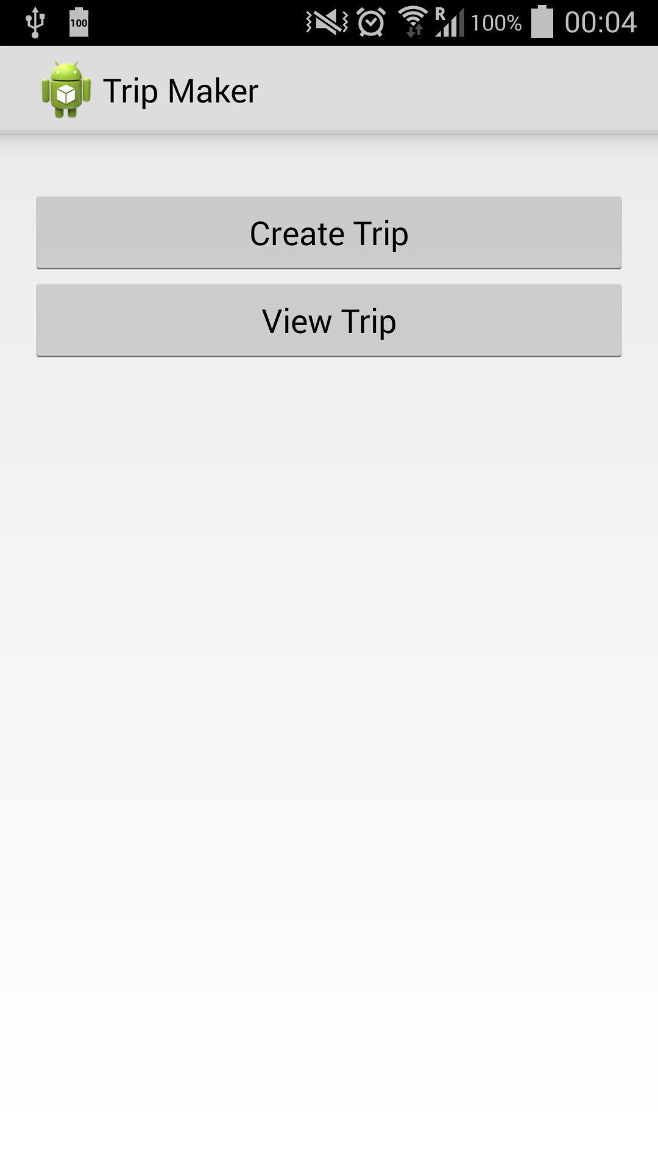

When click on CreateTrip it opens a new screen as shown

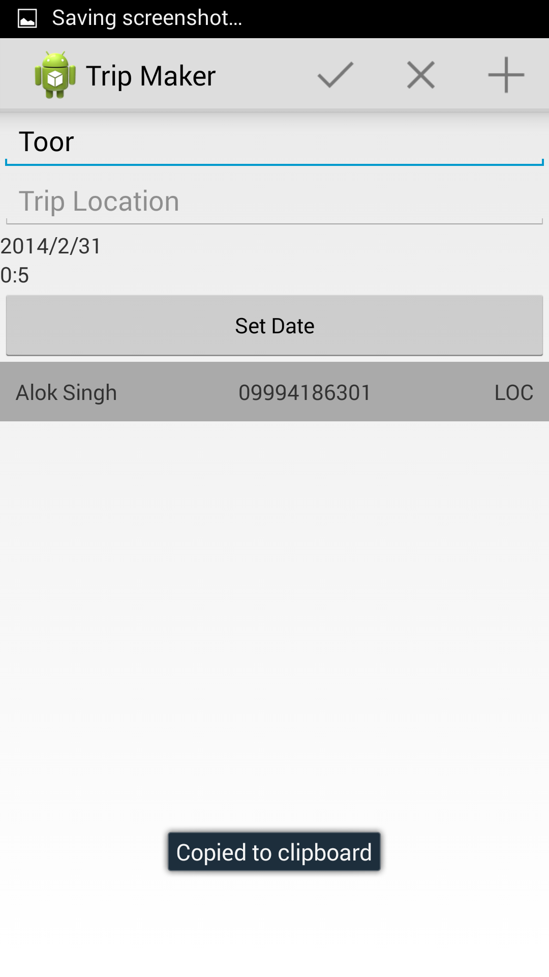

Added Dialogs to pick date and time

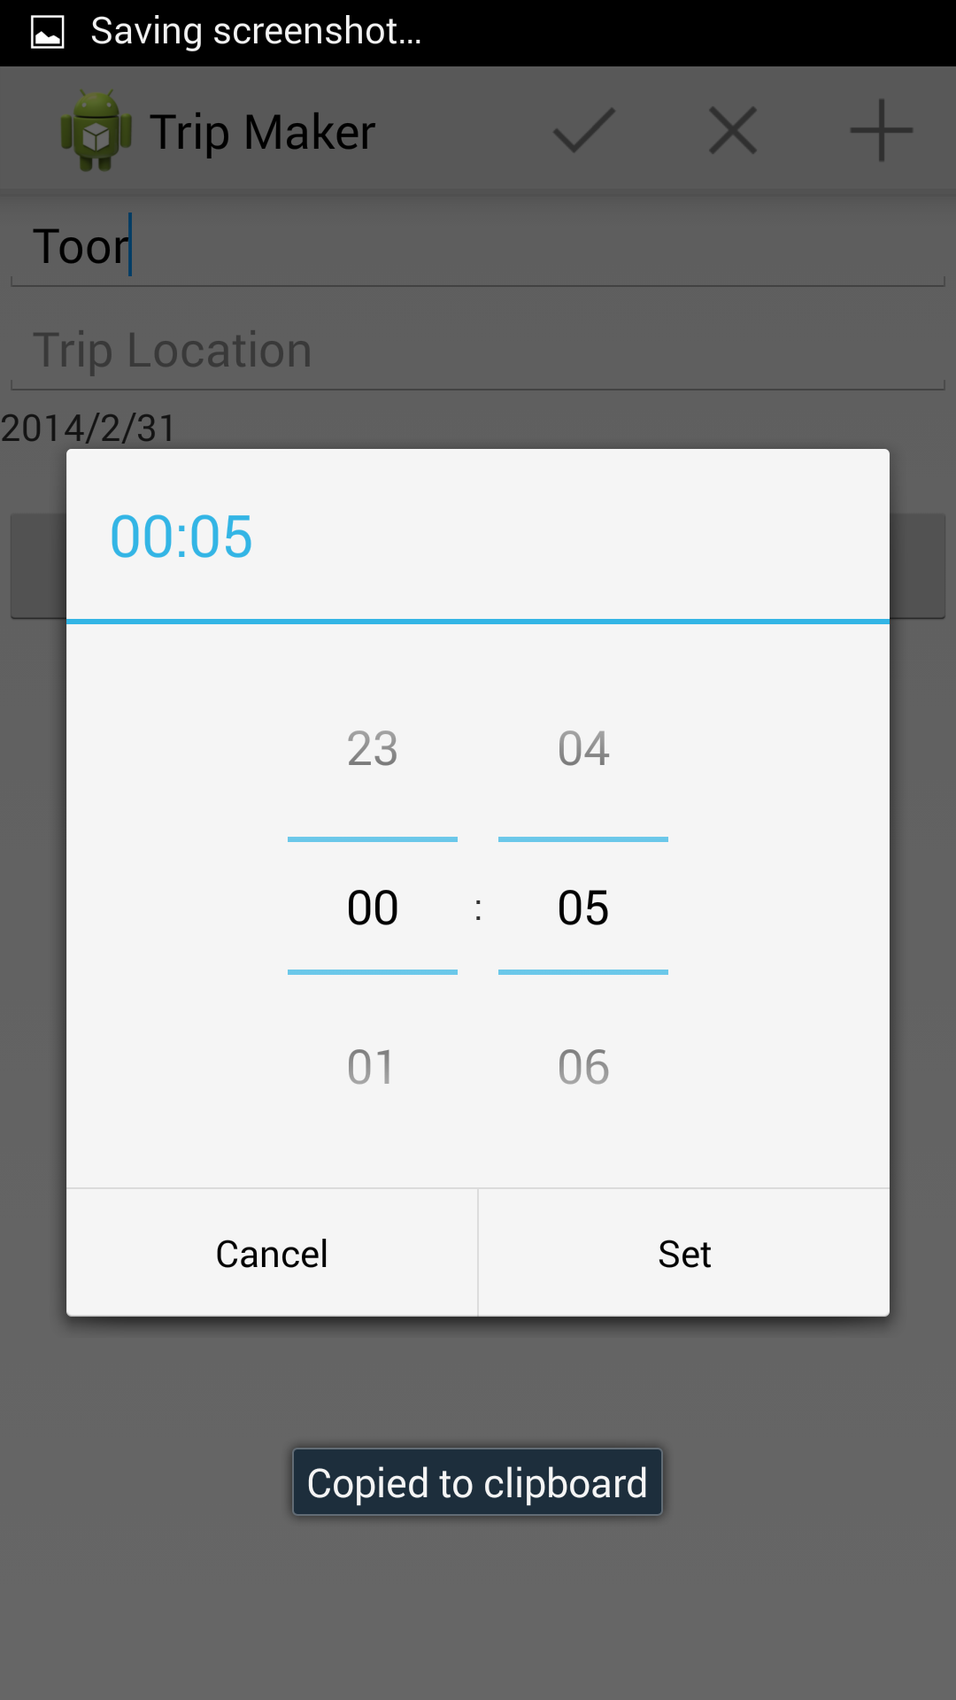

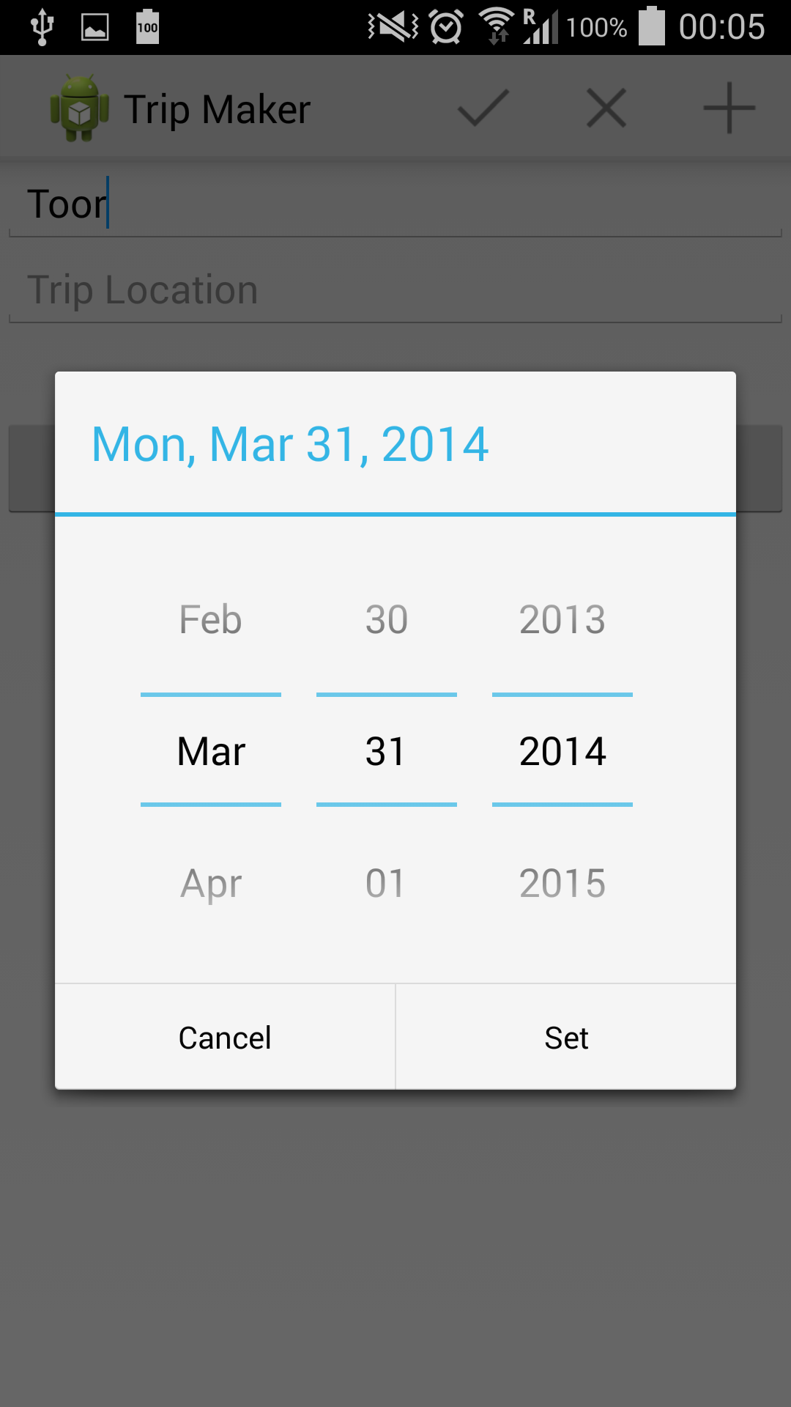

Added Contact Picker to dynamically pick contacts from contacts app

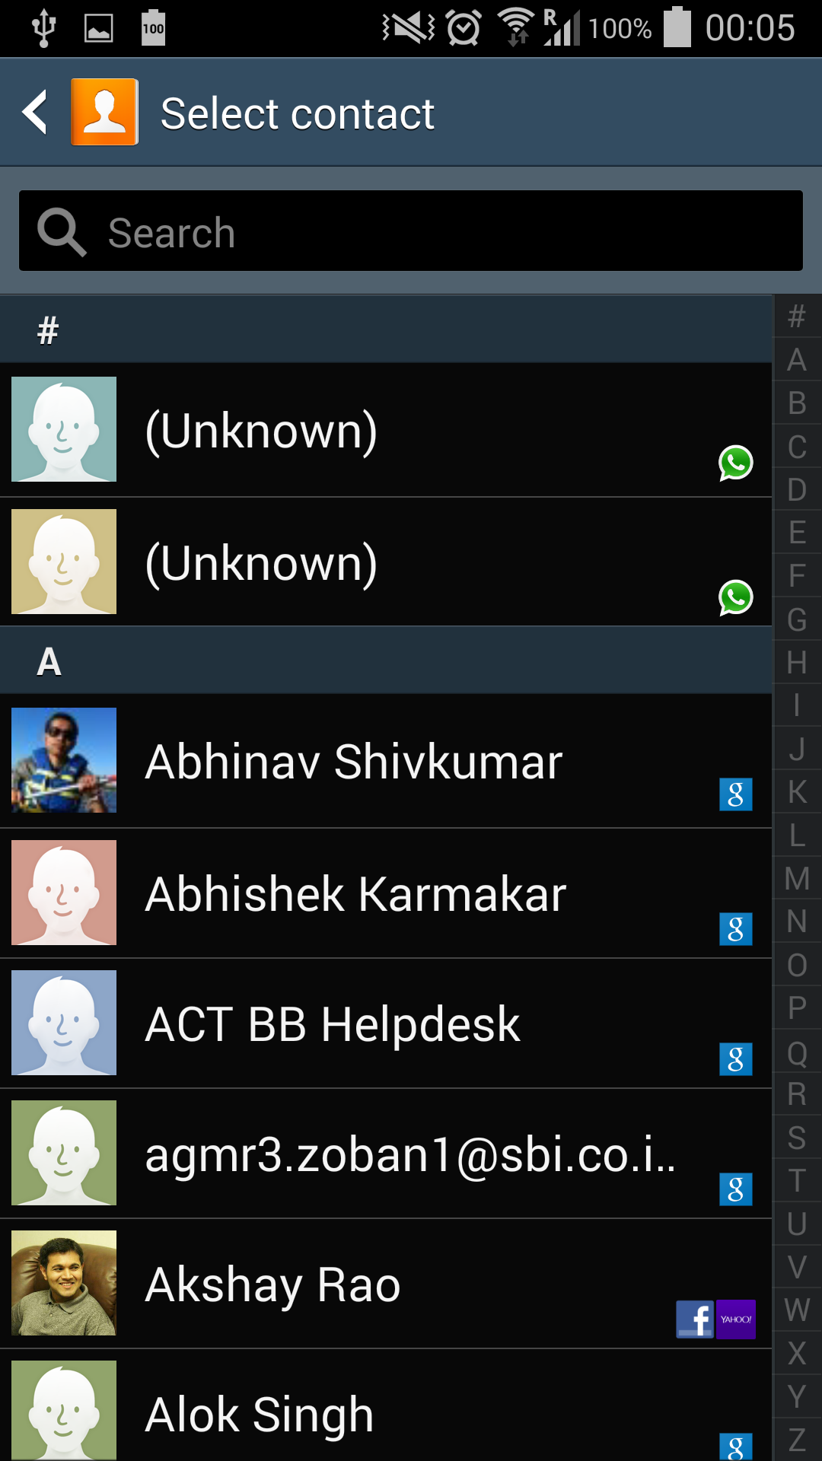

Added view trips view to show trips saved to DB

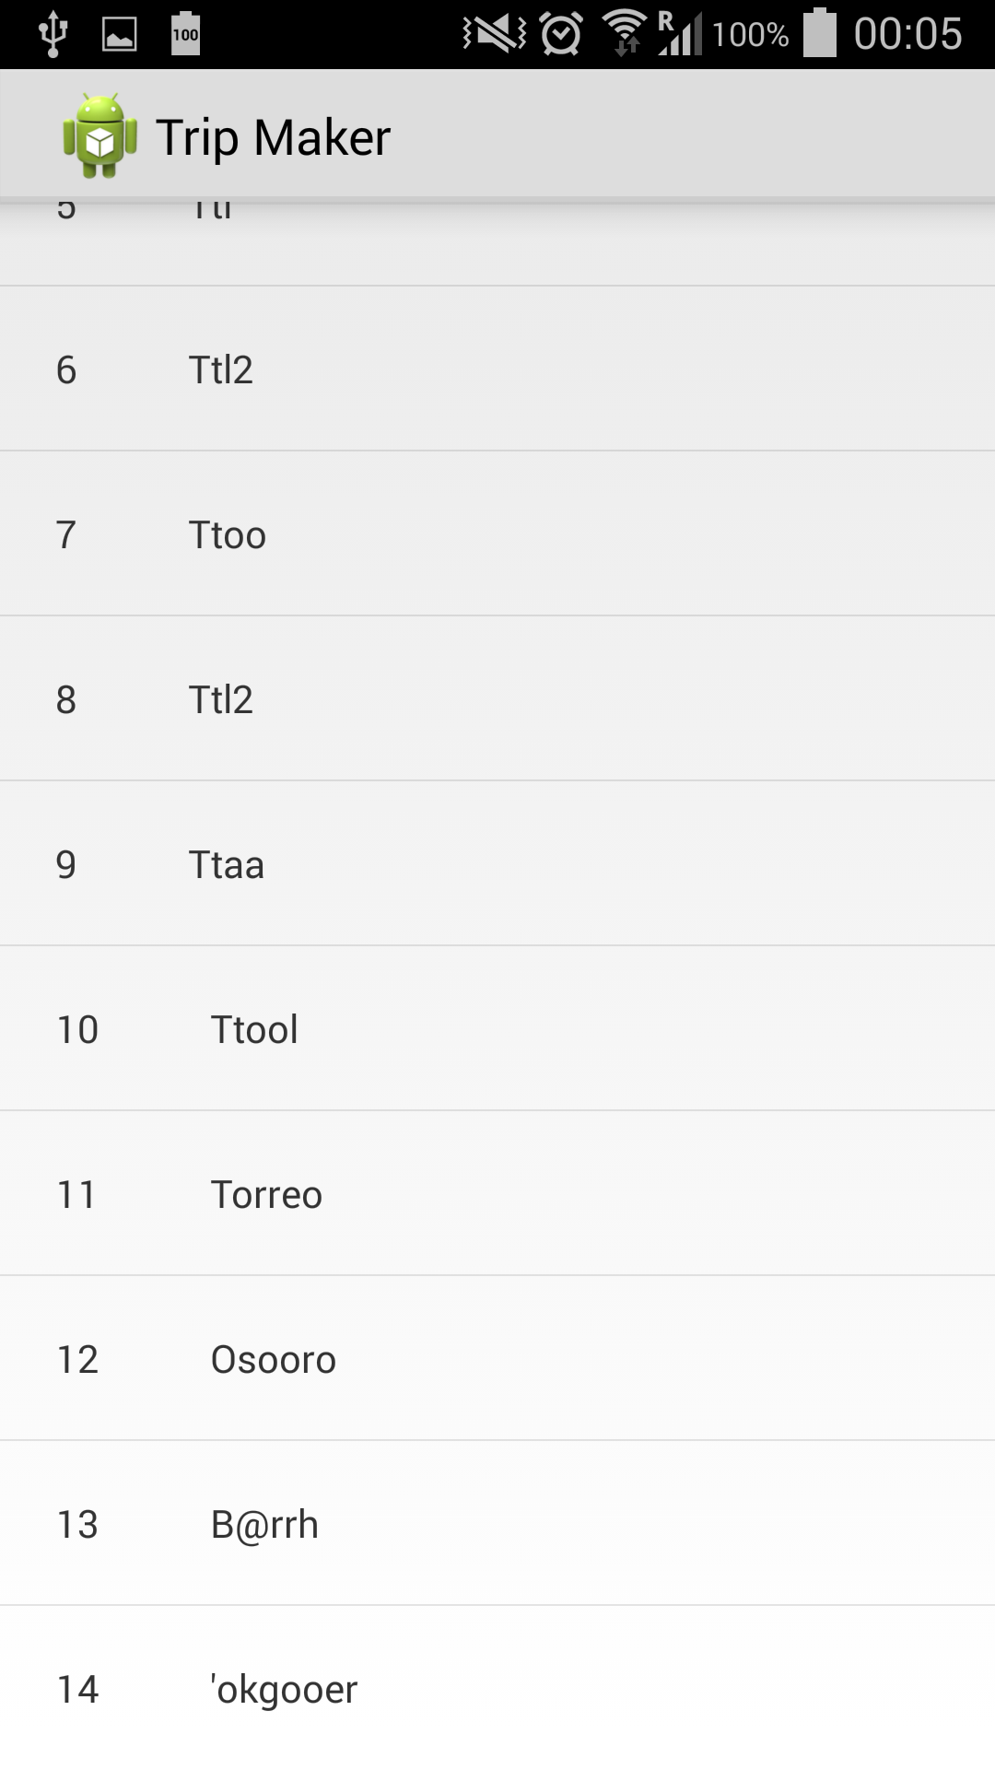

And clicking any of these Trips shows the trip

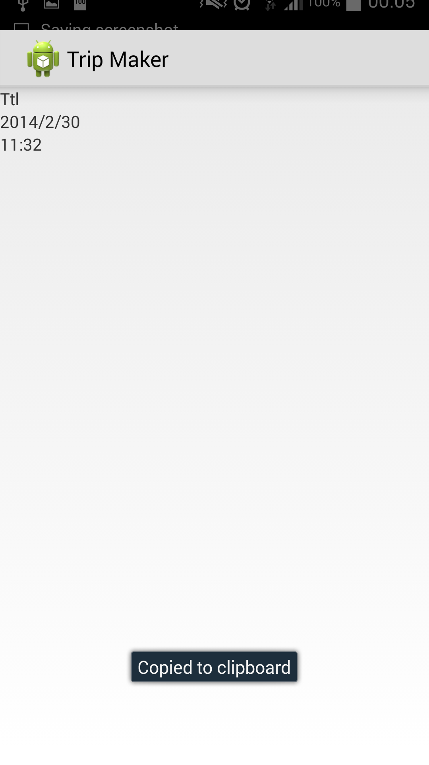

Used SQLiteOpenHelper for extending database operations.

Use fragments to implement Create Trip view.