1

**Lab Experiment: 01**

**Student Detail:**

**• Name:** Prashant Joshi

**• Student ID:** 590010879

**• Branch:** MCA

**• Batch:** B1

**• Instructor:** Dr. Sourbh Kumar

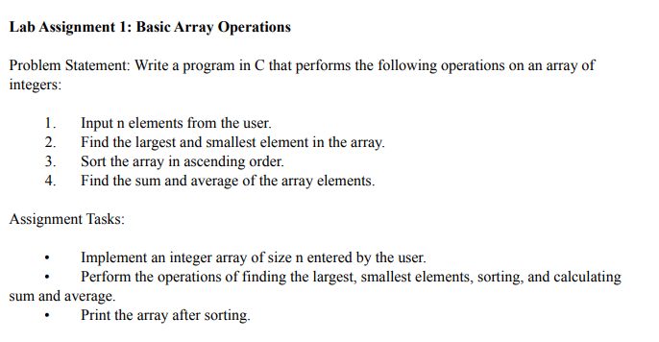

Solution:

#include <stdio.h>

void inputArray(int arr[], int n) {

printf("Enter %d elements:\n", n);

for (int i = 0; i < n; i++) {

scanf("%d", &arr[i]);

}

}

int findLargest(int arr[], int n) {

int largest = arr[0];

for (int i = 1; i < n; i++) {

if (arr[i] > largest) {

largest = arr[i];

}

}

return largest;

}

int findSmallest(int arr[], int n) {

int smallest = arr[0];

for (int i = 1; i < n; i++) {

if (arr[i] < smallest) {

smallest = arr[i];

}

}

return smallest;

}

void sortArray(int arr[], int n) {

for (int i = 0; i < n - 1; i++) {

for (int j = i + 1; j < n; j++) {

if (arr[i] > arr[j]) {

int temp = arr[i];

arr[i] = arr[j];

arr[j] = temp;

}

}

}

}

int findSum(int arr[], int n) {

int sum = 0;

for (int i = 0; i < n; i++) {

sum += arr[i];

}

return sum;

}

double findAverage(int sum, int n) {

return (double)sum / n;

}

void printArray(int arr[], int n) {

printf("Sorted array: ");

for (int i = 0; i < n; i++) {

printf("%d ", arr[i]);

}

printf("\n");

}

int main() {

int n;

printf("Enter the number of elements in the array: ");

scanf("%d", &n);

int arr[n];

inputArray(arr, n);

int largest = findLargest(arr, n);

int smallest = findSmallest(arr, n);

int sum = findSum(arr, n);

double average = findAverage(sum, n);

sortArray(arr, n);

printf("Largest element: %d\n", largest);

printf("Smallest element: %d\n", smallest);

printf("Sum of elements: %d\n", sum);

printf("Average of elements: %.2f\n", average);

printArray(arr, n);

return 0;

}

Output:

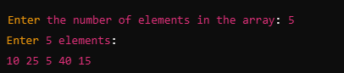

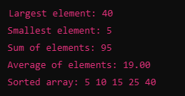

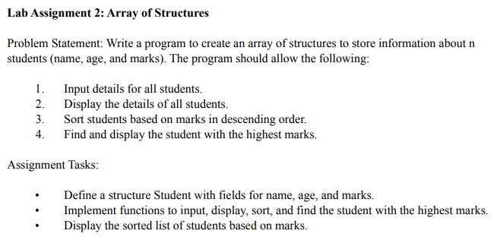

Solution:

#include <stdio.h>

#include <string.h>

struct Student {

char name[50];

int age;

float marks;

};

// Function to input details for all students

void inputStudents(struct Student students[], int n) {

for (int i = 0; i < n; i++) {

printf("Enter details for student %d:\n", i + 1);

printf("Name: ");

scanf(" %[^\n]", students[i].name); // To read a string with spaces

printf("Age: ");

scanf("%d", &students[i].age);

printf("Marks: ");

scanf("%f", &students[i].marks);

}

}

// Function to display details of all students

void displayStudents(struct Student students[], int n) {

printf("\nStudent Details:\n");

for (int i = 0; i < n; i++) {

printf("Name: %s, Age: %d, Marks: %.2f\n", students[i].name, students[i].age, students[i].marks);

}

}

// Function to sort students based on marks in descending order

void sortStudents(struct Student students[], int n) {

struct Student temp;

for (int i = 0; i < n - 1; i++) {

for (int j = i + 1; j < n; j++) {

if (students[i].marks < students[j].marks) {

temp = students[i];

students[i] = students[j];

students[j] = temp;

}

}

}

}

// Function to find and display the student with the highest marks

void displayTopStudent(struct Student students[], int n) {

struct Student topStudent = students[0];

for (int i = 1; i < n; i++) {

if (students[i].marks > topStudent.marks) {

topStudent = students[i];

}

}

printf("\nStudent with the highest marks:\n");

printf("Name: %s, Age: %d, Marks: %.2f\n", topStudent.name, topStudent.age, topStudent.marks);

}

int main() {

int n;

printf("Enter the number of students: ");

scanf("%d", &n);

struct Student students[n];

inputStudents(students, n);

printf("\nBefore Sorting:");

displayStudents(students, n);

sortStudents(students, n);

printf("\nAfter Sorting by Marks (Descending Order):");

displayStudents(students, n);

displayTopStudent(students, n);

return 0;

}

Output:

