WEEK 2 TASK REPORT
DATA EXTRACTION, TRANSFORMATION,
AND LOADING (ETL) PLANNING
Virtual Retail Environment | SQL Developer Internship

Submitted by | Pratik Vijay Rathod
Technology | MySQL 8.0, SQL, CSV, Java/JDBC concepts
Project | Virtual Retail ETL Pipeline
Submission | Week 2 — ETL Planning

1. Executive Summary
This report proposes a controlled Extract, Transform, and Load (ETL) pipeline for a virtual retail platform. The process takes data from customer, product, supplier, inventory, and order source records and prepares it for the normalized MySQL 8.0 target database designed in Week 1. The pipeline is batch-oriented and separates extraction, staging, transformation, validation, loading, reconciliation, and monitoring.
The core principle is to preserve source data in staging before applying transformations. This allows errors to be traced back to the original file and row, supports reprocessing, and prevents incomplete or malformed records from silently entering production tables. Valid records are standardized and loaded in dependency order: reference data such as categories, products, suppliers, and warehouses first, followed by inventory and transactional records such as orders and order items. Rejected rows are written to a data-quality log with a reason for investigation.

2. ETL Objectives and Scope
- Integrate retail data from CSV exports or operational source systems into the Week 1 MySQL schema.
- Maintain traceability from every imported record to its source file, source row, and ETL batch.
- Improve data quality through validation, standardization, duplicate detection, and referential integrity checks.
- Load data in dependency order while preserving transactional consistency.
- Provide measurable outcomes through accepted/rejected counts and reconciliation checks.

2.1 Source Data Inventory
Source | Typical fields | Target entities
Customer export | Customer code, name, email, phone, address, creation date, status | Customer and Customer_Address
Product catalog | SKU, product name, category, description, selling price, cost price | Category and Product
Supplier catalog | Supplier name, contact, supplier-specific product details | Supplier and Product_Supplier
Inventory snapshot | SKU, warehouse, quantity on hand, reorder threshold | Warehouse and Inventory
Order export | Order number, customer code, order date, status, SKU, quantity, unit price, payment data | Retail_Order, Order_Item, Payment
The included CSV files are illustrative source extracts. They deliberately contain a few inconsistent dates, blank values, invalid email addresses, unknown customer references, zero quantities, and invalid cost values so the pipeline can demonstrate data-quality controls.

3. ETL Process Flow
The flowchart shows the proposed end-to-end process. Validation failures are routed to a reject log instead of being silently discarded.
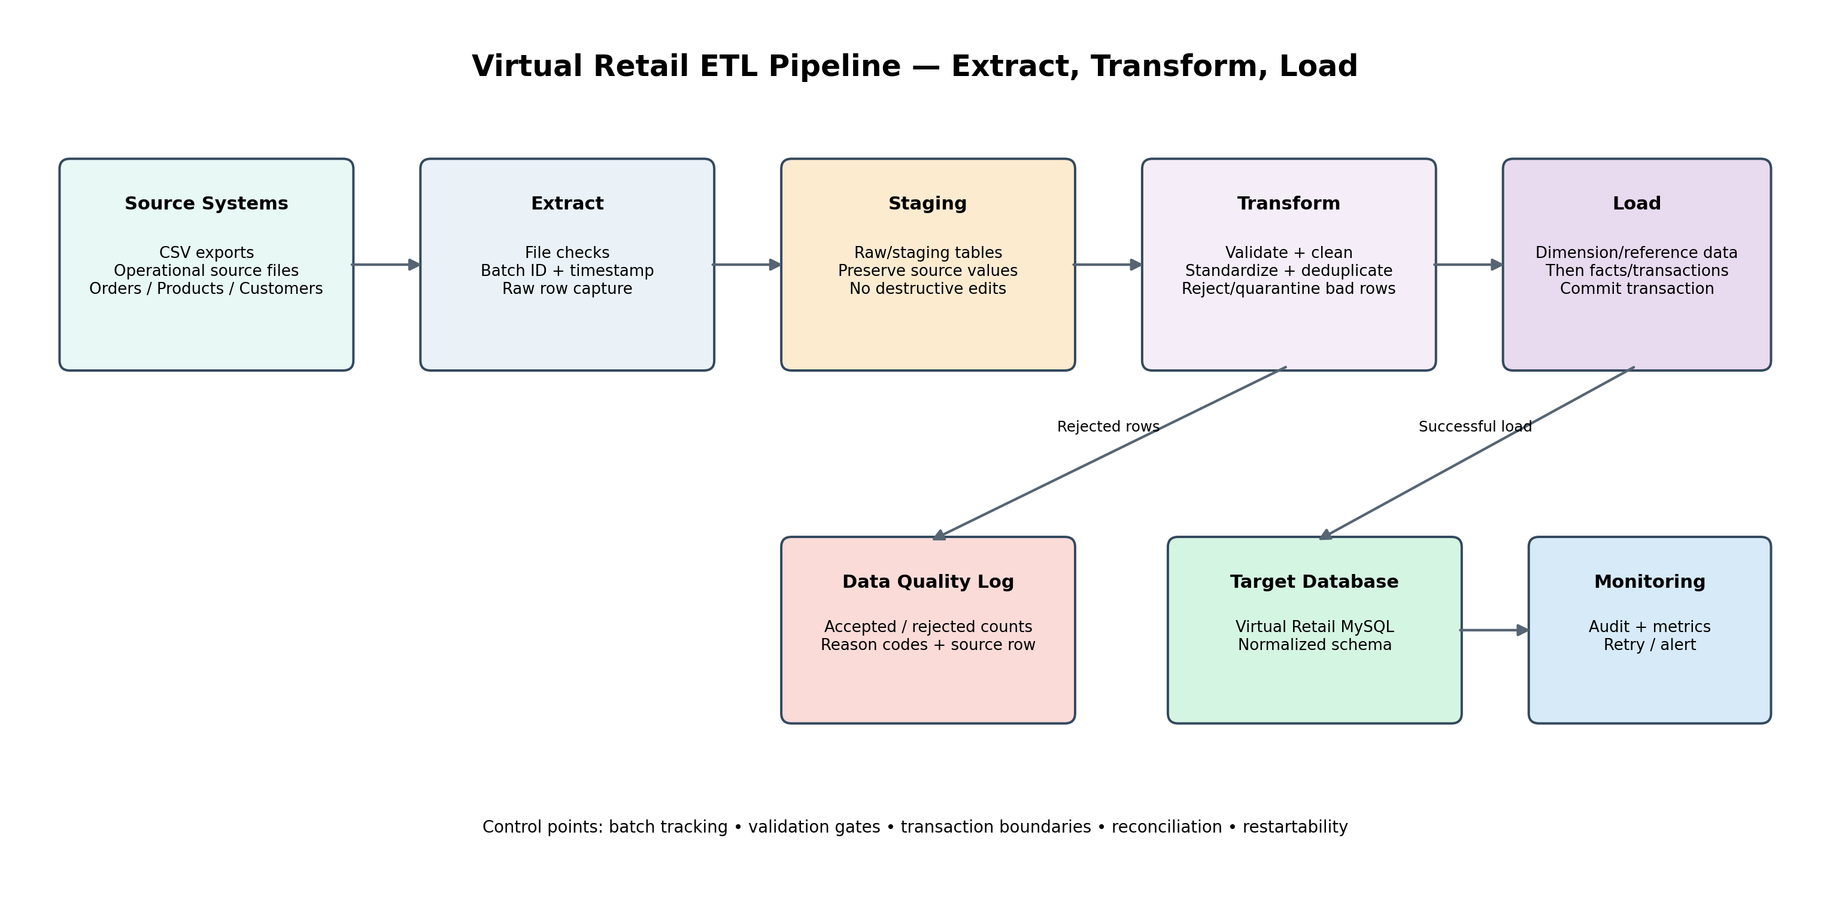

3.1 Step-by-Step Pipeline
Step 1 — Define the batch: Create a unique batch ID, record source name, start timestamp, operator/process, and expected file or record count.
Step 2 — Extract: Read source CSV files or query source tables using a consistent snapshot or cutoff timestamp. Validate file presence, encoding, headers, delimiter, and schema.
Step 3 — Stage raw records: Load source values into staging tables. Preserve source row number and batch ID. Avoid overwriting source values during initial extraction.
Step 4 — Profile and validate: Check required fields, data types, allowed values, duplicates, numeric ranges, date formats, and parent-key references.
Step 5 — Transform: Trim strings, normalize case, standardize dates and statuses, convert numeric values, map source codes, and handle blanks according to rules.
Step 6 — Quarantine invalid records: Write rejected rows to etl_reject with source file, source row, entity, reason code, and raw record. Do not load them into target tables.
Step 7 — Load reference/master data: Load categories, customers, suppliers, warehouses, and products before dependent tables. Apply documented upsert or insert-only policies.
Step 8 — Load operational data: Load inventory and order headers before order items; then payment/shipment records. Resolve source business keys to target surrogate keys.
Step 9 — Reconcile: Compare extracted, accepted, rejected, skipped, and loaded counts. Verify totals and target row counts.
Step 10 — Close batch: Mark the batch SUCCESS, PARTIAL, or FAILED. Store metrics, duration, and error summary; notify or alert the operator when needed.

4. Extraction Methods and Technology
CSV file extraction: Use MySQL Workbench Table Data Import Wizard for a controlled learning setup. For repeatable jobs, use LOAD DATA LOCAL INFILE only when client/server settings and file permissions allow it.
Database extraction: Use SELECT queries with a stable filter or watermark such as updated_at. For large tables, extract in key ranges or time windows.
API extraction: For future integrations, call vendor APIs through an application or ETL service, handle pagination, rate limits, retries, and authentication securely.
Batch scheduling: A scheduled Java process, cron/Task Scheduler, or an ETL orchestration tool can run the job at a defined interval. Record each run in etl_batch.
Technologies: MySQL 8.0, SQL, CSV, MySQL Workbench, Java/JDBC for orchestration, and optionally Python/Apache Airflow or another scheduler in a production environment.

5. Staging and Batch Control Design
Staging tables use text-compatible columns for source values that may not yet be valid (for example, a price may contain a currency symbol or an invalid date may not parse). Staging records are not the final business data. A batch-control table records source, timestamps, status, and row counts. A reject table captures validation failures and raw record context.
- etl_batch: batch ID, source name, start/end timestamps, status, extracted/loaded/rejected counts, notes.
- stg_customer, stg_product_inventory, stg_order_line: raw source columns, batch ID, source row number, and processing flag.
- etl_reject: rejected entity, source file/row, validation reason, raw record, and timestamp.
- Production staging should also record file checksum, schema version, source system, and ETL code version.

6. Transformation and Data Quality Strategy
Whitespace and casing: Apply TRIM to names and codes. Convert email addresses to lowercase for matching. Preserve original source files for audit.
Null and blank values: Convert empty strings to NULL using NULLIF(TRIM(value),''). Use a fallback such as UNKNOWN only when the business meaning permits it; do not invent required customer data.
Email validation: Check required email presence and a basic format rule. Invalid email rows are rejected or sent for manual correction.
Date standardization: Use source-specific STR_TO_DATE formats. Do not guess ambiguous dates such as 10/11/2026; confirm whether the source means month/day or day/month.
Numeric validation: Validate prices and quantities before CAST. Prices must be non-negative; order quantities must be positive integers. Invalid costs may be NULL only if business policy permits.
Status mapping: Map source status spellings/cases into approved target ENUM values. Unknown statuses should be quarantined instead of automatically treated as valid.
Duplicate handling: Detect duplicate business keys such as email, SKU, and order number. Define whether the newest source record wins, whether updates are allowed, or whether the duplicate is rejected.
Referential integrity: Resolve customer code and SKU to target IDs before loading order lines. Unknown parent references are rejected or held for a later re-run after master data arrives.
Deduplication: Use business keys and source update timestamps where available. Avoid deleting records without a documented retention and survivorship rule.
Currency and precision: Use DECIMAL for money, standardize currency codes, and avoid floating-point values for financial data.

7. Loading Strategy

7.1 Load Order
- Categories and customers (plus customer addresses when address data is available).
- Suppliers and warehouses.
- Products after categories exist.
- Product_Supplier after products and suppliers exist.
- Inventory after products and warehouses exist.
- Retail_Order headers after customers and address references are resolved.
- Order_Item rows after order headers and products exist.
- Payments, shipments, returns, and reviews after their parent records exist.

7.2 Insert, Upsert, and Transaction Policy
Use insert-only loading when source data is immutable or duplicates should be treated as errors. Use INSERT ... ON DUPLICATE KEY UPDATE only for explicitly approved master-data updates. Do not blindly upsert transactional records such as orders or payments, because a repeated batch could duplicate financial activity. Use a unique source transaction key or idempotency key to make retries safe. Commit a logical group of target writes together; on failure, roll back the transaction and preserve the batch/reject details.

7.3 Order Header and Line Handling
Order source files commonly contain one row per order line. Group rows by order_number and create one Retail_Order header per order, then create separate Order_Item rows. Resolve the source customer code through a source-to-target mapping table. Do not create a new order header for every product line. Validate that all lines for an order agree on header-level fields such as customer, date, and status; inconsistencies should be rejected for review.

8. Error Handling, Restartability, and Auditability
- Use batch IDs so each staging and reject record can be traced to a specific run.
- Separate fatal errors (file unreadable, schema mismatch, database unavailable) from row-level errors (invalid email, malformed price).
- Retry transient connection or API failures with bounded retries and backoff; do not retry permanent validation failures without correction.
- Make the ETL idempotent: a rerun should not duplicate customers, products, orders, or payments.
- Store row-level reject reasons and aggregate metrics. Allow corrected rejected rows to be reprocessed under a new batch or controlled retry batch.
- Use transaction boundaries around target loads and keep raw staging data until reconciliation and retention requirements are satisfied.
- Record ETL job version, source file checksum, execution time, and operator or scheduler identity in a production audit trail.

9. Performance and Scalability
- Use bulk loading for large CSV files instead of row-by-row inserts when permitted.
- Load in manageable batches and commit at controlled boundaries; choose batch size based on memory, lock duration, and recovery needs.
- Index staging batch_id and business-key columns used for joins, but avoid excessive staging indexes that slow ingestion.
- Use EXPLAIN to inspect joins and filters; ensure target foreign-key and lookup columns are indexed.
- Prefer incremental extraction using updated_at or change-data-capture where the source supports it; retain periodic full reconciliation.
- Use connection pooling and prepared statements in Java/JDBC.
- Separate heavy analytics from transactional workloads with reporting replicas or a warehouse as volume grows.
- Monitor throughput, rejected percentage, load duration, slow queries, and replication lag if replicas are used.

10. Security and Compliance Considerations
- Use a dedicated ETL database account with only required SELECT/INSERT/UPDATE privileges.
- Keep credentials in environment variables or a secret manager; never hard-code passwords in SQL files or source control.
- Use TLS for connections where supported and restrict access to source exports and reject logs.
- Mask or minimize personally identifiable information in logs and sample files.
- Do not store raw card numbers or CVV; use payment provider tokens and references.
- Apply retention rules to staging data and securely delete files when no longer needed.

11. Reconciliation and Acceptance Criteria
Check | Acceptance condition
Row-count reconciliation | Extracted = loaded + rejected + intentionally skipped, with each skipped reason documented.
Master-data checks | No duplicate SKU/email business keys; all loaded product categories and suppliers resolve.
Inventory checks | Quantities are non-negative integers and every inventory row references an existing product and warehouse.
Order checks | Every order item references a valid order and product; order header fields are consistent across source lines.
Financial checks | Line subtotal, discounts, tax, shipping, and order totals reconcile within the agreed currency precision.
Batch checks | Batch status is SUCCESS only if all required validations pass; otherwise PARTIAL or FAILED.
Repeatability | Re-running the same source batch does not create duplicate orders or payments.

12. Implementation Guide
- Create the Week 1 virtual_retail database schema in MySQL Workbench.
- Run the Week 2 ETL staging script to create batch, staging, and reject tables.
- Create a batch record and note its batch_id.
- Import the included CSV files into the matching staging tables using Workbench's import wizard; map columns carefully and retain source row numbers.
- Run data_quality_examples.sql and inspect invalid or duplicate rows.
- Review etl_reject records and decide whether to correct, skip, or reprocess them.
- Load reference tables first, then product/inventory, and finally transaction tables using source-key mappings.
- Run Week 1 reports and compare expected values with loaded data.
- Reconcile counts and mark the batch status only after validation.

13. Limitations and Future Improvements
- The demo uses CSV files rather than live vendor APIs or production point-of-sale systems.
- The order-loading section requires a proper source-key mapping table and grouped header/line logic before execution in a real environment.
- Add a source_customer_map table for stable customer_code-to-customer_id resolution.
- Add source_order_map and source_payment_map to support idempotent transaction loading.
- Automate the pipeline with Java/JDBC or an orchestration tool and add automated unit/integration tests.
- Add alerting, dashboard metrics, data lineage, schema evolution handling, and change-data-capture support.

14. Conclusion
The proposed ETL plan gives the virtual retail database a repeatable and auditable data ingestion process. By extracting source records into staging, validating and transforming them with documented rules, and loading target tables in dependency order, the design reduces data-quality risks and protects relational integrity. Batch tracking, reject logging, reconciliation, and idempotent loading make the pipeline easier to troubleshoot and restart. The flowchart and SQL examples provide a practical foundation for implementation and can be extended to scheduled Java/JDBC jobs or a dedicated ETL platform as the retail system grows.

Appendix — Project Files
- docs/etl_flowchart.png — ETL flowchart
- sql/etl_staging_and_load.sql — staging and loading patterns
- sql/data_quality_examples.sql — validation and transformation examples
- data/customers_source.csv — sample customer source
- data/products_inventory_source.csv — sample product/inventory source
- data/orders_source.csv — sample order-line source
- README.md — setup instructions
- submission_description.txt — portal description

