WEEK 1 TASK REPORT
DATA MODELING AND ARCHITECTURE DESIGN
Virtual Retail Environment | SQL Developer Internship

Submitted by | Pratik Vijay Rathod
Technology | MySQL 8.0, SQL, Java/JDBC architecture
Project | Virtual Retail Database
Submission | Week 1 — Data Modeling and Architecture Design

1. Executive Summary
This report presents a relational database design for a virtual retail platform. The platform must support the complete retail lifecycle: customer registration and address management, product discovery, supplier sourcing, stock monitoring across warehouses, order placement, payment tracking, shipment fulfilment, returns, and product reviews. The design translates these operational requirements into a structured MySQL 8.0 database with clear entity boundaries, primary and foreign keys, integrity constraints, and indexes.
The proposed design follows a normalized relational approach, primarily targeting Third Normal Form (3NF). Transactional data is stored in InnoDB tables, while calculated order totals are exposed through a reporting view. Product prices are copied into order items at purchase time so historical sales remain accurate even when the current catalog price changes. The architecture separates presentation, application/business logic, data access, and database responsibilities, making the solution easier to maintain and scale.

2. Business Context and Scope
The virtual retail business sells products through an online storefront. Customers browse a catalog, place orders, pay using supported payment methods, and receive shipments. Retail administrators manage products, categories, suppliers, warehouses, and inventory. Customer service staff may review orders, returns, and customer feedback. Management uses SQL reports to monitor sales, stock availability, and customer purchasing patterns.

2.1 In-Scope Capabilities
- Customer profiles and multiple addresses
- Product catalog and product categories
- Supplier directory and supplier-product mapping
- Inventory by warehouse and reorder thresholds
- Order header and line-item management
- Payment status and payment references
- Shipment and tracking status
- Returns and return line items
- Product reviews and ratings
- Operational SQL reports and order-summary view

2.2 Assumptions
- A customer may have multiple addresses and orders.
- An order contains one or more order items.
- A product may be supplied by multiple suppliers, and a supplier may supply multiple products.
- A product may be stocked in multiple warehouses.
- An order may have multiple payment attempts and shipment records.
- The initial currency is INR, but the order stores a currency code for future flexibility.
- Inventory deduction, stock reservation, payment gateway calls, and shipment orchestration are application-level transactional workflows not fully automated by this schema.

3. Requirement Analysis
Business area | Data requirement
Customer relationship management | Store customer contact information, status, and addresses; support customer order history.
Catalog management | Maintain product SKU, name, description, category, price, and active status.
Supplier management | Store supplier contacts and map suppliers to products with purchase cost and lead time.
Inventory management | Track quantity on hand and reorder level for each product at each warehouse.
Sales and order tracking | Record order header, order status, item quantities, purchase-time price, discounts, tax, and shipping.
Payment tracking | Capture payment method, amount, reference, status, and payment timestamp.
Fulfilment | Track shipment carrier, tracking number, originating warehouse, and delivery state.
Returns | Record return reason, status, returned line items, quantities, and refund amount.
Customer feedback | Allow one review per customer per product with a 1–5 rating.
Analytics | Report revenue trends, best-selling products, low-stock products, supplier catalog, and customer lifetime order value.

4. Entity-Relationship Model
The ERD below summarizes the core entities and selected relationships. PK denotes Primary Key, FK denotes Foreign Key, and UQ denotes a unique constraint. The SQL schema is the authoritative detailed definition.
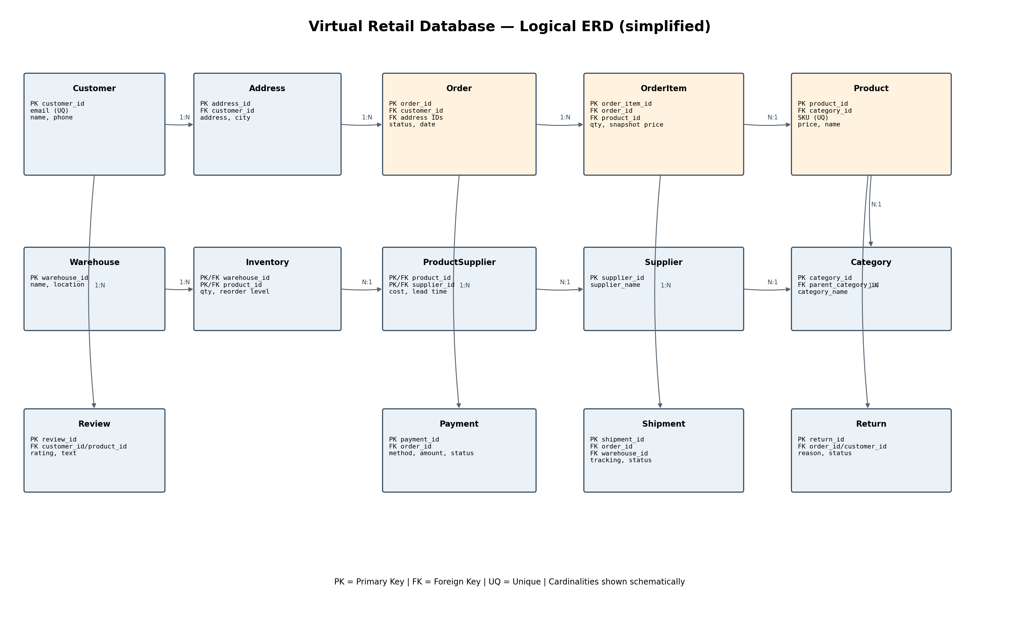

4.1 Main Entities and Responsibilities
Entity | Purpose
Customer | Customer identity and contact details; email is unique.
Customer_Address | One customer can maintain multiple billing/shipping addresses.
Category | Product classification; optional parent category supports a hierarchy.
Product | Catalog item with unique SKU, category, current selling price, and status.
Supplier | Supplier contact and active status.
Product_Supplier | Associative entity resolving the many-to-many product/supplier relationship.
Warehouse | Physical fulfilment location.
Inventory | Associative entity recording product stock at each warehouse.
Retail_Order | Order-level information such as customer, addresses, status, and date.
Order_Item | Products and quantities within an order; preserves unit price at purchase.
Payment | Payment attempts or records linked to an order.
Shipment | Fulfilment and tracking information for an order.
Product_Return / Return_Item | Return header and returned order lines, including quantity and refund.
Review | Customer rating and feedback for a product.

4.2 Relationship Cardinalities
- Customer → Customer_Address: 1:N — one customer can have many addresses.
- Customer → Retail_Order: 1:N — one customer can place many orders; each order belongs to one customer.
- Retail_Order → Order_Item: 1:N — an order contains multiple line items.
- Product → Order_Item: 1:N — a product can appear in many order line items.
- Category → Product: 1:N — each product belongs to one category.
- Product ↔ Supplier: M:N — implemented through Product_Supplier.
- Product ↔ Warehouse: M:N — implemented through Inventory.
- Retail_Order → Payment: 1:N — an order may have payment attempts or payment records.
- Retail_Order → Shipment: 1:N — an order may be fulfilled in multiple shipments.
- Retail_Order → Product_Return: 1:N — an order can have multiple return requests.
- Product_Return → Return_Item: 1:N — a return can contain multiple returned items.
- Customer ↔ Product review: A customer may review many products; each product may receive many reviews.

5. Relational Schema and Key Design
Every entity uses a surrogate BIGINT UNSIGNED AUTO_INCREMENT identifier unless a natural composite key is more suitable. The product SKU, customer email, order number, supplier email (when supplied), payment reference, and tracking number are protected by unique constraints. The Inventory and Product_Supplier tables use composite primary keys because each row represents a unique pair of parent records.

5.1 Key Choices
- Primary keys uniquely identify rows and provide stable references even if business attributes change.
- Foreign keys enforce valid relationships and prevent orphaned records.
- Order_Item stores unit_price_at_purchase as a historical snapshot; it must not rely on the current Product.unit_price.
- Inventory uses (warehouse_id, product_id) as its primary key to prevent duplicate stock rows for the same product and warehouse.
- Product_Supplier uses (product_id, supplier_id) as its primary key to prevent duplicate supplier mappings.
- Order numbers and SKUs are business identifiers and are unique, but they are not used as internal foreign-key targets.

6. Normalization Strategy
First Normal Form (1NF): Each field stores a single value; repeating product lists are not stored inside an order header. Order products are represented as separate Order_Item rows.
Second Normal Form (2NF): Non-key attributes in associative tables depend on the full composite key. Inventory quantity depends on both warehouse_id and product_id. Supplier-specific purchase cost and lead time depend on both product_id and supplier_id.
Third Normal Form (3NF): Non-key attributes depend on the key, the whole key, and nothing but the key. Customer details are not repeated in order rows; supplier details are not duplicated in Product_Supplier; category data is separated from Product.
Controlled calculated data: Order total is calculated in vw_order_summary rather than redundantly stored. This reduces update anomalies. Order line price is intentionally stored as a historical snapshot, not a redundant current catalog value.

7. Database Architecture
The proposed architecture uses a three-tier logical model. The database is accessed only through the application/data access layer, rather than directly from the user interface.
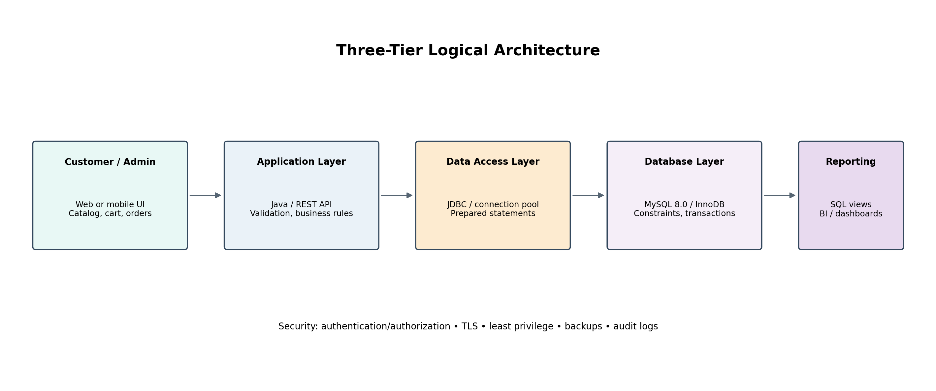

7.1 Layer Responsibilities
Presentation layer: Web or mobile interface for customers, administrators, and customer support. Displays catalog, cart, order history, and reports.
Application / business layer: Java service or REST API validates requests, applies pricing and order rules, checks permissions, coordinates stock/payment/fulfilment workflows, and handles errors.
Data access layer: JDBC or a Java persistence framework uses parameterized queries, connection pooling, transactions, and repository methods.
Database layer: MySQL 8.0 with InnoDB stores normalized records, enforces keys and constraints, and supports transactional consistency.
Reporting layer: SQL views and read-optimized queries provide business metrics. For larger scale, reporting can use a replica or analytics warehouse.

8. Indexing Strategy
Unique indexes: Customer email, product SKU, order number, payment reference, and tracking number prevent duplicate business identifiers.
Foreign-key / join indexes: Indexes on customer_id, category_id, order_id, product_id, and shipment status support joins and lookups.
Composite indexes: (customer_id, order_date) supports customer order history; (order_status, order_date) supports order queues; (order_id, payment_status) supports payment status lookup.
Inventory key: The composite primary key (warehouse_id, product_id) supports exact stock lookup and uniqueness.
Review index: (product_id, rating) supports product review summaries and rating filters.
Trade-off: Indexes improve reads but consume disk and slow inserts/updates. Add indexes only after reviewing real query plans with EXPLAIN.

9. Scalability, Reliability, and Security
Scalability: Use connection pooling, pagination, caching for read-heavy catalog data, and horizontal application scaling. Partitioning or sharding should be considered only after measuring volume and access patterns. Large analytics workloads may be moved to a read replica or warehouse.
Reliability: Use InnoDB transactions for order/payment/stock workflows. Define rollback behavior and idempotency keys for retryable API calls. Schedule automated backups and test restoration. Monitor slow queries and database health.
Concurrency: When reserving stock, lock the relevant inventory rows within a transaction (for example, SELECT ... FOR UPDATE) and validate available quantity before decrementing. Avoid overselling by keeping stock reservation logic atomic.
Security: Use least-privilege database accounts, prepared statements, encrypted transport (TLS), secret management, access control, and audit logging. Do not store raw card numbers or CVV. Use a compliant payment provider and store only its token/reference.
Privacy: Collect only necessary customer data, restrict access, define retention/deletion policies, and protect exports and backups.
Operational controls: Use schema migrations, staging environments, automated tests, monitoring, and documented incident recovery.

10. Retail Workflow Mapping
Product onboarding: Administrator creates category and product; supplier mapping is added; inventory is initialized for one or more warehouses.
Order placement: Customer selects products; application validates product availability and creates Retail_Order plus Order_Item rows in a transaction.
Payment: Payment provider processes payment; application records payment reference and status. A failed attempt remains visible for audit and retry.
Fulfilment: Application allocates stock from a warehouse, creates shipment record, and updates order/shipment status as carrier events arrive.
Delivery and customer service: Order history is retrieved through customer/date indexes and the order summary view.
Return/refund: Customer service creates Product_Return and Return_Item records, validates eligible quantities, and records refund/payment status.
Management reporting: SQL queries summarize monthly revenue, best-selling items, low-stock products, supplier lead times, and customer purchase value.

11. SQL Reporting and Validation
The accompanying queries.sql file demonstrates order totals, low-stock alerts, product sales ranking, customer lifetime order value, monthly revenue, supplier catalog reporting, and customer order history. The sample_data.sql file provides small demo records so the schema and reports can be tested in MySQL Workbench.

11.1 Recommended Validation Checks
- Confirm all tables are created successfully and foreign-key constraints are active.
- Run sample_data.sql and verify the sample rows appear in each table.
- Query vw_order_summary and compare computed totals against the line-item arithmetic.
- Attempt to insert duplicate customer email, SKU, or order number; the database should reject it.
- Attempt to create an order item referencing a nonexistent order/product; the foreign key should reject it.
- Check inventory rows for reorder alerts and verify indexes using EXPLAIN on representative queries.

12. Limitations and Future Enhancements
- Add order status history and inventory movement ledger for complete auditability.
- Add coupons/promotions, product variants, shopping carts, and wishlist tables if required by business scope.
- Add tax jurisdiction rules and currency exchange handling for multi-region retail.
- Introduce stock reservation/expiry, cancellation restocking, and returns restocking policies.
- Add role-based access control and audit events at application level.
- Add warehouse transfer and purchase-order workflows for procurement.
- Integrate a payment gateway and shipping carrier APIs through secure application services.

13. Conclusion
The proposed Virtual Retail Database provides a practical and extensible relational foundation for online retail operations. Its entities cover customers, catalog, supplier sourcing, warehouse inventory, orders, payments, shipments, returns, and reviews. Normalization reduces duplication and update anomalies, while foreign keys, unique constraints, CHECK constraints, and indexes improve data quality and query performance. The architecture separates user interaction from business logic and persistence, allowing the system to evolve from a learning prototype into a more robust application. The attached SQL scripts make the design reproducible and testable in MySQL 8.0.

Appendix A — Project Files
- sql/schema.sql — schema DDL
- sql/sample_data.sql — demo data
- sql/queries.sql — reporting queries
- docs/retail_erd.png — ER diagram
- docs/architecture.png — architecture diagram
- README.md — setup and repository instructions
Prepared for the Week 1 SQL Developer Internship task. Review the report and replace/add personal details if your internship portal requires a different name or format.

