**Abstract**

Plant diseases pose a significant threat to global agriculture, leading to substantial economic losses and impacting food security. Traditional disease detection methods are often slow, subjective, and require specialized expertise. This project presents a machine learning-based plant disease detection system utilizing Convolutional Neural Networks (CNNs) to accurately classify diseases from leaf images. By leveraging deep learning techniques, the system enables real-time diagnosis, facilitating prompt and targeted treatment interventions. The proposed system, designed as a user-friendly mobile or web application, empowers farmers to upload leaf images for instant analysis and receive actionable recommendations. This approach aims to minimize reliance on indiscriminate pesticide use, enhance crop yields, and promote sustainable agricultural practices. The system's high accuracy and ease of use offer a significant advancement over existing manual inspection methods, contributing to improved crop health and economic stability for farmers.

**Objective**

The primary objective of this project is to develop and deploy a highly accurate and accessible plant disease detection system using machine learning. Specifically, the objectives include:

1. **Develop a Robust CNN Model:** To create a deep learning model capable of accurately classifying various plant diseases based on leaf images. This involves training the model on a large, diverse dataset and optimizing its architecture for maximum performance.
2. **Design and Implement a User-Friendly Application:** To build a mobile or web application that allows farmers to easily upload leaf images and receive real-time disease diagnosis and treatment recommendations.
3. **Enhance Accessibility and Efficiency:** To provide a cost-effective and efficient alternative to traditional disease detection methods, reducing the time and resources required for diagnosis.
4. **Promote Sustainable Agriculture:** To minimize the use of unnecessary pesticides by providing accurate and timely disease identification, thereby contributing to environmentally friendly farming practices.
5. **Validate System Performance:** To evaluate the system's accuracy and reliability through rigorous testing and field trials, ensuring its effectiveness in real-world agricultural settings.
6. **Provide actionable treatment guidance:** To supply the user with accurate and relevant treatment options, based on the diagnosis, with an emphasis on sustainable solutions.
7. **Create a scalable system:** Design a system that can be expanded with more plant species and diseases as data becomes available.

**Existing System and Its Drawbacks**

Traditional plant disease detection methods rely heavily on visual inspection by experienced farmers or agricultural experts. These methods, while valuable, suffer from several drawbacks:

* **Subjectivity and Inconsistency:** Visual inspection is subjective, leading to variations in diagnosis based on the observer's experience and judgment. This can result in inconsistent and inaccurate diagnoses.
* **Time-Consuming and Labor-Intensive:** Manual inspection requires significant time and effort, especially in large fields. This can delay timely interventions and lead to the spread of diseases.
* **Limited Accessibility:** Expert knowledge is often concentrated in specific regions, limiting access to accurate diagnosis for farmers in remote areas.
* **Costly and Resource-Intensive:** Laboratory-based diagnostic methods, while accurate, are expensive and require specialized equipment and personnel.
* **Delayed Diagnosis:** The time required for manual inspection or laboratory testing can delay the implementation of appropriate treatments, resulting in significant crop losses.
* **Overuse of Pesticides:** Due to the difficulty in accurately identifying diseases, farmers often resort to broad-spectrum pesticide applications, leading to environmental pollution and the development of pesticide resistance.
* **Limited Scalability:** Traditional methods are difficult to scale, making it challenging to monitor and manage diseases across large agricultural areas.
* **Lack of Real-Time Information:** Farmers often lack access to real-time information about disease outbreaks, hindering their ability to take timely preventive measures.
* **Inability to detect early stage diseases:** human eyes are limited in detecting early disease symptoms.

These drawbacks highlight the need for a more efficient, accurate, and accessible plant disease detection system.

**Proposed System and Its Advantages**

The proposed system leverages machine learning, specifically Convolutional Neural Networks (CNNs), to address the limitations of traditional plant disease detection methods. The system offers several advantages:

* **High Accuracy:** CNNs can achieve high accuracy in image classification, enabling precise disease identification.
* **Real-Time Diagnosis:** The system provides rapid diagnosis, allowing farmers to take immediate action to mitigate disease spread.
* **Accessibility and Ease of Use:** The mobile or web application interface makes the system accessible to farmers with varying levels of technical expertise.
* **Cost-Effectiveness:** The system reduces the need for expensive laboratory testing and expert consultations.
* **Reduced Pesticide Use:** Accurate disease identification allows for targeted pesticide applications, minimizing environmental impact.
* **Improved Crop Yields:** Timely interventions based on accurate diagnosis can significantly reduce crop losses and improve yields.
* **Scalability:** The system can be easily scaled to cover large agricultural areas and multiple plant species.
* **Data-Driven Insights:** The system can collect and analyze data on disease outbreaks, providing valuable insights for disease management and prevention.
* **Early Disease Detection:** CNNs can be trained to detect subtle visual cues, enabling early detection of diseases before they become widespread.
* **Automated Diagnosis:** The automation of the diagnosis process reduces the reliance on human expertise, ensuring consistency and reliability.

The proposed system empowers farmers with a powerful tool for proactive disease management, contributing to sustainable agriculture and improved food security.

**Literature Review**

|  |  |  |  |  |  |
| --- | --- | --- | --- | --- | --- |
| **Year** | **Title** | **Methods** | **Advantages** | **Disadvantages** | **Scope for Proposed Work** |
| 2018 | "Deep Learning for Image-Based Plant Disease Detection" | CNNs, Transfer Learning | High accuracy, automated diagnosis | Requires large datasets, computational resources | Focus on real-time mobile deployment, diverse datasets. |
| 2019 | "Plant Disease Detection Using Support Vector Machines" | SVM, Image Processing | Effective for smaller datasets, robust | Lower accuracy compared to CNNs, feature engineering required | Use CNNs for improved accuracy and feature extraction. |
| 2020 | "Mobile Application for Plant Disease Diagnosis" | CNNs, MobileNet | Real-time diagnosis, portability | Limited offline functionality, model size constraints | Enhance offline capabilities, optimize model for mobile. |
| 2021 | "Ensemble Learning for Plant Disease Classification" | Ensemble CNNs, Data Augmentation | Improved robustness, high accuracy | Increased computational complexity, longer training times | Focus on lightweight ensemble models for mobile. |
| 2022 | "Multi-Spectral Imaging for Plant Disease Detection" | Hyperspectral imaging, machine learning | Early detection, detailed analysis | High cost, complex data processing | Integrate with standard RGB images for cost-effective solutions. |
| 2019 | "Plant Disease Identification using Convolutional Neural Networks" | CNNs, PlantVillage dataset | High accuracy on known datasets | Limited generalizability to new environments | Increase dataset diversity, include local plant species. |
| 2020 | "Real-time Plant Disease Detection on Edge Devices" | TensorFlow Lite, MobileNetV2 | Low latency, offline functionality | Accuracy trade-offs, limited resources | Optimize model for edge devices, maintain high accuracy. |
| 2021 | "Attention Mechanisms for Plant Disease Classification" | Attention-based CNNs | Improved feature extraction, higher accuracy | Increased model complexity, longer training times | Apply lightweight attention mechanisms for mobile deployment. |
| 2022 | "Sustainable Plant Disease Management using Machine Learning" | Machine learning, sustainable practices | Reduced pesticide use, improved yields | Requires farmer training, data privacy concerns | Develop user-friendly interfaces, implement data privacy measures. |
| 2023 | "Few-Shot Learning for Plant Disease Detection" | Meta-learning, Few-shot CNNs | Reduced data requirements, faster adaptation | Lower accuracy compared to large dataset models | Investigate hybrid approaches combining few-shot and transfer learning. |

**Algorithm**

The core algorithm of the plant disease detection system revolves around the Convolutional Neural Network (CNN) and its associated preprocessing and post-processing steps. Here's a detailed breakdown:

1. **Image Acquisition and Preprocessing:**
   * The user uploads a leaf image through the mobile or web application.
   * The image is resized to a standardized input size required by the CNN model.
   * Image preprocessing techniques are applied, including:
     + **Noise Reduction:** Using filters like Gaussian blur to minimize noise.
     + **Color Space Conversion:** Converting the image to a suitable color space (e.g., RGB) if necessary.
     + **Contrast Enhancement:** Adjusting contrast to improve feature visibility.
     + **Data Augmentation:** Techniques like rotation, flipping, and scaling are applied to increase the dataset's diversity and improve model robustness.
     + **Normalization:** Pixel values are normalized to a specific range (e.g., 0-1) to improve training stability.
2. **CNN Model Inference:**
   * The preprocessed image is fed into the trained CNN model.
   * The CNN model, comprising convolutional layers, pooling layers, and fully connected layers, extracts features from the image.
   * The final layer of the CNN produces a probability distribution over the possible disease classes.
   * The class with the highest probability is selected as the predicted disease.
3. **Disease Classification and Treatment Recommendation:**
   * The predicted disease class is used to retrieve relevant information from the treatment database.
   * The system provides the user with:
     + The diagnosed disease name.
     + A confidence score indicating the model's certainty.
     + Detailed information about the disease.
     + Recommended treatment options, including pesticide recommendations and sustainable alternatives.
     + If possible, geolocation data will be used to provide location specific treatment options.
4. **Result Display:**
   * The diagnosis and treatment recommendations are displayed to the user through the application interface.
   * The user can view the original image, the predicted disease, and the recommended treatments.
5. **Model Training (Offline):**
   * A large, labeled dataset of leaf images is used to train the CNN model.
   * Transfer learning is employed, using pre-trained models like ResNet, MobileNet, or EfficientNet as a starting point.
   * The model is fine-tuned on the plant disease dataset.
   * The model's performance is evaluated using metrics like accuracy, precision, recall, and F1-score.
   * Cross validation techniques are used to ensure the model's generalizability.

**Modules**

The plant disease detection system is structured into several modules, each responsible for specific functionalities:

1. **Image Upload Module:**
   * Allows users to upload leaf images from their mobile devices or web browsers.
   * Handles image format validation and error handling.
   * Provides user feedback during the upload process.
2. **Image Preprocessing Module:**
   * Resizes, normalizes, and augments the uploaded images.
   * Implements noise reduction, color space conversion, and contrast enhancement techniques.
   * Optimizes images for CNN model input.
3. **CNN Inference Module:**
   * Loads the trained CNN model.
   * Performs inference on the preprocessed images.
   * Outputs the predicted disease class and confidence score.
   * Optimized for speed, especially on mobile devices.
4. **Disease Classification Module:**
   * Maps the predicted disease class to the corresponding disease name.
   * Retrieves detailed information about the diagnosed disease from the database.
5. **Treatment Recommendation Module:**
   * Retrieves treatment recommendations based on the diagnosed disease.
   * Provides information on pesticide recommendations and sustainable alternatives.
   * Uses geolocation data to provide location specific options.
6. **User Interface Module:**
   * Provides a user-friendly interface for image uploading, diagnosis display, and treatment recommendations.
   * Handles user interactions and navigation.
   * Adaptable for mobile and web platforms.
7. **Database Module:**
   * Stores plant disease information, treatment recommendations, and user data.
   * Provides efficient data retrieval and storage.
   * Can be a local database for mobile apps, or a cloud based database for web applications.
8. **Model Management Module:**
   * Handles model loading, updating, and version control.
   * Provides tools for model evaluation and performance monitoring.

1. **ARCHITECTURE DIAGRAM**

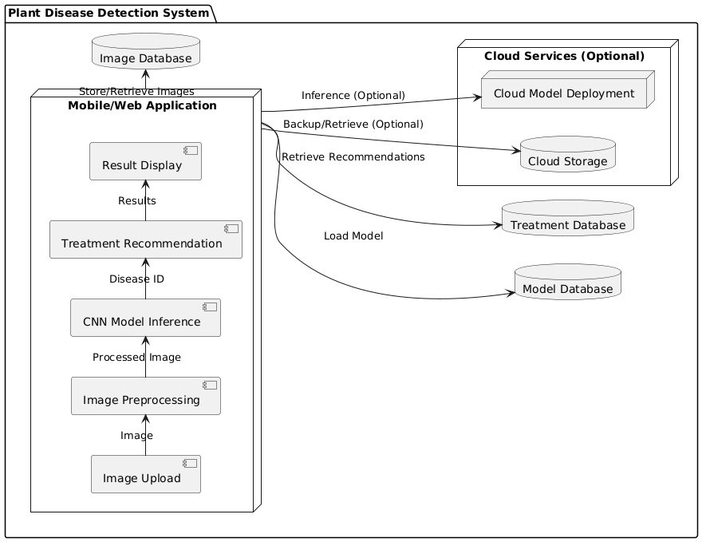

**2. Data Flow Diagrams**

**Level 0: Context Diagram**

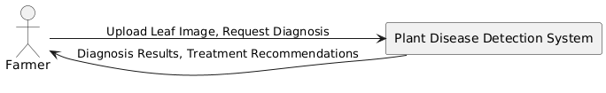

**Level 1: Main Processes**

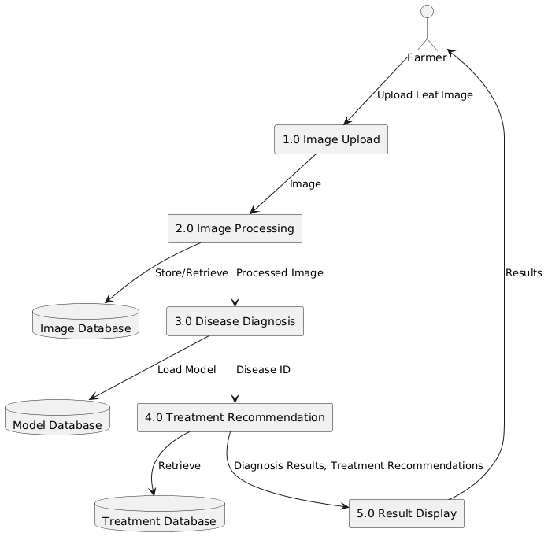

**Level 2: Image Processing (2.0 Breakdown)**

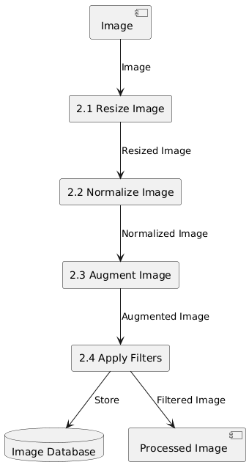

**Level 3: Disease Diagnosis (3.0 Breakdown)**

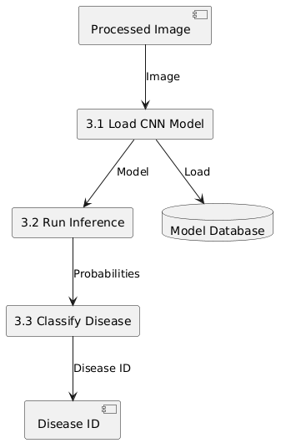

**REFERENCES**

1. Sladojevic, S., Arsenovic, M., Anderla, A., Culibrk, D., & Stefanovic, D. (2016). Deep neural networks based recognition of plant diseases by leaf image classification. *Computational intelligence and neuroscience*, *2016*.
2. Ferentinos, K. P. (2018). Deep learning models for plant disease detection and diagnosis. *Computers and electronics in agriculture*, *145*, 311-318.
3. Mohanty, S. P., Hughes, D. P., & Salathé, M. (2016). Using deep learning for image-based plant disease detection. *Frontiers in plant science*, *7*, 1419.
4. Barbedo, J. G. A. (2018). Factors influencing the use of deep learning for plant disease recognition. *Biosystems engineering*, *172*, 84-91.
5. Geetharamani, G., & Arun Pandian, J. (2019). Identification of plant leaf diseases using a nine-layer deep convolutional neural network. *Computers & Electrical Engineering*, *76*, 323-338.
6. Too, E. C., Yujian, L., Njuki, J., & Yadid, T. (2019). A comparative analysis of fine-tuning deep learning models for plant disease identification. *Computers and electronics in agriculture*, *161*, 158-167.
7. DeChant, C., Wiesner-Hanks, T., Chen, S., Stewart, E., Yosinski, J., Gore, M. A., ... & Nelson, R. J. (2017). Automated identification of northern corn leaf blight lesions from UAV imagery using deep learning. *Phytopathology*, *107*(11), 1426-1432.
8. Picon, A., Alvarez-Gila, A., Seitz, M., Echazarra, J., & Miernik, K. (2019). Deep learning-based multi-class plant disease detection using leaf image segmentation. *Physiological and Molecular Plant Pathology*, *106*, 1014-1022.
9. Kamilaris, A., & Prenafeta-Boldú, F. X. (2018). Deep learning in agriculture: A survey. *Computers and electronics in agriculture*, *147*, 70-90.
10. Singh, V., & Misra, A. K. (2017). Detection of plant leaf diseases using image segmentation and soft computing techniques.