ArangoDB
Tuesday, December 7, 2021
11:53 AM

Refer https://www.youtube.com/watch?v=4C4zqhXwCKs
To create an instance of arangodb in docker
( Note: docker should be installed in the system)

docker run -e ARANGO_NO_AUTH=1 -p 8529:8529 -d --name test1-arangodb arangodb
[Note: ARANGO_NO_AUTH means no user name and password required.)
then in the browser: type
localhost:8529

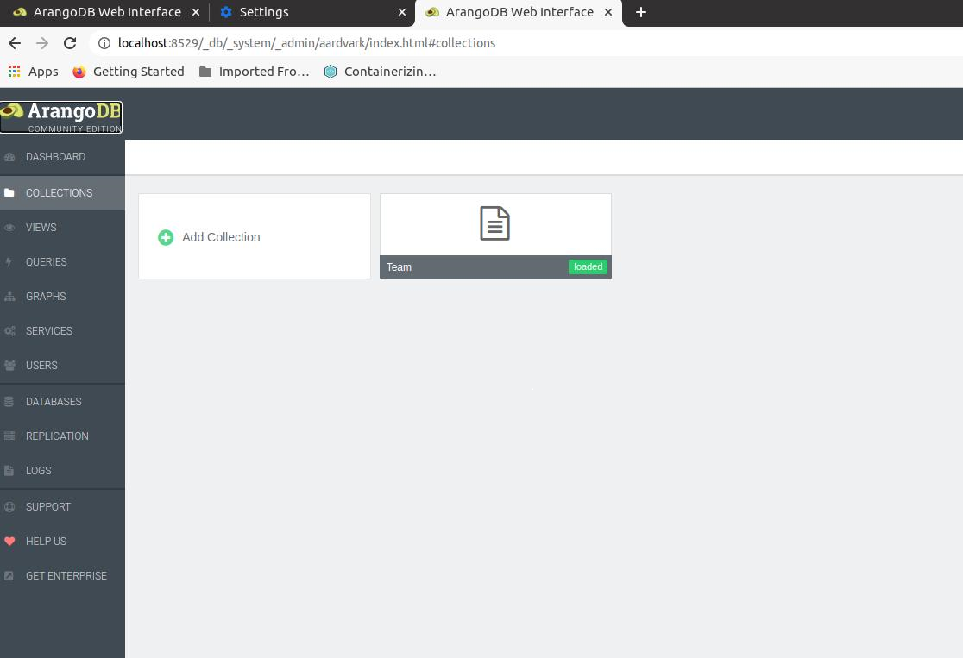

As we can see, a UI for arangoDb is opened where we can operate on the db through this UI. For now we created a collection named "Team" of the type "Document"

To insert a document:
Go to Queries and type
insert {name : "Rohini"} into Team

then press <ctrl> + <enter> or press execute button

Like this create two more documents:
insert {name: "Sagar"} into Team
insert {name: "Rishab"} into Team

Click on Collection -> Team to view all the documents in the collection
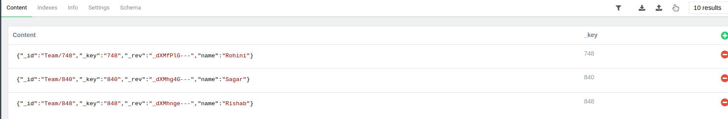

To query for a document:
Go to Queries and type
return document("Team/840")
This will return the document with key as 840 i.e document with name "Sagar"

return document(["Team/840", "Team/848"])
This will return multiple documents

To return all documents in the collection
for team in Team
return team

To return a document applying some filters
for team in Team
filter team.name == "Rohini"
return team

How is horizontal scaling?
multi model db?
Can we store schema less data? yes
Diff between cassandra and arangodb. Use cases of each
Perf of read input output of both dbs ------ *
purging logic of old data
queries performance.
Is there any possibility of TTL option in arangodb? How is it different from Cassandra? better or worse
What is the storage footprint? does graph in arangodb occupies additional storage?
Till what volume arangodb stays stable ---------*
How is the connectivity with applications(scala) - plugins available for scala connectors
How is the joining tables performance- sorting
Multicolumn indexing ---- done
Explore arango import- client library- import json data
Explore arango export- complexity and all.
Sharding options in arango --------------- *
Read-write performance - if graph is provided but does it compromise read-write performance -------- *

arangodb client tool

Explore arango cloud

datastax site

TTL demo - Chinmay
Joins - Chinmay
Graphs - Rachana
nested array insertion - Rachana

