**IMAGE CLASSIFICATION USING CONVOLUTIONAL NEURAL NETWORK (CNN)**

**Introduction:**

The project's objective was to create an image classification model that could identify and categorise pictures of five famous athletes: Virat Kohli, Maria Sharapova, Roger Federer, Serena Williams, and Lionel Messi.

**Dataset and Preprocessing:**

There were 168 photos in the dataset that featured the aforementioned celebrities.

To guarantee consistency, images were shrunk to (128, 128) pixels.

An 80-20 ratio was used to divide the dataset into training and testing sets.

**Model Architecture:**

The chosen model is a Convolutional Neural Network (CNN) implemented using TensorFlow and Keras.

Model Architecture:

Input Layer: Convolutional layer with 32 filters and a (3, 3) kernel, followed by ReLU activation and MaxPooling.

Flatten Layer: To flatten the output for fully connected layers.

Dense Layers: Two dense layers with 256 and 512 units, ReLU activation, and a dropout layer to prevent overfitting.

Output Layer: Dense layer with 5 units (corresponding to the 5 classes) and softmax activation for multi-class classification.

Batch Normalization was added for improved convergence and training stability.

**Training Process:**

The model was trained for 50 epochs with a batch size of 128.

Adam optimizer and sparse categorical crossentropy loss were used.

Early stopping was implemented to prevent overfitting based on validation accuracy.

Training history was monitored and visualized using accuracy and loss plots.

The training process aimed to maximize accuracy on the validation set.

**5. Critical Findings:**

The model achieved an accuracy of approximately 82.35% on the test set.

The training accuracy increased over epochs, but there is a slight indication of overfitting as the validation accuracy plateaus and starts to decrease.

Class-wise performance varied, with some classes achieving higher precision, recall, and F1-score than others.

The model demonstrated the ability to correctly predict the class of a new image from the test set.

**Accuracy Plot**

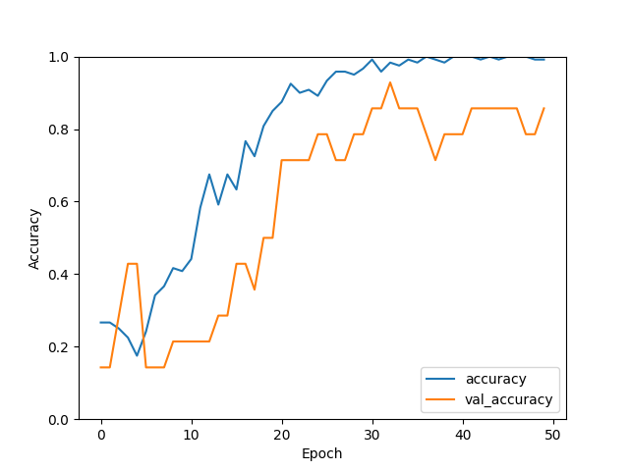

**Loss Plot**

