**ASSIGNMENT 1**

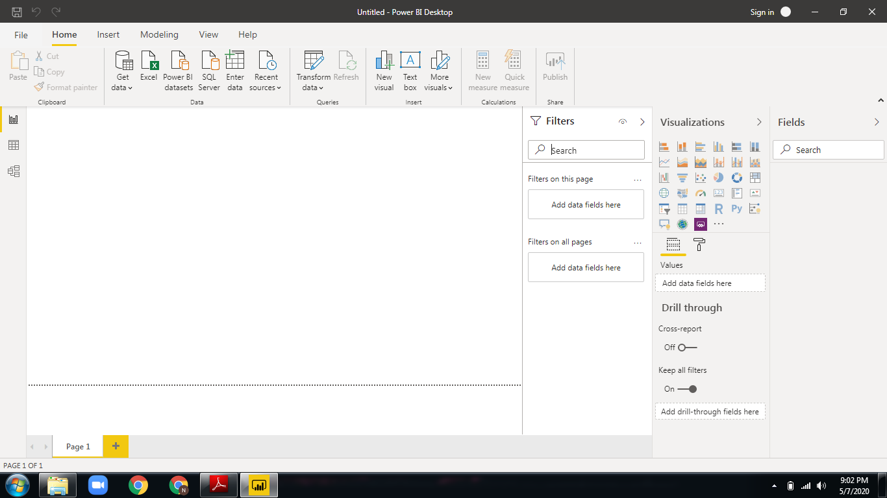

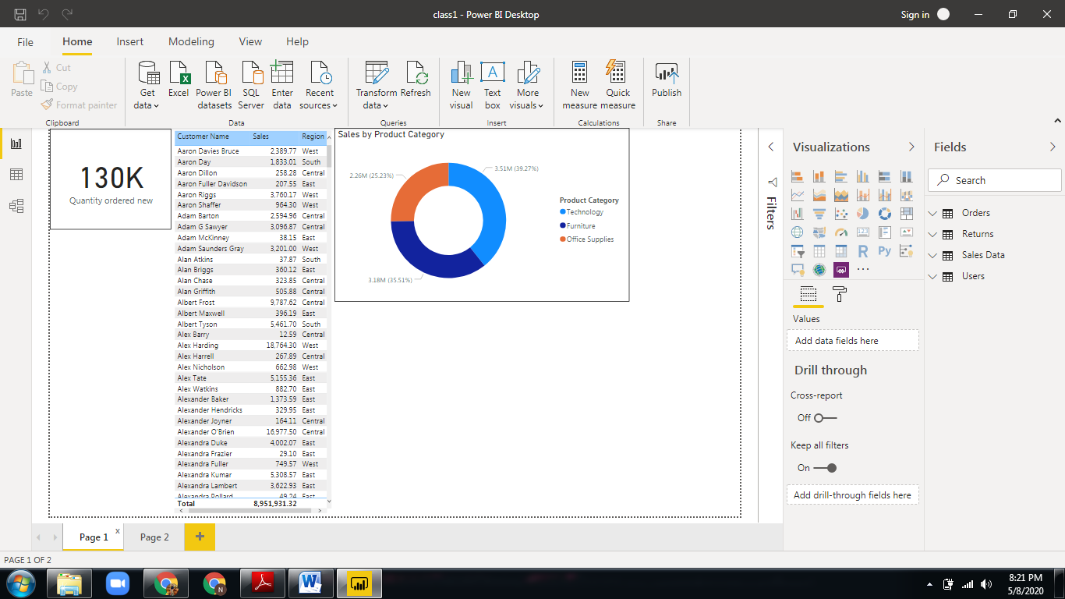

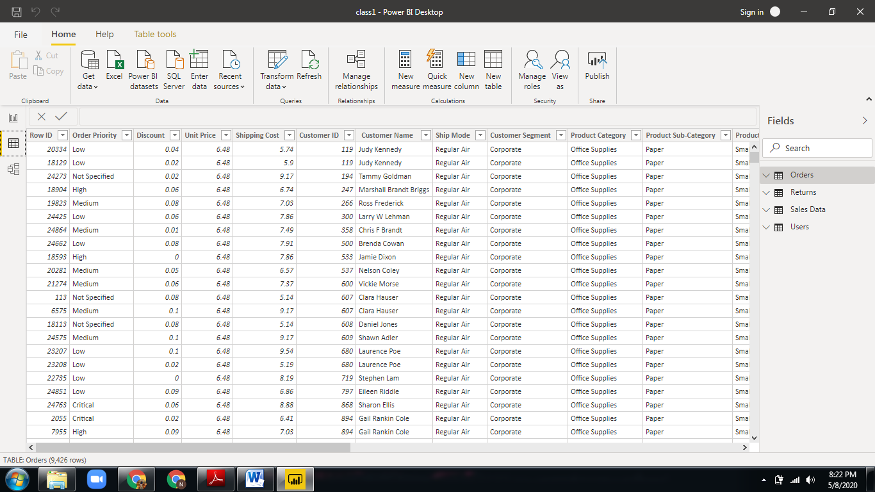

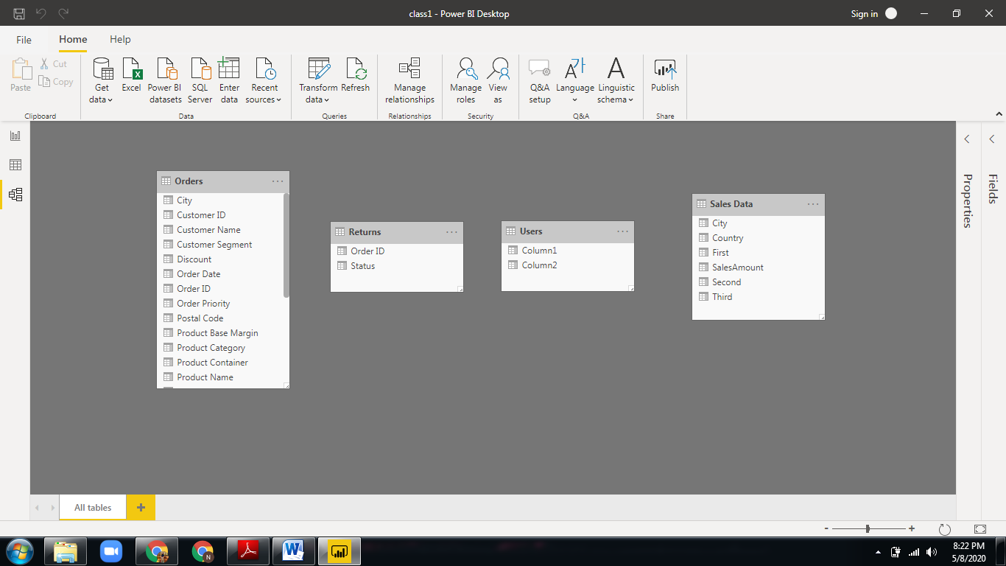

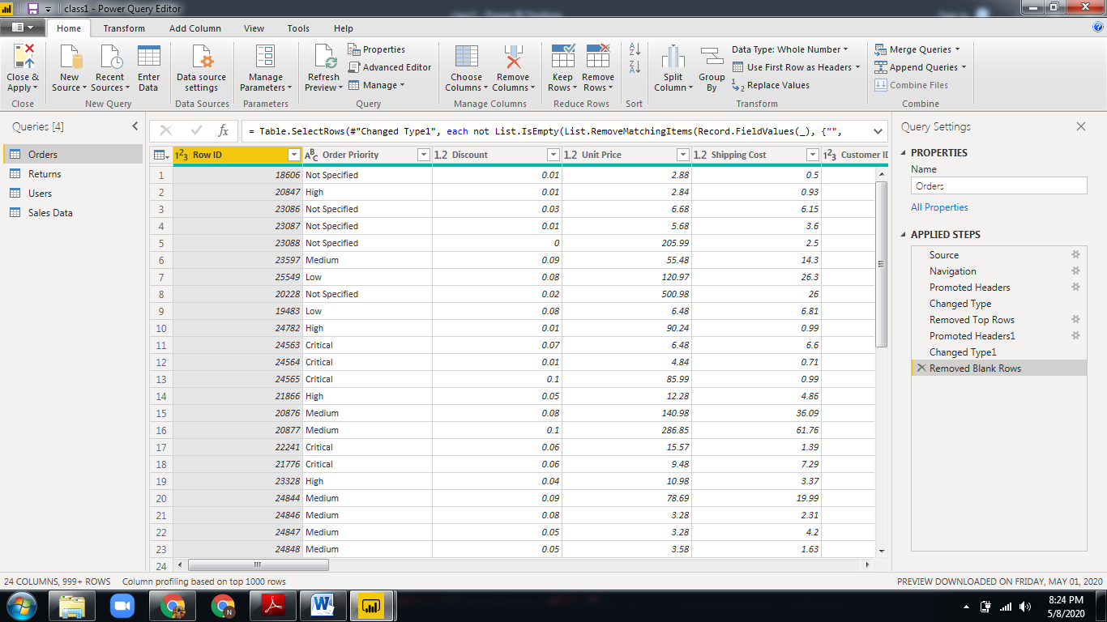

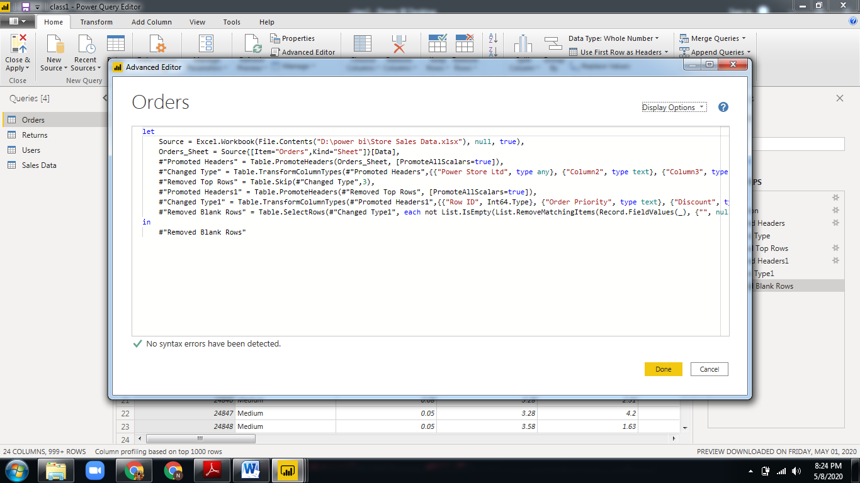

|  |  |  |
| --- | --- | --- |
| Application | Description | Price |
| Power BI Desktop | Power BI Desktop is a free application you install on your local computer that lets you connect to, transform, and visualize your data.  The most common uses for Power BI Desktop are as follows:   * Connect to data * Transform and clean that data, to create a data model * Create visuals, such as charts or graphs, that provide visual representations of the data * Create reports that are collections of visuals, on one or more report pages * Share reports with others by using the Power BI service | **Free** |
| Power BI Pro | * Share rich data visualizations that help everyone make decisions based on facts, not instinct. * Distribute findings to team members inside and outside your organization, adjusting permissions as needed. * Access visualizations on the go using the [Power BI Mobile app](https://powerbi.microsoft.com/en-us/mobile/) to make data-driven decisions from anywhere. * Enhance collaboration by using team commenting and stay current with content subscriptions and update alerts. * Discover insights quickly * Get more done with familiar tools * Govern your data securely | **$9.99** Monthly per user |
| Power BI Premium | * Power BI Premium offers advanced, self-service data preparation that allows every user—from business analyst to data scientist—to accelerate the delivery of insights and collaborate with ease. * Accelerate decision making when everyone has access to insights * Unlock big data with self-service data prep * Simplify data management and access * Improve publishing efficiency and accuracy of BI content | **$4,995**  Monthly price per dedicated cloud compute and storage resource with annual subscription |