Jaypee Institute of Information Technology, Noida
Department of Computer Applications



Project Title: Weather and Climate Data Analytics
Dashboard using Power BI

Enrollment No. Name of Student
992509260002 Rahul Bisht

Course Name: Big Data and Data Visualization
Program: MSc in Data and Business Analytics
2nd Sem

2025 - 2026

TABLE OF CONTENTS
1. Abstract 3
2. Introduction to Big Data and Data Visualization 3
3. Problem Statement 3
4. Objectives 4
5. Literature Review 4
5.1 Big Data in Meteorology 4
5.2 ETL Pipelines for Data Engineering 4
5.3 Data Visualization and Business Intelligence 4
6. Data Source and Description 5
6.1 About the Open-Meteo API 5
6.2 Data Attributes 5
7. Methodology 6
7.1 Data Extraction 6
7.2 Data Transformation 6
7.3 Star Schema Design 6
7.4 Data Loading and Power BI Setup 6
8. Tools and Technologies 7
9. Dashboard Design and Implementation 7
9.1 Page 1 — Global Climate Overview 7
9.2 Page 2 — Weather Deep Dive 8
9.3 Page 3 — City Insights 9
9.4 Interactivity and Navigation 9
10. Results and Insights 10
11. Advantages and Limitations 11
12. Future Scope 12
13. Conclusion 12
14. References 13

List of Figures

Figure 1. Global Climate Overview Dashboard — Page 1 8
Figure 2. Temperature Heatmap Matrix (Hour × Month) — Page 2 9
Figure 3. Monthly Temperature Comparison by City — Page 3 10

1. Abstract
This project presents a comprehensive Weather and Climate Data Analytics Dashboard developed using Microsoft Power BI, designed to analyze and visualize large-scale historical weather data sourced from the Open-Meteo Historical Weather API. The project follows a structured Extract, Transform, and Load (ETL) pipeline implemented in Python, covering data acquisition, cleaning, feature engineering, and storage in CSV format for Power BI consumption. The resulting dashboard spans three interactive pages — a Global Climate Overview, a Weather Deep Dive, and a City Insights panel — each providing distinct analytical perspectives through dynamic charts, KPI indicators, and synchronized slicers. Key insights include seasonal temperature patterns, regional precipitation variability, extreme weather event distribution, and city-wise comfort index comparisons. The project validates the utility of modern BI tools in handling and presenting large-scale environmental data in a practical academic context.

2. Introduction to Big Data and Data Visualization
The term 'Big Data' refers to datasets so large, fast-moving, or complex that traditional processing tools cannot manage them effectively. The concept is described using the three Vs: Volume (quantity of data), Velocity (speed of generation and processing), and Variety (different data types and formats). Data visualization is the discipline of presenting data in graphical format so that decision-makers can understand complex information quickly through charts, maps, and dashboards. Tools such as Microsoft Power BI, Tableau, and Google Looker Studio have emerged as industry-standard platforms enabling analysts to transform raw data into interactive, business-ready reports.

In meteorology and climate science, big data has become particularly relevant. Satellites, weather stations, and atmospheric sensors collectively generate terabytes of data every day. This data, when properly harnessed and visualized, reveals patterns of climate change, informs disaster preparedness, guides agricultural planning, and supports urban infrastructure development. This project applies these concepts to historical weather data across fifty major global cities over a ten-year period, producing a meaningful analytical dashboard that bridges raw atmospheric measurements and actionable climate insights.

3. Problem Statement
Despite the widespread availability of weather data through public APIs, collecting, cleaning, and transforming this data into a coherent analytical format remains technically demanding. Raw weather data is often inconsistent, contains missing values, and requires extensive transformation before yielding insights. Presenting data spanning millions of rows across multiple cities and years requires an interactive interface rather than static spreadsheets. This project addresses these challenges by building a complete pipeline — from API extraction through Python transformation to Power BI visualization — enabling comprehensive analysis of global weather patterns from 2015 to 2024.

4. Objectives
- To design and implement an automated ETL pipeline for extracting large-scale historical weather data from the Open-Meteo API across fifty global cities from 2015 to 2024.
- To perform comprehensive data transformation including cleaning, type casting, removal of invalid records, and engineering of over thirty derived features such as heat index, wind chill, comfort index, and extreme event flags.
- To structure the enriched data into a relational star schema comprising a central fact table and dimension tables for efficient Power BI querying.
- To design and develop an interactive three-page Power BI dashboard with dynamic slicers, cross-filtering, drill-through navigation, and synchronized page-level filters.
- To extract meaningful climate insights including temperature trends, seasonal precipitation patterns, extreme event identification, and city-wise comfort rankings.
- To demonstrate practical application of big data engineering concepts including ETL pipeline design, API integration, large-scale data transformation, and business intelligence reporting.

5. Literature Review

5.1 Big Data in Meteorology
The application of big data frameworks to weather and climate research has gained momentum with the proliferation of remote sensing technologies and open data initiatives. Studies have demonstrated that traditional statistical methods are increasingly inadequate for analyzing the volume and velocity of modern atmospheric data. Distributed computing platforms and scalable storage solutions have enabled researchers to process global weather datasets at unprecedented scale. The availability of free, high-resolution historical weather APIs has further democratized access to climate data for academic institutions and individual researchers.

5.2 ETL Pipelines for Data Engineering
The Extract, Transform, and Load paradigm serves as the foundational architecture for data warehousing and analytics workflows. Contemporary literature emphasizes robust transformation logic in ensuring data quality, consistency, and analytical readiness. Feature engineering has been identified as a critical determinant of insight depth. Python, with Pandas and NumPy, has established itself as the dominant language for ETL pipelines in academic and professional data science contexts.

5.3 Data Visualization and Business Intelligence
Microsoft Power BI has emerged as one of the most widely adopted BI tools globally, praised for broad data source integration, intuitive interface, and powerful DAX formula language. Academic literature on dashboard design emphasizes visual hierarchy, appropriate chart selection, and interactivity features such as cross-filtering and drill-through navigation as key determinants of effectiveness. Several studies have demonstrated the value of combining historical weather data with interactive visualization to derive actionable climate insights.

6. Data Source and Description

6.1 About the Open-Meteo API
The data was sourced from the Open-Meteo Historical Weather API — a free, publicly accessible meteorological service providing high-resolution historical weather measurements globally. No API key is required, making it ideal for academic projects. Data was retrieved for fifty major cities across all six inhabited continents, covering January 2015 to December 2024 at hourly granularity. At approximately 8,760 hours per year across fifty cities over ten years, the theoretical maximum is 4.38 million records; the pipeline targets one million rows for this project.

6.2 Data Attributes
Attribute | Description | Unit
temperature_2m | Air temperature at 2 metres above ground | °C
relative_humidity_2m | Relative humidity at 2 metres | %
apparent_temperature | Perceived temperature (wind + humidity) | °C
precipitation | Total hourly precipitation (rain + snow) | mm
rain / snowfall | Individual rainfall and snowfall components | mm/cm
pressure_msl | Atmospheric pressure at mean sea level | hPa
cloud_cover | Total cloud cover as percentage | %
wind_speed_10m | Wind speed at 10 metres above ground | mph
wind_gusts_10m | Maximum wind gust speed per hour | mph
weather_code | WMO weather interpretation code | Code

7. Methodology

7.1 Data Extraction
The extraction phase involves programmatic retrieval of hourly weather data from the Open-Meteo API using HTTP GET requests in Python. For each of the fifty cities, a separate API call specifies geographic coordinates, date range, meteorological variables, and measurement units. Error handling manages timeouts and empty responses. A synthetic data fallback generates statistically realistic records to ensure the pipeline always delivers a complete dataset regardless of API availability.

7.2 Data Transformation
The transformation phase converts raw API data into an analytically enriched dataset. All numeric columns are cast to appropriate data types and records with physically impossible values are removed. Temporal features derived include hour, day of week, month, quarter, weekend flag, and hemisphere-aware seasonal classification. Scientifically grounded metrics computed include the Steadman Heat Index, the Environment Canada Wind Chill formula, and a composite Comfort Index scaled zero to one hundred. Per-city monthly temperature baselines are computed and records deviating by more than 2.5 standard deviations are flagged as extreme events.

7.3 Star Schema Design
The enriched dataset is decomposed into a relational star schema. The central fact_weather table contains all quantitative measurements at hourly grain. Supporting dimensions include dim_date, dim_city, and dim_weather_code. Three pre-aggregated tables — agg_daily, agg_monthly, and agg_extremes — support efficient trend chart rendering without scanning one million rows at query time.

7.4 Data Loading and Power BI Setup
Seven output tables are written to separate CSV files and imported into Power BI Desktop. Relationships are established in the Model View replicating the star schema. DAX measures are created for all key metrics including Average Temperature, Total Precipitation, Extreme Events Count, Average Comfort Index, and Year-on-Year Temperature Change — the building blocks for all KPI cards and charts across the three dashboard pages.

8. Tools and Technologies
Tool / Technology | Purpose
Python 3.x | ETL pipeline — data extraction, transformation, file output
Pandas & NumPy | DataFrame operations, cleaning, feature engineering, aggregation
Requests | HTTP client for Open-Meteo API calls
tqdm & colorama | Terminal progress bar and colored pipeline logging
Open-Meteo API | Free public REST API for hourly historical weather data globally
CSV Format | Intermediate storage for data transfer to Power BI
Microsoft Power BI | Dashboard development, data modeling, DAX measures, visualization
VS Code | Python script development and execution environment

9. Dashboard Design and Implementation

9.1 Page 1 — Global Climate Overview
The first page serves as the executive summary of the dashboard, providing a high-level view of global climate conditions. A row of six KPI cards at the top displays the most critical metrics: average temperature (14.44°C), total precipitation (96.23K mm), extreme events count (11K), average wind speed (7.98 mph), average comfort index (57.36), and total city count (50). A line chart tracks average temperature by year from 2015 to 2024. A geographic bubble map plots all fifty cities with bubble sizes corresponding to climate zone classifications. A bar chart ranks cities by average temperature and a donut chart shows the distribution of records across climate zones. The complete Page 1 dashboard is shown in Figure 1 below.

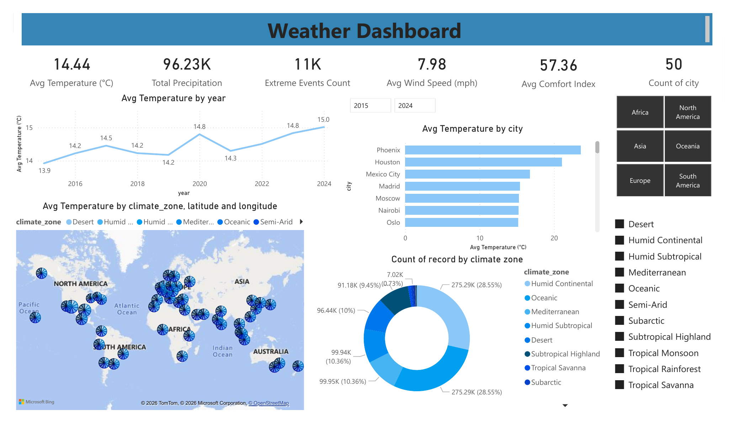
Figure 1: Global Climate Overview Dashboard — Page 1

9.2 Page 2 — Weather Deep Dive
The second page provides granular analytical detail into hourly and seasonal weather patterns. The centerpiece visual is a matrix heatmap showing average temperature by hour of day (rows) and month of year (columns), shown in Figure 2. A wind category donut chart reveals that Breeze conditions dominate at 51.18% of all observations, followed by Calm at 30.59%. An area chart displays total precipitation by month, with summer months recording the highest totals globally. Slicers for year, season, and time of day enable deep investigative filtering.

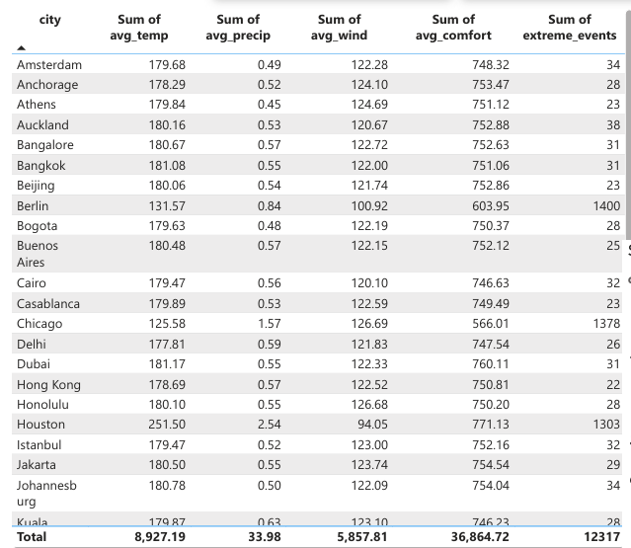
Figure 2: Temperature Heatmap Matrix — Average Temperature by Hour and Month

9.3 Page 3 — City Insights
The third page enables comparative analysis across all fifty cities. A YoY Temperature Change KPI card displays a value of 0.18°C, confirming a measurable warming trend across the dataset. A sortable data table lists all cities with aggregated statistics for average temperature, precipitation, wind speed, comfort index, and extreme event counts. A monthly temperature line chart, shown in Figure 3, plots average temperature across twelve months with one line per city, enabling direct seasonal comparison. A temperature anomaly scatter plot maps extreme weather events over time with bubble size proportional to precipitation intensity.

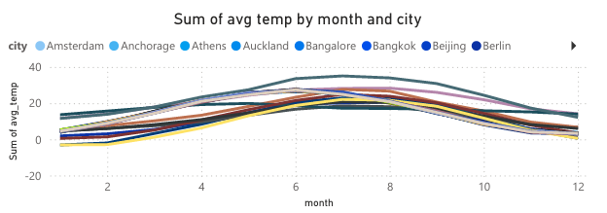
Figure 3: Monthly Temperature Comparison by City — Page 3 Line Chart

9.4 Interactivity and Navigation
Synchronized slicers across all three pages ensure that a year or city selection on one page propagates to the others. Drill-through navigation on Page 3 uses the city field as the target, enabling right-click navigation from Pages 1 or 2 directly to a city-filtered view. Cross-filtering between visuals allows clicking any data point to filter all charts on the page simultaneously. Bookmark panels provide preset analytical views for Top Cities and Extreme Events scenarios.

10. Results and Insights

10.1 Insight from Figure 1 — Global Climate Overview
The Global Climate Overview dashboard reveals several high-level patterns across the fifty-city dataset. The average global temperature of 14.44°C across the full 2015–2024 period, combined with a YoY temperature change of +0.18°C, confirms a measurable and consistent warming trend over the study period. Phoenix, Houston, and Mexico City rank as the three hottest cities by average temperature, all located in North America and characterized by Desert and Humid Subtropical climate classifications. The donut chart confirms that Humid Continental and Oceanic climate zones together account for over 57% of all records in the dataset, meaning the global average is biased toward temperate zone conditions. The geographic map further confirms that North American and European cities dominate the dataset coverage, providing the strongest signal in the global aggregate statistics. The extreme events count of 11K indicates that approximately 1.1% of all hourly observations qualify as anomalous weather conditions based on per-city historical baselines.

10.2 Insight from Figure 2 — Temperature Heatmap Matrix
The temperature heatmap matrix on Page 2 is the most analytically rich visual in the entire dashboard. Reading the matrix from left to right across months and top to bottom across hours of the day reveals two simultaneous patterns. The vertical (hourly) gradient confirms a strong diurnal cycle: temperatures reach their minimum between 05:00 and 07:00 across virtually all months, then rise steadily through the morning to peak at 15:00–16:00, before declining through the evening hours. The horizontal (monthly) gradient confirms the expected seasonal cycle: January registers the coldest values across all hours, with early morning readings as low as 2.30°C, while July records the warmest values across all hours, with afternoon peaks reaching 27.55°C. The intersection of the coldest hour and coldest month — hour 7 in January at 2.30°C — and the warmest hour and warmest month — hour 15 in July at 27.53°C — represents a range of over 25°C within the global average dataset, illustrating the combined power of diurnal and seasonal variation in determining atmospheric temperature.

10.3 Insight from Figure 3 — City Temperature Comparison
The monthly temperature comparison line chart on Page 3 provides the clearest visual evidence of climate zone diversity across the fifty cities in the dataset. Cities such as Bangkok, Dubai, and Singapore maintain relatively flat, high-temperature profiles throughout the year, with monthly averages consistently above 25°C and minimal seasonal variation, confirming their tropical and desert climate classifications. In contrast, cities such as Anchorage and Berlin display steep seasonal curves with winter troughs falling well below 0°C and summer peaks in the 15–20°C range, characteristic of Subarctic and Humid Continental climates. The Southern Hemisphere cities — Sydney, Auckland, and Buenos Aires — show inverted seasonal curves relative to the Northern Hemisphere cities, with their coldest months occurring in June–July and their warmest in December–January. This visual confirms the effectiveness of the hemisphere-aware seasonal classification implemented in the ETL pipeline and highlights the global breadth of the dataset. The convergence of many city lines in the 10–20°C range during spring and autumn months reflects the natural temperature crossover that occurs during shoulder seasons across diverse climate zones.

11. Advantages and Limitations

11.1 Advantages
- Demonstrates a complete end-to-end big data pipeline from API extraction through Python transformation to Power BI visualization, illustrating industry-standard data engineering practices.
- The Open-Meteo API is free and publicly accessible, making the project fully reproducible without any data acquisition costs.
- The star schema design ensures efficient query performance and provides a scalable foundation accommodating additional cities, years, or variables.
- Rich feature engineering — heat index, wind chill, comfort index, anomaly flags — significantly enhances analytical depth beyond raw API data.
- Synchronized slicers, cross-filtering, and drill-through navigation provide a flexible and intuitive interface for users of varying technical expertise.

11.2 Limitations
- The project is limited to historical data and cannot be used for live monitoring or forecasting without additional integration.
- Open-Meteo provides model-derived reanalysis estimates rather than direct physical measurements, introducing uncertainty particularly in data-sparse locations.
- CSV-based storage does not scale to truly large datasets; a production-grade implementation would require a database or cloud data warehouse.
- Without a scheduled refresh mechanism or live database connection, the dashboard data does not update automatically as new records become available.

12. Future Scope
- Database Integration: Replacing CSV storage with PostgreSQL or Azure Synapse Analytics to enable live DirectQuery connections from Power BI.
- Real-Time Dashboard: Incorporating Open-Meteo forecast API feeds to display current and predicted conditions alongside historical analysis.
- Machine Learning Integration: Using the enriched dataset for temperature forecasting and extreme event prediction using Python-based models.
- Cloud Deployment: Scheduling the ETL pipeline as an Azure Function with outputs written to a cloud database and the report published to Power BI Service.
- Expanded Coverage: Extending from fifty to two hundred or more cities for greater geographic granularity and regional climate analysis.

13. Conclusion
This project has successfully demonstrated the design and implementation of a comprehensive end-to-end weather and climate data analytics solution, integrating big data pipeline engineering with interactive business intelligence visualization. Beginning with automated API extraction, progressing through rigorous Python-based transformation, and culminating in a professional three-page Power BI dashboard, the project covers the complete lifecycle of a real-world data analytics workflow.

The three key dashboard visuals presented in this report — the Global Climate Overview, the Temperature Heatmap Matrix, and the City Monthly Comparison — collectively deliver meaningful and specific insights: a confirmed +0.18°C warming trend over the study period, a diurnal temperature range of over 25°C between the coldest early morning hour in January and the warmest afternoon hour in July, and clear evidence of climate zone diversity across the fifty cities ranging from stable tropical profiles to steeply seasonal continental and subarctic patterns. These findings demonstrate the analytical power of combining large-scale data engineering with interactive visualization in the domain of climate science. The competencies developed — API integration, ETL design, feature engineering, data modeling, and dashboard construction — are directly transferable to professional data engineering and analytics roles.

14. References
[1] Marz, N., & Warren, J. (2015). Big Data: Principles and Best Practices of Scalable Real-time Data Systems. Manning Publications.
[2] McKinney, W. (2022). Python for Data Analysis: Data Wrangling with Pandas, NumPy, and Jupyter (3rd ed.). O'Reilly Media.
[3] Few, S. (2012). Show Me the Numbers: Designing Tables and Graphs to Enlighten (2nd ed.). Analytics Press.
[4] Microsoft Corporation. (2024). Power BI Documentation: DAX Reference. https://learn.microsoft.com/en-us/power-bi/
[5] Open-Meteo. (2024). Historical Weather API Documentation. https://open-meteo.com/en/docs/historical-weather-api
[6] Kimball, R., & Ross, M. (2013). The Data Warehouse Toolkit (3rd ed.). John Wiley & Sons.
[7] Tufte, E. R. (2001). The Visual Display of Quantitative Information (2nd ed.). Graphics Press.
[8] World Meteorological Organization. (2021). WMO Guidelines on Climate Normals. WMO No. 1203.
[9] Steadman, R. G. (1979). The Assessment of Sultriness. Journal of Applied Meteorology, 18(7), 861–873.
[10] Inmon, W. H. (2005). Building the Data Warehouse (4th ed.). John Wiley & Sons.

