

Date: 21/02/2020 Section: K19EG

**Subject:** Internet Programming Laboratory (CSE 326)

**Project Title:** Daily Expense Tracker System.

**Submitted To:** Nikita Kaushik Mam

**Submitted By:**

|  |  |  |  |
| --- | --- | --- | --- |
| **Roll No.** | **Name** | **Registration No.** | **Signature** |
| **28** | Ayushi Agrawal | 11918141 |  |
| **29** | Abhinav Raj | 11903251 |  |
| **30** | Prathamesh Rajendrakumar Patil | 11903263 |  |

# [www.dailyexpensestracker.com](http://www.dailyexpensestracker.com)

**Introduction:**

Daily Expense Tracker System is a system which will keep a track of Income-Expense of a House-Wife on a day to day basis, This System takes Income from House-Wife and divides in daily expense allowed, If u exceed that days expense it will cut if from your income and give new daily expense allowed Amount, and if that days expense is less it will add it in savings. Daily expense tracking System will generate report at the end of month to show Income-Expense Curve. It will let you add the savings amount which you had saved for some particular Festivals or day like Birthday or Anniversary.

**Modules:**

* User (House-Wife) Login.
* User (House-Wife) Register.
* Add Expense.
* Add Income.
* View Income-Expense Curve.
* Savings.
* Add savings to income for next month.
* Add Special Expense(Expense which will be refunded to again)

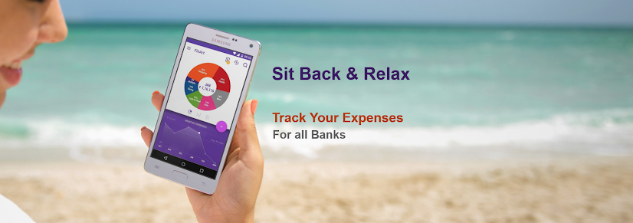

# Description:

This will track users daily expenses and guide him about his income and expenses ratio to get financially better planner. This platform will contain user login so only he can access his data

**User Login:**

In the login section, user can log in to his account using user id and password to input data and analyze the expenses and set limits and plan better.

## Registration:

In this module, user get registered in my site and give his overall details related to him, i.e. he fills in a registration form by giving the total details such as name, address, city, sex, dob, mobile numbers, e-mail address, etc..

## Who Can register:

In this module we will share some FAQs on the people who can register and who can’t. We will try to provide some information about this system like why it is necessary to everyone to plan their expenses.

## Refer A Friend:

In referring a friend module anyone will be able to send an invitation to his friend to know about this platform.

## Contact Us:

Through the contact section people can communicate with the site admin panel if they are facing problem with their account or to manage the expenses.

## Feed Giveback:

In this Feedback module people can share their experience or any kind of suggestions to improve the service.

**Application:**

This system will be used by House-Wife to control their Income-Expense from Day-to-Day to Yearly Basics. And to keep a watch on their expense.

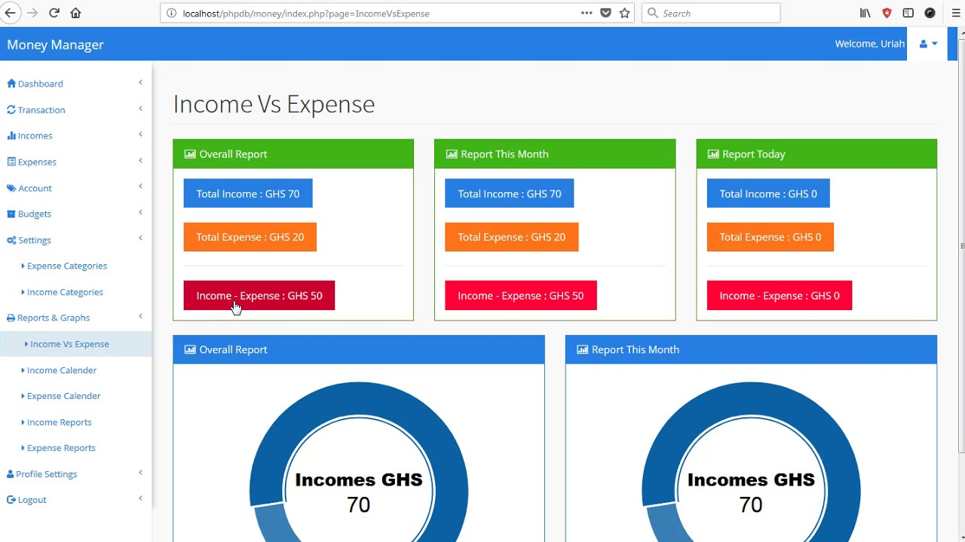

## Tracking Expenses Creates Financial Awareness

The real reason you track your expenses is to create financial awareness. If you don’t know where your money goes or how you spend it, you won’t know what habits you can change in order to make your money work for you. Even your small daily expenses can make you blow your budget. Those who become millionaires are aware of the money that they make and that they spend. True wealth is built as you spend less than you make and to do that you need to know what you are spending. If you want to build wealth, then you need to stop wasting money.

## It Also Helps Identify Spending Issues

Tracking your spending can help you identify serious spending issues. You can also see if your spending matched your priorities. It is easier to make changes when you realize that you are not reaching your financial goals because you eat out every night. Tracking your spending allows you to see where your money is really going. It is essential if you want to understand your financial habits and make changes to them. It can help you realize when you need to stop spending, so you do not end up with a financial hangover.

## Stick to Your Budget

It is also essential when you are trying to budget. If you do not track your money, then you will not know when to stop spending in a category. it does not need to take very much time each day, but if you consistently track your expenses, you will be able to get out of debt and make the necessary changes to finances. This will allow you to begin to build wealth and go after the things that you want out of life.

## The Easy Way to Track Expenses

An easy way to track your expenses is to simply write down every penny that you spend and where you spent it in a notebook. You may want to make a page for each budget category or simply put the category next to the amount you spent. This gives you a quick look at where your money goes, although it may be more difficult to separate the money into categories or look at spending trends. It at least makes you more aware of where your money is going.

**Expense management**  *refers to the systems deployed by a business to process, pay, and audit employee-initiated expenses. These costs include, but are not limited to, expenses incurred for travel and entertainment. Expense management includes the policies and procedures that govern such spending, as well as the technologies and services utilized to process and analyze the data associated with it.*

## Free and open-source personal financial management software

| **Name** | **Written in** | **Operating system** | **Mobile Presence** | **Software license** | **Description** | **Countries of origin** | **Last stable release date** | **Language** |
| --- | --- | --- | --- | --- | --- | --- | --- | --- |
| GnuCash | C, Scheme, C++  Java (Android App) | Windows, Mac OS, Linux. | Android (limited companion app) | GPL,Apache License 2 (Android App) | Personal and small-business financial-accounting software that supports tracking bank accounts, stocks, income andnexpenses |  | 3.4 / 30 Dec 2018 | Multilingual |
| HomeBank | C, GTK+ | OpenBSD, Linux, FreeBSD, Microsoft Windows, Mac OS, AmigaOS |  | GPL | Personal accounting software package[[5]](https://en.wikipedia.org/wiki/List_of_personal_finance_software#cite_note-5) | Contributors in multiple countries | 5.2.7 / Jul 28, 2019 | Multilingual |
| KMyMoney | C++ | FreeBSD, Linux, Windows |  | GPL (v2) | Supports different account types, categorisation of expenses and incomes, reconciliation of bank accounts and import/export to the “QIF” file format | Worldwide | 5.0.4 / Apr 21, 2019 | Multilingual |
| Ledger | C++ | Any Unix-like including macOS, Microsoft Windows | Android (via Termux) | BSD | A command-line based double-entry bookkeeping application. |  | 3.1.3 / Mar 31, 2019 | Multilingual |

### **Top 9 Personal Budget Software Apps**

* [**You Need a Budget (YNAB)**](https://www.youneedabudget.com/)
* [**Mvelopes**](https://www.mvelopes.com/)
* [**Quicken**](https://www.quicken.com/)
* [**Mint**](https://www.mint.com/)
* [**CountAbout**](https://countabout.com/)
* [**Moneydance**](http://moneydance.com/)
* [**Personal Capital**](https://www.personalcapital.com/)
* **Acorns**

The word "**budget**" has the power to make a lot of people panic, as it has a reputation for being both tedious and challenging.

Personal finance and budget software apps can take the tedium and challenge out of the budgeting process. They can help you stick to a spending plan, and many come with handy extra features depending on your needs.

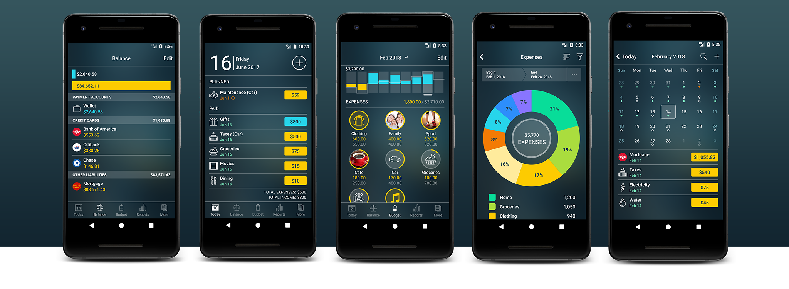

**If you are not using an expense tracker, you are missing out on the ability to manage your finances wisely and effortlessly. You will end up spending money without even realising it, and your daily expenses will go through the roof. On the other hand, if you use a money manager app, you will be aware when and why you are spending money and how much you spend.**

**If you are still sceptical about using a daily expense manager, here are 11 reasons that will show you why you need one:**

## 1. You have no control over your money

If you don’t check your spending and create a budget, you will have no control whatsoever on your money. Instead, money will control you, and you will either have perpetual lack of funds or you will end up steeped in debt. A money manager app helps you decide between short-term and long-term spending.

## 2. You have no financial goals

If you are spending money frivolously, you will not have money to set financial goals. However, when you have a daily expense manager, you will be able to work with limited resources and use your money in a wise manner so that you can create financial goals and ensure you meet them.

## 3. You are unaware what is happening with your money

If you are clueless about how much is your inflow and how much you are spending, you will not know at the end of the month what happened to your money. An expense tracker helps you figure out what is happening to your money, and whether you can afford something you want.

## 4. You spend and save in a haphazard manner

If you don’t have great financial management skills, you will not know how to categorize your expenses. However, tracking your expenses and budgeting them will help you become aware of how much you have to allocate to each expense category, and if you are short, you will be able to make adjustments with ease.

## 5. You have no clue about making your money work for you

In this day and age, when expenses are going through the roof, it has become crucial that you learn to make your money work for you so that you can create a nest egg for the future.

## 6. You don’t have funds for emergencies

Remember, emergencies come when you least expect. Hence, if you don’t have money stashed away for a rainy day, you will end up borrowing from family and friends. This way you could get into debt that will be difficult to pay back due to your poor money management skills.

## 7. Allows you to communicate with your spouse about money

If you are married, you may have the same financial goals as your spouse but could be going in different directions as you don’t know how to create a budget and work within that. With a daily expense manager, you know the inflow and outflow and can decide together how to use the money more constructively so that you are working together towards your financial goals.

## 8. You do not take hints about financial problems

In case you are disorganised about your finances, you will never be able to see the big picture. As a result, when financial problems come, you will panic and not be prepared for them. Using an expense tracker, helps you see your money situation and figure out possible money problems before they occur. This way, you can make adjustments and be prepared when the issue arises.

## 9. You take loans without knowing your financial situation

Using your credit cards rampantly or taking personal or auto loans can cause your debt to skyrocket. However, if you track your expenses, you will have a realistic picture in front of you and will know whether you are in a position to increase or take debt.

## 10. You cannot make your money grow

With proper tracking of your finances, you will not be able to determine unnecessary spending. This spending, if saved, can easily add up to quite a bit. A daily money tracker helps you budget your money so that you use it wisely. If you find that every month your expenses are more than what you earn, it is time to put your house in order and get a money manager app that keeps track of your money without any problem.