**(Phase 3)**

**IOT- Noise Pollution Monitoring**

**System**

**by**

**RAJARAJAN R (aut2271360229)**

## Introduction

Internet of things or commonly called IoT refers to the network of physical devices, vehicles, electronic appliances and other items embedded with sensors, software and connectivity which enables these things to connect, collect and exchange data without requiring human-to-human or human-to- computer interaction [1]. IoT is currently growing due to some factors such as convergence of multiple technologies, real time analytics, machine learning, commodity sensor and embedded systems. Take a smart home for instance, IoT is used in this invention to control lighting, heating, air-conditioning, media and security systems. This means it can save energy as it can automatically ensure lights and other electronics

|  |
| --- |
|  |
| **Figure 1.** Working principle of IoT |

## Literature Review

IoT has been implemented in many noise monitoring systems nowadays including mobile phones and vehicles. These technologies were invented and developed because of the demand from society to have systematic and efficient system for monitoring purpose. With the use of cloud server, the users can access the data at anytime and anywhere It is an effective way to reduce the work for authorities and less time consuming when recording data.

* 1. *Air and Sound Monitoring System*

To apply air and sound monitoring system where its objective is to measure the quality of air and sound in the environment, Arduino is used as microcontroller. All sensors such as sound sensor, temperature sensor and gas sensor are connected to it. Sound sensor or mic sensor provides digital output and it detects sound from atmosphere. A WiFi module is also connected to Arduino and it is used to transfer data from the sensors to cloud server. ESP8266 WiFi module is used to store

## Methodology

* 1. *Hardware Development*

For the hardware parts, LM 393 sound sensor is used to read the readings of the sound level from the environment. The reading of sound sensor is calibrated using the real sound level meter to get the accurate readings of the sound level. The 16x2 LCD will show the values of sound level at that researched area and give the warning that says the level of sound is high when the measurement exceeds the set value. If the users could not read the readings due to poor eyesight, they can know the level of sound by using the light emitting diodes (LED) which in red, blue and green colour placed below the LCD. LED acts as an indicator to indicate when the noise is very high. It will turn to red, blue for low noise while green for intermediate level. All these components such as sound sensor, LCD, and LEDs will be connected to the ESP8266 NodeMCU.

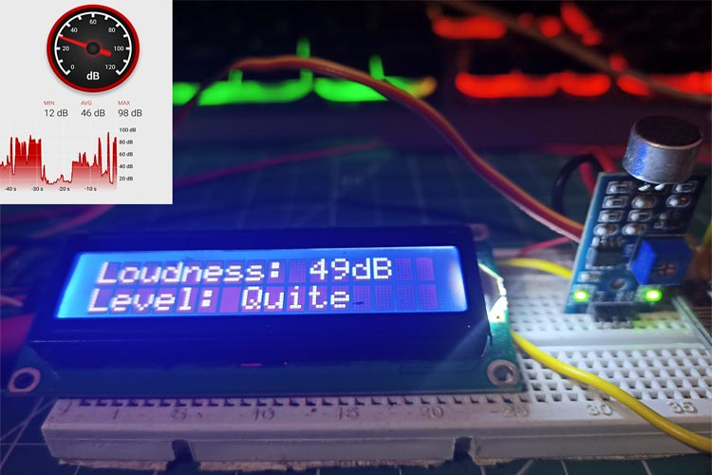

**Figure 2.** Prototype of the Project and interface of the app on

mobile smartphone.

## Results and Observations

The prototype is calibrated using actual sound level meter to get the accurate measurement of sound level or sound intensity. The prototype is used to measure the sound level at five different times which are during morning, afternoon, evening, night and midnight at a place where students are staying. The reading is taken 30 minutes per range of time. Within that time, the lowest and highest sound intensity were recorded and from the readings, the range of sound level was determined during that specific range of time. The results are tabulated in Table 1.

**Table 1.** Data Analysis from Prototype.

|  |  |  |  |  |
| --- | --- | --- | --- | --- |
| **Time** | **Weekend (Saturday)** | **Weekday (Sunday)** | **Allowable Noise Level according to Environmental Department of** | **Permissible Level of Comfort according** |
|  | **(dBA)** | **(dBA)** | **Malaysia (dBA)** | **to CIBSE (dBA)** |
| **Morning 7.00am-12.00pm** | 47 – 60 | 57 – 71 | 55 | 60 |
| **Afternoon 12.01pm-14.00pm** | 43 – 49 | 54 – 69 | 55 | 60 |
| **Evening 2.01pm-7.00pm** | 43 – 49 | 62 – 69 | 55 | 60 |
| **Night**  **7.01pm-12.00am** | 42 – 59 | 48 – 63 | 55 (7.01pm–10.00pm)  45 (10.00pm– 12.00am) | 60 |
| **Midnight** | 34 – 35 | 34 – 35 | 45 | 60 |

**12.01am-6.59am**

The allowable noise level that is suggested for researched area is below 55dBA for daytime and 45dBA for night. This justification is based on the researched area which is categorized as medium density residential area. Based on CIBSE, 60dBA is the maximum allowable sound level to achieve comfort in a building. Any sound that exceeds 60dBA will interrupt the speech intelligibility and the learning process. Based on Table 1, during weekend, the sound level in the morning and night are in between 47dBA to 60dBA and 42dBA to 59dBA. It shows that noise problem does occur during that time because the value of 55dBA is included in the range. As for afternoon, evening and midnight, all readings of sound level are below the allowable noise level standard which are during afternoon (43dBA – 49dBA), evening (43dBA – 49dBA) and midnight (34dBA -35dBA). Thus, during these times, noise problem does not occur. As for weekend, the suitable time for students to study is the whole day starting from morning until midnight because all readings are showing that they are within permissible level of comfort which is 60dBA.. As for weekday, the sound level during morning until night are all above the allowable noise level standard which are; morning (57dBA – 71dBA), afternoon (54dBA – 69dBA), evening (62dBA – 69dBA) and night (48dBA – 63dBA). It can be concluded that during that specific time, the noise problem does occur. As for midnight, the sound level recorded is 34dBA to 35dBA which indicates no noise problem.