Rajendra Singh | Address | 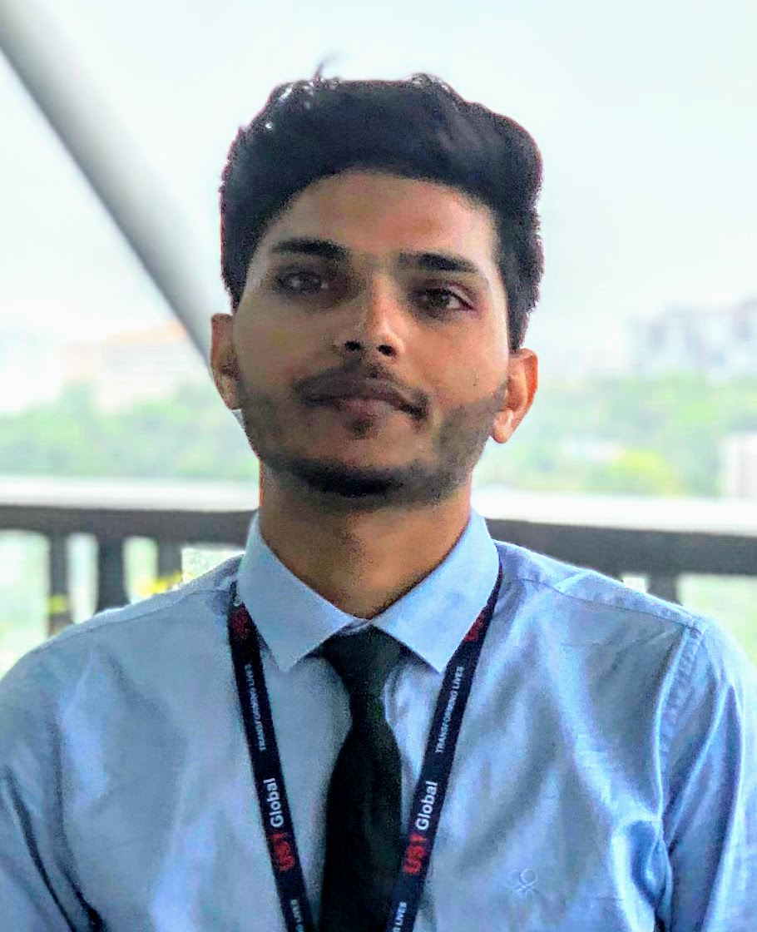  : 315, Tilang-B, IIT Palakkad, Kerala, India
Fourth year | E-Mail  Phone | : 111601017@smail.iitpkd.ac.in  : +91 7073091997
Computer Science and Engineering | Web | : https://iamrajee.github.io/
Indian Institute of Technology, Palakkad | DOB | : 27th November 1997

SUMMARY
- Skills | : Artificial intelligence(AI) and Robotics
- Internships | : UST Global, Researshala and IIT Madras.
- Projects | : Simultaneous localization and mapping (SLAM), Swarm Algorithms
- Position | : Former Head, Robotics club, IIT Palakkad
- Achivement | : KVPY fellowship, AWES Scholarship, IIT-Jee( 99.3 Percentile)

EDUCATION
Program | Institution | %/CGPA | Year
B. Tech | Indian Institute of Technology, Palakkad | 7.19 (Till VI Semester) | 2016-Present
XII | Delhi Public School, Udaipur | 89% | 2015-16
X | Delhi Rajasthan Public School, Rajsamand | 96% | 2013-14

TECHNICAL SKILLS
Title | Skills
Robotics | • SLAM(RtabMap, Gmapping, Hector) • Perception(SIFT, SURF, HOG, R-CNN, ICP, SGM, etc.)  • Sensor fusion(CLT, EKF, PF, DST) • Motion and path planning(A*,D*,RRT,OMPL, Bezier and B-spine curve)  • Swarm algorithms(PSO,ACO,ABC) • Robot kinematics and dynamics(DH, Newton and Lagrange method) • Embedded system(ARM, RTOS, FPGA)
Reinforcment Learning | Q-learning, TD, Sarsa, Monto carlo, Multi-armed bandit, DQN, DDPG, A3C, Genetic algorithm
Deep Learning | CNN, RNN(LSTM, Seq2seq,etc.), GANs, Unstructured data, Topic modeling, Word embedding
Languages | C++ , Python and Java
Software/Tools | ROS1/2, Moveit, Gazebo, V-REP, Matlab, Fusion 360, Keil, Atmel studio 6, Eagle, OpenGL, Cuda
Hardware | Rplidar A2M8, Realsense D435, Nvidia Jetson(Tx2, nano), Raspi3B+, GstarIV GPS, Zybo-zyng FPGA, KL25Z arm cortex-M0+ , Atmega16/32/2560, NodeMCU, GSM, Pyboard, OpenMV, PlutoX

WORK EXPERIENCES
- Summer intern, UST Global, Trivandrum May-July, 2019
Studied various SLAM algorithm and implemented it using ROS by fusing sensor data of lidar and 3d depth camera. Later, I worked on control and planning of robotics maniputor for vision based pick and place task.

- Data Science intern, Researchshala, Chandigarh May-July, 2018
Worked on NLP projects related to transfer learning, topic modelling, web and pdf scraping, extrating and analysing useful information from unstructured data.

- Vistaar Program, IIT Madras May-June, 2017
Studied state of art 3D printing technology and then built Prusa i3 3D printer and a robotic arm using this printer.

SEMINAR PRESENTATIONS
- Visual SLAM on mobile manipulator using ROS, Industry-Academia Conclave’19, IIT Palakkad August, 2019
- Low cost 3D printer Prusa-i3, Open House’17, Centre for Inovation(CFI), IIT Madras October, 2017

SELECTED PROJECTS
- Implemented SLAM on automated guided vehicle(AGV) by sensor fusion of data from 2D lidar and 3D camera.
- Vision based control and trajectory planning of robotics manipulator in pointcloud data.
- Path planning of Swarm of drone for flying in synchronized manner, under Smart India Hackerthon 2019.
- Built EOG based typing system for individual with motor neuron diseases.
- Built automated Toilet Cleaning Robot for cleaning toilet seat and floor, Inter-IIT 2017-18, IIT Madras.
- Build model for Satellite image classification using just 14 images, for Inter-IIT 2018-19, IIT Bombay.

To know more about these projects, please visit: https://iamrajee.github.io/projects/

RELEVANT COURSES
Area | Courses
Maths | Linear algebra, Probability, Stochastic Process and Statistics, Differential and Integral Calculus
CS | Data Structures and Algorithms, DBMS, OS, Computer networks, Compilers, Parallel programming
AI | Principle of machine learning, Deep learning, Reinforcement learning
Robotics | Robotics manipulation and control, Embedded system, Signal and system, Engineering mechanics, Biomedical and Instrumentation

POSITION OF RESPONSIBILITY
- Head of Robotics Club, IIT Palakkad July 2018 - May 2019
  - Teach basics and advance concept of robotics.
  - Mentor student projects.
  - Encourage student to participate in regional and national competition.
  - Prepare and lead team in competitions.

SCHOLASTIC ACHIEVEMENTS
- Winner, Kaizen Robotics Competition, Lema labs. 2017
- Awarded KVPY Fellowship by DST, Govt. of India. 2016
- Qualified IIT-Jee Advanced 2016 with a percentile of 99.3 amongst a total of 1.2 million students. 2016
- Best Student of Year Award 2014–15, Rajsamand District Private Education Committee. 2015
- Awarded Merit Scholarship Class X, Army Welfare Education Society(AWES). 2014

REFERENCES
• Mr. Ashok Nair  Director Service Delivery,  UST Global, Thiruvananthapuram  E-Mail: ashok.nair@ust-global.com | • Mr. Shubham Jain  Founder and CEO,  Researshala, Chandigarh  E-Mail: shubham@researchshala.com | • Dr. Piyush P. Kurur  Professor, Department of Computer Science and Engineering, IIT Palakkad  E-Mail: ppk@iitpkd.ac.in

