Rajendra Singh | Address | 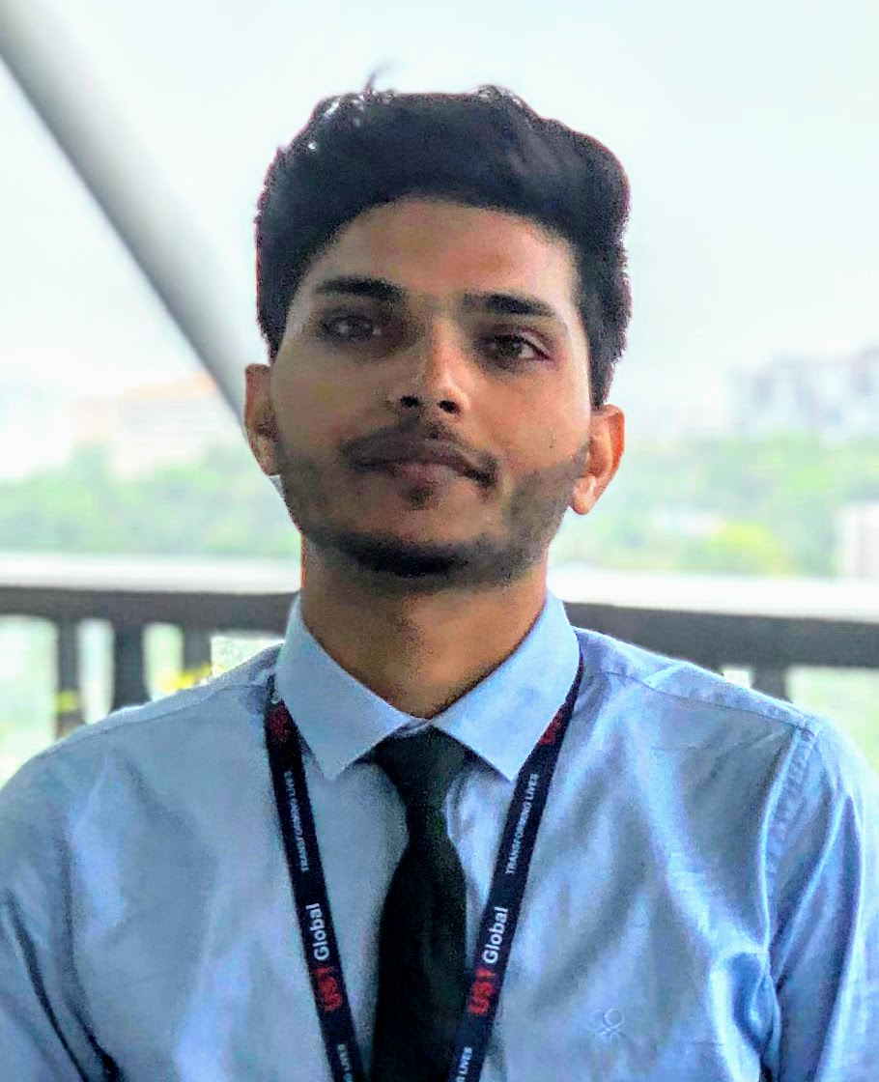  : 315, Tilang-B, IIT Palakkad, Kerala - 678623
Fourth year | E-Mail  Phone | : 111601017@smail.iitpkd.ac.in  : +91 7073091997
Computer Science and Engineering | Web | : Linkedin, Github, website
Indian Institute of Technology, Palakkad | DOB | : 27th Nov 1997

SUMMARY

- Skilled in ML, DL and AI.
- Interned with UST Global, Researshala and IIT Madras.
- Former Head, Robotics club, IIT Palakkad
- Selected for KVPY fellowship.
- IIT-Jee 99.3 percentile.

EDUCATION

Program | Institution | %/CGPA | Year of Completion
B. Tech | Indian Institute of Technology, Palakkad | 7.19 (Till VI Semester) | 2020
XII | Delhi Public School, Udaipur | 89% | 2016
X | Delhi Rajasthan Public School, Rajsamand | 96% | 2014

SCHOLASTIC ACHIEVEMENTS

- Qualified for Round 2, Smart India Hackerthon Hardware edition. 2019
- Winner, Kaizen Robotics Program Competition, Lema labs. 2017
- Awarded KVPY Fellowship by DST, Govt. of India. 2016
- Qualified IIT-Jee Advanced 2016 with a percentile of 99.3 amongst a total of 1.2 million students. 2016
- Ranked First, Science Quiz by Science and Technology Department, Rajasthan. 2014
- In top 10, Class X, Board of Secondary Education, Rajasthan. 2014
- Best Student of Year Award 2014–15, Rajsamand District Private Education Committee. 2014
- Awarded Merit Scholarship Class IX, Army Welfare Education Society. 2013

TECHNICAL SKILLS

- AI
- Deep learning and data science
I’ve done several projects on NLP and have good knowledge of keras, nltk, gensim, spacy.
- Competitive Programming
I participated in various competitions and have strong hold on C, C++ and Python.
- CSE Basics
In depth knowledge of Data structures and Algorithms, DBMS, OS, Computer networks and Compilers.
- Hardware
Rplidar A2M8, Realsense D435, GstarIV GPS, Nvidia Jetson(Tx2, nano), Raspi3B+

SELECTED PROJECTS

- Build model for satellite image classification using just 14 images, for Inter IIT 2018-19, IIT Bombay.
- Created cricket database system using MySQL.
- Implemention of slam on AGV by sensor fusion of data from 2D lidar and 3D camera.
- Vision based control and trajectory planning of robotics manipulator using pointcloud data.
- Tiger language to JavaScript compiler using sml function programming language.

For more projects, please visit: https://iamrajee.github.io/projects/

EXPERIENCES

- Summer intern, UST Global, Trivandrum May-July, 2019
Studied various slam algorithm and implemented it using ROS by fusing sensor data of lidar and 3d depth camera. Later, I worked on control and planning of robotics maniputor for vision based pick and place task.
- Data Science intern, Researchshala, Chandigarh May-July, 2018
Worked on projects related to transfer learning, topic modelling, web and pdf scraping, extrating and analysing useful information from unstructured data.
- Vistaar Program, IIT Madras May-June, 2017
Studied state of art 3d printing technology and then built prusa i3 3d printer and a robotic arm using this printer.

RELEVANT COURSES AND WORKSHOPS

Courses | Workshops
• Probability, Linear Algebra | • Machine Learning Workshop
• ML, AI, RL and DL | • Robotic Basics and Advance Workshop
• Robot manipulation and control | • IOT Workshop

POSITION OF RESPONSIBILITY

- Head of Robotics Club, IIT Palakkad July 2018 - May 2019
- Event cordinator, Rajasthan-Assam, EBSB, IIT Palakkad January 2019

EXTRACURRICULAR ACTIVITIES

- Active member of Data Analysis and Coding Club, IIT Palakkad
- Teaching at secondary school of Palakkad under NSS, IIT Palakkad

REFERENCES

• Mr. Ashok Nair  Director Service Delivery,  UST Global, Thiruvananthapuram  E-Mail: Ashok.nair@ust-global.com | • Mr. Shubham Jain  Founder and CEO,  Researshala, Chandigarh  E-Mail: shubham@researchshala.com | • Dr. Piyush P. Kurur  Professor, Department of Computer Science and Engineering, IIT Palakkad  E-Mail: ppk@iitpkd.ac.in

