Rajendra Singh | Address | 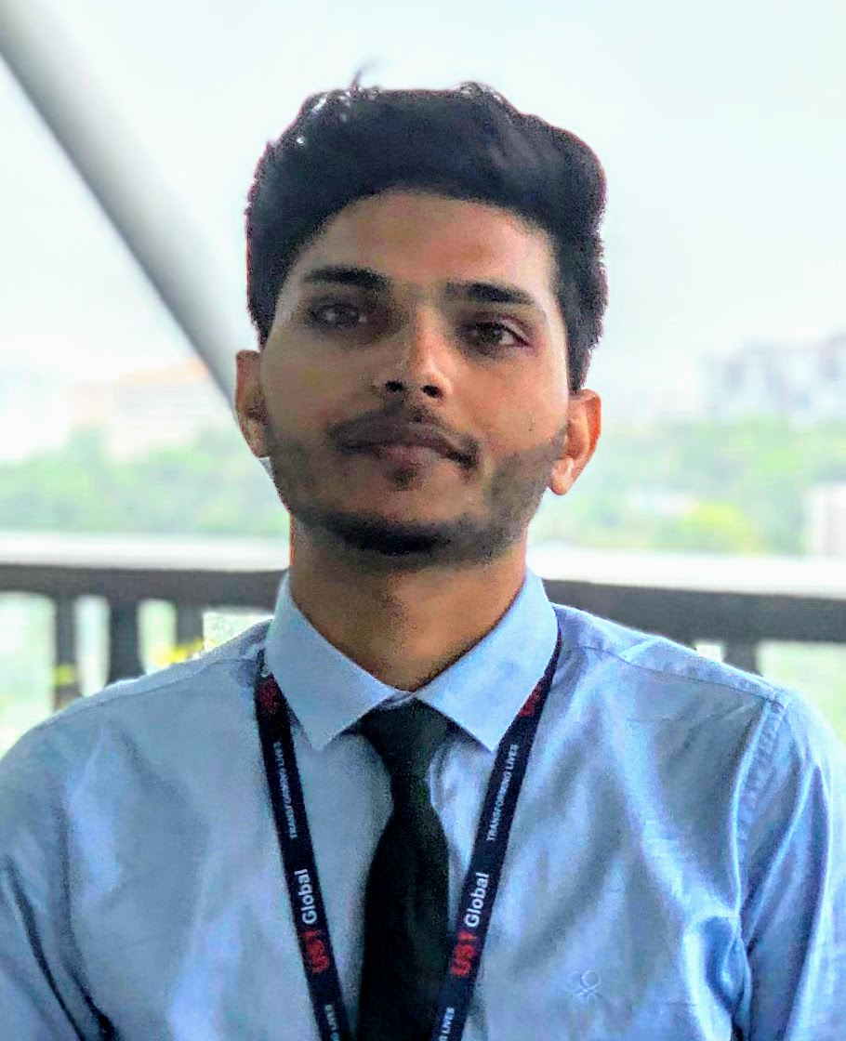  : 315, Tilang-B, IIT Palakkad, Kerala, India
Fourth year | E-Mail  Phone | : 111601017@smail.iitpkd.ac.in  : +91 7073091997
Computer Science and Engineering | Web | : https://www.linkedin.com/in/rajendra-singh-6b0b3a13a/
Indian Institute of Technology, Palakkad | DOB | : 27th November 1997

SUMMARY
- Skills | : Web and App development
- Internships | : Researshala
- Projects | : Chat bot, Sentiment Analysis, Database Management
- Achivement | : KVPY fellowship, AWES Scholarship

EDUCATION
Program | Institution | %/CGPA | Year
B. Tech | Indian Institute of Technology, Palakkad | 7.19 (Till VI Semester) | 2016-Present
XII | Delhi Public School, Udaipur | 89% | 2015-16
X | Delhi Rajasthan Public School, Rajsamand | 96% | 2013-14

TECHNICAL SKILLS
Title | Skills
Competitive Coding | Java, C++, Python
Web and App development | HTML,PHP CSS, JavaScript, Perl, SQL
Machine Learning | NLP, Unstructured data, Topic modeling, Word embedding
Software/Tools | Android Studio, Ruby on Rails, Azure, Google Cloud

WORK EXPERIENCES
- Summer Internship at Researchshala, Chandigarh May-July, 2018
Worked on projects related to Chat bot, Sentiment analysis, Web scraping, Analysing unstructured data.

SELECTED PROJECTS
- Database and backend : Database Management system for cricket data Jan-May, 2019
- Costumber feedback on web : Chat bot trained on facebook’s babi data set May-July, 2018
- App Development and Data Feed : Smart farming using Internet of Things(IOT) July-Nov, 2017

POSITION OF RESPONSIBILITY
- Event cordinator, Rajasthan-Assam, Ek Bharat Shreshtha Bharat, IIT Palakkad January 2019
  - Organised the cultural event of Ek Bharat Shreshtha Bharat of Rajasthan-Assam under goverment of India, at IIT Palakkad.

SCHOLASTIC ACHIEVEMENTS
- Awarded KVPY Fellowship by DST, Govt. of India. 2016
- Best Student of Year Award 2014–15, Rajsamand District Private Education Committee. 2015
- In top 10 Merit, Class X, Rajasthan board of secondary education(RBSE) 2014
- Awarded Merit Scholarship Class X, Army Welfare Education Society(AWES). 2014

REFERENCES
• Mr. Ashok Nair  Director Service Delivery,  UST Global, Thiruvananthapuram  E-Mail: ashok.nair@ust-global.com | • Mr. Shubham Jain  Founder and CEO,  Researshala, Chandigarh  E-Mail: shubham@researchshala.com | • Dr. Piyush P. Kurur  Professor, Department of Computer Science and Engineering, IIT Palakkad  E-Mail: ppk@iitpkd.ac.in

