Rajendra Singh | Address | 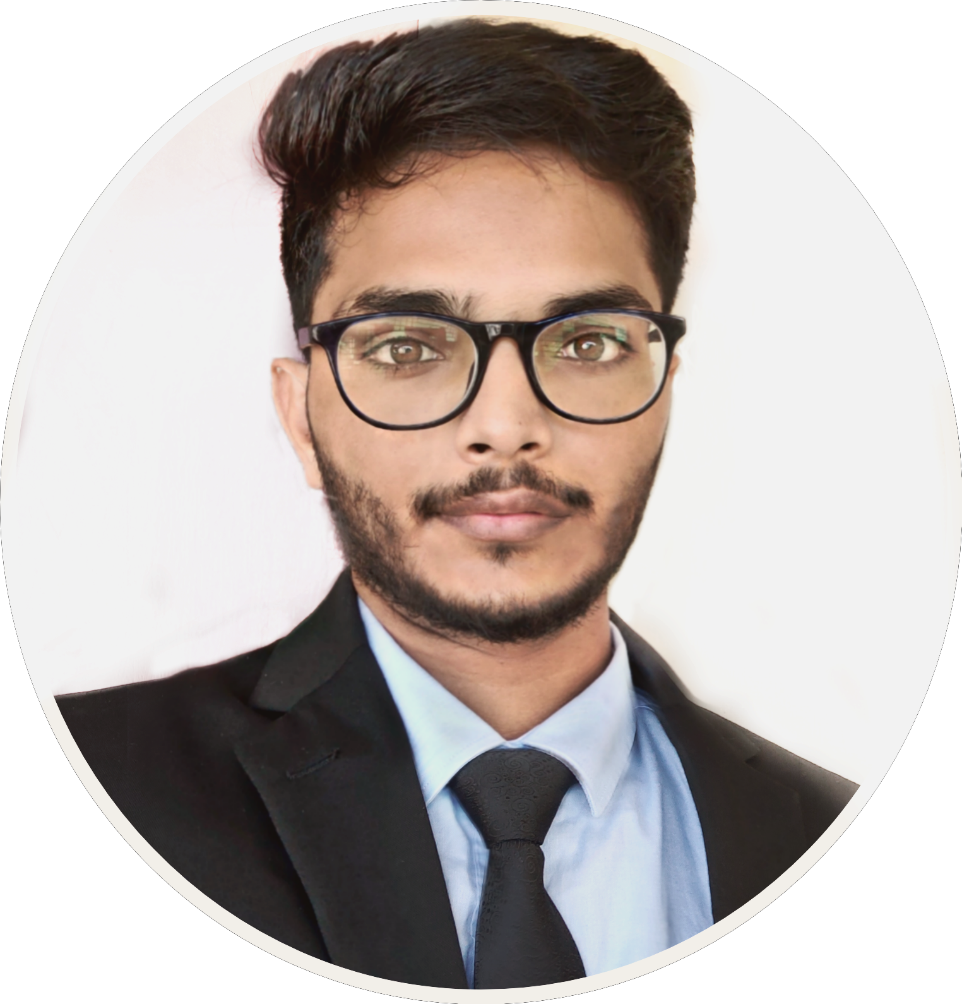  : 315, Tilang-B, IIT Palakkad, Kerala, India
Fourth year | E-Mail  Phone | : 111601017@smail.iitpkd.ac.in  : +91 7073091997
Computer Science and Engineering | DOB | : 27th November 1997
Indian Institute of Technology, Palakkad | Web | : https://iamrajee.github.io/

SUMMARY
- Domain | : | Artificial intelligence(AI) and Robotics
- Internships | : | UST Global, Researshala and IIT Madras.
- Projects | : | SLAM, Swarm robotics, Manipulators
- Position | : | Former Head, Robotics club, IIT Palakkad
- Achivements | : | KVPY fellowship, AWES Scholarship
- About | : | Passionate about vision-based robotics, research oriented and looking forward to work with enuthusiatic team in this domain.

EDUCATION
Program | Institution | %/CGPA | Year
- B. Tech | Indian Institute of Technology, Palakkad | 7.19 (Till VI Semester) | 2016 - April, 2020
- XII | Delhi Public School, Udaipur | 89% | 2015 - 16
- X | Delhi Rajasthan Public School, Rajsamand | 96% | 2013 - 14

TECHNICAL SKILLS
Title | Skills
‣ Robotics | • SLAM(2D / 3D) • Perception(Feature matching, Segmentation, Detection)  • Motion and path planning • Sensor fusion(Kalman, Particle filter)  • Swarm algorithms • Robot kinematics and dynamics(DH/Newton/Eular/Lagrangian method) • Control system • Embedded system(ARM, RTOS, FPGA)
‣ Reinforcment Learning | Q-learning, Sarsa, Monto carlo, TD, Multi-armed bandit, DQN, Genetic algorithm
‣ Machine Learning | Linear Regression, Regularization(Ridge,LASSO), Classification(Naive Bayes, SVM, KNN, Decision Trees), Clustering(K-mean/DBSCAN/BIRCH/DIANA), Ensembling, Cross validation
‣ Deep Learning | CNN, RNN, LSTM, Unstructured data, Topic modeling, Word embedding
‣ Languages | C, C++ , Python
‣ Software/Tools | ROS 1/2, Moveit, Gazebo, V-REP, Matlab, Fusion 360, Keil, Atmel studio 6, OpenGL
‣ Hardware | Rplidar A2M8, Realsense D435, Nvidia Jetson(Tx2, nano), Raspi3B+, GstarIV GPS, Zybo-zyng FPGA, KL25Z arm cortex-M0+ , Atmega16/32/2560, NodeMCU, GSM, Pyboard, OpenMV, PlutoX

WORK EXPERIENCES
- Research intern, UST Global, Trivandrum
May-July, 2019
Studied various SLAM algorithm and implemented it using ROS by fusing sensor data of lidar and 3d depth camera. Later, I worked on control and planning of robotics maniputor for vision based pick and place task.

- Data Science intern, Researchshala, Chandigarh
May-July, 2018
Worked on NLP projects related to transfer learning, topic modelling, web and pdf scraping, extrating and analysing useful information from unstructured data.

- Vistaar Program, IIT Madras
May-June, 2017
Studied state of art 3D printing technology and then built Prusa i3 3D printer and a robotic arm using this printer.

SEMINAR PRESENTATIONS
- Visual SLAM on mobile manipulator using robot operating system
August, 2019
- Industry-Academia Conclave, IIT Palakkad
Presented a poster showcasing implementation of 3D visual SLAM on a industrial manipulator robot.

- Low cost Prusa-i3 3D printer
October, 2017
- Open House, Centre for Inovation(CFI), IIT Madras
Showcased low cost, self made Prusa-i3 3D printer and its applications.

SELECTED PROJECTS
‣ Swarm | Simulating swarm behaviour of flocking and foraging in V-REP and Argos simulator | October-December, 2019
‣ Q-learning | Q-learning based controlled for ARdrone, simulated in gazebo using ROS | August - October, 2019
‣ Manipulator | Vision based control and trajectory planning of robotics manipulator in pointcloud data | June - July, 2019
‣ SLAM | Implemented SLAM on AGV by sensor fusion of data from 2D lidar and 3D camera | May - June, 2019
‣ Biomedical | Built EOG based typing system for individual with motor neuron diseases | January - April, 2019
To know more about these projects, please visit: https://iamrajee.github.io/projects/

SELECTED COMPETITIONS
‣ SIH, Hardware | Path planning to fly two drones in synchronized manner, maintaining same altitude and attitude. | January - June, 2019
‣ E-yantra | Simulated thristy crow story using wheel robot, overhead camera, aruco marker, blender models, Augment environment using OpenGL, Path planning and navigation on hexagon grid us IR sensors. | August,18-March, 2019
‣ Inter-IIT | Build model for Satellite image classification using just 14 images, for Inter-IIT, IIT Bombay | July - December, 2018
‣ Inter-IIT | Built automated Toilet Cleaning Robot for cleaning toilet seat and floor, Inter-IIT, IIT Madras | July - December, 2017

RELEVANT COURSES
Area | Courses
‣ Maths | Linear algebra, Probability, Stochastic Process and Statistics, Differential and Integral Calculus
‣ CS | Data Structures and Algorithms, DBMS, OS, Computer networks, Compilers, Parallel programming
‣ AI | Principle of machine learning, Deep learning, Reinforcement learning
‣ Robotics | Robotics manipulation and control, Embedded system, Signal and system, Engineering mechanics, Biomedical and Instrumentation

POSITION OF RESPONSIBILITY
- Head of Robotics Club, IIT Palakkad July 2018 - May 2019
  - Teach basics and advance concept of robotics.
  - Mentor student projects.
  - Encourage student to participate in regional and national competition.
  - Prepare and lead team in competitions.

SCHOLASTIC ACHIEVEMENTS
- Winner, Kaizen Robotics Competition, Lema labs. 2017
- Awarded Kishore Vaigyanik Protsahan Yojana(KVPY) Fellowship by DST, Govt. of India. 2016
- Qualified IIT-Jee Advanced 2016 with a percentile of 99.3 amongst a total of 1.2 million students. 2016
- Best Student of Year Award 2014–15, Rajsamand District Private Education Committee. 2015
- Awarded Merit Scholarship Class X, Army Welfare Education Society(AWES). 2014

REFERENCES
• Mr. Ashok Nair  Director Service Delivery,  UST Global, Thiruvananthapuram  E-Mail: ashok.nair@ust-global.com | • Mr. Shubham Jain  Founder and CEO,  Researshala, Chandigarh  E-Mail: shubham@researchshala.com | • Dr. Piyush P. Kurur  Professor, Department of Computer Science and Engineering, IIT Palakkad  E-Mail: ppk@iitpkd.ac.in

