Rajendra Singh | Address | 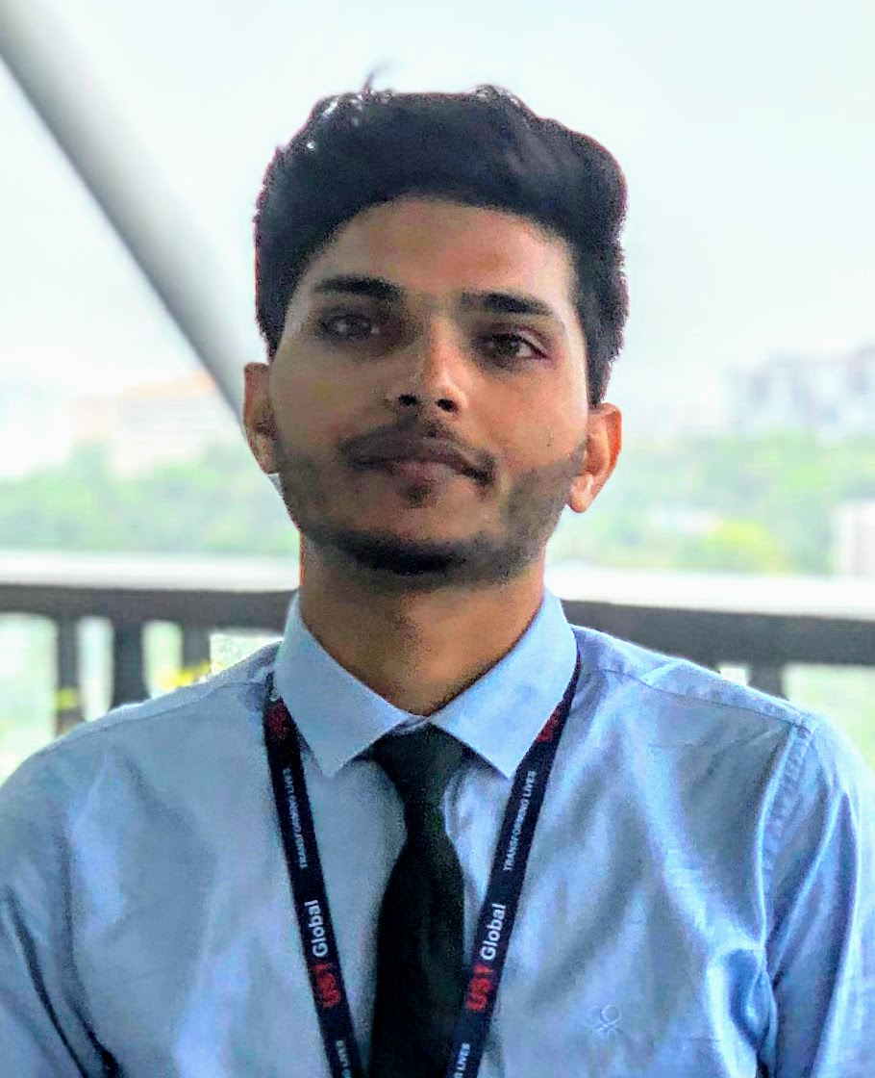  : 315, Tilang-B, IIT Palakkad, Kerala - 678623
Fourth year | E-Mail  Phone | : 111601017@smail.iitpkd.ac.in  : +91 7073091997
Computer Science and Engineering | Web | : LinkedIn, Github, website
Indian Institute of Technology, Palakkad | DOB | : 27th Nov 1997

SUMMARY

- Skilled in Robotics, ML, DL and AI.
- Interned with UST Global and Researshala.
- Selected for KVPY fellowship.
- Former head, Robotics club, IIT Palakkad

EDUCATION

Program | Institution | %/CGPA | Year of Completion
B. Tech | Indian Institute of Technology, Palakkad | 7.19 | 2020 (Till VI Semester)
XII | Delhi Public School, Udaipur | 89% | 2016
X | Delhi Rajasthan Public School, Rajsamand | 96% | 2014

SCHOLASTIC ACHIEVEMENTS

- Qualified for Round 2, Smart India Hackerthon Hardware edition 2019
- Winner, Kaizen Robotics Program Competition, Lema labs 2017
- Awarded KVPY Fellowship by DST, Govt. of India 2016
- Qualified IIT-Jee Advanced 2016 with a percentile of 99.3 amongst a total of 1.2 million students. 2016
- Ranked First, Science Quiz by Science and Technology Department, Rajasthan 2014
- In top 10, Class X, Board of Secondary Education, Rajasthan 2014
- Best Student of Year Award 2014–15, Rajsamand District Private Education Committee 2014
- Awarded Merit Scholarship Class IX, Army Welfare Education Society 2013

TECHNICAL SKILLS

- AI and Robotics
I'm skilled at ROS, RL, brain computer interface, embedded system, robot control and manipulation.
- Deep learning and data science
I’ve done several projects on NLP and CNN.
- Competitive Programming
I participated in various competitions and have strong hold on C, C++ and Python.
- In depth knowledge of Data structures and Algorithms, DBMS, OS, Computer networks and Compilers.

SELECTED PROJECTS

- Built Automated Toilet Cleaning Robot, Ranked 6th in Inter IIT 2017-18, IIT Madras

- Built an IOT Based Autonomous Farming under Makerthon 2017, Lema Labs, IIT Madras Research Park
- Built electrooculogram based Assistive Communication System
- Built ROS based autonomous navigation and mapping robot
- Satellite Image Classification, Inter IIT 2018-19, IIT Mumbai
- Swarm of two Unmanned aerial vehicle, Smart India Hackerthon 2019

EXPERIENCES

- Summer intern UST Global, Trivandrum May-July, 2019
Implemented SLAM and robot manipulation.
- Data Science intern, Researchshala, Chandigarh May-July, 2018
Worked on various NLP techniques
- Vistaar Program, IIT Madras May-June, 2017
Built Prusa i3 3D Printer and 3D Printed Robotic Arm

RELEVANT COURSES AND WORKSHOPS

Courses | Workshops
• Probability, Linear Algebra | • Machine Learning Workshop
• ML, AI, RL and DL | • Robotic Basics and Advance Workshop
• Robot manipulation and control | • IOT Workshop

POSITION OF RESPONSIBILITY

- Head of Robotics Club, IIT Palakkad July 2018 - May 2019
- Event cordinator, Rajasthan-Assam, EBSB, IIT Palakkad January 2019

EXTRACURRICULAR ACTIVITIES

- Active member of Data Analysis and Coding Club, IIT Palakkad
- Teaching at secondary school of Palakkad under NSS, IIT Palakkad

REFERENCES

• Mr. Ashok Nair  Director Service Delivery,  UST Global, Thiruvananthapuram  E-Mail: Ashok.nair@ust-global.com | • Mr. Shubham Jain  Founder and CEO,  Researshala, Chandigarh  E-Mail: shubham@researchshala.com | • Dr. Piyush P. Kurur  Professor, Department of Computer Science and Engineering, IIT Palakkad  E-Mail: ppk@iitpkd.ac.in

