Rajendra Singh | Address | 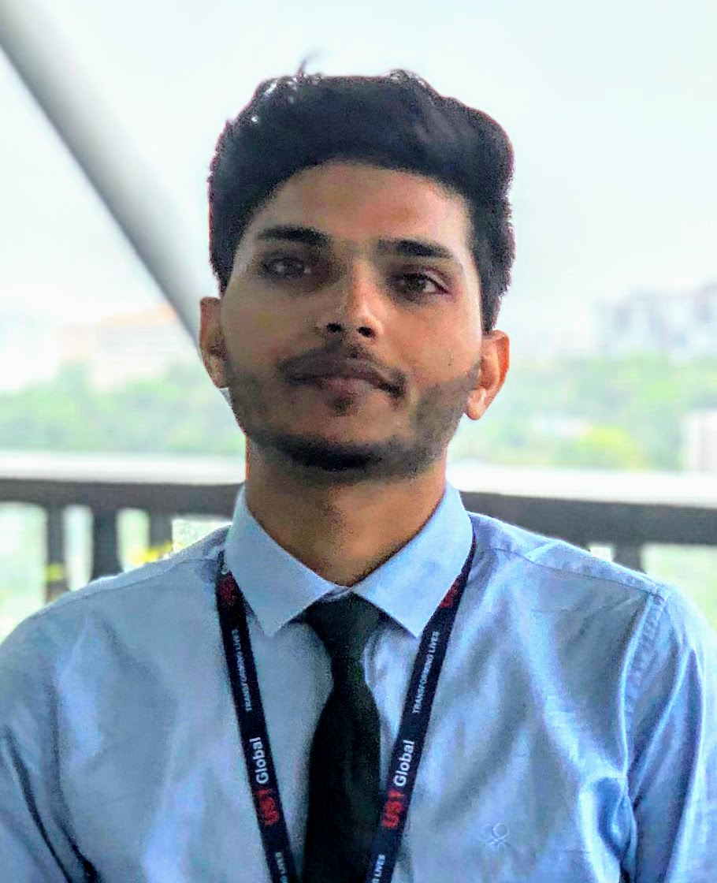  : 315, Tilang-B, IIT Palakkad, Kerala - 678623
Fourth year | E-Mail  Phone | : 111601017@smail.iitpkd.ac.in  : +91 7073091997
Computer Science and Engineering | Web | : Linkedin, Github, website
Indian Institute of Technology, Palakkad | DOB | : 27th November 1997

SUMMARY

- Skilled in AI and Robotics.
- Interned with UST Global, Researshala and IIT Madras.
- Former Head, Robotics club, IIT Palakkad
- Selected for KVPY fellowship.
- IIT-Jee 99.3 percentile.

EDUCATION

Program | Institution | %/CGPA | Year
B. Tech | Indian Institute of Technology, Palakkad | 7.19 (Till VI Semester) | 2016-Present
XII | Delhi Public School, Udaipur | 89% | 2015-16
X | Delhi Rajasthan Public School, Rajsamand | 96% | 2013-14

SCHOLASTIC ACHIEVEMENTS

- Winner, Kaizen Robotics Competition, Lema labs. 2017
- Awarded KVPY Fellowship by DST, Govt. of India. 2016
- Qualified IIT-Jee Advanced 2016 with a percentile of 99.3 amongst a total of 1.2 million students. 2016
- Best Student of Year Award 2014–15, Rajsamand District Private Education Committee. 2015
- Awarded Merit Scholarship Class X, Army Welfare Education Society. 2014

TECHNICAL SKILLS

Title | Skills
Robotics | Motion planning, perception, swarm robotics, control and manipulation, Manipulator kinematics and dynamics, brain computer interface
Reinforcment learning | MDP, TD methods, Monto Carlo, Multi-armed bandit, DQN, DDPG, Genetic algorithm
Data science | NLP, CNN, RNN, analysing unstructured data, sentiment analysis, topic modeling
Languages | C++ , Python and Java
Software/Tools | ROS, ROS2, Moveit, Gazebo, V-REP, Flexbe, Matlab, AutoCAD, Fusion 360, Atmel studio 6
Hardware | Rplidar A2M8, Realsense D435, Nvidia Jetson(Tx2, nano), Raspi3B+, GstarIV GPS, Zybo-zyng FPGA, KL25Z arm cortex-M0+ , Atmega16/32/2560, NodeMCU, GSM, Pyboard, OpenMV, PlutoX

SELECTED PROJECTS

- Implemention of slam on AGV by sensor fusion of data from 2D lidar and 3D camera.
- Vision based control and trajectory planning of robotics manipulator using pointcloud data.
- Path planning for swarm of two drones, for Smart India Hackerthon 2019.
- Built EOG based typing system for individual with motor neuron diseases.
- Built automated toilet cleaning robot, Ranked 6th in Inter IIT 2017-18, IIT Madras.
- Build model for satellite image classification using just 14 images, for Inter IIT 2018-19, IIT Bombay.
To know more about the projects, please visit: https://iamrajee.github.io/projects/

EXPERIENCES

- Summer intern, UST Global, Trivandrum May-July, 2019
Studied various slam algorithm and implemented it using ROS by fusing sensor data of lidar and 3d depth camera. Later, I worked on control and planning of robotics maniputor for vision based pick and place task.

- Data Science intern, Researchshala, Chandigarh May-July, 2018
Worked on projects related to transfer learning, topic modelling, web and pdf scraping, extrating and analysing useful information from unstructured data.

- Vistaar Program, IIT Madras May-June, 2017
Studied state of art 3d printing technology and then built prusa i3 3d printer and a robotic arm using this printer.

RELEVANT COURSES

Area | Courses
Maths | Linear algebra, Probability, Stochastic Process and Statistics, Discrete mathematics
CS | DS and Algorithms, DBMS, OS, Computer networks, Compilers, Parallel programming
AI | Principle of machine learning, Deep learning, Reinforcement learning
Robotics | Robotics manipulation and control, Embedded system, Signal and system, Engineering mechanics, AutoCAD, Fusion 360, Biomedical and Instrumentation

POSITION OF RESPONSIBILITY

- Head of Robotics Club, IIT Palakkad July 2018 - May 2019
  - Teach basics and advance concept of robotics.
  - Mentor student projects.
  - Encourage student to participate in regional and national competition.
  - Prepare and lead team in competitions.

- Event cordinator, Rajasthan-Assam, Ek Bharat Shreshtha Bharat, IIT Palakkad January 2019
  - Organised the cultural event of Ek Bharat Shreshtha Bharat of Rajasthan-Assam under goverment of India, at IIT Palakkad.

EXTRACURRICULAR ACTIVITIES

- Teaching at secondary school of Palakkad under NSS, IIT Palakkad

REFERENCES

• Mr. Ashok Nair  Director Service Delivery,  UST Global, Thiruvananthapuram  E-Mail: ashok.nair@ust-global.com | • Mr. Shubham Jain  Founder and CEO,  Researshala, Chandigarh  E-Mail: shubham@researchshala.com | • Dr. Piyush P. Kurur  Professor, Department of Computer Science and Engineering, IIT Palakkad  E-Mail: ppk@iitpkd.ac.in

