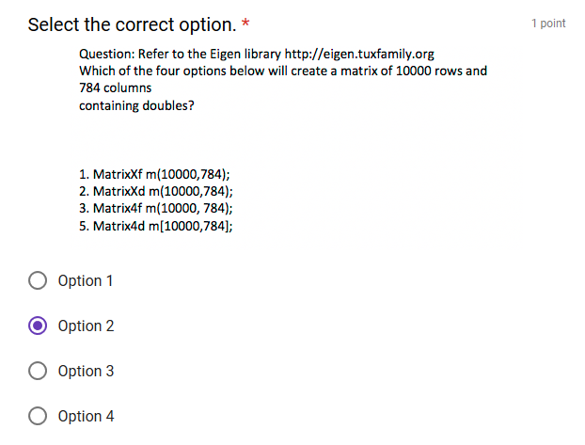

Search for “MatrixXd m(2,2);” in <http://eigen.tuxfamily.org/dox/group__TutorialMatrixClass.html>

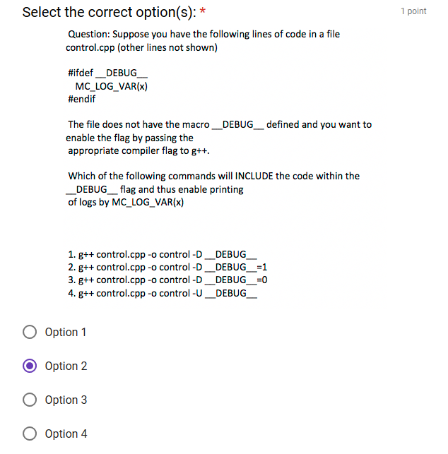

<https://www.tutorialspoint.com/compile_cpp_online.php>

#include <iostream>

#ifdef __DEBUG__

#define PI 3.14

#endif

using namespace std;

int main()

{

cout << "Hello World" << endl;

cout << PI <<endl;

return 0;

}

**Important:**

**g++ -o main *.cpp -D __DEBUG__=1**

go to Project 🡪 “compile time options” 🡪 Change compilation command to “g++ -o main *.cpp -D __DEBUG__=1”

g++ -o main *.cpp --std=c++11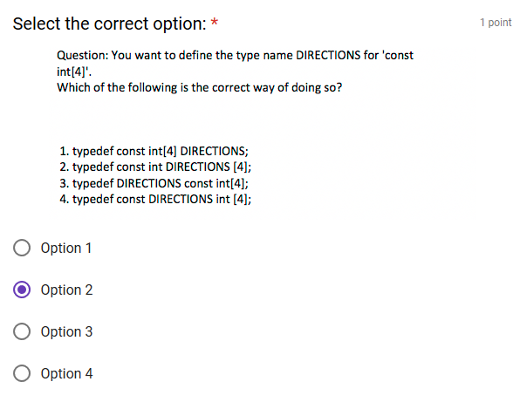

#include <iostream>

using namespace std;

int main()

{

**typedef const int TEST[5];**

TEST test1 = { 1, 2, 3, 4, 5 };

cout << test1[1] << endl;

}

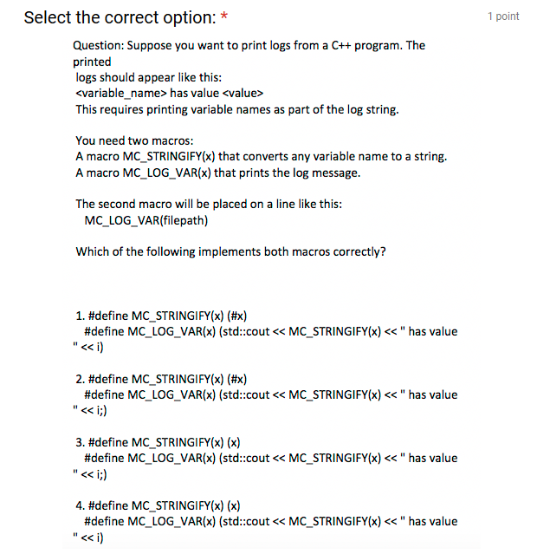

**Answer : 1**

**g++ -o main *.cpp --std=c++11**

#include <iostream>

#define MC_STRINGIFY(x) (#x)

#define MC_LOG_VAR(x) (std::cout<<MC_STRINGIFY(x)<<" has value "<<x)

using namespace std;

int main()

{

int i=4;

//cout<<MC_STRINGIFY(i);

MC_LOG_VAR(i);

}



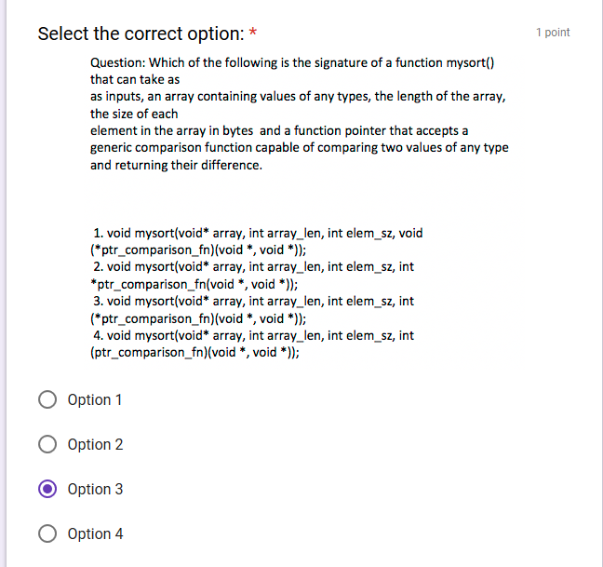



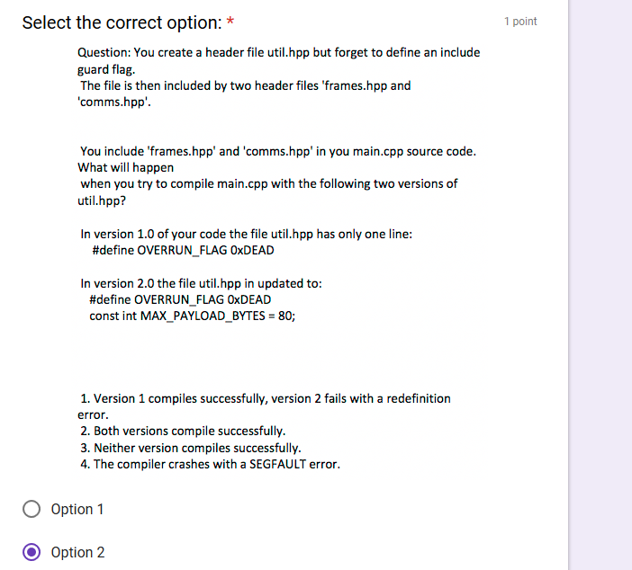

#include <iostream>

#define x 1

const int y=2;

using namespace std;

int main()

{

cout<<x<<endl;

cout<<y<<endl;

}

**$g++ -o main *.cpp**  
**$main**  
1

2