#### **DEPARTMENT OF INFORMATION SCIENCE & ENGINEERING**

#### **DBMS LABORATORY WITH MINI PROJECT**

#### **18CSL58**

#### **TIMETABLE MANAGEMENT SYSTEM**

#### **SYNOPSIS**

## **About Project**

A Database Management System project which uses a database to store all the various timetables of a college or university. It also provides a web interface for students and lecturers to use.

## **Team Details**

* Patel Kavan 1JS18IS063
* Rajiv Ranjan Singh 1JS18IS072

## **User Requirements**

* The college has many departments, each of which has many faculty members that take classes for various semesters. We keep a record of the timings of all classes taken by faculties of all semesters, in all departments.
* The database will store the timetables of all classes in all semesters of all departments, from which the timetables of all teachers and lab instructors can be extracted.
* Any teacher can view her free slots as well as that of any other faculty member. This can also be accessed by students.
* If the timetable of a faculty is changed or they have any other works or are absent, the database can be updated and the timetable of the respective teacher is reorganized.
* The faculty will have an option to show that they are not free at any particular time if they wish to do so.
* The database also keeps track of all vacant classes at any a particular time, so that it can be used by any other teacher if the need arises.

## **Entity Relationship Diagram**

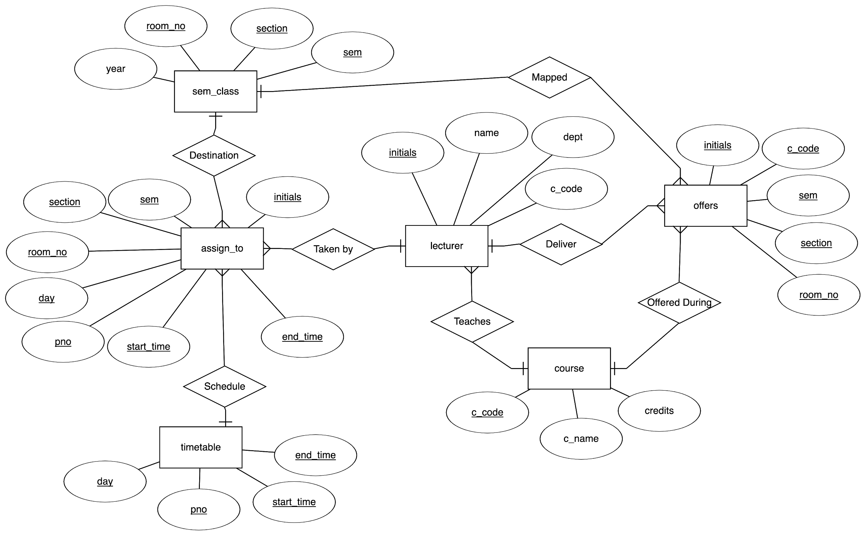

## **Relational Schema**

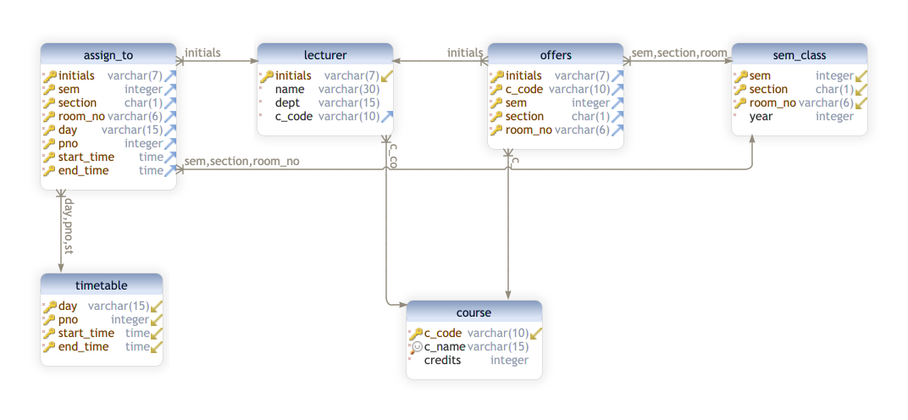

## **Details**

Number of Tables Created: 6

|  |  |  |  |
| --- | --- | --- | --- |
| **Table No.** | **Table Name** | **No. of Attributes** | **No. of Tuples Inserted** |
| 1 | ASSIGN_TO | 8 | 168 |
| 2 | COURSE | 3 | 7 |
| 3 | LECTURER | 4 | 26 |
| 4 | OFFERS | 5 | 40 |
| 5 | SEM_CLASS | 4 | 8 |
| 6 | TIMETABLE | 4 | 30 |

## **Technologies**

* Frontend: HTML, CSS & Bootstrap
* Backend: PHP
* Query Language: SQL
* RDBMS: PostgreSQL

## **Usage**

* Start PostgreSQL service using the command

brew services start postgresql

To stop the service use the command

brew services stop postgresql

* Make sure to set the DATABASE_NAME, DATABASE_PASS and DATABASE_USER parameters in the pg_connect function in the request.php file.
* Open PostgreSQL terminal using the command

psql postgres

Create a new database using the command

CREATE DATABASE {DATABASE_NAME};

* Load the demo.sql file into PostgreSQL using the command

psql -U {DATABASE_USER} {DATABASE_NAME} < demo.sql

* Run PHP server inside src folder which has index.php file using the command

php -S localhost:3000