

**Tribhuvan University**

**Faculty of Humanities and Social Science**

**Title** of Project Report

College InfoStream

Submitted to

Department of Computer Application

Birendra Multiple Campus, Bharatpur, Chitwan

In partial fulfillment of the requirements for Bachelor in Computer Application

Submitted By

Rajan Chaudhary and Prajwal Lamichhane

Under The Supervision of

[**Sobaraj Paudel**](https://www.facebook.com/groups/301789927983061/user/100001020453218/?__cft__%5b0%5d=AZWZfghdZkIZM6_hWO3kLsSMsF0RP6wOtRE1IvQE-EVi8NHxqUgiaY6nH7OvdpuQoypQDe5BgLiJmm3OYZGB6pHewjK97fkwvMMEtTiGL8n5Hxs0YdXb2w3iqwhRrOxJRdvOYXsJevNMggXY4qcX8dW79f1p-7-9yevn8bMd3lXfpAWaWW1UyAAspp-RhFg20yo&__tn__=-UC%2CP-R)

(A typical specimen of certificate)

Contents

Introduction…………………………………………………………1

Problem Statement…………………………………………………1

Objectives……………………………………………………………1

Methodology…………………………………………………………2

A. Requirement Identification…………………………………………3

i. Study of Existing System………………………………………………3

ii. Requirement Analysis………………………………………………….3

B. Feasibility Study………………………………………………..4

i. Technical…………………………………………………………….4

ii. Operational…………………………………………………………4

iii. Economic…………………………………………………………..4

C . High Level Design Of System……………………………………….5

i. Flow Chart…………………………………………………………5

ii. ER Diagram……………………………………………………….5

iii. Grantt Chart………………………………………………………..5

Expected Outcomes………………………………………………..6

References………………………………………………………….6

Introduction

College InfoStream is an essential tool for managing the flow of information within an educational institution. It provides an efficient and effective means of disseminating important updates, announcements, and notices to student, faculty, and staff members. The traditional-paper based notice boards and bulletin boards have become increasingly absolete in today’s digital age, and a digital solution is required to streamline the process of managing notices. The college InfoStream is a web-based application that automates the entire process of creating, publishing, and managing notices,notes,assignments and other related documents making it easier for users to stay informed and up-to-date on important college news and events. In this project proposal , we aim to develop A College Notice Management System that is user-friendly, robust, and highly functional to meet the needs of educational institutions.

Problem Statement

1.Inefficient management of paper-based notice boards and bulletin boards.

2.Time-consuming process of manually creating and posting notices.

3.Difficulty in tracking and updating notices posted on bulletin boards.

4.Inconsistent formatting and design of notices.

5.Inability to reach out to students, faculty, and staff members who are not physically present on campus.

Objectives

1.To create a user-friendly web-based application for managing college notices.

2.To automate the process of creating, publishing, and managing notices.

3.To improve the efficiency and effectiveness of the notice management process.

4.To reduce paper waste and contribute to the college's sustainability goals.

Methodology

We are going to use waterfall methodology while building this project. This project has specific documentation, ample time, fixed requirements, well-understood technology so in order to build this system, waterfall methodology can be a proper choice.

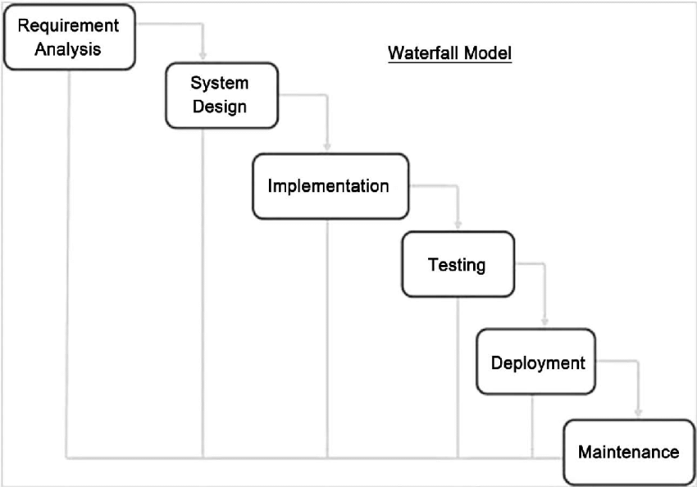

The waterfall model is very simple to understand and use. In waterfall model each phase must be completed before the next phase can begin and there is no overlapping between the phases. It is easy to arrange task and clearly defined stages.so waterfall model will be better approach for this project.

A .Requirement Identification

i . Study of Existing System

Before developing a College Notice Management System, it is important to study the existing system and identify its strengths and weaknesses. The first step in the study of the existing system is to conduct a survey of students, faculty, and staff members to gather their feedback and opinions on the current notice management system. The study of the existing system will also involve an analysis of the technology used to manage notices.

In conclusion, the study of the existing system is a critical component of the development of a College Notice Management System. It provides valuable insights into the areas that require improvement and helps in identifying the requirements for the new system.

ii. Requirement Analysis

1 . User Management: The system should have a user management module that allows administrators to manage user accounts, create new accounts, and set user permissions.

. only admin has permission to add notice to system

. only authenticated user has access to system

. Authentic user can send feedback to system

. Students can submit their assignments through system

2 .Notice Creation and Publication: The system should have a module that allows users to create and publish notices easily. The module should have features such as the ability to add images, videos, and attachments to notices, as well as the ability to schedule notices for future publication.

3 .Notification System: The system should have a notification system that sends alerts to users when new notices are posted or when existing notices are updated.

4. Search and Filtering: The system should have a search and filtering feature that allows users to search for notices based on specific criteria such as date, category, or keywords.

5. Security: The system should be designed with security features such as secure logins, data encryption, and user authentication to protect sensitive information.

6.Scalability: The system should be designed to be scalable to accommodate future growth and expansion.

7 .Integration: The system should be able to integrate with other systems used by the college, such as the college's website or student information system.

B. Feasibility Study

i. Technical

->Assess the availability of technology resources such as hardware, software, and IT personnel to support the development and maintenance of the system.

->Determine the technical requirements for the system such as programming languages, frameworks, and databases.

ii. Operational

Determine the extent of training required for users and administrators to effectively use the system.

iii. Economic

->Determine the budget required for development, implementation, and maintenance of the system.

->Conduct a cost-benefit analysis to determine the economic viability of the project.

Tools Used:

Front end:

HTML

CSS

JAVASCRIPT

Backend:

PHP

SQL

Python

Other tools

Code Editor

Database

XAMPP Server

C . High level Design of System

i. Flow Chart

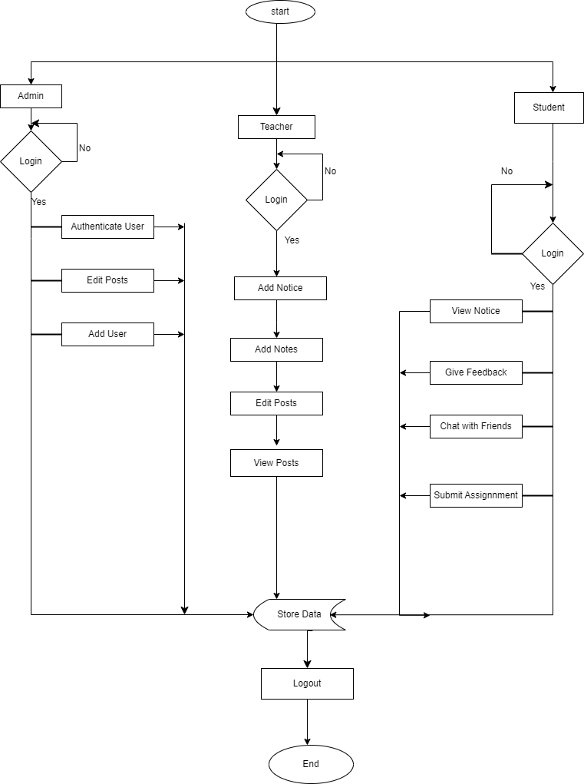

iii. Grantt Chart

|  |  |  |  |  |  |  |  |  |  |  |  |  |
| --- | --- | --- | --- | --- | --- | --- | --- | --- | --- | --- | --- | --- |
| Topics | weeks | | | | | | | | | | | |
| 1w | 2w | 3w | 4w | 5w | 6w | 7w | 8w | 9w | 10w | 11w | 12w |
| Planning |  |  |  |  |  |  |  |  |  |  |  |  |
| Analysis |  |  |  |  |  |  |  |  |  |  |  |  |
| Design |  |  |  |  |  |  |  |  |  |  |  |  |
| Coding |  |  |  |  |  |  |  |  |  |  |  |  |
| Testing |  |  |  |  |  |  |  |  |  |  |  |  |
| Maintenance |  |  |  |  |  |  |  |  |  |  |  |  |
| Documentation |  |  |  |  |  |  |  |  |  |  |  |  |

Expected Outcome

When the project is completed user will be able to register into application . Admin will have permission to authenticate registered user and staff. Teachers can upload their notes, files and notices. Student can view and download notes and also can give feedback to particular post. Students will be able to submit their assingments and projects. , the notice management system will encourage greater engagement from students and faculty members, who will have access to a wider range of information and opportunities to participate in college events and activities.

References

1. S. S. Patil and S. B. Patil, "Web Based College Notice Management System," International Journal of Innovative Research in Computer and Communication Engineering, vol. 4, no. 4, pp. 4167-4172, 2016.
2. N. K. Nande, R. P. Wadhai, and A. S. Khandare, "Online Notice Board System for Educational Institutes," International Journal of Engineering Research and Technology, vol. 3, no. 10, pp. 1067-1071, 2014.
3. R. K. Sharma, A. Kumar, and D. V. Singh, "Design and Development of Web-based College Notice Board System," International Journal of Computer Applications, vol. 72, no. 17, pp. 6-11, 2013.
4. V. Kumar and A. Kumar, "A Study of Online Notice Board System for Educational Institutes," International Journal of Advanced Research in Computer Science and Software Engineering, vol. 3, no. 9, pp. 568-572, 2013.
5. A. K. Gautam and D. K. Mishra, "Online Notice Board Management System for Educational Institutions," International Journal of Advanced Research in Computer Science, vol. 7, no. 4, pp. 266-270, 2016.