CheatSheet: https://kubernetes.io/docs/reference/kubectl/quick-reference/
https://www.k8s.guide/resources/kubectl-cheatsheet/

1.) Introduction to Kubernetes
1. What is Kubernetes?
Kubernetes (K8s) is an open-source container orchestration platform used to deploy, manage, scale, and maintain containerized applications.
Docker → Container Platform
Kubernetes → Container Orchestration Platform
Kubernetes becomes especially useful when we have many containers/microservices that need to be managed automatically.

2. Why do we need Kubernetes?
Docker is excellent for running containers, but it has limitations when applications become large.
Problem with Docker
Problem | Docker | Kubernetes
Multiple hosts | ❌ Limited | ✅ Cluster
Auto-healing | ❌ | ✅
Auto-scaling | ❌ Built-in | ✅
Load balancing | Limited | ✅
Enterprise support | Limited | ✅
Large-scale applications | Difficult | ✅

3. Problem #1 — Single Host
Suppose:
Server
|
Docker
|
├── Container 1
├── Container 2
└── Container 3
If the server goes down, all containers running on that server are affected.
Kubernetes uses a cluster containing multiple nodes:
Kubernetes Cluster
|
┌───────────----------------------┼────--------------------------───────┐
↓ ↓ ↓
Node 1 Node 2 Node 3
| | |
Containers Containers Containers

4. Problem #2 — No Auto-Healing
Auto-Healing means Kubernetes automatically detects failed or unhealthy containers/Pods and takes corrective action.
Containers are ephemeral, meaning they are designed to be replaceable and can disappear/fail.
Ephemeral: Ephemeral means temporary or short-lived.
In Kubernetes, containers and Pods are considered ephemeral because they can be created, destroyed, and replaced at any time.
Without Kubernetes:
Container crashes
↓
Manual intervention
↓
Restart container
With Kubernetes:
Container/Pod fails
↓
Kubernetes detects failure
↓
Creates/restarts replacement
↓
Application continues running
This is called self-healing / auto-healing.

5. Problem #3 — No Auto-Scaling
Imagine your application normally needs: 3 containers
But traffic suddenly increases: 100 users → 10,000 users
You may need more application instances.
Kubernetes can automatically scale workloads based on demand using mechanisms such as Horizontal Pod Autoscaling (HPA).
Low traffic
↓
3 Pods

High traffic
↓
10 Pods
NOTE: When traffic decreases, the number of Pods can also be reduced.

6. Problem #4 — Enterprise Requirements
Production applications require more than simply running containers.
Examples:
- Load balancing
- Networking
- Security
- API gateways
- IP filtering
- High availability
- Scaling
- Service discovery
Kubernetes provides a platform that can integrate with additional tools and components to support these production requirements.

7. Docker vs Kubernetes
Docker
Docker mainly helps us:
Build → Package → Run → Manage Containers
Kubernetes
Kubernetes helps us:
- Deploy
- Manage
- Scale
- Network
- Monitor
- Recover
- Update
multiple containerized applications across a cluster.
Simple interview answer:
Docker is a container platform, whereas Kubernetes is a container orchestration platform used to manage containers at scale.

8. Kubernetes Cluster
A cluster is a group of machines/nodes managed together by Kubernetes.
Yes, Kubernetes traditionally follows a Master–Worker architecture, but the modern terminology is Control Plane–Worker Node architecture.
Kubernetes Cluster
|
┌──────────------------------───┴─────────---------------------────┐
↓ ↓
Control Plane Worker Nodes
|
┌─────────┼─────────┐
↓ ↓ ↓
Pod Pod Pod
Control Plane (Master)
The Control Plane manages the Kubernetes cluster.
Main components:
- API Server → communication with Kubernetes
- Scheduler → decides which Worker Node runs a Pod
- Controller Manager → maintains desired state / auto-healing
- etcd → stores cluster state and configuration
Worker Node
Worker nodes run the actual applications.
Main components:
- kubelet → communicates with Control Plane
- Container Runtime → runs containers
- kube-proxy → handles networking

9. Pods
Kubernetes generally works with Pods, rather than directly managing individual containers.
Pod
|
└── Container
A Pod is the smallest deployable unit in Kubernetes.
You will learn Pods in detail in later lessons.

10. Kubernetes and CNCF
Kubernetes originated from Google's experience with large-scale container management systems and is now developed as a major Cloud Native Computing Foundation (CNCF) project.
The Kubernetes ecosystem can also be extended using concepts such as:
- Custom Resources
- Custom Resource Definitions (CRDs)
- Controllers
- Ingress Controllers
This allows Kubernetes to work with additional tools and capabilities.

SUMMARY:
1. Docker = Container Platform
2. Kubernetes = Container Orchestration Platform
3. Kubernetes works as a Cluster
4. Kubernetes provides Auto-Healing and Auto-Scaling
5. Kubernetes is designed for managing
containerized applications at scale
Kubernetes solves the problems of managing containers at scale by providing clustering, self-healing, scaling, networking, and production-oriented orchestration capabilities.

2.) KUBERNETES ARCHITECTURE
1. Why Kubernetes Architecture?
Docker can run containers, but managing many containers across multiple machines becomes difficult.
Kubernetes provides:
- Cluster management
- Auto-healing
- Auto-scaling
- Load balancing
- Networking
- Security
- High availability

2. Kubernetes Architecture
Kubernetes has two major parts:
Kubernetes Cluster
|
┌───────--------------------------------───┴───────--------------------------------───┐
↓ ↓
CONTROL PLANE DATA PLANE
(Master) (Workers)
| |
Manages cluster Runs Pods
Simple rule:
Control Plane = Brain 🧠
Data Plane = Hands 🖐️
The Control Plane decides what should happen, while Worker Nodes actually run the workloads.

3. Control Plane
The Control Plane contains:

Control Plane
│
├── API Server
├── etcd
├── Scheduler
├── Controller Manager
└── Cloud Controller Manager
🔹 API Server
The API Server is the main entry point to Kubernetes.
For example:
kubectl create deployment nginx --image=nginx
Flow:
kubectl
↓
API Server
↓
Kubernetes
Almost all communication with the cluster goes through the API Server.
API Server = Gateway/Entry point
🔹 etcd
etcd is Kubernetes' key-value data store.
It stores information about the cluster, such as:
- Cluster state
- Nodes
- Pods
- Deployments
- Configuration
Kubernetes
|
etcd
|
Cluster State
etcd = Database/Storage of cluster state
🔹 Scheduler
The Scheduler decides which Worker Node should run a Pod.
Example:
New Pod
↓
Scheduler
↓
Which node?
↓
Worker Node 2
It considers available resources and scheduling constraints.
Scheduler = Decides where the Pod runs
🔹 Controller Manager
Controllers continuously compare:
Desired State
vs
Actual State
Example:
Desired = 3 Pods
Actual = 2 Pods
↓
Controller
↓
Creates another Pod
↓
Actual = 3 Pods ✅
This contributes to Kubernetes' self-healing/reconciliation behavior.
Controller Manager = Maintains desired state

🔹 Cloud Controller Manager
Used when Kubernetes works with cloud platforms.
It allows Kubernetes to interact with cloud resources such as:
- Load balancers
- Cloud networking
- Cloud storage
- Cloud infrastructure
CCM = Connects Kubernetes with cloud-provider APIs

4. Data Plane / Worker Node
The Data Plane contains the machines that actually run your application.
Each Worker Node generally has:
Worker Node
│
├── kubelet
├── kube-proxy
└── Container Runtime
↓
Pods
🔹 kubelet
kubelet is an agent running on each Worker Node.
Its job is to make sure the Pods assigned to that node are running correctly.
Control Plane
↓
kubelet
↓
Pod
↓
Container
kubelet = Worker Node agent

🔹 Container Runtime
The Container Runtime is responsible for actually running containers.
Examples:
- containerd
- CRI-O
Pod
↓
Container
↓
Container Runtime
↓
Running Application
Container Runtime = Runs containers
🔹 kube-proxy
kube-proxy provides networking functionality on Worker Nodes and helps direct traffic to the appropriate Pods.
kube-proxy = Networking

5. Docker vs Kubernetes
Docker
Docker
↓
Container
The basic unit is a Container.
Kubernetes
Kubernetes
↓
Pod
↓
Container
The basic deployable unit is a Pod.
So:
Docker → Container
Kubernetes → Pod → Container

6. Example: Deploying an Application
Suppose you want to deploy an Nginx application.
User
↓
kubectl
↓
API Server
↓
Scheduler
↓
Worker Node
↓
kubelet
↓
Pod
↓
Container Runtime
↓
Nginx Container
Meanwhile:
etcd
↓
Stores cluster state

Controller Manager
↓
Continuously checks desired state

kube-proxy
↓
Handles networking

7. Complete Architecture
Kubernetes Cluster
│
┌───────────---------------------------------───┴─-----------------------─────────────┐
│ │
CONTROL PLANE DATA PLANE
(Master) (Worker Nodes)
│ │
┌────-------──┼─────--------─┐ ┌─-----───--──┼──------────┐
│ │ │ │ │ │
API Scheduler etcd kubelet kubeproxy Runtime
Server
│
Controller
Manager
│
Cloud Controller
Manager

⭐ Important Revision Table
Component | Simple Explanation
API Server | 🚪 Entry point; receives requests from kubectl and other components.
etcd | 🗄️ Stores Kubernetes cluster state and configuration.
Scheduler | 📍 Decides which Worker Node should run a Pod.
Controller Manager | 🔄 Ensures actual state = desired state.
Cloud Controller Manager | ☁️ Connects Kubernetes with cloud provider resources.
kubelet | 👷 Agent on Worker Node that manages Pods.
kube-proxy | 🌐 Handles networking and Service traffic.
Container Runtime | ▶️ Actually runs containers (containerd, CRI-O).
Pod | 📦 Smallest Kubernetes deployable unit; contains one or more containers.

🧠 Remember This
API Server → Communication
etcd → Store
Scheduler → Decide
Controller → Maintain
kubelet → Manage Pods
kube-proxy → Network
Runtime → Run Containers

And the most important concept:
Control Plane manages the cluster; Data Plane runs the applications.

3.) How to Manage Hundreds of Kubernetes clusters ??? | KOPS
1. Why Production Kubernetes?
When learning Kubernetes, we commonly use:
- Minikube
- K3s
- Docker Desktop Kubernetes
These are mainly useful for learning/development/testing.
In production, organizations need to manage:
- Cluster creation
- Cluster configuration
- Upgrades
- Scaling
- Security
- Networking
- Storage
- Monitoring
- Cluster deletion
- Multiple clusters
So a DevOps engineer needs tools that can manage the entire Kubernetes cluster lifecycle.

2. Local Kubernetes vs Production Kubernetes
Local | Production
Minikube | EKS / GKE / AKS / KOPS / OpenShift etc.
Usually single node | Multiple nodes
Small resources | Large resources
Development | Production
Easy setup | Highly configurable
Limited HA | High Availability
Local machine | Cloud / Data Center
Important: Minikube is NOT a replacement for a production Kubernetes cluster.
Minikube is excellent for learning Kubernetes concepts, but production environments require much more infrastructure.

3. What is a Kubernetes Distribution?
A Kubernetes distribution is Kubernetes packaged with additional components, configuration, tooling, support, and integrations.
Examples:
- Amazon EKS
- Google GKE
- Azure AKS
- Red Hat OpenShift
- KOPS
- Rancher
- Tanzu
For example:
Kubernetes
|
+-----------------------------------------+------------------------------------------+
| | |
EKS GKE AKS
| | |
AWS Google Azure
Managed distributions provide cloud-specific integrations and operational support.

4. Kubernetes vs EKS
Kubernetes
You can manually install Kubernetes on AWS EC2 instances.
Example:
AWS EC2
|
+-- Kubernetes Control Plane
|
+-- Worker Nodes
But you are responsible for managing the Kubernetes infrastructure.
EKS
Amazon provides a managed Kubernetes service.
AWS
|
+-- EKS
|
+-- Kubernetes Control Plane
|
+-- Worker Nodes
The cloud provider handles significant portions of the control-plane management.
Interview point: Kubernetes is the open-source orchestration platform; EKS is AWS's managed Kubernetes service.

5. Why Do We Need Tools Like KOPS?
Imagine an organization has:
Cluster 1
Cluster 2
Cluster 3
...
Cluster 100
Creating and maintaining every cluster manually would be extremely difficult.
Instead, use automation.

KOPS
|
+---------------------------------------------------------+--------------------------------------------------------+
| | |
Cluster1 Cluster2 Cluster3
| | |
Workers Workers Workers
KOPS automates many cluster lifecycle operations.

6. What is KOPS?
KOPS = Kubernetes Operations
KOPS is a tool used to create and manage Kubernetes clusters, particularly on AWS.
It helps with:
- Cluster creation
- Configuration
- Updates
- Upgrades
- Cluster lifecycle management
- Cluster deletion

7. KOPS vs Manual Kubernetes Installation
Without KOPS
You may have to manually configure:
EC2
↓
Networking
↓
Control Plane
↓
etcd
↓
Worker Nodes
↓
Certificates
↓
Networking
↓
Storage
↓
Kubernetes
This becomes difficult when the number of clusters increases.
With KOPS
KOPS
|
+--> Infrastructure
+--> Kubernetes
+--> Configuration
+--> Networking
+--> Cluster lifecycle
Automation reduces repetitive manual work.

8. Other Kubernetes Management Options
The video mentions several alternatives:
1. EKS
AWS managed Kubernetes.
2. GKE
Google Cloud managed Kubernetes.
3. AKS
Azure managed Kubernetes.
4. OpenShift
Red Hat's Kubernetes platform.
5. Rancher
Kubernetes management platform.
6. Tanzu
VMware's Kubernetes platform.
7. KOPS
Kubernetes cluster lifecycle management tool, particularly associated with AWS.

9. KOPS Architecture — Simple View
A useful mental model:
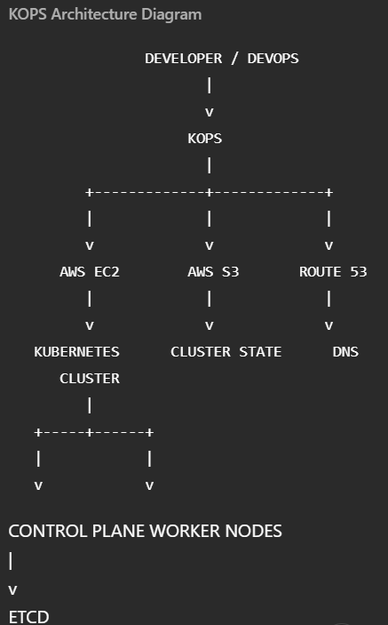
Important AWS services involved
- EC2 → compute
- EBS → persistent storage
- S3 → KOPS cluster configuration/state
- Route 53 → DNS

10. Why S3 is Important in KOPS
KOPS uses an S3 bucket to store cluster configuration/state.
Conceptually:
KOPS
|
v
S3
|
Cluster configuration
Cluster state
Configuration data
Example: s3://my-kops-bucket
The bucket name needs to be unique within AWS.

11. AWS CLI Prerequisites
Before using KOPS with AWS, you need AWS CLI configured.
Conceptually:
AWS CLI
|
+-- Access Key
+-- Secret Access Key
+-- Region
Configuration is commonly done using: aws configure
You provide:
AWS Access Key ID
AWS Secret Access Key
Default Region
Output Format

Security note
For real production environments, avoid using an AWS root account or long-lived credentials unnecessarily. Prefer IAM roles and least-privilege permissions.

12. KOPS Prerequisites
Python 3
AWS CLI
kubectl
KOPS
Conceptually:
Python
↓
AWS CLI
↓
AWS authentication
↓
KOPS
↓
Kubernetes cluster
↓
Kubectl
kubectl is used to interact with the Kubernetes cluster after it is available.

https://github.com/iam-veeramalla/Kubernetes-Zero-to-Hero/tree/main

4.) KUBERNETES PODS | DEPLOY YOUR FIRST APP
1. What is a Pod?
A Pod is the smallest deployable unit in Kubernetes.
Kubernetes does not directly manage containers. Instead:
Kubernetes
↓
Pod
↓
Container
A Pod provides the environment in which one or more containers run.
Most Pods contain one container, but a Pod can contain multiple tightly coupled containers.
- Simple definition: Pod = A wrapper around one or more containers that share networking and certain resources.

2. Container vs Pod
Docker
With Docker, you generally run:
Docker
↓
Container
↓
Application
Example: docker run nginx
Kubernetes
With Kubernetes:
Kubernetes
↓
Pod
↓
Container
↓
Application
You don't normally tell Kubernetes:
"Run this container."
Instead, you define a Pod that describes how the container should run.

3. Why does Kubernetes use Pods?
Pods provide a higher-level abstraction around containers.
A Pod can provide:
- Shared network
- Shared IP address
- Shared storage volumes
- Shared lifecycle
- Resource configuration
- Container coordination
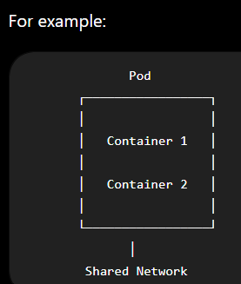
NOTE: Containers inside the same Pod can communicate with each other using localhost.

4. Single-container Pod
The most common case:
Pod
|
└── NGINX Container

Example:
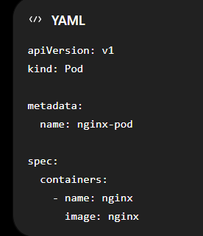
This creates:
nginx-pod
|
└── nginx container

5. Multi-container Pod
A Pod can also contain multiple containers.
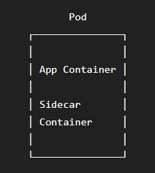
These containers:
- Share the same network namespace
- Can communicate through localhost
- Can share volumes
- Have the same Pod lifecycle

Example use case
Pod
├── Application
└── Logging Sidecar
The application generates logs and the sidecar processes/ships them.

6. Important Kubernetes Hierarchy
Remember this:
Cluster
↓
Node
↓
Pod
↓
Container
↓
Application
Example:
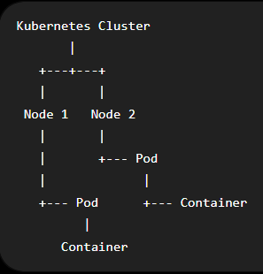
This hierarchy is extremely important for Kubernetes interviews.

7. What is kubectl?
kubectl is the command-line tool used to communicate with and manage a Kubernetes cluster.
Think of it as:
You
|
kubectl
|
Kubernetes API Server
|
Kubernetes Cluster
Examples:
- kubectl get pods
- kubectl create pod
- kubectl describe pod
- kubectl logs
- kubectl delete pod

8. kubectl get pods
To see Pods:
kubectl get pods
OR
Kubectl get pod
Example output:
NAME READY STATUS RESTARTS AGE
nginx-pod 1/1 Running 0 2m

Meaning
Column | Meaning
NAME | Pod name
READY | Ready containers / total containers
STATUS | Current Pod state
RESTARTS | Container restart count
AGE | Pod age

For: 1/1
it means: 1 container is ready out of 1 container.

9. What is Minikube?
Minikube is used to run a Kubernetes cluster locally.
Conceptually:
Your Laptop
|
Minikube
|
Kubernetes Cluster
|
Node(s)
|
Pods
It is useful for:
- Learning Kubernetes
- Development
- Testing
- Experimentation
It is not equivalent to a full production Kubernetes environment.

- Start Docker Engine
- minikube start
- kubectl get nodes

- Go to https://kubernetes.io/docs/concepts/workloads/pods/ copy the .yaml file Go to D drive Cloud_computing/Kubernetes folder In cmd write “notepad pod.yaml” to create .yaml file Paste pods/simple-pod.yaml into it Save
- In docker we can write “docker run -d nginx:1.14.2 ---name nginx -p 80:80” equivalent to pods/simple-pod.yaml file
- kubectl create -f pod.yaml: This will creates the pod. We can also use “kubectl apply -f pod.yaml”
- kubectl get pods: This will verify the pod is created or not
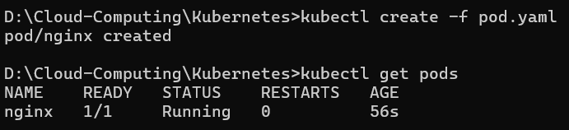
- kubectl get pods -o wide:
- Login to the cluster using “minikube ssh”
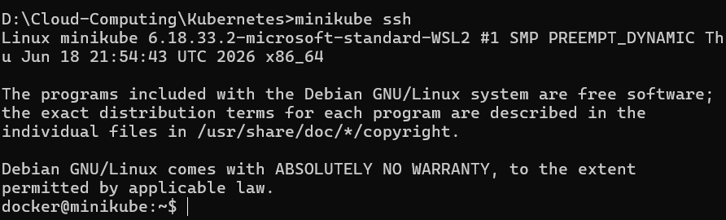
- curl <IP_address>:
ex: curl 10.244.0.8
- In this we can see the index.html file of nginx
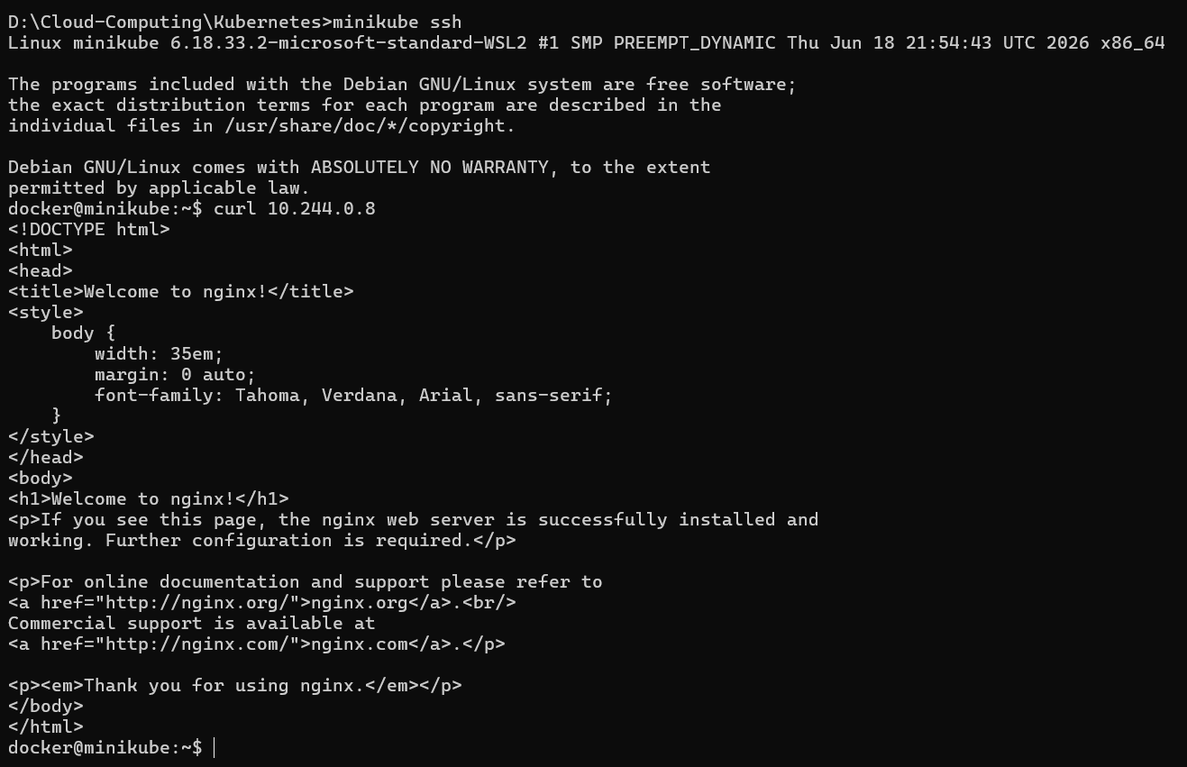
- exit: To exit from minikube ssh
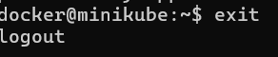
- kubectl delete pod “pod_name”
ex: kubectl delete pod nginx
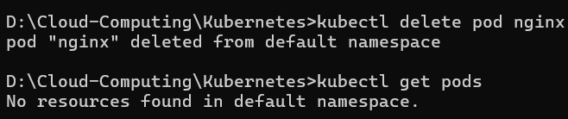
- In pod.yaml, we can also add volumes, volumeMounts, etc…
- kubectl logs <pod_name>: Shows the logs generated by the <pod_name> Pod.
ex: kubectl logs nginx
- If kubectl logs nginx returns nothing, that's normal for some images/apps that haven't written anything to stdout/stderr.
- kubectl describe pod <pod_name>:
- Used to get detailed information about a Pod.
kubectl → Kubernetes CLI
describe → Shows detailed information
pod → Resource type
<pod_name> → Name of the Pod
- Shows detailed information and events of a Pod, mainly useful for troubleshooting.
NOTE: Pod is running specification on Docker Container

Q.) How do we debug pods/application in Kubernetes
Answer: Use commands like “kubectl describe pod <pod_name” and “kubectl logs <pod_name>

5.) Kubernetes Deployment
Q.) How to add autoscaling and autoscaling in Kubernetes
Solution: We use Deployment for this
Deployment
|
↓
ReplicaSet
(Controller)
|
↓
Pods
|
↓
Containers

In Kubernetes, Container → Pod → Deployment is a useful way to understand the hierarchy:
1. Container
A container is where your application actually runs.
- Contains your application + dependencies.
- Usually created using Docker/Containerd.
- Kubernetes does not directly manage containers; it manages Pods.
Example:
Container
└── Django Application
├── Python
├── Django
└── Dependencies
2. Pod
A Pod is the smallest deployable unit in Kubernetes.
- A Pod contains one or more containers.
- Containers inside the same Pod share:
  - Network
  - IP address
  - Storage volumes
- Usually, 1 Pod = 1 main application container.
Example:
Pod
└── Container
└── Django App
A Pod can also have multiple containers:

Pod
├── Django Container
└── Sidecar Container
3. Deployment
A Deployment manages Pods.
Deployment is used for auto-scaling and auto-healing
It is used when you want Kubernetes to:
- Create Pods
- Maintain a desired number of replicas
- Restart/replace failed Pods
- Perform rolling updates
- Roll back versions
Example:
Deployment
│
├── Pod 1
│ └── Django Container
│
├── Pod 2
│ └── Django Container
│
└── Pod 3
└── Django Container

Feature | Container | Pod | Deployment
What is it? | Runs application | Runs container(s) | Manages Pods
Level | Application runtime | Kubernetes unit | Kubernetes controller
Contains | App + dependencies | 1+ containers | Multiple Pods
Scaling | ❌ | Manually possible | ✅
Self-healing | ❌ | ❌ | ✅
Rolling update | ❌ | ❌ | ✅
Example | Django container | Django Pod | 3 Django Pods
Easy to remember:
Deployment
↓ manages
Pods
↓ contains
Containers
↓ runs
Application
In one line:
Container runs your application, Pod provides the environment for containers, and Deployment manages and scales Pods.

- kubectl get all
- kubectl get all -A

Q.) Commands to Deploy pods
Sol:
- Delete existing nginx pod
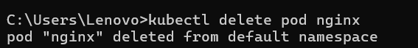
- Create nginx pod again
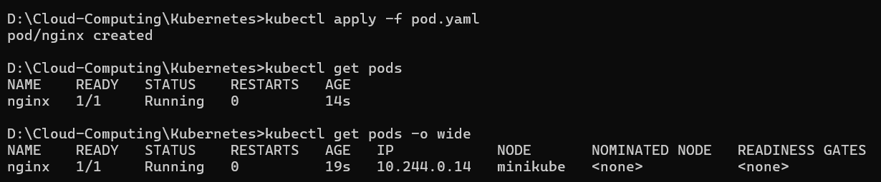
- Login to Kubernetes cluster
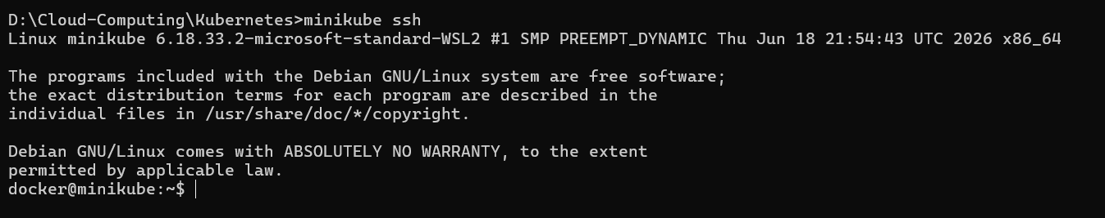
- Create “deployment.yaml” file using (“notepad "deployment.yaml") Search Kubernetes deployments Go to https://kubernetes.io/docs/concepts/workloads/controllers/deployment/ Copy the content of controllers/nginx-deployment.yaml and paste in deployment.yaml
crtl + S In CMD run “kubectl apply -f deployment.yaml” In the we will see the pod is created automatically
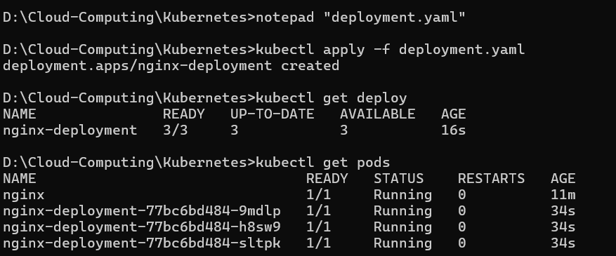
In this Deployment creates Replica-set This Replica-set creates pod
- kubectl get rs
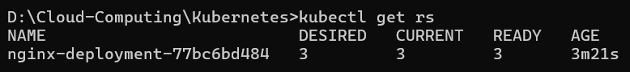
Q.) Use of Replica set in deployment
Answer: A ReplicaSet's main purpose is to maintain the desired number of Pods created by a Deployment.
Example
Suppose your Deployment specifies:
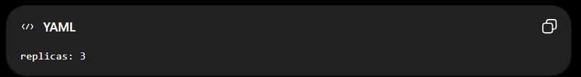The Deployment creates a ReplicaSet, and the ReplicaSet ensures that 3 Pods are always running:
Deployment
↓
ReplicaSet
↓
┌──────┼──────┐
↓ ↓ ↓
Pod 1 Pod 2 Pod 3

Q.) What if pod is deleted?
Answer:
If a Pod is deleted, what happens depends on who created/managed the Pod.
If Pod is managed by a Deployment
Suppose:
Deployment
↓
ReplicaSet
↓
Pod 1
Pod 2
Pod 3
You have:
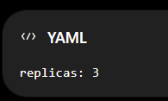
Now you delete Pod 2:
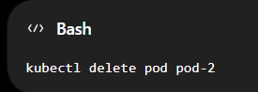
The ReplicaSet detects:
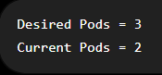
So it automatically creates a new Pod:
Deployment
↓
ReplicaSet
↓
Pod 1
Pod 3
Pod 4 ← new Pod
The new Pod will usually have a different name and IP address.
Important: The ReplicaSet does NOT recover the same Pod. It creates a new Pod to maintain the desired replica count.

Q.) What if pod is created manually and deleted?
Asnwer: If you create a Pod manually and then delete it, Kubernetes will NOT recreate it.
NOTE: This is the major advantage of deployment over manual pod creation.
NOTE: In real world we never create pod manually. We create pods using deployments.

6.) EVERYTHING ABOUT KUBERNETES SERVICES | DISCOVERY | LOAD BALANCING | NETWORKING
1. Why Do We Need Kubernetes Services?
NOTE: Ideal pod number is depends on requirement
Before understanding Services, understand the problem with directly accessing Pods.
Suppose we have a Deployment:
Deployment
|
└── ReplicaSet
|
├── Pod-1 → 10.244.1.10
├── Pod-2 → 10.244.1.11
└── Pod-3 → 10.244.1.12
Each Pod gets its own IP address.
But Pods are ephemeral. (IMPORTANT)
If Pod-1 crashes:
Pod-1 → 10.244.1.10 ❌
Kubernetes creates a replacement:
New Pod → 10.244.1.15
The IP changed.
Therefore, if another application was directly communicating with:
10.244.1.10
the connection can break.
Kubernetes Services solve this problem by providing a stable network endpoint in front of changing Pods.

2. What is a Kubernetes Service?
A Service is a Kubernetes abstraction that provides a stable endpoint for accessing a group of Pods.
It provides:
- Stable IP address
- Stable DNS name
- Service discovery
- Traffic distribution/load balancing
- A mechanism to expose applications
- Decoupling between clients and Pods
Officially, a Service exposes an application running in the cluster behind a single endpoint even when the application is backed by multiple Pods.
Think:
Kubernetes Service
|
Stable Endpoint
|
┌────---───────┼───────----─────┐
↓ ↓ ↓
Pod-1 Pod-2 Pod-3
10.244.1.10 10.244.1.11 10.244.1.12
The client does not need to know the individual Pod IPs.

3. The Three Major Problems Solved by Services
Problem 1 — Changing Pod IPs
- Pods can be recreated and receive new IPs.
- Solution: Service provides a stable endpoint.
Problem 2 — Multiple Pod Replicas
Suppose:
Frontend
|
↓
Backend
├── Pod-1
├── Pod-2
└── Pod-3
The frontend should not need to know all three IP addresses.
Solution: Service provides one endpoint and distributes traffic among backend Pods.
Problem 3 — External Access
Suppose your application is running inside Kubernetes.
How can users outside the cluster access it?
Solution: Services such as NodePort and LoadBalancer can expose applications externally.

4. Service Architecture
The basic architecture is:
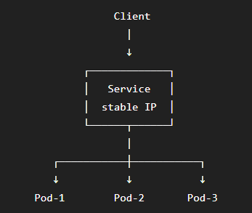
The Service identifies backend Pods using Labels and Selectors.

Services provided by Kubernetes
a.) LoadBalancing
b.) Service Discovery: Done using Label & Selector
c.) Explose to external world

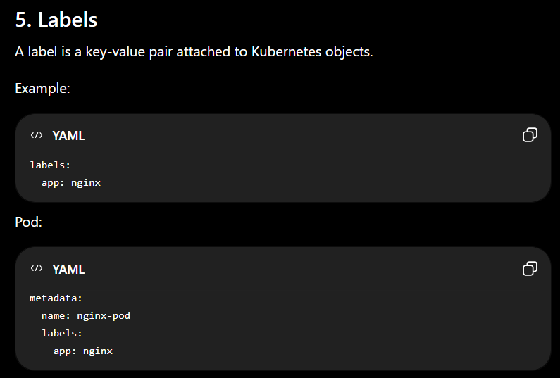
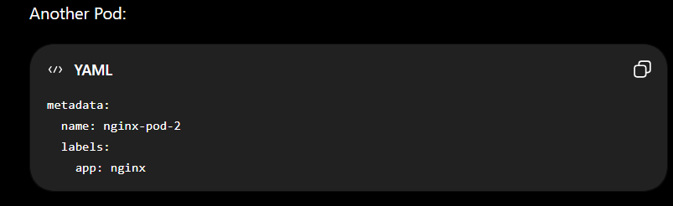

6.) Selectors
A Service uses a selector to determine which Pods should receive traffic.
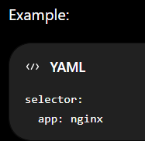
This means: Send Service traffic to Pods having app=nginx.
Architecture:
Service
|
| selector: app=nginx
|
├── Pod-1 app=nginx ✅
├── Pod-2 app=nginx ✅
├── Pod-3 app=nginx ✅
└── Pod-4 app=redis ❌
This is one of the most important concepts for Kubernetes interviews.

7. Basic Service YAML
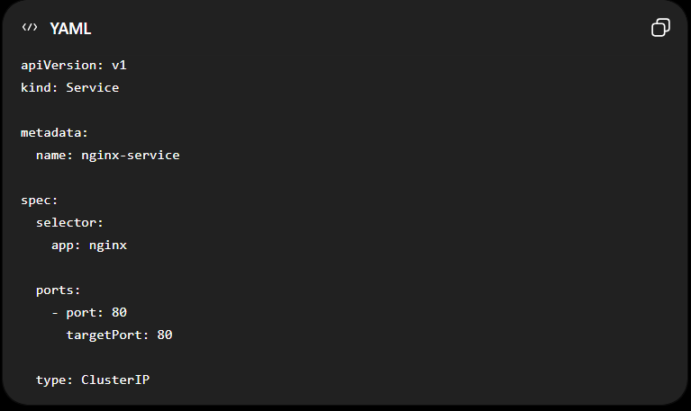
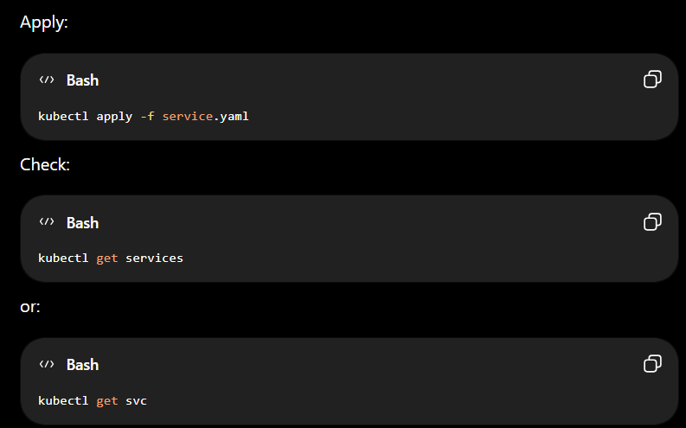

8. Important Service Ports
This is a very common interview question.
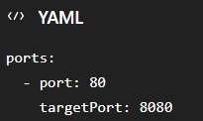
There are two important ports here.
a.) port: The port exposed by the Service.
b.) targetPort: The port on the Pod/container where traffic should be sent.
Example:
Client
|
| :80
↓
Service
|
| :8080
↓
Pod
So:
Service port = 80
Pod port = 8080

9. containerPort vs targetPort
Another common interview question.
1.) containerPort
Declared in the Pod specification:
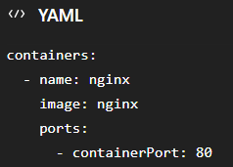
It is mainly metadata/documentation for the container port.
2.) targetPort
Defined in the Service:
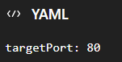
It tells the Service where to send traffic on the selected backend Pods.
Remember:
containerPort → Pod/container specification
targetPort → Service → backend Pod port

10. Kubernetes Service Types
The major Service types are:
1. ClusterIP
2. NodePort
3. LoadBalancer
4. ExternalName
Kubernetes documents these as the available Service types.

11. ClusterIP
ClusterIP is the default Service type.
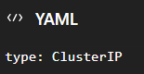
It provides an internal IP accessible from within the cluster.
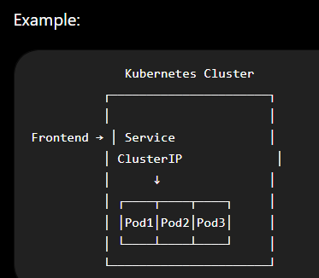
Use it for:
- Backend services
- Databases
- Internal APIs
- Microservices communication
Officially, ClusterIP exposes the Service on a cluster-internal IP and is the default Service type.

12. NodePort
NodePort exposes the Service on a port of every node.
Example:
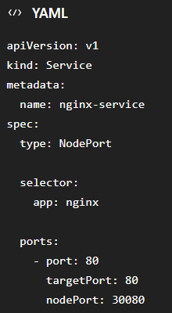
Access:
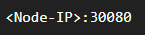
Architecture:
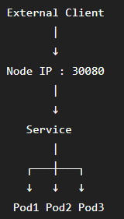
NodePort uses a static port on each Node.

13. NodePort Port Range
By default, Kubernetes NodePorts normally use: 30000 – 32767
So you commonly see:
30080
30001
30050
Example: 192.168.49.2:30080
14. LoadBalancer
LoadBalancer is generally used when you want external access through a cloud/provider load balancer. (LoadBalancer expose service to external world)
Example:
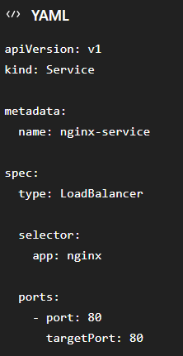
Architecture:
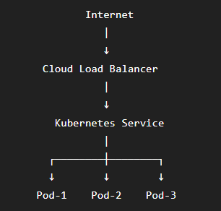
Examples of cloud environments:
- AWS
- Azure
- Google Cloud
Important:
Kubernetes itself does not provide the external load-balancer infrastructure. A cloud provider or another load-balancer implementation must provide it.
15. ExternalName
ExternalName maps a Service to an external DNS name.
Example:
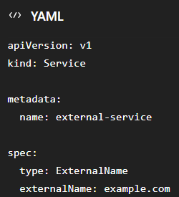
Conceptually:
Application
|
↓
external-service
|
↓
example.com
It uses DNS CNAME behavior and does not create proxying/load-balancing by itself.

16. Service Type Comparison
Type | Internal | External | Main Use
ClusterIP | ✅ | ❌ | Internal communication
NodePort | ✅ | ✅ | Basic external access
LoadBalancer | ✅ | ✅ | Cloud/public exposure
ExternalName | DNS-based | Depends | External service alias

17. Service Discovery
Service Discovery means:
How does one application find another application without knowing its changing Pod IP?
Kubernetes supports service discovery primarily through:
- DNS
- Environment variables
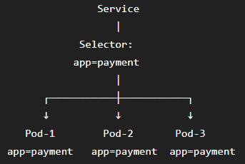

18.) Load Balancing
Suppose:
Service
|
├── Pod-1
├── Pod-2
└── Pod-3
Incoming traffic reaches the Service.
The Service infrastructure routes traffic to backend endpoints.
Conceptually:
Request 1 → Pod-1
Request 2 → Pod-2
Request 3 → Pod-3
Request 4 → Pod-1
...
This allows multiple replicas to serve concurrent traffic.
Kubernetes Services provide a stable virtual endpoint and route traffic toward the backend endpoints represented by EndpointSlices.
19.) EndpointSlice
This is an important modern Kubernetes concept.
A Service needs to know:
Which Pods currently belong to me?
Kubernetes maintains EndpointSlice objects containing information about the endpoints backing a Service.
Example:
Service
|
↓
EndpointSlice
|
├── Pod-1 IP
├── Pod-2 IP
└── Pod-3 IP
When Pods change:
Pod-1 ❌
Pod-4 ✅
the EndpointSlice information is updated.
This is one reason clients don't need to track Pod IP changes themselves.

20.) kube-proxy
kube-proxy is traditionally associated with implementing Kubernetes Service networking on nodes.
It watches Service and EndpointSlice information and configures the node's networking rules so traffic can reach the appropriate backend Pods.
Service
|
↓
EndpointSlice
|
↓
kube-proxy / service proxy implementation
|
↓
Backend Pods
Important modern nuance:
kube-proxy is the default Kubernetes service-proxy implementation, but some networking implementations provide their own service proxy instead.

21.) Kubernetes Networking Model
Kubernetes networking addresses several distinct problems:
1. Container ↔ Container
2. Pod ↔ Pod
3. Pod ↔ Service
4. External Client ↔ Service

22.) Container-to-Container Communication
Containers inside the same Pod share the Pod's network namespace.
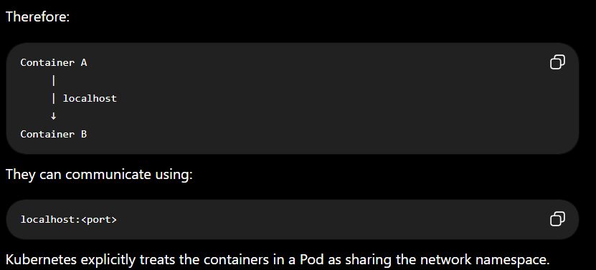

23.) Pod-to-Pod Communication
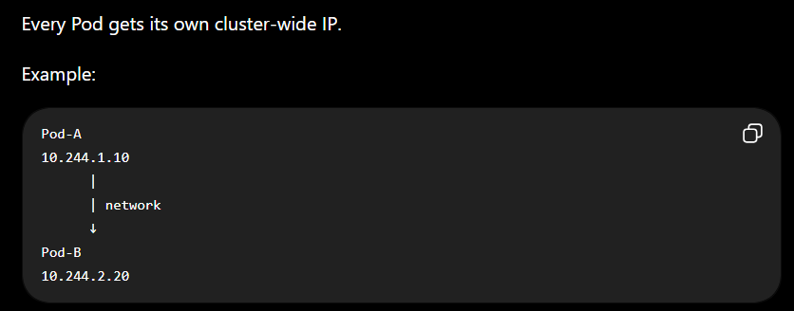
The Kubernetes network model expects Pods to be able to communicate across nodes without requiring users to manually create links between Pods.

24.) Pod-to-Service Communication
Instead of:
Frontend → Backend Pod IP
We Use:
Frontend
|
↓
Backend Service
|
↓
Backend Pods
The Service gives the backend application a stable endpoint.

25.) External-to-Service Communication
For external clients:
Internet
|
↓
LoadBalancer
|
↓
Service
|
↓
Pods
Or:
External Client
|
↓
NodeIP:NodePort
|
↓
Service
|
↓
Pods

25.) Complete Kubernetes Service Flow
This is the most important diagram to remember:
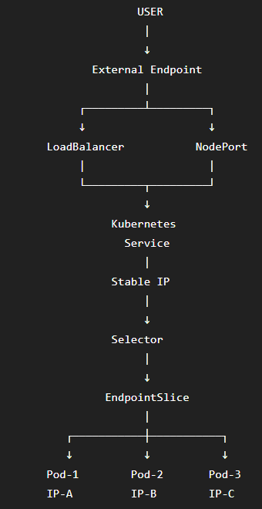
For Internal traffic:
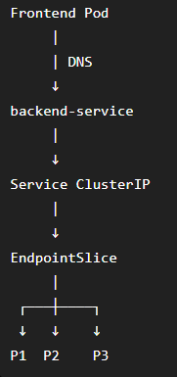

26.) Service vs Pod
Feature | Pod | Service
IP | Changes | Stable
Lifetime | Ephemeral | Stable abstraction
Load balancing | No | Yes
Service discovery | No | Yes
Selects Pods | No | Yes
External exposure | Not normally | Yes
DNS name | Pod DNS possible | Service DNS

27.) Service vs Deployment
Very important:
Deployment
Responsible for:
- Creating Pods
- Maintaining desired replicas
- Rolling updates
- Rollbacks
- Self-healing through ReplicaSets
Service
Responsible for:
- Stable network endpoint
- Service discovery
- Routing traffic to backend endpoints
- Exposing applications
Think:
Deployment → manages Pods
Service → provides networking access to Pods
They solve different problems.

28. Real-World Microservices Example
Suppose an e-commerce application contains:
Frontend
Payment
Order
User
Product
Database
You could have:
frontend-service
payment-service
order-service
user-service
product-service
Architecture:
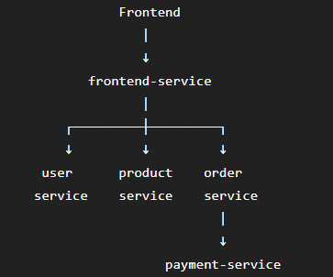
Each microservice can have multiple Pods:
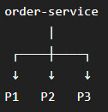

The frontend only needs:
order-service
not:
10.244.1.15
10.244.1.18
10.244.2.10
This is the power of Service Discovery.

29. Important Commands
1.) List Services
kubectl get svc OR kubectl get services
2.) Detailed Infromation
kubectl describe svc <service-name>
3.) Get Pods with labels
kubectl get pods –show-labels
4.) Get EndpointSlices
kubectl get endpointslices
5.) Check a particular Service
kubectl get svc nginx-service
6.) Delete Service
kubectl delete svc nginx-service

