docker
docker -v
docker pull hello-world (Syntax: docker pull IMAGE_NAME (NOTE: It pulls only docker image)
Syntax: docker run IMAGE_NAME (It pulls the image + builds a new container)
docker images
To create container from different images: docker run IMAGE_NAME
docker run hello-world: creates an container with random name (We can see it in
docker desktop Container)
To generate this message, Docker took the following steps:
a. The Docker client contacted the Docker daemon.
b. The Docker daemon pulled the "hello-world" image from the Docker Hub.
(amd64)
c. The Docker daemon created a new container from that image which runs the
executable that produces the output you are currently reading.
d. The Docker daemon streamed that output to the Docker client, which sent it
to your terminal.

DOCKER COMMANDS:
1.) docker run -it IMAGE_NAME: docker run -it IMAGE_NAME creates and starts a new container from the specified Docker image and gives you an interactive terminal.
- docker run → Creates + starts a container.
- -i → Keeps STDIN open so you can type commands.
- -t → Allocates a terminal (TTY).
- IMAGE_NAME → Name of the Docker image to use.
Example: docker run -it ubuntu
This downloads ubuntu if needed, creates a container, and opens an Ubuntu terminal:
root@abc123:/#
2.) docker ps -a: It shows all Docker containers, including both running and stopped containers.
- docker ps → Shows running containers only
- -a / --all → Shows all containers
3.) docker stop CONT_NAME or CONT_ID: stops a running Docker container.
- CONT_NAME → Container name
- CONT_ID → Container ID
4.) docker start CONT_NAME or COUT_ID: starts a stopped Docker container.
- CONT_NAME → Container name
- CONT_ID → Container ID
5.) docker rmi IMAGE_NAME: deletes a Docker image from your system.
- docker rmi → Remove image
- IMAGE_NAME → Name of the image you want to delete
6.) docker rm CONT_NAME: deletes a Docker container.
- docker rm → Remove container
- CONT_NAME → Name of the container
7.) docker pull IMAGE_NAME:version: Downloads a specific version of a Docker image from Docker
Hub.
Example:
- docker pull python:3.12
- docker pull mysql (It pulls latest version)
- docker pull mysql:8.0
8.) docker run -d IMAGE_NAME: Creates and runs a Docker container in the background.
Example: docker run -d nginx
👉 Runs an Nginx container in detached (background) mode.
9.) docker run –name CONT_NAME -d IMAGE_NAME: Creates and runs a container with a custom name in the background.
Example: docker run --name mycontainer -d nginx
👉 Container name: mycontainer
👉 Runs in background (detached) mode.
docker run --name some-mysql -e MYSQL_ROOT_PASSWORD=my-secret-pw -d mysql:8.0
This command creates and runs a MySQL 8.0 container in the background.
- --name some-mysql → Names the container some-mysql
- -e MYSQL_ROOT_PASSWORD=my-secret-pw → Sets the MySQL root password
- -d → Runs in the background
- mysql:8.0 → Uses the MySQL 8.0 image

DOCKER IMAGE LAYER:
Container
↓
Layer 2
↓
Layer 1
↓
Base Layer
(Linux)
- Base Layer → Usually contains the operating system/filesystem base, such as Ubuntu, Alpine, or Debian.
- Layer 1 → Changes/additions made to the base image.
- Layer 2 → More changes/additions.
- Container → A writable layer is added on top when you run the image.
Example:
</> dockerfile
FROM ubuntu
RUN apt update
RUN apt install nginx
Conceptually:
Container (writable)
↓
RUN apt install nginx
↓
RUN apt update
↓
Ubuntu (Base Layer)
Key point: Docker images are made of read-only layers, while a running container adds a
writable layer on top.

PORT BINDING: Port binding connects a port on your host machine to a port inside the Docker container.
10.) docker run -p HOST_PORT:CONTAINER_PORT IMAGE_NAME
Example: docker run -p 8080:80 nginx
Here:
- 8080 → Port on your computer
- 80 → Port inside the container
- nginx → Docker image
So, when you open: http://localhost:8080
the request is forwarded to port 80 of the Nginx container.

TROUBLESHOOT COMMANDS:
Docker Troubleshooting Commands: These commands help you find and fix Docker container problems:
11.) docker logs CONT_NAME/CONT_ID: Displays the logs/output of the CONT_NAME/CONT_ID container.
12.) docker exec -it CONT_ID /bin/bash: Opens an interactive Bash terminal inside a running container.
- docker exec → Executes a command inside a container
- -it → Interactive terminal
- CONT_ID → Container ID/name
- /bin/bash → Opens the Bash shell
Example: docker exec -it mysql-older /bin/bash
C:\Users\Lenovo>docker exec -it mysql-older /bin/bash
bash-5.1# ls
afs dev etc lib64 opt run sys var
bin docker-entrypoint-initdb.d home media proc sbin tmp
boot entrypoint.sh lib mnt root srv usr
bash-5.1# env
MYSQL_MAJOR=8.0
HOSTNAME=15fa2a78de64
PWD=/
MYSQL_ROOT_PASSWORD=my-secret-pw
HOME=/root
MYSQL_VERSION=8.0.46-1.el9
GOSU_VERSION=1.19
TERM=xterm
SHLVL=1
PATH=/usr/local/sbin:/usr/local/bin:/usr/sbin:/usr/bin:/sbin:/bin
MYSQL_SHELL_VERSION=8.0.46-1.el9
_=/usr/bin/env

DOCKER V/S VM:
Feature | Docker | Virtual Machine (VM)
Virtualizes | Application | Entire OS
Size | Lightweight | Heavy
Startup | Seconds | Minutes
Resource usage | Low | High
OS | Shares host OS kernel | Has its own OS/kernel
Isolation | Process/container level | Full OS level
Example | Docker container running MySQL | Ubuntu VM running on Windows

DOCKER NETWORK:
13.) docker network ls:
14.) docker network create NETWORK_NAME:
15.) docker network rm NETWORK_NAME:

DEVELOPING WITH DOCKER: Pratical using MongoDB and Node application

DOCKER COMPOSE: It is a Tool for defining and running multi-container applications
NOTE: Using yaml file: In .yaml file we need not to create any network, by default “docker compose” does this for us
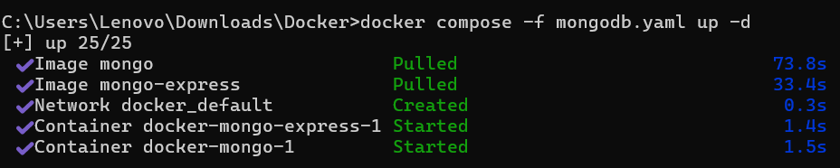
14.) docker compose -f fileName.yaml up -d
15.) docker compose -f fileName.yaml down
NOTE: Here, we can the “apnacollage-db” database is not present because we refreshed it. To solve this problem we use “volumes”
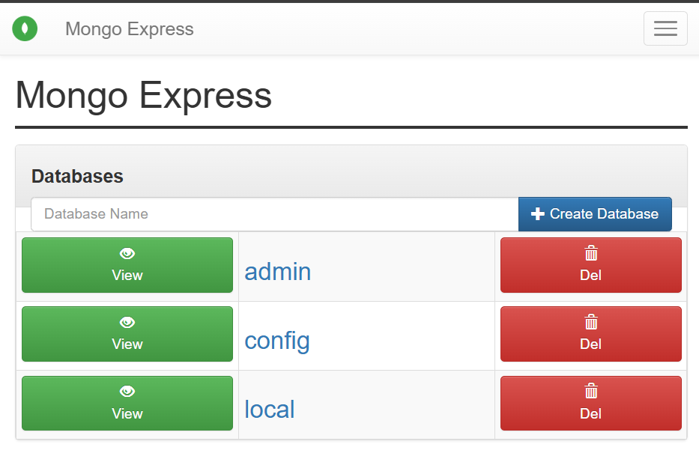
Example:
a.) docker compose -f mongodb.yaml up -d
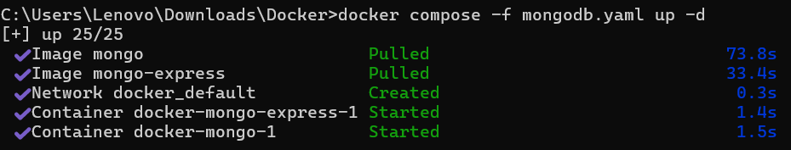
b.) docker compose -f mongodb.yaml down
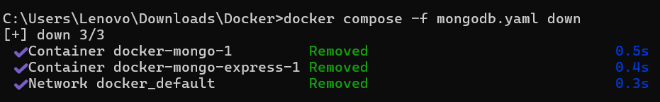

DOCKERIZING OUR APP
Process of converting a application into a container is called “dockerizing our app”.
test_app docker image container
Important Dockerfile Instructions:
Instruction | Meaning
FROM | Specifies the base image to build your Docker image from.
WORKDIR | Sets the working directory inside the container.
COPY | Copies files/folders from your computer into the image.
RUN | Executes a command while building the image, e.g. installing packages.
CMD | Specifies the default command that runs when the container starts.
EXPOSE | Documents the port the application listens on inside the container.
ENV | Sets environment variables inside the container.
EXAMPLE:
FROM python:3.12
WORKDIR /app
COPY . .
RUN pip install -r requirements.txt
ENV PORT=5000
EXPOSE 5000
CMD ["python", "app.py"]
Easy way to remember:
FROM → WORKDIR → COPY → RUN → ENV → EXPOSE → CMD
- FROM → Where to start
- WORKDIR → Where to work
- COPY → What to bring
- RUN → What to install/execute during build
- ENV → Configuration
- EXPOSE → Which port
- CMD → What to run at startup
16.) docker build -t testapp:1.0 .
This command builds a Docker image from a Dockerfile.
Breakdown:
- docker build → Build a Docker image.
- -t → Assign a name and tag to the image.
- testapp → Image name.
- :1.0 → Image tag/version.
- . → Use the current directory as the build context. Docker looks for the Dockerfile here.

HOW TO PUBLISH OUR IMAGES ON DOCKER HUB: docker push iamrajvardhanmall/testapp

DOCKER VOLUMES
Docker Volume is a mechanism used to persist data generated by containers.
- 📦 Stores data outside the container's writable layer.
- 🔄 Data remains even if the container is deleted or recreated.
- 🔗 Can be shared between multiple containers.
- 💾 Useful for databases, application files, logs, etc.
EXAMPLE:
docker volume create myvolume
docker run -v myvolume:/data nginx
Here, myvolume is mounted to /data inside the container.

