**ILP CI CD Deliverables 2:  
  
1) Jenkins Tool Configuration:   
  
i) MAVEN & JDK**

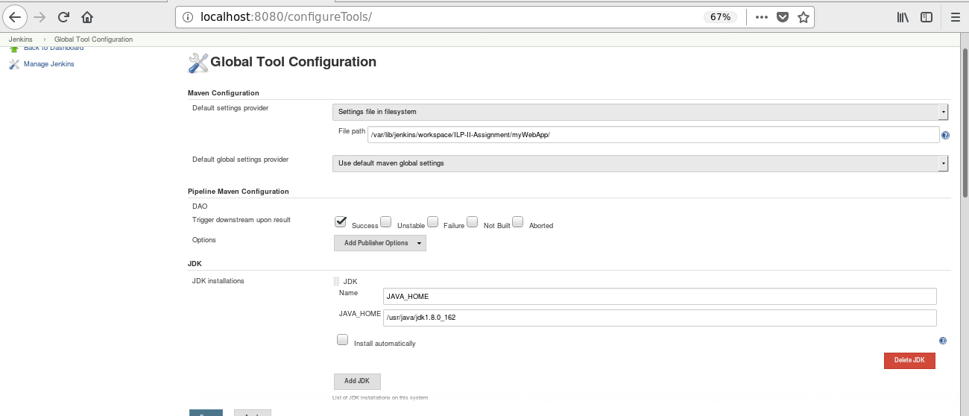

**ii) 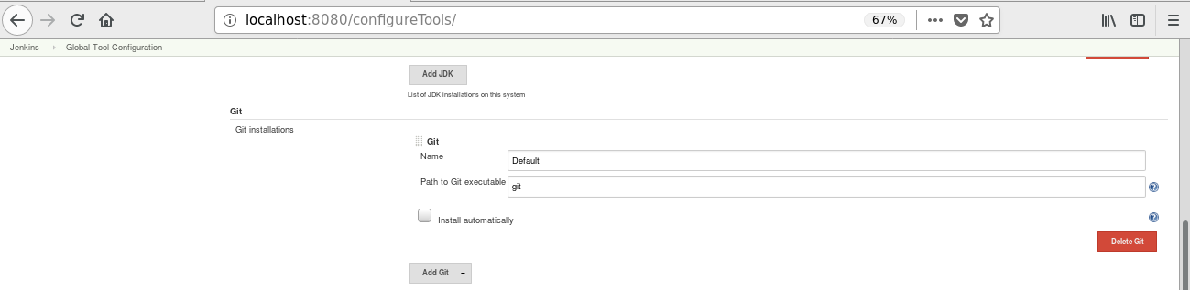Jenkins Tool Configuration GIT:**

**iii) Jenkins Sonar Scanner:**

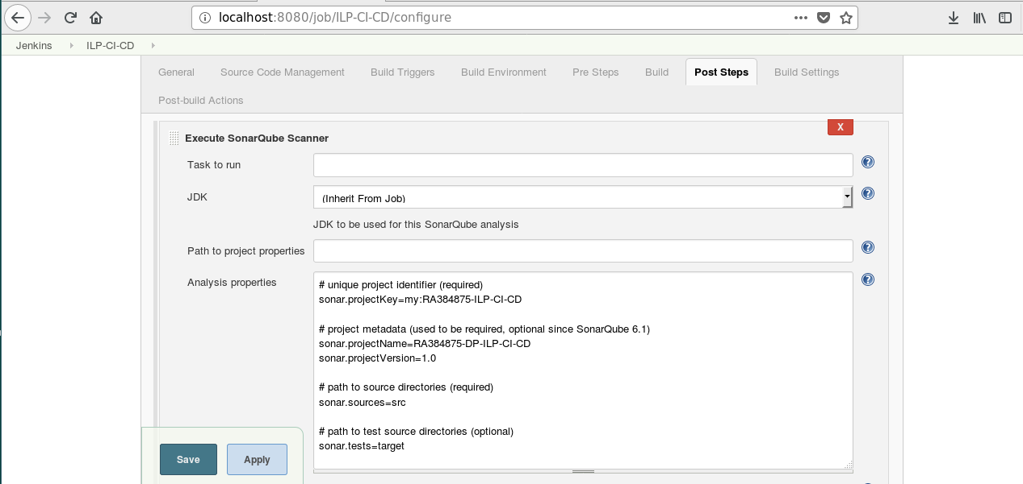

**2. System Configuration  
  
i) Jenkins GIT Lab:** [**https://topgear-training-gitlab.wipro.com/RA384875/ILP-CI-CD**](https://topgear-training-gitlab.wipro.com/RA384875/ILP-CI-CD)

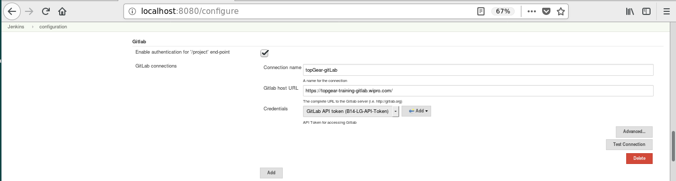

**ii) Jenkins GIT Lab Repository History:**

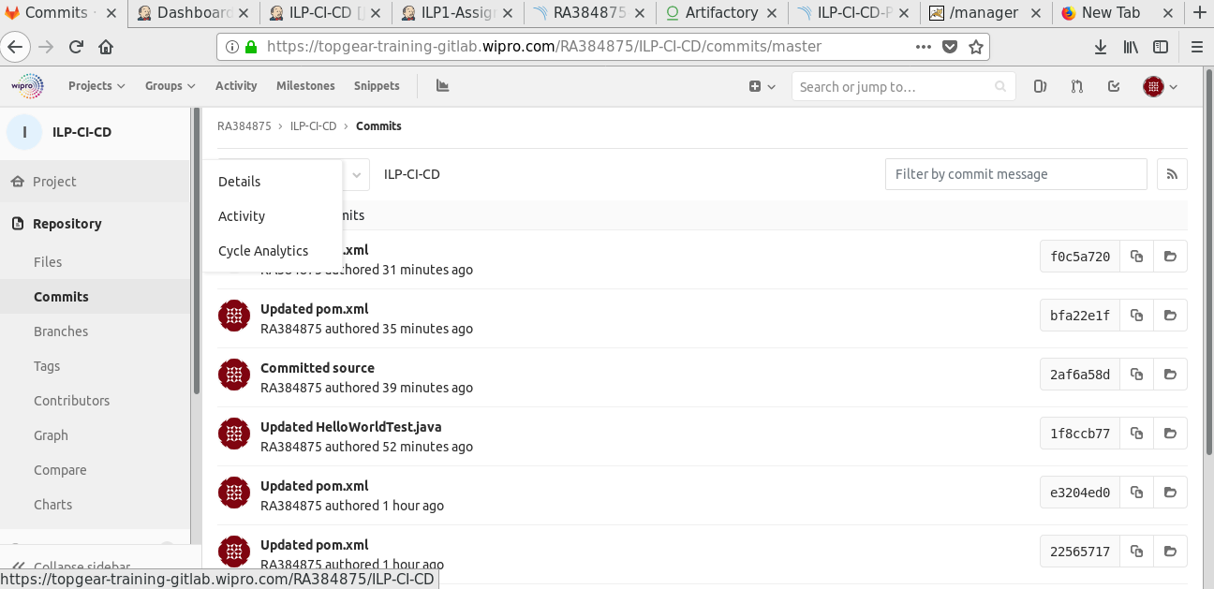

**iii) Jenkins Jfrog:**

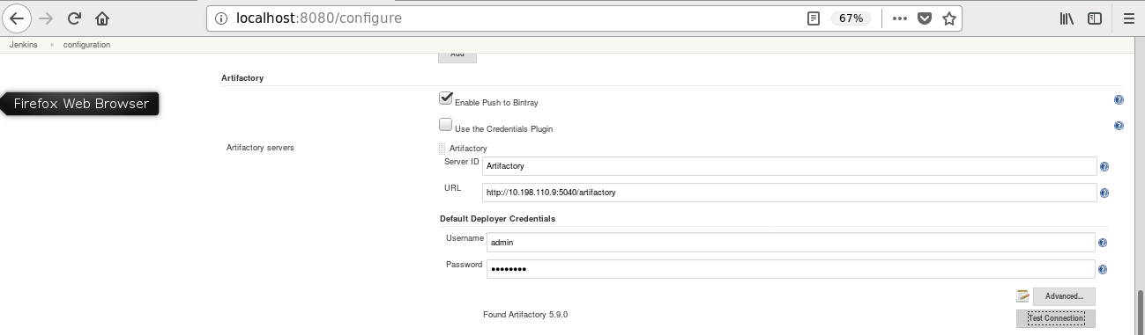

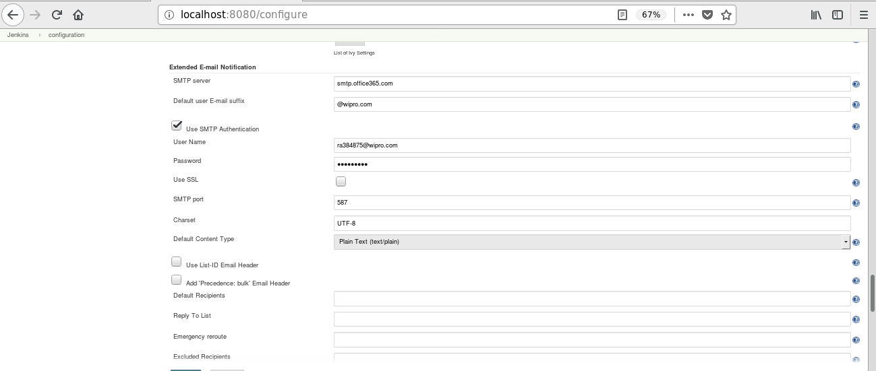**iv) Jenkins Email Notification-I :**

**iv) Jenkins Email Notification-II :**

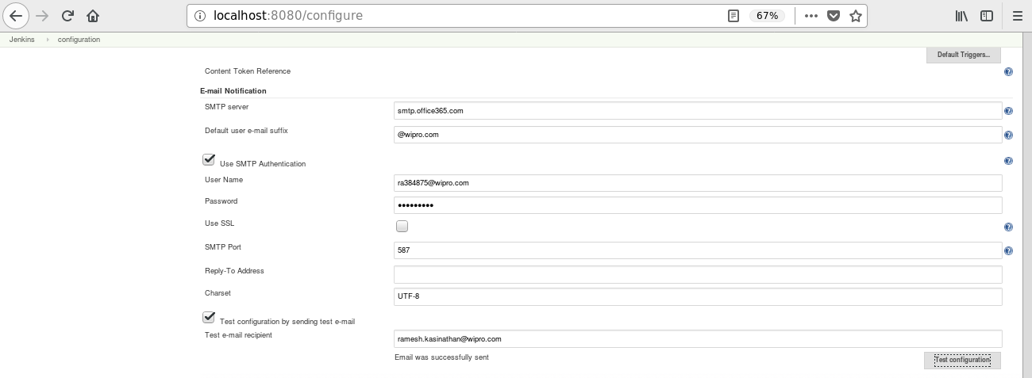

**v) Jenkins Sonar Server:**

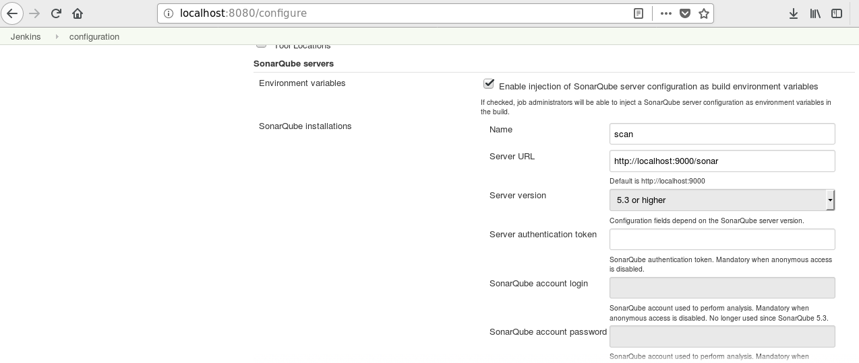

**3) Jenkins Job Configuration:  
   
 Jenkins Job Configuration-I:**

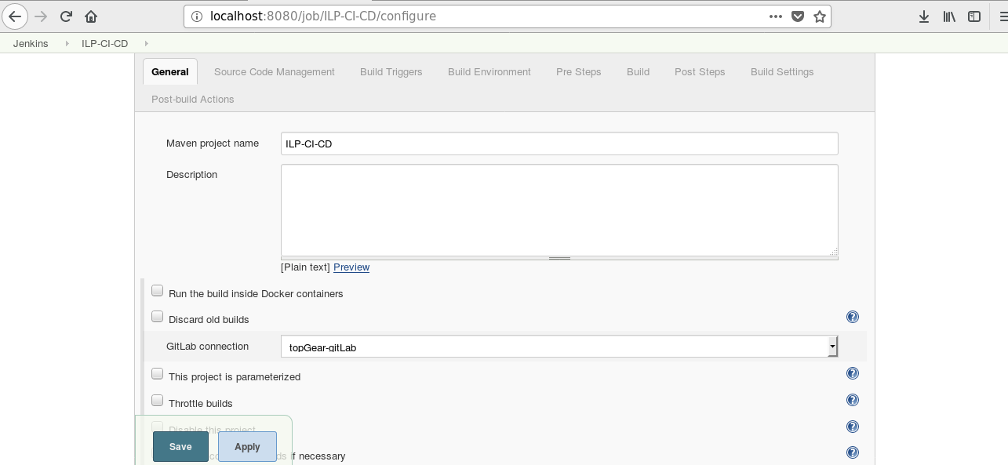

**Jenkins Job Configuration-II:**

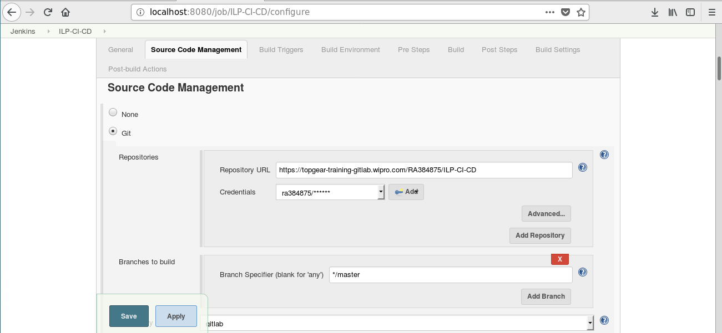

**Jenkins Job Configuration-III:**

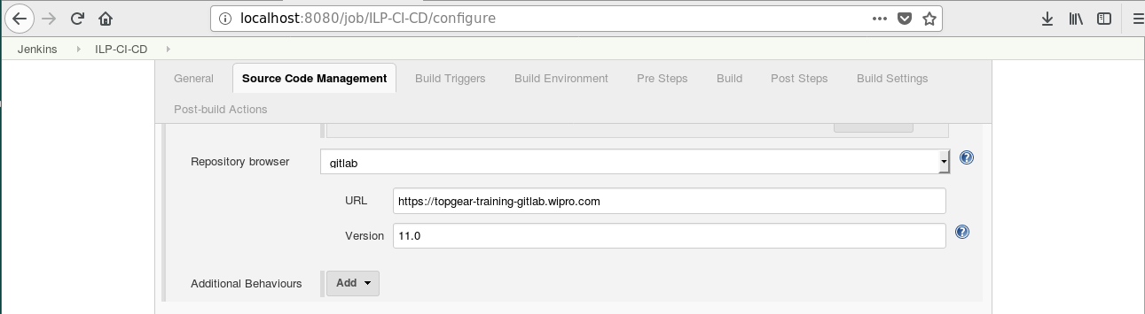

**Jenkins Job Configuration-IV:**

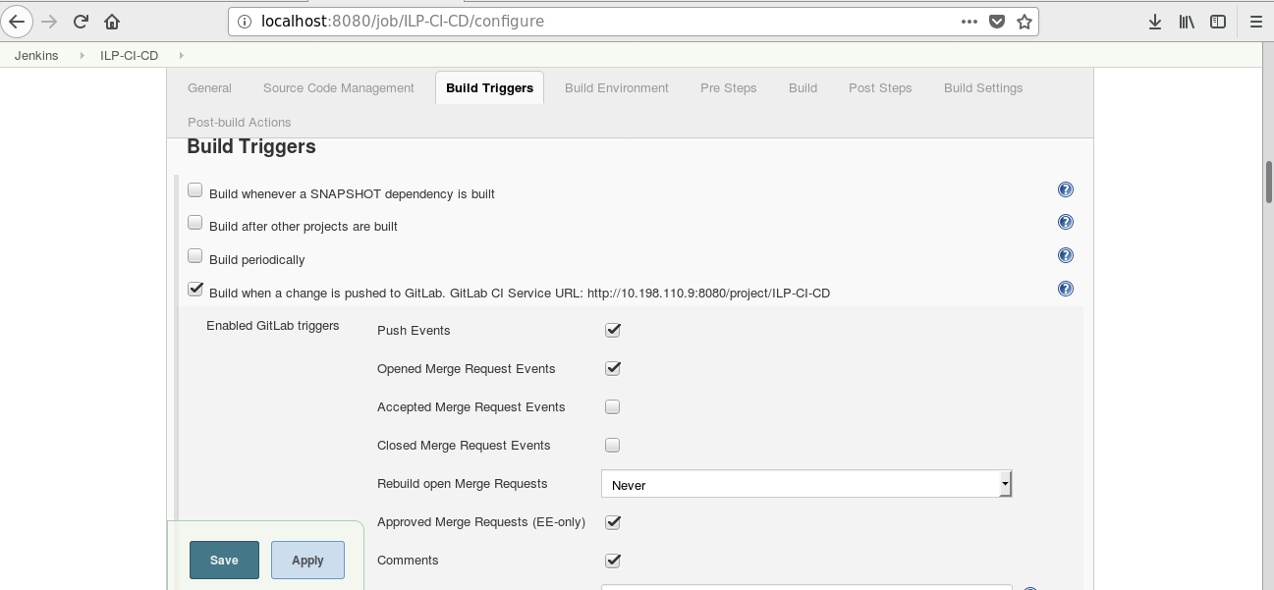

**Jenkins Job Configuration-V:**

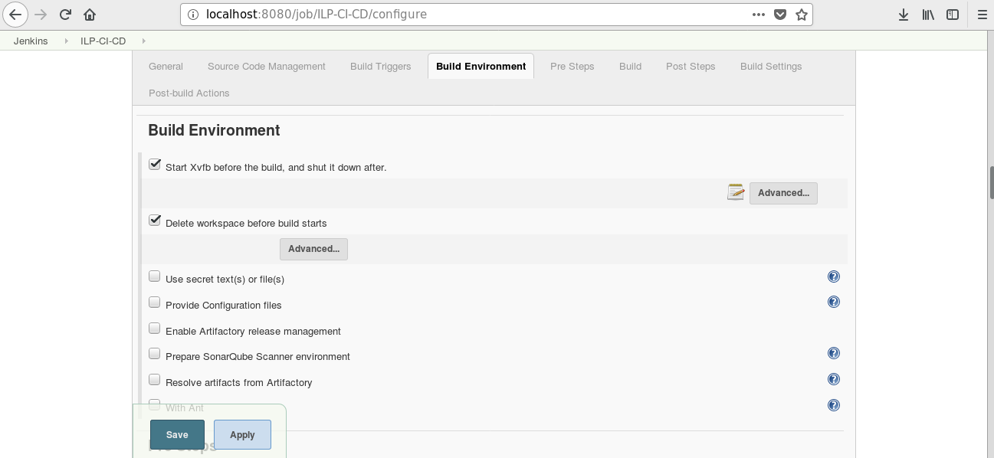

**Jenkins Job Configuration-VI:**

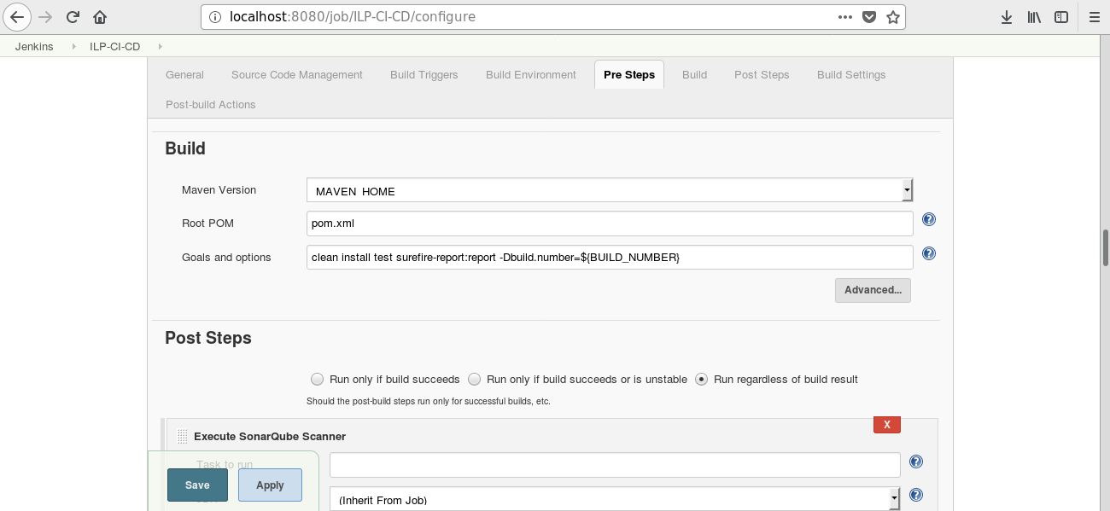

**Jenkins Job Configuration-VII:**

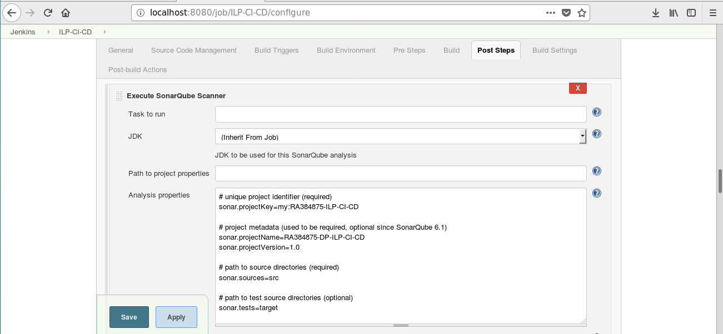

**Jenkins Job Configuration-VIII:**

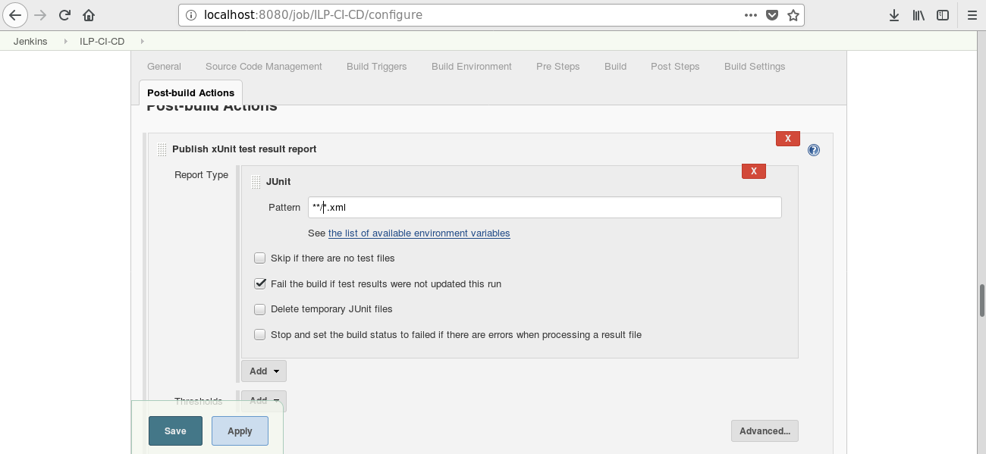

**Jenkins Job Configuration-IX:**

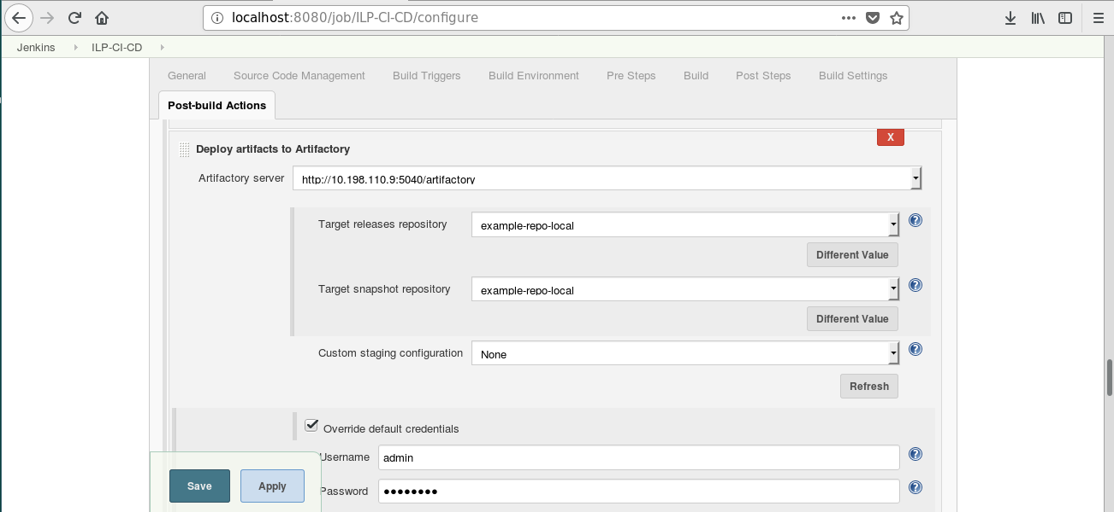

**Jenkins Job Configuration-X:**

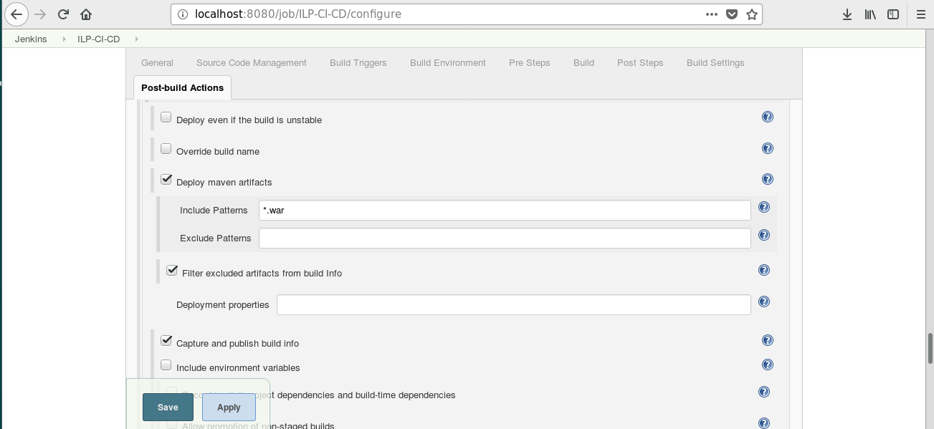

**Jenkins Job Configuration-XI:**

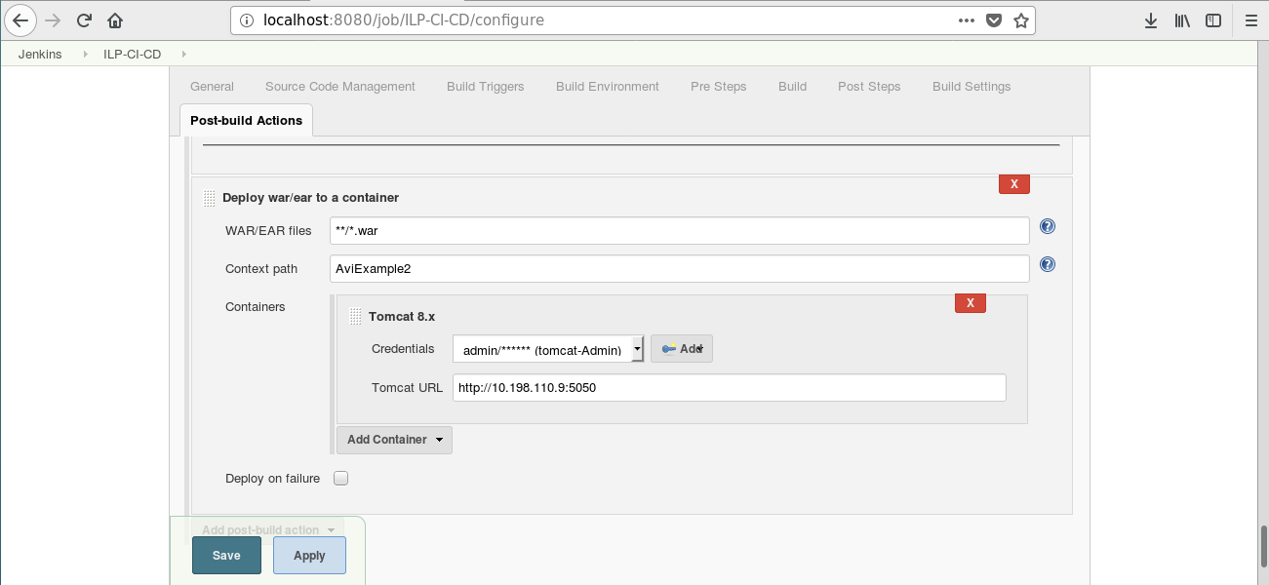

**Jenkins Job Build History:**

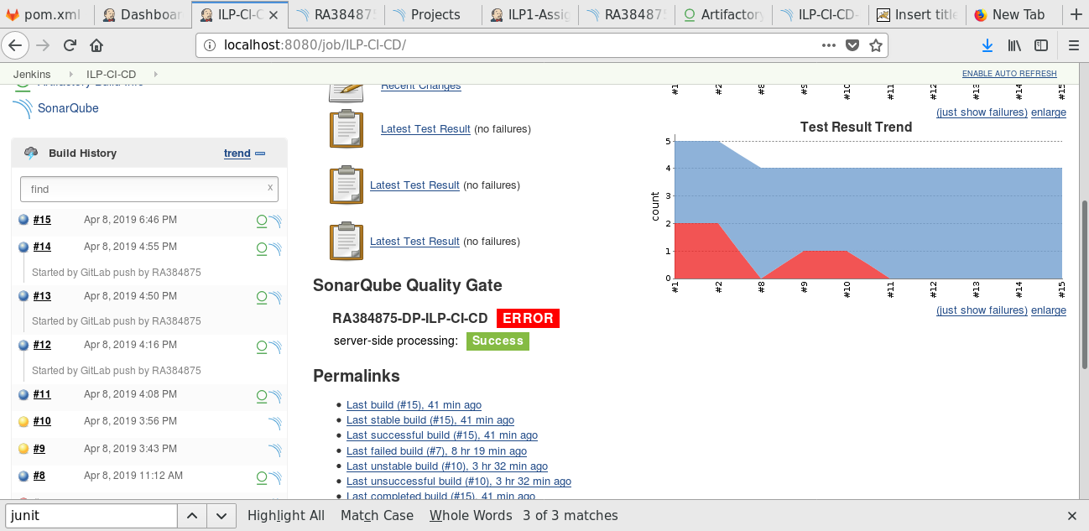

**Jenkins Console Output:  
  
Console Output**

**Started by GitLab push by RA384875**

**Building in workspace /var/lib/jenkins/workspace/ILP-CI-CD**

**[WS-CLEANUP] Deleting project workspace...**

**[WS-CLEANUP] Deferred wipeout is used...**

**[WS-CLEANUP] Done**

**Cloning the remote Git repository**

**Cloning repository https://topgear-training-gitlab.wipro.com/RA384875/ILP-CI-CD**

**> git init /var/lib/jenkins/workspace/ILP-CI-CD # timeout=10**

**Fetching upstream changes from https://topgear-training-gitlab.wipro.com/RA384875/ILP-CI-CD**

**> git --version # timeout=10**

**using GIT_ASKPASS to set credentials**

**Setting http proxy: proxy2.wipro.com:8080**

**> git fetch --tags --progress https://topgear-training-gitlab.wipro.com/RA384875/ILP-CI-CD +refs/heads/*:refs/remotes/origin/\***

**> git config remote.origin.url https://topgear-training-gitlab.wipro.com/RA384875/ILP-CI-CD # timeout=10**

**> git config --add remote.origin.fetch +refs/heads/*:refs/remotes/origin/* # timeout=10**

**> git config remote.origin.url https://topgear-training-gitlab.wipro.com/RA384875/ILP-CI-CD # timeout=10**

**Fetching upstream changes from https://topgear-training-gitlab.wipro.com/RA384875/ILP-CI-CD**

**using GIT_ASKPASS to set credentials**

**Setting http proxy: proxy2.wipro.com:8080**

**> git fetch --tags --progress https://topgear-training-gitlab.wipro.com/RA384875/ILP-CI-CD +refs/heads/*:refs/remotes/origin/\***

**skipping resolution of commit remotes/origin/master, since it originates from another repository**

**> git rev-parse refs/remotes/origin/master^{commit} # timeout=10**

**> git rev-parse refs/remotes/origin/origin/master^{commit} # timeout=10**

**Checking out Revision 50d8b638d3511772e12fc7054c9113fed8259743 (refs/remotes/origin/master)**

**> git config core.sparsecheckout # timeout=10**

**> git checkout -f 50d8b638d3511772e12fc7054c9113fed8259743**

**Commit message: "Updated pom.xml"**

**> git rev-list --no-walk 08b3c5b41fde35e958eda87ee61129872195b7cf # timeout=10**

**Xvfb starting$ /usr/bin/Xvfb :1 -screen 0 1024x768x24 -fbdir /var/lib/jenkins/xvfb-14-4728751924951527734.fbdir**

**No emails were triggered.**

**Parsing POMs**

**Modules changed, recalculating dependency graph**

**Established TCP socket on 37576**

**[ILP-CI-CD] $ /usr/java/jdk1.8.0_162/bin/java -cp /var/lib/jenkins/plugins/maven-plugin/WEB-INF/lib/maven35-agent-1.12-alpha-1.jar:/opt/apache-maven-3.5.2/boot/plexus-classworlds-2.5.2.jar:/opt/apache-maven-3.5.2/conf/logging jenkins.maven3.agent.Maven35Main /opt/apache-maven-3.5.2 /var/cache/jenkins/war/WEB-INF/lib/remoting-3.14.jar /var/lib/jenkins/plugins/maven-plugin/WEB-INF/lib/maven35-interceptor-1.12-alpha-1.jar /var/lib/jenkins/plugins/maven-plugin/WEB-INF/lib/maven3-interceptor-commons-1.12-alpha-1.jar 37576**

**<===[JENKINS REMOTING CAPACITY]===>channel started**

**Executing Maven: -B -f /var/lib/jenkins/workspace/ILP-CI-CD/pom.xml -Dmaven.repo.local=/var/lib/jenkins/maven-repositories/0 clean install test surefire-report:report -Dbuild.number=14**

**[INFO] Scanning for projects...**

**[WARNING]**

**[WARNING] Some problems were encountered while building the effective model for wipro.avi:AviExample2:war:0.0.14-SNAPSHOT**

**[WARNING] 'version' contains an expression but should be a constant. @ wipro.avi:AviExample2:0.0.${BUILD_NUMBER}-SNAPSHOT, /var/lib/jenkins/workspace/ILP-CI-CD/pom.xml, line 7, column 12**

**[WARNING]**

**[WARNING] It is highly recommended to fix these problems because they threaten the stability of your build.**

**[WARNING]**

**[WARNING] For this reason, future Maven versions might no longer support building such malformed projects.**

**[WARNING]**

**[INFO] Initializing Artifactory Build-Info Recording**

**[HUDSON] Collecting dependencies info**

**[WARNING] The POM for org.eclipse.m2e:lifecycle-mapping:jar:1.0.0 is missing, no dependency information available**

**[WARNING] Failed to retrieve plugin descriptor for org.eclipse.m2e:lifecycle-mapping:1.0.0: Plugin org.eclipse.m2e:lifecycle-mapping:1.0.0 or one of its dependencies could not be resolved: Failure to find org.eclipse.m2e:lifecycle-mapping:jar:1.0.0 in https://repo.maven.apache.org/maven2 was cached in the local repository, resolution will not be reattempted until the update interval of central has elapsed or updates are forced**

**[INFO]**

**[INFO] ------------------------------------------------------------------------**

**[INFO] Building AviExample2 Maven Webapp 0.0.14-SNAPSHOT**

**[INFO] ------------------------------------------------------------------------**

**[WARNING] The POM for org.eclipse.m2e:lifecycle-mapping:jar:1.0.0 is missing, no dependency information available**

**[WARNING] Failed to retrieve plugin descriptor for org.eclipse.m2e:lifecycle-mapping:1.0.0: Plugin org.eclipse.m2e:lifecycle-mapping:1.0.0 or one of its dependencies could not be resolved: Failure to find org.eclipse.m2e:lifecycle-mapping:jar:1.0.0 in https://repo.maven.apache.org/maven2 was cached in the local repository, resolution will not be reattempted until the update interval of central has elapsed or updates are forced**

**[INFO]**

**[INFO] --- maven-clean-plugin:2.5:clean (default-clean) @ AviExample2 ---**

**[INFO]**

**[INFO] --- maven-resources-plugin:2.6:resources (default-resources) @ AviExample2 ---**

**[WARNING] Using platform encoding (UTF-8 actually) to copy filtered resources, i.e. build is platform dependent!**

**[INFO] skip non existing resourceDirectory /var/lib/jenkins/workspace/ILP-CI-CD/src/main/resources**

**[INFO]**

**[INFO] --- maven-compiler-plugin:3.1:compile (default-compile) @ AviExample2 ---**

**[INFO] Changes detected - recompiling the module!**

**[WARNING] File encoding has not been set, using platform encoding UTF-8, i.e. build is platform dependent!**

**[INFO] Compiling 1 source file to /var/lib/jenkins/workspace/ILP-CI-CD/target/classes**

**[INFO]**

**[INFO] --- build-helper-maven-plugin:1.9.1:add-test-source (add-integration-test-sources) @ AviExample2 ---**

**[INFO] Test Source directory: /var/lib/jenkins/workspace/ILP-CI-CD/src/integration-test/java added.**

**[INFO]**

**[INFO] --- build-helper-maven-plugin:1.9.1:add-test-resource (add-integration-test-resources) @ AviExample2 ---**

**[INFO]**

**[INFO] --- maven-resources-plugin:2.6:testResources (default-testResources) @ AviExample2 ---**

**[WARNING] File encoding has not been set, using platform encoding UTF-8, i.e. build is platform dependent!**

**[WARNING] Using platform encoding (UTF-8 actually) to copy filtered resources, i.e. build is platform dependent!**

**[INFO] skip non existing resourceDirectory /var/lib/jenkins/workspace/ILP-CI-CD/src/test/resources**

**[INFO] skip non existing resourceDirectory /var/lib/jenkins/workspace/ILP-CI-CD/src/integration-test/resources**

**[INFO]**

**[INFO] --- maven-compiler-plugin:3.1:testCompile (default-testCompile) @ AviExample2 ---**

**[INFO] Changes detected - recompiling the module!**

**[WARNING] File encoding has not been set, using platform encoding UTF-8, i.e. build is platform dependent!**

**[INFO] Compiling 3 source files to /var/lib/jenkins/workspace/ILP-CI-CD/target/test-classes**

**[INFO]**

**[INFO] --- maven-surefire-plugin:2.18.1:test (default-test) @ AviExample2 ---**

**[INFO] Surefire report directory: /var/lib/jenkins/workspace/ILP-CI-CD/target/surefire-reports**

**[INFO] parallel='none', perCoreThreadCount=true, threadCount=0, useUnlimitedThreads=false, threadCountSuites=0, threadCountClasses=0, threadCountMethods=0, parallelOptimized=true**

**-------------------------------------------------------**

**T E S T S**

**-------------------------------------------------------**

**Running com.patel.mywebdemo.ProcessLoginTest**

**Tests run: 3, Failures: 0, Errors: 0, Skipped: 0, Time elapsed: 0.042 sec - in com.patel.mywebdemo.ProcessLoginTest**

**Results :**

**Tests run: 3, Failures: 0, Errors: 0, Skipped: 0**

**[JENKINS] Recording test results**

**[INFO]**

**[INFO] --- maven-war-plugin:2.2:war (default-war) @ AviExample2 ---**

**[INFO] Packaging webapp**

**[INFO] Assembling webapp [AviExample2] in [/var/lib/jenkins/workspace/ILP-CI-CD/target/AviExample2]**

**[INFO] Processing war project**

**[INFO] Copying webapp resources [/var/lib/jenkins/workspace/ILP-CI-CD/src/main/webapp]**

**[INFO] Webapp assembled in [44 msecs]**

**[INFO] Building war: /var/lib/jenkins/workspace/ILP-CI-CD/target/AviExample2.war**

**[INFO] WEB-INF/web.xml already added, skipping**

**[INFO]**

**[INFO] >>> tomcat7-maven-plugin:2.2:run (start-tomcat) > process-classes @ AviExample2 >>>**

**[INFO]**

**[INFO] --- maven-resources-plugin:2.6:resources (default-resources) @ AviExample2 ---**

**[WARNING] Using platform encoding (UTF-8 actually) to copy filtered resources, i.e. build is platform dependent!**

**[INFO] skip non existing resourceDirectory /var/lib/jenkins/workspace/ILP-CI-CD/src/main/resources**

**[INFO]**

**[INFO] --- maven-compiler-plugin:3.1:compile (default-compile) @ AviExample2 ---**

**[INFO] Nothing to compile - all classes are up to date**

**[WARNING] Failed to getClass for org.apache.tomcat.maven.plugin.tomcat7.run.RunMojo**

**[INFO]**

**[INFO] <<< tomcat7-maven-plugin:2.2:run (start-tomcat) < process-classes @ AviExample2 <<<**

**[INFO]**

**[INFO]**

**[INFO] --- tomcat7-maven-plugin:2.2:run (start-tomcat) @ AviExample2 ---**

**[INFO] Running war on http://localhost:6080/AviExample2**

**[INFO] Creating Tomcat server configuration at /var/lib/jenkins/workspace/ILP-CI-CD/target/tomcat**

**[INFO] create webapp with contextPath: /AviExample2**

**[INFO] Initializing ProtocolHandler ["http-bio-6080"]**

**[INFO] Starting service Tomcat**

**[INFO] Starting Servlet Engine: Apache Tomcat/7.0.47**

**[INFO] Starting ProtocolHandler ["http-bio-6080"]**

**[INFO]**

**[INFO] --- maven-failsafe-plugin:2.19.1:integration-test (default) @ AviExample2 ---**

**-------------------------------------------------------**

**T E S T S**

**-------------------------------------------------------**

**1554722769122 geckodriver INFO geckodriver 0.19.1**

**1554722769133 geckodriver INFO Listening on 127.0.0.1:29975**

**1554722769671 mozrunner::runner INFO Running command: "/usr/lib/firefox/firefox" "-marionette" "-profile" "/tmp/rust_mozprofile.3gJMzs8ufwAs"**

**1554722772286 Marionette INFO Enabled via --marionette**

**1554722776183 Marionette INFO Listening on port 40355**

**Apr 08, 2019 4:56:16 PM org.openqa.selenium.remote.ProtocolHandshake createSession**

**INFO: Detected dialect: W3C**

**Running com.demo.HelloWorldTest**

**### Home Page Successful ###**

**[Child 16622, Chrome_ChildThread] WARNING: pipe error (3): Connection reset by peer: file /build/firefox-9j9NY8/firefox-58.0.2+build1/ipc/chromium/src/chrome/common/ipc_channel_posix.cc, line 353**

**[GFX1-]: Receive IPC close with reason=AbnormalShutdown**

**[Child 16527, Chrome_ChildThread] WARNING: pipe error (15): Connection reset by peer: file /build/firefox-9j9NY8/firefox-58.0.2+build1/ipc/chromium/src/chrome/common/ipc_channel_posix.cc, line 353**

**[GFX1-]: Receive IPC close with reason=AbnormalShutdown**

**[Child 16527, Chrome_ChildThread] WARNING: pipe error (3): Connection reset by peer: file /build/firefox-9j9NY8/firefox-58.0.2+build1/ipc/chromium/src/chrome/common/ipc_channel_posix.cc, line 353**

**Tests run: 1, Failures: 0, Errors: 0, Skipped: 0, Time elapsed: 3.173 sec - in com.demo.HelloWorldTest**

**Results :**

**Tests run: 1, Failures: 0, Errors: 0, Skipped: 0**

**[WARNING] File encoding has not been set, using platform encoding UTF-8, i.e. build is platform dependent! The file encoding for reports output files should be provided by the POM property ${project.reporting.outputEncoding}.**

**[JENKINS] Recording test results**

**[INFO]**

**[INFO] --- tomcat7-maven-plugin:2.2:shutdown (stop-tomcat) @ AviExample2 ---**

**[INFO] Pausing ProtocolHandler ["http-bio-6080"]**

**[INFO] Stopping service Tomcat**

**[INFO] Stopping ProtocolHandler ["http-bio-6080"]**

**[INFO]**

**[INFO] --- maven-failsafe-plugin:2.19.1:verify (default) @ AviExample2 ---**

**[WARNING] File encoding has not been set, using platform encoding UTF-8, i.e. build is platform dependent! The file encoding for reports output files should be provided by the POM property ${project.reporting.outputEncoding}.**

**[JENKINS] Recording test results[INFO]**

**[INFO] --- maven-install-plugin:2.4:install (default-install) @ AviExample2 ---**

**[INFO] Installing /var/lib/jenkins/workspace/ILP-CI-CD/target/AviExample2.war to /var/lib/jenkins/maven-repositories/0/wipro/avi/AviExample2/0.0.14-SNAPSHOT/AviExample2-0.0.14-SNAPSHOT.war**

**[INFO] Installing /var/lib/jenkins/workspace/ILP-CI-CD/pom.xml to /var/lib/jenkins/maven-repositories/0/wipro/avi/AviExample2/0.0.14-SNAPSHOT/AviExample2-0.0.14-SNAPSHOT.pom**

**[INFO]**

**[INFO] --- maven-resources-plugin:2.6:resources (default-resources) @ AviExample2 ---**

**[WARNING] Using platform encoding (UTF-8 actually) to copy filtered resources, i.e. build is platform dependent!**

**[INFO] skip non existing resourceDirectory /var/lib/jenkins/workspace/ILP-CI-CD/src/main/resources**

**[INFO]**

**[INFO] --- maven-compiler-plugin:3.1:compile (default-compile) @ AviExample2 ---**

**[INFO] Nothing to compile - all classes are up to date**

**[INFO]**

**[INFO] --- build-helper-maven-plugin:1.9.1:add-test-source (add-integration-test-sources) @ AviExample2 ---**

**[INFO] Test Source directory: /var/lib/jenkins/workspace/ILP-CI-CD/src/integration-test/java added.**

**[INFO]**

**[INFO] --- build-helper-maven-plugin:1.9.1:add-test-resource (add-integration-test-resources) @ AviExample2 ---**

**[INFO]**

**[INFO] --- maven-resources-plugin:2.6:testResources (default-testResources) @ AviExample2 ---**

**[WARNING] File encoding has not been set, using platform encoding UTF-8, i.e. build is platform dependent!**

**[WARNING] Using platform encoding (UTF-8 actually) to copy filtered resources, i.e. build is platform dependent!**

**[INFO] skip non existing resourceDirectory /var/lib/jenkins/workspace/ILP-CI-CD/src/test/resources**

**[INFO] skip non existing resourceDirectory /var/lib/jenkins/workspace/ILP-CI-CD/src/integration-test/resources**

**[INFO] skip non existing resourceDirectory /var/lib/jenkins/workspace/ILP-CI-CD/src/integration-test/resources**

**[INFO]**

**[INFO] --- maven-compiler-plugin:3.1:testCompile (default-testCompile) @ AviExample2 ---**

**[INFO] Nothing to compile - all classes are up to date**

**[INFO]**

**[INFO] --- maven-surefire-plugin:2.18.1:test (default-test) @ AviExample2 ---**

**[INFO] Skipping execution of surefire because it has already been run for this configuration**

**[JENKINS] Recording test results**

**[INFO]**

**[INFO] >>> maven-surefire-report-plugin:3.0.0-M3:report (default-cli) > [surefire]test @ AviExample2 >>>**

**[INFO]**

**[INFO] --- maven-resources-plugin:2.6:resources (default-resources) @ AviExample2 ---**

**[WARNING] Using platform encoding (UTF-8 actually) to copy filtered resources, i.e. build is platform dependent!**

**[INFO] skip non existing resourceDirectory /var/lib/jenkins/workspace/ILP-CI-CD/src/main/resources**

**[INFO]**

**[INFO] --- maven-compiler-plugin:3.1:compile (default-compile) @ AviExample2 ---**

**[INFO] Nothing to compile - all classes are up to date**

**[INFO]**

**[INFO] --- build-helper-maven-plugin:1.9.1:add-test-source (add-integration-test-sources) @ AviExample2 ---**

**[INFO] Test Source directory: /var/lib/jenkins/workspace/ILP-CI-CD/src/integration-test/java added.**

**[INFO]**

**[INFO] --- build-helper-maven-plugin:1.9.1:add-test-resource (add-integration-test-resources) @ AviExample2 ---**

**[INFO]**

**[INFO] --- maven-resources-plugin:2.6:testResources (default-testResources) @ AviExample2 ---**

**[WARNING] File encoding has not been set, using platform encoding UTF-8, i.e. build is platform dependent!**

**[WARNING] Using platform encoding (UTF-8 actually) to copy filtered resources, i.e. build is platform dependent!**

**[INFO] skip non existing resourceDirectory /var/lib/jenkins/workspace/ILP-CI-CD/src/test/resources**

**[INFO] skip non existing resourceDirectory /var/lib/jenkins/workspace/ILP-CI-CD/src/integration-test/resources**

**[INFO] skip non existing resourceDirectory /var/lib/jenkins/workspace/ILP-CI-CD/src/integration-test/resources**

**[INFO] skip non existing resourceDirectory /var/lib/jenkins/workspace/ILP-CI-CD/src/integration-test/resources**

**[INFO]**

**[INFO] --- maven-compiler-plugin:3.1:testCompile (default-testCompile) @ AviExample2 ---**

**[INFO] Nothing to compile - all classes are up to date**

**[INFO]**

**[INFO] --- maven-surefire-plugin:2.18.1:test (default-test) @ AviExample2 ---**

**[INFO] Skipping execution of surefire because it has already been run for this configuration**

**[WARNING] Failed to getClass for org.apache.maven.plugins.surefire.report.SurefireReportMojo**

**[JENKINS] Recording test results**

**[INFO]**

**[INFO] <<< maven-surefire-report-plugin:3.0.0-M3:report (default-cli) < [surefire]test @ AviExample2 <<<**

**[INFO]**

**[INFO]**

**[INFO] --- maven-surefire-report-plugin:3.0.0-M3:report (default-cli) @ AviExample2 ---**

**[WARNING] Unable to locate Test Source XRef to link to - DISABLED**

**[INFO] Artifactory Build Info Recorder: Saving Build Info to '/var/lib/jenkins/workspace/ILP-CI-CD/target/build-info.json'**

**[INFO] Artifactory Build Info Recorder: Deploying build info ...**

**[INFO] Deploying build descriptor to: http://10.198.110.9:5040/artifactory/api/build**

**[INFO] Build successfully deployed. Browse it in Artifactory under http://10.198.110.9:5040/artifactory/webapp/builds/ILP-CI-CD/14**

**[INFO] ------------------------------------------------------------------------**

**[INFO] BUILD SUCCESS**

**[INFO] ------------------------------------------------------------------------**

**[INFO] Total time: 43.958 s**

**[INFO] Finished at: 2019-04-08T16:56:28+05:30**

**[INFO] Final Memory: 50M/396M**

**[INFO] ------------------------------------------------------------------------**

**[JENKINS] Archiving /var/lib/jenkins/workspace/ILP-CI-CD/pom.xml to wipro.avi/AviExample2/0.0.14-SNAPSHOT/AviExample2-0.0.14-SNAPSHOT.pom**

**channel stopped**

**[ILP-CI-CD] $ /home/osgdev/sonar-scanner-3.2/bin/sonar-scanner -e -Dsonar.host.url=http://localhost:9000/sonar -Dsonar.projectName=RA384875-DP-ILP-CI-CD -Dsonar.projectVersion=1.0 -Dsonar.tests=target -Dsonar.projectKey=my:RA384875-ILP-CI-CD -Dsonar.sources=src -Dsonar.projectBaseDir=/var/lib/jenkins/workspace/ILP-CI-CD**

**INFO: Option -e/--errors is no longer supported and will be ignored**

**INFO: Scanner configuration file: /home/osgdev/sonar-scanner-3.2/conf/sonar-scanner.properties**

**INFO: Project root configuration file: NONE**

**INFO: SonarQube Scanner 3.2.0.1227**

**INFO: Java 1.8.0_121 Oracle Corporation (64-bit)**

**INFO: Linux 4.4.0-112-generic amd64**

**INFO: User cache: /var/lib/jenkins/.sonar/cache**

**INFO: SonarQube server 6.4.0**

**INFO: Default locale: "en_IN", source code encoding: "UTF-8" (analysis is platform dependent)**

**INFO: Load global settings**

**INFO: Load global settings (done) | time=237ms**

**INFO: User cache: /var/lib/jenkins/.sonar/cache**

**INFO: Load plugins index**

**INFO: Load plugins index (done) | time=11ms**

**INFO: Process project properties**

**INFO: Load project repositories**

**INFO: Load project repositories (done) | time=173ms**

**INFO: Load quality profiles**

**INFO: Load quality profiles (done) | time=110ms**

**INFO: Load active rules**

**INFO: Load active rules (done) | time=2025ms**

**INFO: Load metrics repository**

**INFO: Load metrics repository (done) | time=193ms**

**INFO: Publish mode**

**INFO: Project key: my:RA384875-ILP-CI-CD**

**INFO: ------------- Scan RA384875-DP-ILP-CI-CD**

**INFO: Load server rules**

**INFO: Load server rules (done) | time=153ms**

**INFO: Initializer GenericCoverageSensor**

**INFO: Initializer GenericCoverageSensor (done) | time=0ms**

**INFO: Base dir: /var/lib/jenkins/workspace/ILP-CI-CD**

**INFO: Working dir: /var/lib/jenkins/workspace/ILP-CI-CD/.scannerwork**

**INFO: Source paths: src**

**INFO: Test paths: target**

**INFO: Source encoding: UTF-8, default locale: en_IN**

**INFO: Index files**

**INFO: 38 files indexed**

**INFO: Quality profile for java: Sonar way**

**INFO: Quality profile for xml: Sonar way**

**INFO: Sensor JavaSquidSensor [java]**

**INFO: Configured Java source version (sonar.java.source): none**

**INFO: JavaClasspath initialization**

**WARN: Bytecode of dependencies was not provided for analysis of source files, you might end up with less precise results. Bytecode can be provided using sonar.java.libraries property**

**INFO: JavaClasspath initialization (done) | time=3ms**

**INFO: JavaTestClasspath initialization**

**WARN: Bytecode of dependencies was not provided for analysis of test files, you might end up with less precise results. Bytecode can be provided using sonar.java.test.libraries property**

**INFO: JavaTestClasspath initialization (done) | time=0ms**

**INFO: Java Main Files AST scan**

**INFO: 4 source files to be analyzed**

**INFO: 4/4 source files have been analyzed**

**INFO: Java Main Files AST scan (done) | time=1240ms**

**INFO: Java Test Files AST scan**

**INFO: 1 source files to be analyzed**

**INFO: Java Test Files AST scan (done) | time=97ms**

**INFO: Sensor JavaSquidSensor [java] (done) | time=2174ms**

**INFO: Sensor SurefireSensor [java]**

**INFO: parsing /var/lib/jenkins/workspace/ILP-CI-CD/target/surefire-reports**

**INFO: 1/1 source files have been analyzed**

**INFO: Sensor SurefireSensor [java] (done) | time=126ms**

**INFO: Sensor JaCoCoSensor [java]**

**INFO: Sensor JaCoCoSensor [java] (done) | time=6ms**

**INFO: Sensor SonarJavaXmlFileSensor [java]**

**INFO: 7 source files to be analyzed**

**INFO: Sensor SonarJavaXmlFileSensor [java] (done) | time=250ms**

**INFO: 7/7 source files have been analyzed**

**INFO: Sensor XML Sensor [xml]**

**INFO: Sensor XML Sensor [xml] (done) | time=101ms**

**INFO: Sensor Analyzer for "php.ini" files [php]**

**INFO: Sensor Analyzer for "php.ini" files [php] (done) | time=3ms**

**INFO: Sensor Zero Coverage Sensor**

**INFO: Sensor Zero Coverage Sensor (done) | time=40ms**

**INFO: Sensor CPD Block Indexer**

**INFO: Sensor CPD Block Indexer (done) | time=63ms**

**INFO: SCM provider for this project is: git**

**INFO: 7 files to be analyzed**

**INFO: 0/7 files analyzed**

**WARN: Missing blame information for the following files:**

**WARN: * /var/lib/jenkins/workspace/ILP-CI-CD/target/tomcat/work/Tomcat/localhost/AviExample2/org/apache/jsp/index_jsp.java**

**WARN: * /var/lib/jenkins/workspace/ILP-CI-CD/target/tomcat/conf/web.xml**

**WARN: * /var/lib/jenkins/workspace/ILP-CI-CD/target/failsafe-reports/TEST-com.demo.HelloWorldTest.xml**

**WARN: * /var/lib/jenkins/workspace/ILP-CI-CD/target/surefire-reports/TEST-com.patel.mywebdemo.ProcessLoginTest.xml**

**WARN: * /var/lib/jenkins/workspace/ILP-CI-CD/target/AviExample2/WEB-INF/web.xml**

**WARN: * /var/lib/jenkins/workspace/ILP-CI-CD/target/tomcat/conf/tomcat-users.xml**

**WARN: * /var/lib/jenkins/workspace/ILP-CI-CD/target/failsafe-reports/failsafe-summary.xml**

**WARN: This may lead to missing/broken features in SonarQube**

**INFO: 1 file had no CPD blocks**

**INFO: Calculating CPD for 3 files**

**INFO: CPD calculation finished**

**INFO: Analysis report generated in 176ms, dir size=214 KB**

**INFO: Analysis reports compressed in 35ms, zip size=46 KB**

**INFO: Analysis report uploaded in 90ms**

**INFO: ANALYSIS SUCCESSFUL, you can browse http://localhost:9000/sonar/dashboard/index/my:RA384875-ILP-CI-CD**

**INFO: Note that you will be able to access the updated dashboard once the server has processed the submitted analysis report**

**INFO: More about the report processing at http://localhost:9000/sonar/api/ce/task?id=AWn8s0XA4EgiZYe_77mh**

**INFO: Task total time: 9.320 s**

**INFO: ------------------------------------------------------------------------**

**INFO: EXECUTION SUCCESS**

**INFO: ------------------------------------------------------------------------**

**INFO: Total time: 11.744s**

**INFO: Final Memory: 10M/159M**

**INFO: ------------------------------------------------------------------------**

**Xvfb stopping**

**INFO: Starting to record.**

**INFO: Processing JUnit**

**unlink: No such file or directory**

**unlink /var/lib/jenkins/xvfb-14-4728751924951527734.fbdir/Xvfb_screen0 failed, Invalid argumentINFO: [JUnit] - 8 test report file(s) were found with the pattern '**/*.xml' relative to '/var/lib/jenkins/workspace/ILP-CI-CD' for the testing framework 'JUnit'.**

**WARNING: The file '/var/lib/jenkins/workspace/ILP-CI-CD/pom.xml' is an invalid file.**

**WARNING: At line 2 of file:/var/lib/jenkins/workspace/ILP-CI-CD/pom.xml:cvc-elt.1: Cannot find the declaration of element 'project'.**

**WARNING: The result file '/var/lib/jenkins/workspace/ILP-CI-CD/pom.xml' for the metric 'JUnit' is not valid. The result file has been skipped.**

**WARNING: The file '/var/lib/jenkins/workspace/ILP-CI-CD/src/main/webapp/WEB-INF/web.xml' is an invalid file.**

**WARNING: At line 5 of file:/var/lib/jenkins/workspace/ILP-CI-CD/src/main/webapp/WEB-INF/web.xml:cvc-elt.1: Cannot find the declaration of element 'web-app'.**

**WARNING: The result file '/var/lib/jenkins/workspace/ILP-CI-CD/src/main/webapp/WEB-INF/web.xml' for the metric 'JUnit' is not valid. The result file has been skipped.**

**WARNING: The file '/var/lib/jenkins/workspace/ILP-CI-CD/target/AviExample2/WEB-INF/web.xml' is an invalid file.**

**WARNING: At line 5 of file:/var/lib/jenkins/workspace/ILP-CI-CD/target/AviExample2/WEB-INF/web.xml:cvc-elt.1: Cannot find the declaration of element 'web-app'.**

**WARNING: The result file '/var/lib/jenkins/workspace/ILP-CI-CD/target/AviExample2/WEB-INF/web.xml' for the metric 'JUnit' is not valid. The result file has been skipped.**

**WARNING: The file '/var/lib/jenkins/workspace/ILP-CI-CD/target/failsafe-reports/TEST-com.demo.HelloWorldTest.xml' is an invalid file.**

**WARNING: At line 2 of file:/var/lib/jenkins/workspace/ILP-CI-CD/target/failsafe-reports/TEST-com.demo.HelloWorldTest.xml:SchemaLocation: schemaLocation value = 'https://maven.apache.org/surefire/maven-surefire-plugin/xsd/surefire-test-report.xsd' must have even number of URI's.**

**WARNING: The result file '/var/lib/jenkins/workspace/ILP-CI-CD/target/failsafe-reports/TEST-com.demo.HelloWorldTest.xml' for the metric 'JUnit' is not valid. The result file has been skipped.**

**WARNING: The file '/var/lib/jenkins/workspace/ILP-CI-CD/target/failsafe-reports/failsafe-summary.xml' is an invalid file.**

**WARNING: At line 2 of file:/var/lib/jenkins/workspace/ILP-CI-CD/target/failsafe-reports/failsafe-summary.xml:cvc-elt.1: Cannot find the declaration of element 'failsafe-summary'.**

**WARNING: The result file '/var/lib/jenkins/workspace/ILP-CI-CD/target/failsafe-reports/failsafe-summary.xml' for the metric 'JUnit' is not valid. The result file has been skipped.**

**WARNING: The file '/var/lib/jenkins/workspace/ILP-CI-CD/target/tomcat/conf/tomcat-users.xml' is an invalid file.**

**WARNING: At line 18 of file:/var/lib/jenkins/workspace/ILP-CI-CD/target/tomcat/conf/tomcat-users.xml:cvc-elt.1: Cannot find the declaration of element 'tomcat-users'.**

**WARNING: The result file '/var/lib/jenkins/workspace/ILP-CI-CD/target/tomcat/conf/tomcat-users.xml' for the metric 'JUnit' is not valid. The result file has been skipped.**

**WARNING: The file '/var/lib/jenkins/workspace/ILP-CI-CD/target/tomcat/conf/web.xml' is an invalid file.**

**WARNING: At line 22 of file:/var/lib/jenkins/workspace/ILP-CI-CD/target/tomcat/conf/web.xml:cvc-elt.1: Cannot find the declaration of element 'web-app'.**

**WARNING: The result file '/var/lib/jenkins/workspace/ILP-CI-CD/target/tomcat/conf/web.xml' for the metric 'JUnit' is not valid. The result file has been skipped.**

**INFO: Setting the build status to SUCCESS**

**INFO: Stopping recording.**

**Deploying /var/lib/jenkins/workspace/ILP-CI-CD/target/AviExample2.war to container Tomcat 8.x Remote with context AviExample2**

**Redeploying [/var/lib/jenkins/workspace/ILP-CI-CD/target/AviExample2.war]**

**Undeploying [/var/lib/jenkins/workspace/ILP-CI-CD/target/AviExample2.war]**

**Deploying [/var/lib/jenkins/workspace/ILP-CI-CD/target/AviExample2.war]**

**Email was triggered for: Success**

**Sending email for trigger: Success**

**Request made to compress build log**

**Sending email to: avinash.patel@wipro.com raghavendran.sethumadhavan1@wipro.com ramesh.rajamani@wipro.com ramesh.kasinathan@wipro.com**

Finished: SUCCESS  
  
================================================================

**4.) Git Lab History**



**5)Jfrog-Artifactory:**

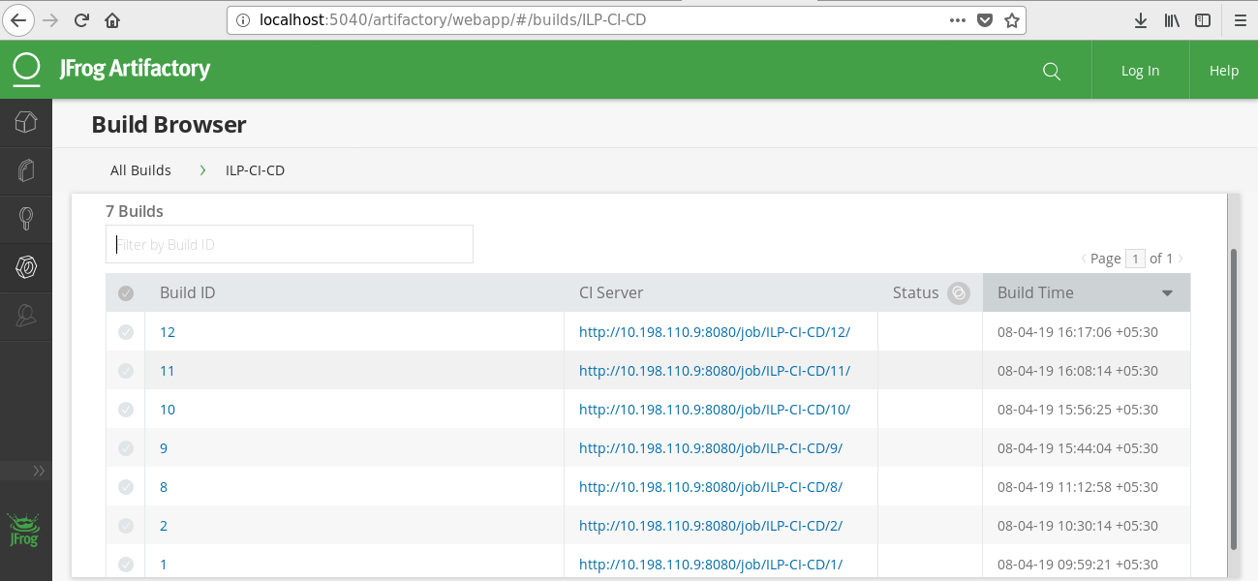  
  
**6) Sonar Code Reports:**

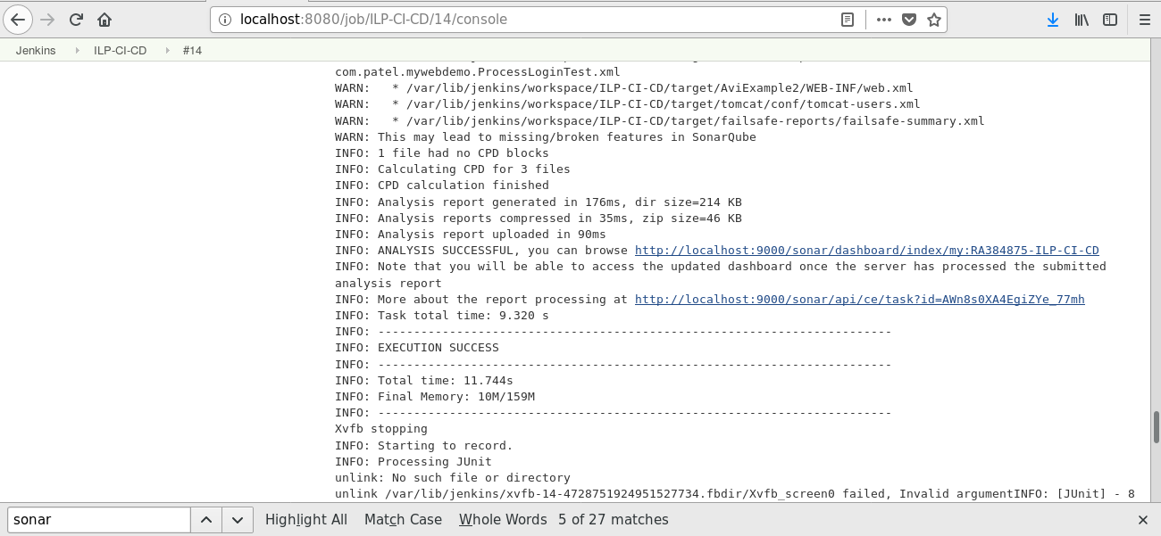

**i) SonarQube Dashboard-I**

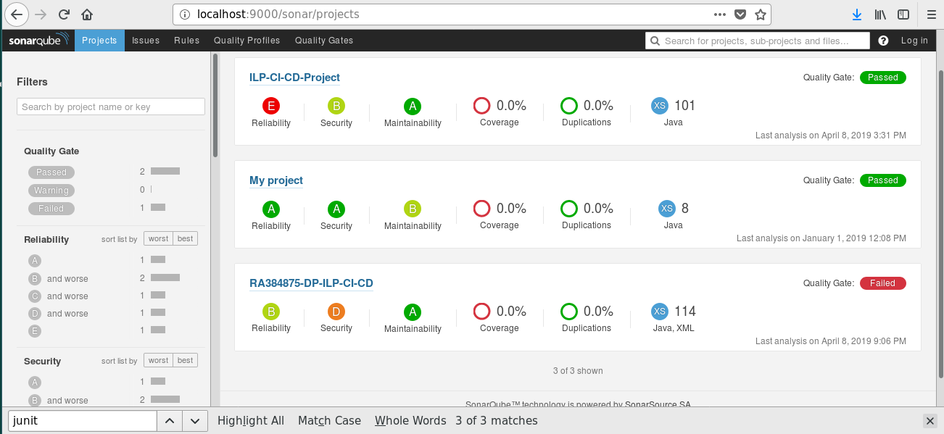

**ii) SonarQube Dashboard-II**

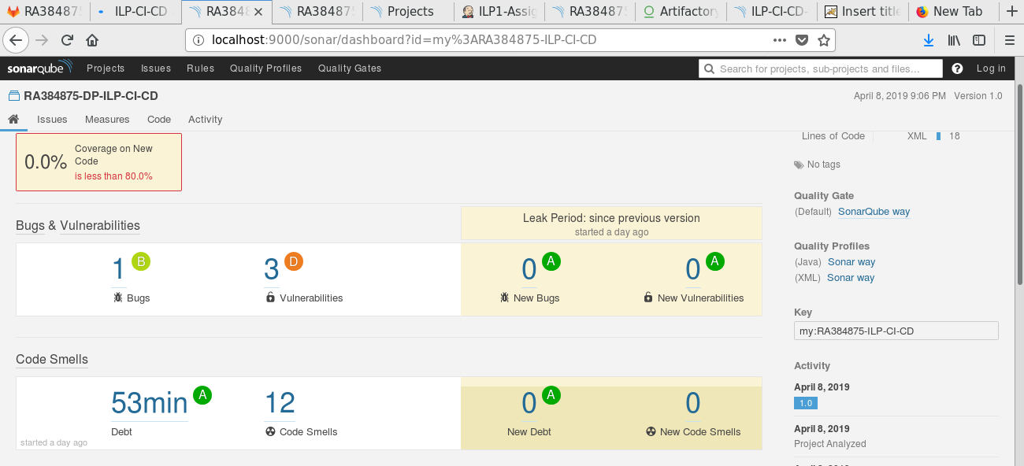

**7) Unit Integration Test Reports:**

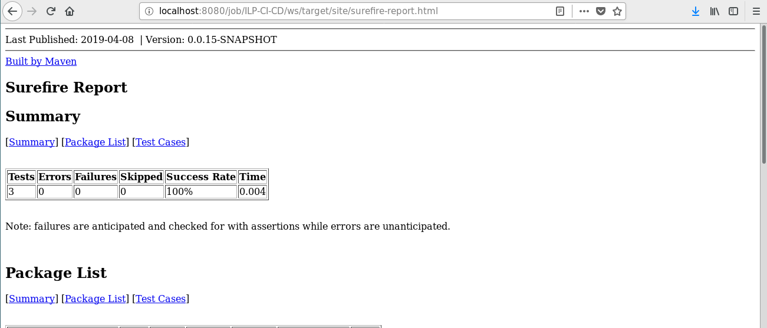

**8) i) Selenium Test Report From Jenkins:**

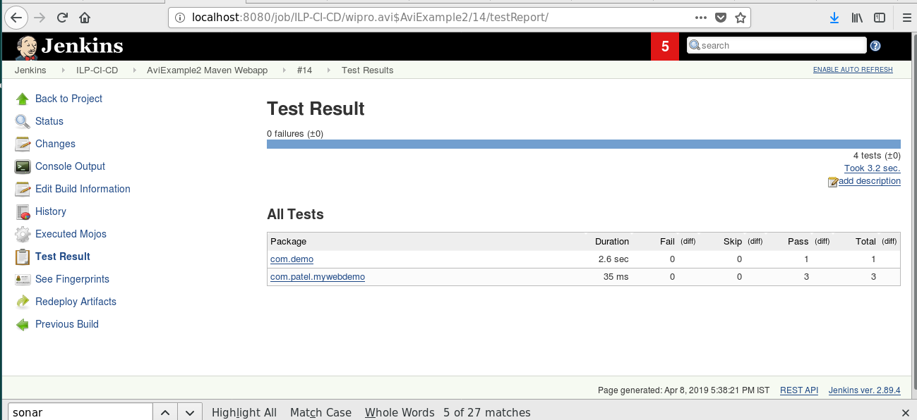

**ii)**

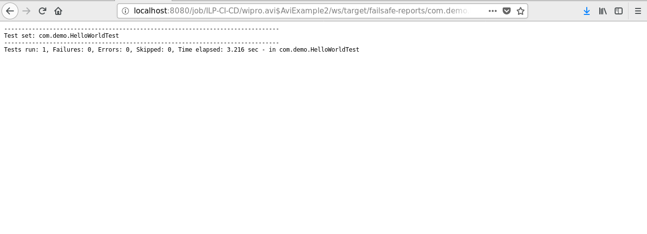

**iii) Test Trend**

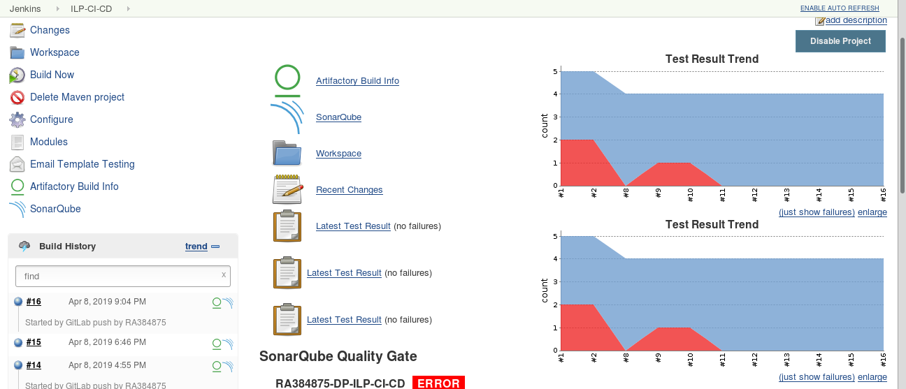

**9) Tomcat Configuration:**

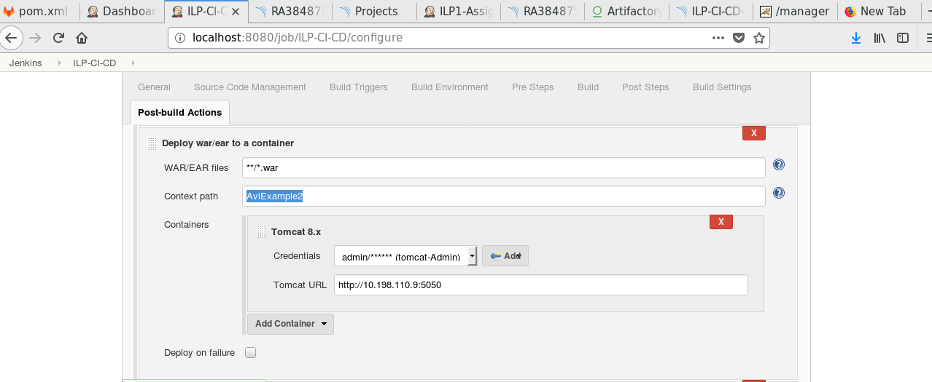

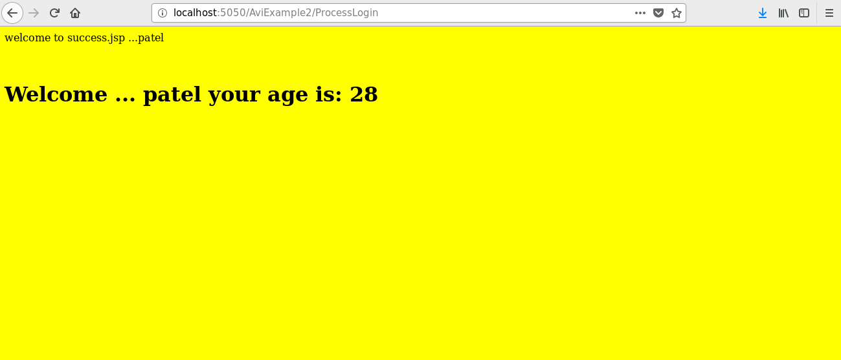**10) Application Output:**  
  
 **Thank you.**