ILP – 1 – CI – Submission

1: Jenkins Tool Configuration  
  
 i) Jenkins Maven & JDK:

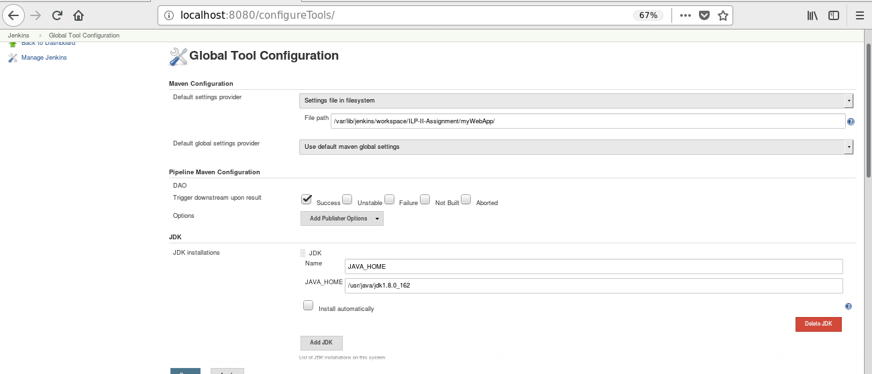

ii) Jenkins Git

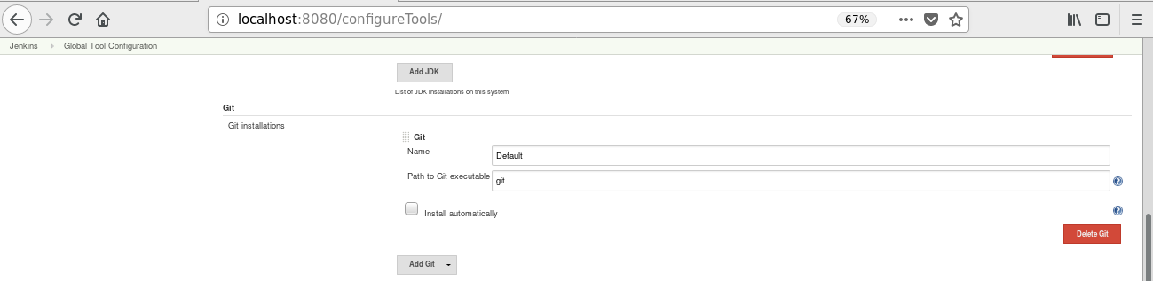

2. Jenkins System Configurations

i) Gitlab

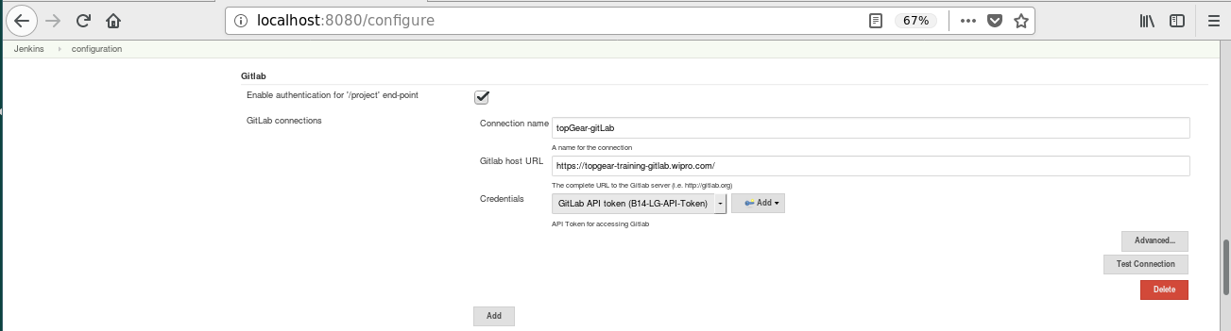

ii) Jfrog-Artifactory

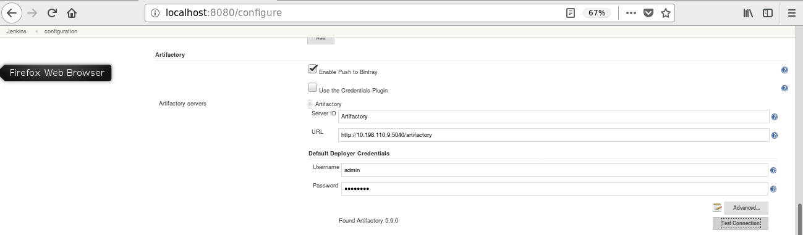

iii) Extended Email Notification:

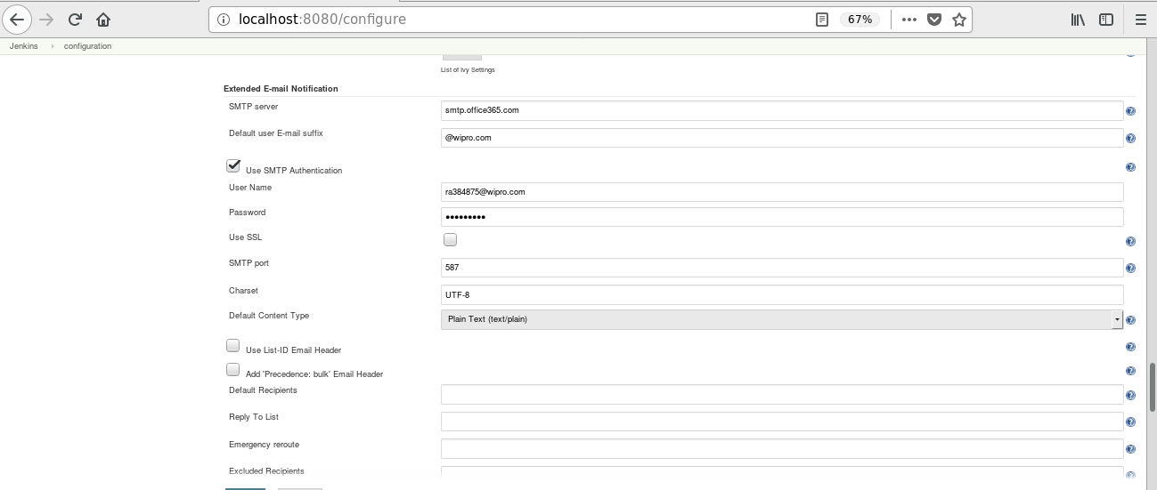

iv) Email Notification:

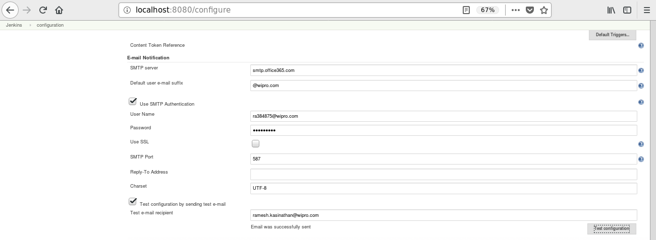

3. Jenkins Job Configuration:

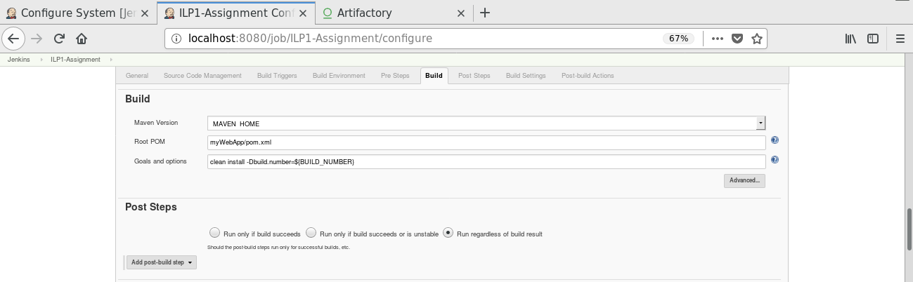

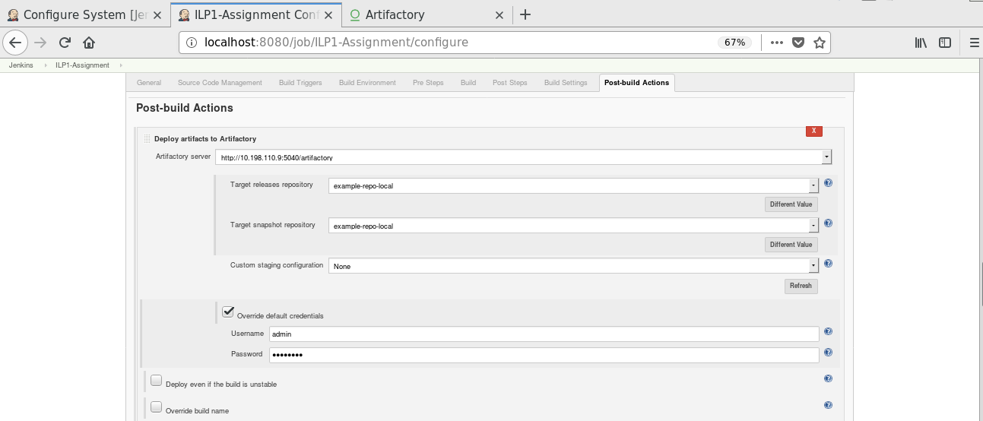

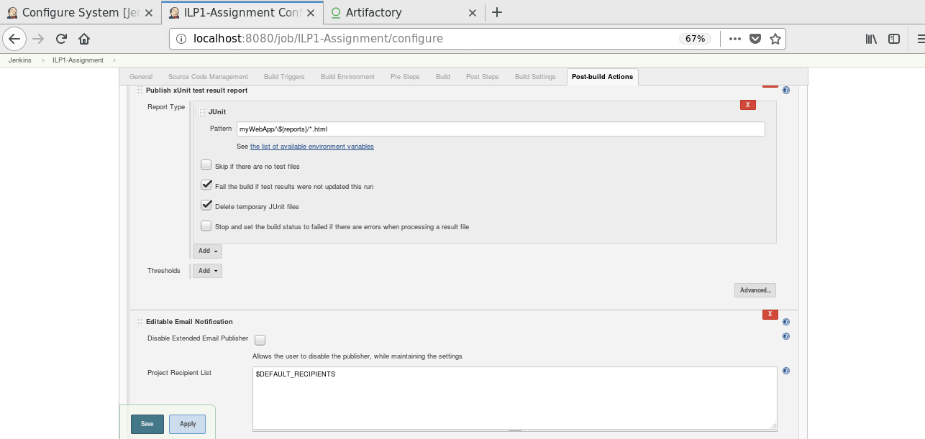

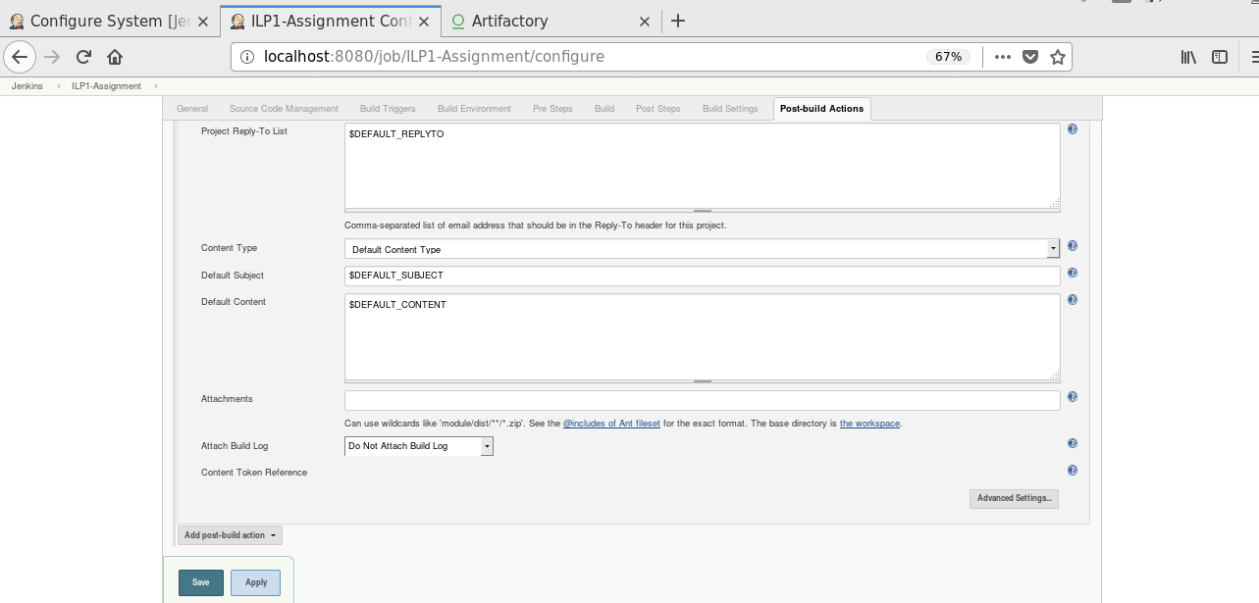

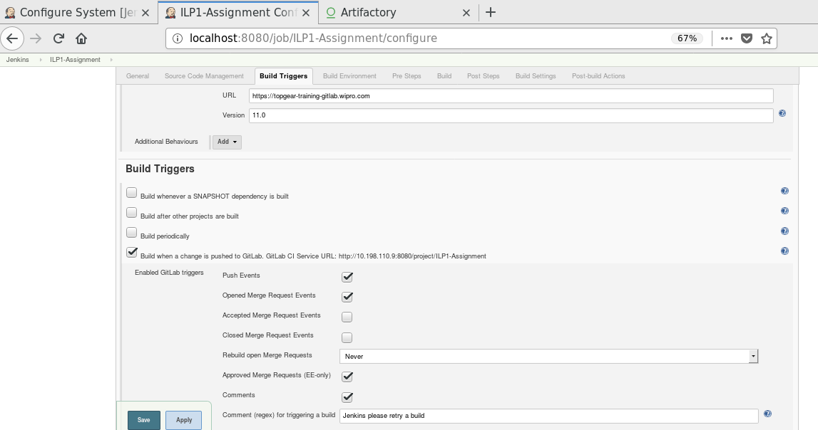

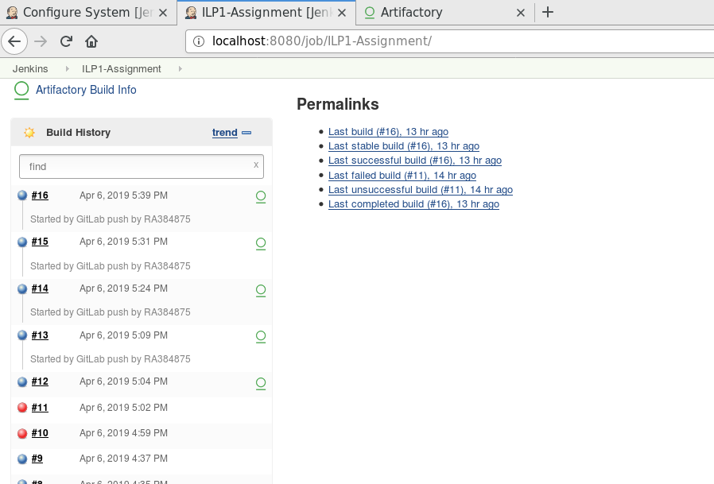

Jenkins SampleOutPut:

Started by GitLab push by RA384875

Building in workspace /var/lib/jenkins/workspace/ILP1-Assignment

[WS-CLEANUP] Deleting project workspace...

[WS-CLEANUP] Deferred wipeout is used...

[WS-CLEANUP] Done

Cloning the remote Git repository

Cloning repository https://topgear-training-gitlab.wipro.com/RA384875/DP-ILP_CI-CD-mywebApp

> git init /var/lib/jenkins/workspace/ILP1-Assignment # timeout=10

Fetching upstream changes from https://topgear-training-gitlab.wipro.com/RA384875/DP-ILP_CI-CD-mywebApp

> git --version # timeout=10

using GIT_ASKPASS to set credentials

Setting http proxy: proxy2.wipro.com:8080

> git fetch --tags --progress https://topgear-training-gitlab.wipro.com/RA384875/DP-ILP_CI-CD-mywebApp +refs/heads/*:refs/remotes/origin/*

> git config remote.origin.url https://topgear-training-gitlab.wipro.com/RA384875/DP-ILP_CI-CD-mywebApp # timeout=10

> git config --add remote.origin.fetch +refs/heads/*:refs/remotes/origin/* # timeout=10

> git config remote.origin.url https://topgear-training-gitlab.wipro.com/RA384875/DP-ILP_CI-CD-mywebApp # timeout=10

Fetching upstream changes from https://topgear-training-gitlab.wipro.com/RA384875/DP-ILP_CI-CD-mywebApp

using GIT_ASKPASS to set credentials

Setting http proxy: proxy2.wipro.com:8080

> git fetch --tags --progress https://topgear-training-gitlab.wipro.com/RA384875/DP-ILP_CI-CD-mywebApp +refs/heads/*:refs/remotes/origin/*

skipping resolution of commit remotes/origin/master, since it originates from another repository

> git rev-parse refs/remotes/origin/master^{commit} # timeout=10

> git rev-parse refs/remotes/origin/origin/master^{commit} # timeout=10

Checking out Revision a4400d921d013a36fb1f653e56030fed3241fbba (refs/remotes/origin/master)

> git config core.sparsecheckout # timeout=10

> git checkout -f a4400d921d013a36fb1f653e56030fed3241fbba

Commit message: "Updated settings.xml"

> git rev-list --no-walk 278e63f197f25546f5f187ee92ec607dfc95b49b # timeout=10

No emails were triggered.

Parsing POMs

Modules changed, recalculating dependency graph

Established TCP socket on 40107

[myWebApp] $ /usr/java/jdk1.8.0_162/bin/java -cp /var/lib/jenkins/plugins/maven-plugin/WEB-INF/lib/maven35-agent-1.12-alpha-1.jar:/opt/apache-maven-3.5.2/boot/plexus-classworlds-2.5.2.jar:/opt/apache-maven-3.5.2/conf/logging jenkins.maven3.agent.Maven35Main /opt/apache-maven-3.5.2 /var/cache/jenkins/war/WEB-INF/lib/remoting-3.14.jar /var/lib/jenkins/plugins/maven-plugin/WEB-INF/lib/maven35-interceptor-1.12-alpha-1.jar /var/lib/jenkins/plugins/maven-plugin/WEB-INF/lib/maven3-interceptor-commons-1.12-alpha-1.jar 40107

<===[JENKINS REMOTING CAPACITY]===>channel started

Executing Maven: -B -f /var/lib/jenkins/workspace/ILP1-Assignment/myWebApp/pom.xml clean install -Dbuild.number=17

[INFO] Scanning for projects...

[WARNING]

[WARNING] Some problems were encountered while building the effective model for SampleApp-ILP-CI-CD:SampleApp:war:17

[WARNING] 'version' contains an expression but should be a constant. @ SampleApp-ILP-CI-CD:SampleApp:${BUILD_NUMBER}, /var/lib/jenkins/workspace/ILP1-Assignment/myWebApp/pom.xml, line 5, column 12

[WARNING]

[WARNING] It is highly recommended to fix these problems because they threaten the stability of your build.

[WARNING]

[WARNING] For this reason, future Maven versions might no longer support building such malformed projects.

[WARNING]

[INFO] Initializing Artifactory Build-Info Recording

[HUDSON] Collecting dependencies info

[INFO]

[INFO] ------------------------------------------------------------------------

[INFO] Building SampleApp 17

[INFO] ------------------------------------------------------------------------

[INFO]

[INFO] --- maven-clean-plugin:2.5:clean (default-clean) @ SampleApp ---

[INFO]

[INFO] --- maven-resources-plugin:2.6:resources (default-resources) @ SampleApp ---

[WARNING] Using platform encoding (UTF-8 actually) to copy filtered resources, i.e. build is platform dependent!

[INFO] skip non existing resourceDirectory /var/lib/jenkins/workspace/ILP1-Assignment/myWebApp/src/main/resources

[INFO]

[INFO] --- maven-compiler-plugin:3.1:compile (default-compile) @ SampleApp ---

[INFO] Changes detected - recompiling the module!

[WARNING] File encoding has not been set, using platform encoding UTF-8, i.e. build is platform dependent!

[INFO] Compiling 3 source files to /var/lib/jenkins/workspace/ILP1-Assignment/myWebApp/target/classes

[INFO]

[INFO] --- maven-resources-plugin:2.6:testResources (default-testResources) @ SampleApp ---

[WARNING] Using platform encoding (UTF-8 actually) to copy filtered resources, i.e. build is platform dependent!

[INFO] skip non existing resourceDirectory /var/lib/jenkins/workspace/ILP1-Assignment/myWebApp/src/test/resources

[INFO]

[INFO] --- maven-compiler-plugin:3.1:testCompile (default-testCompile) @ SampleApp ---

[INFO] No sources to compile

[INFO]

[INFO] --- maven-surefire-plugin:2.12.4:test (default-test) @ SampleApp ---

[INFO] No tests to run.

[JENKINS] Recording test results

[INFO]

[INFO] --- maven-war-plugin:2.3:war (default-war) @ SampleApp ---

[INFO] Packaging webapp

[INFO] Assembling webapp [SampleApp] in [/var/lib/jenkins/workspace/ILP1-Assignment/myWebApp/target/SampleApp-17]

[INFO] Processing war project

[INFO] Copying webapp resources [/var/lib/jenkins/workspace/ILP1-Assignment/myWebApp/WebContent]

[INFO] Webapp assembled in [176 msecs]

[INFO] Building war: /var/lib/jenkins/workspace/ILP1-Assignment/myWebApp/target/SampleApp-17.war

[INFO]

[INFO] --- maven-install-plugin:2.4:install (default-install) @ SampleApp ---

[INFO] Installing /var/lib/jenkins/workspace/ILP1-Assignment/myWebApp/target/SampleApp-17.war to /var/lib/jenkins/.m2/repository/SampleApp-ILP-CI-CD/SampleApp/17/SampleApp-17.war

[INFO] Installing /var/lib/jenkins/workspace/ILP1-Assignment/myWebApp/pom.xml to /var/lib/jenkins/.m2/repository/SampleApp-ILP-CI-CD/SampleApp/17/SampleApp-17.pom

[INFO] Artifactory Build Info Recorder: Saving Build Info to '/var/lib/jenkins/workspace/ILP1-Assignment/myWebApp/target/build-info.json'

[INFO] Deploying artifact: http://10.198.110.9:5040/artifactory/example-repo-local/SampleApp-ILP-CI-CD/SampleApp/17/SampleApp-17.war

[INFO] Artifactory Build Info Recorder: Deploying build info ...

[INFO] Deploying build descriptor to: http://10.198.110.9:5040/artifactory/api/build

[INFO] Build successfully deployed. Browse it in Artifactory under http://10.198.110.9:5040/artifactory/webapp/builds/ILP1-Assignment/17

[INFO] ------------------------------------------------------------------------

[INFO] BUILD SUCCESS

[INFO] ------------------------------------------------------------------------

[INFO] Total time: 11.085 s

[INFO] Finished at: 2019-04-07T10:44:53+05:30

[INFO] Final Memory: 24M/191M

[INFO] ------------------------------------------------------------------------

[JENKINS] Archiving /var/lib/jenkins/workspace/ILP1-Assignment/myWebApp/pom.xml to SampleApp-ILP-CI-CD/SampleApp/17/SampleApp-17.pom

[JENKINS] Archiving /var/lib/jenkins/workspace/ILP1-Assignment/myWebApp/target/SampleApp-17.war to SampleApp-ILP-CI-CD/SampleApp/17/SampleApp-17.war

channel stopped

INFO: Starting to record.

INFO: Processing JUnit

INFO: [JUnit] - 7 test report file(s) were found with the pattern 'myWebApp/\${reports}/*.html' relative to '/var/lib/jenkins/workspace/ILP1-Assignment' for the testing framework 'JUnit'.

WARNING: The file '/var/lib/jenkins/workspace/ILP1-Assignment/myWebApp/${reports}/all-tests.html' is an invalid file.

WARNING: At line 1 of file:/var/lib/jenkins/workspace/ILP1-Assignment/myWebApp/$%7Breports%7D/all-tests.html:cvc-elt.1: Cannot find the declaration of element 'html'.

WARNING: At line 6 of file:/var/lib/jenkins/workspace/ILP1-Assignment/myWebApp/$%7Breports%7D/all-tests.html:The element type "link" must be terminated by the matching end-tag "</link>".

WARNING: Technical validation:The element type "link" must be terminated by the matching end-tag "</link>".

WARNING: The result file '/var/lib/jenkins/workspace/ILP1-Assignment/myWebApp/${reports}/all-tests.html' for the metric 'JUnit' is not valid. The result file has been skipped.

WARNING: The file '/var/lib/jenkins/workspace/ILP1-Assignment/myWebApp/${reports}/allclasses-frame.html' is an invalid file.

WARNING: At line 1 of file:/var/lib/jenkins/workspace/ILP1-Assignment/myWebApp/$%7Breports%7D/allclasses-frame.html:cvc-elt.1: Cannot find the declaration of element 'html'.

WARNING: At line 6 of file:/var/lib/jenkins/workspace/ILP1-Assignment/myWebApp/$%7Breports%7D/allclasses-frame.html:The element type "link" must be terminated by the matching end-tag "</link>".

WARNING: Technical validation:The element type "link" must be terminated by the matching end-tag "</link>".

WARNING: The result file '/var/lib/jenkins/workspace/ILP1-Assignment/myWebApp/${reports}/allclasses-frame.html' for the metric 'JUnit' is not valid. The result file has been skipped.

WARNING: The file '/var/lib/jenkins/workspace/ILP1-Assignment/myWebApp/${reports}/alltests-errors.html' is an invalid file.

WARNING: At line 1 of file:/var/lib/jenkins/workspace/ILP1-Assignment/myWebApp/$%7Breports%7D/alltests-errors.html:cvc-elt.1: Cannot find the declaration of element 'html'.

WARNING: At line 6 of file:/var/lib/jenkins/workspace/ILP1-Assignment/myWebApp/$%7Breports%7D/alltests-errors.html:The element type "link" must be terminated by the matching end-tag "</link>".

WARNING: Technical validation:The element type "link" must be terminated by the matching end-tag "</link>".

WARNING: The result file '/var/lib/jenkins/workspace/ILP1-Assignment/myWebApp/${reports}/alltests-errors.html' for the metric 'JUnit' is not valid. The result file has been skipped.

WARNING: The file '/var/lib/jenkins/workspace/ILP1-Assignment/myWebApp/${reports}/alltests-fails.html' is an invalid file.

WARNING: At line 1 of file:/var/lib/jenkins/workspace/ILP1-Assignment/myWebApp/$%7Breports%7D/alltests-fails.html:cvc-elt.1: Cannot find the declaration of element 'html'.

WARNING: At line 6 of file:/var/lib/jenkins/workspace/ILP1-Assignment/myWebApp/$%7Breports%7D/alltests-fails.html:The element type "link" must be terminated by the matching end-tag "</link>".

WARNING: Technical validation:The element type "link" must be terminated by the matching end-tag "</link>".

WARNING: The result file '/var/lib/jenkins/workspace/ILP1-Assignment/myWebApp/${reports}/alltests-fails.html' for the metric 'JUnit' is not valid. The result file has been skipped.

WARNING: The file '/var/lib/jenkins/workspace/ILP1-Assignment/myWebApp/${reports}/index.html' is an invalid file.

WARNING: At line 1 of file:/var/lib/jenkins/workspace/ILP1-Assignment/myWebApp/$%7Breports%7D/index.html:cvc-elt.1: Cannot find the declaration of element 'html'.

WARNING: At line 5 of file:/var/lib/jenkins/workspace/ILP1-Assignment/myWebApp/$%7Breports%7D/index.html:The element type "META" must be terminated by the matching end-tag "</META>".

WARNING: Technical validation:The element type "META" must be terminated by the matching end-tag "</META>".

WARNING: The result file '/var/lib/jenkins/workspace/ILP1-Assignment/myWebApp/${reports}/index.html' for the metric 'JUnit' is not valid. The result file has been skipped.

WARNING: The file '/var/lib/jenkins/workspace/ILP1-Assignment/myWebApp/${reports}/overview-frame.html' is an invalid file.

WARNING: At line 1 of file:/var/lib/jenkins/workspace/ILP1-Assignment/myWebApp/$%7Breports%7D/overview-frame.html:cvc-elt.1: Cannot find the declaration of element 'html'.

WARNING: At line 6 of file:/var/lib/jenkins/workspace/ILP1-Assignment/myWebApp/$%7Breports%7D/overview-frame.html:The element type "link" must be terminated by the matching end-tag "</link>".

WARNING: Technical validation:The element type "link" must be terminated by the matching end-tag "</link>".

WARNING: The result file '/var/lib/jenkins/workspace/ILP1-Assignment/myWebApp/${reports}/overview-frame.html' for the metric 'JUnit' is not valid. The result file has been skipped.

WARNING: The file '/var/lib/jenkins/workspace/ILP1-Assignment/myWebApp/${reports}/overview-summary.html' is an invalid file.

WARNING: At line 1 of file:/var/lib/jenkins/workspace/ILP1-Assignment/myWebApp/$%7Breports%7D/overview-summary.html:cvc-elt.1: Cannot find the declaration of element 'html'.

WARNING: At line 6 of file:/var/lib/jenkins/workspace/ILP1-Assignment/myWebApp/$%7Breports%7D/overview-summary.html:The element type "link" must be terminated by the matching end-tag "</link>".

WARNING: Technical validation:The element type "link" must be terminated by the matching end-tag "</link>".

WARNING: The result file '/var/lib/jenkins/workspace/ILP1-Assignment/myWebApp/${reports}/overview-summary.html' for the metric 'JUnit' is not valid. The result file has been skipped.

INFO: Skipping tests recording.

Email was triggered for: Success

Sending email for trigger: Success

Sending email to: avinash.patel@wipro.com raghavendran.sethumadhavan1@wipro.com ramesh.rajamani@wipro.com ramesh.kasinathan@wipro.om

Finished: SUCCESS

Jfrog – Deployment History:

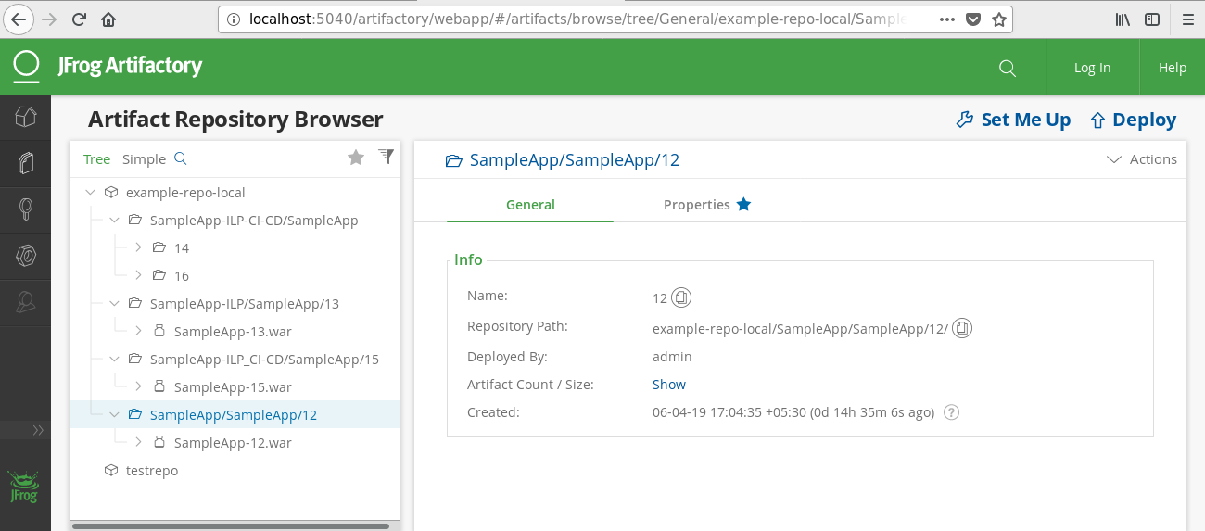

Application Output:

