gRPC
(Google Remote Procedure Call)

[gRPC official website]
-- https://grpc.io

[download link]
-- https://pecl.php.net/package/grpc
-- select/click DLL (icon)
-- 8.2 Thread Safe (TS) x64 (your local machine compatible)
extract and unzip folder
-- paste on 'DLL' file inside (.\wampserver64\bin\php\php8.2.13\ext) folder
-- add/enable inside file (.\wampserver64\bin\apache\apache2.4.58\bin\php.ini)
extension=grpc

[download protoc exe file and config env path in your local machine]
Url: https://github.com/protocolbuffers/protobuf/releases [assets]
-- protoc-28.3-win64.zip
config env path eg.
-- .\..\..\protoc-29.3\bin

[How Config Laravel Project setup gRPC]
-- You have create/existing laravel 12 api project.

[Install google protobuf]
Url: https://packagist.org/packages/google/protobuf
-- composer require google/protobuf

[create/make 'protoc' directive in root folder]
- protoc
application.proto
gen-proto.sh

[go to protoc inside 'folder' run git bash cli window]
-- ./gen-proto.sh

Rest Api v/s gRPC
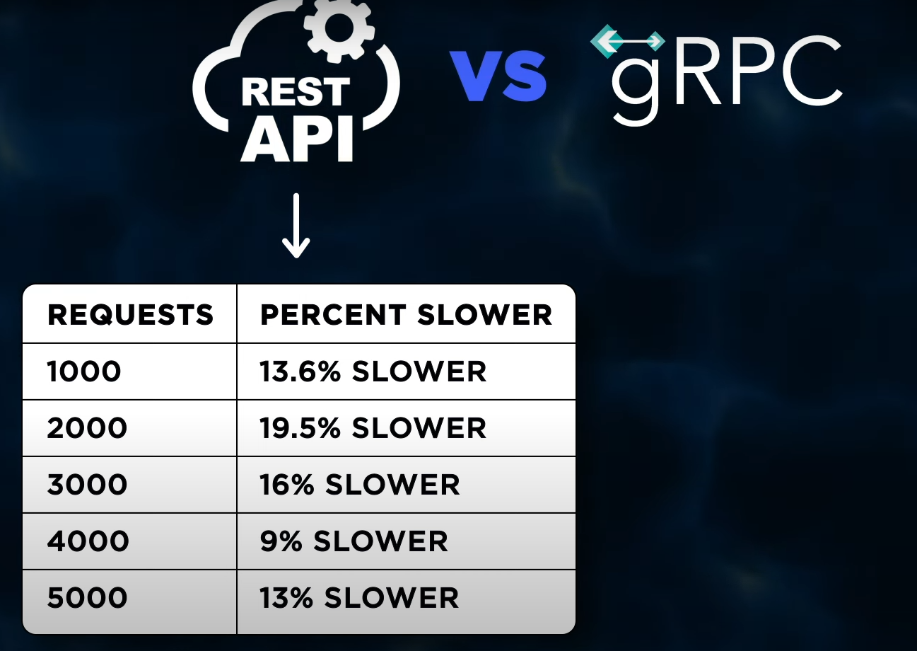

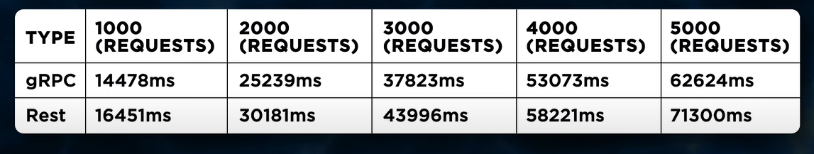

What’s the Difference Between gRPC and REST ?
-- https://aws.amazon.com/compare/the-difference-between-grpc-and-rest/

Companies using gRPC
Netflix: Uses gRPC along with HTTP/HTTPS, Apache Kafka, and custom protocols to support its streaming platform

Dropbox: Migrated their RPC framework to gRPC because it aligned with their existing custom RPC frameworks

Square: Uses gRPC to build scalable and fast APIs
Warner Bros. Discovery: A global media and entertainment company that uses gRPC

BigCommerce: An open SaaS solution that helps merchants sell more
Liftoff: Helps advertisers, publishers, and game developers scale revenue growth

Comcast Advertising: Drives the TV advertising industry
Optimize Health: A remote care vendor that uses technology and real-time data to treat patients

Trumid: A fintech company building a credit trading network

What is Protobuf ?

Protobuf, which is short for “Protocol Buffers,” is an efficient, language-agnostic data serialization mechanism. It enables developers to define structured data in a .proto file, which is then used to generate source code that can write and read data from different data streams.

History of Protobuf

Google before being released as an open source project in 2008. The initial public release—known as Proto2—included a basic serialization framework and support for a select number of programming languages, such as Python, C++, and Java.

In 2015, Google released gRPC

How does Protobuf work ?
Protobuf uses a binary data format, which is more compact and faster to read and write than text-based formats. It also provides an interface definition language (IDL) that makes it easy to define the structure of the data to be serialized.

A Protobuf file is saved using the .proto file extension. The .proto file is written in Protobuf’s IDL format, and it contains all of the information about the structure of the data. The data is modeled as “messages,” which are groups of name-value pairs. Here’s an example of a simple Protobuf message in a .proto file:
syntax = "proto3";

message Customer {
required int32 id = 1;
required string name = 2;
required string email = 3;
optional string address = 4;
}

gRPC Source:
https://medium.com/@cobch7/what-is-grpc-94e232010547

