Unliquidated Obligations

Version 1.0
June 2008

Revision History
Date | Version | Description | Author
June 2008 | 1.0 | First Draft, PFF procedures only | Pat Everett, Tech Writer

Table of Contents
1. Introduction 4
1.1 Roles 4
1.2 PFF Workflow 5
1.3 Accessing ULO 5
2. Navigating through the Open Items List 6
3. Assigning and Reassigning OIs to Reviewers (All Users) 7
To assign or reroute a New Item OI 7
To reassign an OI within your organization 7
To reassign an OI within your organization 8
To reroute an OI to the Budget Division 8
To verify a reassignment 9
4. Validating/invalidating OIs (Reviewers) 10
4.1 Open Item Review Fields 11
4.2 Document Fields 11
4.3 Line Item Fields 11
To change a OI Line Item’s information 12
To validate or invalidate a line item 14
To view an OI’s or Line Item’s review history 15
To confirm a deobligation 16
5. Running reports 17
Appendix A, ULO Field Codes 18
Status 18
Deobligation Codes 18
Justification 19

Introduction
An open item is an unpaid balance on an original purchase order or a contract award plus all modifications. An OI balance consists of two parts:
- Undelivered orders (UDO), obligations for goods that have not been delivered or services that have not been performed. Payments for these orders have been obligated but not prepaid or advanced.

- Delivered orders (DO), unpaid expenditures for goods or tangible property that have been received or for services performed.

An OI review validates whether the current balances on the OI and its line items are correct and whether the OI and all its line items are stated properly.
NOTE: Business policies, not the application, define how UDOs and Dos relate to each other and to the Total Line Amount. Therefore, the total of a UDO and a DO may NOT equal the Total Line Amount, especially if the OI has several line items.
The web-based Unliquidated Obligations (ULO) application expedites these reviews. The application tracks each OI’s progress from the time it appears an Excel spreadsheet from the Central Office or Region 7 through its reviews in the Budget Division and at the Service Center. The application continues tracking each open item as it returns to the Central Office.
The Budget Division receives the OIs from the Central Office and Region 7 in three types of spreadsheet files:
- PFF, which requires a simple review to determine whether each OI is valid or invalid.
- Sample OIs, which may require specific documentation to support validation.
Audit OIs, which may require specific documentation to support validation.
NOTE: This version of the Unliquidated Obligations User Manual is only for PFF files.

Roles
The ULO application has three types of users:
- Organization Administrator, who assigns OIs to individual reviewers within a service center’s organizations.
- BD Administrator, who oversees the work by assigning OIs to service centers and confirming deobilgations after reviewers have invalidated an OI.
- Reviewer, who completes the actual reviews of OIs and their line items to determine whether they are valid, and need to stay open, or are invalid, and can be closed. A reviewer can also suggest that an OI be assigned to a different reviewer, either within the original reviewer’s organization or in another organization.

NOTE: Organization Administrators can also review OIs, and the BD Administrator can perform all the Organization Administrator’s and Reviewer’s tasks.

PFF Workflow
When an OI is uploaded into ULO for review, it follows a certain workflow:
- The OI is uploaded into the ULO database as a part of the PFF file. The review of the OI’s line items is assigned to one or more Organizations.
- The Organization Administrator assigns the OI to an individual reviewer within the Administrator’s Organization. Or, he reroutes it to another Organization. The BD Administrator must approve the rerouting to another organization.
- The reviewer determines the current UDO and DO for each line item in OI.
- The reviewer determines that a line item is valid—it remains open with an unpaid balance. Or, the reviewer determines that a line item is invalid—it must be closed and deobligated.
- If at least one line item in the OI is valid at the end of the review, the OI will remain open.
If all line items are invalid at the end of the review, the review must deobligate the OI in Pegasys, and the BD Administrator must confirm the deobligation.
- The BD Administrator sends a report with the review findings back to the Central Office.

Accessing ULO
The ULO application is web-based. To access ULO, open your web browser and type the following URL: http://p1130s-webstg01/OpenItems/Logon.aspx
Or go through GSA’s Insite: WHAT ARE THE LINKS?
On the login page, type your username and password. The username is the first part of your GSA e-mail address, for example, john.daniels from the address john.daniels@gsa.gov
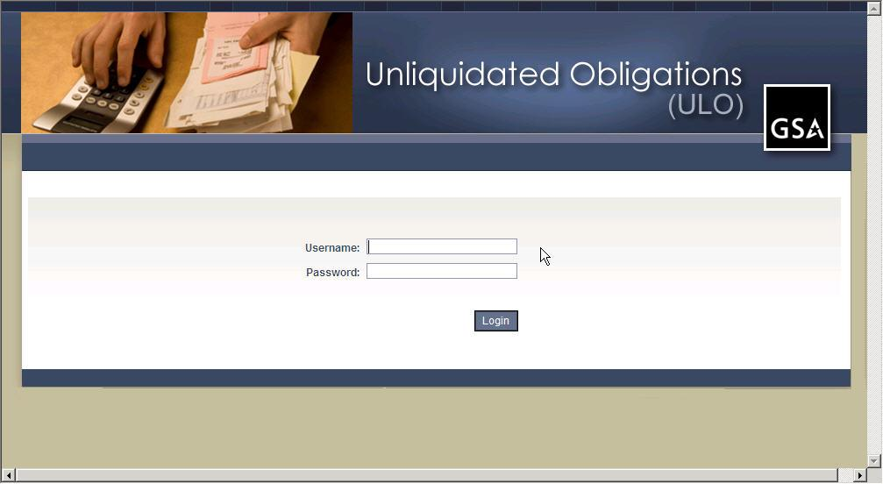

Navigating through the Open Items List
When you first log in to ULO, you will see the Open Items List, which includes all OIs that were received by the most recent date in Received Date, according to your role.
The BD Administrator’s default list is the Total Universe for the current load, or review.
The Organization Administrator’s is the Organization’s OI in the current review.
Each Reviewer’s is My Workload, or the OIs that have been assigned to the reviewer in the current review. The menu also varies with the user’s role.
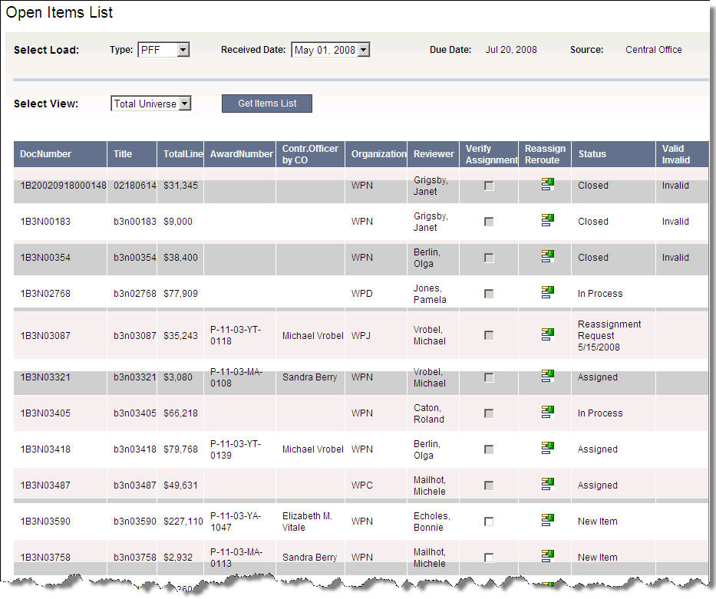
- To view OIs from a different data load, select a Type and Received Date using the drop-down menu. These appear in the row for Select Load.
- To view OIs for a different organization or the Total Universe, select an option using the drop-down menu next to Select View, then click Get Items List.
- To sort OIs by a column, click on the column title.

Assigning and Reassigning OIs to Reviewers
(All Users)
When data are uploaded, each OI is automatically assigned to an Organization. Then Organization Administrators assigns each OI within their organizations to individual reviewers. (The BD Administrator assigns OIs to reviewers in WPN.)
If the Organization Administrator decides that the OI must be reviewed by another Organization, she must notify the BD Administrator of the needed reassignment.
- Reassigning means that the OI will be assigned to someone within the organization where the OI is already assigned.
- Rerouting means that the OI will be assigned to someone in another organization.
Once a reviewer is assigned to an OI, the OI appears in his My Workload on the Open Items Details page.
To assign or reroute a New Item OI
- From the Open Items List or the Open Items Details, click the Reassign or Reroute Item icon to open the Reassign Reviewer window.
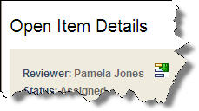
- If the OI is to be assigned to someone within your organization, go to To reassign an OI within your organization.
Or, if the OI is to be assigned to another organization, go to To reroute an OI to the Budget Division.

To reassign an OI within your organization

First select the Open Item from the Open Items List and click the Reassign icon.
Or, go to the Open Item Details page, then click the Reassign icon next to the reviewer’s name.
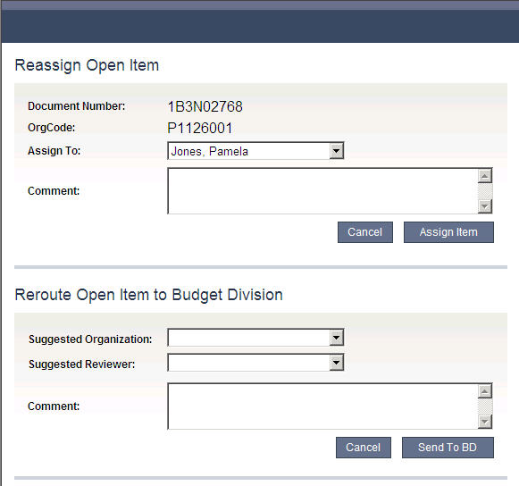
- In the top section of the Reassign Reviewer window, choose a name from the drop-down list next to Assign To:
- Type a Comment as needed.
- Click Assign Item.
The item will be assigned to the designated reviewer. The reviewer will be notified by an e-mail, and he can see it in My Workload list when he logs in.

To reroute an OI to the Budget Division
First select the Open Item from the Open Items List and click the Reassign icon.
- In the bottom section of the Reassign Reviewer window, choose names from the drop-down list next to Suggested Organization and Suggested Reviewer.
- Type a Comment as needed.
- Click Send to BD.
Once the OI appears in the list of disputed assignments, the BD will need to verify or redirect the reassignment.
After the BD Administrator verifies the rerouting, the OI will be assigned to the designated reviewer. The new reviewer will be notified by an e-mail, and he can see it in My Workload list when he logs in, and the OI will disappear from the original reviewer’s workload.
To verify a reassignment
Only the BD Administrator can verify a reassignment.
- Log in as the BD Administrator.
- Click Disputed Assignments on the top menu line to go to the list of reassignments.

- From the Reassignment Requests List, select Load and View from the drop-down boxes.
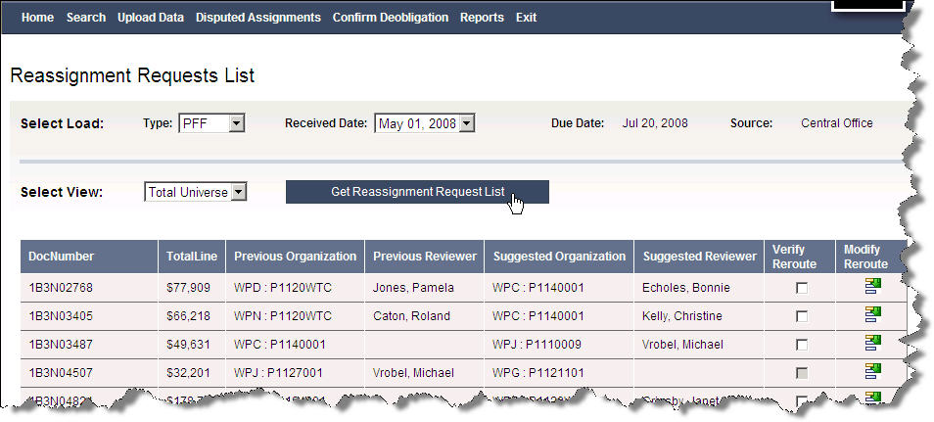
- Click Get Reassignment Request List to get a list of the requests that you want.
- To accept the suggested reassignment, click Verify Reroute.
The OI is assigned as requested.
- To reassign of the OI elsewhere, click the Reassign icon under Modify Reroute.
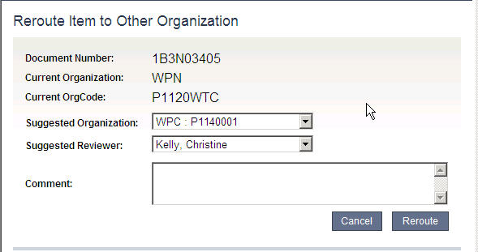
- When the Reroute Item window opens, choose a Suggested Organization and Suggested Reviewer.
- Type Comments as needed.
- Click Reroute, then Verify Reroute on the Reassignment Requests list.
The item will be assigned to the designated reviewer. The reviewer will be notified by an e-mail, and he can see it in My Workload list when he logs in.

Validating/invalidating OIs
(Reviewers)
An OI is an unpaid balance on a purchase order or a contract award plus all modifications. An OI balance consists of two parts:
- Undelivered orders (UDO), unexpended obligations for goods that have not been delivered or services that have not been performed.
- Delivered orders (DO), unpaid expenditures for goods received or good and tangible property that have been received or for services performed.

A reviewer records whether each OI assigned to his or her workload is
- Valid—and therefore is to remain open.
- Invalid—and therefore is closed.
Use this application to record current balances for UDOs and Dos to help assist with OI validations and deobligations.

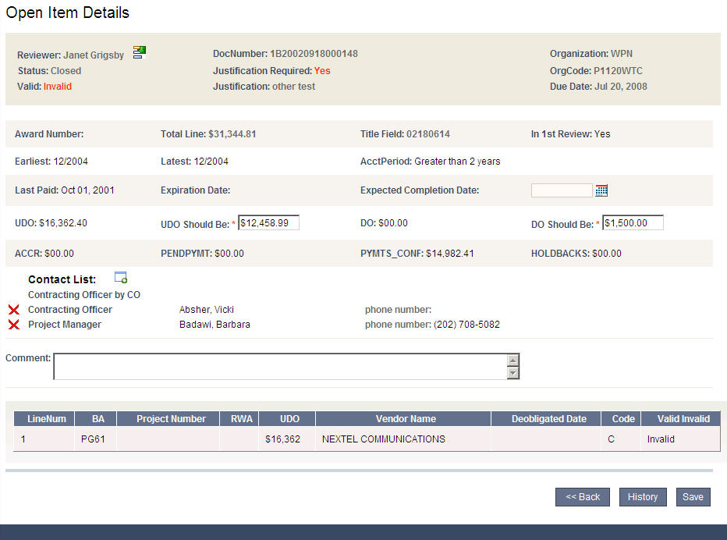

Open Item Review Fields
The following fields describe the Open Item review:
- Reviewer, the person who assigned to review this OI’sfor this load.
- Status, step in the review process: New Item (assigned or unassigned), Assigned, In Process, or Closed.
- Valid, determination of whether the OI is Valid or Invalid. This remains blank until the review is closed.
- DocNumber, unique ID for the OI. It comes from the file source.
- Justification Required, a Yes/No designation from the file source. Justification, the reason the OI is valid or invalid.
- Organization, the GSA group that is to conduct the OI review.
- OrgCode, the reviewing organization’s GSA code.
- Due Date, the date when the review must be completed.

Document Fields
The fields in this section are mostly from the source file. The reviewer uses most of these to assist with the research for the OI’s validity. However, updates are required for
- UDO Should Be, the current unpaid balance for undelivered goods or services.
- DO Should Be, the current unpaid balance for delivered goods or services.
- Expected Completion Date, the anticipated date that the OI work will be finished.
- Contact List, persons to contact about the OI. These come from the source file or can be added through ULO. The ones added through ULO can be deleted by clicking on the big red X next to the name.

Line Item Fields
These fields describe the line item, including the GSA and Vendor information, as well as codes designating the reason for the deobligation.

To change an OI’s information
- From My Workload, click the row of an OI to open the Open Item Details.
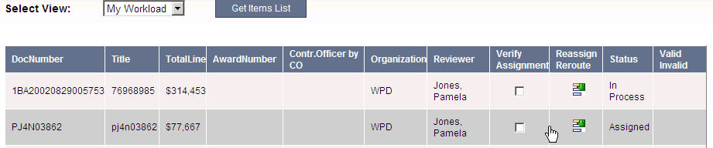
- Type UDO Should Be and DO Should Be.
NOTE: These fields are required, so type an amount, even if it is the same as the UDO or DO already on the page, or it is zero (0). If you do NOT add information for both of these, you will not be able to update the Line Item on its detail page.
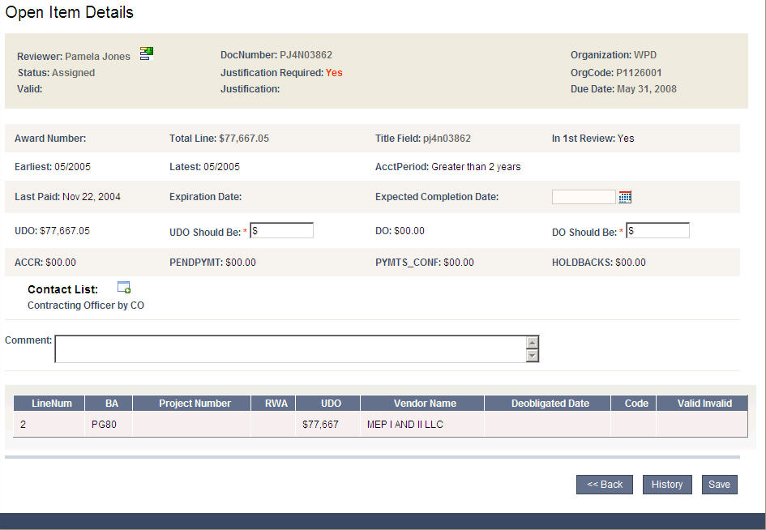
- Click the Line Item to be updated to open the Line Item Details. When the details page opens, the amounts you entered in UDO Should Be and DO Should Be on the previous page appear here. (If they do NOT, return to the Open Item Details page and fill them in as noted above.)
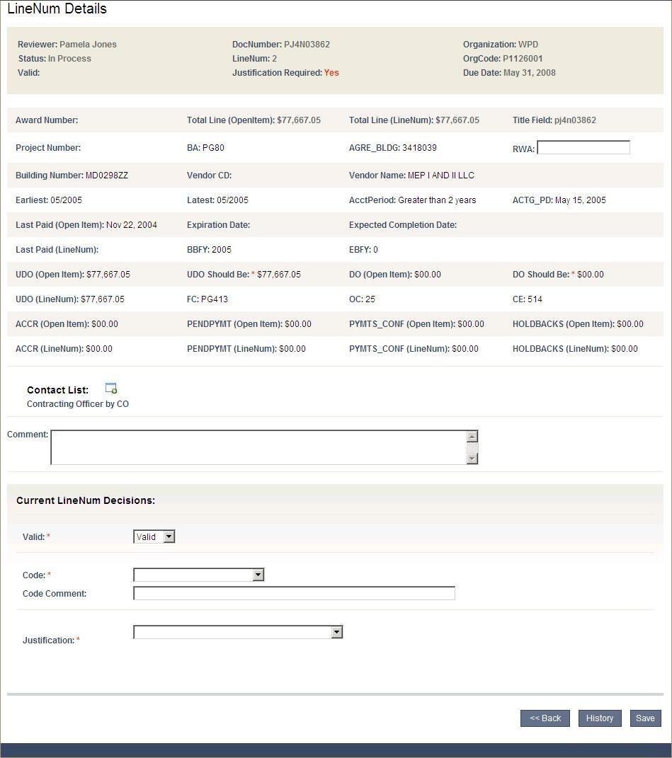
- Type in RWA number. (Optional)
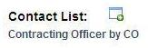
- Select Expected Completion Date. (Required)
- Click Contact List icon to choose a Project Manager or Contracting Officer who can discuss the Open Item if questions arise. (Optional)
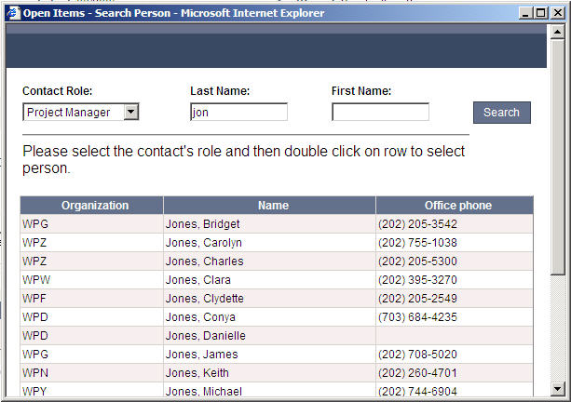
- In the Contact List window, choose Project Manager or Contracting Officer.
- Type as much of the Last Name and First Name as you know.
- Click Search.
- Double click the contact’s name to add name to the Line Item and close the window.
- Click Save, if you are not ready to validate or invalidate.
Or, continue with To validate or invalidate a line item.
If you save your change, they will appear with the Line Item on the Open Item Details page and the OI’s Status will be changed to In Process.
To validate or invalidate a line item
NOTE: If you are not already on the LineNum Details page, choose the line item from the Open Details page.
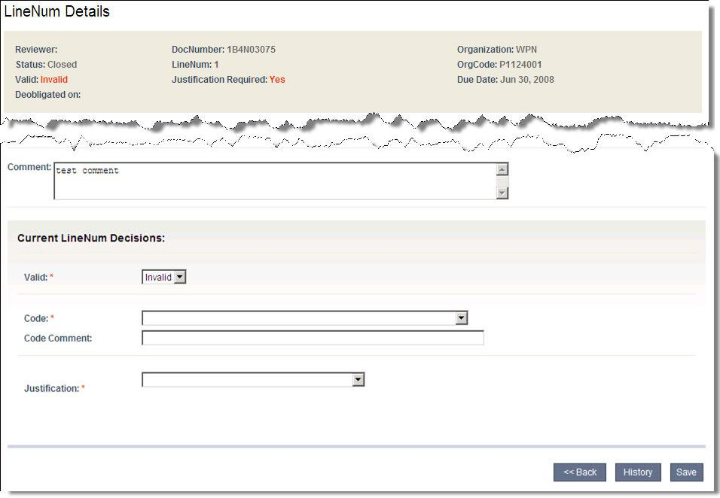
- Choose Valid or Invalid in the drop-box. (Required)
- If Justification Required Is Yes on the Open Items Detail page, choose a Justification from the drop-down box.
Justification choices depend on whether the OI is Valid or Invalid. Once you choose a justification, add any information as directed.
- Click Save.
Once you save a line item, the following may occur:
- If the Line Item is Valid, the OI remains valid and open.
- If the Line Item is Invalid:
- If other Line Items for the OI are still valid, the OI remains valid and open until all Line Items are closed.
- If it is the only line item for the OI, or it is the last one to be closed, the OI itself is closed.
Once closed, the OI must be deobligated. The BD Administrator must confirm all deobligations.
To view an OI’s or Line Item’s review history
- To view actions from previous reviews, click History on the Open Item Details or Line Item Details page.
- Click Close to return to the previous page.
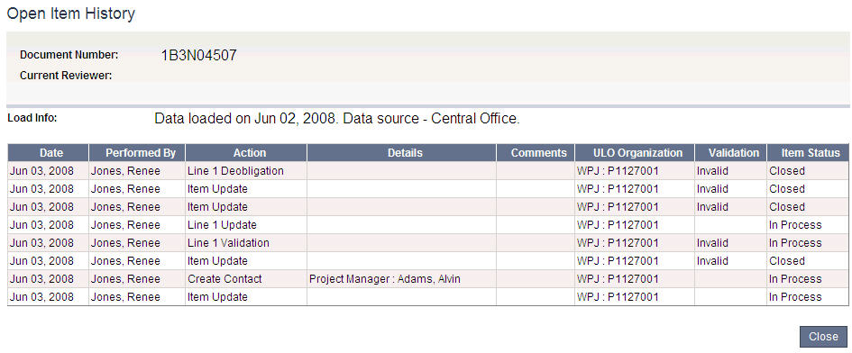

Confirming Deobligations of Invalid Open Items
(BD Administrator)
Once a reviewer, or several reviewers, has determined all line items for an OI are invalid, the BD Administrator must confirm the deobligation.
To confirm a deobligation
- As the BD Administrator, click Confirm Deobligation to retrieve a list of invalid OIs.
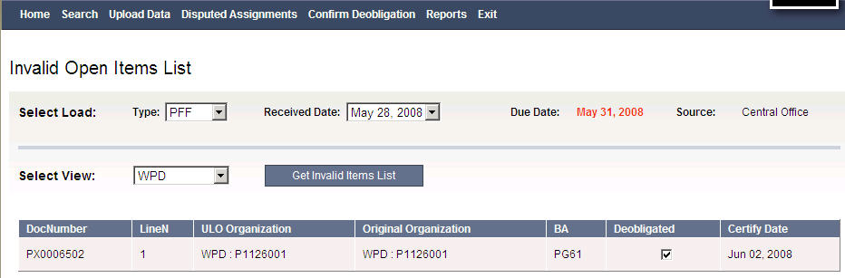
- Select your Load and View.
- When the list of Invalid Open Items appears, check Deobligated to confirm that the OI is invalid.

Running reports
From the BD Administrator’s menu line, click Reports to view a list of reports. Click the Report title to create an Excel spreadsheet.
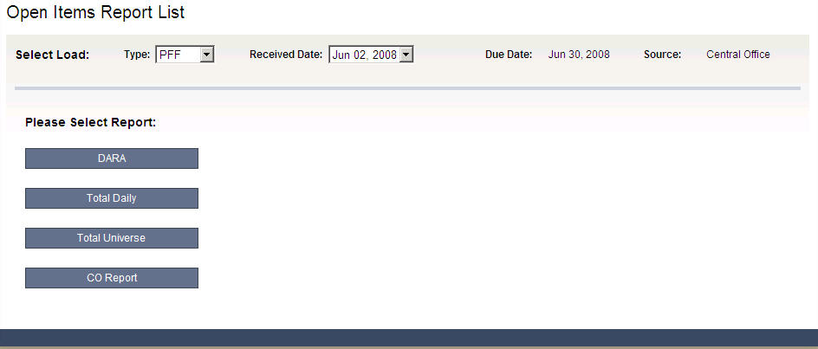
- DARA
- Total Daily
- Total Universe
- CO Report

Appendix A, ULO Field Codes
The following tables and lists include codes and definitions for various ULO data:

Status
New Item, an OI that has appeared in ULO for the first time and has yet to be assigned to an individual review
Assigned, the OI has been assigned to an individual reviewer for this data upload but has the review has not started yet
Reassignment Request, the OI assignment needs to be changed
In Process, the OI review for this data upload has begun but additional data are needed (This can mean that one or more line items has been reviewed but reviews of one or more line items are still pending.)
Completed, the OI review is complete and ready for verification. (This means all line items have been validated or invalidated in this data upload.)

Deobligation Codes
Code  Valid | Description
Correct | Correct
B | Move Dollars from UDO to DO
Invalid
A1 | Deobligate (PY funds)
A2 | Deobligate (CY funds)
C | Move dollars from DO to UDO
D | Additional UDO is needed (new obligation)
E | Additional DO is needed (new obligation)
Needs research See remarks | Additional follow-up research is needed before determination can be made.

Justification
Justification | Additional Information Needed
The contract is not complete and work is ongoing.
The service period has not expired.
Contractor has filed claim against GSA. | Please provide claim #
Waiting on release of claims from vendor. | Please provide the last communication date between the contracting officer and vendor.
There has been no recent activity. | Please provide the time frame for the notice to be issued with the next few days.
Other | Description of justification

