**Topics: Descriptive Statistics and Probability**

1. Look at the data given below. Plot the data, find the outliers and find out $μ, σ, σ^{2}$

|  |  |
| --- | --- |
| **Name of company** | **Measure X** |
| Allied Signal | 24.23% |
| Bankers Trust | 25.53% |
| General Mills | 25.41% |
| ITT Industries | 24.14% |
| J.P.Morgan & Co. | 29.62% |
| Lehman Brothers | 28.25% |
| Marriott | 25.81% |
| MCI | 24.39% |
| Merrill Lynch | 40.26% |
| Microsoft | 32.95% |
| Morgan Stanley | 91.36% |
| Sun Microsystems | 25.99% |
| Travelers | 39.42% |
| US Airways | 26.71% |
| Warner-Lambert | 35.00% |

**Solution :Mean( $μ$)= sum of the terms / number of terms = 33.27133**

**Variance :**

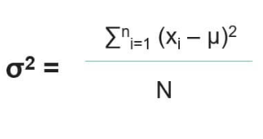

**Variance ($σ^{2})$ =268.0035049**

**Std deviation ( $, σ)$ = root of variance = 16.37081**

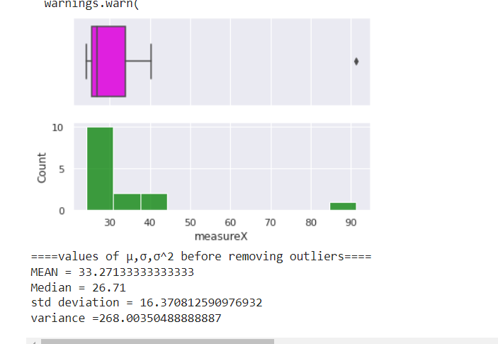

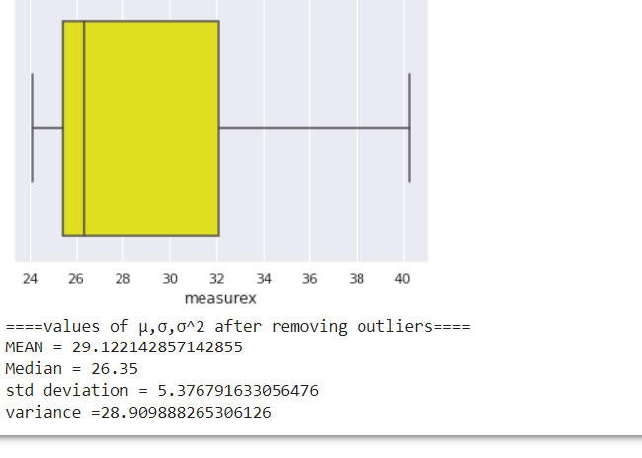



Answer the following three questions based on the box-plot above.

1. What is inter-quartile range of this dataset? (please approximate the numbers) In one line, explain what this value implies.

**ANS : Q1= 5,Q3=13 ,(approximately ) hence Interquartile range = Q3-Q1 =13-5 =8**

**50 % of the values lies between range 8**

1. What can we say about the skewness of this dataset?

**This dataset shows positive skewness**

1. If it was found that the data point with the value 25 is actually 2.5, how would the new box-plot be affected?

**I will not be affected since 2.5 lies in the whisker space.**



Answer the following three questions based on the histogram above.

1. Where would the mode of this dataset lie?

**Mode of the data set could be 5.5 or 6 approximately**

1. Comment on the skewness of the dataset.

**The data shows positive skewness with right tailed.**

1. Suppose that the above histogram and the box-plot in question 2 are plotted for the same dataset. Explain how these graphs complement each other in providing information about any dataset.
   * + **Both of them will clearly show the ouliers to the right ends of histogram and upper fence of the box plot .**
     + **It shows the right skewness since histogram shows a sharp curve at the right similarly in the box plot the median will be at the lower end thus highlighting that there is a positive skewness.**
     + **Also in both histogram more concentration of bars on the left and the longer whisker at the bottom tail shows the data concentration is more towards the left.**
2. AT&T was running commercials in 1990 aimed at luring back customers who had switched to one of the other long-distance phone service providers. One such commercial shows a businessman trying to reach Phoenix and mistakenly getting Fiji, where a half-naked native on a beach responds incomprehensibly in Polynesian. When asked about this advertisement, AT&T admitted that the portrayed incident did not actually take place but added that this was an enactment of something that “could happen.” Suppose that one in 200 long-distance telephone calls is misdirected. What is the probability that at least one in five attempted telephone calls reaches the wrong number? (Assume independence of attempts.)

**probability of p = 1 /200 = .005 , q= 1 - .005 = 0.995**

**Hence the FORMULA IS p (5) = nCr Pr q (n-r)**

**=5 C1 (0.995 ) (0.005)**

**= 5! /4! (0.995 ) (0.005)**

The probability that at least one in five attempted telephone calls reaches the wrong number **=**

**0.0245037375156**

1. Returns on a certain business venture, to the nearest $1,000, are known to follow the following probability distribution

|  |  |  |  |
| --- | --- | --- | --- |
| X | P(x) | Xi pi | (xi- mean)2 |
| -2,000 | 0.1 | -200 | (-2000-800 )2 =2242000 |
| -1,000 | 0.1 | -100 | 3240000 |
| 0 | 0.2 | 0 | 640000 |
| 1000 | 0.2 | 200 | 40000 |
| 2000 | 0.3 | 600 | 1440000 |
| 3000 | 0.1 | 300 | 4840000 |

1. What is the most likely monetary outcome of the business venture? Expected value

**Summation of (xipi) = $800**

1. Is the venture likely to be successful? Explain

**For success we will consider the probability where business shows returns =**

**0.2+0.3+0.1 = 0.6= 60% hence the venture will be successful**

1. What is the long-term average earning of business ventures of this kind? Explain

**HERE long-term average earning means we need to calculate the positive returns average which is 200+600+300 =1100**

1. What is the good measure of the risk involved in a venture of this kind? Compute this measure

**For good measure of the risk involved we need to calculate the std deviation**

* **std deviation =ssqroot (summation (xi- mean)2 /n ) =sqroot (12442000/6) =sqroot 2073667 = $1440.023**