**Topics: Normal distribution, Functions of Random Variables**

1. The time required for servicing transmissions is normally distributed with *μ* = 45 minutes and *σ* = 8 minutes. The service manager plans to have work begin on the transmission of a customer’s car 10 minutes after the car is dropped off and the customer is told that the car will be ready within 1 hour from drop-off. What is the probability that the service manager cannot meet his commitment?

**Solution SINCE THE WORK WILL START AFTER 10 MINUTES THE CAR SHOULD BE READY IN 55 MINUTES SO WE HAVE TO CHECK WHAT IS THE PROBABILITY THAT the manager will not be able to get the car ready within 50 mins ie 60 -10**

**z(X< = 50 ) = 50-45 /8 =0.625**

**using the score table area for z(X< = 50 ) = 0.7324**

**hence we need the area for z(X >50 ) = 1-0.7324 =0.2676**

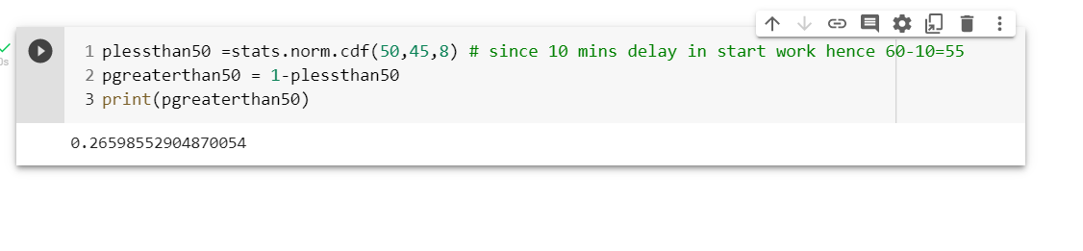

1. 0.3875
2. 0.2676
3. 0.5
4. 0.6987
5. The current age (in years) of 400 clerical employees at an insurance claims processing center is normally distributed with mean *μ* = 38 and Standard deviation *σ* =6. For each statement below, please specify True/False. If false, briefly explain why.

More employees at the processing center are older than 44 than between 38 and 44.

**ANS False since as shown below the (cdf) probability of of employees at the processing center are older than 44 is 0.1587 than between 38 and 44 is 0.3413**

**Solution;A ;- First we find p( x < 40 )**

Z **( x < 44) = 44-38 / 6 = 6/6 = 1**

**Area under** Z **( x < = 44) =** 0.8413

Area under Z **( x > 44) =1-** 0.8413 =0.1587

Area under Z **(38< x < = 44) =** 0.8413 -0.5 =0.3413

Using python code

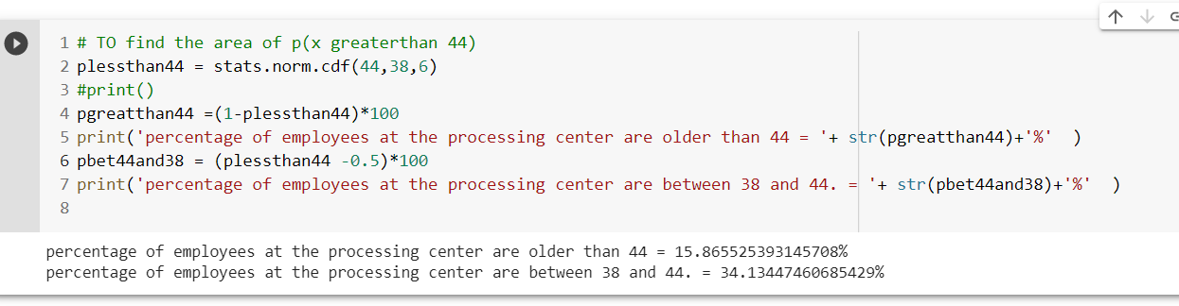

1. A training program for employees under the age of 30 at the center would be expected to attract about 36 employees. - TRUE

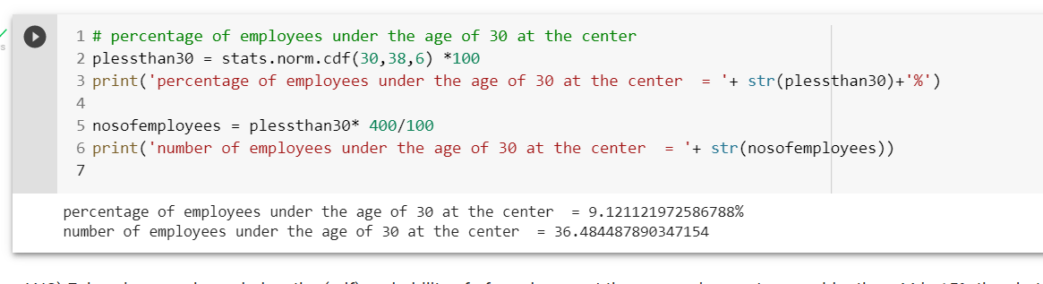

1. If *X1* ~ *N*(μ, σ2) and *X*2 ~ *N*(μ, σ2) are *iid* normal random variables, then what is the difference between 2 *X*1 and *X*1 + *X*2? Discuss both their distributions and parameters.

According to the Central Limit Theorem, any large sum of independent, identically distributed(iid) random variables is approximately Normal.

Normal distribution is defined by 2 parameters .

From the properties of random variable

*X*1 + *X*2 = *N*(μ+ μ, σ2 +σ2)

And 2 *X*1 = *N*(2μ, 4σ2)

the difference between 2 *X*1 and *X*1 + *X*2 = *N*(2 μ-2 μ, 4σ2 -4σ2) = *N(0,0)*

1. Let X ~ N(100, 202). Find two values, *a* and *b*, symmetric about the mean, such that the probability of the random variable taking a value between them is 0.99.

SOLUTION ;= WE NEED Area within the three std deviation as per empirical rule almost 99.7 % data lies between the three std deviation. Hence a = 100-3 *20 =40 and b = 100 + 3 *20 = 160 (APPROX VALUES ) hence D is the answer.

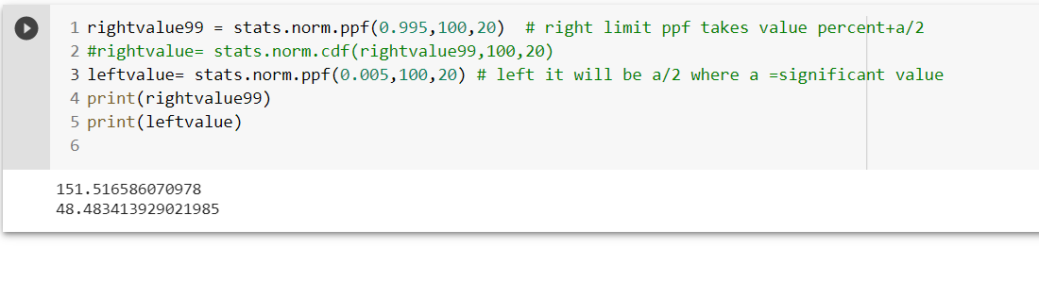

1. 90.5, 105.9
2. 80.2, 119.8
3. 22, 78
4. 48.5, 151.5
5. 90.1, 109.9
6. Consider a company that has two different divisions. The annual profits from the two divisions are independent and have distributions Profit1 ~ N(5, 32) and Profit2 ~ N(7, 42) respectively. Both the profits are in $ Million. Answer the following questions about the total profit of the company in Rupees. Assume that $1 = Rs. 45
7. Specify a Rupee range (centered on the mean) such that it contains 95% probability for the annual profit of the company.
8. Specify the 5th percentile of profit (in Rupees) for the company

[HINT ; INORDER TO FIND THE FIFTH PERCENTILE FROM THE LEFT SIDE WE NEED TO FIND THE DIFFERENCE FROM THE MEAN AND THE 1.5 TH PART OF STD DEVIATION.]

1. Which of the two divisions has a larger probability of making a loss in a given year?

SOLUTION A;= using empirical rule 2 std deviations

**For company 1** - With average=$5 =rs225 and std dev=$3 = 135 in million rupees , 540

ACCORDING to the empirical rule ; (68-95-99.7) 95 % data lies between two std deviation hence we can say that a Rupee range (centered on the mean) such that it contains 95% probability for the annual profit of the company is

(225 -2 * 135) and (225 + 2 * 135) =

Thus the rang e is between [-37 millionrupee , 489 million rupees]

**For company 2** - With average =315 and std dev = 180 in million rupees ,

ACCORDING to the empirical rule ; (68-95-99.7) 95 % data lies between two std deviation hence we can say that a Rupee range (centered on the mean) such that it contains 95% probability for the annual profit of the company is

(315 -2 * 180) and (315 + 2 * 180) =

Thus the rang e is between [-37 millionrupee , 675 million rupees]

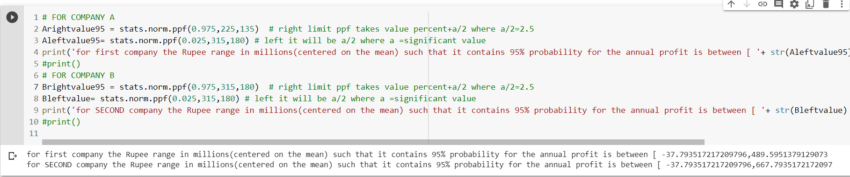

Need CHECK SOLUTION C;= BOTH HAVE EQUAL PROBABILITY OF MAKING LOSS OF RANGE BETWEEN [-37 millionrupee , ] Need CHECK WHAT WILL BE THE LOWER RANGE SINCE ITS MILLION WE HAVE TO CONSIDER A SMALLEST CHANGE SO SHOULD WE SAY 0 MILLION TO [-437millionrupee