Data

The dataset was got from TRF and the historic yield was got from different plantations.

A table enlisting the variables and their characteristics is given below:

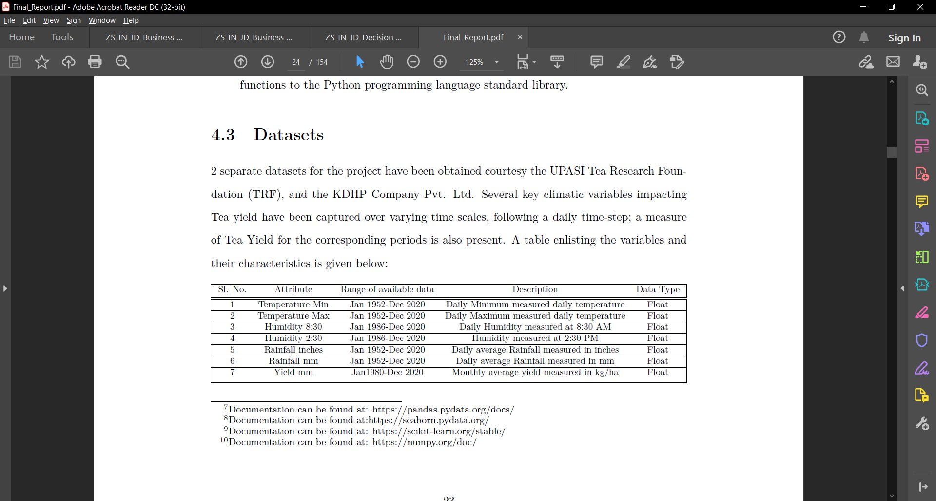

This data has been collected and compiled through a combination of manual and automated methods. Rainfall has been measured at equal spatial intervals through a fibre-reinforcedplastic (FRP) rain-gauge. Rainfall for a specific period of time is calculated by averaging the measurement of water collected in the various rain-gauges present in the region. Measured rainfall of 1 mm, implies that the volume of water collected would be:

200 cm2 (dimension of the collection area) x /10*cm* = 20cm3, or 20 ml.

Further, Humidity is the measure of moisture content of the atmosphere, this is expressed as Relative Humidity which is the ratio of water vapour actually present in the atmosphere to the amount of water vapour required to saturate it at that temperature (expressed as a percentage). Relative humidity is measured using the wet and dry bulb thermometer readings and is read directly from hygrometric tables.

Tea yield is measured using the weight of Tea leaves plucked divided by the hectarage of the area harvested. Tea Yield has been captured in the dataset as monthly yield, which is the daily yield averaged over the course of a single month.

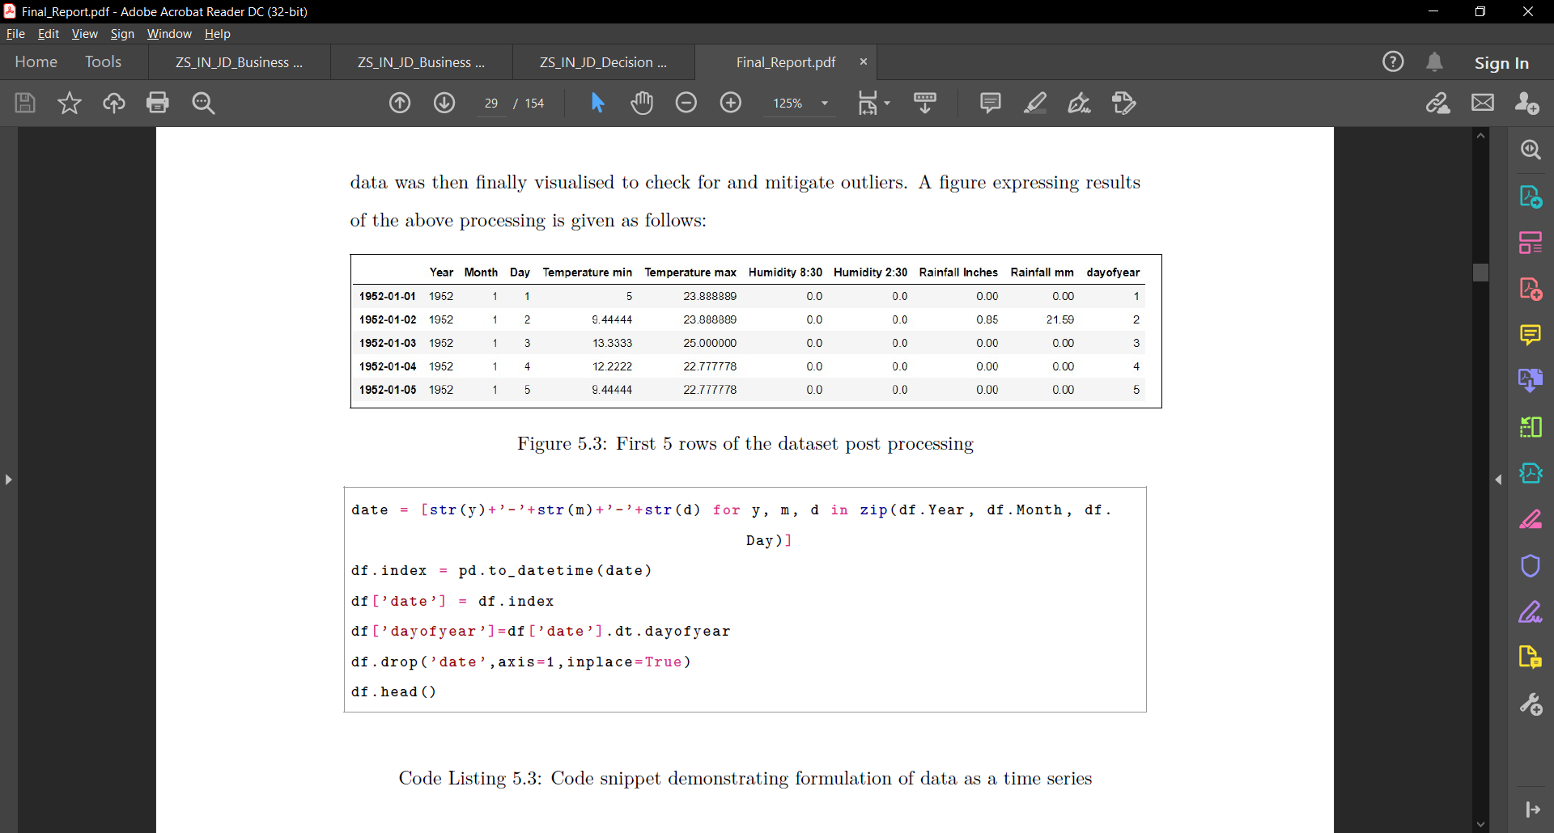

This is the dataset post preprocessing.