Trader Performance vs. Bitcoin Market Sentiment
Analysis of Hyperliquid Historical Trades and the Fear & Greed Index

1. Executive Summary
This analysis merges 211,224 Hyperliquid trade records from 32 accounts (May 2023 – May 2025) with the daily Bitcoin Fear & Greed Index to examine how trader behavior and profitability shift across market sentiment regimes. Of these records, 104,402 are realized (PnL-closing) trades, forming the core dataset for performance analysis.
Four findings stand out:
- Traders are more active and take larger positions during Fear. Average position size is $7,375 in Fear vs. $4,234 in Greed — traders bet bigger when the market is anxious.
- Raw profitability looks similar or slightly higher in Greed ($105.70 avg PnL/trade, 82.5% win rate) than Fear ($101.86 avg PnL/trade, 84.4% win rate) — but this hides a critical risk difference.
- Risk-adjusted returns strongly favor Fear. The volatility of returns during Greed is roughly 16x higher than during Fear, driven by a handful of extreme outlier trades (both large wins and severe losses). Fear-period trading is far more consistent.
- Shorting is markedly more profitable during Fear (avg $186.52/trade) than during Greed (avg $44.94/trade), while long positions perform comparably in both regimes — suggesting skilled traders are successfully shorting into panic.

2. Data & Methodology
Dataset 1 — Fear & Greed Index: daily sentiment classification (Extreme Fear, Fear, Neutral, Greed, Extreme Greed) with an underlying 0–100 index value, Feb 2018 – May 2025 (2,644 days).
Dataset 2 — Hyperliquid Historical Trades: 211,224 individual fills across 246 coins and 32 accounts, including execution price, size (tokens & USD), side, direction (open/close long/short), closed PnL, fees, and timestamps.
The two datasets were joined on calendar date (IST). 479 of 480 trading days in the trade log had a matching sentiment reading (>99.9% coverage). Analysis focuses on the 104,402 trades with non-zero Closed PnL, since PnL is only realized when a position is closed. Sentiment was analyzed both at the 5-level granularity and collapsed into three buckets (Fear = Fear + Extreme Fear, Greed = Greed + Extreme Greed, Neutral) for cleaner comparison.

3. Performance by Sentiment Level
Average per-trade PnL rises toward the sentiment extremes — Extreme Greed produces the highest average PnL per trade ($130.21) and the highest win rate (89.2%), while Extreme Fear produces the lowest average PnL ($71.03) despite a still-solid 76.2% win rate.
Sentiment | Trades | Total PnL ($) | Avg PnL ($) | Win Rate (%) | Avg Size ($) | Total Fees ($)
Extreme Fear | 10,406 | 739,110 | 71.03 | 76.2% | 5,468 | 12,230
Fear | 29,808 | 3,357,155 | 112.63 | 87.3% | 8,041 | 46,999
Neutral | 18,159 | 1,292,921 | 71.20 | 82.4% | 5,556 | 22,263
Greed | 25,176 | 2,150,129 | 85.40 | 76.9% | 5,439 | 29,678
Extreme Greed | 20,853 | 2,715,171 | 130.21 | 89.2% | 2,780 | 13,666

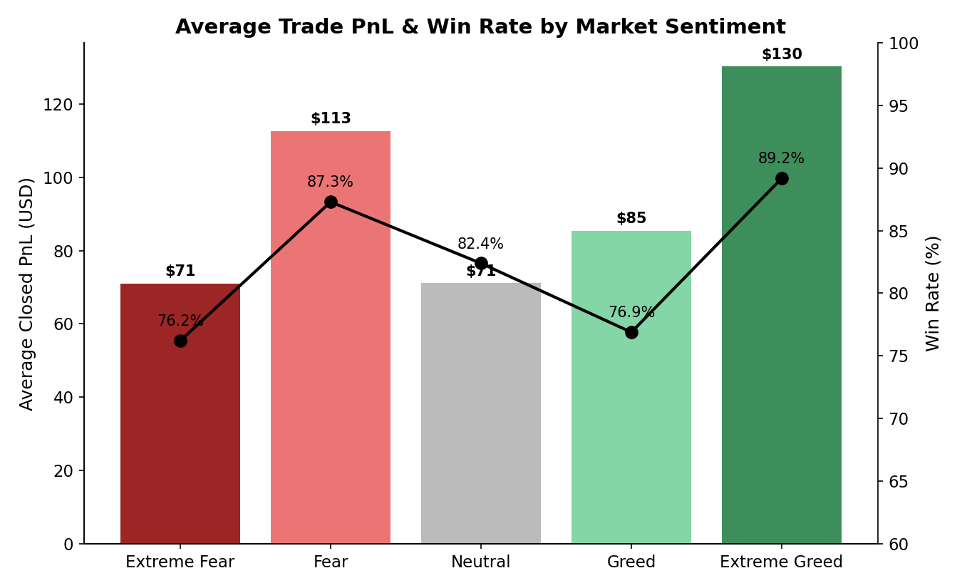
Figure 1. Average closed PnL (bars) and win rate (line) across the five sentiment levels.

4. Risk-Adjusted Performance: The Hidden Story
Looking only at average PnL understates an important difference: the dispersion of outcomes. Normalizing each trade's PnL by its position size (return on notional) reveals that Greed-period trades carry far more tail risk.
Sentiment Bucket | Trades | Avg PnL ($) | Win Rate (%) | Avg Return on Notional (%) | Std Dev of Return (%) | Risk-Adj. Ratio*
Fear | 40,214 | 101.86 | 84.4% | 2.60% | 11.28% | 0.230
Neutral | 18,159 | 71.20 | 82.4% | 2.06% | 25.25% | 0.082
Greed | 46,029 | 105.70 | 82.5% | 5.62% | 180.10% | 0.031
*Risk-adjusted ratio = mean return on notional / standard deviation of return on notional (a Sharpe-like measure at the trade level).

Fear-period trades show a risk-adjusted ratio of 0.230 — roughly 7x better than Greed's 0.031. The Greed bucket's return standard deviation (180%) is inflated by rare extreme trades: the single worst Greed-period trade lost 384% of its notional value (consistent with a liquidation event), and a handful of trades gained 100–150% of notional. Fear-period returns are comparatively tight and consistent (11.3% std dev), suggesting traders manage risk more carefully — or get flushed out faster — when sentiment is negative.

5. Long vs. Short Positioning
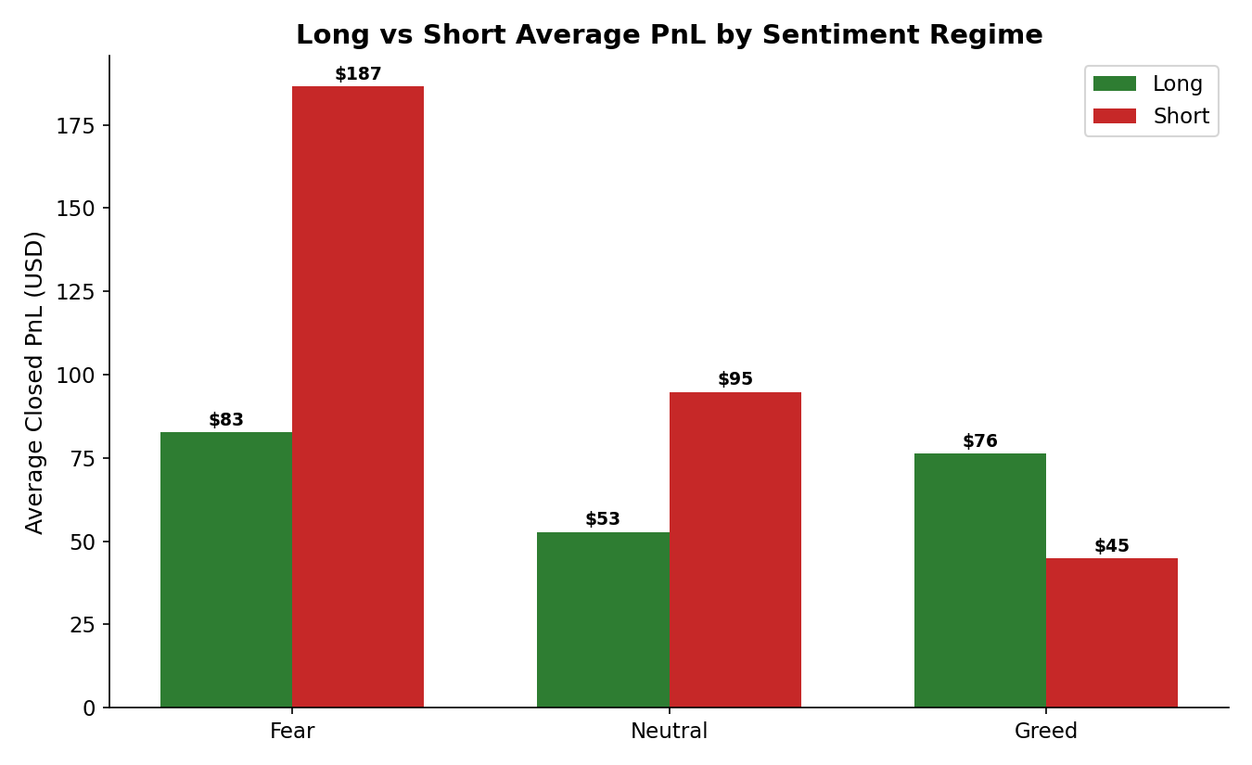
Figure 2. Average PnL for long-closing vs. short-closing trades, by sentiment regime.
The clearest directional edge in the data: shorts closed during Fear average $186.52 in profit, more than double the $82.73 average for longs closed in the same regime. In Greed, the pattern flips — longs ($76.26 avg) modestly outperform shorts ($44.94 avg), though the gap is far smaller. This is consistent with classic contrarian behavior: the most profitable trades in this dataset are shorts placed as fear builds, and (to a lesser extent) longs held through greed.

6. Trading Activity & Position Sizing
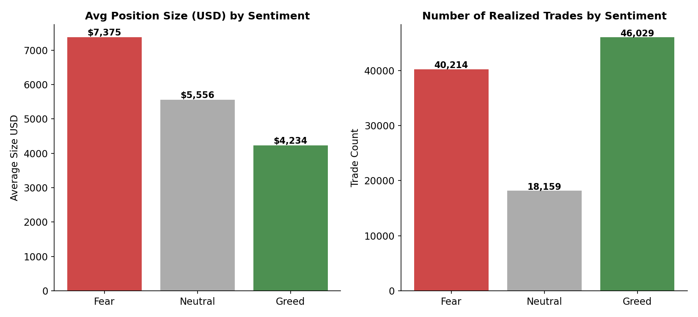
Figure 3. Average position size and total realized-trade count by sentiment bucket.
Traders in this dataset are notably more active during Fear (40,214 realized trades) than Greed (46,029) is close in raw count, but per-day activity is higher in Fear — the correlation between the daily sentiment value and daily trade count is -0.25, meaning trade volume rises as sentiment falls toward fear. Average position size also swells to $7,375 in Fear vs. $4,234 in Greed, roughly 74% larger — traders lean in harder when sentiment sours.

7. Cumulative PnL Over Time
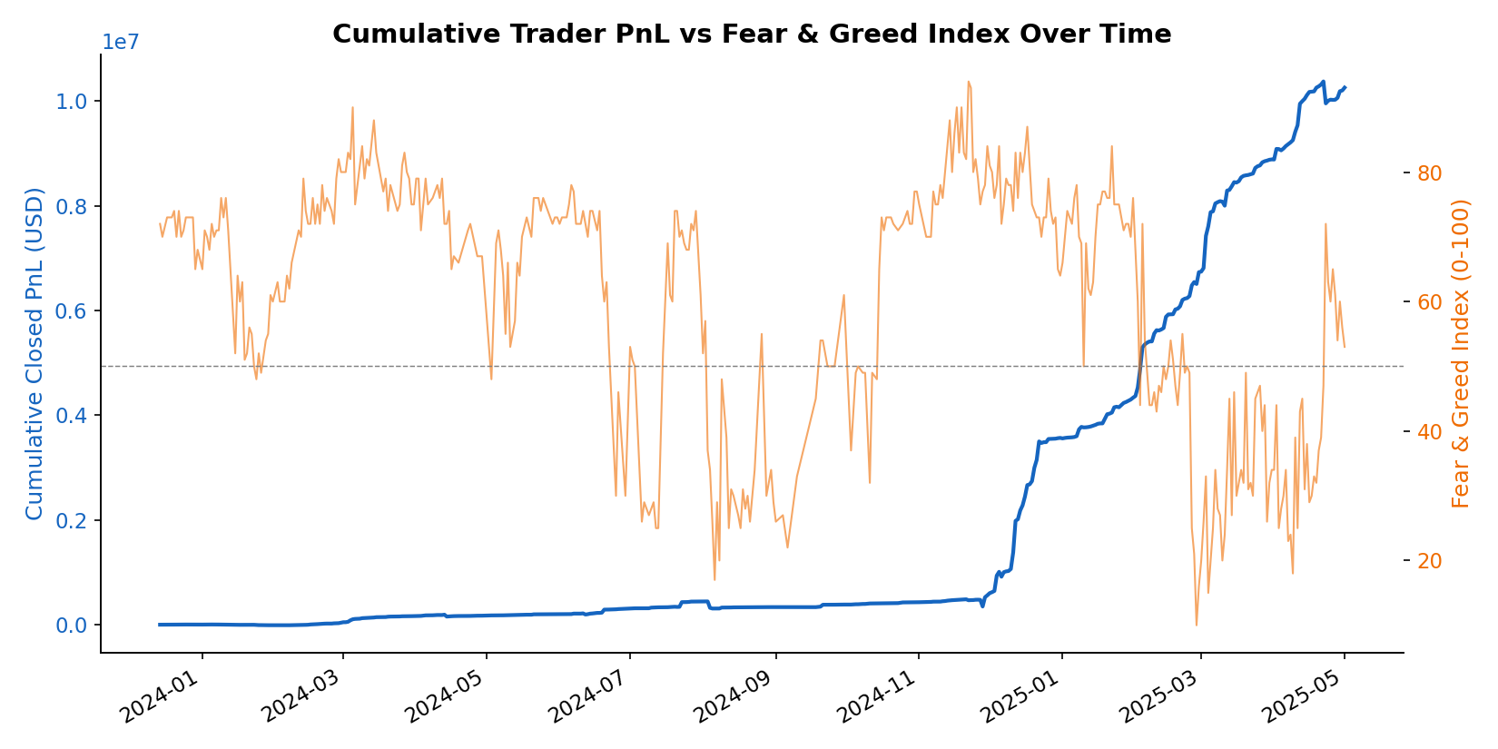
Figure 4. Cumulative realized trader PnL (blue) plotted against the daily Fear & Greed Index (orange).
Cumulative PnL grows fairly steadily across the sample with no single sentiment regime dominating the trend — day-level correlation between the sentiment index value and daily PnL is weak (-0.10), confirming that sentiment alone is not a strong standalone predictor of daily profitability. Its value lies in the risk and positioning patterns uncovered above, not in timing the sentiment index directly.

8. Asset-Level Winners & Losers
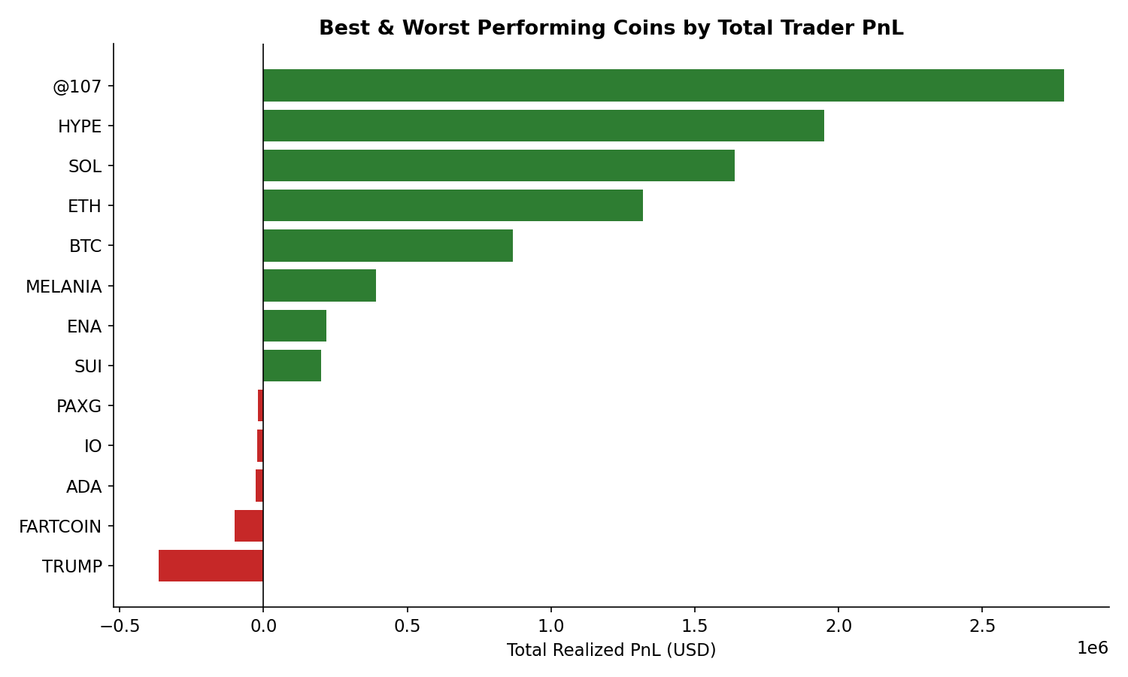
Figure 5. Coins with the largest aggregate realized PnL (green) and losses (red) across all traders.
PnL is heavily concentrated: a small number of tokens (an obfuscated symbol '@107', HYPE, SOL, ETH, BTC) account for the bulk of aggregate profit, while a few high-volatility/meme-adjacent tokens — TRUMP and FARTCOIN in particular — are responsible for the largest aggregate losses in the dataset, a reminder that coin selection matters as much as sentiment timing.

9. Strategic Implications
- Favor contrarian shorts in Fear regimes. The short-side edge during Fear is the single strongest, most consistent signal in this dataset.
- Size positions conservatively during Greed. Even though average PnL is comparable to Fear, the risk of outsized losses (including liquidation-scale drawdowns) is far higher — position sizing and stop-losses matter more when sentiment is euphoric.
- Don't rely on the sentiment index alone as a timing signal — its correlation with daily PnL is weak. It is more useful as a risk-regime indicator (how much variance to expect) than a directional predictor.
- Concentrate risk management on a small set of high-volatility/meme tokens (e.g., TRUMP, FARTCOIN), which drove disproportionate losses regardless of sentiment.
- Investigate top-performing accounts (e.g., win rates above 90% with thousands of trades) as potential sources of strategy patterns worth emulating or studying further.

10. Limitations
- The dataset does not include an explicit leverage or account-equity field, so true leverage/margin-utilization could not be computed directly; position size (USD notional) was used as a proxy for risk appetite.
- Sentiment is a single daily value applied market-wide; it does not capture intraday sentiment shifts or coin-specific sentiment.
- The trader sample (32 accounts) may not be representative of the broader Hyperliquid user base, and results should not be read as generalizable trading advice.

