Great Salt Lake proposal: technical appendix
Table of Contents

Great Salt Lake proposal: technical appendix
Copied from the Claude Doc version, where each section below is a tab: https://claude.ai/artifact/4Eb8aFdgegEy98VF4YkkfF

1.1 Overview: our proposal
Our proposal raises the Great Salt Lake from 4,189.7 ft today to a goal of 4,198.5 ft, and holds it there. On average inflow the lake first reaches the goal in 2047. In 2055 it stands at 4,198.57 ft, inside a 10th–90th percentile band of 4,194.55 to 4,204.29 ft. The package spends $100M a year of public money from 2027 to 2055 and returns a net economic value of $55.0B over that period. Water moves from the lowest-value use in the basin, irrigated hay at $368 per acre-foot, to the lake, where the same acre-foot is worth $2,440.

The settings this document describes
Every number in this document comes from one configuration of the model, found by a goal search: the cheapest package that reaches 4,198.5 ft by 2055 on $100M a year. The goal is the bottom of the state's healthy range (4,198 ft) plus half a foot of margin. The state's own simulations put the added inflow needed at 800 KAF a year (Great Salt Lake Strike Team, 2026). In our model, 800 KAF a year holds the lake at 4,198.04 ft.
Lever | Setting
Public budget | $100M a year, 2027–2055
Monitoring and verification | $50M a year, inside the budget
Lease-to-own rights | $2M a year; right priced at $6,000 per acre-foot
Scarcity charge | $85 per acre-foot to start, with the escalator on
Crop levy | $400 per acre-foot applied above 1.5 acre-feet an acre; 90% of revenue to farm transition
Mandate | 1,200 KAF a year floor, phased in over 1 year, penalty $0
Repossession | On, capped at 140 KAF a year, 3% interest on instalments
Cloud seeding | $1.5M a year
Phragmites removal | $25M a year
Crop switching | $2.5M a year from the budget, topped up by levy revenue
Residential lawns | No watering cut asked

Headline results
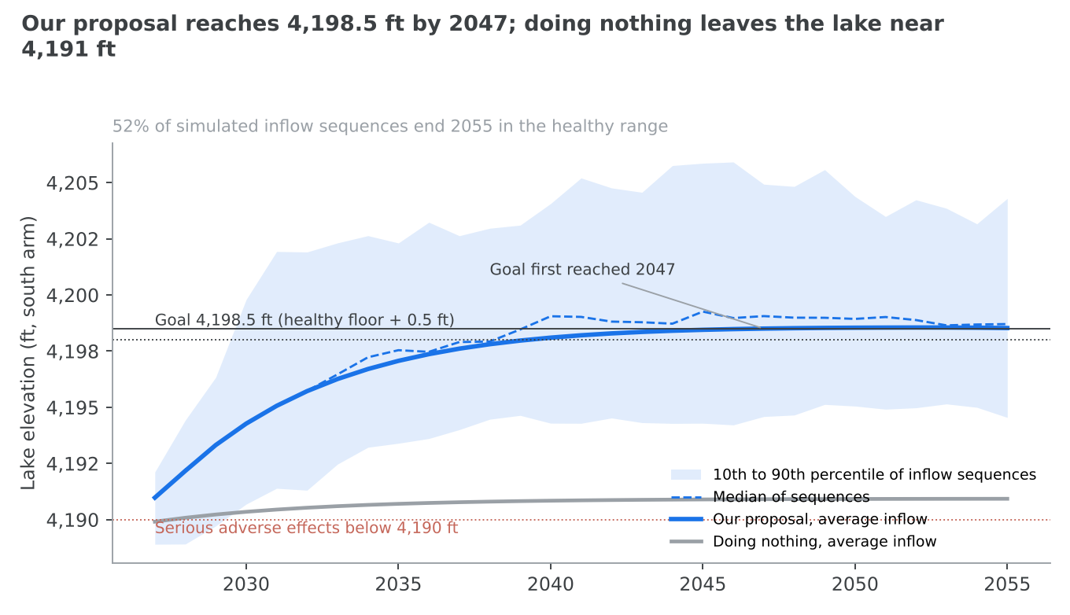
The lake responds quickly at first and then levels off, because a larger lake evaporates more (tab 1.2). On average inflow it climbs to 4,194.27 ft by 2030 (band 4,190.69 to 4,199.80 ft) and 4,197.07 ft by 2035 (band 4,193.40 to 4,202.31 ft). It reaches 4,198.10 ft in 2040 (band 4,194.29 to 4,204.07 ft) and the 4,198.5 ft goal in 2047 (band 4,194.59 to 4,204.93 ft). It ends 2055 at 4,198.57 ft on the yearly schedule, or 4,198.53 ft when the same package is held flat (band 4,194.55 to 4,204.29 ft).
Weather matters more than any lever. Across 120 simulated inflow sequences, 51.7% end 2055 inside the healthy range of 4,198 to 4,205 ft and none fall below the 4,190 ft level the state treats as seriously harmful. The median sequence ends at 4,198.70 ft. With no package, the lake settles near 4,190.93 ft (band 4,183.0 to 4,194.66 ft), 63.3% of sequences end below 4,190 ft and 0.8% end healthy (tab 1.10).
By 2055 the package delivers 857 KAF a year of net water to the lake. That is after two pressures the model subtracts: population growth draws 92 KAF a year and a warming climate takes 100 KAF a year from the rivers.
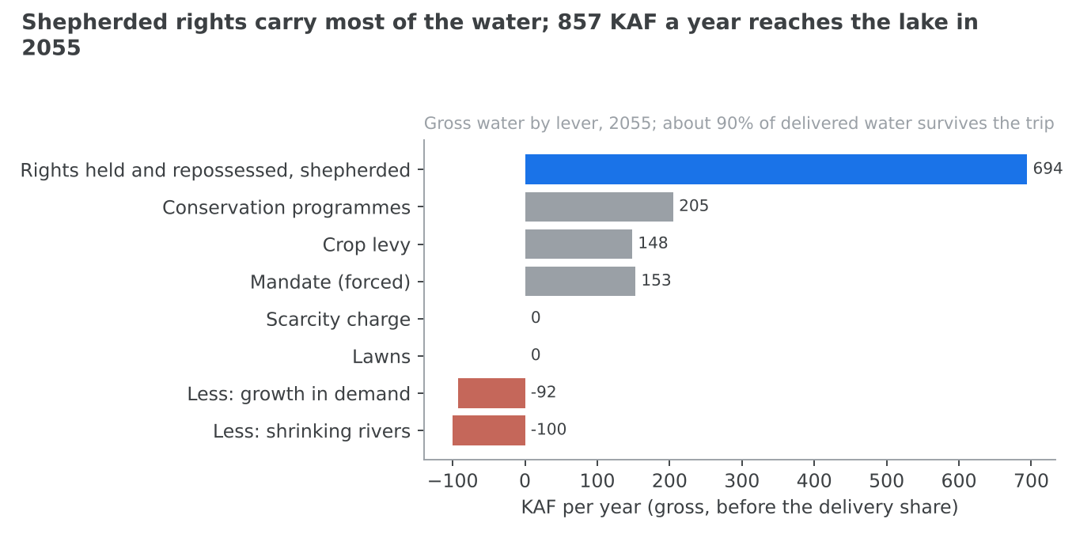
Of the water moved, 69.8% (694 KAF) is bought and shepherded to the lake as state-held rights, 148 KAF comes through the price signals of the charge and levy, and 153 KAF is ordered under the mandate. The four conservation programmes add 204.9 KAF a year between them.

The full cost, set against the benefit
The public budget is not the cost. Our cost counts the $100M budget, plus farm revenue lost without compensation, plus livestock receipts put at risk when local feed falls. In 2035 that is $452Mayear($100M + $210.3M + $141.8M), against a benefit of $2,221M. In 2055 it is $298Mayear($100M + $56.2M + $141.9M), against $2,091M. The 2055 cost works out at $348 for every acre-foot delivered, below the $368 an acre-foot of hay earns and far below the $2,440 it is worth in the lake.
The net economic value of $55.0B sums, over 2027–2055, the value of the water in the lake less farm revenue lost and livestock receipts at risk, plus the wages of transition jobs.

Three ways to divide the economy
Who consumes the water. Measured by depletion, the water actually consumed rather than diverted, the basin uses 2,387 KAF a year (Great Salt Lake Strike Team, 2026). Alfalfa and other hay take 1,025 KAF, other crops and incidental losses 559 KAF, residential lawns 408.5 KAF, industry, commerce and institutions 218.4 KAF, mineral extraction 136 KAF, reservoir evaporation 27 KAF and indoor household use 13.1 KAF. Agriculture is 1,584 KAF, two-thirds of the total.
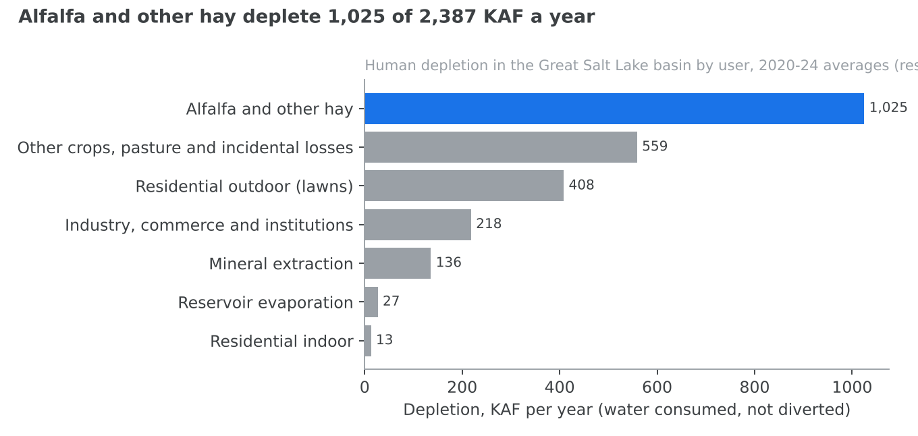
Who gives up water under our proposal. Agriculture does, almost entirely. The levy frees 148.2 KAF of hay depletion, repossession has taken 549.6 KAF of farm water by 2035, and crop switching and on-farm efficiency are farm programmes. Cities and industry lose almost nothing by 2055. The scarcity charge falls from $87 per acre-foot in 2027 to nearly zero once the lake recovers, and by then it cuts less than 0.1 KAF a year. No lawn-watering cut is asked.
Who earns the most from each acre-foot. Hay earns $368 per acre-foot consumed. Mineral extraction on the lake earns $8,315, institutional and government users about $354,000, manufacturing on city water about $1.3M, and commercial businesses about $2.4M. The same acre-foot left in the lake is worth $2,440.
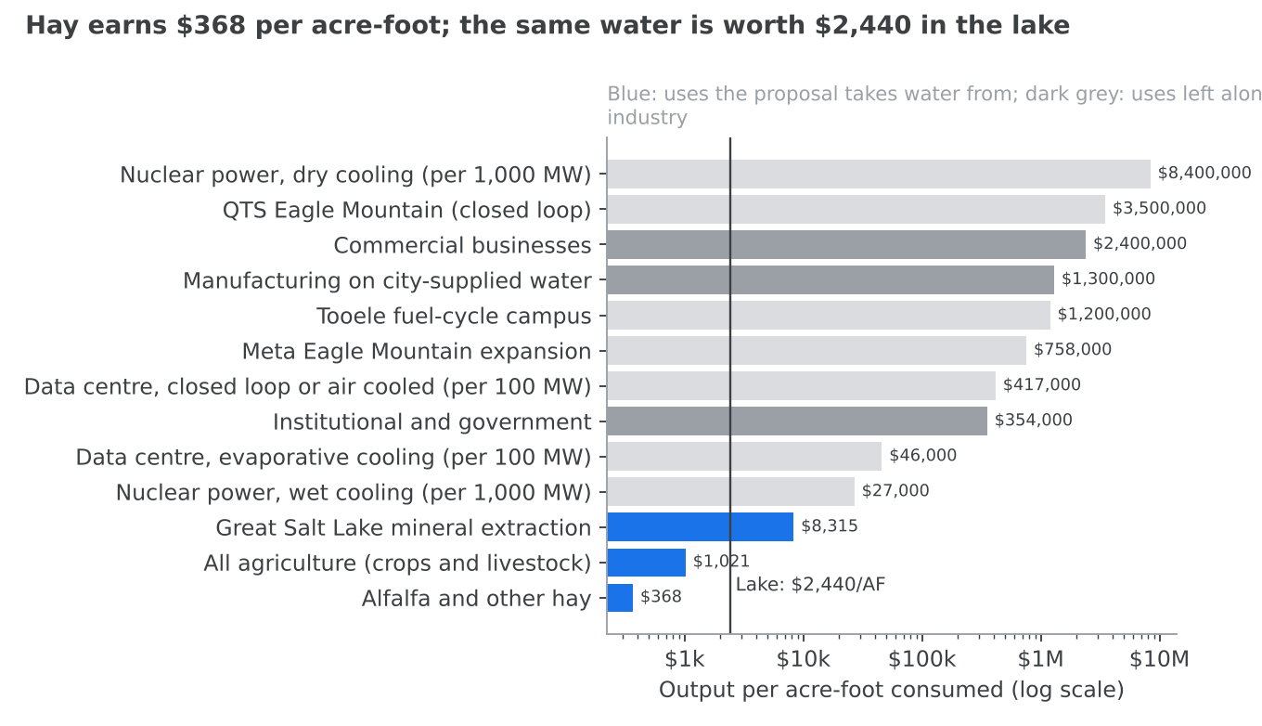

Jobs
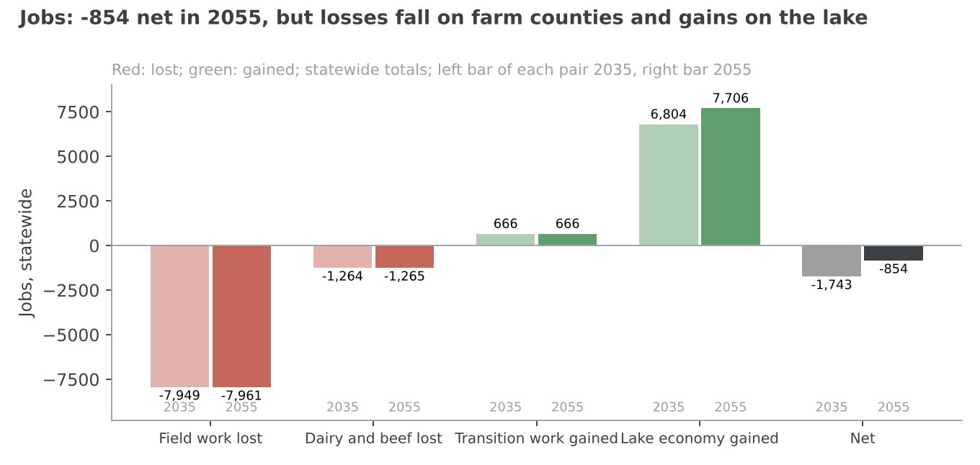
In 2055 the package costs 7,961 field jobs and 1,265 dairy and beef jobs, and adds 666 transition and monitoring jobs and 7,706 lake-economy jobs, for a net of −854. The losses fall in farm counties and the gains around the lake, so the net figure hides a real dislocation (tabs 1.8 and 1.9).

Alfalfa in brief
Alfalfa is where the water is and where its value is lowest. Hay depletes 1,025 KAF a year, 43% of all human use in the basin, and earns $368 an acre-foot. Utah grows 3.9% of US alfalfa and the basin about 1.8%. In the model, 414,635 acres leave irrigation and 1.78M tons of hay are forgone by 2055, which is 3.6% of the US alfalfa crop. The model counts every acre-foot taken from agriculture as hay, so this overstates the cut to alfalfa itself (tab 5). Most of the water reaches the lake as rights the state holds and shepherds. These are bought from willing sellers, or repossessed and paid for in instalments where the voluntary market falls short. Tab 1.6 treats alfalfa in depth.

1.2 Where we are now
The Great Salt Lake stood at 4,189.7 ft at the end of water year 2026, below the 4,190 ft level the state treats as seriously harmful and more than 8 ft under the bottom of its healthy range (U.S. Geological Survey, 2026a). People take more water from its rivers than the lake can spare. Every foot of recovery costs more water than the foot below it.

A lake with no outlet
The Great Salt Lake is a terminal lake: rivers flow in and nothing flows out except by evaporation. Its level is the balance between what arrives and what the sun takes. When inflow falls, the lake shrinks until its smaller surface evaporates only as much as now arrives, and then it settles at a lower level. When inflow rises, it grows until the larger surface evaporates the extra.
The amounts are large. From 1931 to 1976 the lake lost an average of 2.9 million acre-feet a year to evaporation, about 45 inches of water off its surface (Arnow, 1978). Its three main rivers, the Bear, the Weber and the Jordan, delivered an average of 1,665 KAF a year between 2000 and 2025 (Great Salt Lake Strike Team, 2026). Before reaching the lake, people in the basin deplete 2,387 KAF a year: water consumed by crops, lawns, industry and evaporating reservoirs, and not returned to the rivers. Two-thirds of that, 1,584 KAF, is agriculture (Great Salt Lake Strike Team, 2026).
Weather swings the inflow hard from year to year. Flow from the three rivers fell below 1,000 KAF in 2021 and 2022, rebounded above 2,000 KAF in 2023 and 2024, then fell to 1,281 KAF in 2025 (Great Salt Lake Strike Team, 2026). A wet year can lift the lake by feet; a run of dry years undoes it.

How far it has fallen
The state's healthy range is 4,198 to 4,205 ft (Office of the Great Salt Lake Commissioner, 2024). The Commissioner asks for a contingency plan to keep the south arm above 4,190 ft "to avoid serious adverse effects". Today's 4,189.7 ft is below that floor. At that level the lake covers about 929 square miles; at the bottom of the healthy range it would cover about 1,423 (Root, 2023). The difference, about 500 square miles, is lakebed open to the wind.
If inflow simply continues at its 2000–2025 average, the lake settles near 4,191 ft and goes no higher. The state's own simulations put the added inflow needed to reach 4,198 ft by 2055 at 800 KAF a year (Great Salt Lake Strike Team, 2026). That is about a third of everything the basin now consumes.

What is at stake
Dust and health. Exposed lakebed blows fine dust over the cities of the basin, home to 86% of Utahns (Utah Population Committee, 2025). A 2026 study of the lake estimates that every 100 km² of exposed lakebed costs $81M to $175M a year in health damage, or $1.1B to $2.3B a year at today's exposed area (Harris et al., 2026).
Minerals. Companies extract minerals from the lake's brine. In 2010 dollars the mineral sector produced $1,130.8M of output, including indirect and induced effects, and supported 5,368 jobs (Utah Legislature, 2022). The companies' full base water rights depend on the lake staying at or above 4,198 ft (Great Salt Lake Strike Team, 2026).
Brine shrimp. The harvest of brine shrimp eggs for aquaculture produced $56.7M of output and 574 jobs (Utah Legislature, 2022).
Recreation and tourism. Recreation on and around the lake produced $135.8M of output and 1,764 jobs (Utah Legislature, 2022).
Birds. The lake's wetlands and shoreline are a stopover for migratory birds. We did not model them, and they are not counted in any figure in this document.
In total the lake economy supported 7,706 jobs. One economic study for the state put the cost of a declining lake at $1.69B to $2.17B a year (Audubon, 2019).

Why each foot costs more than the last
The lake is shaped like a shallow dish. As it rises, it spreads over flat ground, so its surface grows faster than its depth. A larger surface evaporates more, so the inflow needed to hold the lake at a level rises steeply with the level.
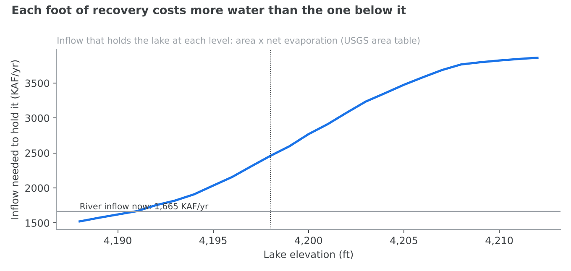
To hold the lake at 4,190 ft takes about 1,621 KAF a year. To hold it at 4,198 ft takes about 2,459 KAF a year, and at 4,205 ft about 3,475 KAF. Going from 4,190 to 4,191 ft costs about 47 KAF a year of extra inflow; going from 4,197 to 4,198 ft costs about 149 KAF. The table shows the same thing in terms of added inflow: the first 200 KAF a year raises the lake by about 2.6 ft, while the last 200 KAF before the goal raises it by about 1.3 ft.
Inflow added to today's average (KAF/yr) | Level the lake settles at (ft)
0 | 4,190.93
200 | 4,193.51
400 | 4,195.25
600 | 4,196.71
800 | 4,198.04
1,000 | 4,199.40
1,200 | 4,200.67
This is why the problem gets harder the closer we come to solving it, and why our proposal has to keep delivering water after the lake has risen, not just until it does. Tab 2B.1 sets out the water balance in full.

1.3 Our proposal
Our proposal is seven instruments that work as one system: price signals that make water scarce, programmes that free water cheaply, rights the state buys and holds, a mandate as a backstop, and monitoring that makes sure the water arrives. Together they put 678 KAF of net water into the lake in their first year, 922 KAF by 2030, 910 KAF in 2035 and 857 KAF in 2055. All figures below are from the model at the settings in tab 1.1.

1. Monitoring and verification
What it does. Monitoring pays for meters, gauges, water accounting and the legal work of protecting dedicated water as it travels down the rivers. It buys no water itself. Its job is to make sure the water we pay for reaches the lake instead of being taken by a downstream diverter.
What it delivers. It lifts the share of dedicated water that arrives at the lake from 0.85 to 0.898, and adds to how much water the river system can shepherd each year. By 2055 the shepherding capacity is 895 KAF a year, against 850 KAF without the extra monitoring.
What it costs. $50M a year, half the public budget, and $1,830.6M over 2027–2055. It is the largest single line because every other instrument depends on it.

2. Water rights and lease-to-own agreements
What it does. The state leases water from willing sellers and holds it as dedicated water for the lake. A lease-to-own agreement lets part of each payment count towards buying the right outright, at a price of $6,000 an acre-foot.
What it delivers. The state holds 280 KAF of rights from the first year, which is the most willing sellers will offer: the model's lease and sale capacity is the binding limit, not money. Together with repossessed water, 694 KAF a year is shepherded to the lake by 2055. The lease rate rises from $75 to $135 an acre-foot as holdings grow. At $2M a year, no right is ever owned outright: paying one off would take 43.1 years, past the 2055 horizon.
What it costs. $289.1M over 2027–2055 from the budget. Across all shepherded water in 2055, the state pays $30.25 an acre-foot in lease payments.

3. The scarcity charge
What it does. A charge on each acre-foot depleted by agriculture, mineral extraction, industry, commerce and institutions: 1,938.4 KAF a year in all. Household use and reservoir evaporation are outside it. The rate starts at $85 an acre-foot. A thermostat moves it toward a target each year, and an escalator pushes it higher while the lake stays short of the goal. As the lake recovers, the charge falls away.
What it delivers. In 2027 the rate is $87 and users cut 248.5 KAF a year in response. By 2035 the rate has fallen to $9 and the cut to 26.4 KAF; by 2055 the rate is close to zero. The charge does its work early, when the lake is lowest, and then steps aside as bought water takes over.
What it costs. It costs the public nothing; it raises $147.3M in 2027 and $17.7M in 2035. Its cost falls on the users who pay it and on the farm output they forgo, which we count in the full cost (tab 1.8).

4. The crop levy
What it does. A levy of $400 for each acre-foot a hay field applies above 1.5 acre-feet an acre. It targets the heaviest irrigators first. Of the levy revenue, 90% is returned to farmers through the crop-switching programme.
What it delivers. 211,371 acres of hay ground fall within its scope. On those acres the average excess over the threshold is 0.91 acre-feet, and growers cut half of it. That frees 148.2 KAF a year of depletion.
What it costs. Growers pay $41.6M a year, of which $37.5M comes back to them as crop-switching payments.

5. The mandate and repossession
What it does. The mandate is a backstop. It sets a floor of 1,200 KAF a year of reduced depletion and orders only what the voluntary instruments have not already found. Where the market falls short, the state can repossess water rights, paying for them in instalments at 3% interest, up to 140 KAF a year. No penalty is set: a farm under the mandate is ordered to cut, not fined.
What it delivers. The mandate carries the early years. It orders 599 KAF in 2027 and 571 KAF in 2035, and only 153 KAF by 2055, once bought and shepherded water has grown. Repossession reaches 549.6 KAF by 2035. Ordered water is harder to track than bought water, so the model assumes only 71% as much of it arrives.
What it costs. Repossessed rights are paid for from the rights budget. The farm revenue lost on ordered water is not compensated, and is counted in the full cost.

6. Conservation programmes
What they do. Four programmes free water directly. Cloud seeding adds winter snow. Phragmites removal replaces a thirsty invasive reed in the lake's wetlands with native plants. Crop switching pays farmers to move from alfalfa to lower-water crops such as winter wheat. On-farm efficiency upgrades irrigation systems.
What they deliver and cost.
Programme | Spending ($M a year) | Water to the lake (KAF a year) | Cost per acre-foot delivered
Cloud seeding | 1.5 | 50, at its cap | $28.6
Phragmites removal | 25 | 36.9 | $678
Crop switching | 40.0 (2.5 from the budget, the rest from the levy) | 100, at its cap | $398
On-farm efficiency | 19 | 18 | $1,056
Together they deliver 204.9 KAF a year. Cloud seeding and crop switching are at their caps: the limit is how many storms and how many willing farms there are, not money.

7. Residential lawns
What it does. The model can ask households to cut lawn watering and enforce it with fines. What it delivers. Our proposal asks for no cut, so it delivers nothing and costs nothing. Polling shows 58% of Utah voters prefer incentives and 22% prefer penalties (Deseret News & Hinckley Institute of Politics, 2026), and lawn savings reach the lake poorly (tab 2A.7).

How the money is spent
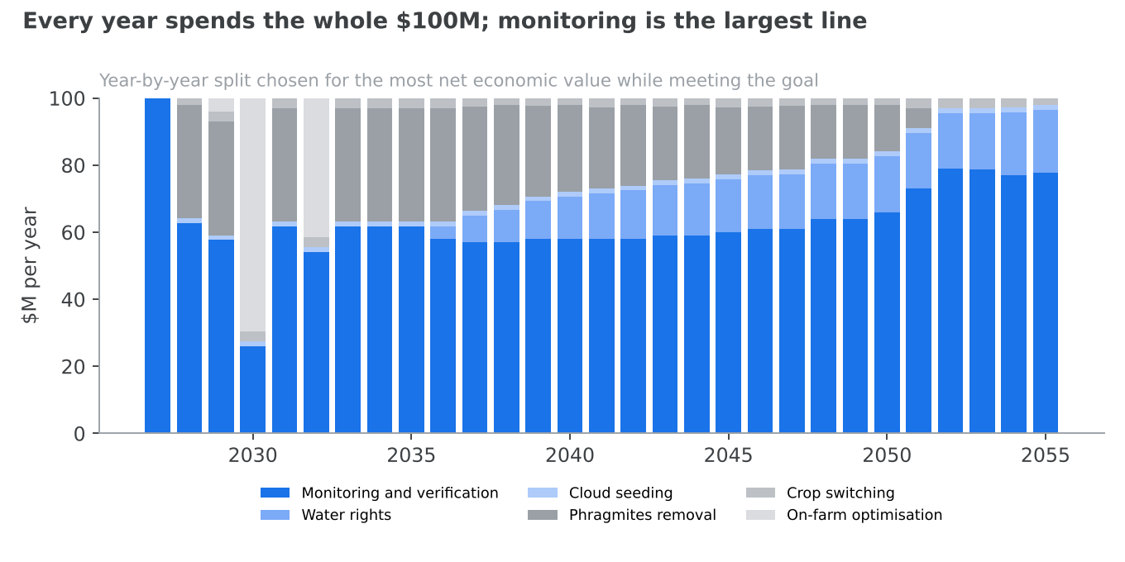
Every year spends the whole $100M. Over 2027–2055 that is $2,900M: monitoring $1,830.6M, rights $289.1M, phragmites $553M, on-farm efficiency $115.1M, crop switching $72.1M from the budget and cloud seeding $40M. The yearly schedule front-loads monitoring, so in 2027 the whole $100M goes to it.

How the instruments work together
The instruments hand the work from one to another over time. In the first years, while the lake is lowest, the scarcity charge and the mandate do most of the work, because they act at once. At the same time the programmes and the levy start freeing water at low cost, and the levy's revenue pays for crop switching. As rights are bought and repossessed, and as monitoring raises shepherding capacity, bought water takes over: by 2055, 69.8% of the water moved is bought, 148 KAF comes through prices and 153 KAF is ordered. The charge then falls almost to zero.
The result is a package that does not rely on any one instrument. Without monitoring, bought water would leak to downstream users. Without the charge and mandate, the lake would wait years for the market to grow. Without bought water, the lake would depend on orders that are harder to defend and harder to track.

1.4 Why we came up with this solution
An acre-foot of water used to grow hay in the basin earns $368. The same acre-foot left to reach the lake is worth $2,440, more than six times as much. Hay also consumes more of the basin's water than any other use. That gap, on that volume, is the whole case for our proposal: move water from the use where it is worth least to the place where it is worth most, and pay the people who give it up.

What an acre-foot earns in hay
Utah's alfalfa crop was worth $2,275.8M over 2019–2023, from 2.56 million harvested acres, or $889 an acre (USDA National Agricultural Statistics Service, 2024a). An acre of alfalfa near Salt Lake City needs 28.97 inches of irrigation water beyond what rain supplies, or 2.41 ft (Hill et al., 2011). Dividing one by the other gives $368 for each acre-foot of irrigation water the crop consumes.
\text{hay value per AF} = \frac{\$889 \text{ per acre}}{2.41 \text{ AF per acre}} \approx \$368
This is gross value of production, before the farmer's costs. The farmer's own net return is lower: the state's agricultural optimisation report puts the forgone return on an acre of hay at $305, and the net value of irrigation water at $236 an acre-foot depleted (Utah Division of Water Resources, 2026a). We use the higher gross figure for the comparison so as not to flatter our case.

What an acre-foot is worth in the lake
No source states a value per acre-foot for the lake, so we derive one. An economic study for the state estimated the cost of a declining lake at $1.69B to $2.17B a year, a midpoint of $1.93B (Audubon, 2019). Spread over the roughly 790 KAF a year of added inflow needed to avoid that decline, this is about $2,440 an acre-foot.
\text{lake value per AF} = \frac{\$1.93\text{B per year}}{790 \text{ KAF per year}} \approx \$2{,}440
Two cautions apply. The numerator is mostly gross output, much of it mineral extraction, rather than net welfare, and it is in 2019 dollars. On the other hand, a 2026 study of dust alone puts the health benefit of an acre-foot reaching the lake at $600 to $1,800 (Harris et al., 2026), without counting minerals, brine shrimp or recreation. Our $2,440 sits between those views, and tab 2B.7 sets out the range.

Why the water comes from hay
Three facts point at hay. It is the largest use: alfalfa and other hay deplete 1,025 KAF a year, 43% of all human depletion in the basin (Great Salt Lake Strike Team, 2026). It is the lowest-value use: every other user earns more from an acre-foot, from mineral extraction at $8,315 to commercial businesses at about $2.4M. And hay water can be measured and moved: a field taken out of irrigation frees a known volume at a known headgate, which a lawn or a factory cannot easily match.
The other uses are poor sources. Lawns consume 408.5 KAF a year, but a city's saving reaches the lake poorly; we assume only a quarter of it arrives (tab 2A.7). Industry, commerce and institutions consume 218.4 KAF and earn hundreds of thousands of dollars or more from each acre-foot, so taking their water would cost far more than it returns.

What we considered and rejected
Money alone. With the mandate switched off, more money hardly helps. A $25M budget leaves the lake at 4,197.50 ft in 2055; $100M reaches 4,197.75 ft; $200M reaches 4,198.07 ft; and anything from $300M up stops at 4,198.11 ft. The limit is how much water willing sellers will lease or sell, not how much the state can pay. A backstop mandate is what closes the last half foot.
Buying the rights outright. At $6,000 an acre-foot, buying all 800 KAF of the needed water outright would cost about $4.8B. We use lease-to-own instead, so that leasing payments slowly build ownership, and we keep the outright purchase for later (tab 2A.4).
Large on-farm efficiency programmes. Better irrigation reduces what is diverted but often not what is consumed. In western Kansas, efficiency upgrades increased water extraction, with a rebound of over 100% (Pfeiffer & Lin, 2010). Utah's own programme expects "negligible change" in depletion from its first 20 projects (Hasenyager & Bunker, 2024). We fund on-farm work at $19M a year and count only 55% of its nominal saving.
Fines on lawn watering. Only 22% of Utah voters favour penalties (Deseret News & Hinckley Institute of Politics, 2026), and the model's lawn module has a known flaw (tab 5). We ask for no lawn cut.
A penalty priced at the lake's value. The model can charge a farm that refuses the mandate up to $2,440 an acre-foot. We set the penalty at zero, so the mandate orders a cut but does not fine.
Other packages from the goal search. The search found a second package that also meets the goal: a lower charge of $66.2, no lease-to-own money and a slower mandate. It reaches the goal one year later, in 2048, with a lower net economic value of $53.75B, so we kept the package in tab 1.1, which reaches it in 2047 with $55.0B.

1.5 The models
Our results come from eight linked models. A lake model turns water into a lake level; an inflow model adds the weather; a lever model decides how much water each instrument frees; a delivery model decides how much of it arrives; and economic, jobs and support models score the outcome. A goal search then tunes the levers. Below each model, its assumptions are listed in a line each and linked to the Section 2 tab that explains them; the sub-heading named in italics is the entry in that tab.

1. The lake model
What it does. It turns a year's inflow into a lake level. How it works. The lake has no outlet, so in the long run it settles where the water evaporating off its surface equals the water arriving. The model reads the lake's area at each level from the USGS elevation-area table and multiplies it by net evaporation, gross evaporation less the rain and snow falling on the lake. It finds the level whose evaporation matches the inflow, scaled by a closure factor fitted to the state's published simulations. Each year the lake moves a fixed share of the way from where it is toward that level.
\text{area}(E^*) \times (e_{\text{gross}} - p_{\text{lake}}) = \text{inflow} \times 0.933, \qquad E_{t+1} = E_t + 0.17\,(E^* - E_t)
What it produces. The lake level each year, and the equilibrium level for any inflow: 4,190.93 ft with no added water and 4,198.04 ft with 800 KAF a year added. Why it is built this way. A one-equation balance is transparent, and once fitted it reproduces the state's long-run simulated levels of 4,191.1, 4,193.7 and 4,198.0 ft to within 0.23 ft.
- We assume the lake loses 3.77 ft of water a year to evaporation. → tab 2B.1 · Gross evaporation
- We assume 1.25 ft of rain and snow falls on the lake each year. → tab 2B.1 · Precipitation on the lake
- We assume a closure factor of 0.933 between gauged inflow and the open lake. → tab 2B.1 · The closure factor
- We assume the lake's area at each level follows the USGS 2023 elevation-area table. → tab 2B.1 · The area curve
- We assume the lake closes 17% of the gap to its equilibrium each year. → tab 2B.2 · How fast the lake responds
- We assume the lake starts at 4,189.7 ft. → tab 2B.2 · Where the lake starts
- We assume a healthy range of 4,198 to 4,205 ft and a serious-harm level of 4,190 ft. → tab 2B.2 · The targets

2. The inflow model
What it does. It supplies the river inflow for each year. How it works. The central run uses the 2000–2025 average of 1,665 KAF a year. For uncertainty, the model draws 120 inflow sequences with the observed year-to-year spread and the tendency of dry years to follow dry years. Climate and growth then take water away gradually: by 2055 a warming climate removes 100 KAF a year from the rivers and population growth draws 92 KAF a year. Alternative baselines (the driest recent decade, the full gauged record, a warming trend) and a long-drought option stress the result. What it produces. The 10th, 50th and 90th percentile lake path, and the share of sequences that end healthy. Why it is built this way. Weather moves the lake more than any lever, so a single path would hide most of the risk.
- We assume today's inflow averages 1,665 KAF a year. → tab 2B.2 · River inflow now
- We assume the lake needs 800 KAF a year of added inflow. → tab 2B.2 · The goal
- We assume year-to-year inflow varies with a coefficient of variation of 0.5. → tab 2B.11 · Year-to-year spread
- We assume a dry year makes the next one dry with a correlation of 0.35. → tab 2B.11 · Drought persistence
- We assume a long drought cuts inflow to 0.75 of normal. → tab 2B.11 · Long droughts
- We assume 120 simulated sequences are enough. → tab 2B.11 · Number of simulations
- We assume a warming climate takes 100 KAF a year from the rivers by 2055. → tab 2B.4 · Streamflow decline
- We assume growth draws 92 KAF a year by 2055. → tab 2B.4 · Growth in demand

3. The lever model
What it does. It works out how much water each instrument frees each year. How it works. Each instrument has its own rule. The scarcity charge cuts use in proportion to the charge as a share of the water's net value, up to a cap. The crop levy falls on application above a threshold, and the model treats application as spread across fields, so it catches the heaviest irrigators first. Each programme turns money into water at a cost per acre-foot until it reaches a cap. Leases follow a rising supply curve, and the mandate orders whatever is still missing, up to its floor. What it produces. Water freed by each lever, prices, revenue and spending. Why it is built this way. Each rule is the simplest form that captures the instrument's limit: a price response, a technical cap, or a willing-seller ceiling.
- We assume a 1,200 KAF mandate floor, phased in over one year, with no penalty. → tab 2A.1 · The mandate floor
- We assume repossession of up to 140 KAF a year, paid at 3% interest. → tab 2A.1 · Repossession
- We assume farms cut use by 0.4 times the charge as a share of the water's net value, up to 60% of use. → tab 2A.2 · How farms respond
- We assume cities and industry respond with a price elasticity of 0.3, up to 40% of use. → tab 2A.2 · How cities and industry respond
- We assume the charge closes a quarter of the gap to its target each year and escalates by a step of 0.12 a year while the lake is short. → tab 2A.2 · The thermostat and escalator
- We assume each programme's cost per acre-foot, delivery share and cap. → tab 2A.3 · Cloud seeding, Phragmites removal, Crop switching, On-farm efficiency
- We assume willing sellers lease 130 KAF a year and sell 150 KAF, at a lease price rising with an elasticity of 1. → tab 2A.4 · The lease supply curve
- We assume a water right costs $6,000 an acre-foot to buy outright. → tab 2A.4 · The price of a right
- We assume the levy falls on 228,000 acres of hay ground applying 2.4 AF an acre on average. → tab 2A.5 · The hay ground in scope
- We assume the levy can cut at most half of an acre's application. → tab 2A.5 · How irrigators respond
- We assume $100M a year, of which $50M goes to monitoring. → tab 2A.6 · The budget
- We assume 743,000 basin homes have a lawn using 371 KAF a year. → tab 2A.7 · Lawns and their water

4. The delivery model
What it does. It decides how much freed water reaches the lake. How it works. Water the state holds as a right is shepherded down the rivers, up to a capacity that starts at 150 KAF a year and grows by 25 KAF a year, plus what monitoring adds. Of shepherded water, 85% arrives, rising to 89.8% with monitoring. Ordered water arrives at only 71% of that rate, because it is harder to track. What it produces. Gross and net water to the lake. Why it is built this way. Freeing water upstream does not put it in the lake: downstream users can divert it unless it is measured and legally protected.
- We assume 85% of dedicated water survives the trip, before monitoring. → tab 2B.3 · The delivery share
- We assume shepherding capacity starts at 150 KAF and grows 25 KAF a year. → tab 2B.3 · Shepherding capacity
- We assume monitoring adds up to 10 points of delivery share and 50 KAF of capacity. → tab 2B.3 · What monitoring buys
- We assume ordered water arrives at 71% of the rate of bought water. → tab 2A.1 · Delivering ordered water

5. The water-use model
What it does. It describes who consumes the basin's water. How it works. It splits 2,387 KAF of depletion into hay, other crops, minerals, industry, lawns, indoor use and reservoirs, and defines the 1,938.4 KAF the charge falls on. What it produces. The base each lever works on, and the sector figures in tab 1.1. Why it is built this way. Depletion, not diversion, is what the lake loses.
- We assume basin depletion of 2,387 KAF a year, 1,025 KAF of it hay. → tab 2B.6 · Depletion by user
- We assume alfalfa needs 2.41 ft of irrigation water an acre. → tab 2B.5 · Water per acre
- We assume announced industrial projects need 19.078 KAF a year. → tab 2B.10 · The industrial pipeline

6. The economic model
What it does. It sets the cost against the benefit. How it works. The benefit is net water to the lake times $2,440 an acre-foot. The cost is the public budget plus farm revenue lost without compensation plus livestock receipts at risk. Net economic value sums the lake value, less farm and livestock losses, plus transition wages, over 2027–2055. What it produces. Yearly cost and benefit, cost per acre-foot delivered, and the $55.0B net economic value. Why it is built this way. A budget-only cost would hide what farmers and ranchers give up.
- We assume an acre-foot in the lake is worth $2,440 and one in hay $368. → tab 2B.7 · The value of lake water, The value of hay water
- We assume hay earns a net $305 an acre and irrigation water is worth $236 an acre-foot to a farm. → tab 2B.7 · Farm net values
- We assume the basin grows 596,000 tons of forage a year more than its own herds eat. → tab 2B.5 · Where the hay goes
- We assume households would pay $128 a year. → tab 2B.9 · Willingness to pay

7. The jobs model
What it does. It counts jobs lost and gained. How it works. Field jobs fall at 19.2 per 1,000 acres taken out of irrigation; dairy and beef jobs fall as local feed is cut; transition jobs rise at 7.4 per $1M spent; lake-economy jobs rise toward 7,706 as the lake recovers. What it produces. Jobs by type in each year. Why it is built this way. The losses and gains are in different places and must be shown separately.
- We assume 19.2 field jobs per 1,000 irrigated acres. → tab 2B.8 · Farm jobs
- We assume up to 1,900 dairy and beef jobs are at risk. → tab 2B.8 · Livestock jobs
- We assume 7.4 transition jobs per $1M spent. → tab 2B.8 · Transition jobs
- We assume 7,706 lake-economy jobs at a healthy lake. → tab 2B.8 · Lake-economy jobs

8. The support model and the goal search
What it does. The support model scores how six groups would view the package, and the goal search finds the package that reaches the goal. How it works. Each group weighs bought water, the lake, farm income and cost, with weights set from polling. The goal search tries many packages on $100M a year and keeps those that reach 4,198.5 ft by 2055, preferring higher net economic value. What it produces. Support scores between 78.1 and 100, averaging 86, and the package in tab 1.1. Why it is built this way. A package that reaches the goal but cannot pass the legislature is no package.
- We assume 58% of voters prefer incentives and 22% penalties. → tab 2B.9 · Polling
- We assume each group's weights on bought water, the lake, farm income and cost. → tab 2B.9 · Support scores

1.6 Alfalfa
Alfalfa and other hay consume 1,025 KAF of the basin's water a year, 43% of all human use, and earn $368 for each acre-foot. Our proposal takes most of its water from hay because that is where the volume is and where the value is lowest. It does so by paying farmers and leaving the choice of whether to sell with them. We are not hostile to farming: an acre-foot is worth more than six times as much in the lake as in hay, and our package pays for that difference.

How much water alfalfa uses, and why
Alfalfa is a perennial that grows from early spring to autumn and is cut several times a season, so it transpires water for far longer than a grain crop. Near Salt Lake City an acre of alfalfa uses 37.22 inches of water a season. Rain supplies part of that, and the rest, 28.97 inches or 2.41 ft, has to come from irrigation (Hill et al., 2011). Farmers apply more than the crop consumes, because some water runs off or seeps back to the river. Utah alfalfa growers apply an average of 2.4 acre-feet an acre: 2.6 on sprinkler and pivot fields, 2.0 on flood-irrigated ones (USDA National Agricultural Statistics Service, 2024b).
Across the basin, the hay and turf group accounts for 64.7% of agricultural depletion, and nearly all of it is alfalfa and grass hay (Utah Division of Water Resources, 2026a). The 2022 Census of Agriculture counts about 228,000 irrigated acres of hay in the twelve Utah counties of the basin (USDA National Agricultural Statistics Service, 2024c).

What it earns
Utah harvested 490,000 acres of alfalfa in 2023 and produced 1.96 million tons, 12th among the states. All hay covered 660,000 acres (USDA National Agricultural Statistics Service, 2024a). Over 2019–2023 the alfalfa crop was worth $889 an acre, and divided by the 2.41 ft of irrigation water it consumes, that is $368 an acre-foot.
The price swings. Utah alfalfa sold for $127 a ton in 2016, $297 in 2022 and $222 in 2023 (USDA National Agricultural Statistics Service, 2024a). At 2025 prices, the value per acre-foot would be about $310 rather than $368.
What the farmer keeps is less than the value of the crop. The state's agricultural optimisation report puts the return a grower gives up by not irrigating an acre of alfalfa for a full season at $305. Including $50 an acre for the costs of leasing, it puts the payment growers would accept at $355 an acre, or $236 for each acre-foot of depletion saved (Utah Division of Water Resources, 2026a). Those are the prices our leases and levy have to beat.

Where the hay goes
Utah exports between 10% and 20% of its hay production (Utah State University Extension, 2020); growers have put the share going overseas at 6% to 8% (Salt Lake Tribune, 2023a). We assume the basin grows 596,000 tons of forage a year more than its own herds eat. That is above the 150,000 to 520,000 tons those export shares imply for Utah's roughly 2.5 million tons of hay, and no source measures it directly (tab 2B.5).
This matters because it decides who bears the cut. The first tons the proposal takes out are tons that would have left the basin anyway. Only when the cut exceeds the surplus does it reach the feed local dairies and beef herds depend on. In our run it does: the model forgoes 1.78 million tons of hay, three times the surplus, so it also counts $141.9M a year of livestock receipts at risk and 1,265 dairy and beef jobs lost by 2055.
That 1.78 million tons is too high to be all alfalfa. The model counts every acre-foot taken from agriculture as hay at 2.4 acre-feet an acre, so it removes 414,635 acres from irrigation. The basin has only about 228,000 acres of irrigated hay, producing roughly 0.91 million tons. Some of the water the model takes must come from other crops and pasture. We report the model's figures as a ceiling and list the discrepancy in tab 5.

Utah's place in the national market
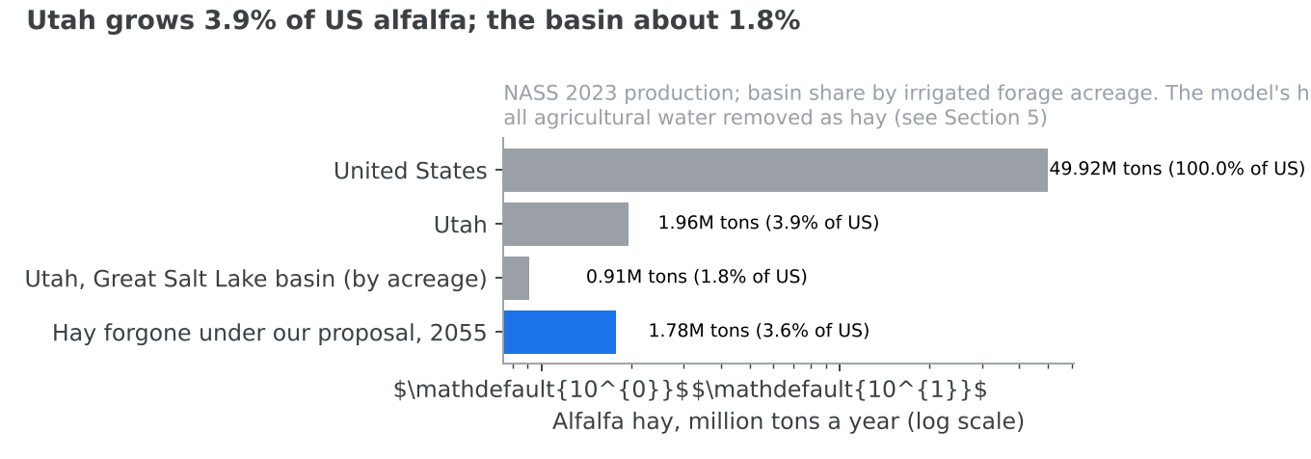
The United States grew 49.9 million tons of alfalfa in 2023 and 118.8 million tons of all hay (USDA National Agricultural Statistics Service, 2024a). Utah's 1.96 million tons is 3.9% of the national alfalfa crop, and the basin's share is about 1.8%. The hay forgone in our run equals 3.6% of the US alfalfa crop and 91% of Utah's. Tab 2B.5 works through what a cut of that size does to the national market.

What it means for farmers
The losses are real and they fall on farm counties. In 2055 our package costs 7,961 field jobs and 1,265 dairy and beef jobs. Uncompensated farm revenue lost is $210.3M a year in 2035, while the mandate still carries much of the load, and falls to $56.2M by 2055 as bought water replaces ordered water.
The package is built to pay rather than take. Most of the water the lake receives by 2055, 694 KAF a year, comes from rights the state leases or buys. Growers who pay the crop levy pay $41.6M a year, and $37.5M of it comes straight back to them through crop-switching payments. The crop-switching programme spends $40.0M a year to free 100 KAF, at $398 for each acre-foot delivered. A grower who switches keeps farming, keeps the land and is paid for the water the switch frees.

Alternative crops

Winter wheat
Winter wheat is the most practical replacement. It grows through the cool months and is harvested in early summer, so it misses the hottest, thirstiest part of the season. Switching an acre from alfalfa to winter wheat saves 0.61 acre-feet of depletion, at a cost of $276 for each acre-foot saved. Spring wheat saves 0.50 acre-feet at $493, and corn 0.53 acre-feet at $424 (Utah Division of Water Resources, 2026a). The same report finds that switching from alfalfa to winter small grains could cut basin agricultural depletion by up to 10%.
The wheat market can absorb it. Utah grew 4.6 million bushels of winter wheat in 2023, against 1,247.7 million bushels nationally (USDA National Agricultural Statistics Service, 2024a): less than half of one per cent. Extra Utah wheat would not move the national price. The cost of $276 an acre-foot is the measure of the income a grower gives up by switching; our crop-switching payments are set to cover it.

Hemp (new research)
This subsection is new research, added for this document and not part of the verified research base. We could not open the pages it rests on, only search summaries of them, so its figures should be checked before they are relied on.
Hemp is sometimes proposed as a low-water crop. The evidence we found does not support that. A Purdue estimate puts hemp's season water need at 25 to 30 inches of rain and irrigation combined, and Colorado State University field work found irrigated hemp yielded far more than unirrigated hemp, with the researcher describing its water use as high compared with other crops (Hemp Industry Daily, n.d.). That is close to what alfalfa needs from irrigation alone in the basin, so switching would save little water.
The market is also thin. US hemp production was worth $445M in 2024 from 45,294 planted acres, and floral hemp made up 87% of the value grown in the open; grain hemp was worth $2.62M nationally (USDA National Agricultural Statistics Service, 2025a). A basin switching tens of thousands of acres would add a large share of a small national crop and drive its price down. We therefore do not count on hemp, and our crop-switching programme is costed on wheat.

1.7 Data centres
The one data-centre campus with a published water figure would consume about 987 acre-feet a year, less than 0.1% of what hay consumes in the basin. Every announced industrial project together is put at 19.1 KAF a year in our model, but that total is our own estimate: no project except one has published a volume. Where the research base is silent, we say so and move the claim to Section 3.

What the research shows
The Box Elder campus. The clearest case is a data-centre campus in Box Elder County whose water-right application projects that it "would divert about 1,215 acre-feet of water annually at full buildout ... leaving net depletion of about 987 acre-feet a year" (Salt Lake Tribune, 2026b). About four-fifths of what it diverts is consumed; the rest returns to the system.
Meta and QTS at Eagle Mountain. Our research found no published annual water volume, in acre-feet, for Meta's Eagle Mountain expansion or for the QTS campus there.
The Tooele nuclear campus. The state's request for information on a nuclear lifecycle campus in Tooele estimates water use of about 15,000 gallons a day, or about 0.017 KAF a year, and 5,000 to 10,000 permanent jobs once fully operational, contingent on federal selection (Utah Office of Energy Development, 2026).
Reporting. The Utah Division of Water Rights now runs a reporting programme for large data-centre water use (Utah Division of Water Rights, 2026), so measured volumes should become available.
Public opinion. A 2026 poll of Utah voters found they put water ahead of data-centre growth (Noble Predictive Insights, 2026).

Water feared and water consumed
The fear is that data centres will drain the lake. On the evidence we have, they consume little of the basin's water. The Box Elder campus's 987 acre-feet a year is 0.04% of the basin's 2,387 KAF of depletion. Our model's figure for the whole announced industrial pipeline, 19.1 KAF a year, would be 0.8% of basin depletion, against 1,025 KAF for hay. Even if that pipeline figure were several times too low, industry would remain a small user next to agriculture.
How much a facility consumes depends on how it is cooled, and our model treats evaporative and closed-loop data centres as different users. The research base does not measure either, and it does not say whether returned water can be treated and sent on to the lake. We list both as predictions in Section 3.

Output per acre-foot
Industrial users earn far more from an acre-foot than farms do. Our model's figures for proposed facilities run from $46,000 an acre-foot for an evaporatively cooled data centre to $417,000 for a closed-loop one, and $3.5M for QTS, against $368 for hay. A nuclear plant with wet cooling produces about $27,000 of electricity per acre-foot, based on a published water-consumption factor of 672 gallons per megawatt-hour (Macknick et al., 2012). Except for the nuclear figure, these rest on no published water volume, so they appear in Section 3 as predictions rather than findings.

How our proposal handles industrial growth
Our model already takes 92 KAF a year from the lake by 2055 for growth in demand, which covers new industrial and municipal use together, and every lake level in this document is net of it. New industrial depletion falls inside the scarcity-charge base, so while the lake is short of its goal, a new facility pays for each acre-foot it consumes. Because industry earns over a hundred times more per acre-foot than hay, it can afford to pay the charge or to buy water rights from willing sellers, which moves water from low-value to high-value use without taking it from the lake.

1.8 Effects during the process (2035)
By 2035, eight years in, the lake stands at 4,197.07 ft on average inflow (10th–90th percentile band 4,193.40 to 4,202.31 ft), close to the healthy range. Getting there costs $452M a year in all, and the water delivered is worth $2,221M a year. The pain is concentrated: this is the year when the farm losses are largest relative to the gains, and when the jobs lost and gained are furthest apart.

Jobs
Who | Jobs in 2035
Field workers | −7,949
Dairy and beef | −1,264
Transition and monitoring work | +666
Lake economy (minerals, brine shrimp, recreation) | +6,804
Net | −1,743
About 9,200 farm and ranch workers would need new work. The jobs gained are not in the same places. Field, dairy and beef losses fall in the farm counties of the basin, such as Box Elder, Cache and Utah counties, while lake-economy jobs gather around the lake's mineral works, its brine shrimp harvest and the recreation on its shores. A statewide net of −1,743 therefore understates the dislocation: a farm county can lose hundreds of jobs while the state as a whole loses few. Lake-economy jobs reach 6,804 of their 7,706 total in 2035, because the lake is not yet fully recovered.

Farmland
By 2035 the package has already taken almost all the farmland it will take. Field job losses are within a few dozen of their 2055 level, when 414,635 acres are out of irrigation and 1.78 million tons of hay are forgone each year. As tab 1.6 explains, the model counts all agricultural water removed as hay, so the true cut to alfalfa is smaller. Uncompensated farm revenue lost is $210.3M a year, the highest it will be, because the mandate still orders 571 KAF a year and repossession has taken 549.6 KAF. That falls to $56.2M by 2055 as bought water replaces ordered water.

Health
With the package, the lake covers 1,342 square miles in 2035, against 957 with no package. That is 998 km² less exposed lakebed. At $81M to $175M a year in health damage for every 100 km² of exposed lakebed (Harris et al., 2026), the package avoids $808M to $1,746M a year of dust-related health costs. The research base gives these costs in dollars only; it holds no count of illnesses, hospital visits or deaths avoided, which we list as a gap in tab 5.

Minerals, brine shrimp and recreation
At 4,197.07 ft the lake is still just under 4,198 ft, the level at which mineral companies receive their full base water rights (Great Salt Lake Strike Team, 2026). At a healthy lake the three lake industries produce $1,130.8M (minerals), $135.8M (recreation) and $56.7M (brine shrimp) of output a year in 2010 dollars (Utah Legislature, 2022). By 2035 they support 6,804 jobs.

The whole account
Item | $M a year, 2035
Public budget | 100.0
Farm revenue lost, uncompensated | 210.3
Livestock receipts at risk | 141.8
Full cost | 452.0
Benefit: 910 KAF delivered to the lake at $2,440 | 2,221.4
The full cost is four and a half times the public budget. Even so, the benefit is almost five times the full cost. Water users also pay $41.6M in crop levy and $17.7M in scarcity charge in 2035. These are transfers rather than costs to the economy, and most of the levy returns to farmers through crop switching.

1.9 Effects at the end (2055)
By 2055 the lake is held at 4,198.53 ft on average inflow (10th–90th percentile band 4,194.55 to 4,204.29 ft), inside the healthy range, and 51.7% of simulated inflow sequences end healthy. The full cost has fallen to $298M a year while the water delivered is worth $2,091M a year. The farm losses remain, but they are smaller and mostly paid for.

Jobs
Who | Jobs in 2055
Field workers | −7,961
Dairy and beef | −1,265
Transition and monitoring work | +666
Lake economy (minerals, brine shrimp, recreation) | +7,706
Net | −854
The lake economy is back to its full 7,706 jobs, so the net loss has halved since 2035, from −1,743 to −854. The geography has not changed. The 9,226 field, dairy and beef jobs lost are in the farm counties, and the 7,706 lake jobs are around the lake. The statewide net hides a shift of work from rural counties to the lake's industries and shore. These farm job figures are likely too high: they apply a farm-wide average of 19.2 jobs per 1,000 acres to hay, which needs less labour than most crops, and they assume all 414,635 acres removed were in production (tab 2B.8).

Farmland
In 2055, 414,635 acres are out of irrigation and 1.78 million tons of hay are forgone each year, on the model's accounting that treats all agricultural water removed as hay (tab 1.6). Uncompensated farm revenue lost has fallen to $56.2M a year, a quarter of its 2035 level, because by now 694 KAF a year of the water comes from rights the state leases or holds, and only 153 KAF is ordered. Farmers also receive $37.5M a year in crop-switching payments funded by the levy.

Health
With the package the lake covers 1,465 square miles in 2055, against 963 with no package: 1,299 km² less exposed lakebed. At $81M to $175M a year for every 100 km² (Harris et al., 2026), that avoids $1,052M to $2,273M a year of dust-related health costs, more than the full cost of the package on its own. As in 2035, the research base gives no count of illnesses avoided.

Minerals, brine shrimp and recreation
On average inflow the lake is above 4,198 ft, the level at which mineral companies receive their full base water rights (Great Salt Lake Strike Team, 2026), though in nearly half of the simulated sequences it is below. At a healthy lake, mineral extraction produces $1,130.8M of output a year and 5,368 jobs, recreation $135.8M and 1,764 jobs, and brine shrimp $56.7M and 574 jobs, all in 2010 dollars (Utah Legislature, 2022).

The whole account
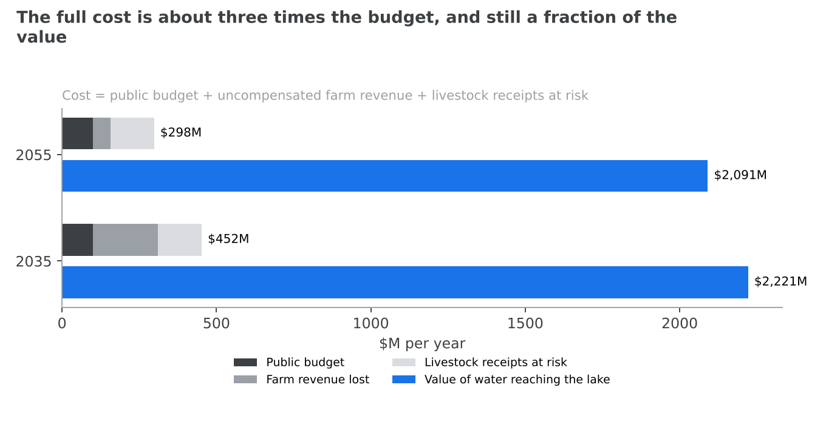
Item | $M a year, 2055
Public budget | 100.0
Farm revenue lost, uncompensated | 56.2
Livestock receipts at risk | 141.9
Full cost | 298.0
Benefit: 857 KAF delivered to the lake at $2,440 | 2,090.9
The full cost is $348 for every acre-foot delivered, less than an acre-foot earns in hay and a seventh of what it is worth in the lake. Summed over 2027–2055, the net economic value of the package is $55.0B. The largest remaining cost is not the budget but the $141.9M of livestock receipts at risk, which arises because the hay cut in our run is larger than the basin's forage surplus; if the true cut to alfalfa is smaller, as tab 1.6 suggests, so is this cost.

1.10 Effects if we do nothing
With no package, the lake settles near 4,190.93 ft by 2055 on average inflow (10th–90th percentile band 4,183.0 to 4,194.66 ft). In 63.3% of simulated inflow sequences it ends below the 4,190 ft serious-harm level, and in only 0.8% does it end healthy. Doing nothing costs no public money and no farm jobs, but it gives up about $2,091M a year of value in the lake and leaves a real chance that much of the lake dries out.

Jobs
Who | Jobs in 2055, no package
Field workers | 0
Dairy and beef | 0
Transition and monitoring work | 0
Lake economy | 1,135
No farm jobs are lost, and no transition jobs are created. The model shows 927 lake-economy jobs in 2035 and 1,135 in 2055 even with no package, because the lake partly recovers after dry years; this is a feature of the model's rebound, not a forecast that the lake economy grows (tab 5). Against the package, doing nothing keeps about 9,200 farm and ranch jobs in the farm counties and forgoes about 6,600 lake-economy jobs around the lake.

Farmland
No land leaves irrigation and no hay is forgone. Farm and ranch incomes carry on as they are, so long as the water supply holds. In the dry scenarios below, it may not: a falling lake does not protect upstream irrigators from drought.

Health
With no package the lake covers about 963 square miles in 2055, against 1,465 with the package, leaving about 1,299 km² more lakebed exposed. At $81M to $175M a year for every 100 km² (Harris et al., 2026), that extra exposed lakebed costs $1,052M to $2,273M a year in dust-related health damage. As elsewhere, the research base gives this in dollars only, not in illnesses.

Minerals, brine shrimp and recreation
The lake stays below 4,198 ft in almost every sequence, so mineral companies would not receive their full base water rights (Great Salt Lake Strike Team, 2026). The lake industries, which at a healthy lake produce $1,130.8M (minerals), $135.8M (recreation) and $56.7M (brine shrimp) a year in 2010 dollars and 7,706 jobs (Utah Legislature, 2022), would operate on a much smaller lake.

The lake drying out
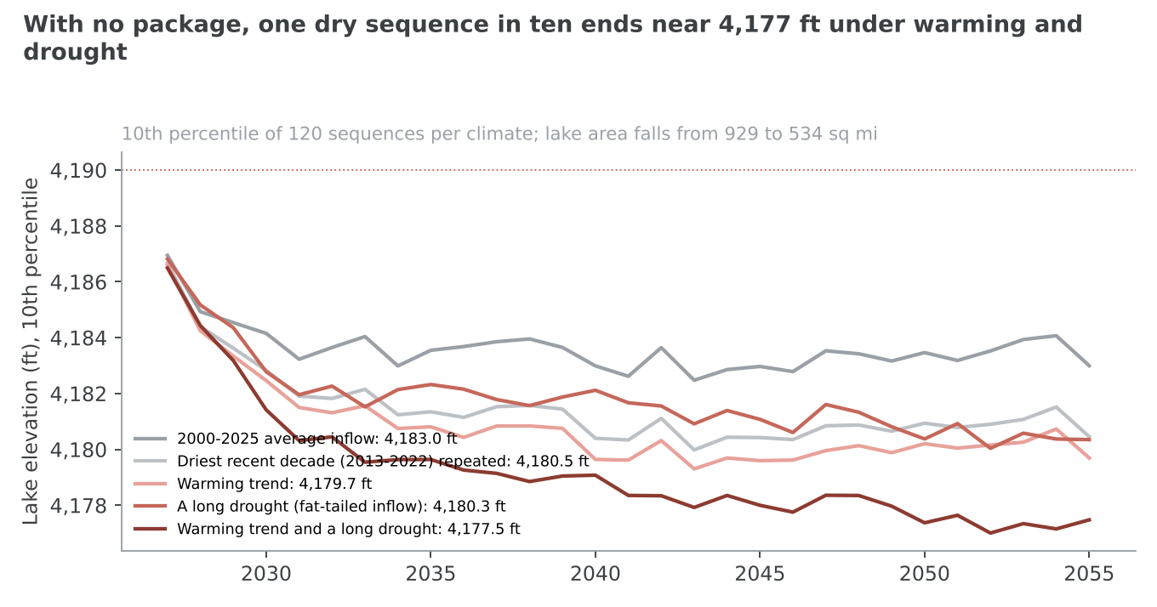
The average path hides the danger. The lake does not just stop rising; in dry sequences it keeps falling. We ran the no-package case under four drier futures, each with 120 inflow sequences.
Scenario, no package | Lake in 2055, driest 1 in 10 (ft) | Share of sequences below 4,190 ft
2000–2025 average inflow | 4,183.00 | 63%
The driest recent decade (2013–2022) repeated | 4,180.46 | 81%
A warming trend | 4,179.69 | 88%
A long drought | 4,180.35 | 66%
A warming trend and a long drought together | 4,177.48 | 92%
In the worst case, one sequence in ten leaves the lake at 4,177.48 ft in 2055, more than 12 ft below today. Its surface would shrink from about 929 square miles today to about 534, losing over two-fifths of its area and exposing that lakebed to the wind. Even in the median sequence of that scenario the lake ends at 4,183.55 ft.
Our brief asked us to cite a widely reported warning that the lake could disappear within about five years. That paper is not in our research base, so we do not cite it; we describe the risk from our own model instead and list the missing citation in tab 5.

The whole account
Item | $M a year, 2055, no package
Public budget | 0
Farm revenue lost | 0
Livestock receipts at risk | 0
Full cost | 0
Value forgone: 857 KAF a year not delivered, at $2,440 | 2,091
Doing nothing is not free. Against our package it forgoes about $2,091M a year of value in the lake, to save $298M a year in public money, farm revenue and livestock receipts. Measured separately, its extra exposed lakebed costs $1,052M to $2,273M a year in health damage.

2 Our assumptions
Our model rests on 102 figures. Of these, 27 are taken directly from a source, 13 are derived from other figures by a stated formula, and 62 are assumptions: values we chose, most of them bounded or supported by published evidence. Only three have no source of any kind, and they are set out in Section 3. This section explains every figure, in two parts, each ordered by how much the figure moves the lake level in 2055.

How this section is organised
Part A, the levers (tabs 2A.1–2A.7), covers what a legislature would set: the mandate, the scarcity charge, the conservation programmes, lease-to-own agreements, the crop levy, the budget and residential lawns. Part B, the constants (tabs 2B.1–2B.11), covers what the model relies on but nobody sets: the lake's water balance, river inflow, delivery, climate and growth, crop water use, who uses the water, its value, jobs, public opinion, industrial demand and the variability of inflow.
Each tab tells the story of its assumptions: the value, where it comes from and how it was checked, the economics where the assumption is a market, and the closest real-world analogue where one exists. Each assumption has its own sub-heading, which tab 1.5 links to.

How each figure was checked
Every figure was re-checked at source in October 2026, and each carries a verdict:
Verdict | Figures | Meaning
Confirmed | 19 | The source states the value, or it follows by stated arithmetic
Corrected | 24 | A source gave a different value; the model now uses it
Range revised | 9 | The value holds; its plausible range was changed
Derived | 1 | Worked out from other checked figures
Evidence | 33 | An assumption with published studies that support or bound it
Unsupported | 8 | Labelled as sourced, but the figure was not found; now treated as an assumption
No evidence | 8 | An assumption with nothing published behind it after a real search
Where we draw on a historical analogue, we rate how closely it matches our situation on a scale of 1 to 5. A 5 is the Great Salt Lake's own measured data; a 4 is the same mechanism in Utah or a closely comparable place; a 3 is the same mechanism elsewhere with important differences; a 2 is a related mechanism; a 1 is a search that found nothing.

Which assumptions matter most
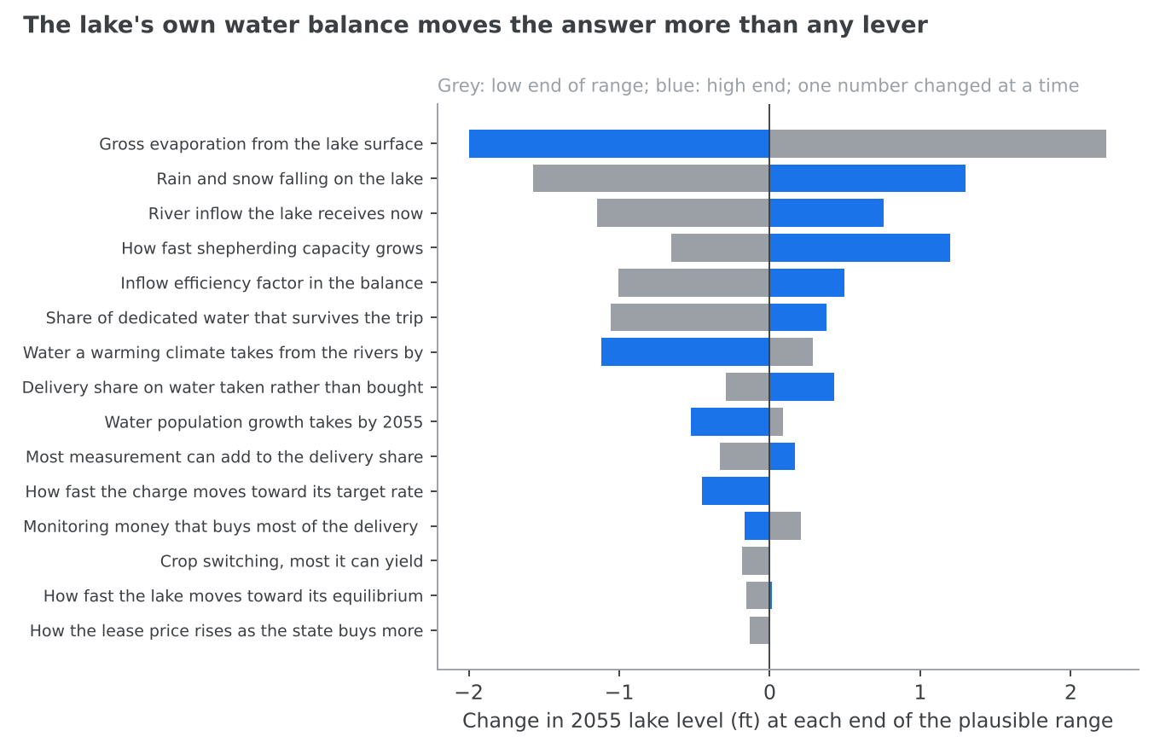
We moved each figure from the low to the high end of its plausible range, one at a time, and recorded how far the 2055 lake level moved. The twelve that matter most are:
Figure | Swing in the 2055 level (ft) | Tab
Gross evaporation | 4.23 | 2B.1
Precipitation on the lake | 2.88 | 2B.1
River inflow now | 1.90 | 2B.2
Growth of shepherding capacity | 1.85 | 2B.3
The closure factor | 1.50 | 2B.1
The delivery share | 1.43 | 2B.3
Streamflow decline by 2055 | 1.41 | 2B.4
Delivery of ordered water | 0.72 | 2A.1
Growth in demand by 2055 | 0.61 | 2B.4
Most measurement can add to the delivery share | 0.50 | 2B.3
Speed of the charge thermostat | 0.38 | 2A.2
Monitoring money that buys most of the delivery gain | 0.37 | 2B.3
The lake's own water balance moves the answer far more than any lever. Two cautions apply. First, gross evaporation, precipitation and the closure factor were fitted together to the state's published lake levels, so raising one would force the others to move; varying each alone overstates its effect. Second, these swings are for the average-inflow run; the weather itself moves the 2055 level across a band of about 10 ft (tab 2B.11).
Most of the levers move the 2055 level very little, because the package is limited by how much water willing sellers will offer and how much can be shepherded, not by any one setting. That is why the ordering in Part A starts with the mandate and the charge, which act on that limit, and ends with the budget and lawns, which barely move the result.

2A.1 Our assumptions regarding the mandate and repossession
The mandate is our backstop: it orders a cut only where the voluntary instruments fall short, and repossession lets the state acquire rights, at market value and in instalments, where the market will not supply them. Of the figures here, the one that matters most is how much ordered water actually reaches the lake. Moving it across its plausible range shifts the 2055 lake by 0.72 ft, more than any other lever.

The mandate floor
What we assume. A floor of 1,200 KAF a year of reduced depletion, the top of the 0 to 1,200 KAF range we allow. Basis. This is a policy choice, not a measurement. The state's updated water budget puts the inflow needed to reach 4,198 ft by 2055 at about 2,465 KAF a year, against a 2000–2025 average of 1,665 KAF: a gap of 800 KAF a year (Great Salt Lake Strike Team, 2026). Because not all water freed upstream reaches the lake, the cut must be larger than the gap: a 1,100 KAF cut delivers 800 KAF only if about 73% of it arrives. A 1,200 KAF floor is the full gap grossed up for those losses. Because the mandate orders only what the voluntary levers have not already found, the floor is a ceiling on coercion, not a target: in 2055 the mandate orders just 153 KAF. Verdict: a policy choice with published support for its size.

Phase-in and penalty
We phase the mandate in over one year, the fastest setting, and set the penalty for non-compliance at zero. Published targets bound the phase-in between about 8 years (the governor's pledge to refill the lake by 2034, the year of the Winter Olympics) and 29 years (the 2055 planning horizon) (New York Review of Books, 2026); the Lower Colorado Basin's cut was phased over 3 years (Greenberg Traurig, 2023). A one-year phase is at the aggressive end of that range; it is the setting the goal search chose. The penalty can run up to $2,440 an acre-foot, the lake's value. Utah law already lets the State Engineer fine a knowing violation up to $5,000, or $1,000 if not knowing, and order replacement of up to 200% of the water taken (Utah Legislature, 2026b). At current lease prices that replacement rule is worth about $500 to $760 an acre-foot. We use no penalty, so the mandate orders the cut and existing enforcement law applies.

How a mandate widens the market
What we assume. A credible mandate widens the voluntary market by 70%: farmers who would not have leased water come forward when a cut may be ordered anyway. The analogue. The Lower Colorado River Basin is the closest case. In 2023 the Lower Basin states agreed to conserve an additional 3 million acre-feet through 2026 "to avoid forced cuts", after the federal government asked for reductions of 2 to 4 million acre-feet in 2023 alone (Hager, 2023). By 2026, Lower Basin states were conserving an estimated 1.3 MAF a year, of which 770,000 acre-feet were additional, federally compensated reductions on top of 533,000 acre-feet already required, an extra share of 1.44 (Congressional Research Service, 2026). We rate both cases 3 out of 5: the mechanism is right, but the threat was bundled with large federal payments, and the Secretary of the Interior holds powers over Lower Basin water that Utah's State Engineer does not hold over the lake's tributaries. In the Upper Basin, a 1.7-fold rise in participation between 2023 and 2024, from 64 to 109 projects, matches our 0.7 exactly, but was caused by a take-it-or-leave-it fixed price, not a threat (Smith, 2024); we rate it 2. We keep 0.7, below the Lower Basin figure, because Utah's backstop is a state mandate without federal money behind it.

Repossession
What we assume. The state may compulsorily acquire up to 140 KAF a year of water rights, paying in instalments at 3% interest. Basis. A policy choice and a legal limit: compulsory acquisition at market value takes time to process. No published figure says how much water Utah could acquire this way in a year. For scale, 10% of agricultural depletion is about 158 KAF a year, and the state's own near-term goal is to secure 100,000 acre-feet in total, temporary or permanent (Office of the Great Salt Lake Commissioner, 2024). Our cap of 140 KAF a year is near the top of the 0 to 150 KAF range. Verdict: no evidence; an assumption at the edge of its range.
Interest. The 3% rate sits between the 1.82% the state pays on average on its outstanding general obligation debt (Utah State Treasurer, 2025a) and the roughly 4% its investment pool was earning at the end of 2025 (Utah State Treasurer, 2025b). Verdict: corrected from 1.5%, and labelled an assumption.
Which ground is taken. We assume repossessed ground is 26% less productive than average, because the selection is weighted away from the best land. The state's yield classes support a discount of about 23% or more for the lowest third of acres (Utah Division of Water Resources, 2026a). Compulsory acquisition still pays fair market value; the discount comes from which land is chosen, not from underpaying for it.

Delivering ordered water
What we assume. Water freed by an order arrives at the lake at 71% of the rate of water the state holds as a right. Basis. A cut ordered on a farm is harder to track than a right the state holds: the freed water stays in the river with no owner protecting it, and a downstream diverter may take it. The state's own reports make the point that conservation "may not benefit the lake if the water is used and depleted by downstream users" (Great Salt Lake Strike Team, 2025). The analogue. In the Upper Colorado's conservation programme, water left in streams "is not tracked to Lake Powell", and officials "are not measuring how much of that conserved water ends up" there (Smith, 2024). We rate this 2: it shows that the delivered share of unprotected water is unmeasured, not what it is. Verdict: no evidence. No published study compares how much mandated and acquired water reaches a lake. This is one of the most consequential unmeasured numbers in our model, and the strongest argument for buying water rather than ordering it.

2A.2 Our assumptions regarding the scarcity charge
The scarcity charge puts a price on each acre-foot depleted while the lake is short of its goal. We assume users respond as the economics of irrigation and municipal water demand predict: modestly, because water demand is inelastic, but most strongly among growers of low-value crops such as hay. The charge's speed of adjustment matters most of these figures; it moves the 2055 lake by 0.38 ft across its range.

The rate and the base
The charge starts at $85 an acre-foot and falls on 1,938.4 KAF a year: all basin depletion except household use (421.6 KAF) and reservoir evaporation (27 KAF) (Great Salt Lake Strike Team, 2026). It is derived as agriculture (1,584 KAF) plus minerals, commerce, institutions and city-supplied industry (354.4 KAF).
\text{charge base} = 2{,}387 - 421.6 - 27 = 1{,}938.4 \text{ KAF a year}

How farms respond
The market. For a farm, water is an input. Its demand for water slopes down: the higher the price of an acre-foot, the fewer acre-feet it is worth applying, because the last acre-feet add little yield. A charge raises the price of every acre-foot depleted. Growers cut first where water earns least: the last irrigation of the season, the poorest fields, and low-value crops like hay. The cost falls on the grower, who either pays the charge or gives up the crop the water would have grown.
What we assume. A farm cuts its depletion by a share equal to 0.4 times the charge, expressed as a fraction of what the water is worth to the farm, up to a cap of 60% of agricultural depletion.
\text{share cut} = \min\left(0.4 \times \frac{\text{charge}}{\$236},\; 0.6\right)
The value of the water to a farm. We take $236 an acre-foot, the payment growers would accept to stop irrigating full-season alfalfa, per acre-foot of depletion saved (Utah Division of Water Resources, 2026a). The charge is levied on depletion, so the per-acre-foot-depleted figure is the right one. Verdict: corrected from $133, which was a per-acre-foot-applied figure.
The elasticity and its analogue. Our 0.4 behaves like a price elasticity of demand for irrigation water. A meta-analysis of 24 US studies since 1963 found a mean price elasticity of 0.48 and noted that long-run elasticities, the ones that matter for policy, are likely larger (Scheierling et al., 2006). We rate it 4 out of 5: it measures exactly this quantity, pooled across US regions and decades rather than measured in Utah. Utah's crop mix, dominated by low-value hay, sits at the more responsive end, so 0.4 is a cautious choice. Verdict: evidence; range 0.2 to 0.7.
The cap. No charge can drive farm water use to zero. A study of the lake's three tributary watersheds found a saturating response: all irrigated alfalfa in the Jordan and Bear watersheds would be fallowed at any payment, but only about half of Weber's, 95,200 acres (Li & Khan, 2024). We rate it 3: the right place and crop, but a fallowing payment rather than a charge. The state's own treatable-acreage bound for fallowing implies about 40% of agricultural depletion is reachable; a charge can reach further through other crops and deficit irrigation, so we set 60%, within a 30% to 80% range. Verdict: evidence.

How cities and industry respond
What we assume. Municipal and industrial users respond with a price elasticity of 0.3, and can cut at most 40% of their depletion. Their reference price is $640 an acre-foot.
The analogue. A meta-analysis of residential water demand found a mean price elasticity of −0.41 and a median of −0.35, "providing substantial evidence for water demand being price inelastic" (Dalhuisen et al., 2003); we rate it 3, since it covers households, not industry. A review of industrial water demand concludes that industrial demand is also inelastic, though more responsive than household demand (Gracia-de-Renteria & Barberan, 2021); we rate it 2, as it is mostly European with no pooled figure. Our 0.3 sits slightly below the household median, which suits a mix that includes less responsive industrial users. The state's most aggressive conservation scenario cuts municipal use by 23% to 33% over 50 years (Utah Division of Water Resources, 2019); because depletion is concentrated outdoors, where cuts concentrate, a 40% cap on depletion is at the upper edge of what is published.
The reference price. The largest wholesaler in the basin charges its member cities between $474.11 and $811.41 an acre-foot for 2026/27, with a median of $639.92 (Jordan Valley Water Conservancy District, 2026); we rate this 5, the exact quantity in the basin. Lowest-tier municipal rates in the study area run from $456 to $1,385 an acre-foot (Li & Khan, 2024). Verdict: corrected from $380, which was below every listed rate.

The thermostat and escalator
What we assume. The charge does not jump. Each year it closes a quarter of the gap between its current rate and its target, standing in for about a four-year review cycle. While the lake stays more than 15% short of the goal, an escalator raises the rate by a step of 0.12 a year, up to four times its starting level.
Basis. Utah law requires water providers to update their conservation plans at least every five years (Utah Legislature, 2026c), which is a speed of about 0.2 a year; our 0.25 is a little faster. Federal drought guidance supports surcharges that rise "as the drought worsens" (U.S. Environmental Protection Agency, 2017), but publishes no rate of escalation or cap. The 15% dead band reflects how uncertain the basin's water accounts are: the state's updated water budget raised total depletion by 13.7% when averaged over 1989–2023 (Great Salt Lake Strike Team, 2026). Verdict: evidence for the speed and the dead band; the escalator step and cap are design choices.
What it produces. In 2027 the rate is $87 and users cut 248.5 KAF a year. As bought water arrives and the lake rises, the thermostat lowers the rate: to $9 by 2035, when the cut is 26.4 KAF, and close to zero by 2055.

2A.3 Our assumptions regarding conservation programmes
We model each programme the same way: money buys water at a fixed cost per acre-foot until the programme reaches a cap set by nature or by how many people will take part, and only a share of the water freed reaches the lake. In supply terms, each programme is a flat supply curve that stops dead at its cap. Crop switching's cap matters most of these figures, moving the 2055 lake by 0.18 ft across its range. Every programme takes three years to reach full output, an assumption the state's own report supports by phasing irrigation upgrades over ten years (Utah Division of Water Resources, 2026a).
\text{water delivered} = \min\left(\frac{\text{spending}}{\text{cost per AF}},\ \text{cap}\right) \times \text{delivery share}
Programme | Cost per AF freed | Share reaching the lake | Cap (KAF a year) | Delivered in our run
Cloud seeding | $10 | 0.35 | 50 | 50 KAF at $28.6 per AF delivered
Phragmites removal | $610 | 0.90 | 50 | 36.9 KAF at $678
Crop switching | $318.4 | 0.80 | 100 | 100 KAF at $398
On-farm efficiency | $581 | 0.55 | 70 | 18 KAF at $1,056

Cloud seeding
Cost. We assume $10 an acre-foot of added runoff, the top of the state's estimate: "The additional water produced by cloud seeding is estimated to cost $5 to $10 per acre-foot" (Utah State University Extension, 2025). Verdict: confirmed.
Share reaching the lake. We assume 35%. Seeded snow melts into the same rivers as all other water and is diverted and consumed upstream like it. Across the basin, about 42% of all water supply reaches the lake: 1,665 KAF of inflow against 2,320 KAF of human depletion (Great Salt Lake Strike Team, 2026). Seeded water arrives in spring runoff in the headwaters, above most storage, so in dry years reservoirs may capture more of it. Verdict: evidence; no source gives a delivery share for seeded water.
Cap. We assume new seeding can add at most 50 KAF a year to the lake, limited by storms and target areas, not money. The analogues are strong. The northern Utah seeding programme over the Bear River basin, which drains to the lake, was estimated in a 2012 study to add about 56,000 acre-feet a season (North American Weather Consultants, 2022); we rate this 5, the same mechanism in the same basin. The central and southern Utah programme likely adds more than 70,000 acre-feet a year (North American Weather Consultants, 2023); we rate it 4, since those watersheds drain away from the lake. If our cap means added water from new or expanded seeding, 50 KAF is plausible; if it means the whole programme, the state's 77 to 102 KAF would be the better estimate. Verdict: evidence.

Phragmites removal
Phragmites is an invasive reed that has spread through the lake's wetlands and transpires far more water than the native plants it displaces.
Cost. We assume $610 an acre-foot, the low end of the state's documented estimate of "between $610 and $4,050 per ac-ft" (Utah Division of Water Resources, 2025b). A 2026 legislative slide gives a much lower summary figure, $60M for 300 KAF a year, or $200 an acre-foot (Utah Legislature, 2026d). The two official figures disagree by an order of magnitude, and our range spans both. Verdict: corrected from $186.
Cap and timing. We assume at most 50 KAF a year. The state estimates that removing phragmites throughout its known range "could range from 17,000 to 57,000 ac-ft per year" in savings (Utah Division of Water Resources, 2025b). The state's phragmites strategy estimates the reed uses 3.62 acre-feet of water an acre against 1.55 for native saltgrass; across 30,000 acres that is a theoretical saving of about 62 KAF a year (Utah Division of Forestry, Fire and State Lands, 2024). We rate it 4: the right place and mechanism, but the figures are modelled, not measured. Treated stands have to die back before the saving appears: "It typically takes us three to five years to remove any given patch" (Utah Public Radio, 2026), so we assume a three-year lag.
Share reaching the lake. We assume 90%, because the stands are on the lake's edge, below nearly all diversions. No source gives a figure, and the state notes that "additional research is needed to quantify water savings from phragmites treatment" (Great Salt Lake Strike Team, 2026). Verdict: unsupported; an assumption.

Crop switching
Cost. This is a derived figure. The state's report costs switching from alfalfa at $276 an acre-foot of depletion saved for winter wheat, $424 for corn and $493 for spring wheat (Utah Division of Water Resources, 2026a). We use the blended rate that fills the programme's capacity at $39.8M a year:
\text{cost per AF} = \frac{\$39.8\text{M} \times 0.8}{100{,}000 \text{ AF}} = \$318.4
It lies inside the published range, closer to winter wheat, which is the cheapest switch and the one the report finds can deliver most.
Cap. We assume 100 KAF a year. The state's report finds that switching alfalfa to winter small grains "could reduce depletions by up to 10%", about 83 to 132 KAF a year, and describes this as a technical scenario that needs very wide adoption. Our 100 KAF is therefore near the technical maximum. The analogue. The federal Colorado River pilot programme, which paid farmers across the basin, including in Utah, to fallow or switch to lower-water crops, saved 11,408 acre-feet in 2017 and 25,319 in 2018 (U.S. Bureau of Reclamation, 2019). We rate it 3: the same mechanism, but a short, budget-limited pilot in another basin. Our cap is four times its best year, in a basin where far more of the water is in hay. Verdict: evidence.
Share reaching the lake. We assume 80%: water left in the river still passes diversions on its way down. Utah officials "cannot point to a specific amount of the reported agricultural water savings" that reached the lake (Johns, 2026); we rate this 2, as it shows the share is unmeasured. Verdict: no evidence.

On-farm efficiency
Cost. We assume $581 an acre-foot, the midpoint of the state's $148 to $1,014 range across pivot upgrades and surface-to-sprinkler conversions (Utah Division of Water Resources, 2026a). The report's own volume-weighted figure, $563, is within 3%. Verdict: confirmed.
Cap. We assume 70 KAF a year, bounded by how much ground can be converted. Utah sprinkler upgrades offer 16 KAF under $210 an acre-foot and 37 KAF under $510; the whole-basin irrigation strategy reaches 132.6 KAF at $563. Verdict: range revised.
Share reaching the lake. We assume 55%, and here the analogues are sobering. In western Kansas, efficiency upgrades from 1995 to 2005 increased groundwater extraction, "a rebound effect of over 100%" (Pfeiffer & Lin, 2010); we rate it 3, as a groundwater system with different crops. Utah's own programme reported "Diversion: potential for notable decreases; Depletion: negligible change expected" from its first 20 projects (Hasenyager & Bunker, 2024); we rate it 4. The state's dashboard reports more than 125,000 acre-feet a year of savings, but these are diversion savings, not depletion (Johns, 2026). The evidence points to a share below 55%, possibly near zero. Because the report's costs are already per acre-foot of depletion saved, a lower share may double-count; we keep 55% and spend only $19M a year on this programme, the least cost-effective in the package. Verdict: evidence.

2A.4 Our assumptions regarding lease-to-own agreements
Leasing water from willing sellers is the backbone of our proposal: by 2055 it, together with repossessed rights, carries 694 KAF a year to the lake. We assume the lease market behaves like any market in a scarce asset. The more the state buys, the less willing the remaining holders are to sell, so the price rises; and there is a limit to how much anyone will sell at any price. In our run that limit, not money, decides how much water the state holds.

The lease supply curve
The economics. Each irrigator has a reservation price: the lowest payment at which leasing the water beats farming with it. Farmers with poor ground, high costs or plans to retire have low reservation prices and lease first. As the state leases more, it has to reach farmers who value their water more highly, so the price it must pay rises. That is an upward-sloping supply curve. The elasticity of supply says how steeply: an elasticity of 1 means a 1% rise in the price brings forth 1% more water. Beyond some volume, no plausible price brings more water forward, and the curve turns vertical.
What we assume. The lease rate starts from a base of $250 an acre-foot a year and rises with the volume the state already holds, with a supply elasticity of 1. The rate cannot fall below 0.3 times the base or rise above 6 times it. Willing sellers will lease up to 130 KAF a year and sell up to 150 KAF outright.
\text{lease rate} = \$250 \times \left(1 + \frac{\text{held}}{q_{\text{ref}}}\right)^{1/\varepsilon}, \qquad \varepsilon = 1,\quad 0.3 \le \frac{\text{rate}}{\$250} \le 6
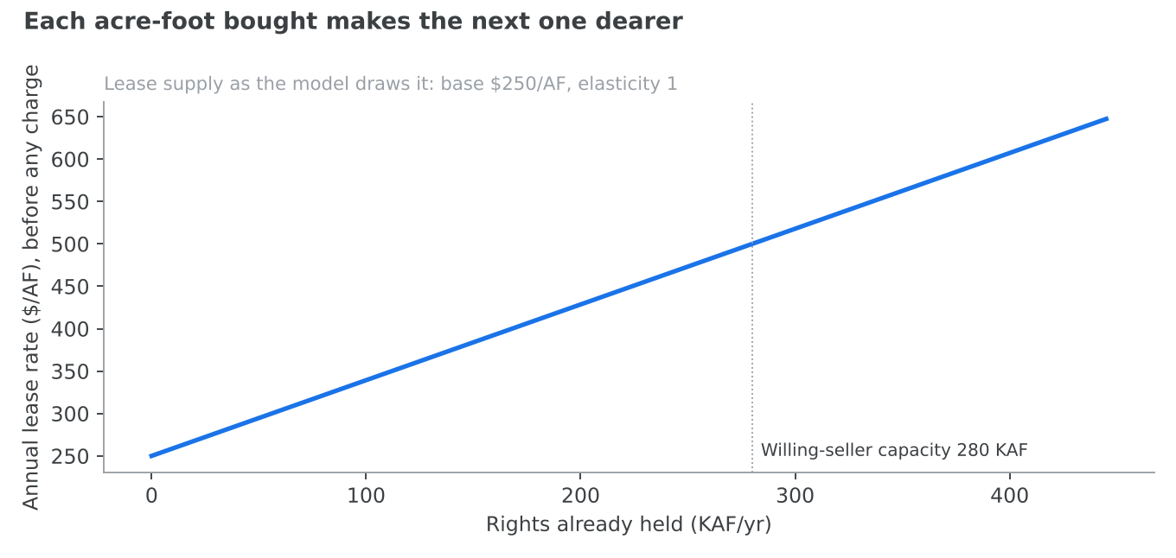
Who it falls on. The cost falls on the state, which pays a rising price for each additional acre-foot. Farmers who lease are better off than they were, by construction: they lease only if the payment beats their own use of the water.

The base rate
The state's agricultural optimisation report found that "ceasing alfalfa irrigation early and full-season leasing were the top-performing leasing options, with an average cost of $236 per AF" (Utah Division of Water Resources, 2026a). A policy brief for the Strike Team put the cost per acre-foot of water banking at between $150 and $300 (Kem C. Gardner Policy Institute, 2023). Our $250 sits in that range. Verdict: corrected from $380, which matched Colorado River programmes rather than this basin.

The elasticity
The analogue. The only observed price and quantity pair comes from the Upper Colorado River's conservation pilot. In 2023 it paid about $16M for 38,000 acre-feet, about $421 an acre-foot; in 2024 it paid nearly $29M for about 64,000 acre-feet, about $453 (Aspen Journalism, 2025). Taken at face value, a 68% rise in quantity for a 7% rise in price implies an elasticity of about 3 to 7. But the programme was redesigned between the two years, with a fixed take-it-or-leave-it price and better outreach, so the pair does not isolate the supply curve. We rate it 3. Our elasticity of 1 is deliberately steeper than that: it assumes the state, as the only large buyer, will drive up the price as it buys. Because the price moves but the willing-seller caps decide the quantity, the result is not sensitive to it; it moves the 2055 lake by 0.13 ft. Verdict: evidence.

The floor and ceiling
The floor of 0.3 times the base, $75 an acre-foot, stops the scarcity charge from driving the price to nothing. Evidence suggests farmers do not respond below about $150: an early offer of $150 an acre-foot in the Upper Colorado was called "insulting", and Colorado, Utah and Wyoming later paid about $500 (Aspen Journalism, 2025). That points to a floor nearer 0.4 or 0.6. We keep 0.3 because the charge lowers what water is worth to the farmer. The ceiling of 6 times the base is permissive: the highest observed agricultural lease payment, $650 an acre-foot, is 2.6 times our base (Salt Lake Tribune, 2023b). It rarely binds. Verdict: evidence for both.

How much willing sellers will offer
Leases. We assume 130 KAF a year. The analogues. The lake's own Watershed Enhancement Trust transacted "nearly 72,500 acre-feet of water" in 2025, up from about 64,000 in 2023 and 69,190 in 2024, against an objective of 100,000 acre-feet a year (Great Salt Lake Watershed Enhancement Trust, 2026). We rate it 5: the same lake, basin and mechanism. In the Upper Colorado, four states at full federal funding enrolled about 64,000 acre-feet in 2024, 2% to 3% of eligible irrigation water (Smith, 2024); we rate it 4. The state's own leasing scenario of 10%, 132 KAF basin-wide, is described as "herculean". Our 130 KAF is that ceiling: nearly twice what the Trust achieves today. Verdict: corrected from 200 KAF.
Outright sales. We assume 150 KAF a year. The Trust's permanent transactions run at roughly 13 to 21 KAF a year (Great Salt Lake Watershed Enhancement Trust, 2026); we rate this 4, as the categories in the published chart could not be matched to the numbers with certainty. Australia's Murray–Darling Basin, the only long-running basin-scale programme of voluntary permanent purchases for the environment, recovered 2,075 GL a year of entitlement, about 1,683 KAF, over roughly 15 years (Parliament of Australia, 2025): about 110 KAF a year in a basin ten times larger. We rate it 3: the mechanism matches, but Australia has unbundled, tradable water entitlements and a mature market. Our 150 KAF is about seven times the Trust's realised pace, a deliberate stretch for a funded state programme. Verdict: range revised to 20 to 600 KAF.
What happens in our run. The state holds 280 KAF of rights, 130 leased and 150 bought, from the first year to the last: the willing-seller limit binds throughout. As the lake recovers and the charge falls, the lease rate rises from $75 to $135 an acre-foot. Leasing costs $21M a year, $30.25 for every acre-foot shepherded to the lake in 2055, and $289.1M over 2027–2055.

The price of a right
What we assume. Buying a right outright costs $6,000 an acre-foot. Basis. Utah figures disagree widely. Cedar City paid just over $12,100 an acre-foot for 942.75 acre-feet of mostly 1860-priority water in 2023 (Western Water, 2023). The state's $30M purchase of the US Magnesium facility and its water rights works out at about $207 an acre-foot, but that was a bankruptcy sale of mineral brine rights and a plant (KJZZ-TV, 2026). Capitalising a $250 lease at 3% to 4% gives $6,250 to $8,300 an acre-foot. Our $6,000 is a capitalised lease price, at the low end of that band. Verdict: range revised to $3,000 to $12,100; the low Utah figures are unresolved.

How long until the state owns the right
A lease-to-own agreement credits part of each payment toward buying the right, so that over time the state stops renting and owns. The policy question is how fast. At our setting of $2M a year set aside for ownership, the model reports that paying off the rights would take 43.1 years, beyond 2055, so the state owns no right outright within the horizon. The $2M is a setting with no source behind it (Section 3). The goal search left it low because ownership does not change how much water reaches the lake before 2055: a leased acre-foot and an owned one are shepherded alike. A legislature that wants permanent protection after 2055 would raise this line, and shorten the payoff, at the cost of money for monitoring or programmes now.
HB 410. Utah's 2026 water leasing law limits full-season leasing off a field to no more than two years in every five (Office of the Great Salt Lake Commissioner, 2026). We read that rule as applying to temporary leases, not to the acquisition of rights, so we apply no two-in-five multiplier to lease-to-own rights. If the rule did apply, holding a constant volume would need 2.5 times the enrolled acres. This legal reading should be checked against the enrolled bill.

2A.5 Our assumptions regarding the crop levy
The crop levy charges $400 for each acre-foot a hay field applies above 1.5 acre-feet an acre. It leaves ordinary irrigation untouched and puts a high price only on the heaviest use, then returns 90% of what it raises to farmers through crop switching. We assume it falls on about 211,000 acres and frees 148.2 KAF a year. How much water a hay acre receives on average matters most here, moving the 2055 lake by 0.11 ft across its range.

How the levy works as a price
A levy above a threshold is a two-part price. The first 1.5 acre-feet on an acre cost the farmer nothing extra; every acre-foot beyond costs $400. A farmer weighs that $400 against what the extra water adds to the crop. Since an acre-foot of hay water earns about $368 gross, and much less at the margin where the last irrigations add little yield, cutting back is usually the cheaper choice. The cost therefore falls on the heaviest irrigators, who either cut back or pay. Growers below the threshold are unaffected.
\text{water freed} = \text{acres in scope} \times \text{average excess above 1.5 AF} \times \text{share cut} \times \text{depletion factor}
In our run, 211,371 acres apply more than the threshold, an average of 0.91 acre-feet too much. Growers cut half of that, and the levy frees 148.2 KAF a year of depletion and raises $41.6M a year, of which $37.5M funds crop switching.
No real-world levy on over-application in an American irrigation basin exists to serve as an analogue, and we have not manufactured one. The figures below rest on the state's agronomic data.

The hay ground in scope
How many acres. We assume 228,000 acres of irrigated hay in the Utah part of the basin. The 2022 Census of Agriculture's county tables give 219,944 irrigated forage acres in eleven basin counties, from Box Elder's 48,790 to Salt Lake County's 742; Wasatch County's figure is withheld and estimated at about 8,000 (USDA National Agricultural Statistics Service, 2024c). Verdict: corrected from 399,500 acres, which fits only if Idaho and Wyoming are included, and a Utah levy cannot reach them.
How much they apply. We assume 2.4 acre-feet an acre on average. The 2023 national irrigation survey reports Utah alfalfa at 523,658 irrigated acres with 2.4 acre-feet applied on average, 2.6 on pressure systems and 2.0 on gravity systems, and all other hay also at 2.4 (USDA National Agricultural Statistics Service, 2024b). Verdict: corrected from 2.64.
How application varies. A levy above a threshold only bites on fields above it, so the spread between fields matters. We treat application as lognormal around the mean, with a coefficient of variation of 0.3. The same survey's farm-size classes range from 1.43 acre-feet an acre on the smallest farms to 3.22 on the largest, a spread between classes of 0.29 (USDA National Agricultural Statistics Service, 2024d). That is a lower bound on the spread between fields, since it ignores variation within each class. Verdict: range revised to 0.25 to 0.6.

How irrigators respond
How much of the excess they cut. We assume growers cut at most half of an acre's application. The state's report gives the depletion saved by each option as a share of full fallowing (1.504 acre-feet an acre): stopping irrigation after June saves 0.77 acre-feet, 51%; stopping after July saves 0.52, 35%; switching to winter wheat saves 0.61, 41% (Utah Division of Water Resources, 2026a). The deepest options short of fallowing save 35% to 51%, so 50% sits at the top of what is achievable without taking the field out of production. Verdict: evidence.
How much depletion that frees. We assume each acre-foot an acre cut frees 1.3 acre-feet of depletion across the acreage. The state gives 1.50 acre-feet an acre for full fallowing of alfalfa and 0.52 to 0.77 for split-season cuts. Our 1.3 is near the full-fallow end. If growers respond mostly with partial-season cuts, the true factor would be nearer 0.6 to 0.8 and the levy would free less water. Verdict: evidence; range 1.0 to 1.6. It moves the 2055 lake by 0.07 ft.
What growers give up. The return a grower forgoes on an acre of alfalfa taken out of irrigation is $305: the state's willingness-to-accept figure of $355 an acre, less $50 an acre for leasing costs, and confirmed by rebuilding it from yields, a price of $212 a ton and operating costs (Utah Division of Water Resources, 2026a). Verdict: corrected from $175.

Where the revenue goes
Of the $41.6M the levy raises, 90% goes back to farmers through the crop-switching programme, which turns it into 100 KAF a year of delivered water (tab 2A.3). The levy therefore works as a fee-and-rebate: heavy irrigators pay, and growers who switch to lower-water crops are paid. That is a policy choice, made because a levy that funds the transition it demands is easier to defend in farm counties than one that funds the state.

2A.6 Our assumptions regarding the budget and its split
We assume $100M a year of public money from 2027 to 2055, $2,900M in all, with half of it spent on monitoring and verification. The $100M is a constraint from our brief, not a sourced figure, and we list it in Section 3. It is the right order of magnitude for a sustained state programme, and Utah households say they would pay more than this for a healthy lake. Within the range we tested, the size of the budget barely moves the 2055 lake, because willing sellers, not money, are the binding limit.

The budget
What we assume. $100M a year, every year, from 2027 to 2055. Basis. A policy constraint, not a measurement. For scale: in its 2023 General Session the Legislature "funded over $500 million for water conservation, development and infrastructure", including $200 million for agricultural water optimisation (Utah State Senate, 2023), most of it one-time money. Surveys suggest Utah households would pay $128 a year each for a recovered lake, about $153.6M a year statewide (tab 2B.9). A sustained $100M a year is therefore within what the state has spent and what its residents say they would pay.
Why more money does not buy much more lake. With the mandate switched off, we ran the model at budgets from $25M to $800M a year.
Budget ($M a year, mandate off) | Net water to the lake in 2055 (KAF a year) | Lake level in 2055, average inflow (ft)
25 | 774.9 | 4,197.50
50 | 789.0 | 4,197.59
100 | 815.6 | 4,197.75
200 | 863.4 | 4,198.07
300 or more | 869.9 | 4,198.11
Quadrupling the budget from $25M to $100M adds 0.25 ft. Beyond $300M nothing changes, because every willing seller has already sold. These are average-inflow runs; across simulated weather each carries a band about 10 ft wide, as the package does (4,194.55 to 4,204.29 ft in 2055), so these differences are small next to the weather. That is why our package spends its money where it changes how much water arrives, on monitoring and programmes, and relies on a mandate as a backstop for the last half foot.

How the budget is split
Line | $M a year (setting) | $M over 2027–2055 (schedule)
Monitoring and verification | 50 | 1,830.6
Phragmites removal | 25 | 553.0
Water rights and lease-to-own | 2 | 289.1
On-farm efficiency | 19 | 115.1
Crop switching (budget share; the levy adds more) | 2.5 | 72.1
Cloud seeding | 1.5 | 40.0
Total | 100 | 2,900
The split came from the goal search: the package that reaches 4,198.5 ft by 2055 on $100M a year. The yearly schedule differs from the flat settings because it front-loads monitoring: in 2027 the whole $100M goes to monitoring, and the programmes start in 2028. Nothing is left unspent in any year.

Monitoring and verification
What we assume. $50M a year, the top of the 0 to $50M range. Basis. A policy choice. Actual Utah spending on water measurement is far smaller: the Legislature appropriated $1M of one-time and $1M of ongoing money for measurement in the basin, and federal agencies added $3M (Great Salt Lake Strike Team, 2025); a 2025 request sought $6.3M one-time and $3.6M ongoing (Utah Legislature, 2024). Our $50M is therefore many times observed spending: a well-funded shepherding and verification programme, not an observed cost. The goal search put it at its maximum because, in our model, monitoring raises both the share of water that arrives and the volume that can be shepherded, and those limits bind before money does (tab 2B.3). Verdict: evidence; a policy choice.

Lease-to-own money
What we assume. $2M a year. Whatever this line does not absorb flows to the conservation programmes. No source states a lease-to-own budget, and the lake's water trust works through one-year, multi-year and permanent transactions funded from a one-time $40M appropriation in 2022 (Great Salt Lake Watershed Enhancement Trust, 2026). We list it in Section 3. Tab 2A.4 explains what it means for ownership.

2A.7 Our assumptions regarding residential lawns
Our proposal asks for no cut in lawn watering, so none of the figures here changes our results; every lawn figure moves the 2055 lake by less than 0.01 ft. We set them out because lawns are the second-largest use of water in the basin and the first place many people look for savings. The evidence says lawn restrictions are unpopular, hard to enforce, and deliver little water to the lake.

Lawns and their water
How many lawns. We assume 743,000 basin homes have an irrigated lawn. This is derived:
1.2\text{M households} \times 0.86 \text{ in the basin} \times 0.72 \text{ with a lawn} \approx 743{,}000
Utah had about 1.2 million households in 2025, of nearly 3.0 people each (Kem C. Gardner Policy Institute, 2025), and 86% of Utahns live in the twelve basin counties (Utah Population Committee, 2025). The 72% with a lawn lies between the 65% of Utah homes that are detached houses and the 73.5% that are single-family homes of any kind (U.S. Census Bureau, 2025). Verdict: confirmed for the count; evidence for the 72%.
How much water. We assume the basin's lawns use 371 KAF a year: 108 gallons a person a day of residential outdoor use, the state's 2015 average (Utah Division of Water Resources, 2019), times 3.07 million basin residents. Each home averages 5,785 square feet of landscaping, the population-weighted average of the same report's county figures. Together these imply about 45 inches of water a year on the basin's lawns, against about 50 inches measured on average homes and the 24 inches that turf actually needs near Salt Lake City (Jackson & Mohadjer, 2003). Verdict: corrected. Whether the 371 KAF is water delivered or water consumed is unresolved; the state's own budget counts 408.5 KAF of lawn depletion in 2024 (tab 2B.6).

Enforcement and fines
The economics. A household waters its lawn because it values a green yard. A watering restriction works only if the expected penalty, the chance of a citation times the fine times the chance it is collected, exceeds what the household gains by watering. We assume a season of lawn watering is worth $140toahousehold.Twoanchorsputithigher:AustralianhouseholdswouldpayaboutA$239 a year to avoid continuous severe restrictions (Hensher et al., 2006), and a Salt Lake City household spends about $288 a season on summer outdoor water (Salt Lake City Department of Public Utilities, 2026). A Las Vegas study of turf-removal rebates implies households need roughly $105 a season to give up a lawn (Brelsford & Abbott, 2018); we rate it 3, since Nevada water is dearer and its yards smaller. Our $140 sits between. Verdict: evidence.
Compliance without enforcement. We assume 35% of households comply with no enforcement at all. Restrictions alone do little: a study of permanent outdoor watering restrictions found they "had surprisingly little effect on average summer water use" (University of Waterloo, 2020). Verdict: range revised to 5% to 55%.
What enforcement achieves. A randomised trial of automated enforcement in Fresno, California, covering more than 80,000 households, found it "decreases water use by 3 percent and violations by 17 percent" (University of Chicago Energy & Environment Lab, 2022); we rate it 2, as an urban Californian case. Whether certainty of punishment matters more than its size is contested: a study of industrial pollution found certainty more effective only where enforcement was already strong, and severity dominant in most of the sample (Earnhart & Friesen, 2022); we rate it 2. We assume 75% of fines are collected, close to the 69% a state audit found for parking fines (Office of the New York State Comptroller, 2017), since water fines added to a utility bill should collect better. Verdict: evidence.

How much reaches the lake
What we assume. A quarter of any water a city saves reaches the lake. Basis. Most water not applied to a lawn was not going to be consumed anyway, and what is freed can be taken by growth or by downstream users. The state's turf figures put an upper bound of about 44% on the share of water saved that is depletion saved. The analogue. In Salt Lake County in 2023, 45% of residential, institutional and other water use returned through the county's reclamation plants, so 55% was consumed (Jordan Valley Water Conservancy District, 2024). We rate it 5: the right place and mechanism, measured. It is an average for all household use, not the share of a lawn saving that is protected all the way to the lake, which is lower. Verdict: unsupported as a figure; an assumption between those bounds.

Why we ask for no cut
Only 22% of Utah voters favour restrictions with penalties on cosmetic water use, while 58% prefer incentives (Deseret News & Hinckley Institute of Politics, 2026). With a quarter of the saving reaching the lake, enforcement weak and penalties unpopular, a lawn cut buys little water at a high political cost.
We also found a flaw in the model's lawn module. It raises full fine revenue from any watering ask, however small, and that money buys water rights. A 0.02% ask moved the 2055 lake by 0.6 ft, which is an artefact, not a result. The goal search ignores asks under 5%, and our package asks for none, so our results are not affected; the module should be fixed before anyone relies on a small lawn ask (tab 5).

2B.1 Our assumptions regarding evaporation and the lake's water balance
The lake's water balance is the most sensitive part of our model. Gross evaporation alone moves the 2055 lake by 4.23 ft across its plausible range, precipitation on the lake by 2.88 ft and the closure factor by 1.50 ft, more than any lever. These are physical constants, not markets, so we explain them briefly. They were fitted together to reproduce the state's own simulated lake levels, which keeps the model honest even where any one of them is uncertain.
\text{area}(E) \times \underbrace{(3.77 - 1.25)}_{\text{net evaporation, 2.52 ft a year}} = \text{inflow} \times 0.933

Gross evaporation
What we assume. The lake loses 3.77 ft of water a year from its surface, about 45 inches. Basis. The US Geological Survey's water budget for 1931–1976 found that evaporation "averaged 2.9 million acre-ft. The latter is equivalent to about 45 in. per year for the average lake level" (Arnow, 1978). A later study put the mean saline evaporation depth for 1950–2010 at 1.14 m, about 3.74 ft (Mohammed & Tarboton, 2012). The state's recent budget gives 2,733 KAF a year of lake evaporation over 1989–2024 (Great Salt Lake Strike Team, 2026), which over today's smaller area implies a lower depth of about 35 inches, while state planning documents cite estimates "ranging from 2,000,000 to 5,000,000 acre-feet per year" (Utah Division of Water Resources, 2023). Formula. 45 inches a year ÷ 12 = 3.75 ft; the model uses 3.77. Verdict: confirmed; range 3.4 to 4.1 ft.

Precipitation on the lake
What we assume. 1.25 ft of rain and snow falls on the lake each year, 15 inches. Basis. The 1991–2020 normal at Salt Lake City airport is 15.52 inches (Wikipedia, 2025), and the USGS water budget implies about 14 inches on the lake. The western side of the lake is drier, so the lake-wide figure may be a little lower. Formula. 15 inches ÷ 12 = 1.25 ft. Verdict: confirmed; range 1.0 to 1.5 ft.

The closure factor
What we assume. Only 93.3% of gauged river inflow acts on the open lake in the balance. Basis. This factor is derived: it is the value that best reproduces the state's published long-term mean lake levels for three inflow scenarios. Those are 4,191.1 ft with no added water, 4,193.7 ft with 250 KAF a year added and 4,198.0 ft with 800 KAF added (Great Salt Lake Strike Team, 2026). With a factor of 0.933 our model gives 4,190.93, 4,194.05 and 4,198.04 ft, a root-mean-square error of 0.23 ft. A factor below 1 means some gauged inflow does not reach the open lake. Verdict: corrected from 1.03, which was fitted to a coarser area curve.
A caution. Evaporation, precipitation and this factor are collinear: the calibration pins only their combination, net evaporation divided by the closure factor. Raising evaporation alone would force a recalibration that lowers the other terms, so the sensitivity of each one alone, as shown in tab 2, overstates how much any of them could move the answer.

The area curve
What we assume. The lake's surface area at each level follows the US Geological Survey's 2023 elevation-area table, in one-foot steps (Root, 2023). Basis. The table is built from a half-metre topographic and bathymetric model of the lakebed. Verdict: corrected; it replaced three area anchors that the old model interpolated between.
Lake level (ft) | Area (sq mi) | Inflow needed to hold it (KAF a year)
4,190 | 937.6 | 1,621
4,194 | 1,104.2 | 1,909
4,198 | 1,422.5 | 2,459
4,202 | 1,779.7 | 3,076
4,205 | 2,010.5 | 3,475
The curve steepens through the healthy range because the lake spreads over the flat ground around it. That is the physical reason each foot of recovery costs more water than the one below it (tab 1.2).

2B.2 Our assumptions regarding river inflow, the targets and lake response
We assume the lake receives 1,665 KAF a year of river inflow today, starts at 4,189.7 ft, and needs 800 KAF a year more to reach the bottom of its healthy range by 2055. Of these, inflow matters most: moving it across its plausible range shifts the 2055 lake by 1.90 ft. The targets come straight from the state; the speed at which the lake responds is fitted to the state's own simulations.

River inflow now
What we assume. 1,665 KAF a year, the average for 2000–2025. Basis. The state's 2026 summary: "Between 2000 and 2025, inflows averaged 1,665 KAF per year" (Great Salt Lake Strike Team, 2026). Verdict: confirmed; range 1,500 to 1,850 KAF.
The choice of baseline matters a great deal, so we also run three alternatives, scaled from the US Geological Survey's gauges on the Bear, Weber and Jordan rivers (U.S. Geological Survey, 2025). Because the gauges miss smaller and ungauged inflows, we use only their ratios to the 2000–2025 average, never their totals.
Baseline | Inflow (KAF a year) | Level the lake settles at with no package (ft) | Water needed to reach 4,198 ft (KAF a year)
Driest recent decade, 2013–2022 (0.86 × average) | 1,432 | 4,186.32 | +1,027
2000–2025 average (our default) | 1,665 | 4,190.93 | +794
Full gauged record, 1950–2025 (1.37 × average) | 2,281 | 4,196.81 | +178
Warming trend (0.82 × average) | 1,365 | 4,185.09 | +1,094
The full gauged record is much wetter than this century, which is why we do not use it as the default. The warming case assumes about 4.7 °F of warming at 3.8% less streamflow per degree, the dry end of published sensitivity (University Corporation for Atmospheric Research, 2013).

Where the lake starts
What we assume. 4,189.7 ft, the level at the end of water year 2026, on 30 September 2026. Basis. The US Geological Survey's daily record at Saltair shows 4,189.7 ft (provisional) on that date, against 4,191.1 ft a year earlier (U.S. Geological Survey, 2026a). Our plan starts in 2027, so the end of water year 2026 is the right starting point. Verdict: corrected from 4,191.1 ft. The lake starts below the 4,190 ft serious-harm level.

The targets
What we assume. A healthy range of 4,198 to 4,205 ft, and a serious-harm level of 4,190 ft. Basis. The state determined "that the healthy range of the lake for both human and ecological interests is between 4,198 and 4,205 feet above sea level", and asks for a contingency plan "to keep the South Arm of the lake from falling below 4,190 feet ... to avoid serious adverse effects" (Office of the Great Salt Lake Commissioner, 2024). The state's plan and the Strike Team also describe serious adverse effects below 4,192 ft, so our 4,190 ft is the more lenient of the two published floors. Verdict: confirmed.

The goal
What we assume. 800 KAF a year of added inflow, and a goal level of 4,198.5 ft: the bottom of the healthy range plus half a foot of margin. Basis. The state's simulations describe "Additional 800 KAF/year inflow to the lake from water conservation or other sources. This scenario represents the additional inflow needed to fill Great Salt Lake to the minimum healthy lake level (4,198 feet) by 2055" (Great Salt Lake Strike Team, 2026). It is computed as the needed mean inflow of about 2,465 KAF less the 1,665 KAF average, the same baseline our model uses. In our model, 800 KAF a year holds the lake at 4,198.04 ft. Depending on the climate assumed, the state's range runs from 471 to 1,055 KAF. Verdict: corrected from 875 KAF, a figure that appears in no source.

How fast the lake responds
What we assume. Each year the lake closes 17% of the gap between its level and the level its inflow would hold. Basis. The state's simulations find that "an additional 800 KAF/year of inflow results in a 2034 mean elevation of 4,196.9 feet and a long-term mean elevation of 4,198.0 feet" (Great Salt Lake Strike Team, 2026). Re-run in our model's balance from 4,191.0 ft in October 2025, a speed of 0.17 gives 4,196.87 ft in 2034; a speed of 0.12 would give 4,195.93 ft, a foot too slow. Formula. For a first-order approach to equilibrium, the share of the gap remaining after n years is (1 − k)ⁿ; fitting the state's 2034 figures gives k between 0.15 and 0.21, centred near 0.17.
The analogue. Mono Lake in California is the closest case of a saline terminal lake given a legally mandated rise in inflow. In 1994 the state water board set a target level of 6,392 ft and determined "that the lake should reach the target lake level within 20 years", based on hydrologic models. By December 2022 the lake stood at about 6,378 ft and had not exceeded 6,384 ft since the decision (California State Water Resources Control Board, 2023). The board's 20-year expectation corresponds to a response speed of about 0.12, and the lake has been slower still. We rate it 4: the same mechanism, but Mono Lake is far smaller and deeper, with a single diverter and a court-ordered remedy. Verdict: corrected from 0.12; labelled an assumption, with a range of 0.12 to 0.22. It moves the 2055 lake by 0.17 ft. Mono Lake's slow recovery is a warning that our timing could prove optimistic.

2B.3 Our assumptions regarding delivery and shepherding
Freeing water upstream does not put it in the lake. Unless it is measured, legally protected and tracked down the rivers, a downstream user can divert it. We call that protection shepherding, and we assume both a limit on how much water can be shepherded each year and a share that is lost on the way. These are among the most consequential numbers in our model: the growth of shepherding capacity moves the 2055 lake by 1.85 ft across its range, and the delivery share by 1.43 ft. Both are assumptions, because no one has yet measured them.

The delivery share
What we assume. 85% of shepherded water reaches the lake before monitoring, rising to 89.8% in our run once monitoring is paid for. Basis. The share covers losses to evaporation and seepage on the way and water never formally dedicated. Measured transit losses on Western streams run from about 0% to 13%: on Elkhead Creek in Colorado, early interpretation suggested "a transit loss of nearly 10 percent" (U.S. Geological Survey, 2010). That supports 85% to 95% for conveyance alone.
The analogues. The best evidence is from the lake itself. The Watershed Enhancement Trust's 2025 report notes that a transaction of 7,213 acre-feet "could not be delivered during season", about 10% of the 72,485 acre-feet transacted, which implies a delivered share of about 0.90 (Great Salt Lake Watershed Enhancement Trust, 2026). We rate it 4: the right place and mechanism, but the Trust accounts on a diversion basis and reports no measured arrivals. California's Walker River transfers to Walker Lake, a terminal lake, report only volumes released, such as 25,000 acre-feet in 2023 (California State Water Resources Control Board, 2024); we rate them 2 for this purpose. We searched for a measured ratio of water arriving at a terminal lake to water dedicated upstream and found none. Verdict: evidence; range 0.70 to 0.95.

Shepherding capacity
Where it starts. We assume the system can shepherd 150 KAF a year in 2027. The state reports water dedicated and delivered to the lake rising from 18,386 acre-feet in 2021 to 149,277 in 2024 and 163,468 in 2025, the last figure preliminary (Great Salt Lake Strike Team, 2026). Much of this is water that mineral companies agreed not to take from the lake itself, rather than water sent down the rivers; river-delivered dedications are about 70 to 135 KAF. Verdict: confirmed.
How fast it grows. We assume 25 KAF a year, every year. Basis. Dedicated deliveries grew by an average of 36.3 KAF a year from 2021 to 2025, but by only 14.2 KAF between 2024 and 2025, and the Trust's river transactions grew by about 4 KAF a year over 2023–2025. That brackets the rate between about 5 and 35 KAF a year. Growth is lumpy, and the 2023–2024 jump came mostly from in-lake mineral rights rather than river shepherding. Our 25 KAF is a policy-driven upper-middle value. As of October 2025 only three saved-water change applications had been filed. Verdict: evidence; range 0 to 80 KAF. This is the fourth most sensitive figure in our model: if capacity grew at only 5 KAF a year, much of the water our package frees could not be delivered.

What monitoring buys
Monitoring buys no water. It buys the measurement, accounting and legal capacity that let more water be shepherded and less of it lost. We model two effects, each saturating, so the first dollars buy the most:
\text{extra capacity} = 50 \text{ KAF} \times \left(1 - e^{-2.4 \times M / 50}\right), \qquad \text{delivery gain} = 0.10 \times \left(1 - e^{-M / \$60\text{M}}\right)
where M is monitoring spending in $M a year. At $50M a year, monitoring raises shepherding capacity by about 45 KAF (to 895 KAF in 2055) and the delivery share to 0.898.
Basis. No source links monitoring dollars to delivered water; every one we found is qualitative. The State Engineer "must accurately measure water to verify that the conserved water is safeguarded from intervening diverters and delivered to the lake" (Great Salt Lake Strike Team, 2025). Water commissioners on 13 distribution systems in the basin monitor about 700 measurement sites (Utah Division of Water Rights, 2025a).
The analogues. Utah now runs an accounting tool that tracks "the quantity of Dedicated Water delivered to or in the lake" (Utah Division of Water Rights, 2025b); we rate it 4 as institutional confirmation of the mechanism, though it publishes no effect size. The Walker River order funds the modernisation of un-modernised gauges and a conveyance-loss study as part of shepherding water to Walker Lake (California State Water Resources Control Board, 2024); we rate it 4. Metering also changes behaviour: a Weber Basin study found secondary-water meters "reduced consumption by 20% to 29%" (Vandenack, 2022), which we rate 3 because it measures demand, not delivery. Verdict: no evidence for the size of either effect; the 10-point cap and the $60M scale are modelling judgements. Across their ranges they move the 2055 lake by 0.50 ft and 0.37 ft.

2B.4 Our assumptions regarding climate and growth
We assume two pressures work against the lake over the plan: a warming climate takes 100 KAF a year from the rivers by 2055, and a growing population draws 92 KAF a year more. Both rise gradually; by 2035 they take 28.6 and 26.3 KAF a year. Every lake level in this document is net of them. Neither figure is stated in any source, so both are assumptions, but each is bounded by published evidence. Streamflow decline is the seventh most sensitive figure in our model, moving the 2055 lake by 1.41 ft across its range; growth moves it by 0.61 ft.

Streamflow decline
What we assume. By 2055, a warming climate removes 100 KAF a year from the inflow the lake would otherwise receive. Basis. A 2013 study of the Salt Lake City watersheds found that "the stream flow would decline by 1.8 to 6.5 percent for each degree of temperature rise, with an average reduction of 3.8 percent" (University Corporation for Atmospheric Research, 2013). As an illustration, about 2 °F of further warming by 2055 at that rate would cut 3.6% to 13% from the headwaters; applied to roughly 1,665 KAF of lake inflow that is 60 to 215 KAF a year. Our 100 KAF sits in that range. The state's reports give no quantitative forecast of future streamflow. Verdict: unsupported as a stated figure; an assumption with a range of 0 to 300 KAF.
This is a gradual trend, separate from the warming baseline in tab 2B.2, which assumes 4.7 °F of warming already in place from the start and cuts inflow by 18%.

Growth in demand
What we assume. By 2055, population and economic growth add 92 KAF a year to municipal and industrial depletion. Basis. Utah's households are projected to grow from 1.2 million in 2025 to 2.3 million in 2065 (Kem C. Gardner Policy Institute, 2025). Yet municipal and industrial depletion in the basin "have not changed substantially since 1989": after peaking at 385 KAF in 2020, they fell to 325 KAF in 2023 (Great Salt Lake Strike Team, 2025). Our 92 KAF is 28% of the 2023 figure, roughly what a 28% rise in basin population by 2055 would add at constant use per person. No source projects it. Verdict: unsupported; an assumption with a range of 40 to 180 KAF.
Growth in demand also covers new industrial users such as data centres (tab 1.7). The announced industrial pipeline we track, 19.1 KAF a year, is a fifth of it.

2B.5 Our assumptions regarding alfalfa water consumption
An acre of alfalfa near Salt Lake City consumes 2.41 ft of irrigation water a season, and the basin grows about 1.8% of the nation's alfalfa. That second figure is the one this tab tests. It is often said that the basin's hay is about 1% of the national supply, so that cutting it would barely touch the market. Our check puts the basin nearer 1.8%, and the hay forgone in our model run at 3.6%. Both are still small next to the price swings the market already absorbs. None of these figures moves the 2055 lake by more than 0.11 ft.

Water per acre
Consumptive use. Near Salt Lake City, an acre of alfalfa grown for beef uses 37.22 inches of water a season through evapotranspiration. Of that, 28.97 inches, 2.41 ft, must come from irrigation; the rest is rain (Hill et al., 2011). This net irrigation requirement is what we use to value hay water, because it is the water the crop takes from the rivers. The research base holds Utah figures only; it has no national average consumptive use per acre, so we do not quote one.
Water applied. Utah alfalfa growers apply 2.4 acre-feet an acre on average: 2.6 on pressure systems and 2.0 on gravity (USDA National Agricultural Statistics Service, 2024b). Fallowing a full season of alfalfa saves 1.50 acre-feet of depletion an acre, according to the state (Utah Division of Water Resources, 2026a). Each figure answers a different question, and we use each where it fits: net irrigation for value, application for the levy, depletion for what reaches the lake.
Yield. We assume 4.3 tons an acre, Utah's 2025 alfalfa yield (USDA National Agricultural Statistics Service, 2025b). It is higher than the 4.0 tons of 2023 and 2024, and statewide rather than basin-specific. Verdict: confirmed; range 3 to 5.5 tons.

The national market, and the 1% claim
Utah's share. The United States produced 49.9 million tons of alfalfa hay in 2023; Utah produced 1.96 million tons, ranking 12th (USDA National Agricultural Statistics Service, 2024a).
\frac{1.96 \text{ million tons (Utah)}}{49.9 \text{ million tons (US)}} = 3.9\%
The basin's share. The basin has about 228,000 irrigated hay acres. At about 4 tons an acre, that is roughly 0.91 million tons, about 1.8% of the national alfalfa crop.
So the "about 1%" figure understates the basin's share by nearly half, but the conclusion it was meant to support holds in direction: the basin is a small part of a national market. The model's own hay forgone, 1.78 million tons, is 3.6% of the US alfalfa crop and 91% of Utah's. That figure overstates the cut to alfalfa, because the model counts all agricultural water taken as hay (tab 1.6).

What a cut does to the market
The economics. Hay is traded across state lines and overseas, so a fall in basin supply shifts the national supply curve slightly to the left. The price rises until buyers cut their purchases, and other growers add theirs, enough to close the gap. How far the price rises depends on how responsive buyers and other growers are:
\%\Delta P \approx \frac{\%\Delta Q_{\text{supply}}}{\varepsilon_{\text{demand}} + \varepsilon_{\text{supply}}}
A cut of 1.8% to 3.6% of national supply, spread over the combined responsiveness of all buyers and sellers in the country, would raise the national price by a small fraction of that cut, if the two elasticities together are around 1 or more. The research base holds no estimate of the elasticity of hay demand or supply, so we cannot put a number on the price change, and we list the gap in tab 5 and our expectation in Section 3.
What we can say from the data. Utah alfalfa prices already swing far more than any plausible effect of our cut. They were $127 a ton in 2016, $297 in 2022 and $222 in 2023 (USDA National Agricultural Statistics Service, 2024a): a fall of 25% in a single year, after more than doubling between 2016 and 2022. Buyers, growers and dairies already live with that volatility.
Who it falls on. A higher price helps growers outside the basin and those inside who keep growing. It hurts buyers: local dairies and beef herds, and exporters. That is why our model counts livestock receipts at risk, $141.9M a year in 2055, and 1,265 dairy and beef jobs (tab 2B.8).

Where the hay goes
What we assume. The basin grows 596,000 tons of forage a year more than its own herds eat. Basis. No published figure measures it. Utah exports "between 10% and 20% of production" (Utah State University Extension, 2020), which on statewide hay production of about 2.5 million tons is 250,000 to 520,000 tons; growers have estimated the share going overseas at 6% to 8% (Salt Lake Tribune, 2023a). Basin counties produced 893,966 tons of forage on a dry-matter basis in 2022 and carried 340,600 head of cattle, but no published feed-demand figure lets us subtract one from the other (USDA National Agricultural Statistics Service, 2024c). Our 596,000 tons is above the top of the export range. Verdict: unsupported; an assumption with a range of 150,000 to 600,000 tons.
Why it matters. The surplus decides how much of a hay cut falls on exports, which local farmers and ranchers do not depend on, before it reaches local feed. In our run the hay forgone exceeds the surplus three times over, so the model counts the remainder against local livestock. A higher surplus, or a smaller true cut to alfalfa, would shrink the livestock cost.

2B.6 Our assumptions regarding who uses the water
People in the basin consume 2,387 KAF of water a year, and agriculture accounts for 1,584 KAF of it. We count depletion, the water consumed and not returned to the rivers, rather than diversion, because depletion is what the lake loses. These figures set the base each lever works on, but because they are measured rather than chosen, none of them moves the 2055 lake in our sensitivity tests.

Depletion by user
What we assume. The table below, rebuilt from the state's 2026 water budget so that it adds up to the basin total.
User | Depletion (KAF a year) | Share | In the charge base?
Alfalfa and other hay | 1,025 | 43% | Yes
Other crops, pasture and incidental losses | 559 | 23% | Yes
Residential outdoor (lawns) | 408.5 | 17% | No
Industry, commerce and institutions | 218.4 | 9% | Yes
Mineral extraction | 136 | 6% | Yes
Reservoir evaporation | 27 | 1% | No
Residential indoor | 13.1 | 1% | No
Total | 2,387 | 100% | 1,938.4 KAF charged
Basis. The state's 2020–2024 averages are agriculture 1,551 KAF, agricultural incidental losses (riparian vegetation along canals and flood-irrigated fields) 33 KAF, municipal and industrial use 640 KAF, mineral extraction 136 KAF and reservoir evaporation 27 KAF, for a total of 2,387 KAF (Great Salt Lake Strike Team, 2026). The rows are then split as follows.
- Hay is 64.7% of agricultural depletion. The state's agricultural report finds that "most agricultural irrigated lands (by area and depletion volume) in GSL Basin are in Hay/Turf crop group ... nearly all the depletions in this category are alfalfa and grass hay" (Utah Division of Water Resources, 2026a). 0.647 × 1,584 = 1,025 KAF.
- Other crops are the remainder of agriculture: 1,584 − 1,025 = 559 KAF.
- Residential use is known only for 2024: "the watering of residential lawns depleted 408.5 KAF ... outdoor depletions accounted for 96.9% of all residential depletions" (Great Salt Lake Strike Team, 2026). Residential use is therefore 408.5 ÷ 0.969 = 421.6 KAF, of which 13.1 KAF is indoor.
- Industry, commerce and institutions are the rest of municipal and industrial use: 640 − 421.6 = 218.4 KAF.
Verdict: corrected. The old table did not add up to the basin total: it omitted reservoir evaporation, used an indoor figure of 66 KAF found in no source, and put minerals at 152 KAF rather than 136.
Two cautions. First, the residential split is for 2024, while the other rows are 2020–2024 averages, so the industry row carries that mismatch; we give it a range of 320 to 390 KAF for minerals and industry together. Second, the state's December 2025 revision of its water budget, which now assumes 91% of outdoor water is depleted, raised total depletion substantially. The earlier method gave lower figures, and our numbers follow the newer one.

The charge base
The scarcity charge falls on all depletion except household use and reservoir evaporation:
\text{charge base} = 1{,}584 \text{ (agriculture)} + 354.4 \text{ (minerals, industry, commerce)} = 1{,}938.4 \text{ KAF a year}
Households are outside it by design; as tab 2A.7 explains, a city's saving reaches the lake poorly. Reservoir evaporation has no user to charge. Verdict: corrected from 1,912 KAF, which was consistent with the old table's errors.

Agriculture's share in context
Agriculture's two-thirds of depletion is why our proposal looks there first. It is also why the volume figures matter more than they appear to: the hay row, 1,025 KAF, is larger than the 800 KAF a year the lake needs. Even a partial cut to hay water, if it is shepherded to the lake, closes most of the gap.

2B.7 Our assumptions regarding the value of water
We value an acre-foot in the lake at $2,440 and an acre-foot in hay at $368. Every cost-benefit figure in this document, and the case in tab 1.4, rests on that gap. Neither value changes the lake level in the model, so neither appears in the sensitivity ranking, but the lake value sets the benefit and the net economic value directly.

The value of lake water
What we assume. $2,440 an acre-foot. Basis. No source states this figure; it is derived. An economic study for the state put the cost of a declining lake at $1.69B to $2.17B a year (Audubon, 2019). We divide the midpoint by the added inflow needed to avoid that decline:
\frac{(\$1.69\text{B} + \$2.17\text{B}) / 2}{790 \text{ KAF a year}} = \frac{\$1.93\text{B}}{790 \text{ KAF}} \approx \$2{,}440 \text{ an acre-foot}
The ends of the study's range give $2,110 to $2,750. Why it is reasonable. The decline study counts the losses a shrinking lake imposes: mineral extraction, brine shrimp, recreation, health and more. Dividing by the water needed to prevent them prices that water. Its weaknesses. The numerator is mostly gross output, much of it from mineral extraction, rather than net welfare, and it is in 2019 dollars. Cross-checks. A 2026 working paper finds that "for every additional acre-foot of water that reaches Great Salt Lake ... Utah receives about $600 to $1,800 worth of health benefits from reduced dust pollution alone" (Harris et al., 2026). Utah households' stated willingness to pay, about $162M a year statewide (Salt Lake Tribune, 2026a), works out at about $200 an acre-foot over 800 KAF, but that counts only what people would pay, not the economic losses avoided. Verdict: derived; range widened to $600 to $3,600, with $600 the dust-only figure.

The value of hay water
What we assume. $368 an acre-foot. Basis. Derived from Utah's alfalfa value of production over 2019–2023, $2,275.8M on 2.56 million acres, or $889 an acre (USDA National Agricultural Statistics Service, 2024a), divided by the 2.41 ft of irrigation water an acre of alfalfa needs near Salt Lake City (Hill et al., 2011).
\frac{\$889 \text{ per acre}}{2.41 \text{ ft per acre}} = \$368 \text{ an acre-foot}
Verdict: corrected from $245, which divided by full evapotranspiration, about 3 ft, and so counted rain as if it were irrigation water. At 2025 hay prices the figure would be about $310, which the $300 to $500 range covers.

Farm net values
The $368 is the gross value of the crop. What a farmer actually gives up is less. The state's agricultural report puts the payment growers would accept to stop irrigating full-season alfalfa at $355 an acre, which includes $50 an acre for the costs of leasing (Utah Division of Water Resources, 2026a). We therefore take:
- Net return on an acre of hay: $305($355 − $50). Rebuilding it from yields, a price of $212 a ton and operating costs, weighted by acreage, gives $304.5. Verdict: corrected from $175.
- Net value of irrigation water to a farm: $236foreachacre−footofdepletionsaved,thereport′sownfigure($355 ÷ 1.50 acre-feet). Verdict: corrected from $133, a per-acre-foot-applied figure.
These are the prices the charge and the leases must compete with (tabs 2A.2 and 2A.4).

What other users earn
User | Output per acre-foot consumed | How derived | Verdict
Alfalfa and other hay | $368 | as above | corrected
Mineral extraction | $8,315 | $1,130.8M output (2010 $) ÷ 136 KAF | corrected
Institutional and government | about $354,000 | state GDP for the sector ÷ its share of 218.4 KAF | confirmed
Manufacturing on city water | about $1.3M | the same method | confirmed
Commercial businesses | about $2.4M | the same method | confirmed
The mineral figure divides the sector's output (Utah Legislature, 2022) by its 2020–2024 depletion. The three urban figures take each sector's 2025 output from the federal state GDP accounts (U.S. Bureau of Economic Analysis, 2025) and divide it by its share of non-residential municipal depletion, using the state's split of commercial 14%, institutional 13% and industrial 3% of municipal use (Utah Division of Water Resources, 2019); they reproduce within 10%. Our model also carries a figure of $1,021 an acre-foot for all agriculture, which could not be reproduced from its sources, so we do not rely on it. Figures for proposed data centres and nuclear plants are discussed in tab 1.7 and listed in Section 3.
City prices. For comparison, wholesale water in Salt Lake County costs cities $474 to $811 an acre-foot, and Salt Lake City's average retail rate works out at about $2,173 an acre-foot (tab 2A.2).

2B.8 Our assumptions regarding jobs
We count four kinds of jobs: field jobs lost as land leaves irrigation, dairy and beef jobs lost as local feed is cut, transition and monitoring jobs created by spending, and lake-economy jobs that return as the lake recovers. In 2055 that gives 9,226 jobs lost and 8,372 gained, a net of −854. None of these figures changes the lake level, so none moves the 2055 lake in our sensitivity tests; but the losses and gains fall in different places, which is why we report them separately.
Jobs | 2035 | 2055
Field workers | −7,949 | −7,961
Dairy and beef | −1,264 | −1,265
Transition and monitoring | +666 | +666
Lake economy | +6,804 | +7,706
Net | −1,743 | −854

Farm jobs
What we assume. 19.2 field jobs for every 1,000 irrigated acres. Basis. Derived: state farm employment divided by state irrigated acres. Utah agriculture "employed over 16,000 people" (Deseret News, 2025), and the 2022 Census of Agriculture counts 853,471 irrigated acres in the state (USDA National Agricultural Statistics Service, 2024e).
\frac{16{,}000 \text{ jobs}}{853{,}471 \text{ acres}} \times 1{,}000 = 18.7 \text{ jobs per 1,000 acres}
The model's 19.2 is within 3%. Verdict: confirmed. Caution. The 16,000 is a headcount that includes part-time workers, nearly half of whom worked under 150 days a year, and it includes range livestock. Hay needs less labour than most crops. Applied to hay, a farm-wide average therefore overstates the field jobs lost.

Livestock jobs
What we assume. Up to 1,900 dairy and beef jobs are at risk if the cut reaches local feed; in our run, 1,265 are lost. Basis. No source gives 1,900. Federal employment data for 2024 count 1,670 wage jobs in Utah cattle ranching and dairy, 594 in beef and 1,076 in dairy, of which about 850 to 1,000 are in the basin counties (U.S. Bureau of Labor Statistics, 2025). Those figures exclude the self-employed, who are many in ranching. Verdict: unsupported; an assumption with a range of 800 to 3,500.

Transition jobs
What we assume. 7.4 jobs for every $1M a year spent on crop transition, measurement and verification, giving 666 jobs a year. The analogue. A national study of the ecological restoration economy found that restoration directly generates 126,111 jobs on $9.47B of output, about 13.3 jobs per $1M, and cites a range in earlier work of 6.8 to 39.7 jobs per $1M depending on place and type (BenDor et al., 2015). We rate it 4: the same mechanism, but national and not specific to Utah. The state's own input-output analysis of irrigation investment gives about 11 jobs per $1M a year (Utah Division of Water Resources, 2026a). Payments to farmers to change crops create far fewer jobs than construction or monitoring, so our 7.4 sits at the low end. Verdict: evidence; range 3 to 14.
Wages. We value a job-year at $65,800, Utah's 2024 average: total covered wages of $114,975M across 1,747,330 jobs (Utah Department of Workforce Services, 2025). Verdict: confirmed.

Lake-economy jobs
What we assume. 7,706 jobs when the lake is healthy, and fewer while it is still recovering. Basis. The lake's economic contribution study, presented to the Legislature, counts total employment of 7,706, direct, indirect and induced: 5,368 in the industrial (mineral) sector, 1,764 in recreation and 574 in brine shrimp (Utah Legislature, 2022). Direct jobs alone are 3,557. The figures are for 2010.
Verdict: corrected from 8,650, a figure found in no source. With no package, the model still shows 927 lake jobs in 2035 and 1,135 in 2055, because the lake partly rebounds after dry years (tab 5).

Where the jobs are
The field, dairy and beef jobs lost are in the farm counties of the basin; the lake-economy jobs are around the lake's mineral works, its brine shrimp harvest and the recreation on its shores. A statewide net of −854 hides a shift of work between places and people. Transition jobs, 666 a year, are the part of the package aimed at the farm counties themselves.

2B.9 Our assumptions regarding public opinion and willingness to pay
Utahns are worried about the lake, will pay to save it, and prefer incentives to penalties. We assume households would pay $128 a year each, $153.6M a year statewide, and that 58% of voters prefer incentives while 22% prefer penalties. These figures shape the design of our package, which pays for water rather than fining for it, and they score how six groups would view it. None changes the lake level.

Polling
What we assume. Asked for the best state approach to cosmetic water use, 58% of Utah voters prefer incentives for water-efficient landscaping, and 22% prefer restrictions with penalties. Basis. A 2026 poll of 800 Utah voters for the Deseret News and the Hinckley Institute of Politics found that "more than half of state voters (58%) prefer state solutions that incentivize water-efficient landscaping, while 22% think the state should impose restrictions with penalties on cosmetic water use (like watering lawns)" (Deseret News & Hinckley Institute of Politics, 2026). Penalties lost in every subgroup measured; the most supportive group, the unemployed, favoured them at 28%. Verdict: confirmed; the poll was originally attributed to a different pollster and has been re-attributed.
Concern is broad. Polls in 2026 found 88% of rural residents concerned about the lake, higher than urban residents; 78% of Democrats but only 36% of Republicans very concerned; and 81% of all Utah voters backing a federal funding package for the lake (Deseret News & Hinckley Institute of Politics, 2026; Noble Predictive Insights, 2026). Voters also put water ahead of data-centre growth.

Support scores
We score how six groups would view a package by weighing four things: how much of the water is bought rather than ordered, how much the lake recovers, what happens to farm income, and the public cost. The weights are our own judgement, set from the polling above, not themselves surveyed.
Group | Weight on bought water | Weight on the lake | Weight on farm income | Weight on cost | Score for our package
Farmers association | 42 | 10 | 30 | −4 | 87.8
Citizens in rural areas | 30 | 26 | 20 | −6 | 83.1
Citizens in metropolitan areas | 24 | 40 | 6 | −8 | 85.0
State office of commerce | 26 | 28 | 10 | −14 | 78.1
Republican legislators | 46 | 18 | 20 | −12 | 80.3
Democratic legislators | 14 | 52 | 8 | −4 | 100
The average is 86, and the weakest group is the state office of commerce, at 78.1, because it weighs the public cost most heavily. Farmers and Republican legislators weigh bought water heavily and dislike being ordered, which is why a package that buys 69.8% of its water scores well with them. These are modelled scores, not survey results, and they should be read as a check on design rather than a forecast of votes. Verdict: the poll facts behind them are confirmed; the weights are assumptions.

Willingness to pay
What we assume. A Utah household would pay $128 a year to save the lake. Basis. A contingent-valuation study by Weber State University economists found that respondents "who were moderately sure their financial contributions would make a difference were willing to pay between $113 and $144 per household each year" (Salt Lake Tribune, 2026a). Our $128 is the midpoint. Across all levels of certainty and ways of paying, the study's estimates run from $36.56 to $485.10, so the moderate band is a cautious middle. The manuscript is under peer review and not yet public, so this rests on press coverage. Verdict: confirmed.
Statewide. Utah had about 1.2 million households in 2025 (Kem C. Gardner Policy Institute, 2025).
\$128 \times 1.2 \text{ million households} = \$153.6\text{M a year}
The press coverage gives "up to $162 million per year across the state's 1.1 million households", which uses an older household count. Verdict: households corrected from 1,265,625, which had been worked backwards from the $162M.
How we use it. Willingness to pay is not part of our benefit figure, which uses the lake's value of $2,440 an acre-foot (tab 2B.7). It is evidence that a sustained public budget of $100M a year is within what residents say they would pay.

2B.10 Our assumptions regarding industrial demand
We put the water every announced industrial project would need at 19.078 KAF a year, and the jobs they would add at 11,900. Both are display figures: they do not enter the lake calculation, which already subtracts 92 KAF a year for growth in demand of every kind (tab 2B.4). Both are also unsupported. Only about 1.2 KAF of the 19.1 KAF can be traced to a published source, so we list both in Section 3.

The industrial pipeline
Water. We assume 19.078 KAF a year. Basis. The research base traces two projects.
- A data-centre campus in Box Elder County would "divert about 1,215 acre-feet of water annually at full buildout ... leaving net depletion of about 987 acre-feet a year" (Salt Lake Tribune, 2026b).
- A proposed nuclear lifecycle campus in Tooele would use about 15,000 gallons a day, about 0.017 KAF a year (Utah Office of Energy Development, 2026).
Together these come to about 1.2 KAF a year. The rest of the 19.1 KAF, for Meta's and QTS's Eagle Mountain campuses and for reactors, could not be traced to any published volume. Verdict: unsupported.
Jobs. We assume 11,900 jobs. The state's booklet for the nuclear campus estimates "5 – 10K permanent jobs ... once fully operational", contingent on federal selection (Utah Office of Energy Development, 2026); data-centre operations add hundreds each. 11,900 is within reach of the upper end, but no source gives it. Verdict: unsupported.

Why it matters little to the lake
Even the full 19.1 KAF would be 0.8% of the basin's 2,387 KAF of depletion and under 2% of what hay consumes. It is a fifth of the 92 KAF a year of growth our model already subtracts from the lake by 2055. If announced projects needed several times more water than we assume, the growth allowance, not the lake, would absorb most of it. New industrial depletion would also pay the scarcity charge while the lake is short of its goal (tab 1.7).

Where better figures will come from
Utah now requires large data centres to report their water use (Utah Division of Water Rights, 2026). As those reports accumulate, the pipeline figure can be replaced with measured volumes.

2B.11 Our assumptions regarding inflow variability
Weather moves the lake more than any lever. To show that, we simulate 120 sequences of river inflow from 2027 to 2055, each with the year-to-year spread and drought persistence of the real record. These figures do not move the average-inflow lake level at all, which is why they sit at the bottom of the sensitivity ranking. What they set is the uncertainty band around every projection in this document: in 2055, 4,194.55 to 4,204.29 ft from the 10th to the 90th percentile, with 51.7% of sequences ending healthy.

Year-to-year spread
What we assume. Annual inflow varies with a coefficient of variation of 0.5: in a typical year, inflow is about half the mean away from it. Basis. Summing the US Geological Survey's water-year flows on the Bear, Weber and Jordan rivers gives a coefficient of variation of 0.50 for 2000–2025, 0.55 for 1989–2025 and 0.60 for 1950–2025 (U.S. Geological Survey, 2025). The state's own account of recent years shows the swings: flow from the three rivers "dropped below 1,000 KAF in 2021 and 2022", rebounded "above 2,000 KAF in 2023 and 2024", then "declined to 1,281 KAF in 2025" (Great Salt Lake Strike Team, 2026). The record itself. Over 1950–2025, the combined annual flow of the three long-record gauges averaged 1,875,736 acre-feet with a standard deviation of 1,189,548, a coefficient of variation of 0.634 (U.S. Geological Survey, 2026b). We rate it 5: the lake's own gauged record. Our 0.5 matches the 2000–2025 period that sets our baseline; the full record is more variable. Verdict: corrected from 0.35, which understated the swings; range 0.4 to 0.65.

Drought persistence
What we assume. A dry year makes the next one dry: the lag-one correlation of annual inflow is 0.35. Basis. The same gauge sums give a correlation of 0.44 for 1989–2025, 0.15 for 2000–2025 and 0.63 for 1950–2025. Over 1950–2025, the combined series gives 0.526 (U.S. Geological Survey, 2026b); we rate it 5. Our 0.35 sits inside the observed spread but below the long-record figure, so the model may understate how much droughts cluster. The state's own simulations resample years independently, a correlation of zero, which understates clustering further. Verdict: evidence; range 0 to 0.7.

Long droughts
What we assume. In the long-drought scenario, inflow over the whole period is cut to 0.75 of normal. The option is off in our central run and used only to stress the result (tab 1.10). The analogues. Both are strong. In the gauged record, the driest 20-year run, 2003–2022, averaged 1,372,061 acre-feet a year, 0.731 of the 1950–2025 mean (U.S. Geological Survey, 2026b); we rate it 5. A tree-ring reconstruction of the Bear River, the lake's largest tributary, over 1,200 years finds that "the most severe period of reduced stream flow occurred during the Medieval Warm Period (ca. mid-1200s CE) and persisted for ~70 years", and that the second half of the twentieth century was the second-wettest 40-year period in that record (DeRose et al., 2015). Its driest 30-year window averaged 0.752 of the long-run mean, almost exactly our 0.75. We rate it 5. The warning in that record is that our baseline, drawn from a wet century, may itself be generous. Verdict: evidence; range 0.5 to 0.95.

Number of simulations
What we assume. 120 inflow sequences. Basis. A modelling choice: enough for a stable 10th and 90th percentile without slowing the interactive model. With 120 runs, a 10th-percentile estimate is accurate to about ±2.7 percentile points; with the 1,000 runs the state uses for its own simulations, about ±1 point (Great Salt Lake Strike Team, 2026). No source sets this number, so we list it in Section 3. For published comparisons, 1,000 runs would be better.
\text{sampling error of the 10th percentile} \approx \sqrt{\frac{0.1 \times 0.9}{n}}, \qquad n = 120 \Rightarrow \pm 2.7 \text{ points}

3 Our predictions
These are the figures we had to set with no research behind them. Three of the model's 102 figures have no source of any kind; the rest of this list is figures we used in the text that the research base does not support. Each line says why we set it as we did. Every other assumption in the model is explained, with its evidence, in Section 2.

Figures with no source
- The public budget: $100M a year, 2027–2055. Set by our brief as the constraint. It is the right order of magnitude: the Legislature put over $500M into water in 2023, mostly one-time, and households say they would pay about $153.6M a year for the lake.
- Money set aside for lease-to-own: $2M a year. Chosen by the goal search. Ownership does not change how much water reaches the lake before 2055, so the search left this line low and spent the money on monitoring and programmes.
- Number of simulated inflow sequences: 120. A modelling choice: enough for a stable 10th and 90th percentile, accurate to about ±2.7 percentile points, without slowing the interactive model. The state uses 1,000 for its own simulations.

Figures used in the text without support
- Water for announced industrial projects: 19.078 KAF a year. Only about 1.2 KAF traces to published figures. We kept the total as a generous allowance, a fifth of the 92 KAF a year of growth the model already subtracts, so that underestimating it would not flatter the lake.
- Jobs from those projects: 11,900. Set near the upper end of the state's 5,000 to 10,000 permanent jobs for the nuclear campus, plus data-centre operations. It is a display figure and enters no result.
- Water consumed by individual data centres, and output per acre-foot. Our figures of $46,000 an acre-foot for an evaporatively cooled data centre, $417,000 for a closed-loop one, $758,000 for Meta's Eagle Mountain expansion, $3.5M for QTS, $1.2M for the Tooele fuel-cycle campus and $8.4M for dry-cooled nuclear power rest on no published water volume. We set them by analogy with the published nuclear water factor and with the much higher output per acre-foot of commercial and manufacturing users, on the reasoning that data centres, like those users, consume little water for the value they produce.
- Whether a data centre's returned water can be treated and sent on to the lake. Not covered by the research base. We expect closed-loop facilities to return most of what they draw, as the one filed campus returns about a fifth of its diversion, but whether that water reaches the lake depends on where it is discharged.
- The effect of our hay cut on national hay prices. The research base has no elasticity of hay demand or supply. We expect the price effect to be small, because the cut is 1.8% to 3.6% of national alfalfa supply and Utah prices already swing by a quarter in a single year, but we cannot put a number on it.
- Hemp's water use and market. The hemp figures in tab 1.6 are new research taken from search summaries we could not open. We use them only to explain why our crop-switching programme is costed on wheat rather than hemp.

4 Bibliography
All sources cited in this document, in APA style. Each entry links to the page or file we used. Two entries, marked as new research, rest on search summaries rather than opened pages (tab 1.6).
- Arnow, T. (1978). Water budget and water-surface fluctuations, Great Salt Lake, Utah (Open-File Report 78-912). U.S. Geological Survey. https://pubs.usgs.gov/of/1978/0912/report.pdf
- Aspen Journalism. (2025). Using less of the Colorado River takes a willing farmer and $45 million in federal funds [Republished by KJZZ]. https://kjzz.org/content/1881386/using-less-colorado-river-takes-willing-farmer-and-45-million-federal-funds
- Audubon. (2019). Potential costs of declining water levels at Great Salt Lake could be in the billions [Summary of ECONorthwest study for the Great Salt Lake Advisory Council]. https://www.audubon.org/news/potential-costs-declining-water-levels-great-salt-lake-could-be-billions
- BenDor, T. K., Lester, T. W., Livengood, A., Davis, A., & Yonavjak, L. (2015). Estimating the size and impact of the ecological restoration economy. PLoS ONE, 10(6), e0128339. https://pmc.ncbi.nlm.nih.gov/articles/PMC4470920
- Brelsford, C., & Abbott, J. K. (2018). How smart are "water smart landscapes"? (arXiv:1803.04593). https://arxiv.org/pdf/1803.04593
- California State Water Resources Control Board. (2023). Mono Lake fact sheet (Water Right Decision 1631: target lake level and timeline). https://waterboards.ca.gov/waterrights/water_issues/programs/mono_lake/docs/2023-mono-lake-fact-sheet.pdf
- California State Water Resources Control Board. (2024). Order approving petitions for temporary change involving transfer and instream flow dedication of 25,000 acre-feet of water (Walker River Irrigation District). https://www.waterboards.ca.gov/waterrights/water_issues/programs/petitions/docs/2024/2024-walker-river-transfer-order.pdf
- Congressional Research Service. (2026). Responding to drought in the Colorado River Basin (CRS Insight IN11982). https://www.everycrsreport.com/reports/IN11982.html
- Dalhuisen, J. M., Florax, R. J. G. M., de Groot, H. L. F., & Nijkamp, P. (2003). Price and income elasticities of residential water demand: A meta-analysis. Land Economics, 79(2), 292–308. https://research.vu.nl/ws/files/1902894/LE%20Dalhuisen.pdf
- DeRose, R. J., Bekker, M. F., Wang, S.-Y., Buckley, B. M., Kjelgren, R. K., Bardsley, T., Rittenour, T. M., & Allen, E. B. (2015). A millennium-length reconstruction of Bear River stream flow, Utah. Journal of Hydrology, 529(2), 524–534 [Data set archived by NOAA National Centers for Environmental Information]. https://www.ncei.noaa.gov/pub/data/paleo/treering/reconstructions/northamerica/usa/utah/bear2015flow.txt
- Deseret News & Hinckley Institute of Politics. (2026). Poll: Utahns are more worried than ever about water. Deseret News. https://www.deseret.com/politics/2026/05/27/poll-utahns-concerned-about-water-great-salt-lake/
- Deseret News. (2025). Utah farms generated $2 billion in 2022 [Reporting Kem C. Gardner Policy Institute research]. https://www.deseret.com/utah/2025/12/18/utah-farms-generated-2-billion-in-2022/
- Earnhart, D., & Friesen, L. (2022). Certainty of punishment versus severity of punishment: Enforcement of environmental protection laws. Land Economics, 99(2), 245. https://le.uwpress.org/content/wple/early/2022/08/16/le.030521-0024R1.full.pdf
- Gracia-de-Renteria, P., & Barberan, R. (2021). Economic determinants of industrial water demand: A review of the applied research literature. Water, 13(12), 1684. https://mdpi-res.com/d_attachment/water/water-13-01684/article_deploy/water-13-01684.pdf
- Great Salt Lake Strike Team & Utah Division of Water Resources. (2026). Great Salt Lake data and insights summary (March 2026; includes Utah State University lake-level simulations). https://d36oiwf74r1rap.cloudfront.net/wp-content/uploads/2026/03/GSL-Summary-Mar2026.pdf
- Great Salt Lake Strike Team. (2025). Great Salt Lake 2025: Data and insights. University of Utah, Utah State University and state agencies. https://d36oiwf74r1rap.cloudfront.net/wp-content/uploads/2025/01/GSL-Jan2025.pdf
- Great Salt Lake Watershed Enhancement Trust. (2026). Great Salt Lake Watershed Enhancement Trust impact report 2025. National Audubon Society & The Nature Conservancy. https://media.audubon.org/2026-04/GSLWET_Impact_Report_2025.pdf
- Greenberg Traurig. (2023). Lower Colorado Basin states compromise on water conservation. https://www.gtlaw.com/en/insights/2023/5/lower-colorado-basin-states-compromise-on-water-conservation
- Hager, A. (2023, May 22). Lower Basin states offer landmark deal to cut back on Colorado River water, for now. KUER 90.1. https://www.kuer.org/health-science-environment/2023-05-22/lower-basin-states-offer-landmark-deal-to-cut-back-on-colorado-river-water-for-now
- Harris, L., Edwards, E. C., & Hernandez-Cortes, D. (2026). Dust in the wind: The health costs of Great Salt Lake desiccation (NBER Working Paper 35270). National Bureau of Economic Research. https://www.nber.org/papers/w35270
- Hasenyager, C., & Bunker, B. (2024). Water optimization programs [Presentation to the Natural Resources, Agriculture, and Environment Interim Committee]. Utah State Legislature. https://le.utah.gov/interim/2024/pdf/00004055.pdf
- Hemp Industry Daily. (n.d.). Myth-busting: Hemp needs more water than many think [New research; read from a search summary, not opened]. https://hempindustrydaily.com/?p=89461
- Hensher, D., Shore, N., & Train, K. (2006). Water supply security and willingness to pay to avoid drought restrictions. Economic Record, 82(256), 56–66. https://eml.berkeley.edu/~train/papers/HensherShoreTrain.pdf
- Hill, R. W., Barker, J. B., & Lewis, C. S. (2011). Crop and wetland consumptive use and open water surface evaporation for Utah, Appendix I: NWS stations. Utah State University for the Utah Division of Water Resources. https://extension.usu.edu/irrigation/files/Appendix_I_ET_NWS_Stations.pdf
- Jackson, W., & Mohadjer, P. (2003). Saving Utah water in the fifth year of drought [Technical paper]. Irrigation Association. https://www.irrigation.org/IA/FileUploads/IA/Resources/TechnicalPapers/2003/SavingUtahWaterInTheFifthYearOfDrought.pdf
- Johns, C. (2026). Utah saves farm water, but can't yet track how much reaches the Great Salt Lake. KSL. https://www.ksl.com/article/news/ksl-investigates/utah-saves-farm-water-but-cant-yet-track-how-much-reaches-the-great-salt-lake/51592182
- Jordan Valley Water Conservancy District. (2024). Salt Lake County consumptive use methodology and 2023 results. Utah Division of Water Rights. https://waterrights.utah.gov/per-capita-consumptive-use/Reports/2023-Salt-Lake.pdf
- Jordan Valley Water Conservancy District. (2026). 2026/2027 adopted water rates summary. https://jvwcd.gov/file/4c9e4734-97c0-4b46-9567-e5e5451bcff1/2026-2027-Adopted-Water-Rates.pdf
- Kem C. Gardner Policy Institute. (2023). Water banking and leasing [Great Salt Lake options brief for the Strike Team]. University of Utah. https://gardner.utah.edu/wp-content/uploads/GSL-Options-Banking.pdf?x71849
- Kem C. Gardner Policy Institute. (2025). Utah's population projected to reach 5.6 million by 2065 [Press release]. Utah Business. https://www.utahbusiness.com/press-releases/2025/11/19/utah-population-projected-reach-over-5-million-2065-growth-change/
- KJZZ-TV. (2026). Utah wins $30M bid to secure US Magnesium facility, water rights for Great Salt Lake. https://kjzz.com/news/local/utah-wins-30m-bid-to-secure-us-magnesium-facility-water-rights-for-great-salt-lake
- Li, M., & Khan, A. A. (2024). How agricultural water conservation can save the Great Salt Lake. Choices, 39(4). Agricultural & Applied Economics Association. https://ageconsearch.umn.edu/record/348176/files/How%20Agricultural%20Water%20Conservation%20Can%20Save%20the%20Great%20Salt%20Lake.pdf
- Macknick, J., Newmark, R., Heath, G., & Hallett, K. C. (2012). Operational water consumption and withdrawal factors for electricity generating technologies. Environmental Research Letters, 7(4), 045802. https://iopscience.iop.org/article/10.1088/1748-9326/7/4/045802
- Mohammed, I. N., & Tarboton, D. G. (2012). An examination of the sensitivity of the Great Salt Lake to changes in inputs. Water Resources Research. https://hydrology.usu.edu/dtarb/Mohammed_Tarboton_2012WR011908.pdf
- New York Review of Books. (2026, June 14). Putting the lake to work. https://www.nybooks.com/online/2026/06/14/putting-the-lake-to-work-great-salt-lake/
- Noble Predictive Insights. (2026). Utah voters put water ahead of data-center growth (Utah Public Opinion Pulse). https://www.noblepredictiveinsights.com/post/utah-voters-put-water-ahead-of-data-center-growth
- North American Weather Consultants. (2022). Summary of 2021–22 winter season operations and evaluation: Northern Utah cloud seeding program. Bear River Water Conservancy District & Utah Division of Water Resources. https://idwr.idaho.gov/wp-content/uploads/sites/2/iwrb/CloudSeeding/Northern-Utah-2021-22-Final.pdf
- North American Weather Consultants. (2023). Summary of 2022–23 winter season operations and evaluation: Southern and central Utah cloud seeding program. Utah Division of Water Resources. https://water.utah.gov/wp-content/uploads/2023/09/Southern-and-Central-Utah-Program-2022-23.pdf
- Office of the Great Salt Lake Commissioner. (2024). The Great Salt Lake strategic plan. State of Utah. https://greatsaltlake.utah.gov/wp-content/uploads/Great-Salt-Lake-Strategic-Plan.pdf
- Office of the Great Salt Lake Commissioner. (2026). Frequently asked questions. State of Utah. https://greatsaltlake.utah.gov/faq/
- Office of the New York State Comptroller. (2017). City of Utica: Parking violation enforcement and collection. https://www.osc.ny.gov/files/local-government/audits/2017-10/lgsa-audit-city-2015-utica.pdf
- Parliamentary Library, Parliament of Australia. (2025). Murray–Darling Basin water recovery (Policy Brief 2025–26). https://www.aph.gov.au/About_Parliament/Parliamentary_departments/Parliamentary_Library/Research/Policy_Briefs/2025-26/WaterrecoveryintheMurray-Darling
- Pfeiffer, L., & Lin, C.-Y. C. (2010). Does efficient irrigation technology lead to reduced groundwater extraction? Empirical evidence [Selected paper]. Agricultural and Applied Economics Association. https://ageconsearch.umn.edu/record/60927/files/Pfeiffer_irrigationtechnology_2_8_10.pdf
- Root, J. C. (2023). Half-meter topobathymetric elevation model and elevation-area-volume tables for Great Salt Lake, Utah, 2002–2016 [Data release]. U.S. Geological Survey. https://doi.org/10.5066/P9DGG75W https://www.sciencebase.gov/catalog/item/6467b42fd34ec11ae4a8afb1
- Salt Lake City Department of Public Utilities. (2026). Current rates. https://www.slc.gov/utilities/pay-my-bill/current-rates/
- Salt Lake Tribune. (2023a, March 16). Should Utah be exporting its alfalfa? https://sltrib.com/news/environment/2023/03/16/should-utah-be-exporting-its
- Salt Lake Tribune. (2023b, November 30). Test program on the Price River promises [Utah System Conservation Pilot Program]. https://www.sltrib.com/news/environment/2023/11/30/test-program-price-river-promises/
- Salt Lake Tribune. (2026a, October 16). Most Utahns are willing to open their wallets to save the Great Salt Lake [Reporting a Weber State University study by Cavlovic, Gnagey and Frantz]. https://www.sltrib.com/news/environment/2026/10/16/most-utahns-are-willing-open-their/
- Salt Lake Tribune. (2026b, October 20). Kevin O'Leary's Utah data center [Water-right application]. https://www.sltrib.com/news/2026/10/20/kevin-olearys-utah-data-center/
- Scheierling, S. M., Loomis, J. B., & Young, R. A. (2006). Irrigation water demand: A meta-analysis of price elasticities. Water Resources Research, 42, W01411. https://doi.org/10.1029/2005WR004009 http://earthref.org/ERR/92882/
- Smith, J. (2024). Using less of the Colorado River takes a willing farmer and $45 million in federal funds. Inside Climate News. https://insideclimatenews.org/news/02062024/colorado-river-upper-basin-conservation-program/
- U.S. Bureau of Economic Analysis. (2025). GDP by state: Utah. https://www.bea.gov/data/gdp/gdp-state
- U.S. Bureau of Labor Statistics. (2025). Quarterly Census of Employment and Wages, Utah, 2024 annual averages. https://data.bls.gov/cew/data/api/2024/a/area/49000.csv
- U.S. Bureau of Reclamation. (2019). Colorado River System Conservation Pilot Program (Assistance Listing 15.567). Federal Program Inventory. https://fpi.omb.gov/program/15.567.html
- U.S. Census Bureau. (2025). American Community Survey 2024 1-year estimates, tables B25024 and B25032 [Via Census Reporter]. https://api.censusreporter.org/1.0/data/show/latest?table_ids=B25024,B25032&geo_ids=04000US49,05000US49035
- U.S. Environmental Protection Agency. (2017). Drought response and recovery: A basic guide for water utilities. https://www.epa.gov/sites/production/files/2017-10/documents/drought_guide_final_508compliant_october2017.pdf
- U.S. Geological Survey. (2010). Gain-loss study of Elkhead Creek downstream from Elkhead Reservoir, Colorado (Scientific Investigations Report 2010-5198). https://pubs.usgs.gov/sir/2010/5198
- U.S. Geological Survey. (2025). Daily discharge: Bear River near Corinne (10126000), Weber River near Plain City (10141000), Jordan River (10170490) [Data set]. National Water Information System. https://waterservices.usgs.gov/nwis/dv/?format=rdb&sites=10126000,10141000,10170490&parameterCd=00060&statCd=00003
- U.S. Geological Survey. (2026a). Daily values, Great Salt Lake at Saltair, site 10010000 [Data set]. National Water Information System. https://waterservices.usgs.gov/nwis/dv/?format=json&sites=10010000&parameterCd=62614&startDT=2025-09-01&endDT=2026-10-23
- U.S. Geological Survey. (2026b). Annual statistics, mean daily discharge, Great Salt Lake tributaries [Data set]. National Water Information System. https://waterservices.usgs.gov/nwis/stat/?format=rdb&sites=10126000&statReportType=annual&statTypeCd=mean&parameterCd=00060
- University Corporation for Atmospheric Research. (2013). Rising temperatures challenge Salt Lake City's water supply [Reporting Bardsley et al., 2013]. https://news.ucar.edu/10534/rising-temperatures-challenge-salt-lake-citys-water-supply
- University of Chicago Energy & Environment Lab. (2022). Man vs. machine: Technological promise and political limits of automated regulation enforcement. https://eelab.epic.uchicago.edu/?p=1060
- University of Waterloo. (2020). Outdoor watering restrictions only work in hottest, driest weather [Summarising Finley & Basu, 2020, Water Resources Research]. https://uwaterloo.ca/news/media/outdoor-watering-restrictions-only-work-hottest-driest
- USDA National Agricultural Statistics Service. (2024a). Utah annual bulletin, 2024. https://data.nass.usda.gov/Statistics_by_State/Utah/Publications/Annual_Statistical_Bulletin/2024-Agricultural-Statistics.pdf
- USDA National Agricultural Statistics Service. (2024b). 2023 Irrigation and Water Management Survey. https://www.nass.usda.gov/Publications/AgCensus/2022/Online_Resources/Farm_and_Ranch_Irrigation_Survey/iwms.pdf
- USDA National Agricultural Statistics Service. (2024c). 2022 Census of Agriculture, Utah county-level data, Table 24. https://nass.usda.gov/Publications/AgCensus/2022/Full_Report/Volume_1,_Chapter_2_County_Level/Utah/st49_2_024_024.pdf
- USDA National Agricultural Statistics Service. (2024d). 2023 Irrigation and Water Management Survey [Text tables]. https://nass.usda.gov/Publications/AgCensus/2022/Online_Resources/Farm_and_Ranch_Irrigation_Survey/iwms.txt
- USDA National Agricultural Statistics Service. (2024e). 2022 Census of Agriculture, Utah state-level data, Table 9. https://www.nass.usda.gov/Publications/AgCensus/2022/Full_Report/Volume_1,_Chapter_1_State_Level/Utah/st49_1_009_010.pdf
- USDA National Agricultural Statistics Service. (2025a). Executive briefing, April 17, 2025: National hemp report [New research; read from a search summary, not opened]. https://data.nass.usda.gov/Newsroom/Executive_Briefings/2025/04-17-2025.pdf
- USDA National Agricultural Statistics Service. (2025b). Utah crop production (January 10, 2025). https://nass.usda.gov/Statistics_by_State/Utah/Publications/News_Releases/2025/UT-Crop-Production-01102025.pdf
- Utah Department of Workforce Services. (2025). Utah employment and wages, annual averages by industry (Table 19). https://jobs.utah.gov/wi/pubs/em/currentreport/table19.pdf
- Utah Division of Forestry, Fire and State Lands. (2024). Phragmites control and restoration strategy. https://ffsl.utah.gov/wp-content/uploads/GSL-Phragmites-Strategy-Overview-and-Reduction-in-water-depletions.pdf
- Utah Division of Water Resources. (2019). Utah's regional M&I water conservation goals. https://conservewater.utah.gov/wp-content/uploads/2021/05/Regional-Water-Conservation-Goals-Report-Final.pdf
- Utah Division of Water Resources. (2023). Great Salt Lake Basin Integrated Plan work plan, Appendix J. https://water.utah.gov/wp-content/uploads/2023/11/GSLBIP-Work-Plan-Appendix-J-FINAL.pdf
- Utah Division of Water Resources. (2025b). Municipal and industrial water conservation opportunities (Great Salt Lake Basin Integrated Plan). https://water.utah.gov/wp-content/uploads/2025/09/MI-Water-Conservation-Opportunities-Report-09_02_2025.pdf
- Utah Division of Water Resources. (2026a). Opportunities and costs for agricultural water optimization in the Great Salt Lake Basin (Great Salt Lake Basin Integrated Plan). https://water.utah.gov/wp-content/uploads/2026/05/GSL-BIP_AgWaterOptimizationReport_FINAL_2026-04-21.pdf
- Utah Division of Water Rights. (2025a). Great Salt Lake distribution management plan. Office of the State Engineer. https://waterrights.utah.gov/GSLDMP/final_GSL_distribution_management_plan_2025101.pdf
- Utah Division of Water Rights. (2025b). Great Salt Lake distribution management plan [Web page, revised October 1, 2025]. Office of the State Engineer. https://waterrights.utah.gov/GSLDMP/
- Utah Division of Water Rights. (2026). Large data center water use reporting. https://waterrights.utah.gov/data-centers/
- Utah Legislature. (2022). Great Salt Lake economic contribution [Natural Resources Interim Committee presentation of Bioeconomics, 2012]. https://le.utah.gov/interim/2022/pdf/00004675.pdf
- Utah Legislature. (2024). GSL watershed measurement infrastructure [Appropriation request, Division of Water Rights]. https://le.utah.gov/interim/2024/pdf/00001081.pdf
- Utah Legislature. (2026b). Utah Code § 73-2-26, Administrative penalties. https://le.utah.gov/xcode/Title73/Chapter2/C73-2-S26_1800010118000101.html
- Utah Legislature. (2026c). Utah Code § 73-10-32, Water conservation plan required. https://le.utah.gov/xcode/Title73/Chapter10/C73-10-S32_2026050620260701.html
- Utah Legislature. (2026d). 2026 appropriations update [Great Salt Lake Commissioner presentation]. https://le.utah.gov/interim/2026/pdf/00000790.pdf
- Utah Office of Energy Development. (2026). Utah nuclear lifecycle innovation campus: RFI booklet. https://energy.utah.gov/wp-content/uploads/RFI-High-Level-Booklet.pdf
- Utah Population Committee. (2025). State and county population estimates with components of change, 2020–2025 [Data set]. Kem C. Gardner Policy Institute. https://d36oiwf74r1rap.cloudfront.net/wp-content/uploads/2025/12/UPC-State-and-County-Population-Estimates-with-Components-of-Change-2020-2025.xlsx
- Utah Public Radio. (2026, April 16). Utah takes aim at invasive reeds to help refill Great Salt Lake. https://www.upr.org/environment/2026-04-16/great-salt-lake-phragmites-invasive-reeds
- Utah State Senate. (2023). Water legislation and funding passed during the 2023 General Session. https://senate.utah.gov/?p=2865
- Utah State Treasurer. (2025a). 2025 debt affordability study. https://treasurer.utah.gov/wp-content/uploads/2025-Debt-Affordability-Study_Released-November-1.pdf
- Utah State Treasurer. (2025b). PTIF portfolio statistics as of December 31, 2025. https://treasurer.utah.gov/wp-content/uploads/20251231-PTIF-Stats-and-Holdings.pdf
- Utah State University Extension. (2020). Predicting current and future alfalfa hay prices [Fact sheet]. https://farmanalysis.usu.edu/static/hay_pricing/pdfs/factsheet.pdf
- Utah State University Extension. (2025). Cloud seeding: Enhancing winter snowpack to bolster Utah's water supply. https://extension.usu.edu/climate/research/cloud-seeding-enhancing-winter-snowpack.php
- Vandenack, T. (2022, August 15). Weber Basin study: Secondary water meters drive down consumption. Standard-Examiner. https://www.standard.net/news/environment/2022/aug/15/weber-basin-study-secondary-water-meters-drive-down-consumption
- Western Water. (2023, October 3). Utah city buys historic water rights for sustainability. https://www.western-water.com/2023/10/03/utah-city-buys-historic-water-rights-for-sustainability/
- Wikipedia. (2025). Climate of Salt Lake City [Citing NOAA 1991–2020 normals]. https://en.wikipedia.org/wiki/Climate_of_Salt_Lake_City

5 Contradictions and gaps
Where two parts of our research disagreed, we chose one value and used it everywhere in this document. The first list records each disagreement and how we resolved it. The second records what the document needed and the research base did not have.

Contradictions found and resolved
What disagreed | What we used | Why
Our brief gave hay water a value of $245 an acre-foot; the live model gives $368. | $368 | The $245 divided crop value by full evapotranspiration, counting rain as irrigation water. The corrected figure divides by the 2.41 ft net irrigation requirement.
Our brief described 103 model figures; the model has 102. | 102 | Counted from the model export: 27 sourced, 13 derived, 62 assumptions.
An earlier goal was 875 KAF a year of added inflow; the state's figure is 800. | 800 KAF | 875 appears in no source. The state's 800 KAF uses the same 1,665 KAF baseline as our model.
Several evidence records quote model values from before the corrections, for example inflow variability of 0.35, a city water price of $380 and a lake response speed of 0.12. | The corrected values: 0.5, $640 and 0.17 | The records were written against the old model; their findings still bear on the corrected values, and we describe them that way.
The model's farmer-compensation figures appear in the data export as empty. | Not used | They were removed from the model as unused. Farm losses are counted instead as uncompensated farm revenue and livestock receipts at risk.
The model's hay forgone, 1.78 million tons from 414,635 acres, exceeds the basin's whole alfalfa crop of about 0.91 million tons from about 228,000 acres. The 1,025 KAF of hay depletion in the state's budget and the 228,000 acres in the census do not reconcile. | The model's figures, reported as a ceiling | The model counts every acre-foot taken from agriculture as hay at 2.4 acre-feet an acre. Some of that water must come from other crops and pasture, so the true cut to alfalfa, and the livestock cost, are smaller (tabs 1.6 and 2B.5).
An older report's yearly spending split no longer matches the model. | The current schedule: monitoring $1,830.6M and phragmites $553M over 2027–2055 | The schedule was re-run with the corrected model.
The do-nothing run shows lake-economy jobs, 927 in 2035 and 1,135 in 2055. | Reported, with an explanation | They arise because the model's lake partly rebounds after dry years. They are an artefact of the rebound, not a forecast that the lake economy grows with no package.
Our brief's table of lake-economy jobs gave minerals 1,764 and recreation 5,368. The source gives recreation 1,764 and the industrial (mineral) sector 5,368. | The source's split | Read directly from the legislative presentation; the total, 7,706, is unchanged.
Our brief described lake water as worth "ten times" hay water. | "More than six times" | $2,440 ÷ $368 is about 6.6.
A common claim puts the basin's hay at about 1% of the national supply. | About 1.8% | 228,000 acres at about 4 tons is about 0.91 million tons, against 49.9 million nationally (tab 2B.5).
Statewide willingness to pay: $162M a year in the press coverage, $153.6M in our model. | $153.6M | The press figure uses 1.1 million households; we use the 2025 count of 1.2 million at $128 each.
Two official estimates of the cost of phragmites removal differ tenfold: $200 an acre-foot on a legislative slide, $610 to $4,050 in the state's documented analysis. | $610, with a range covering both | The documented analysis is the more detailed; we took its low end.
Utah prices for buying a water right range from about $207 an acre-foot (the US Magnesium purchase) to $12,100 (Cedar City). | $6,000, a capitalised lease price | Neither extreme is a typical agricultural sale. This remains unresolved.
The state puts serious adverse effects below 4,190 ft in one place and below 4,192 ft in another. | 4,190 ft | It is the Commissioner's contingency floor; the 4,192 ft reading would make the do-nothing case look worse.
The same news article on the Upper Colorado conservation programme is attributed in our evidence records to two different authors. | Cited as Smith (2024) | The attribution should be checked against the article itself.

Gaps
- The "lake could disappear in five years" paper. Our brief asked us to cite it. It is not in the research base, so we did not, and described the risk from our own model instead (tab 1.10). The team should supply the citation if it is to be used.
- Illness counts. The research base gives health effects in dollars only: $81M to $175M a year for every 100 km² of exposed lakebed. It has no counts of illnesses, hospital visits or deaths avoided. A University of Utah estimate puts current annual health costs near $115M, far below the $1.1B to $2.3B of the working paper we use; that difference is unresolved.
- The elasticity of hay demand and supply. Not in the research base, so the effect of our cut on hay prices is a prediction, not a finding.
- A national average for alfalfa water use per acre. The research base holds Utah figures only.
- Data-centre water volumes. No project except one Box Elder campus publishes a volume; Meta and QTS publish none. Utah's new reporting rule should fill this gap.
- The delivery share of shepherded water, and of ordered water. No published measurement exists of how much dedicated water reaches a terminal lake, or how much less ordered water does. These are among the most sensitive numbers in our model.
- The lawn-fine flaw. The model's lawn module raises full fine revenue from any watering ask, however small, and spends it on water rights. A 0.02% ask moved the 2055 lake by 0.6 ft. Our package asks for no cut, so our results are unaffected, but the module should be fixed.
- Sources that block automated access. Two Wiley journal articles (the irrigation demand meta-analysis and the outdoor watering restrictions study) block bots and were read through other copies. The EarthRef record of the meta-analysis fails under one fetch method, and the Water Online summary of a 2025 study returned a server error.
- HB 410. The enrolled bill text was not opened. Our reading, that its two-in-five limit applies to temporary leases and not to lease-to-own acquisition, should be checked against it.
- New research on hemp. The container this document was written in could not open web pages, so the hemp figures in tab 1.6 come from search summaries and should be checked at source.
- The hosted model. The published, interactive version of our model could not be found, so this document cites the model's data export rather than a live link.
- Birds and wetlands. The lake's value to migratory birds is not modelled or counted in any figure.

