File | One-Line Note
angular.json | The main Angular CLI configuration file that defines project settings, build options, assets, styles, scripts, and environment configurations.
tsconfig.json | The root TypeScript configuration file that specifies compiler options shared across the entire Angular project.
tsconfig.app.json | A TypeScript configuration file specifically for the Angular application, extending tsconfig.json with app-specific compiler settings.
package.json | Stores project metadata, dependencies, development dependencies, and npm scripts used to build, run, and manage the Angular application.
src/main.ts | The application's entry point that bootstraps the root Angular module or standalone application to start the app.
src/app/app.module.ts (NgModule projects) | The root module that declares components, imports other modules, provides services, and bootstraps the root component.
src/app/app.config.ts (Standalone projects) | Replaces AppModule in standalone Angular applications by configuring providers, routing, and application-wide settings.
src/app/app.component.ts | Defines the root component of the application, containing the component's logic, metadata, and associated template.
src/index.html | The single HTML page loaded by the browser that hosts the Angular application through the root component selector (usually <app-root>).

---------------------------------------------------------------------------------------------------------
maximumWarning
Specifies the bundle size limit after which Angular displays a warning during the build. The application is still built successfully, but it indicates that the bundle has grown larger than the recommended size.
"maximumWarning": "500kB"
- If the initial bundle size exceeds 500 kB, Angular prints a warning.
- The build continues successfully.

maximumError
Specifies the bundle size limit after which Angular stops the build by throwing an error.
"maximumError": "1MB"
- If the initial bundle size exceeds 1 MB, the build fails.
- This prevents deploying an application with an excessively large bundle.

Hands On 1 Output
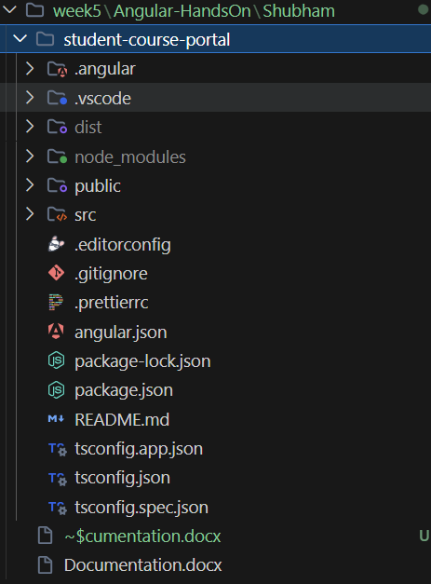
Hands On 2 Output
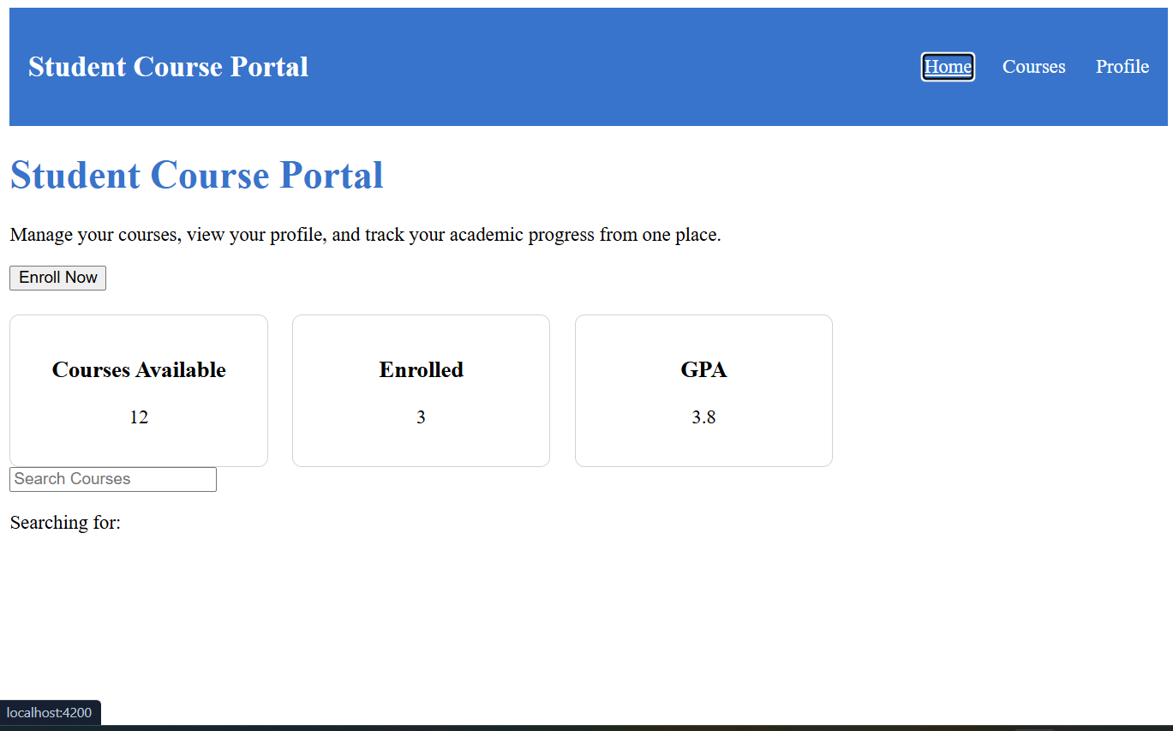
Hands On 7 Output
