**Shopping Cart Project – Angular (Single Page Appl., Development)**

**A Shopping Cart Ecommerce Application with Products, Users, Cart, Categories, Payment Modules (Optional).**

*Sample eCommerce Design / Template for reference*

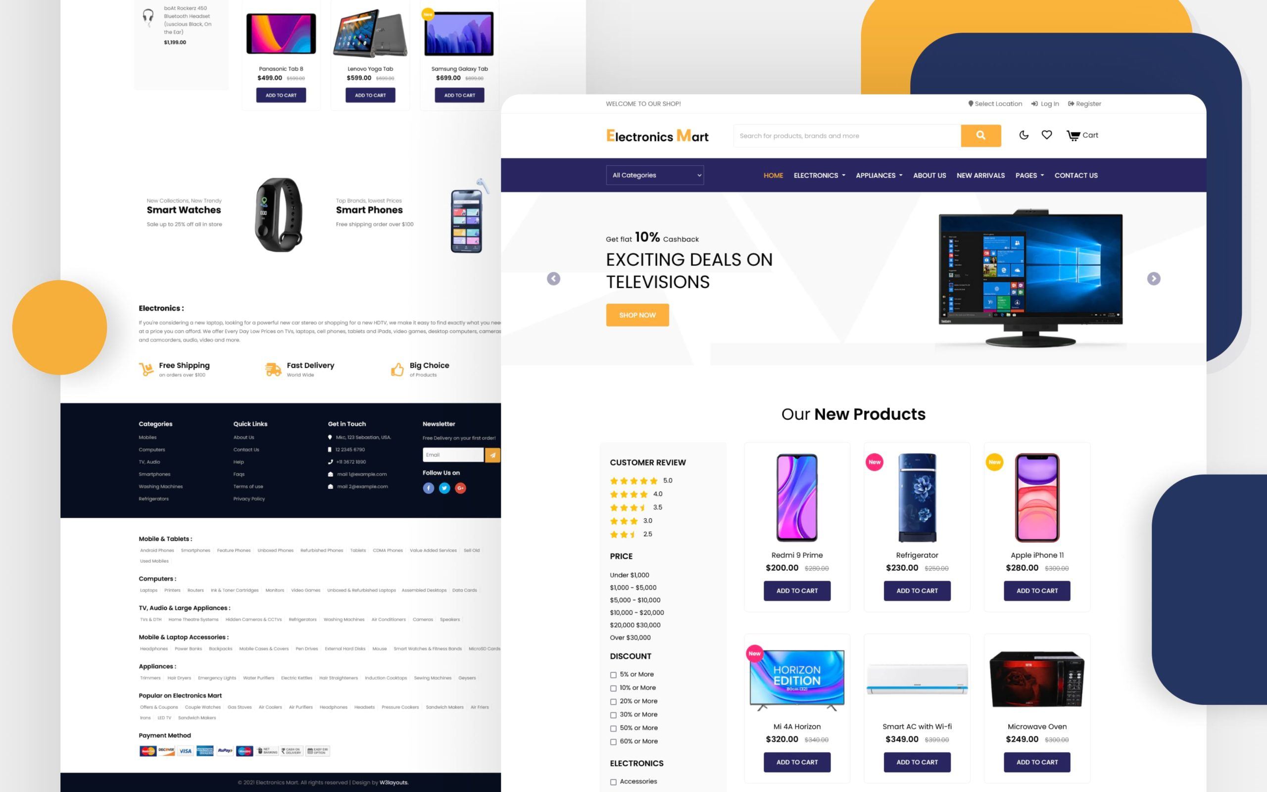

**Modules:**

* Admin
* User

**Admin Roles:**

* Admin can login, data can be in Local Storage
* Admin can manage users: add users, edit the password, delete
* Admin can manage categories: add, edit, delete
* Admin can manage products: add products into categories, edit products, delete products
* Admin can see the history of users, their selected products

**User Roles:**

* Users can register & login, data can be in Local Storage.
* Users can surf the application with multiple products and filters it by the categories.
* Users can view entire product details
* Users can add the product into cart and can edit, delete, change quantity.
* Finally, they can reach to payment module, showing the design of all products selected, prices, discounts, total price.

**Technologies used in development of Shopping Cart:**

Html, Css, Bootstrap – designing the pages

Javascript, jQuery, Ajax, JSON - event handlings, banner sliders, fetch the sample data (restapi)

Typescript, Angular – developing or converting from traditional pages to single page application