DATA 298A MSDA Project I
Workbook 1
Team 07
Aayushi Parag Shah (018180136)
Amaan Arif Khan (018207215)
Dhruva Jigneshkumar Joshi (018191576)
Rohit Raju Dhole (018195320)
Sneha Guravannavar (018210660)
09/30/2025

1. Introduction

1.1 Project Background and Executive Summary
Enterprises increasingly rely on Large Language Models (LLMs) to answer complex, domain-specific questions. However, LLM hallucinations—confident but incorrect statements—pose serious risks in high‑stakes domains like healthcare. Our project addresses this gap by building a guardrail framework for a Drug Information and Interaction Chatbot. The framework verifies model responses against vetted drug knowledge bases before delivering answers to users. Concretely, we will unify structured datasets (e.g., DrugBank, FDA DailyMed, Kaggle Drug–Drug Interactions, and 250k medicines) into a hybrid knowledge base, retrieve evidence, and run verification checks (entity overlap, semantic similarity, severity alignment) to decide whether to allow, flag, or block a response. The end goal is a transparent, reliable, and enterprise‑ready solution that demonstrates how to make LLMs safer in healthcare.
Planned approach: dataset integration → schema design → knowledge base (tables + vector store) → evidence‑based verification → confidence scoring → guardrail enforcement → demo app. We will deliver a working proof‑of‑concept with measurable evaluation and clear governance hooks (audit logs, policies).
Expected contributions: a generalizable guardrail framework for safety‑critical QA, a unified drug knowledge base, a reproducible verification/scoring pipeline, and a demo that contrasts raw vs. guardrailed answers with evidence and confidence scores.

1.2 Project Requirements
Functional requirements (testable):
- Accept user queries on drugs, dosages, side effects, contraindications, and drug–drug interactions.
- Retrieve relevant evidence from the knowledge base (top‑k passages, structured records).
- Verify each candidate's answer against evidence using similarity and entity checks; compute a confidence score.
- Enforce guardrails: allow, flag with warnings, or block unsafe/unsupported answers; optionally regenerate with stricter grounding.
- Provide transparent explanations: show evidence snippets, provenance (dataset/source), and confidence score.
- Log decisions and model prompts for audibility; support policy updates without code changes.
- Provide an admin mode to tune thresholds and review flagged cases.
- Measure quality with precision/recall, false accept/reject rates, and ROC/AUC on a held‑out test set.
Data requirements:
- Licensed access to DrugBank (primary), with FDA DailyMed and Kaggle Drug–Drug Interactions as secondary sources for coverage.
- Unified schema for Drugs, Interactions, Dosages, and Side Effects; synonym mapping for brand/generic names.
- Data versioning, deduplication, and provenance tracking.

1.3 Project Deliverables
- Literature review and technology survey summarizing guardrail methods for LLMs and healthcare QA.
- Data Management Plan, dataset scripts, and unified schema.
- Working prototype of the guardrail pipeline (verification + scoring + enforcement).
- Demo application (Streamlit/Gradio) showing raw vs. guardrailed answers with evidence and scores.
- Evaluation report with quantitative metrics and qualitative feedback.
- Project report and presentation slides.

1.4 Technology and Solution Survey
We surveyed approaches for making LLM outputs reliable in safety‑critical domains. Two broad strategies emerged: (1) constraint generation (schema‑guided outputs, policy rules, tool‑use) and (2) post‑generation verification (retrieve evidence, check consistency, and enforce thresholds). Our solution combines both: evidence‑grounded generation with strict post hoc verification and policy enforcement.
Candidate components and rationale:
- LLMs: GPT‑class or open‑weight models for controlled generation; temperature kept low and answers grounded to retrieved evidence.
- Retrieval: vector DB (e.g., FAISS/Chroma/Pinecone) + SQL tables for high‑precision lookups of interactions and dosages.
- Verification: cosine similarity between answer/evidence embeddings, entity overlap (drug names, dosages), and severity checks.
- Guardrails: rule engine for allow/flag/block decisions; prompts regenerated under stricter constraints when needed.
- App: Streamlit/Gradio demo with evidence, scores, and user feedback loop.

1.5 Literature Survey of Existing Research
Our review covers three main themes that directly inform our project: (a) hallucination detection and factuality metrics, (b) guardrail frameworks and safety mechanisms, and (c) healthcare question answering and retrieval-augmented generation (RAG). Together, these areas highlight both the risks and solutions for building a safe drug information and interaction chatbot.
Hallucination detection and factuality. Ji et al. [1] provide a comprehensive survey of hallucination in natural language generation, outlining failure modes and mitigation strategies. Manakul et al. [2] introduce SelfCheckGPT, a zero-resource method that detects unsupported content by self-consistency sampling. Min et al. [3] propose FActScore, which decomposes long-form answers into atomic claims for fine-grained factual evaluation. Related work such as RAGAS [19] focuses on automated evaluation of RAG pipelines, while Lewis et al. [17] and Izacard and Grave [18] demonstrate how retrieval grounding reduces hallucinations in knowledge-intensive NLP. Xiong et al. [11] and Shi et al. [12] further extend these insights to medicine, confirming that retrieval quality strongly affects factuality. Together, these studies justify our decision to include similarity checks, entity overlap, and selective abstention (refusal when confidence is low) in our verification pipeline.
Guardrail frameworks and safety classifiers. Sava et al. [4] present NeMo Guardrails, a toolkit for controllable and grounded LLM applications. Bai et al. [5] propose Constitutional AI, which aligns models to explicit safety principles using AI feedback. Inan et al. [6] develop Llama Guard, a classifier for input-output safety with strong screening performance, while Han et al. [7] introduce MedSafetyBench to benchmark medical safety risks in LLMs. These frameworks demonstrate complementary strengths: rule-based systems are transparent and auditable, while classifier-based approaches adapt to evolving risks. Our project combines both ideas by applying lightweight rules (e.g., drug name/entity overlap) alongside evidence-based checks.
Healthcare QA and medical RAG. Several biomedical QA benchmarks motivate our domain focus. Jin et al. [8] created PubMedQA for biomedical research QA, and Jin et al. [9] introduced MedQA from large-scale medical exams. Luo et al. [10] proposed BioGPT, a biomedical LLM that shows domain advantages but still hallucinates without grounding. Large-scale efforts such as Med-PaLM [13] and Med-PaLM 2 [14] demonstrate that LLMs encode clinical knowledge but still require safety guardrails. Pal et al. [20] introduce MedMCQA, a multi-subject exam benchmark, while Tsatsaronis et al. [21] present BioASQ, a long-standing biomedical QA challenge. More recently, Khan et al. [15] and the Framework Authors [16] analyze medical hallucinations and propose structured methods for clinical safety evaluation. Wishart et al. [22] detail DrugBank 5.0, which remains a foundational drug knowledge base for both research and applications.
Comparison and justification. Evidence-based methods such as FActScore [3] and MIRAGE [11] offer transparent verification but add computational overhead. Safety classifiers like Llama Guard [6] provide fast screening but can over- or under-block without domain evidence. Rule-based systems like NeMo Guardrails [4] are easy to audit but less adaptive, whereas Constitutional AI [5] emphasizes principle-driven alignment. Medical QA benchmarks [8], [9], [20], [21] highlight the difficulty of the task, while Med-PaLM studies [13], [14] show that even state-of-the-art models require external guardrails. Taken together, these works motivate our hybrid, semester-feasible approach: integrate curated drug datasets (e.g., DrugBank [22]), ground responses in retrieval, verify answers using similarity and entity overlap, and enforce lightweight guardrails with transparent auditing.

2. Data and Project Management Plan

2.1 Data Management Plan
- Data sources: DrugBank (approved for academic use), FDA DailyMed, Kaggle Drug–Drug Interactions, and a 250k medicines dataset.
- Schema: four core entities (Drugs, Interactions, Dosages, Side Effects) with mappings for brand/generic synonyms.
- Storage: relational DB for canonical records; vector store for semantic retrieval; all entries carry source and version tags.
- Quality: deduplicate synonyms, normalize units/dosages, and perform spot checks; retain raw dumps for reproducibility.
- Governance: no PHI/PII; access‑controlled storage; license compliance documented; audit logs for queries and decisions.

2.2 Project Development Methodology
We follow an agile, iterative process with two‑week sprints tracked in Jira. A Git branching model (main, develop, feature/*) supports safe collaboration and reviews. Milestones align with the Gantt plan below; each sprint culminates in a demo and retrospective.

2.3 Project Organization Plan
Work Breakdown Structure (WBS):
- Phase 1 – Foundations: scope, literature survey, tech evaluation.
- Phase 2 – Data: access approvals, schema, ingestion, normalization.
- Phase 3 – KB & Retrieval: relational tables + vector DB; synonym mapping.
- Phase 4 – Verification & Scoring: evidence checks; metrics design; thresholds.
- Phase 5 – Guardrails & App: policy rules; regeneration; Streamlit/Gradio UI.
- Phase 6 – Evaluation & Reporting: test harness, metrics, ablation, final report.

2.4 Project Resource Requirements and Plan
Hardware/infra:
- Developer laptops (16 GB RAM+); optional GPU for embedding/model experiments.
- Cloud or local Postgres; vector DB (FAISS/Chroma locally, Pinecone optional free tier).
Software/tools:
- Python 3.10+, LangChain/LlamaIndex (retrieval), sentence-transformers (embeddings), scikit-learn (metrics).
- Streamlit or Gradio for the demo app; Jira/GitHub for PM and version control.
- LLM API (budget‑conscious usage) for generation under strict prompts and low temperature.
Licensing & costs:
- DrugBank academic license (approved); FDA DailyMed (open).
- Minimal cloud/storage costs within academic/free tiers; small budget for API calls.

2.5 Project Schedule
Gantt Chart:
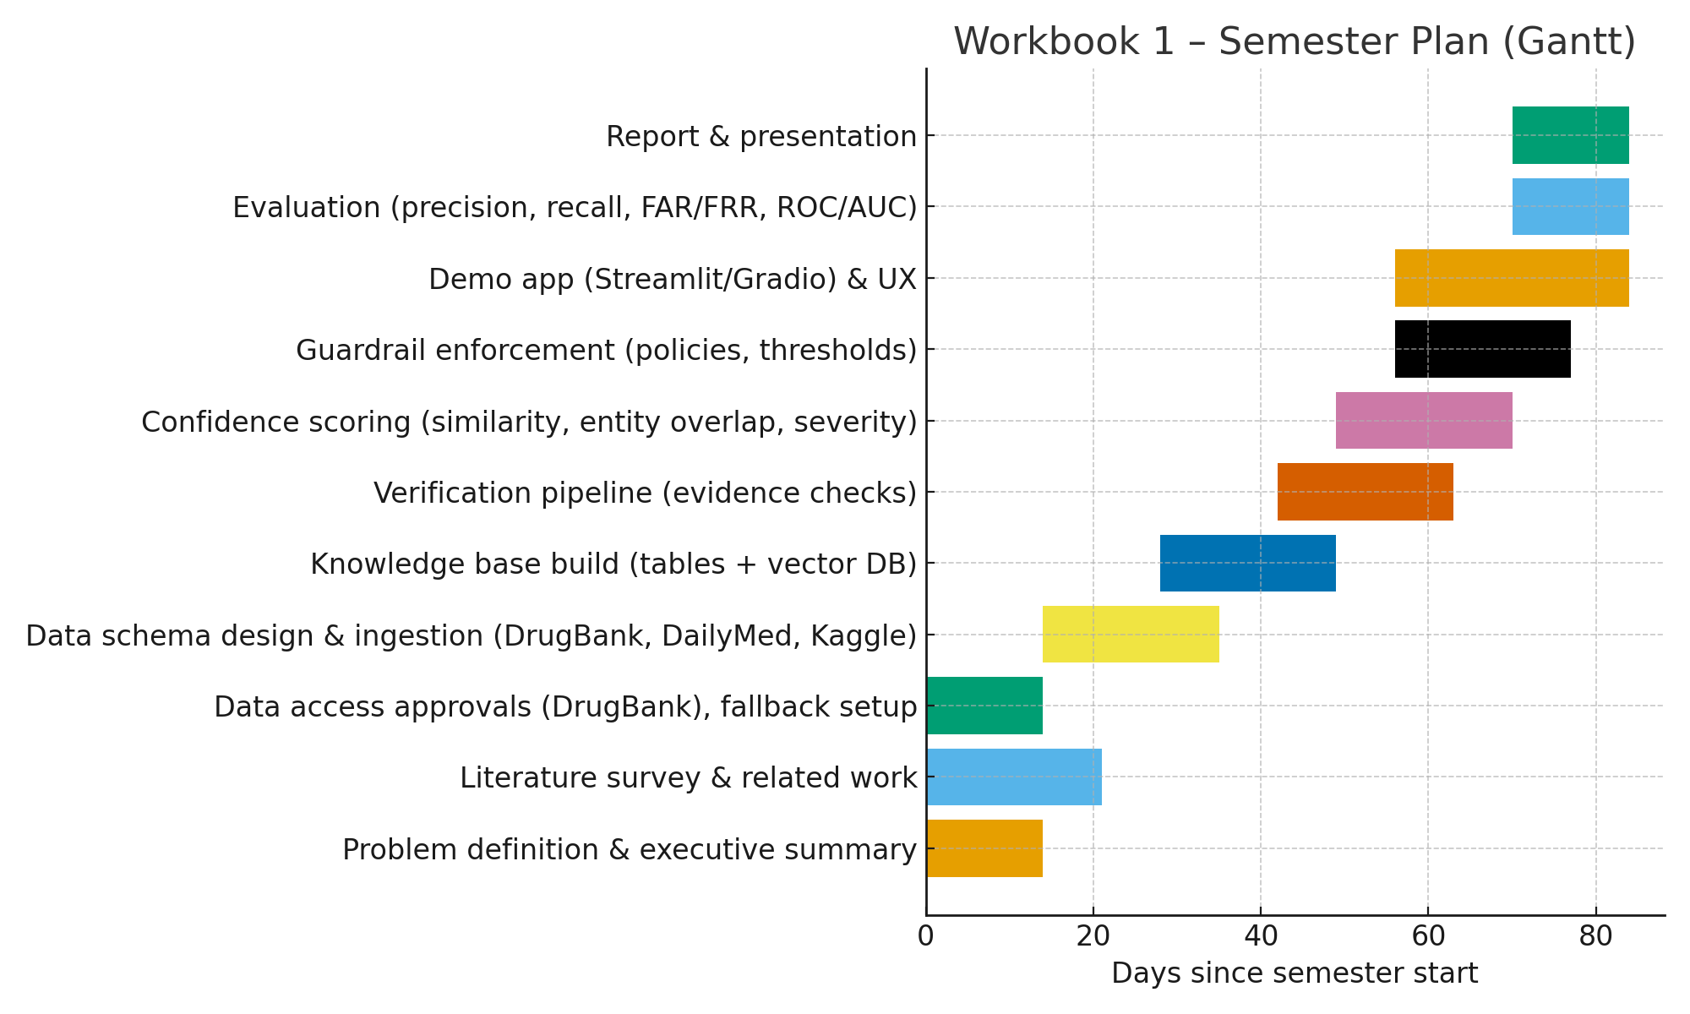
Task | Start (week) | Duration (weeks) | Owner(s)
Problem definition & executive summary | W1 | 2 | Aayushi, Amaan
Literature survey & related work | W1 | 3 | Dhruva, Sneha
Data access approvals (DrugBank), fallback setup | W1 | 2 | Rohit
Data schema design & ingestion (DrugBank, DailyMed, Kaggle) | W3 | 3 | Rohit, Aayushi
Knowledge base build (tables + vector DB) | W5 | 3 | Amaan, Dhruva
Verification pipeline (evidence checks) | W7 | 3 | Amaan, Rohit
Confidence scoring (similarity, entity overlap, severity) | W8 | 3 | Dhruva
Guardrail enforcement (policies, thresholds) | W9 | 3 | Aayushi, Sneha
Demo app (Streamlit/Gradio) & UX | W9 | 4 | Sneha
Evaluation (precision, recall, FAR/FRR, ROC/AUC) | W11 | 2 | All
Report & presentation | W11 | 2 | All
PERT Analysis (selected tasks): expected durations and variance
ID | Task | O | M | P | te | Var | Depends On
A | Problem definition & executive summary | 3 | 5 | 7 | 5.0 | 0.44 | —
B | Literature survey & related work | 7 | 14 | 21 | 14.0 | 5.44 | —
C | Data access approvals | 7 | 10 | 21 | 11.3 | 5.44 | —
D | Schema design & ingestion | 7 | 14 | 21 | 14.0 | 5.44 | C
E | KB build (tables + vector DB) | 7 | 14 | 21 | 14.0 | 5.44 | D
F | Verification pipeline | 7 | 14 | 21 | 14.0 | 5.44 | E
G | Confidence scoring | 5 | 10 | 15 | 10.0 | 2.78 | F
H | Guardrail enforcement | 5 | 10 | 15 | 10.0 | 2.78 | G
I | Demo app & UX | 7 | 14 | 21 | 14.0 | 5.44 | F
J | Evaluation | 5 | 10 | 15 | 10.0 | 2.78 | H, I
K | Report & presentation | 5 | 10 | 15 | 10.0 | 2.78 | J
Estimated critical path: C → D → E → F → G → H → J → K (≈ 93.3 days expected)

References
[1] Z. Ji, N. Lee, R. Frieske, et al., “Survey of hallucination in natural language generation,” ACM Computing Surveys, vol. 55, no. 12, 2023.
[2] P. Manakul, A. Liusie, and M. Gales, “SelfCheckGPT: Zero-resource black-box hallucination detection for generative large language models,” in Proc. EMNLP, 2023.
[3] S. Min, K. Krishna, X. Lyu, et al., “FActScore: Fine-grained atomic evaluation of factual precision in long-form text generation,” in Proc. EMNLP, 2023.
[4] T. Sava, A. Pitis, D. Hakkani-Tur, et al., “NeMo Guardrails: A toolkit for controllable and safe LLM applications,” arXiv:2310.10501, 2023.
[5] Y. Bai, A. Kadavath, S. Kundu, et al., “Constitutional AI: Harmlessness from AI feedback,” arXiv:2212.08073, 2022.
[6] H. Inan, K. Upasani, J. Chi, et al., “Llama Guard: LLM-based input-output safeguard for human-AI conversations,” arXiv:2312.06674, 2023.
[7] T. Han, A. Kumar, C. Agarwal, and H. Lakkaraju, “MedSafetyBench: Evaluating and improving the medical safety of large language models,” arXiv:2403.03744, 2024.
[8] Q. Jin, B. Dhingra, Z. Liu, W. W. Cohen, and X. Lu, “PubMedQA: A dataset for biomedical research question answering,” in Proc. EMNLP-IJCNLP, 2019.
[9] D. Jin, E. Pan, N. Oufattole, et al., “What disease does this patient have? A large-scale open-domain QA dataset from medical exams (MedQA),” arXiv:2009.13081, 2020.
[10] R. Luo, L. Sun, Y. Xia, et al., “BioGPT: Generative pre-trained transformer for biomedical text generation and mining,” arXiv:2210.10341, 2022.
[11] G. Xiong, Q. Jin, Z. Lu, and A. Zhang, “Benchmarking retrieval-augmented generation for medicine (MIRAGE),” arXiv:2402.13178, 2024.
[12] Y. Shi, S. Xu, T. Yang, et al., “MKRAG: Medical knowledge retrieval-augmented generation for medical question answering,” arXiv:2309.16035, 2023.
[13] V. Natarajan, K. Singhal, D. Webster, et al., “Large language models encode clinical knowledge (Med-PaLM),” Nature, 2023.
[14] K. Singhal, T. Tu, J. Gottweis, et al., “Toward expert-level medical question answering with large language models (Med-PaLM 2),” Nature Medicine, 2025.
[15] M. R. Khan, Y. Wang, S. Banerjee, et al., “Medical hallucinations in foundation models and their impact on healthcare,” arXiv:2503.05777, 2025.
[16] A. Framework Authors, “A framework to assess clinical safety and hallucination rates of LLMs,” medRxiv, 2024.
[17] P. Lewis, E. Perez, A. Piktus, et al., “Retrieval-augmented generation for knowledge-intensive NLP tasks,” in Proc. NeurIPS, 2020.
[18] G. Izacard and E. Grave, “Leveraging passage retrieval with generative models for open-domain question answering,” in Proc. EACL, 2021.
[19] R. Es et al., “RAGAS: Automated evaluation for retrieval-augmented generation,” arXiv:2309.15217, 2023.
[20] S. Pal, R. Umapathi, A. Sankarasubbu, “MedMCQA: A large-scale multi-subject medical exam benchmark for QA,” arXiv:2203.14371, 2022.
[21] G. Tsatsaronis, I. V. Andronikou, K. P. Paliouras, et al., “BioASQ: A challenge on large-scale biomedical semantic indexing and question answering,” in Proc. CLEF, 2015.
[22] D. S. Wishart, Y. D. Feunang, A. C. Guo, et al., “DrugBank 5.0: A major update to the DrugBank database for 2018,” Nucleic Acids Research, vol. 46, pp. D1074–D1082, 2018.

