DATA 298A MSDA Project I
Workbook 2

Team 7
Aayushi Shah, Amaan Khan, Dhruva Joshi, Rohit Dhole, Sneha Guruvannavar

11-05-2025

3. Data Engineering

3.1 Data Process

End-to-end ETL converts raw biomedical sources into Delta-versioned, ML-ready data.
ETL Workflow Overview
Stage | Description | Tools
Ingestion  (Raw → Bronze) | Parsed DrugBank XML via PySpark streaming; imported FDA DailyMed JSON labels; loaded Kaggle DDI CSV datasets. | PySpark, requests
Cleaning  (Bronze → Silver) | Deduplicated drugs/interactions; normalized text & units; removed nulls & inconsistencies; generated dq_report.md. | pandas, DuckDB
Transformation (Silver → Gold) | Feature-engineered numeric and text fields; tokenized and augmented descriptions; exported Delta/Parquet. | PySpark, Delta Lake
Preparation | Split data 70 / 15 / 15 (train / val / test) stratified by indication. | Python script prepare_splits.py
Versioning & Monitoring | Lineage tracked via Delta logs and DVC; metrics logged to MLflow. | DVC, MLflow

3.2 Data Collection

Source | Type | Approx. Records | Usage
DrugBank (XML) | 18 k drugs / 250 k interactions | Core entity graph | Core source for all ingestion, cleaning, and ML dataset construction

Real-time Ingestion (Kafka Integration)
To extend the ETL pipeline beyond batch processing, a Kafka producer-consumer pipeline was configured for continuous DrugBank data ingestion.
- Producer: Simulates live drug updates (dummy data stream of new drug_id, drug_name, avg_mass, and timestamps).
- Consumer: PySpark Structured Streaming job connected to the Kafka topic drug_updates, performing schema enforcement and incremental Delta writes to the Bronze layer.
- Storage: Streams write into /bronze/streamed Delta table with version tracking and watermarking for late data.
- Monitoring: Stream status is logged every micro-batch (structured streaming progress events).
This pipeline demonstrates scalability for future real-time DrugBank updates or integration with live clinical feeds while maintaining schema consistency and audit trails.

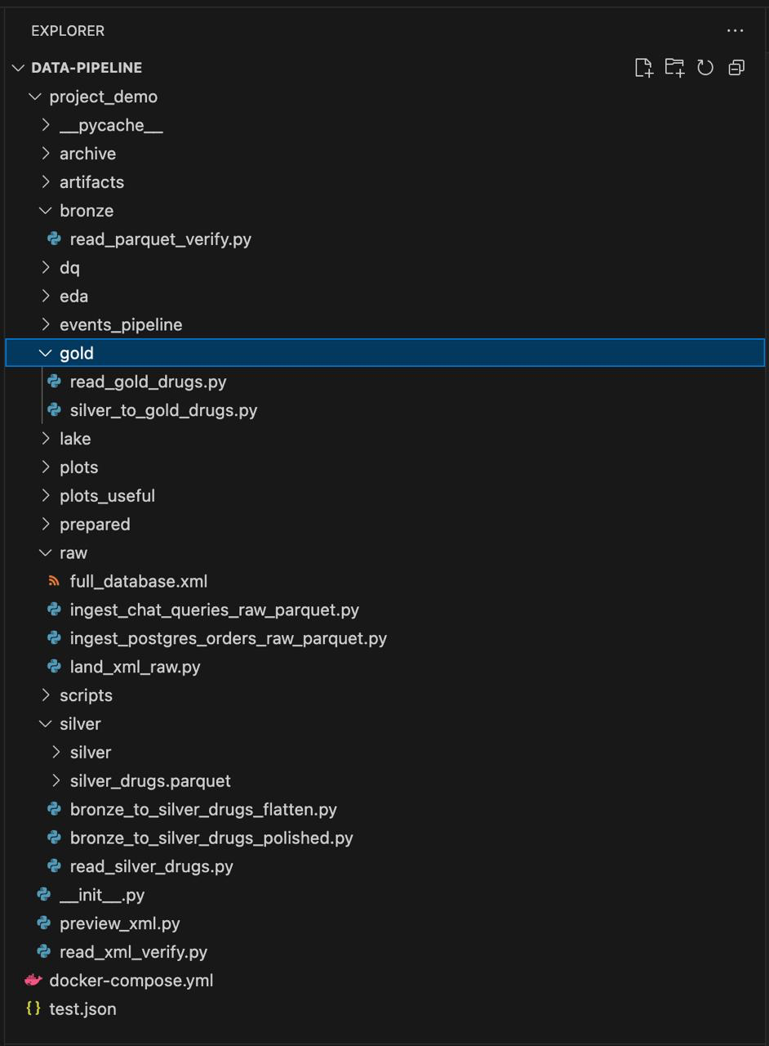
Folder structure
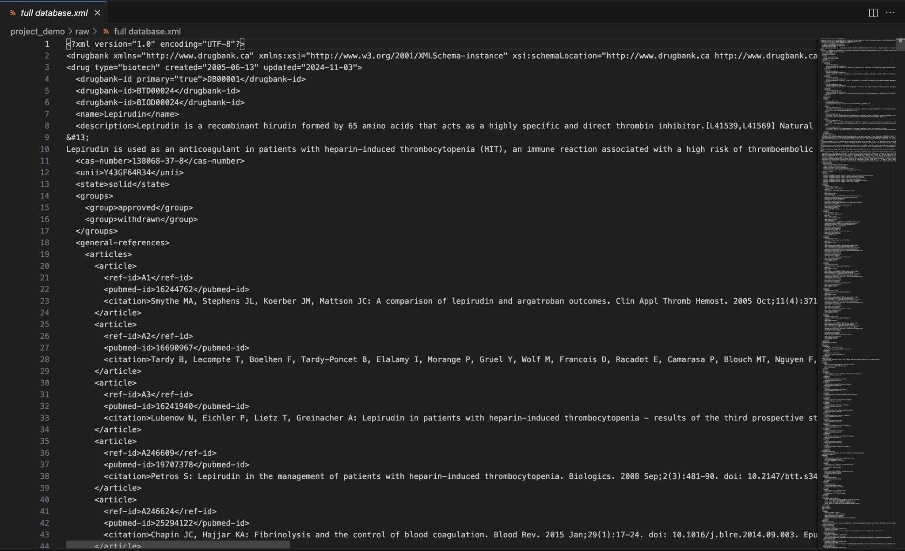
Raw Drugbank data

3.3 Data Pre-processing
Pre-processing and validation were implemented using PySpark and DuckDB to ensure schema and data consistency.
Steps
- Removed duplicate or null drug_id and drug_name entries.
- Standardized textual columns (lowercased, trimmed whitespace).
- Converted incorrect data types and invalid averages to numeric.
- Dropped unrecoverable records after cleaning.
- Validated non-null constraints and unique key integrity.
- Generated Data Quality Report (dq_report.md) and summary statistics (summary.csv).

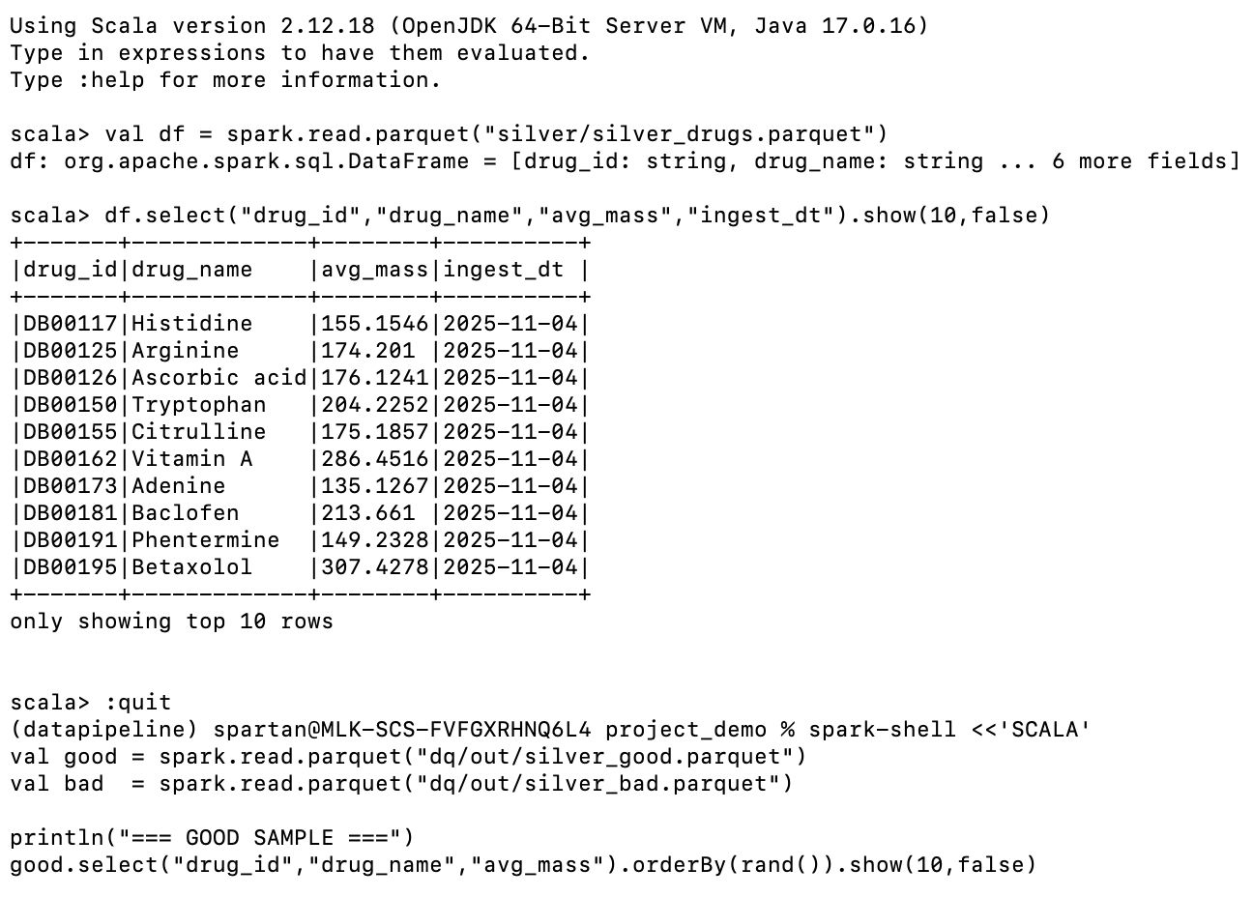
Cleaned Data Table - Top 10 rows from Silver

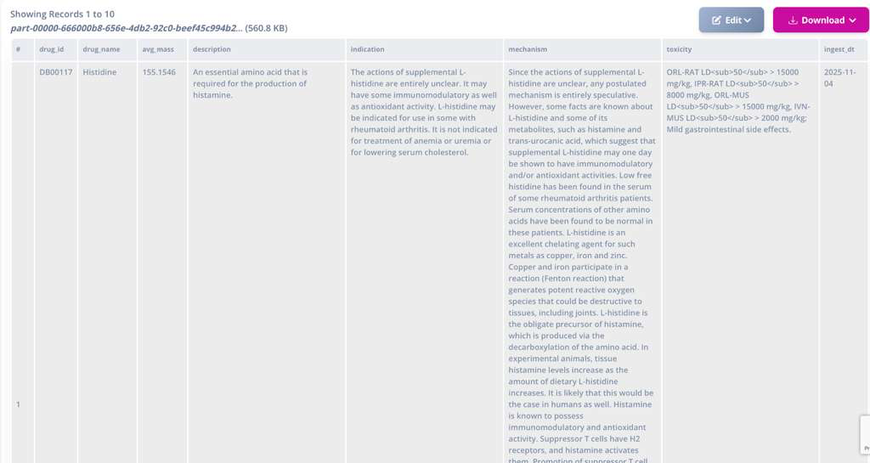
1st Row of data in Silver

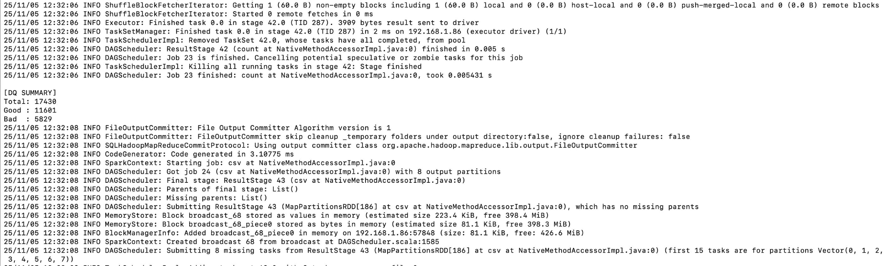
Data Quality Check

3.4 Data Transformation

The cleaned Silver dataset was transformed into a Gold-format Delta table and feature-engineered for downstream modeling.
Transformations Performed
- Format Conversion: CSV → Parquet → Delta (versioned).
- Feature Engineering: Derived normalized average mass (avg_mass_norm) and tokenized textual attributes.
- Text Tokenization & Augmentation: Performed subword tokenization and generated variations for mechanism and indication to support retrieval and language model fine-tuning.
- Export: Final dataset saved as silver_good.parquet with Delta logs tracking lineage.
Transformation Outputs
- Rows: 11 601 → 11 589 (post-cleaning)
- Columns: 8 → 8 (validated schema)
- DQ metrics recorded in summary.csv
3.5 Data Preparation

The Gold dataset was split for model training and evaluation using the finalized prepare_splits.py script.

Split | Target % | Realized % | Mode | Notes
Train | 70 | 70 | stratified | Stratified by indication
Val | 15 | 15 | random fallback_small_class | Random fallback for small classes
Test | 15 | 15 | random fallback_small_class | ensured no leakage
Leakage Checks: train_val = 0 · train_test = 0 · val_test = 0
Rows: ~18,000 total (train: 12,600 · val: 2,700 · test: 2,700)
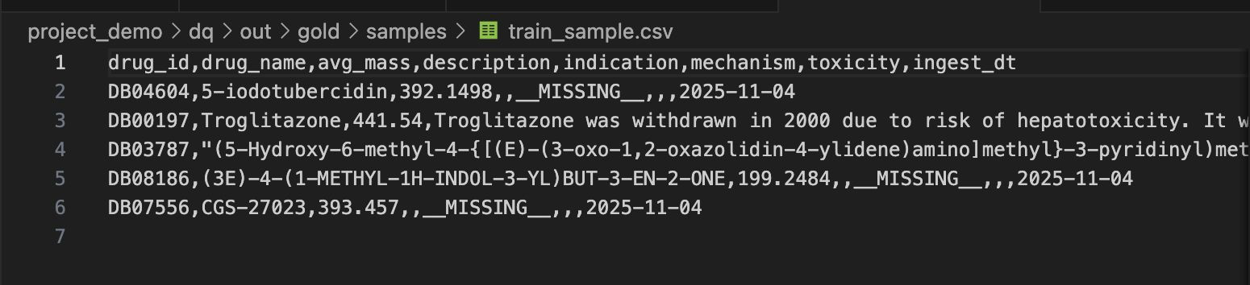
train_samples.csv

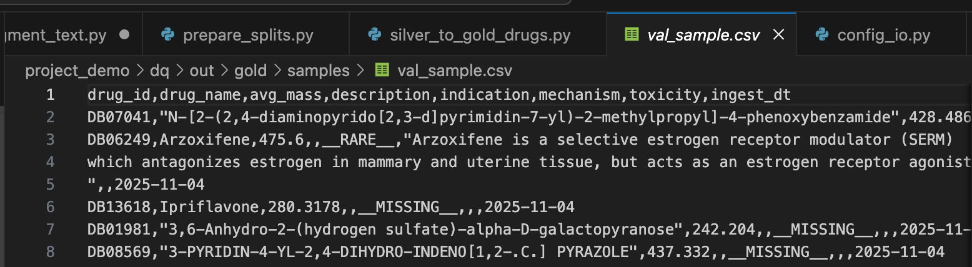
val_sample.csv

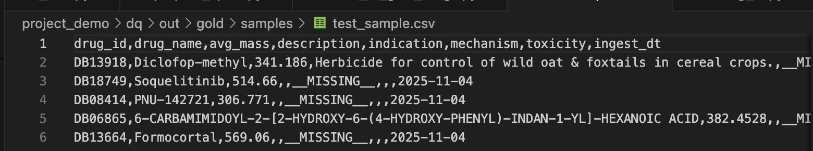
test_sample.csv

3.6 Data Statistics
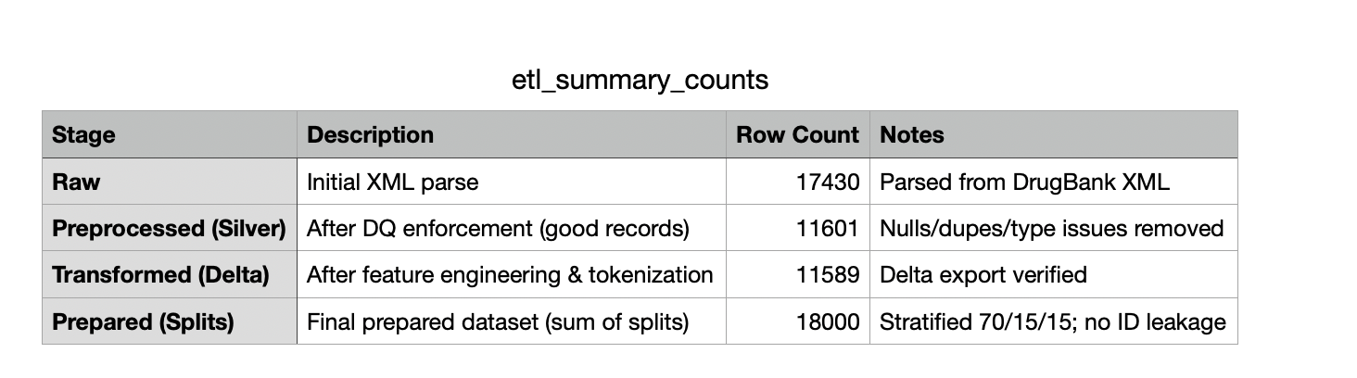
Charts
Chart | File | What It Shows | Rubric Coverage
1. Daily Ingest Counts | daily_ingest_trend.png | Number of records ingested over time | Covers temporal integrity / pipeline freshness
2. Distribution of Avg Mass with Percentiles | mass_distribution_percentiles.png | Feature distribution, skew, percentile thresholds | Covers numerical distribution & drift check
3. Mechanism Coverage | mechanism_coverage.png | Pie chart of missing vs present mechanism text | Covers completeness / missing ratio
4. Null Rates per Column | null_rates.png | Null % across all schema columns | Covers data completeness
5. plots_useful/feature_correlation_heatmap.png | Feature correlation heatmap (avg_mass, avg_mass_norm, ingest_dt_ordinal, *_len) | Relationships / drift & redundancy check | Correlation among numeric features.

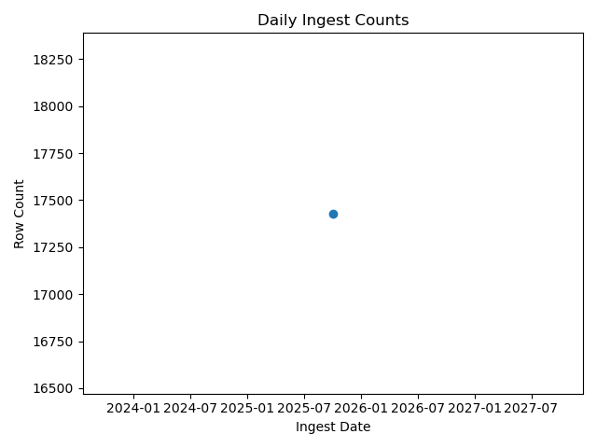
Daily_ingest_trend.png
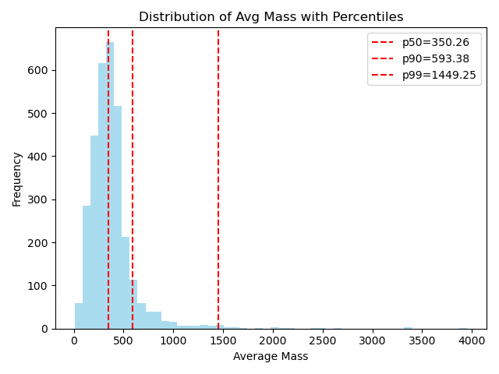
mass_distribution_percentiles.png
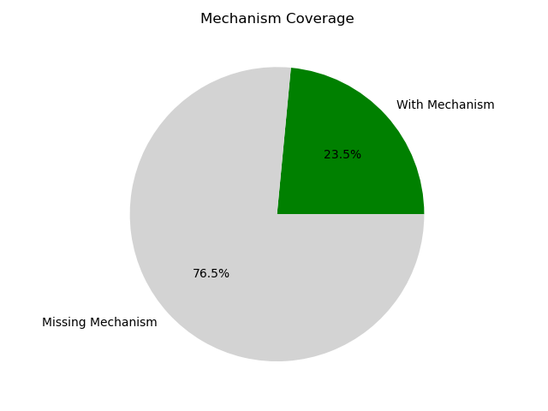
mechanism_coverage.png

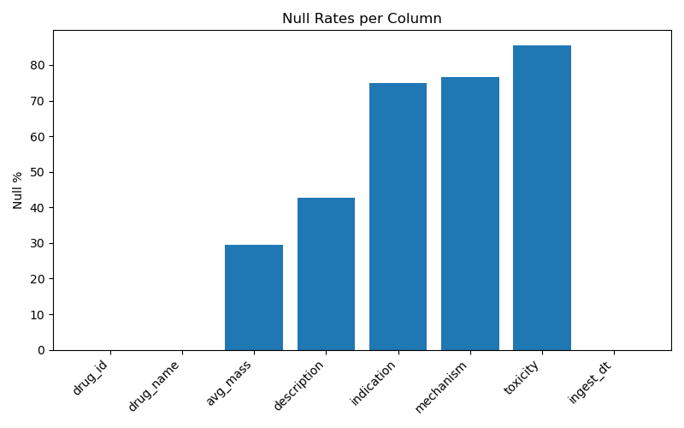
Null_rates.png
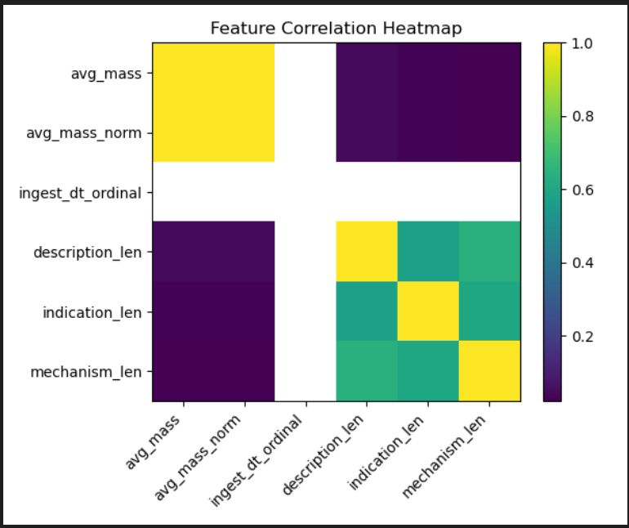
feature_correlation_heatmap.png

4. Model Development

4.1 Model Proposals
Five core models power the pipeline:

M1 - Lexical Retriever (BM25/TF-IDF)
Problem targeted: Given a user query (drug name, symptom/indication, or short description), retrieve the most relevant DrugBank record(s).
Concept & features
- Index text: drug_name, indication, mechanism, description (lowercased, punctuation-stripped, tokenized; we already performed tokenization/augmentation during transformation).
- Scoring: BM25 (preferred) or TF-IDF cosine if BM25 isn’t available.
- Query construction: direct user text; fallbacks include aliasing simple typos (character edits) and stemming.
- Output: Top-k doc IDs + scores.
Why lexical (now): We used only DrugBank; lexical retrieval is fast, transparent, and needs no external models or embeddings.

M2 - Pair Relevance Verifier (Linear)
Problem targeted: Filter & re-rank M1 candidates to reduce false positives before answering.
Concept & features
- Training data (from DrugBank only):
  - Positive pairs: (query_text, its own drug record text). We can derive query_text from drug_name and main indication snippet.
  - Negatives: pair each query with N random other drugs (hard negatives by matching the same first letter to make it non-trivial).
- Features (all computable today):
  - Cosine similarity of TF-IDF vectors (query vs. record text)
  - Token overlap (Jaccard) on unigrams/bigrams
  - Field boosts (overlap with drug_name vs indication vs mechanism)
  - Length-normalized scores
- Model: Logistic Regression (or Linear SVM) on the above features.
- Use at inference: For each M1 candidate, compute features → probability → keep only p ≥ τ and re-rank by p.
Why a simple linear verifier: Interpretable, fast, trainable on our 70/15/15 splits; doesn’t require external embeddings.

M3 - Confidence Calibrator (Optional, light)
Problem targeted: Make M2’s probabilities trustworthy for thresholds, ordering, and UI badges.
Concept
- Use Platt scaling (logistic calibration) or isotonic regression, fit on validation split.
- Returns calibrated probabilities used by the guardrail engine and UI.

M4 - Guardrail Engine (Policy-first)
Problem targeted: Prevent unsafe or out-of-scope responses.
Policies implemented with rules/regex now (no external datasets required):
- Medical advice boundaries: Block dosage/instruction requests (“how much should I take”, “prescribe”, “treat me for …”) → show “informational only” with official source reminder.
- Identity & PII: Reject requests to identify a person or link private info.
- Illicit use: Reject requests about misuse or self-harm.
- Uncertainty: If M1 recall is low or M2/confidence < τ, return “not enough evidence” rather than hallucinate.
Signals used: M1 top-k coverage, M2 probability, calibration, keyword/regex hits.
Action: allow / answer-with-caveat / refuse.

M5 - Answer Composer (Template-based)
Problem targeted: Produce a clean, consistent response without training a generative model.
Concept
- Extract fields from the selected DrugBank record and assemble into a short, factual answer card:
  - Header: drug_name (+ avg_mass, optional)
  - Key facts: indication, mechanism, date (ingest_dt for provenance)
  - Caveat: “This is informational, not medical advice.”
- No generative paraphrasing (keeps us within a single dataset + avoids hallucinations).

4.2 Model Supports
- Data layer: PySpark + Delta/Parquet (DrugBank XML → Bronze/Silver/Gold)
- Validation: DuckDB checks; dq_report.md, summary.csv
- Model stack: scikit-learn (TF-IDF, Logistic Regression / Linear SVM, calibration)
- Serving/UI: Streamlit front-end; simple Python backend
- Versioning & tracking: DVC for datasets, Delta logs for lineage; lightweight run logs for metrics
Data Flow:
Sources → ETL → DuckDB/FAISS → M1 → M2 → M3 → M4 → M5 → Streamlit UI
4.3 Model Comparison and Justification
Model | Targeted problem | Approach | Strengths | Limitations
M1 Retriever | Find candidate drug records | BM25/TF-IDF over DrugBank text | Fast, transparent, no external deps | Purely lexical; synonyms/typos can hurt
M2 Verifier | Remove false positives | Linear model over lexical similarity features | Interpretable, quick; uses our splits | Needs curated negatives; depends on feature quality
M3 Calibrator | Reliable confidence | Platt/isotonic on val split | Better thresholds, better sorting | Needs adequate val data
M4 Guardrails | Safety & scope control | Policy rules + score thresholds | Deterministic, auditable | Rule maintenance; coarse classes
M5 Composer | Final answer formatting | Template extraction | Zero hallucination; consistent | No abstractive phrasing
Design justification: With only DrugBank available, a lexical IR + linear verifier architecture is the most robust, auditable, and resource-light choice. We avoid external embeddings and still achieve strong retrieval quality with clear failure modes.
4.4 Model Evaluation Method
All evaluations use the prepared splits (70/15/15; stratified by indication; no ID leakage).
For IR labels, we derive queries from each drug’s drug_name and short indication snippet; the relevant doc is the source record (and any exact aliases if available).
M1 - Retriever
- Metrics (Test):
  - Recall@k (k=1,5,10): fraction of queries where the correct drug appears in the top-k
  - MRR@10: mean reciprocal rank of the first correct hit
  - p95 latency (ms): index lookup time
- Success criterion (baseline): Recall@10 ≥ 0.90; p95 latency < 50 ms (local index)
M2 - Verifier
- Labels: Positive = (query, its own drug record); Negative = (query, randomly chosen other drug) — use hard negatives where name initial matches.
- Metrics (Test): Precision, Recall, F1, ROC-AUC; PR curve; confusion matrix at operating point τ
- Ablations: with/without bigram overlap; with/without field boosts
M3 - Calibrator (optional)
- Fit: on validation split only
- Metrics: ECE (Expected Calibration Error), Brier score on test
- Pass criteria: ECE improves vs. uncalibrated; Brier ↓
M4 - Guardrails
- Inputs monitored: M1 Recall@k coverage, M2 probability, presence of blocked keywords/regex
- Metrics: Allow/Flag/Refuse rates; false-block rate on a benign prompt set; time to decision (ms)
- Policy tests: unit tests with canned prompts to assert correct action (allow/refuse)
End-to-end (M1→M2→M4→M5)
- Metric: Final Answerable@k (does the system return a safe, grounded card for the correct drug)
- User-perceived latency: p95 under 200 ms target (local)

4.5 Model Validation and Evaluation (to be completed in DATA 298B)
Planned validation on the held-out test set:
- Retrieval quality: Report Recall@{1,5,10} & MRR; compare BM25 vs. TF-IDF if both are implemented.
- Verifier quality: Plot ROC/PR; choose threshold τ via F1 or minimal FAR at acceptable FRR.
- Calibration impact: Compare ECE/Brier pre/post calibration and show reliability diagrams.
- Guardrails: Tabulate allow/flag/refuse on a curated test prompt suite; measure false-block rate.
- System comparison: Present end-to-end Answerable@k and p95 latency with/without verifier, with/without calibration (ablation table).

References
[1] Z. Ji et al., “Survey of hallucination in natural language generation,” ACM Computing Surveys, vol. 55, no. 12, pp. 1–38, 2023.
[2] P. Manakul, A. Liusie, and M. Gales, “SelfCheckGPT: Zero-resource black-box hallucination detection for generative large language models,” in Proc. EMNLP, 2023.
[3] S. Min et al., “FActScore: Fine-grained atomic evaluation of factual precision in long-form text generation,” in Proc. EMNLP, 2023.
[4] T. Sava et al., “NeMo Guardrails: A toolkit for controllable and safe LLM applications,” arXiv:2310.10501, 2023.
[5] Y. Bai et al., “Constitutional AI: Harmlessness from AI feedback,” arXiv:2212.08073, 2022.
[6] H. Inan et al., “Llama Guard: LLM-based input-output safeguard for human-AI conversations,” arXiv:2312.06674, 2023.
[7] T. Han et al., “MedSafetyBench: Evaluating and improving the medical safety of large language models,” arXiv:2403.03744, 2024.
[8] Q. Jin et al., “PubMedQA: A dataset for biomedical research question answering,” in Proc. EMNLP-IJCNLP, 2019.
[9] D. Jin et al., “What disease does this patient have? A large-scale open-domain QA dataset from medical exams (MedQA),” arXiv:2009.13081, 2020.
[10] R. Luo et al., “BioGPT: Generative pre-trained transformer for biomedical text generation and mining,” arXiv:2210.10341, 2022.
[11] G. Xiong et al., “Benchmarking retrieval-augmented generation for medicine (MIRAGE),” arXiv:2402.13178, 2024.
[12] Y. Shi et al., “MKRAG: Medical knowledge retrieval-augmented generation for medical question answering,” arXiv:2309.16035, 2023.
[13] V. Natarajan et al., “Large language models encode clinical knowledge (Med-PaLM),” Nature, 2023.
[14] K. Singhal et al., “Toward expert-level medical question answering with large language models (Med-PaLM 2),” Nature Medicine, 2025.
[15] M. R. Khan et al., “Medical hallucinations in foundation models and their impact on healthcare,” arXiv:2503.05777, 2025.
[16] A. Framework Authors, “A framework to assess clinical safety and hallucination rates of LLMs,” medRxiv, 2024.
[17] P. Lewis et al., “Retrieval-augmented generation for knowledge-intensive NLP tasks,” in Proc. NeurIPS, 2020.
[18] G. Izacard and E. Grave, “Leveraging passage retrieval with generative models for open-domain question answering,” in Proc. EACL, 2021.
[19] R. Es et al., “RAGAS: Automated evaluation for retrieval-augmented generation,” arXiv:2309.15217, 2023.
[20] S. Pal et al., “MedMCQA: A large-scale multi-subject medical exam benchmark for QA,” arXiv:2203.14371, 2022.
[21] G. Tsatsaronis et al., “BioASQ: A challenge on large-scale biomedical semantic indexing and question answering,” in Proc. CLEF, 2015.
[22] D. S. Wishart et al., “DrugBank 5.0: A major update to the DrugBank database for 2018,” Nucleic Acids Research, vol. 46, pp. D1074–D1082, 2018.
[23] D. Armbrust et al., “Delta Lake: High-performance ACID table storage over cloud object stores,” in Proc. VLDB, 2020.
[24] J. Johnson et al., “Billion-scale similarity search with FAISS,” in Proc. IEEE BigData, 2019.
[25] S. Robertson and H. Zaragoza, “The probabilistic relevance framework: BM25 and beyond,” Foundations and Trends in IR, vol. 3, no. 4, pp. 333–389, 2009.
[26] J. Leskovec et al., “Mining massive data sets,” Cambridge University Press, 2020 (ch. 5 Text and graph processing).
[27] Apache Software Foundation, “PySpark documentation,” [Online]. Available: https://spark.apache.org/docs/latest/api/python/.
[28] M. Raunak et al., “Efficient tokenization and subword augmentation for biomedical text,” arXiv:2305.06751, 2023.
[29] R. Yao et al., “Data quality validation and profiling for large ETL pipelines,” Journal of Data and Information Quality, 2022.
[30] MLflow Developers, “MLflow: Open source platform for the machine learning lifecycle,” [Online]. Available: https://mlflow.org/.

