Deploying and Interacting with a Free Virtual Machine in AWS

Rohith.R.D | 22-09-2024

After creating free cloud account(aws),

**Access EC2 Dashboard**

1. In the search bar at the top of the console, type "EC2" and select **EC2** from the results.
2. This will take you to the EC2 dashboard.

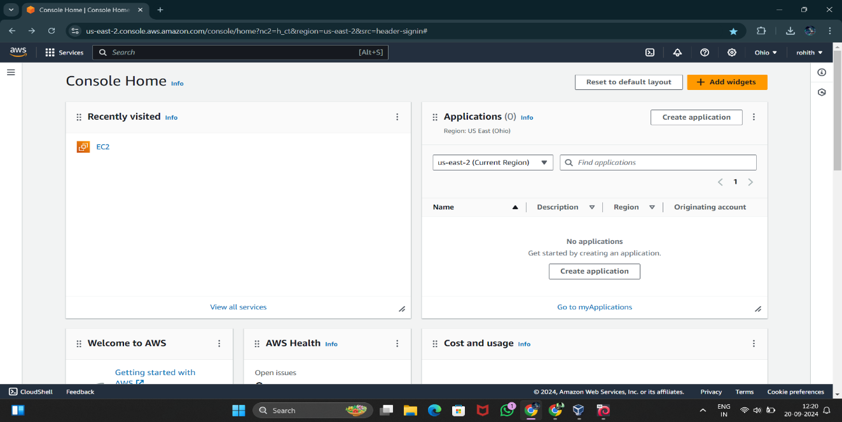

**Launch an EC2 Instance**

1. On the EC2 dashboard, click the **Launch Instance** button.
2. You’ll be redirected to the "Launch an Instance" page.

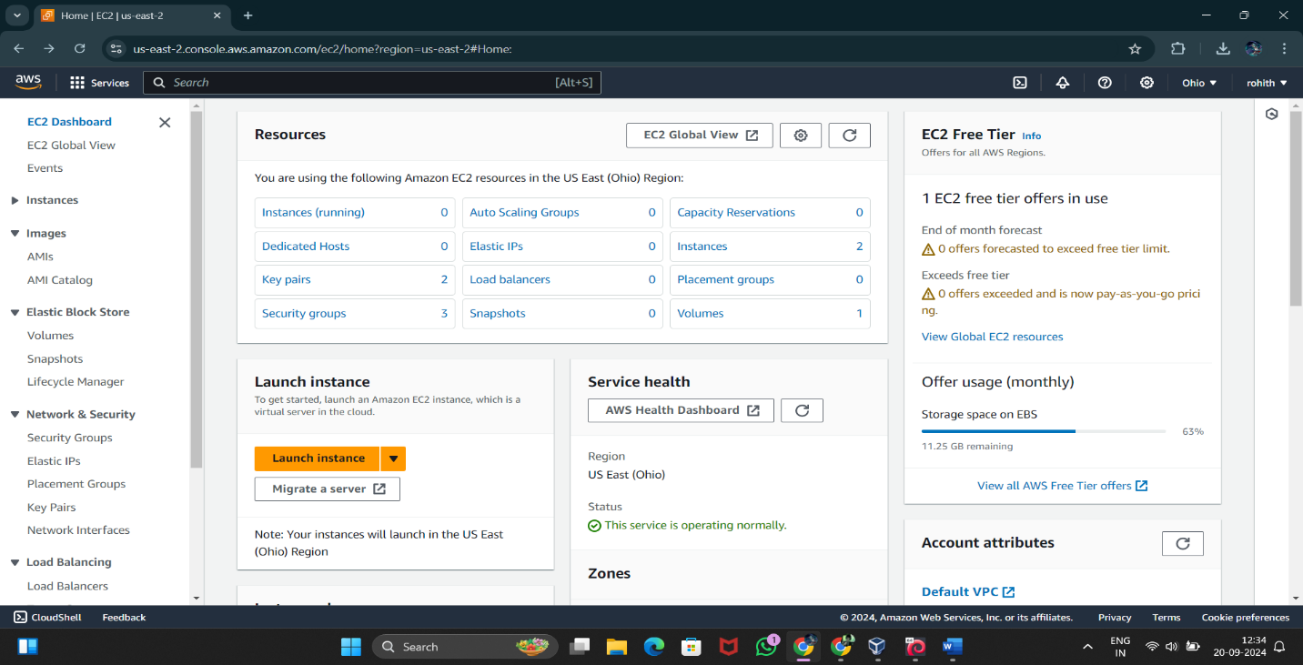

**Choose an Amazon Machine Image (AMI)**

1. You need to select an **Amazon Machine Image (AMI)**, which is essentially the OS for your VM.
   * For example, you can choose **Amazon Linux**, **Ubuntu**, **Windows Server**, etc.
2. 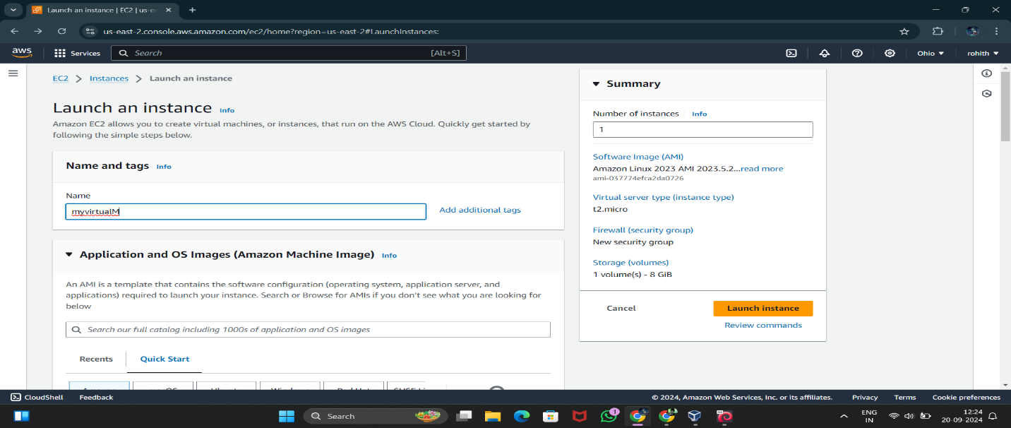Select the AMI that fits your requirements (e.g., Amazon Linux 2 for Linux or Windows Server for Windows).

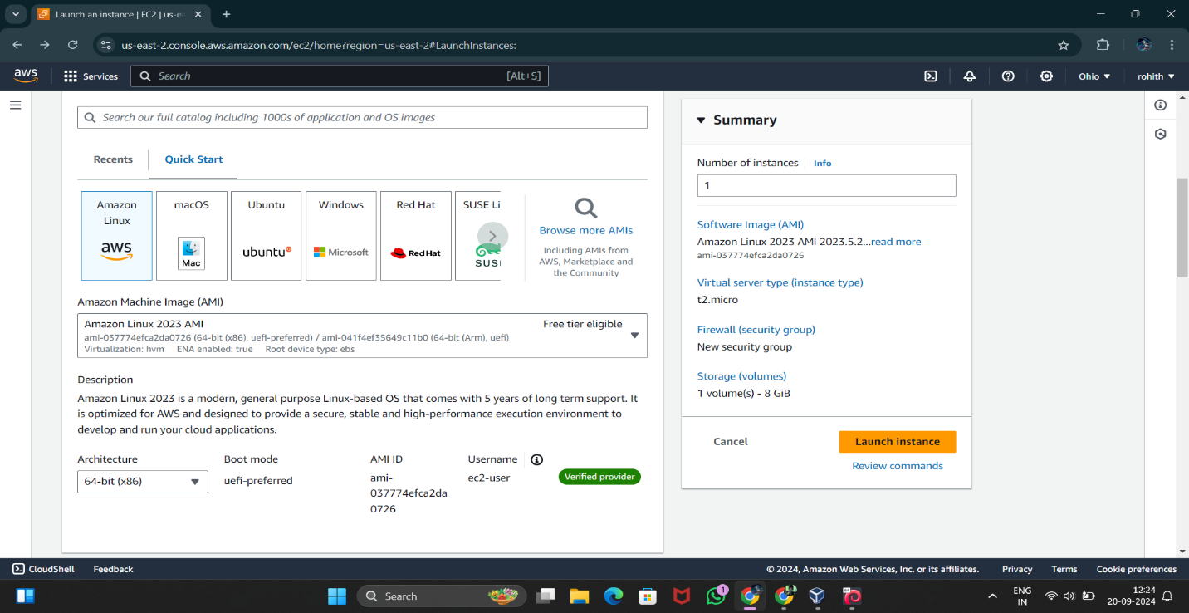

**Choose an Instance Type**

1. The instance type defines the hardware configuration (CPU, memory) of your VM.
2. For basic use, you can choose the **t2.micro** instance type, which is free-tier eligible (good for light workloads).

**Configure Instance Details**

1. In this step, you can configure networking and other advanced settings.
   * Leave the defaults for a basic setup.
   * Ensure your VM will be launched in the default VPC (Virtual Private Cloud) unless you have specific networking requirements.

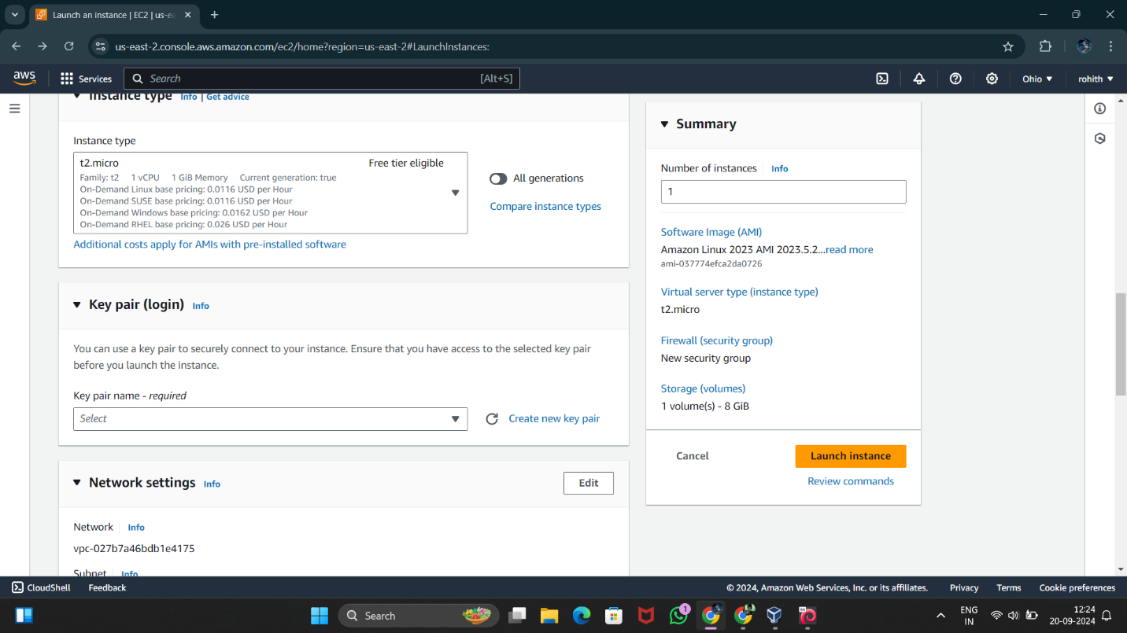

**Configure Security Group**

1. A **Security Group** is essentially a virtual firewall for your VM.
2. By default, SSH (port 22) for Linux or RDP (port 3389) for Windows will be pre-configured.

**Review and Launch**

1. Review your settings.
2. Click **Launch instance**.

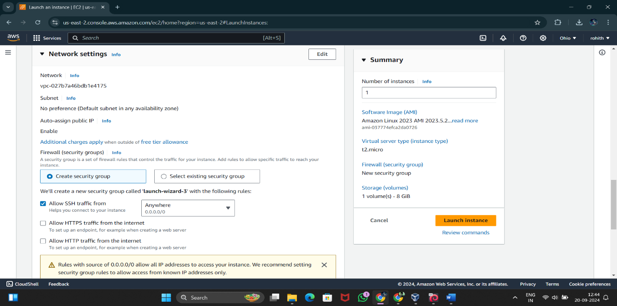

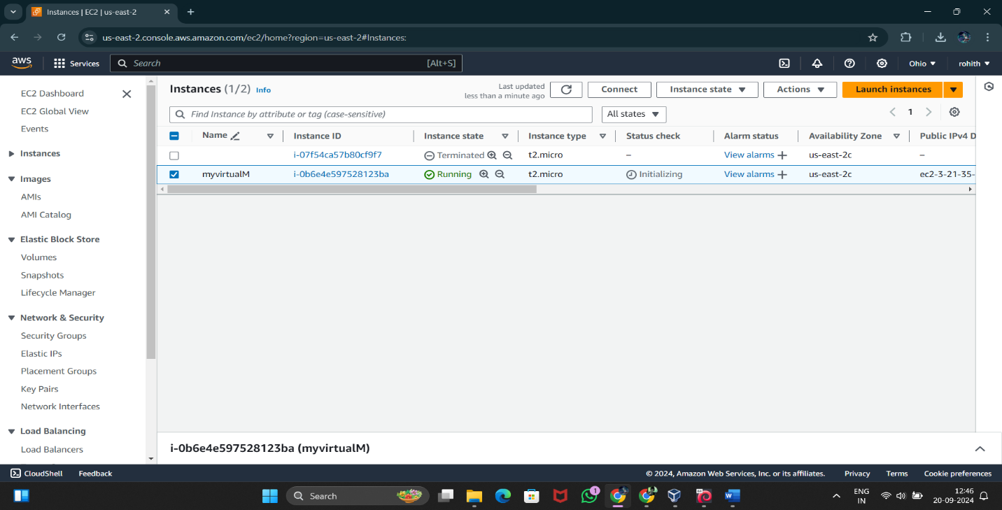**Ping your own VM in cloud**

I was able to ping my VM in cloud through public ip.

Public ip= 3.21.129.195.

It was only able to me after changing the inbound rules in security of my AWS instance.

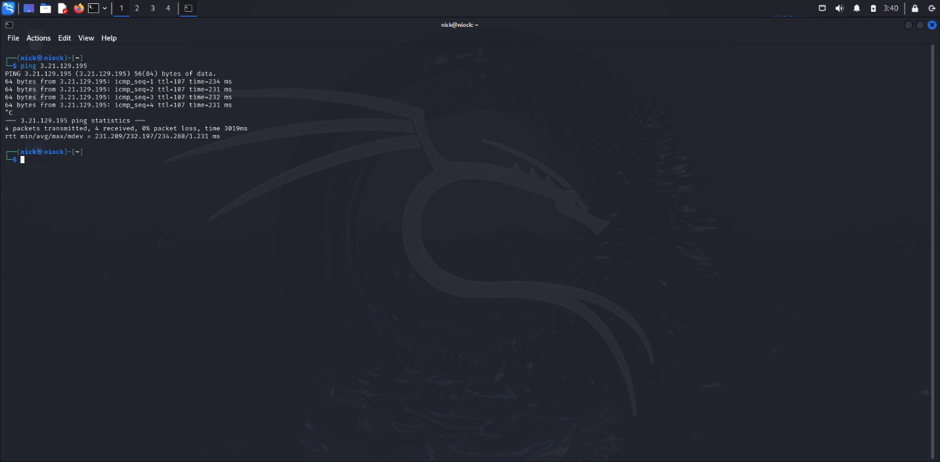

**LOGGING IN TO MY VM VIA SSH**

I got logged in to my VM through ssh.

For that I wanted the security key of aws instance server and put that to kali linux.

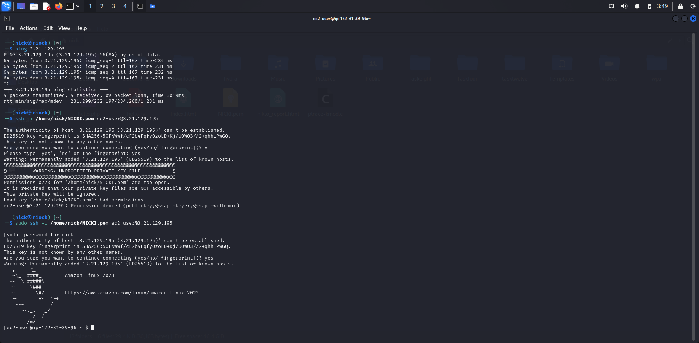

Verifying Public IP Connectivity: Ping Your Public IP from a Cloud VM and Capture the Results

I was unable to ping my public IP from cloud VM.

It is because the ISP providers are blocking ICMP packets.

