AWS – AZURE-GCP-REQUIRED CLOUD AND DEVOPS CERTIFICATIONS

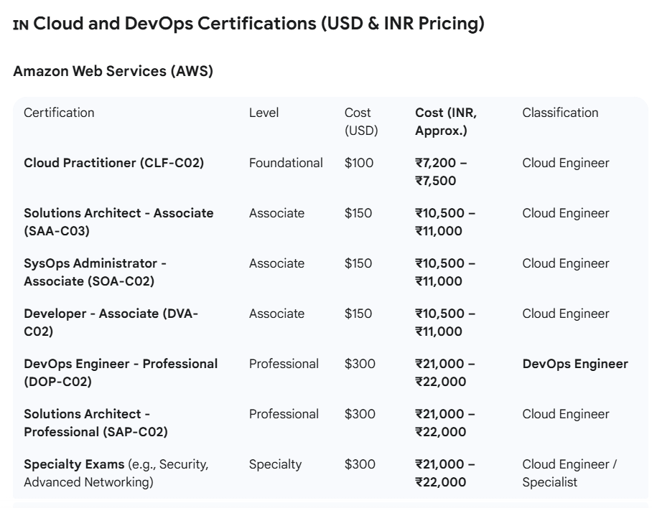

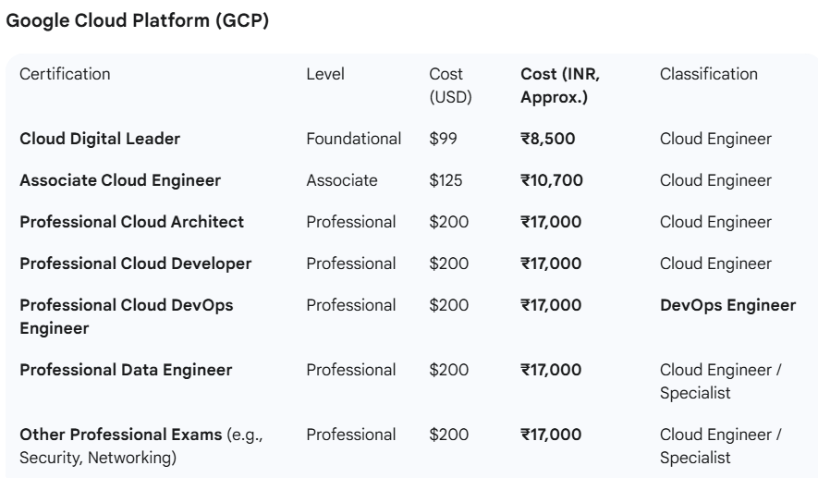

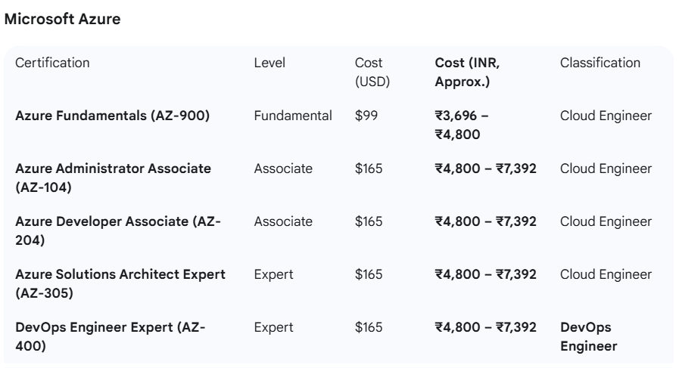

**Note on Azure Pricing:** Microsoft Azure often lists its exam prices significantly lower in India than the direct dollar conversion, sometimes around **₹4,800** per exam. However, prices can fluctuate and vary by exam, with some being listed around **₹7,392** or **₹8,200**. Always check the official Microsoft exam page during registration for the most current and accurate price.

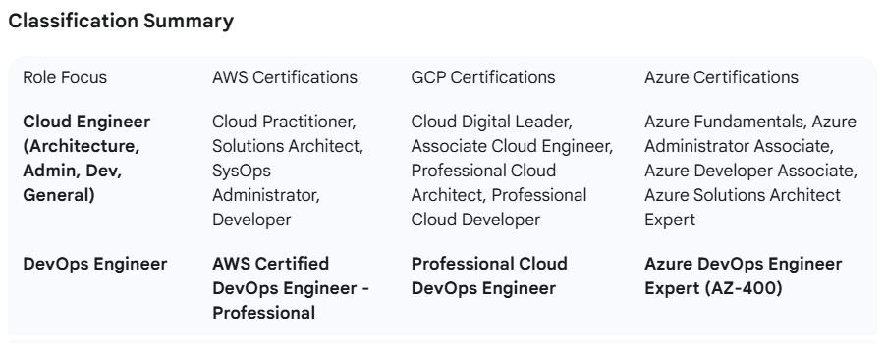

**Key Difference:**

* **Cloud Engineer** focuses on *what* services to use and *how* to set them up.
* **DevOps Engineer** focuses on *how* to automate the deployment, management, and monitoring of those services (CI/CD, IaC, SRE).

**Valuable DevOps Tool Certifications**

* These certifications target essential, non-cloud-specific tools that are crucial for a complete DevOps pipeline.

**1. Containerization & Orchestration**

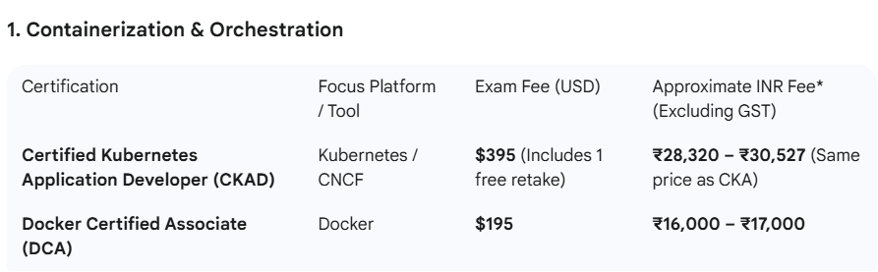

* **CKAD vs. CKA:** CKA focuses on **cluster administration** (installing, maintaining, troubleshooting), while CKAD focuses on **deploying and defining cloud-native applications** (developing manifests, defining resources). Both are highly respected.

### 2. Configuration Management & Automation

While Configuration Management (CM) tools like Ansible, Chef, and Puppet are widely used, their **official vendor certifications** are often less emphasized by recruiters than the cloud or Kubernetes certs. They are still valuable, however, for specific job roles and environments.

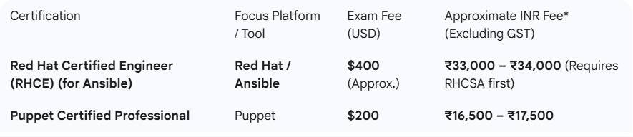

**Note on Ansible:** The RHCE exam is a **performance-based** test and a common way to validate advanced Ansible automation skills in enterprise Linux environments.

### **3. Continuous Integration/Continuous Delivery (CI/CD)**

Jenkins, as an open-source tool, historically didn't have a single dominant certification. However, other CI/CD pipeline vendors do:

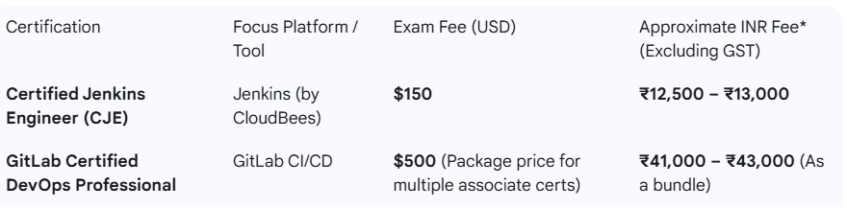

### **4. Security (DevSecOps)**

For experienced professionals, adding a security certification is a huge salary booster, often transitioning the role into a specialized **DevSecOps Engineer**:

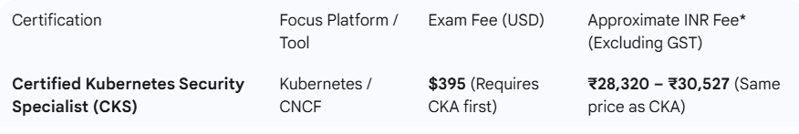

**In Summary:** The major cloud and Kubernetes certifications offer the highest general value. However, certifications like **DCA**, **CKS**, and **RHCE (Ansible)** provide excellent specialization that makes you highly competitive for roles that require deep expertise in those specific tools.

Nearly all professional-level DevOps tool and cloud certifications **expire** and require a **recertification** process to remain valid.

The expiration period and the renewal process vary significantly by vendor. This requirement exists because the DevOps landscape, tools, and cloud platforms change rapidly.

Here is a summary of the renewal policies for the most popular certifications:

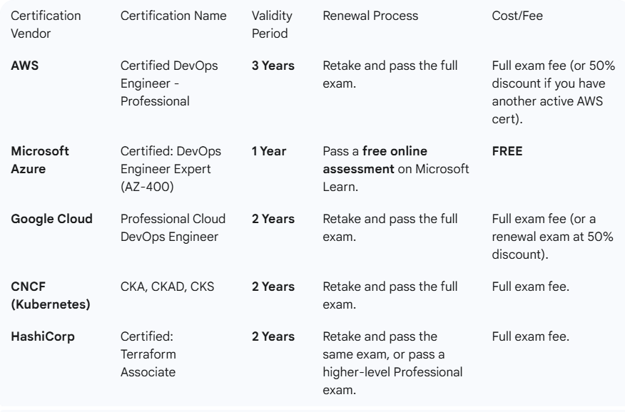

## Key Takeaways on Renewal

1. **Renewal is Necessary:** Certification is an ongoing commitment. Without renewal, your credential expires and is no longer officially valid.
2. **Microsoft is an Exception:** Microsoft is the most user-friendly for renewal, allowing you to pass a **free, non-proctored, open-book assessment** online to extend your certification for another year.
3. **Cloud & CNCF Require Full Re-exam (Mostly):** AWS, Google Cloud, and the CNCF Kubernetes certifications (CKA/CKAD/CKS) generally require you to **re-take and pass the full, proctored exam** again, which involves paying the exam fee. The key is to demonstrate you are current with the technology's latest version.
4. **Purpose of Renewal:** Recertification ensures that your skills reflect the current state of the technology. For instance, the steps for deploying an application with Kubernetes or managing an AWS service will be different today than they were three years ago.

That's an important clarification! Certifications for specific **tools** like Docker, Jenkins, and Ansible also have their own expiration rules.

Here is the breakdown for the major vendor/tool-specific DevOps certifications:

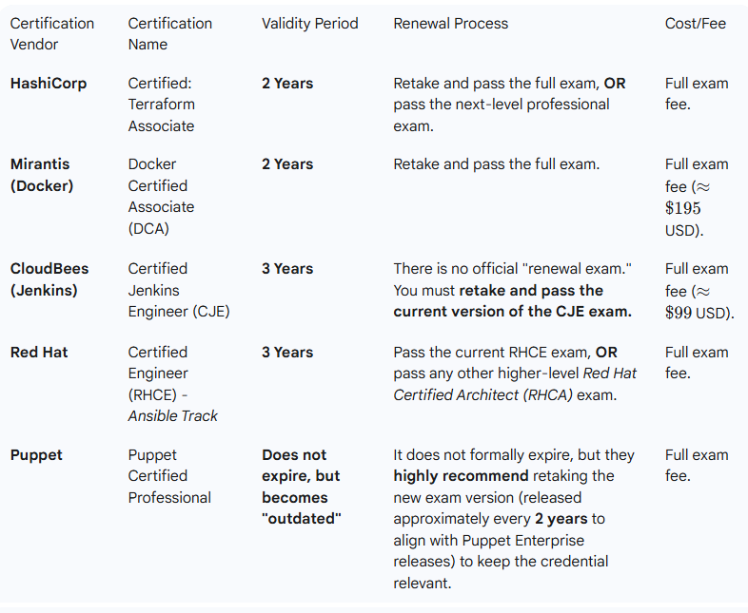

### Summary of "Tool" Cert Renewal

* **Standard Rule:** For almost all tool certifications (Docker, Jenkins, Terraform), you must **retake the full, proctored exam** when your certification expires (typically after 2 or 3 years).
* **Red Hat (Best for Advancement):** Red Hat offers the best path to avoid repeated exams. If you earn a higher-level Red Hat Certified Architect (RHCA) credential, it automatically extends the validity of your RHCE (Ansible) and RHCSA certifications.
* **Staying Current is Key:** Even for Puppet, which technically doesn't expire, the industry expectation is that you will hold a certification based on a recent product version to show relevant skills.