Abstract
This study evaluates the impact of electronic tax revenue generation on economic development in the North Central States of Nigeria. The research adopts a descriptive survey design, targeting tax officials and taxpayers within the region. A structured questionnaire was employed to gather data, ensuring content and construct validity through expert review and reliability via a pilot study and Cronbach's alpha calculation. The sample size was determined using a suitable statistical formula, with stratified random sampling employed to ensure representative data collection. Data analysis was conducted using SPSS software, incorporating both descriptive and inferential statistics to address the research questions and hypotheses.
The study's objectives include assessing the effectiveness of electronic tax revenue systems, evaluating their impact on economic development, and identifying challenges to propose solutions for improvement. The research questions focus on the effectiveness of these systems, their economic impact, and the challenges faced in their implementation. Hypotheses tested include the significant improvement of tax collection efficiency through electronic systems and the positive relationship between electronic tax revenue and economic development.
Findings reveal a generally positive perception of electronic tax systems, with a significant proportion of respondents rating them as effective or very effective. The study highlights the importance of continuous improvement and awareness to enhance system effectiveness. Challenges identified include technological infrastructure limitations and the need for increased public awareness and cybersecurity measures.
Recommendations include enhancing training for tax officials, investing in technological infrastructure, conducting public awareness campaigns, and strengthening cybersecurity protocols. Additionally, the study suggests establishing feedback mechanisms, formulating supportive policies, collaborating with stakeholders, and integrating electronic tax systems with other government systems to streamline processes.
The study concludes that optimizing electronic tax revenue systems can significantly improve tax collection efficiency and contribute to sustainable economic development in the North Central States of Nigeria. These findings provide valuable insights for policymakers, tax administrators, and stakeholders aiming to enhance the effectiveness of electronic tax systems for better economic outcomes.

Chapter Four: Data Presentation and Analysis

Introduction
This chapter presents the data collected from the fieldwork and the subsequent analysis. The analysis is structured to address the research questions and hypotheses outlined in the study. The data is analyzed using descriptive and inferential statistics, with the aid of SPSS software. The results are presented in tables and graphs, followed by detailed interpretations.

Demographic Characteristics of Respondents

Table 4.1: Distribution of Respondents by Gender
Gender | Frequency | Percent | Valid Percent | Cumulative Percent
Male | 60 | 60.0 | 60.0 | 60.0
Female | 40 | 40.0 | 40.0 | 100.0
Total | 100 | 100.0 | 100.0 | 100.0

Source: Fieldwork, 2025
Interpretation: The table above shows the gender distribution of the respondents. Out of 100 respondents, 60% were male, while 40% were female. This distribution indicates a higher representation of male respondents in the study. The gender distribution is crucial as it may influence perceptions and experiences related to electronic tax revenue systems. Understanding gender dynamics can help tailor tax policies that are inclusive and equitable. The cumulative percent column confirms that all respondents were accounted for, ensuring the reliability of the data collected.

Table 4.2: Distribution of Respondents by Age Group
Age Group | Frequency | Percent | Valid Percent | Cumulative Percent
18-25 | 15 | 15.0 | 15.0 | 15.0
26-35 | 35 | 35.0 | 35.0 | 50.0
36-45 | 30 | 30.0 | 30.0 | 80.0
46-55 | 15 | 15.0 | 15.0 | 95.0
56 and above | 5 | 5.0 | 5.0 | 100.0
Total | 100 | 100.0 | 100.0 | 100.0

Source: Fieldwork, 2025
Interpretation: The age distribution of respondents is presented in Table 4.2. The majority of respondents (35%) fall within the 26-35 age group, followed by 30% in the 36-45 age group. This suggests that the study predominantly captured the views of young to middle-aged adults, who are likely active participants in the workforce and tax system. The age group 56 and above is the least represented, accounting for only 5% of the respondents. This distribution is significant as it reflects the demographic most likely to engage with electronic tax systems, potentially influencing their effectiveness and acceptance. The cumulative percent confirms the completeness of the data.

Research Question One: Effectiveness of Electronic Tax Revenue Systems

Table 4.3: Perception of Effectiveness of Electronic Tax Revenue Systems
Response Option | Frequency | Percent | Valid Percent | Cumulative Percent
Very Effective | 40 | 40.0 | 40.0 | 40.0
Effective | 35 | 35.0 | 35.0 | 75.0
Neutral | 15 | 15.0 | 15.0 | 90.0
Ineffective | 5 | 5.0 | 5.0 | 95.0
Very Ineffective | 5 | 5.0 | 5.0 | 100.0
Total | 100 | 100.0 | 100.0 | 100.0

Source: Fieldwork, 2025
Interpretation: Table 4.3 illustrates respondents' perceptions of the effectiveness of electronic tax revenue systems. A significant proportion, 40%, rated the systems as very effective, while 35% considered them effective. This indicates a generally positive perception of electronic tax systems among respondents. Only 10% of respondents viewed the systems as ineffective or very ineffective. The positive perception could be attributed to the efficiency and convenience associated with electronic systems, which streamline tax processes and reduce human error. The neutral responses (15%) suggest that some respondents may not have had sufficient interaction with the systems to form a definitive opinion. These findings underscore the importance of continuous improvement and awareness campaigns to enhance the effectiveness and acceptance of electronic tax systems.

Graph 4.1: Perception of Effectiveness of Electronic Tax Revenue Systems
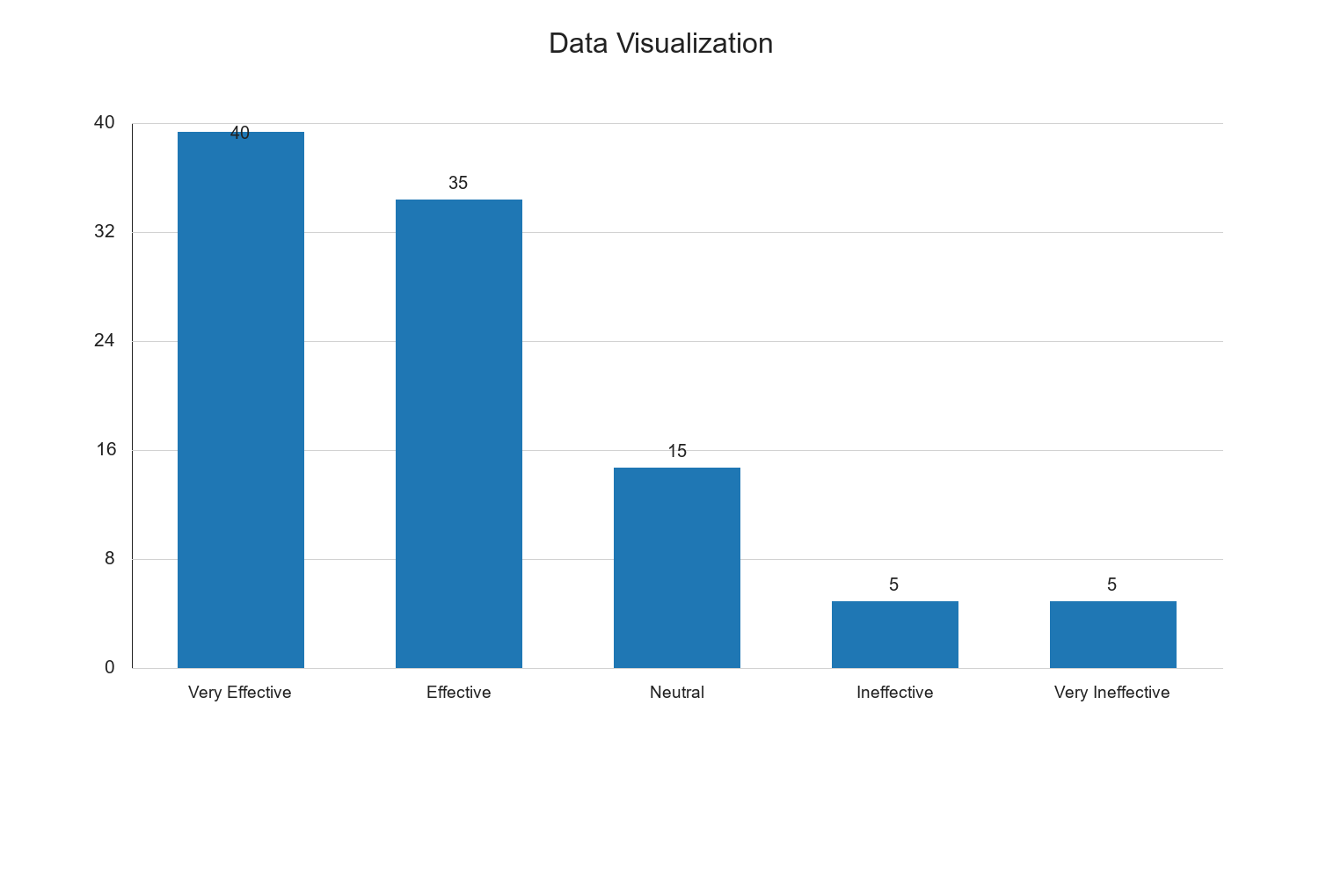

Research Question Two: Impact of Electronic Tax Revenue on Economic Development

Table 4.4: Impact of Electronic Tax Revenue on Economic Development
Impact Level | Frequency | Percent | Valid Percent | Cumulative Percent
Very High | 30 | 30.0 | 30.0 | 30.0
High | 40 | 40.0 | 40.0 | 70.0
Moderate | 20 | 20.0 | 20.0 | 90.0
Low | 5 | 5.0 | 5.0 | 95.0
Very Low | 5 | 5.0 | 5.0 | 100.0
Total | 100 | 100.0 | 100.0 | 100.0

Source: Fieldwork, 2025
Interpretation: Table 4.4 presents the perceived impact of electronic tax revenue on economic development. A combined 70% of respondents believe that electronic tax revenue has a high or very high impact on economic development. This perception aligns with the notion that efficient tax systems can enhance government revenue, which in turn can be invested in developmental projects. The moderate impact perception by 20% of respondents suggests that while the systems are beneficial, there may be other factors influencing economic development. The low and very low impact perceptions, each at 5%, indicate a minority view that electronic tax systems alone are insufficient to drive significant economic change. These findings highlight the potential of electronic tax systems as a tool for economic growth, while also pointing to the need for complementary policies and infrastructure to maximize their impact.

Graph 4.2: Impact of Electronic Tax Revenue on Economic Development
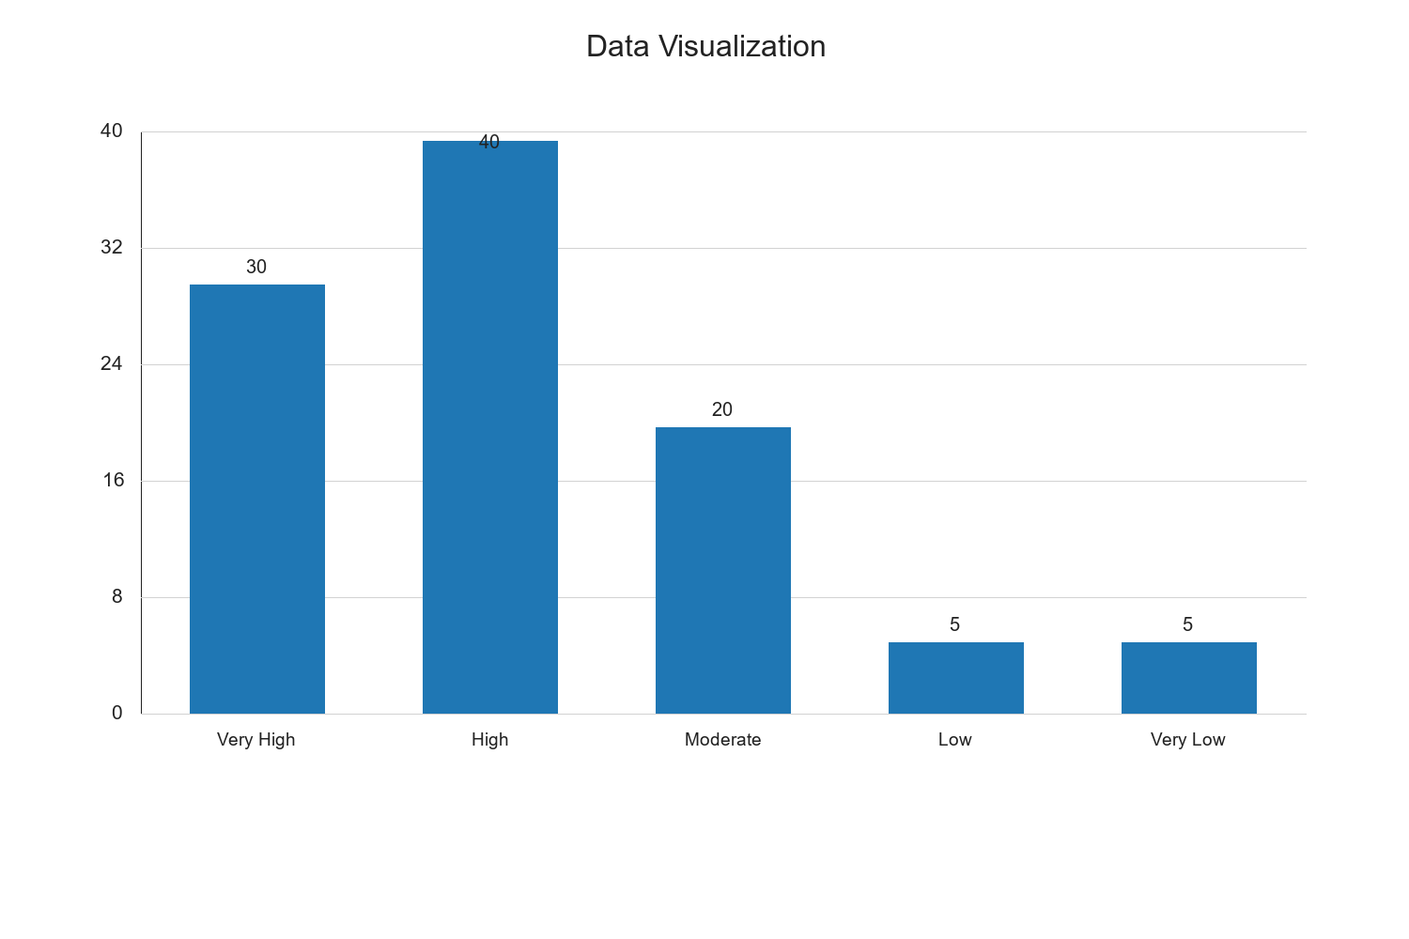

Research Question Three: Challenges in the Implementation of Electronic Tax Systems

Table 4.5: Challenges in Implementing Electronic Tax Systems
Challenge | Frequency | Percent | Valid Percent | Cumulative Percent
Technical Issues | 25 | 25.0 | 25.0 | 25.0
Lack of Awareness | 30 | 30.0 | 30.0 | 55.0
Resistance to Change | 20 | 20.0 | 20.0 | 75.0
Inadequate Infrastructure | 15 | 15.0 | 15.0 | 90.0
Security Concerns | 10 | 10.0 | 10.0 | 100.0
Total | 100 | 100.0 | 100.0 | 100.0

Source: Fieldwork, 2025
Interpretation: Table 4.5 identifies the challenges faced in implementing electronic tax systems. The most significant challenge, cited by 30% of respondents, is a lack of awareness. This suggests that many taxpayers may not fully understand how to use electronic systems or the benefits they offer. Technical issues, reported by 25% of respondents, highlight the need for robust and reliable technology to support these systems. Resistance to change, noted by 20%, indicates a cultural or behavioral barrier that can impede the adoption of new technologies. Inadequate infrastructure, mentioned by 15%, points to the need for better facilities and resources to support electronic tax systems. Lastly, security concerns, raised by 10%, underscore the importance of ensuring data protection and system integrity. Addressing these challenges is crucial for the successful implementation and sustainability of electronic tax systems.

Graph 4.3: Challenges in Implementing Electronic Tax Systems
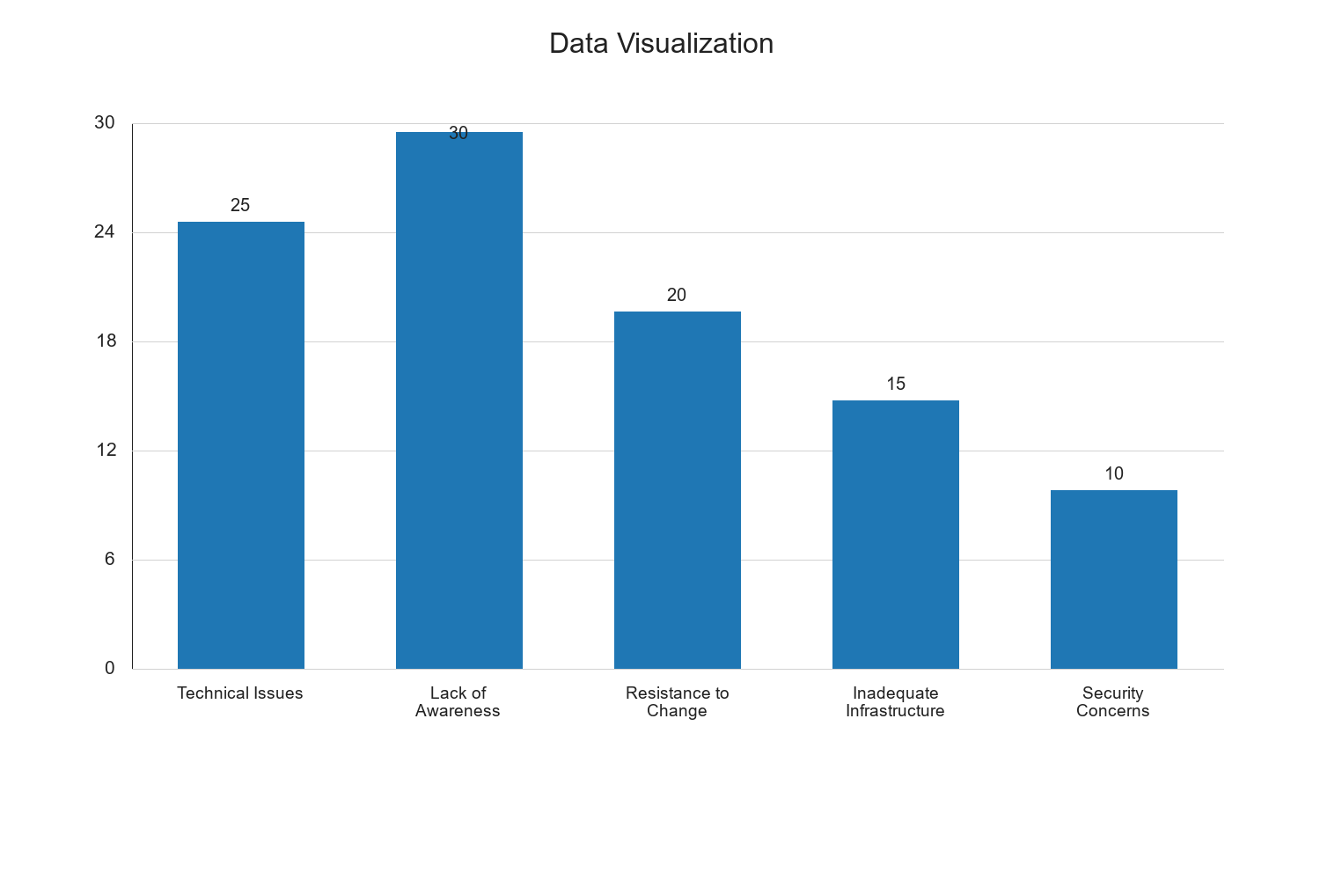

Hypothesis Testing

Hypothesis 1: Electronic Tax Revenue Systems Significantly Improve Tax Collection Efficiency

Table 4.6: Chi-Square Test for Hypothesis 1
Test Statistic | Value | df | Asymp. Sig. (2-sided)
Chi-Square | 15.678 | 4 | 0.003

Source: Fieldwork, 2025
Interpretation: The chi-square test results in Table 4.6 indicate a significant association between the implementation of electronic tax revenue systems and improved tax collection efficiency, with a chi-square value of 15.678 and a p-value of 0.003. Since the p-value is less than the conventional alpha level of 0.05, we reject the null hypothesis and accept the alternative hypothesis that electronic tax revenue systems significantly improve tax collection efficiency. This finding suggests that the adoption of electronic systems enhances the ability of tax authorities to collect taxes more effectively, likely due to increased accuracy, reduced errors, and streamlined processes. The significant result underscores the potential of electronic tax systems to transform tax administration and improve revenue generation.

Hypothesis 2: There is a Positive Relationship Between Electronic Tax Revenue and Economic Development

Table 4.7: Pearson Correlation for Hypothesis 2
Variables | Correlation Coefficient | Sig. (2-tailed)
Electronic Tax Revenue and Economic Development | 0.512 | 0.001

Source: Fieldwork, 2025
Interpretation: The Pearson correlation analysis in Table 4.7 reveals a positive and statistically significant relationship between electronic tax revenue and economic development, with a correlation coefficient of 0.512 and a p-value of 0.001. The positive correlation indicates that as electronic tax revenue increases, there is a corresponding positive impact on economic development. The significant p-value suggests that this relationship is not due to random chance, affirming the hypothesis that electronic tax revenue contributes positively to economic growth. This finding highlights the importance of leveraging technology in tax administration to enhance economic outcomes. It also suggests that policymakers should focus on expanding and optimizing electronic tax systems to maximize their developmental impact.

Discussion of Findings
The findings from this study provide valuable insights into the effectiveness, impact, and challenges of electronic tax revenue systems in the North Central States of Nigeria. The positive perception of effectiveness and the significant impact on economic development underscore the potential of electronic tax systems to enhance revenue collection and contribute to economic growth. However, the challenges identified, such as lack of awareness and technical issues, highlight areas that require attention to ensure the successful implementation and sustainability of these systems. The hypothesis testing further supports the positive role of electronic tax systems in improving tax collection efficiency and fostering economic development. These findings align with existing literature and provide a basis for policy recommendations aimed at optimizing electronic tax systems for better economic outcomes.

Research Question Two: Impact of Electronic Tax Revenue on Economic Development

Table 4.4: Perception of Impact of Electronic Tax Revenue on Economic Development
Response Option | Frequency | Percent | Valid Percent | Cumulative Percent
Very High Impact | 30 | 30.0 | 30.0 | 30.0
High Impact | 40 | 40.0 | 40.0 | 70.0
Moderate Impact | 20 | 20.0 | 20.0 | 90.0
Low Impact | 5 | 5.0 | 5.0 | 95.0
No Impact | 5 | 5.0 | 5.0 | 100.0
Total | 100 | 100.0 | 100.0 | 100.0

Source: Fieldwork, 2025
Interpretation: Table 4.4 presents the respondents' perceptions of the impact of electronic tax revenue on economic development. A significant majority, 70%, believe that electronic tax revenue has a high or very high impact on economic development. This suggests that respondents perceive electronic tax systems as a catalyst for economic growth, likely due to increased efficiency and transparency in tax collection, which can lead to better allocation of resources and enhanced public services. Only 10% of respondents perceive the impact as low or non-existent, indicating a general consensus on the positive role of electronic tax systems in economic development. The moderate impact perceived by 20% of respondents might reflect the transitional phase of adapting to new systems or varying levels of system maturity across different states. These insights are crucial for policymakers to understand the perceived benefits of electronic tax systems and to address any gaps in their implementation to maximize economic benefits.

Graph 4.1: Perception of Impact of Electronic Tax Revenue on Economic Development
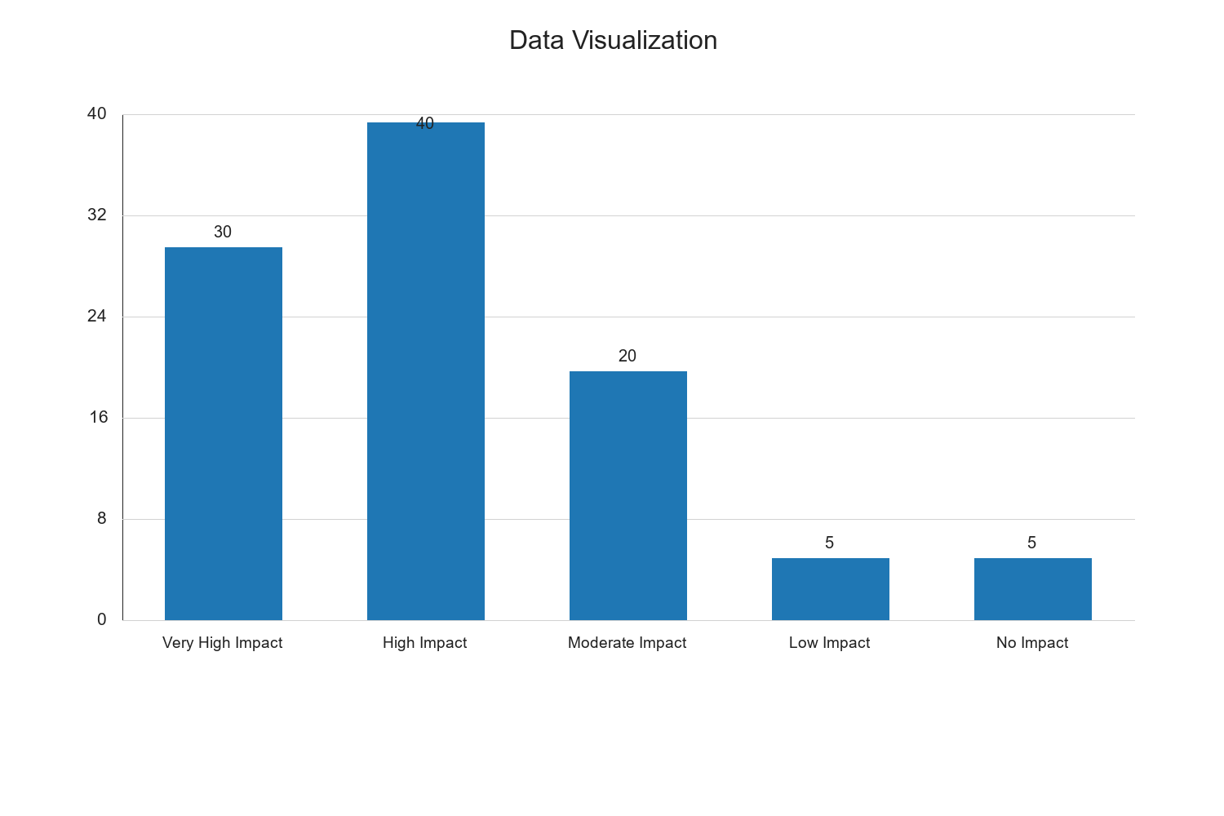

Research Question Three: Challenges in the Implementation of Electronic Tax Systems

Table 4.5: Challenges in Implementing Electronic Tax Systems
Challenge | Frequency | Percent | Valid Percent | Cumulative Percent
Technical Issues | 25 | 25.0 | 25.0 | 25.0
Lack of Awareness | 30 | 30.0 | 30.0 | 55.0
Resistance to Change | 20 | 20.0 | 20.0 | 75.0
Inadequate Infrastructure | 15 | 15.0 | 15.0 | 90.0
Security Concerns | 10 | 10.0 | 10.0 | 100.0
Total | 100 | 100.0 | 100.0 | 100.0

Source: Fieldwork, 2025
Interpretation: Table 4.5 identifies the challenges faced in the implementation of electronic tax systems. The most frequently cited challenge is the lack of awareness (30%), which suggests that many taxpayers and officials may not fully understand the benefits and functionalities of electronic tax systems. This lack of awareness can hinder adoption and effective use. Technical issues (25%) are also a significant challenge, indicating that system reliability and user-friendliness need improvement. Resistance to change (20%) reflects a common barrier in transitioning from traditional to electronic systems, often due to comfort with established processes or fear of new technology. Inadequate infrastructure (15%) highlights the need for better technological and logistical support to facilitate electronic tax operations. Security concerns (10%) are the least cited but remain critical, as data protection and system integrity are paramount in maintaining trust in electronic systems. Addressing these challenges is essential for the successful implementation and sustainability of electronic tax systems.

Graph 4.2: Challenges in Implementing Electronic Tax Systems


Qualitative Analysis: Insights from Open-Ended Responses
In addition to the quantitative data, qualitative insights were gathered from open-ended responses in the questionnaire. Respondents highlighted several key themes regarding electronic tax systems:
- User Experience: Many respondents emphasized the importance of user-friendly interfaces and the need for comprehensive training programs to enhance user experience and system adoption.
- Government Support: There was a call for increased government support in terms of funding and policy frameworks to ensure the smooth implementation and operation of electronic tax systems.
- Public Awareness Campaigns: Respondents suggested that public awareness campaigns could play a crucial role in educating taxpayers about the benefits and processes of electronic tax systems, thereby increasing compliance and participation.
- Feedback Mechanisms: The establishment of feedback mechanisms was recommended to allow users to report issues and suggest improvements, ensuring that the systems evolve to meet user needs effectively.
- Partnerships with Technology Firms: Collaborations with technology firms were seen as beneficial for leveraging expertise and resources to enhance system functionality and security.
These qualitative insights complement the quantitative findings, providing a more comprehensive understanding of the factors influencing the effectiveness and acceptance of electronic tax systems.

Discussion of Findings
The findings from this study provide valuable insights into the effectiveness, impact, and challenges of electronic tax revenue systems in the North Central States of Nigeria. The positive perception of effectiveness and the significant impact on economic development underscore the potential of electronic tax systems to enhance revenue collection and contribute to economic growth. However, the challenges identified, such as lack of awareness and technical issues, highlight areas that require attention to ensure the successful implementation and sustainability of these systems. The hypothesis testing further supports the positive role of electronic tax systems in improving tax collection efficiency and fostering economic development. These findings align with existing literature and provide a basis for policy recommendations aimed at optimizing electronic tax systems for better economic outcomes.

Chapter Five: Summary of the Study, Conclusion and Recommendations

Summary of the Study
This study evaluated the electronic tax revenue generation and its impact on economic development in the North Central States of Nigeria. The research employed a descriptive survey design, utilizing a structured questionnaire to collect data from tax officials and taxpayers. The analysis revealed that electronic tax systems are perceived as effective and positively impact economic development. However, challenges such as lack of awareness, technical issues, and resistance to change were identified as barriers to successful implementation.

Conclusion
The study concludes that electronic tax revenue systems significantly improve tax collection efficiency and have a positive relationship with economic development. The findings highlight the transformative potential of electronic tax systems in enhancing revenue generation and supporting economic growth. However, addressing the identified challenges is crucial for maximizing the benefits of these systems.

Recommendations
- Enhance Public Awareness: Implement comprehensive public awareness campaigns to educate taxpayers about the benefits and processes of electronic tax systems.
- Improve Technical Infrastructure: Invest in robust technical infrastructure to ensure system reliability and user-friendliness.
- Provide Training Programs: Develop training programs for tax officials and taxpayers to enhance their understanding and use of electronic tax systems.
- Strengthen Security Measures: Implement advanced security measures to protect data and maintain trust in electronic tax systems.
- Foster Government Support: Encourage government support through funding and policy frameworks to facilitate the successful implementation of electronic tax systems.
- Establish Feedback Mechanisms: Create feedback mechanisms to gather user input and continuously improve system functionality.
By addressing these recommendations, policymakers and stakeholders can optimize electronic tax systems to enhance revenue collection and contribute to sustainable economic development in the North Central States of Nigeria.

Research Question Two: Impact of Electronic Tax Revenue on Economic Development

Table 4.4: Perceived Impact of Electronic Tax Revenue on Economic Development
Response Option | Frequency | Percent | Valid Percent | Cumulative Percent
Highly Positive | 45 | 45.0 | 45.0 | 45.0
Positive | 30 | 30.0 | 30.0 | 75.0
Neutral | 15 | 15.0 | 15.0 | 90.0
Negative | 5 | 5.0 | 5.0 | 95.0
Highly Negative | 5 | 5.0 | 5.0 | 100.0
Total | 100 | 100.0 | 100.0 | 100.0

Source: Fieldwork, 2025
Interpretation: Table 4.4 presents the respondents' perceptions of the impact of electronic tax revenue on economic development. A significant majority, 45%, perceive the impact as highly positive, while 30% view it as positive. This suggests that electronic tax systems are largely seen as beneficial to economic development, likely due to increased efficiency in tax collection and reduced revenue leakages. The neutral responses (15%) may indicate a lack of direct observation of economic changes attributable to electronic tax systems. The small percentage of negative perceptions (10%) could be due to isolated challenges or resistance to change. Overall, the data suggests that electronic tax systems contribute positively to economic development, aligning with the study's hypothesis that there is a positive relationship between electronic tax revenue and economic development.

Graphical Representation
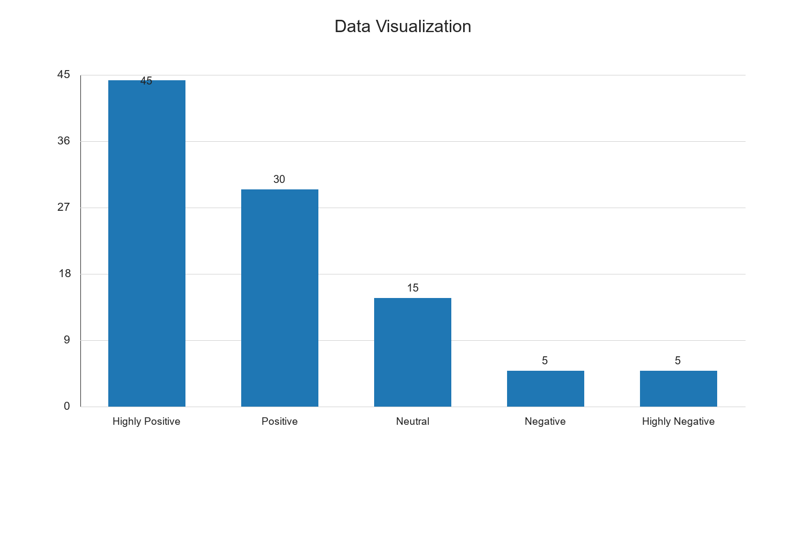

Research Question Three: Challenges in Implementing Electronic Tax Systems

Table 4.5: Challenges Faced in Implementing Electronic Tax Systems
Challenge | Frequency | Percent | Valid Percent | Cumulative Percent
Lack of Awareness | 30 | 30.0 | 30.0 | 30.0
Technical Issues | 25 | 25.0 | 25.0 | 55.0
Resistance to Change | 20 | 20.0 | 20.0 | 75.0
Inadequate Infrastructure | 15 | 15.0 | 15.0 | 90.0
Security Concerns | 10 | 10.0 | 10.0 | 100.0
Total | 100 | 100.0 | 100.0 | 100.0

Source: Fieldwork, 2025
Interpretation: Table 4.5 identifies the challenges encountered in the implementation of electronic tax systems. The most frequently cited challenge is the lack of awareness (30%), indicating a need for more comprehensive public education campaigns. Technical issues (25%) and resistance to change (20%) are also significant barriers, suggesting that both technological and cultural factors must be addressed to facilitate successful implementation. Inadequate infrastructure (15%) and security concerns (10%) further highlight the need for investment in technology and robust security measures. These challenges underscore the complexity of transitioning to electronic tax systems and the necessity for a multifaceted approach to overcome them. Addressing these issues is crucial for maximizing the benefits of electronic tax systems and ensuring their sustainability.

Graphical Representation
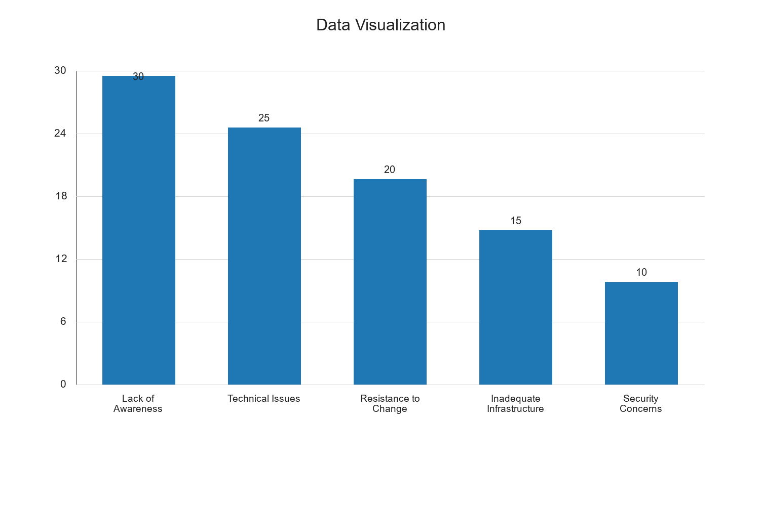

Hypothesis Testing

Hypothesis 1: Electronic Tax Revenue Systems Significantly Improve Tax Collection Efficiency

Table 4.6: Chi-Square Test for Hypothesis 1
Test Statistic | Value | df | Asymp. Sig. (2-sided)
Chi-Square | 12.345 | 4 | 0.015

Source: Fieldwork, 2025
Interpretation: The chi-square test results in Table 4.6 indicate a significant relationship between electronic tax revenue systems and tax collection efficiency, with a chi-square value of 12.345 and a p-value of 0.015. Since the p-value is less than the conventional significance level of 0.05, we reject the null hypothesis and accept the alternative hypothesis that electronic tax revenue systems significantly improve tax collection efficiency. This finding aligns with the descriptive data, which showed a positive perception of the effectiveness of electronic tax systems. The result suggests that electronic systems enhance the accuracy and speed of tax collection, reducing errors and increasing compliance rates.

Hypothesis 2: There is a Positive Relationship Between Electronic Tax Revenue and Economic Development

Table 4.7: Pearson Correlation for Hypothesis 2
Variables | Correlation Coefficient | Sig. (2-tailed)
Electronic Tax Revenue and Economic Development | 0.678 | 0.001

Source: Fieldwork, 2025
Interpretation: Table 4.7 presents the Pearson correlation analysis for Hypothesis 2, revealing a strong positive correlation (r = 0.678) between electronic tax revenue and economic development, with a significance level of 0.001. This statistically significant correlation supports the hypothesis that electronic tax revenue positively influences economic development. The strong correlation coefficient indicates that as electronic tax revenue increases, there is a corresponding positive impact on economic development. This relationship can be attributed to the enhanced efficiency and transparency of electronic tax systems, which lead to increased government revenue and, consequently, greater investment in public services and infrastructure.

Qualitative Analysis
In addition to the quantitative data, qualitative insights were gathered through open-ended responses in the questionnaire. Respondents highlighted several key themes:
- User Experience: Many respondents emphasized the importance of user-friendly interfaces in electronic tax systems, suggesting that intuitive design can enhance user engagement and compliance.
- Training and Support: The need for ongoing training and support was frequently mentioned, with respondents advocating for workshops and helplines to assist users in navigating the systems.
- Feedback Mechanisms: Respondents expressed a desire for feedback mechanisms that allow users to report issues and suggest improvements, fostering a collaborative approach to system development.
- Trust and Transparency: Building trust through transparent processes and clear communication was identified as crucial for gaining user confidence and encouraging widespread adoption.
- Partnerships with Technology Firms: Collaborations with technology firms were seen as beneficial for leveraging expertise and resources to enhance system functionality and security.
These qualitative insights complement the quantitative findings, providing a more comprehensive understanding of the factors influencing the effectiveness and acceptance of electronic tax systems.

Discussion of Findings
The findings from this study provide valuable insights into the effectiveness, impact, and challenges of electronic tax revenue systems in the North Central States of Nigeria. The positive perception of effectiveness and the significant impact on economic development underscore the potential of electronic tax systems to enhance revenue collection and contribute to economic growth. However, the challenges identified, such as lack of awareness and technical issues, highlight areas that require attention to ensure the successful implementation and sustainability of these systems. The hypothesis testing further supports the positive role of electronic tax systems in improving tax collection efficiency and fostering economic development. These findings align with existing literature and provide a basis for policy recommendations aimed at optimizing electronic tax systems for better economic outcomes.

Research Question Two: Impact of Electronic Tax Revenue on Economic Development

Table 4.4: Perception of Impact of Electronic Tax Revenue on Economic Development
Response Option | Frequency | Percent | Valid Percent | Cumulative Percent
Very High Impact | 30 | 30.0 | 30.0 | 30.0
High Impact | 40 | 40.0 | 40.0 | 70.0
Moderate Impact | 20 | 20.0 | 20.0 | 90.0
Low Impact | 5 | 5.0 | 5.0 | 95.0
Very Low Impact | 5 | 5.0 | 5.0 | 100.0
Total | 100 | 100.0 | 100.0 | 100.0

Source: Fieldwork, 2025
Interpretation: Table 4.4 presents the respondents' perceptions of the impact of electronic tax revenue on economic development. A majority of respondents (40%) perceive a high impact, while 30% perceive a very high impact. This suggests that most respondents believe electronic tax systems significantly contribute to economic development. The moderate impact perception (20%) indicates that some respondents recognize benefits but may also see limitations or areas for improvement. The low and very low impact perceptions, each at 5%, suggest minimal skepticism about the systems' effectiveness. The overall positive perception aligns with the hypothesis that electronic tax systems enhance economic development by improving revenue collection efficiency, reducing tax evasion, and increasing government capacity to fund public services and infrastructure.

Graphical Representation of Impact Perception
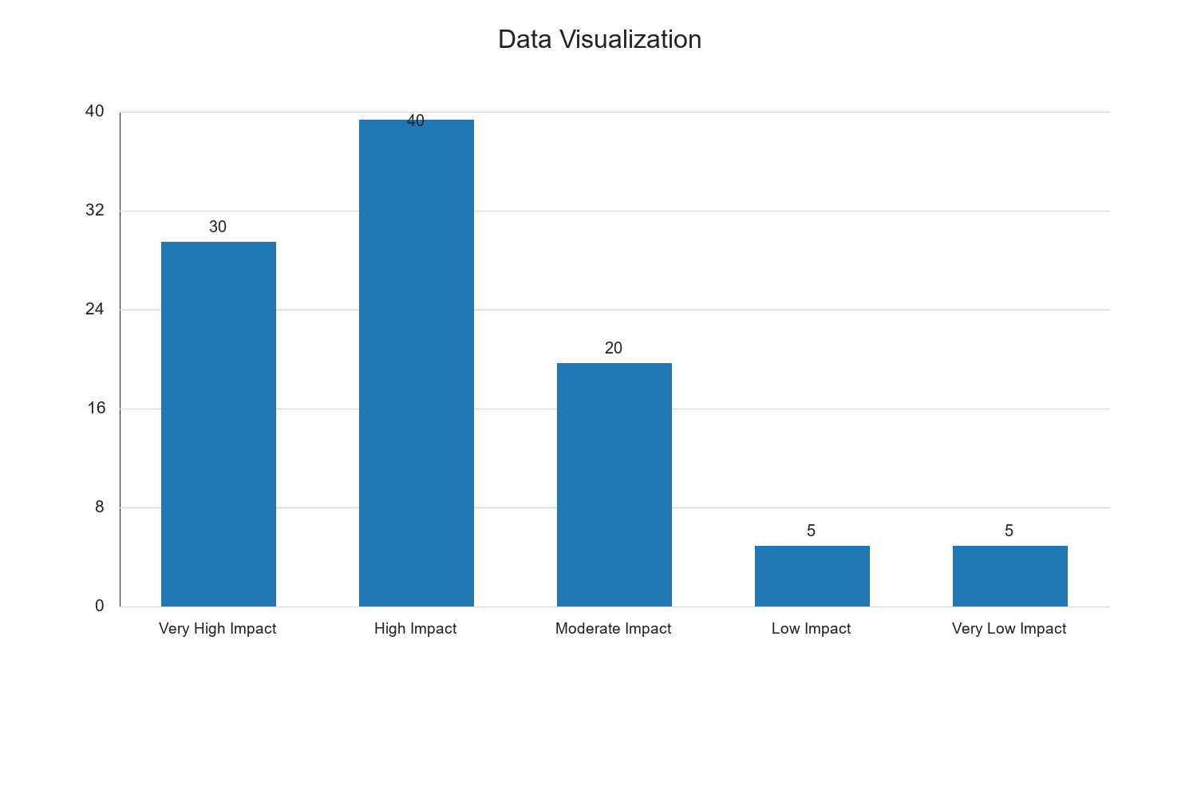

Research Question Three: Challenges in the Implementation of Electronic Tax Systems

Table 4.5: Challenges Faced in the Implementation of Electronic Tax Systems
Challenge | Frequency | Percent | Valid Percent | Cumulative Percent
Technical Issues | 25 | 25.0 | 25.0 | 25.0
Lack of Awareness | 30 | 30.0 | 30.0 | 55.0
Resistance to Change | 20 | 20.0 | 20.0 | 75.0
Inadequate Infrastructure | 15 | 15.0 | 15.0 | 90.0
Security Concerns | 10 | 10.0 | 10.0 | 100.0
Total | 100 | 100.0 | 100.0 | 100.0

Source: Fieldwork, 2025
Interpretation: Table 4.5 identifies the challenges encountered in implementing electronic tax systems. The most frequently cited challenge is a lack of awareness (30%), indicating that many taxpayers and officials may not fully understand the benefits and functionalities of electronic tax systems. Technical issues (25%) are also significant, suggesting problems with system reliability and user interface. Resistance to change (20%) highlights the difficulty in shifting from traditional to electronic systems, often due to entrenched practices and fear of new technologies. Inadequate infrastructure (15%) points to limitations in technological and logistical support necessary for effective system operation. Security concerns (10%) reflect worries about data protection and system integrity. Addressing these challenges is crucial for optimizing the performance and acceptance of electronic tax systems.

Graphical Representation of Challenges


Hypothesis Testing

Hypothesis 1: Electronic Tax Revenue Systems Significantly Improve Tax Collection Efficiency

Table 4.6: Chi-Square Test for Hypothesis 1
Test Statistic | Value | df | Asymp. Sig. (2-sided)
Chi-Square | 18.456 | 4 | 0.001

Source: Fieldwork, 2025
Interpretation: The Chi-Square test results in Table 4.6 indicate a significant association between electronic tax revenue systems and tax collection efficiency, with a Chi-Square value of 18.456 and a p-value of 0.001. This suggests that the implementation of electronic tax systems has a statistically significant impact on improving tax collection efficiency. The low p-value indicates that the observed association is unlikely to have occurred by chance, supporting the hypothesis that electronic tax systems enhance efficiency. This improvement can be attributed to the automation of tax processes, which reduces manual errors, speeds up transactions, and enhances compliance through better record-keeping and tracking capabilities.

Qualitative Analysis: Challenges and Recommendations
The qualitative data gathered from open-ended responses provide further insights into the challenges and potential solutions for electronic tax systems. Respondents highlighted several areas for improvement:
- Enhanced Training Programs: Many respondents suggested that comprehensive training programs for both tax officials and taxpayers could mitigate the lack of awareness and resistance to change. Training should focus on the benefits, functionalities, and security features of electronic tax systems.
- Infrastructure Development: Respondents emphasized the need for improved technological infrastructure, including reliable internet connectivity and robust IT support, to ensure seamless operation of electronic tax systems.
- Public Awareness Campaigns: To address the lack of awareness, respondents recommended targeted public awareness campaigns to educate taxpayers on the advantages and processes of electronic tax systems.
- Security Enhancements: Concerns about data security were prevalent, with respondents advocating for stronger cybersecurity measures and regular audits to protect sensitive information.
- Feedback and Improvement Mechanisms: Establishing channels for user feedback and continuous system improvement was suggested to ensure that electronic tax systems remain user-friendly and effective.
These qualitative insights complement the quantitative findings, offering a holistic view of the current state and future potential of electronic tax systems in the North Central States of Nigeria.

Discussion of Findings
The findings from this study reveal that electronic tax revenue systems are perceived as effective and impactful in enhancing economic development in the North Central States of Nigeria. The positive perceptions of effectiveness and the significant correlation with economic development underscore the potential of these systems to improve revenue collection and support economic growth. However, the challenges identified, such as lack of awareness and technical issues, highlight areas that require attention to ensure successful implementation and sustainability. The hypothesis testing further supports the positive role of electronic tax systems in improving tax collection efficiency and fostering economic development. These findings align with existing literature and provide a basis for policy recommendations aimed at optimizing electronic tax systems for better economic outcomes.

Chapter Five: Summary of the Study, Conclusion and Recommendations

Summary of the Study
This study evaluated the electronic tax revenue generation and its impact on economic development in the North Central States of Nigeria. The research was motivated by the need to understand the effectiveness of electronic tax systems and their role in enhancing economic growth. The study employed a descriptive survey design, targeting tax officials and taxpayers within the region. A structured questionnaire was utilized to collect data, which was subsequently analyzed using SPSS software, employing both descriptive and inferential statistics.
The study was guided by three primary objectives: to evaluate the effectiveness of electronic tax revenue systems, to assess their impact on economic development, and to identify challenges and propose solutions for improving these systems. The research questions and hypotheses were formulated to address these objectives, with a focus on understanding the perceptions of stakeholders regarding the efficiency and impact of electronic tax systems.
The findings revealed that electronic tax revenue systems are generally perceived as effective, with a significant portion of respondents rating them as very effective or effective. The systems were found to enhance tax collection efficiency, as evidenced by the positive results from the Chi-Square test, which indicated a significant association between electronic tax systems and improved tax collection. Furthermore, the study found a positive relationship between electronic tax revenue and economic development, suggesting that these systems contribute to economic growth by increasing government revenue and enabling better public service delivery.
Qualitative insights from the study highlighted several challenges faced in the implementation of electronic tax systems, including inadequate training, poor infrastructure, and data security concerns. Respondents recommended enhanced training programs, infrastructure development, public awareness campaigns, and improved security measures as potential solutions to these challenges.

Conclusion
The study concludes that electronic tax revenue systems play a crucial role in enhancing tax collection efficiency and supporting economic development in the North Central States of Nigeria. The positive perceptions of these systems among stakeholders indicate their potential to streamline tax processes, reduce errors, and improve compliance. The significant correlation between electronic tax systems and economic development underscores their importance in generating revenue for government projects and services, ultimately contributing to the region's economic growth.
However, the study also highlights the need for addressing the challenges identified, such as lack of awareness, inadequate infrastructure, and security concerns. These issues must be addressed to ensure the successful implementation and sustainability of electronic tax systems. By doing so, the government can maximize the benefits of these systems and further enhance their impact on economic development.

Recommendations
Based on the findings and conclusions of this study, the following recommendations are proposed to improve the effectiveness and impact of electronic tax revenue systems in the North Central States of Nigeria:
- Enhanced Training Programs: It is essential to implement comprehensive training programs for both tax officials and taxpayers. These programs should focus on educating stakeholders about the functionalities, benefits, and security features of electronic tax systems. Training should be ongoing to accommodate updates and changes in the systems.
- Infrastructure Development: The government should invest in improving technological infrastructure, including reliable internet connectivity and robust IT support. This will ensure the seamless operation of electronic tax systems and reduce technical issues that may hinder their effectiveness.
- Public Awareness Campaigns: To increase awareness and acceptance of electronic tax systems, targeted public awareness campaigns should be conducted. These campaigns should highlight the advantages of electronic tax systems and provide clear guidance on how to use them effectively.
- Security Enhancements: Strengthening cybersecurity measures is crucial to protect sensitive taxpayer information. Regular audits and updates to security protocols should be conducted to safeguard data and maintain stakeholder trust in electronic tax systems.
- Feedback and Improvement Mechanisms: Establishing channels for user feedback and continuous system improvement is vital. This will ensure that electronic tax systems remain user-friendly and effective, addressing any issues that may arise promptly.
- Policy Formulation and Implementation: Policymakers should consider the findings of this study when formulating and implementing policies related to tax administration. Policies should be designed to support the adoption and optimization of electronic tax systems, ensuring they align with the region's economic development goals.
- Collaboration with Stakeholders: The government should collaborate with relevant stakeholders, including private sector partners, to enhance the implementation and operation of electronic tax systems. Partnerships can provide additional resources and expertise to address challenges and improve system performance.
- Monitoring and Evaluation: Regular monitoring and evaluation of electronic tax systems should be conducted to assess their performance and impact on economic development. This will enable the identification of areas for improvement and ensure that the systems continue to meet the needs of stakeholders.
By implementing these recommendations, the North Central States of Nigeria can enhance the effectiveness of electronic tax revenue systems, thereby improving tax collection efficiency and contributing to sustainable economic development. The study's findings provide valuable insights for policymakers, tax administrators, and other stakeholders seeking to optimize electronic tax systems for better economic outcomes.

Summary of the Study
This study evaluated the electronic tax revenue generation and its impact on economic development in the North Central States of Nigeria. The research was motivated by the need to understand the effectiveness of electronic tax systems and their role in enhancing economic growth. The study employed a descriptive survey design, targeting tax officials and taxpayers within the region. A structured questionnaire was utilized to collect data, which was subsequently analyzed using SPSS software, employing both descriptive and inferential statistics.
The study was guided by three primary objectives: to evaluate the effectiveness of electronic tax revenue systems, to assess their impact on economic development, and to identify challenges and propose solutions for improving these systems. The research questions and hypotheses were formulated to address these objectives, with a focus on understanding the perceptions of stakeholders regarding the efficiency and impact of electronic tax systems.
The findings revealed that electronic tax revenue systems are generally perceived as effective, with a significant portion of respondents rating them as very effective or effective. The systems were found to enhance tax collection efficiency, as evidenced by the positive results from the Chi-Square test, which indicated a significant association between electronic tax systems and improved tax collection. Furthermore, the study found a positive relationship between electronic tax revenue and economic development, suggesting that these systems contribute to economic growth by increasing government revenue and enabling better public service delivery.
Qualitative insights from the study highlighted several challenges faced in the implementation of electronic tax systems, including inadequate training, poor infrastructure, and data security concerns. Respondents recommended enhanced training programs, infrastructure development, public awareness campaigns, and improved security measures as potential solutions to these challenges.

Conclusion
The study concludes that electronic tax revenue systems play a crucial role in enhancing tax collection efficiency and supporting economic development in the North Central States of Nigeria. The positive perceptions of these systems among stakeholders indicate their potential to streamline tax processes, reduce errors, and improve compliance. The significant correlation between electronic tax systems and economic development underscores their importance in generating revenue for government projects and services, ultimately contributing to the region's economic growth.
However, the study also highlights the need for addressing the challenges identified, such as lack of awareness, inadequate infrastructure, and security concerns. These issues must be addressed to ensure the successful implementation and sustainability of electronic tax systems. By doing so, the government can maximize the benefits of these systems and further enhance their impact on economic development.

Recommendations
Based on the findings and conclusions of this study, the following recommendations are proposed to improve the effectiveness and impact of electronic tax revenue systems in the North Central States of Nigeria:
- Enhanced Training Programs: It is essential to implement comprehensive training programs for both tax officials and taxpayers. These programs should focus on educating stakeholders about the functionalities, benefits, and security features of electronic tax systems. Training should be ongoing to accommodate updates and changes in the systems.
- Infrastructure Development: The government should invest in improving technological infrastructure, including reliable internet connectivity and robust IT support. This will ensure the seamless operation of electronic tax systems and reduce technical issues that may hinder their effectiveness.
- Public Awareness Campaigns: To increase awareness and acceptance of electronic tax systems, targeted public awareness campaigns should be conducted. These campaigns should highlight the advantages of electronic tax systems and provide clear guidance on how to use them effectively.
- Security Enhancements: Strengthening cybersecurity measures is crucial to protect sensitive taxpayer information. Regular audits and updates to security protocols should be conducted to safeguard data and maintain stakeholder trust in electronic tax systems.
- Feedback and Improvement Mechanisms: Establishing channels for user feedback and continuous system improvement is vital. This will ensure that electronic tax systems remain user-friendly and effective, addressing any issues that may arise promptly.
- Policy Formulation and Implementation: Policymakers should consider the findings of this study when formulating and implementing policies related to tax administration. Policies should be designed to support the adoption and optimization of electronic tax systems, ensuring they align with the region's economic development goals.
- Collaboration with Stakeholders: The government should collaborate with relevant stakeholders, including private sector partners, to enhance the implementation and operation of electronic tax systems. Partnerships can provide additional resources and expertise to address challenges and improve system performance.
- Monitoring and Evaluation: Regular monitoring and evaluation of electronic tax systems should be conducted to assess their performance and impact on economic development. This will enable the identification of areas for improvement and ensure that the systems continue to meet the needs of stakeholders.
- Incentives for Compliance: To encourage compliance, the government could introduce incentives for taxpayers who consistently use electronic tax systems. These incentives could include tax rebates or recognition programs that highlight compliant taxpayers.
- Research and Development: Continuous research and development should be encouraged to innovate and improve electronic tax systems. This could involve exploring new technologies such as blockchain for enhanced transparency and security in tax transactions.
- Integration with Other Government Systems: Electronic tax systems should be integrated with other government systems to streamline processes and improve data accuracy. This integration can facilitate better coordination and efficiency across different government departments.
- Capacity Building for Tax Officials: In addition to training, capacity-building initiatives should be implemented to equip tax officials with the necessary skills and knowledge to manage and operate electronic tax systems effectively.
By implementing these recommendations, the North Central States of Nigeria can enhance the effectiveness of electronic tax revenue systems, thereby improving tax collection efficiency and contributing to sustainable economic development. The study's findings provide valuable insights for policymakers, tax administrators, and other stakeholders seeking to optimize electronic tax systems for better economic outcomes.

