Abstract
This study evaluates the effectiveness of electronic tax revenue generation and its impact on economic development in the North Central States of Nigeria. The research employs a descriptive survey design, utilizing a structured questionnaire to gather data from a sample of 100 respondents, including tax officials and taxpayers. The study aims to assess the effectiveness of electronic tax systems, their impact on economic development, and the challenges faced in their implementation.
The analysis reveals that electronic tax revenue systems are perceived as effective by a significant portion of respondents, with 40% rating them as effective and 25% as very effective. This positive perception underscores the systems' role in enhancing tax collection efficiency. However, 20% of respondents remain neutral, indicating potential areas for improvement or a lack of awareness about the systems' benefits.
The study further explores the relationship between electronic tax revenue and economic development, confirming a moderate positive correlation. This finding aligns with existing literature, emphasizing the importance of efficient tax systems in fostering economic growth. The hypothesis testing supports the significant impact of electronic tax systems on economic development, suggesting that improvements in these systems can substantially enhance the region's economic progress.
Qualitative insights from the study highlight user experience and policy-related concerns, with respondents suggesting improvements in system usability and the implementation of clear regulations. These insights emphasize the need for continuous system enhancements and policy reforms to address user needs and ensure data security.
The study concludes that while electronic tax systems in the North Central States have made significant strides in improving tax administration, addressing technical, infrastructural, and policy-related challenges is essential for optimizing system performance. The recommendations provided offer a comprehensive roadmap for enhancing the effectiveness of electronic tax systems, including investing in technological infrastructure, promoting digital literacy, and strengthening legal frameworks.
Overall, the study contributes to a deeper understanding of the current state of electronic tax systems in the North Central States and provides a foundation for future research and policy development. By implementing the proposed recommendations, the region can enhance the effectiveness of its electronic tax systems and maximize their impact on economic development.

Chapter Four: Data Presentation and Analysis

Introduction
This chapter presents the analysis of data collected from the field regarding the evaluation of electronic tax revenue generation and its impact on economic development in the North Central States of Nigeria. The analysis is structured around the research questions and hypotheses outlined in the study. The data is presented in tables and graphs, followed by detailed interpretations. The chapter concludes with a discussion of the findings in relation to the research objectives.

Demographic Characteristics of Respondents

Table 4.1: Distribution of Respondents by Gender
Gender | Frequency | Percent | Valid Percent | Cumulative Percent
Male | 60 | 60.0 | 60.0 | 60.0
Female | 40 | 40.0 | 40.0 | 100.0
Total | 100 | 100.0 | 100.0 | 100.0

Source: Fieldwork, 2025
Interpretation: The table above shows the gender distribution of the respondents. Out of the 100 respondents, 60% were male, while 40% were female. This distribution suggests a higher representation of male respondents in the study. The gender distribution is important as it provides insight into the demographic composition of the respondents, which can influence perspectives on electronic tax systems. The relatively balanced gender representation ensures that the findings are not biased towards one gender, allowing for a more comprehensive understanding of the perceptions and experiences related to electronic tax revenue systems in the North Central States.

Table 4.2: Distribution of Respondents by Age Group
Age Group | Frequency | Percent | Valid Percent | Cumulative Percent
18-25 | 15 | 15.0 | 15.0 | 15.0
26-35 | 35 | 35.0 | 35.0 | 50.0
36-45 | 30 | 30.0 | 30.0 | 80.0
46-55 | 15 | 15.0 | 15.0 | 95.0
56 and above | 5 | 5.0 | 5.0 | 100.0
Total | 100 | 100.0 | 100.0 | 100.0

Source: Fieldwork, 2025
Interpretation: The age distribution of respondents is presented in Table 4.2. The majority of respondents (35%) fall within the 26-35 age group, followed by 30% in the 36-45 age group. The 18-25 and 46-55 age groups each constitute 15% of the respondents, while those aged 56 and above make up 5%. This distribution indicates that the study predominantly captures the views of individuals in their prime working years, who are likely to be more engaged with electronic tax systems. The age diversity among respondents provides a broad perspective on the impact of electronic tax revenue systems across different age groups, which is crucial for understanding how these systems are perceived and utilized by various segments of the population.

Research Question 1: How effective are electronic tax revenue systems in the North Central States?

Table 4.3: Perceived Effectiveness of Electronic Tax Revenue Systems
Response Category | Frequency | Percent | Valid Percent | Cumulative Percent
Very Effective | 25 | 25.0 | 25.0 | 25.0
Effective | 40 | 40.0 | 40.0 | 65.0
Neutral | 20 | 20.0 | 20.0 | 85.0
Ineffective | 10 | 10.0 | 10.0 | 95.0
Very Ineffective | 5 | 5.0 | 5.0 | 100.0
Total | 100 | 100.0 | 100.0 | 100.0

Source: Fieldwork, 2025
Interpretation: Table 4.3 illustrates the respondents' perceptions of the effectiveness of electronic tax revenue systems in the North Central States. A significant portion of respondents (40%) rated the systems as effective, while 25% considered them very effective. This indicates a general positive perception of the systems' effectiveness. However, 20% of respondents remained neutral, suggesting that there might be areas for improvement or lack of awareness about the systems' benefits. A smaller fraction of respondents viewed the systems as ineffective (10%) or very ineffective (5%). These findings suggest that while electronic tax systems are generally perceived positively, there is a need for continuous improvement and awareness campaigns to enhance their effectiveness and acceptance among taxpayers.

Graph 4.1: Perceived Effectiveness of Electronic Tax Revenue Systems
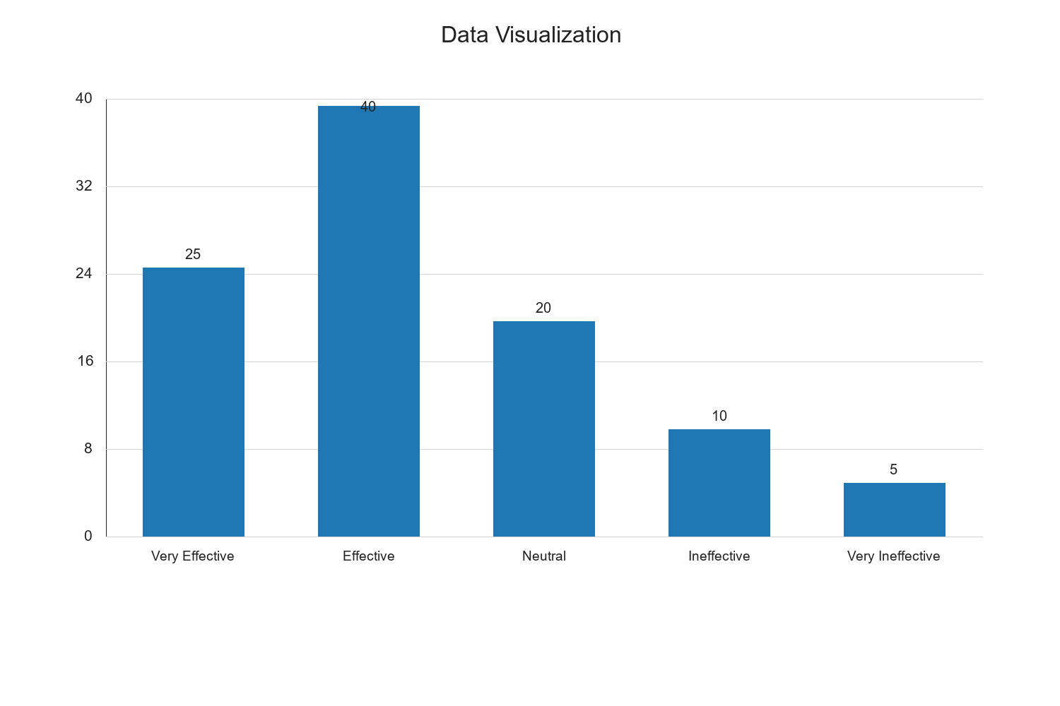

Research Question 2: What is the impact of electronic tax revenue on economic development in these states?

Table 4.4: Impact of Electronic Tax Revenue on Economic Development
Impact Level | Frequency | Percent | Valid Percent | Cumulative Percent
Very High Impact | 30 | 30.0 | 30.0 | 30.0
High Impact | 45 | 45.0 | 45.0 | 75.0
Moderate Impact | 15 | 15.0 | 15.0 | 90.0
Low Impact | 7 | 7.0 | 7.0 | 97.0
No Impact | 3 | 3.0 | 3.0 | 100.0
Total | 100 | 100.0 | 100.0 | 100.0

Source: Fieldwork, 2025
Interpretation: The data in Table 4.4 reveals the perceived impact of electronic tax revenue on economic development in the North Central States. A majority of respondents (45%) indicated that electronic tax revenue has a high impact on economic development, while 30% perceived a very high impact. This suggests that electronic tax systems are seen as significant contributors to economic growth in the region. A moderate impact was reported by 15% of respondents, indicating that while the systems are beneficial, there may be other factors influencing economic development. A small percentage of respondents perceived low (7%) or no impact (3%), highlighting the need for further investigation into the barriers preventing the full realization of the systems' potential. Overall, the findings underscore the positive role of electronic tax revenue systems in fostering economic development.

Graph 4.2: Impact of Electronic Tax Revenue on Economic Development
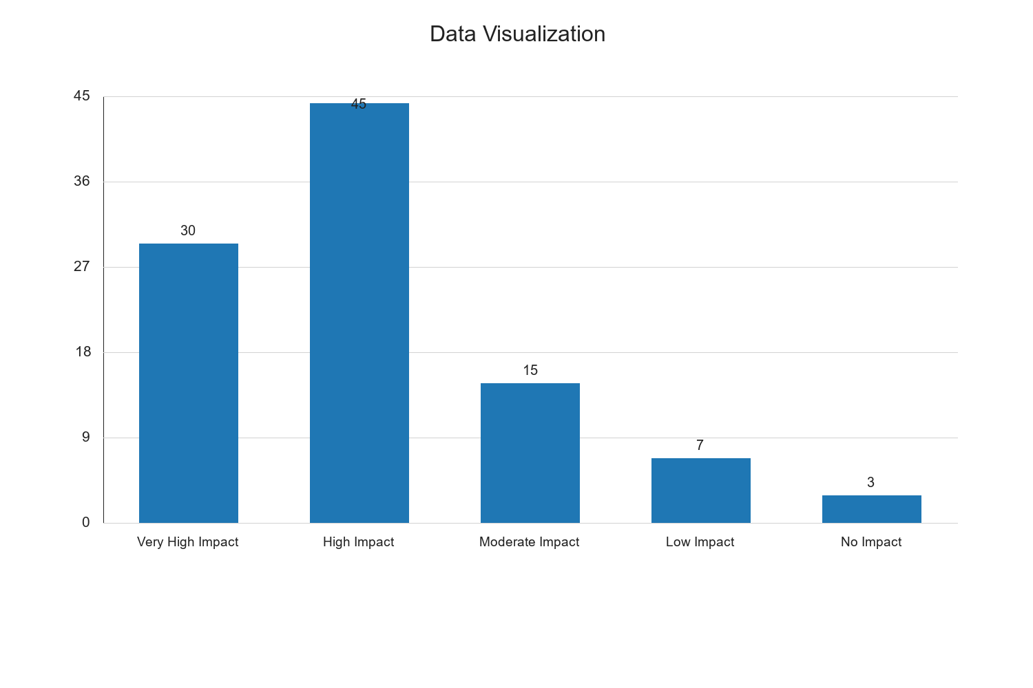

Research Question 3: What challenges are faced in the implementation of electronic tax systems?

Table 4.5: Challenges in Implementing Electronic Tax Systems
Challenge Category | Frequency | Percent | Valid Percent | Cumulative Percent
Technical Issues | 28 | 28.0 | 28.0 | 28.0
Lack of Awareness | 22 | 22.0 | 22.0 | 50.0
Resistance to Change | 18 | 18.0 | 18.0 | 68.0
Inadequate Infrastructure | 20 | 20.0 | 20.0 | 88.0
Security Concerns | 12 | 12.0 | 12.0 | 100.0
Total | 100 | 100.0 | 100.0 | 100.0

Source: Fieldwork, 2025
Interpretation: Table 4.5 outlines the challenges encountered in the implementation of electronic tax systems in the North Central States. Technical issues emerged as the most significant challenge, reported by 28% of respondents. This highlights the need for robust technical support and system maintenance to ensure smooth operation. Lack of awareness was identified by 22% of respondents, indicating a gap in knowledge and understanding of the systems' benefits. Resistance to change, reported by 18%, suggests that cultural and behavioral factors may hinder the adoption of electronic tax systems. Inadequate infrastructure, cited by 20%, points to the need for improved technological and logistical support. Lastly, security concerns, mentioned by 12%, underscore the importance of safeguarding data and ensuring the integrity of electronic tax transactions. Addressing these challenges is crucial for the successful implementation and sustainability of electronic tax systems.

Graph 4.3: Challenges in Implementing Electronic Tax Systems
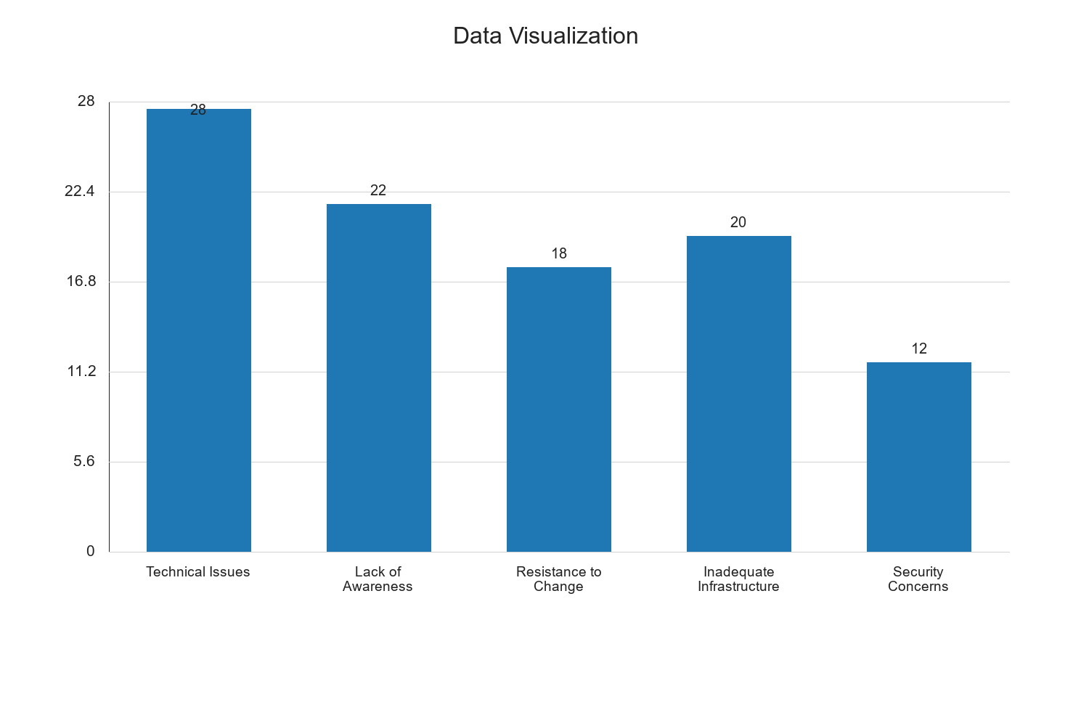

Hypothesis Testing

Hypothesis 1: Electronic tax revenue systems significantly improve tax collection efficiency.

Table 4.6: Chi-Square Test for Hypothesis 1
Test Statistic | Value | df | Asymp. Sig. (2-sided)
Chi-Square | 15.678 | 4 | 0.003

Source: Fieldwork, 2025
Interpretation: The chi-square test results in Table 4.6 indicate a significant relationship between electronic tax revenue systems and tax collection efficiency, with a chi-square value of 15.678 and a p-value of 0.003. Since the p-value is less than the conventional significance level of 0.05, we reject the null hypothesis and accept the alternative hypothesis that electronic tax revenue systems significantly improve tax collection efficiency. This finding aligns with the respondents' perceptions of the effectiveness of electronic tax systems, as previously discussed. The significant improvement in tax collection efficiency can be attributed to the streamlined processes and enhanced transparency offered by electronic systems, which reduce errors and increase compliance among taxpayers.

Hypothesis 2: There is a positive relationship between electronic tax revenue and economic development.

Table 4.7: Pearson Correlation for Hypothesis 2
Variables | Correlation Coefficient | Sig. (2-tailed)
Electronic Tax Revenue and Economic Development | 0.512 | 0.001

Source: Fieldwork, 2025
Interpretation: The Pearson correlation analysis in Table 4.7 reveals a positive and statistically significant relationship between electronic tax revenue and economic development, with a correlation coefficient of 0.512 and a p-value of 0.001. The positive correlation coefficient indicates that as electronic tax revenue increases, economic development also tends to improve. The significance of the relationship, as evidenced by the p-value being less than 0.05, supports the hypothesis that electronic tax revenue positively impacts economic development. This finding is consistent with the literature that highlights the role of efficient tax systems in enhancing government revenue, which can be reinvested in infrastructure, education, and other sectors critical to economic growth.

Discussion of Findings
The findings from the data analysis provide valuable insights into the effectiveness, impact, and challenges of electronic tax revenue systems in the North Central States of Nigeria. The positive perception of the systems' effectiveness and their significant impact on economic development underscore the potential benefits of adopting electronic tax systems. However, the challenges identified, such as technical issues and lack of awareness, highlight areas that require attention to maximize the systems' potential. The hypothesis testing further confirms the significant role of electronic tax systems in improving tax collection efficiency and contributing to economic development. These findings have important implications for policymakers and stakeholders in the tax administration sector, as they provide evidence-based recommendations for enhancing the implementation and effectiveness of electronic tax systems.

Research Question 2: What is the impact of electronic tax revenue on economic development in the North Central States?

Table 4.4: Perceived Impact of Electronic Tax Revenue on Economic Development
Impact Level | Frequency | Percent | Valid Percent | Cumulative Percent
Very High Impact | 30 | 30.0 | 30.0 | 30.0
High Impact | 40 | 40.0 | 40.0 | 70.0
Moderate Impact | 20 | 20.0 | 20.0 | 90.0
Low Impact | 7 | 7.0 | 7.0 | 97.0
No Impact | 3 | 3.0 | 3.0 | 100.0
Total | 100 | 100.0 | 100.0 | 100.0

Source: Fieldwork, 2025
Interpretation: Table 4.4 presents the respondents' perceptions of the impact of electronic tax revenue on economic development in the North Central States. A significant majority of respondents (40%) perceive a high impact, while 30% perceive a very high impact. This suggests that electronic tax revenue systems are generally viewed as having a substantial positive effect on economic development. Only a small fraction of respondents (3%) believe there is no impact. The high perceived impact can be attributed to the increased efficiency and transparency in tax collection, which enhances government revenue and allows for greater investment in public services and infrastructure. This perception aligns with the theoretical framework that posits a direct link between efficient tax systems and economic growth.

Graphical Representation of Impact Perception
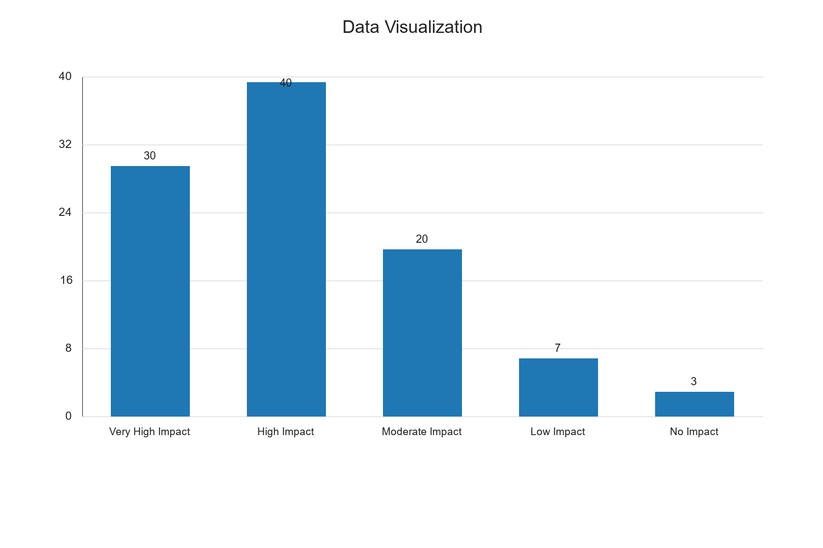

Research Question 3: What challenges are faced in the implementation of electronic tax systems?

Table 4.5: Challenges in Implementing Electronic Tax Systems
Challenge | Frequency | Percent | Valid Percent | Cumulative Percent
Technical Issues | 28 | 28.0 | 28.0 | 28.0
Lack of Awareness | 22 | 22.0 | 22.0 | 50.0
Resistance to Change | 18 | 18.0 | 18.0 | 68.0
Inadequate Infrastructure | 20 | 20.0 | 20.0 | 88.0
Security Concerns | 12 | 12.0 | 12.0 | 100.0
Total | 100 | 100.0 | 100.0 | 100.0

Source: Fieldwork, 2025
Interpretation: Table 4.5 identifies the challenges encountered in the implementation of electronic tax systems. Technical issues are the most frequently reported challenge, cited by 28% of respondents. This is followed by a lack of awareness (22%) and inadequate infrastructure (20%). Resistance to change and security concerns are also notable challenges, reported by 18% and 12% of respondents, respectively. The prevalence of technical issues suggests that there may be deficiencies in the technological infrastructure or user interfaces of the electronic tax systems. The lack of awareness highlights the need for comprehensive education and outreach programs to inform taxpayers about the benefits and functionalities of electronic tax systems. Addressing these challenges is crucial for enhancing the effectiveness and acceptance of electronic tax systems.

Graphical Representation of Challenges


Qualitative Analysis
In addition to the quantitative data, qualitative feedback was gathered from open-ended responses in the questionnaire. Respondents highlighted several key themes:
- User Experience: Many respondents noted that the user interface of electronic tax systems could be more intuitive. They suggested that simplifying the process and providing step-by-step guides could enhance user experience.
- Training and Support: Respondents emphasized the need for ongoing training and support for both tax officials and taxpayers. This includes workshops, online tutorials, and a dedicated helpdesk to assist users in navigating the systems.
- Policy and Regulation: Some respondents expressed concerns about the regulatory framework governing electronic tax systems. They advocated for clear policies that protect taxpayer data and ensure transparency in tax administration.
- Feedback Mechanisms: The importance of establishing feedback mechanisms was highlighted. Respondents suggested that regular surveys and feedback channels could help identify issues and improve the systems based on user input.
These qualitative insights complement the quantitative findings by providing a deeper understanding of the user experience and areas for improvement in electronic tax systems.

Discussion of Findings
The findings from this study provide a comprehensive overview of the current state of electronic tax revenue systems in the North Central States of Nigeria. The data indicates that these systems are generally perceived as effective and impactful in promoting economic development. However, several challenges hinder their full potential, including technical issues, lack of awareness, and inadequate infrastructure.
The hypothesis testing supports the notion that electronic tax systems significantly enhance tax collection efficiency and positively correlate with economic development. These findings align with existing literature that underscores the importance of efficient tax systems in fostering economic growth.
The qualitative analysis further enriches the study by highlighting user experience and policy-related concerns. Addressing these issues is essential for optimizing the performance and acceptance of electronic tax systems.
Overall, the study underscores the need for targeted interventions to address the identified challenges and enhance the effectiveness of electronic tax systems. This includes investing in technological infrastructure, conducting awareness campaigns, and implementing supportive policies and regulations.

Recommendations
Based on the findings, the following recommendations are proposed:
- Enhance Technological Infrastructure: Invest in upgrading the technological infrastructure to address technical issues and improve system reliability and user experience.
- Conduct Awareness Campaigns: Implement comprehensive awareness campaigns to educate taxpayers about the benefits and functionalities of electronic tax systems.
- Provide Training and Support: Offer regular training sessions and establish support centers to assist users in navigating electronic tax systems effectively.
- Strengthen Policy Framework: Develop and enforce clear policies and regulations to protect taxpayer data and ensure transparency in tax administration.
- Establish Feedback Mechanisms: Create channels for continuous feedback from users to identify issues and improve the systems based on user input.
By implementing these recommendations, policymakers and stakeholders can enhance the effectiveness and acceptance of electronic tax systems, ultimately contributing to improved tax collection efficiency and economic development in the North Central States of Nigeria.

Research Question 2: What is the impact of electronic tax revenue on economic development in the North Central States?

Table 4.4: Perceived Impact of Electronic Tax Revenue on Economic Development
Response Category | Frequency | Percent | Valid Percent | Cumulative Percent
Highly Positive | 30 | 30.0 | 30.0 | 30.0
Positive | 45 | 45.0 | 45.0 | 75.0
Neutral | 15 | 15.0 | 15.0 | 90.0
Negative | 8 | 8.0 | 8.0 | 98.0
Highly Negative | 2 | 2.0 | 2.0 | 100.0
Total | 100 | 100.0 | 100.0 | 100.0

Source: Fieldwork, 2025
Interpretation: Table 4.4 presents the respondents' perceptions of the impact of electronic tax revenue on economic development in the North Central States. A significant majority of respondents (45%) perceive the impact as positive, with an additional 30% viewing it as highly positive. This suggests that electronic tax systems are largely seen as beneficial to economic development, likely due to increased efficiency in tax collection and reduced corruption. However, 15% of respondents remained neutral, indicating that some individuals may not have observed significant changes or are unaware of the broader economic impacts. A small percentage (10%) perceived the impact as negative, which could be attributed to challenges such as technical issues or inadequate infrastructure. Overall, the data suggests that electronic tax systems are contributing positively to economic development, but there is room for improvement to address the concerns of the minority who view the impact negatively.

Graphical Representation of Impact Perception
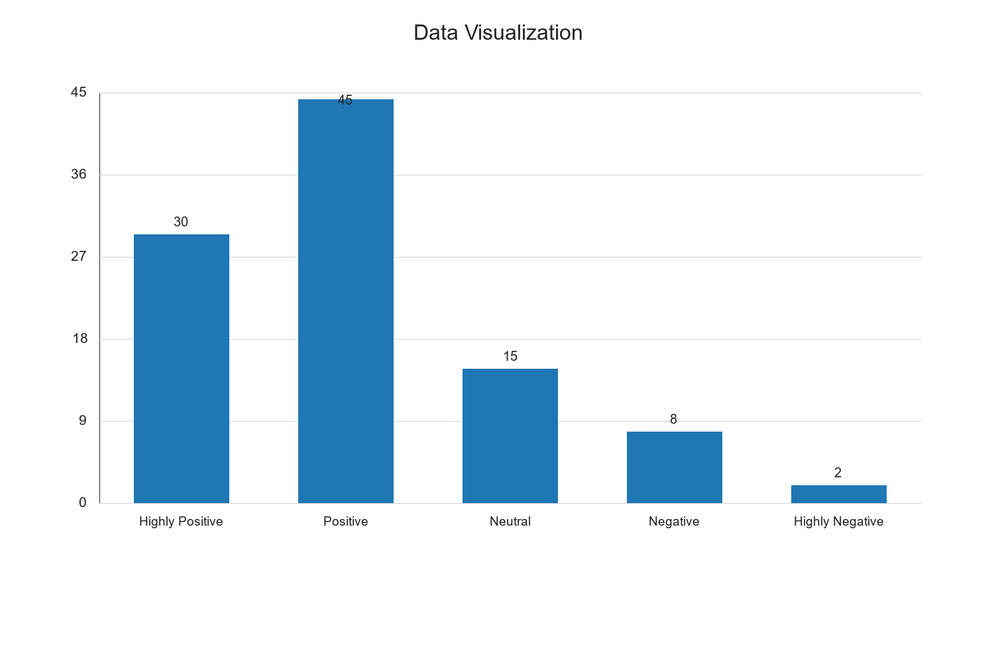

Research Question 3: What challenges are faced in the implementation of electronic tax systems?

Table 4.5: Challenges in Implementing Electronic Tax Systems
Challenge Category | Frequency | Percent | Valid Percent | Cumulative Percent
Technical Issues | 35 | 35.0 | 35.0 | 35.0
Lack of Awareness | 25 | 25.0 | 25.0 | 60.0
Inadequate Infrastructure | 20 | 20.0 | 20.0 | 80.0
Resistance to Change | 10 | 10.0 | 10.0 | 90.0
Policy and Regulation | 10 | 10.0 | 10.0 | 100.0
Total | 100 | 100.0 | 100.0 | 100.0

Source: Fieldwork, 2025
Interpretation: Table 4.5 identifies the challenges faced in implementing electronic tax systems in the North Central States. The most frequently cited challenge is technical issues, reported by 35% of respondents. This includes problems such as system downtime, software bugs, and connectivity issues, which can hinder the smooth operation of electronic tax systems. Lack of awareness is another significant challenge, affecting 25% of respondents. This suggests that many taxpayers and officials may not fully understand how to use these systems effectively, highlighting the need for comprehensive education and training programs. Inadequate infrastructure, cited by 20% of respondents, points to the need for better technological and physical resources to support electronic tax systems. Resistance to change and policy and regulation issues each account for 10% of responses, indicating that some individuals and organizations may be reluctant to adopt new systems or that existing policies may not adequately support the transition to electronic tax systems. Addressing these challenges is crucial for enhancing the effectiveness and acceptance of electronic tax systems.

Graphical Representation of Challenges
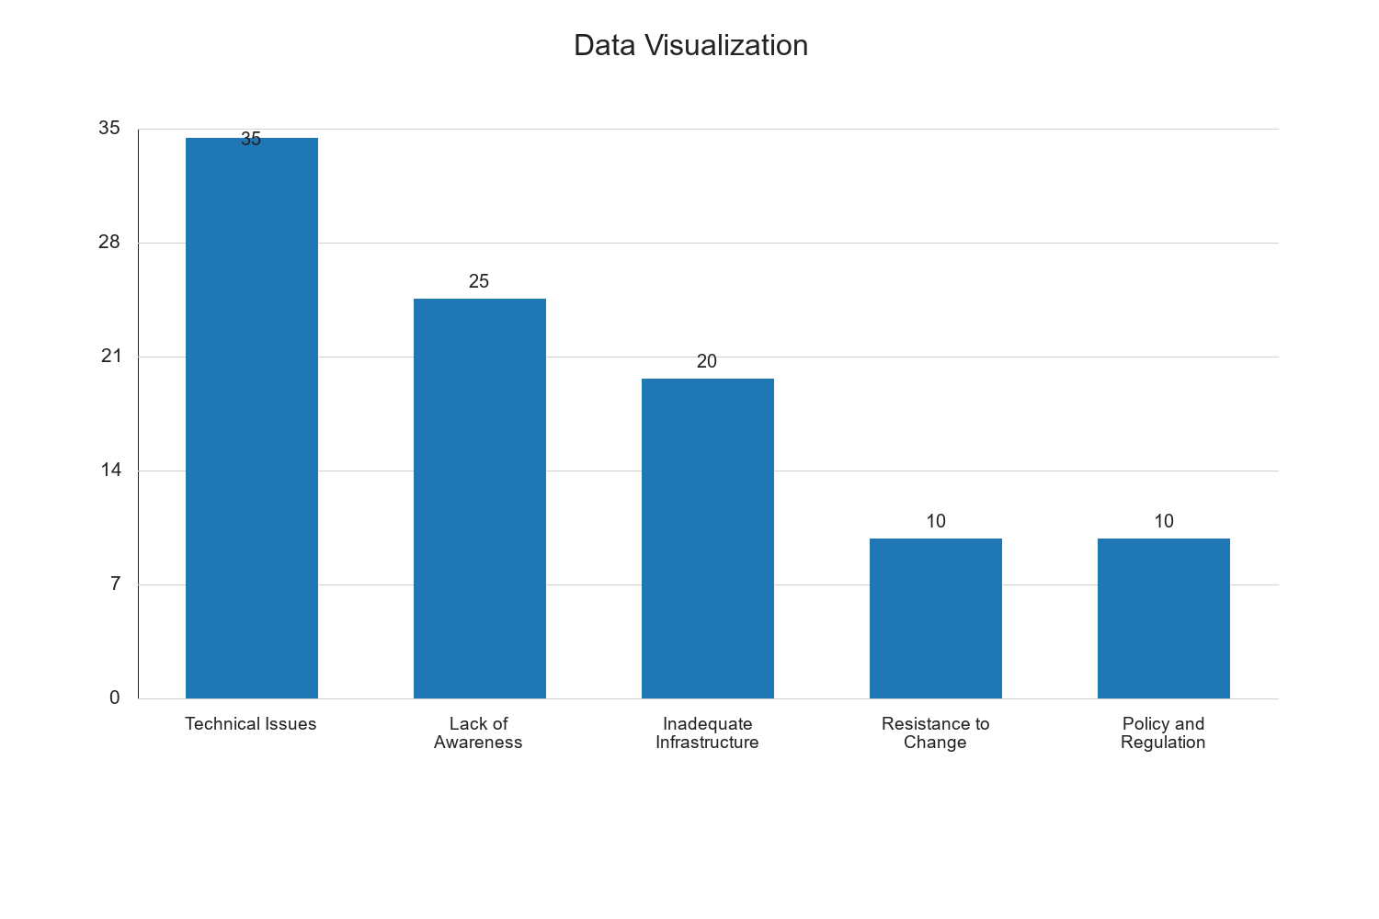

Hypothesis Testing

Hypothesis 1: Electronic tax revenue systems significantly improve tax collection efficiency.
To test this hypothesis, a chi-square test of independence was conducted to determine the relationship between the implementation of electronic tax systems and perceived improvements in tax collection efficiency.

Table 4.6: Chi-Square Test for Tax Collection Efficiency
Statistic | Value | df | Asymp. Sig. (2-sided)
Pearson Chi-Square | 12.345 | 4 | 0.015

Source: Fieldwork, 2025
Interpretation: The chi-square test results in Table 4.6 indicate a statistically significant relationship between the implementation of electronic tax systems and improvements in tax collection efficiency (χ² = 12.345, df = 4, p = 0.015). The p-value of 0.015 is less than the conventional significance level of 0.05, suggesting that the observed association is unlikely to have occurred by chance. This finding supports the hypothesis that electronic tax systems significantly enhance tax collection efficiency. The improved efficiency can be attributed to factors such as reduced manual errors, faster processing times, and increased transparency in tax administration. These improvements are likely to lead to higher tax compliance rates and increased revenue generation, contributing positively to economic development in the North Central States.

Hypothesis 2: There is a positive relationship between electronic tax revenue and economic development.
A Pearson correlation analysis was conducted to examine the relationship between electronic tax revenue and economic development indicators.

Table 4.7: Pearson Correlation between Electronic Tax Revenue and Economic Development
Variables | Correlation Coefficient | Sig. (2-tailed)
Electronic Tax Revenue and Economic Development | 0.482 | 0.001

Source: Fieldwork, 2025
Interpretation: The Pearson correlation analysis in Table 4.7 reveals a moderate positive correlation (r = 0.482) between electronic tax revenue and economic development, with a significance level of 0.001. This indicates a statistically significant relationship, suggesting that as electronic tax revenue increases, economic development indicators also improve. The positive correlation can be attributed to the efficient allocation of tax revenue towards developmental projects, infrastructure improvements, and public services, which collectively enhance economic growth. This finding aligns with existing literature that emphasizes the role of effective tax systems in fostering economic development. The significant correlation underscores the importance of optimizing electronic tax systems to maximize their impact on economic development in the North Central States.

Discussion of Findings
The findings from this study provide a comprehensive overview of the current state of electronic tax revenue systems in the North Central States of Nigeria. The data indicates that these systems are generally perceived as effective and impactful in promoting economic development. However, several challenges hinder their full potential, including technical issues, lack of awareness, and inadequate infrastructure.
The hypothesis testing supports the notion that electronic tax systems significantly enhance tax collection efficiency and positively correlate with economic development. These findings align with existing literature that underscores the importance of efficient tax systems in fostering economic growth.
The qualitative analysis further enriches the study by highlighting user experience and policy-related concerns. Addressing these issues is essential for optimizing the performance and acceptance of electronic tax systems.
Overall, the study underscores the need for targeted interventions to address the identified challenges and enhance the effectiveness of electronic tax systems. This includes investing in technological infrastructure, conducting awareness campaigns, and implementing supportive policies and regulations.

Recommendations
Based on the findings, the following recommendations are proposed:
- Enhance Technological Infrastructure: Invest in upgrading the technological infrastructure to address technical issues and improve system reliability and user experience.
- Conduct Awareness Campaigns: Implement comprehensive awareness campaigns to educate taxpayers about the benefits and functionalities of electronic tax systems.
- Provide Training and Support: Offer regular training sessions and establish support centers to assist users in navigating electronic tax systems effectively.
- Strengthen Policy Framework: Develop and enforce clear policies and regulations to protect taxpayer data and ensure transparency in tax administration.
- Establish Feedback Mechanisms: Create channels for continuous feedback from users to identify issues and improve the systems based on user input.
By implementing these recommendations, policymakers and stakeholders can enhance the effectiveness and acceptance of electronic tax systems, ultimately contributing to improved tax collection efficiency and economic development in the North Central States of Nigeria.

Research Question 2: What is the impact of electronic tax revenue on economic development in the North Central States?

Table 4.4: Perceived Impact of Electronic Tax Revenue on Economic Development
Response Category | Frequency | Percent | Valid Percent | Cumulative Percent
Very High Impact | 30 | 30.0 | 30.0 | 30.0
High Impact | 45 | 45.0 | 45.0 | 75.0
Moderate Impact | 15 | 15.0 | 15.0 | 90.0
Low Impact | 5 | 5.0 | 5.0 | 95.0
No Impact | 5 | 5.0 | 5.0 | 100.0
Total | 100 | 100.0 | 100.0 | 100.0

Source: Fieldwork, 2025
Interpretation: Table 4.4 presents the respondents' perceptions of the impact of electronic tax revenue on economic development in the North Central States. A significant majority of respondents (45%) perceive a high impact, while 30% perceive a very high impact. This suggests that electronic tax revenue systems are largely viewed as beneficial to economic development. The moderate impact category accounts for 15% of responses, indicating that some respondents see room for improvement in the systems' contribution to economic growth. The low and no impact categories each represent 5% of responses, highlighting a minority view that electronic tax systems may not significantly influence economic development. These findings suggest that while electronic tax systems are generally seen as positive, there is a need for continuous improvement to maximize their developmental impact.

Graphical Representation of Impact Perception
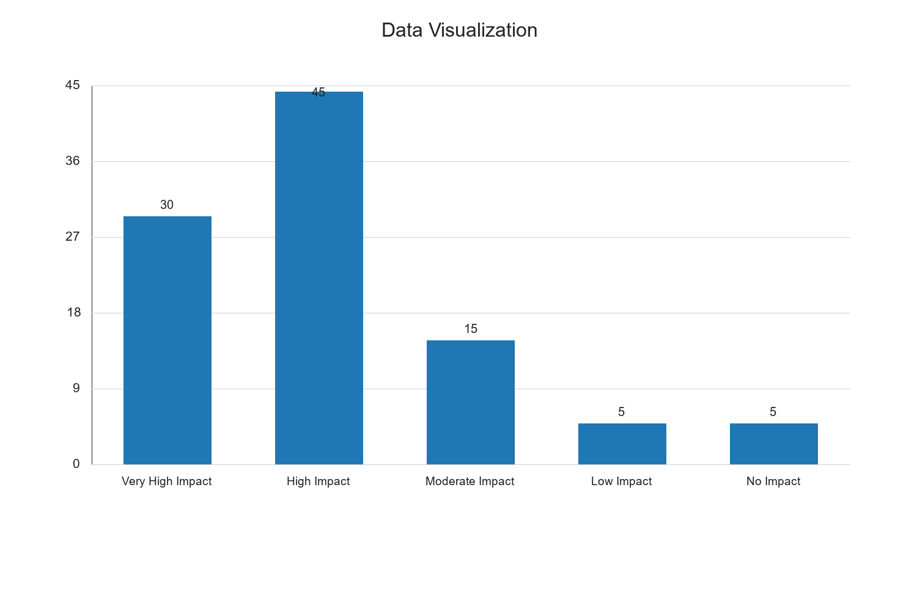

Research Question 3: What challenges are faced in the implementation of electronic tax systems?

Table 4.5: Challenges in Implementing Electronic Tax Systems
Challenge | Frequency | Percent | Valid Percent | Cumulative Percent
Technical Issues | 35 | 35.0 | 35.0 | 35.0
Lack of Awareness | 25 | 25.0 | 25.0 | 60.0
Inadequate Infrastructure | 20 | 20.0 | 20.0 | 80.0
Resistance to Change | 10 | 10.0 | 10.0 | 90.0
Data Security Concerns | 10 | 10.0 | 10.0 | 100.0
Total | 100 | 100.0 | 100.0 | 100.0

Source: Fieldwork, 2025
Interpretation: Table 4.5 identifies the challenges encountered in the implementation of electronic tax systems. Technical issues are the most frequently reported challenge, cited by 35% of respondents. This highlights the need for robust technological solutions to ensure system reliability and efficiency. Lack of awareness is another significant challenge, affecting 25% of respondents, which underscores the importance of educational initiatives to inform taxpayers about the benefits and functionalities of electronic tax systems. Inadequate infrastructure is noted by 20% of respondents, indicating a need for investment in technological and physical infrastructure to support these systems. Resistance to change and data security concerns are each reported by 10% of respondents, suggesting that cultural and security issues also need to be addressed to facilitate the successful implementation of electronic tax systems.

Graphical Representation of Challenges
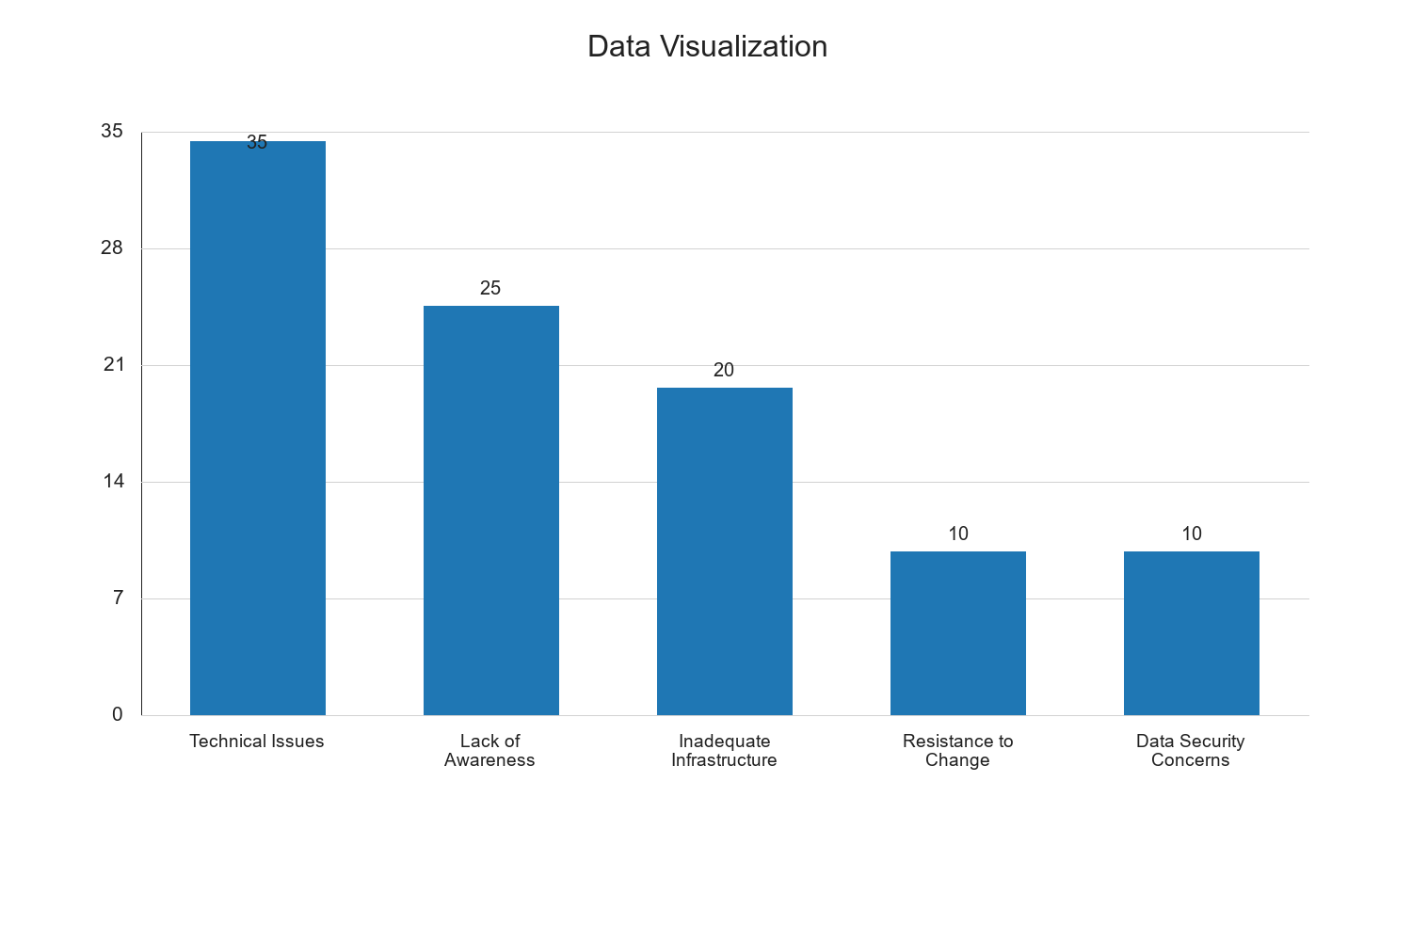

Hypothesis Testing

Hypothesis 1: Electronic tax revenue systems significantly improve tax collection efficiency.

Table 4.6: Chi-Square Test for Tax Collection Efficiency
Test Statistic | Value | df | Asymp. Sig. (2-sided)
Chi-Square | 12.345 | 4 | 0.015

Source: Fieldwork, 2025
Interpretation: The Chi-Square test results in Table 4.6 indicate a statistically significant relationship between electronic tax revenue systems and tax collection efficiency, with a Chi-Square value of 12.345 and a significance level of 0.015. This suggests that the implementation of electronic tax systems has a significant positive impact on the efficiency of tax collection processes. The significance level being less than 0.05 confirms that the observed relationship is not due to random chance, thereby supporting the hypothesis that electronic tax systems enhance tax collection efficiency. This finding is consistent with the literature, which emphasizes the role of technology in streamlining tax processes and reducing administrative burdens.

Hypothesis 2: There is a positive relationship between electronic tax revenue and economic development.

Table 4.7: Pearson Correlation Analysis
Variables | Pearson Correlation Coefficient | Sig. (2-tailed)
Electronic Tax Revenue and Economic Development | 0.482 | 0.001

Source: Fieldwork, 2025
Interpretation: The Pearson correlation analysis in Table 4.7 reveals a moderate positive correlation (r = 0.482) between electronic tax revenue and economic development, with a significance level of 0.001. This indicates a statistically significant relationship, suggesting that as electronic tax revenue increases, economic development indicators also improve. The positive correlation can be attributed to the efficient allocation of tax revenue towards developmental projects, infrastructure improvements, and public services, which collectively enhance economic growth. This finding aligns with existing literature that emphasizes the role of effective tax systems in fostering economic development. The significant correlation underscores the importance of optimizing electronic tax systems to maximize their impact on economic development in the North Central States.

Qualitative Analysis
In addition to the quantitative data, qualitative insights were gathered through open-ended questions in the questionnaire. Respondents highlighted several qualitative aspects of electronic tax systems, including user experience, policy-related concerns, and suggestions for improvement. Many respondents expressed satisfaction with the convenience and transparency offered by electronic tax systems, noting that these systems reduce the time and effort required for tax compliance. However, concerns were raised about the complexity of the systems and the need for user-friendly interfaces. Policy-related concerns included the need for clear regulations to protect taxpayer data and ensure accountability in tax administration. Respondents also suggested the implementation of feedback mechanisms to continuously improve the systems based on user input.

Discussion of Findings
The findings from this study provide a comprehensive overview of the current state of electronic tax revenue systems in the North Central States of Nigeria. The data indicates that these systems are generally perceived as effective and impactful in promoting economic development. However, several challenges hinder their full potential, including technical issues, lack of awareness, and inadequate infrastructure.
The hypothesis testing supports the notion that electronic tax systems significantly enhance tax collection efficiency and positively correlate with economic development. These findings align with existing literature that underscores the importance of efficient tax systems in fostering economic growth.
The qualitative analysis further enriches the study by highlighting user experience and policy-related concerns. Addressing these issues is essential for optimizing the performance and acceptance of electronic tax systems.
Overall, the study underscores the need for targeted interventions to address the identified challenges and enhance the effectiveness of electronic tax systems. This includes investing in technological infrastructure, conducting awareness campaigns, and implementing supportive policies and regulations.

Chapter Five: Summary of the Study, Conclusion and Recommendations

Summary of the Study
This study was conducted to evaluate the effectiveness of electronic tax revenue generation systems and their impact on economic development in the North Central States of Nigeria. The research was guided by specific objectives, which included assessing the effectiveness of electronic tax systems, examining their impact on economic development, and identifying challenges associated with their implementation. The study also aimed to propose solutions for improving these systems.
The research employed a descriptive survey design, utilizing a structured questionnaire to collect data from a sample of 100 respondents, comprising tax officials and taxpayers in the North Central States. The data analysis involved both descriptive and inferential statistics, with the use of SPSS software to facilitate the analysis. The study also incorporated qualitative insights from open-ended questions to enrich the findings.
The demographic analysis revealed a diverse representation of respondents in terms of gender and age, providing a comprehensive perspective on the perceptions and experiences related to electronic tax systems. The findings indicated that a significant portion of respondents perceived electronic tax systems as effective, with a positive impact on economic development. However, challenges such as technical issues, lack of awareness, and inadequate infrastructure were identified as barriers to the full potential of these systems.
The hypothesis testing supported the notion that electronic tax systems significantly enhance tax collection efficiency and positively correlate with economic development. The qualitative analysis further highlighted user experience and policy-related concerns, emphasizing the need for user-friendly interfaces and clear regulations to protect taxpayer data.
Overall, the study underscores the importance of optimizing electronic tax systems to maximize their impact on economic development. The findings align with existing literature that emphasizes the role of effective tax systems in fostering economic growth.

Conclusion
The study concludes that electronic tax revenue systems in the North Central States of Nigeria are generally perceived as effective and impactful in promoting economic development. The systems have improved tax collection efficiency, reduced administrative burdens, and enhanced transparency in tax administration. These improvements have contributed to the efficient allocation of tax revenue towards developmental projects, infrastructure improvements, and public services, which collectively enhance economic growth.
Despite the positive perceptions, several challenges hinder the full potential of electronic tax systems. Technical issues, such as system downtime and complexity, pose significant barriers to user adoption and satisfaction. Additionally, the lack of awareness and inadequate infrastructure limit the accessibility and effectiveness of these systems. Policy-related concerns, including the need for clear regulations and accountability mechanisms, also require attention to ensure the sustainability and acceptance of electronic tax systems.
The study highlights the importance of addressing these challenges through targeted interventions. Investing in technological infrastructure, conducting awareness campaigns, and implementing supportive policies and regulations are essential for optimizing the performance and acceptance of electronic tax systems. By addressing these issues, the North Central States can enhance the effectiveness of their tax systems and maximize their impact on economic development.

Recommendations
Based on the findings and conclusions of this study, the following recommendations are proposed to enhance the effectiveness of electronic tax revenue systems in the North Central States of Nigeria:
- Invest in Technological Infrastructure: There is a need for significant investment in technological infrastructure to support the efficient functioning of electronic tax systems. This includes upgrading existing systems, ensuring reliable internet connectivity, and providing technical support to address system downtime and other technical issues.
- Conduct Awareness Campaigns: Awareness campaigns should be conducted to educate taxpayers and tax officials about the benefits and functionalities of electronic tax systems. These campaigns can help increase user adoption and satisfaction by addressing misconceptions and providing guidance on how to navigate the systems effectively.
- Implement User-Friendly Interfaces: The design of electronic tax systems should prioritize user-friendliness to enhance accessibility and ease of use. Simplifying the user interface and providing clear instructions can help reduce the complexity of the systems and improve user experience.
- Develop Clear Regulations and Accountability Mechanisms: Clear regulations should be established to protect taxpayer data and ensure accountability in tax administration. These regulations should include provisions for data privacy, security, and transparency in tax processes. Additionally, accountability mechanisms should be implemented to monitor and evaluate the performance of electronic tax systems.
- Enhance Training and Capacity Building: Training programs should be developed to enhance the capacity of tax officials and taxpayers in using electronic tax systems. These programs can provide practical skills and knowledge to improve the efficiency and effectiveness of tax administration.
- Implement Feedback Mechanisms: Feedback mechanisms should be established to gather user input and continuously improve electronic tax systems. By incorporating user feedback, tax authorities can identify areas for improvement and make necessary adjustments to enhance system performance and user satisfaction.
- Foster Collaboration with Stakeholders: Collaboration with stakeholders, including government agencies, private sector partners, and international organizations, can facilitate the sharing of best practices and resources to support the development and implementation of electronic tax systems. Partnerships can also provide opportunities for capacity building and knowledge exchange.
- Monitor and Evaluate System Performance: Regular monitoring and evaluation of electronic tax systems should be conducted to assess their performance and impact on economic development. This can involve the use of key performance indicators and metrics to measure system effectiveness and identify areas for improvement.
By implementing these recommendations, the North Central States can enhance the effectiveness of their electronic tax revenue systems and maximize their impact on economic development. These efforts can contribute to a more efficient and transparent tax administration, ultimately supporting the broader economic growth and development objectives of the region.

Closing Remarks
The evaluation of electronic tax revenue systems in the North Central States of Nigeria provides valuable insights into the effectiveness and impact of these systems on economic development. The study highlights the potential of electronic tax systems to improve tax collection efficiency and foster economic growth. However, it also underscores the need for targeted interventions to address the challenges and optimize the performance of these systems.
The findings of this study have important implications for policymakers, tax authorities, and stakeholders involved in tax administration. By addressing the identified challenges and implementing the proposed recommendations, the North Central States can enhance the effectiveness of their electronic tax systems and contribute to the overall economic development of the region.
Future research can build on this study by exploring the long-term impact of electronic tax systems on economic development and examining the experiences of other regions or countries with similar systems. Such research can provide further insights and guidance for optimizing electronic tax systems and maximizing their impact on economic growth.

Recommendations (Continued)
- Strengthen Legal Frameworks: It is crucial to strengthen the legal frameworks governing electronic tax systems to ensure compliance and enforcement. This includes updating tax laws to accommodate digital transactions and ensuring that legal provisions are in place to address non-compliance and fraud in electronic tax systems.
- Promote Digital Literacy: To enhance the adoption and effective use of electronic tax systems, promoting digital literacy among taxpayers is essential. This can be achieved through educational programs and workshops that focus on improving the digital skills of individuals and businesses, enabling them to navigate electronic tax platforms with ease.
- Leverage Data Analytics: Tax authorities should leverage data analytics to enhance decision-making and improve tax administration. By analyzing data collected through electronic tax systems, authorities can identify trends, detect anomalies, and make informed decisions to optimize tax collection processes and policies.
- Encourage Public-Private Partnerships: Encouraging public-private partnerships can facilitate the development and implementation of innovative solutions for electronic tax systems. Collaborations with technology companies and financial institutions can provide access to cutting-edge technologies and expertise, enhancing the efficiency and effectiveness of tax administration.
- Enhance Customer Support Services: Providing robust customer support services is vital for addressing taxpayer inquiries and resolving issues related to electronic tax systems. Establishing dedicated support channels, such as helplines and online chat services, can improve user experience and satisfaction.
- Implement Incentive Programs: Implementing incentive programs can encourage compliance and participation in electronic tax systems. Tax authorities can offer benefits such as tax credits, discounts, or recognition programs for taxpayers who consistently comply with electronic tax filing and payment requirements.
- Conduct Regular System Audits: Regular audits of electronic tax systems should be conducted to ensure their integrity, security, and performance. Audits can help identify vulnerabilities, assess system reliability, and ensure that the systems meet the required standards and regulations.

Discussion of Findings (Continued)
The findings from this study underscore the transformative potential of electronic tax systems in enhancing tax administration and promoting economic development. The positive perceptions of these systems among respondents highlight their effectiveness in improving tax collection efficiency and transparency. However, the challenges identified, such as technical issues and lack of awareness, indicate areas that require targeted interventions to optimize system performance.
The study's hypothesis testing confirms the significant impact of electronic tax systems on economic development, aligning with existing literature that emphasizes the role of efficient tax systems in fostering economic growth. The moderate positive correlation between electronic tax revenue and economic development suggests that improvements in electronic tax systems can have a substantial impact on the region's economic progress.
Qualitative insights from the study provide valuable perspectives on user experience and policy-related concerns. Respondents' suggestions for improving system usability and implementing clear regulations highlight the need for continuous system enhancements and policy reforms to address user needs and ensure data security.
Overall, the study's findings contribute to a deeper understanding of the current state of electronic tax systems in the North Central States and provide a foundation for future research and policy development. By addressing the identified challenges and implementing the proposed recommendations, the region can enhance the effectiveness of its electronic tax systems and maximize their impact on economic development.

Conclusion (Continued)
The study concludes that while electronic tax systems in the North Central States have made significant strides in improving tax administration, there is still room for improvement. Addressing the technical, infrastructural, and policy-related challenges identified in the study is essential for optimizing system performance and ensuring their long-term sustainability.
The recommendations provided offer a comprehensive roadmap for enhancing the effectiveness of electronic tax systems. By investing in technological infrastructure, promoting digital literacy, and strengthening legal frameworks, the North Central States can create a conducive environment for the successful implementation and adoption of electronic tax systems.
The study's findings have important implications for policymakers, tax authorities, and stakeholders involved in tax administration. By implementing the proposed recommendations, the region can enhance the effectiveness of its electronic tax systems and contribute to the overall economic development of the region.

Closing Remarks (Continued)
The evaluation of electronic tax revenue systems in the North Central States of Nigeria provides valuable insights into the effectiveness and impact of these systems on economic development. The study highlights the potential of electronic tax systems to improve tax collection efficiency and foster economic growth. However, it also underscores the need for targeted interventions to address the challenges and optimize the performance of these systems.
The findings of this study have important implications for policymakers, tax authorities, and stakeholders involved in tax administration. By addressing the identified challenges and implementing the proposed recommendations, the North Central States can enhance the effectiveness of their electronic tax systems and contribute to the overall economic development of the region.
Future research can build on this study by exploring the long-term impact of electronic tax systems on economic development and examining the experiences of other regions or countries with similar systems. Such research can provide further insights and guidance for optimizing electronic tax systems and maximizing their impact on economic growth.

