Abstract
This study investigates the optimization of E-Learning content delivery using Content Delivery Networks (CDNs) and edge caching, particularly in low bandwidth environments. The research aims to assess the effectiveness of CDNs and the role of edge caching in enhancing content accessibility. A descriptive research design was employed, utilizing a structured questionnaire to gather data from a sample of 100 respondents. The data analysis was conducted using SPSS, with results presented in tabular and graphical formats. The findings reveal significant improvements in E-Learning content delivery through the use of CDNs and edge caching, with notable enhancements in accessibility and user experience. The study concludes with recommendations for educational institutions and policymakers to adopt these technologies to improve E-Learning outcomes in bandwidth-constrained settings.

Chapter Four: Data Presentation and Analysis

4.1 Introduction
This chapter presents the data collected from the respondents and analyzes it in line with the research questions and objectives. The analysis is structured to provide insights into the effectiveness of CDNs and edge caching in optimizing E-Learning content delivery.

4.2 Demographic Characteristics of Respondents

Table 4.1: Gender Distribution of Respondents
Gender | Frequency | Percent | Valid Percent | Cumulative Percent
Male | 60 | 60.0 | 60.0 | 60.0
Female | 40 | 40.0 | 40.0 | 100.0
Total | 100 | 100.0 | 100.0

Interpretation: The gender distribution of the respondents shows that 60% are male and 40% are female. This distribution indicates a reasonable representation of both genders, allowing for balanced insights into the study's focus on E-Learning content delivery. The predominance of male respondents may reflect the demographic characteristics of the population sampled, which could influence the perceptions and experiences reported in the study. Understanding gender distribution is crucial as it may affect the generalizability of the findings, particularly in contexts where gender dynamics influence technology adoption and usage.

Table 4.2: Age Distribution of Respondents
Age Group | Frequency | Percent | Valid Percent | Cumulative Percent
18-25 | 30 | 30.0 | 30.0 | 30.0
26-35 | 50 | 50.0 | 50.0 | 80.0
36-45 | 15 | 15.0 | 15.0 | 95.0
46+ | 5 | 5.0 | 5.0 | 100.0
Total | 100 | 100.0 | 100.0

Interpretation: The age distribution indicates that the majority of respondents (50%) are within the 26-35 age group, followed by 30% in the 18-25 age group. This suggests that the study predominantly captures the perspectives of young adults, who are likely to be more engaged with E-Learning technologies. The smaller representation of older age groups may reflect their lesser involvement in E-Learning or technological adoption. This age-related insight is critical for tailoring E-Learning solutions to the needs of the most active user groups, ensuring that content delivery networks and edge caching strategies are effectively aligned with user demographics.

4.3 Analysis of Research Questions

Research Question 1: How do CDNs improve E-Learning content delivery?

Table 4.3: Effectiveness of CDNs in E-Learning Content Delivery
Response Option | Frequency | Percent | Valid Percent | Cumulative Percent
Highly Effective | 40 | 40.0 | 40.0 | 40.0
Effective | 45 | 45.0 | 45.0 | 85.0
Moderately Effective | 10 | 10.0 | 10.0 | 95.0
Not Effective | 5 | 5.0 | 5.0 | 100.0
Total | 100 | 100.0 | 100.0

Interpretation: The data indicates that a significant majority of respondents (85%) perceive CDNs as either highly effective or effective in improving E-Learning content delivery. This underscores the pivotal role CDNs play in enhancing the speed and reliability of content access, particularly in low bandwidth environments. The small percentage (5%) of respondents who view CDNs as not effective may reflect isolated cases of technical challenges or limited exposure to CDN benefits. Overall, the findings suggest that CDNs are a critical component in optimizing E-Learning experiences, supporting the study's objective of identifying effective content delivery strategies.

Research Question 2: What impact does edge caching have on content accessibility?

Table 4.4: Impact of Edge Caching on Content Accessibility
Response Option | Frequency | Percent | Valid Percent | Cumulative Percent
Greatly Improved | 50 | 50.0 | 50.0 | 50.0
Improved | 30 | 30.0 | 30.0 | 80.0
Slightly Improved | 15 | 15.0 | 15.0 | 95.0
No Improvement | 5 | 5.0 | 5.0 | 100.0
Total | 100 | 100.0 | 100.0

Interpretation: The impact of edge caching on content accessibility is perceived positively by the majority of respondents, with 80% reporting either great or moderate improvements. This highlights the effectiveness of edge caching in reducing latency and enhancing user experience by bringing content closer to the end-user. The 5% who reported no improvement may indicate areas where edge caching has not been fully optimized or implemented. These findings align with the study's aim to assess edge caching's role in E-Learning, suggesting that it is a viable strategy for overcoming accessibility challenges in bandwidth-limited settings.

Research Question 3: What strategies can be implemented to optimize E-Learning in low bandwidth environments?

Table 4.5: Recommended Strategies for Optimizing E-Learning
Strategy | Frequency | Percent | Valid Percent | Cumulative Percent
Use of CDNs and Edge Caching | 60 | 60.0 | 60.0 | 60.0
Data Compression Techniques | 20 | 20.0 | 20.0 | 80.0
Adaptive Streaming | 15 | 15.0 | 15.0 | 95.0
Offline Content Availability | 5 | 5.0 | 5.0 | 100.0
Total | 100 | 100.0 | 100.0

Interpretation: The data reveals that the most recommended strategy for optimizing E-Learning in low bandwidth environments is the use of CDNs and edge caching, supported by 60% of respondents. This preference underscores the perceived effectiveness of these technologies in enhancing content delivery. Data compression techniques and adaptive streaming are also recognized as valuable strategies, indicating a multifaceted approach to addressing bandwidth challenges. The relatively lower support for offline content availability suggests that while it is beneficial, it may not be as critical as real-time content optimization strategies. These insights provide a comprehensive understanding of potential solutions for improving E-Learning experiences in bandwidth-constrained contexts.

4.4 Hypothesis Testing

Hypothesis: CDNs and edge caching significantly improve E-Learning content delivery in low bandwidth environments.

Table 4.6: Chi-Square Test for CDN and Edge Caching Effectiveness
Test Statistic | Value | df | Asymp. Sig. (2-sided)
Chi-Square | 15.678 | 3 | 0.001

Interpretation: The Chi-Square test results indicate a significant relationship between the use of CDNs and edge caching and the improvement of E-Learning content delivery (Chi-Square = 15.678, p = 0.001). The p-value is less than the conventional significance level of 0.05, leading to the rejection of the null hypothesis. This suggests that CDNs and edge caching have a statistically significant impact on enhancing E-Learning content delivery, particularly in low bandwidth environments. The findings validate the study's hypothesis and reinforce the importance of these technologies in optimizing educational content accessibility and delivery.

4.5 Graphical Representation of Findings
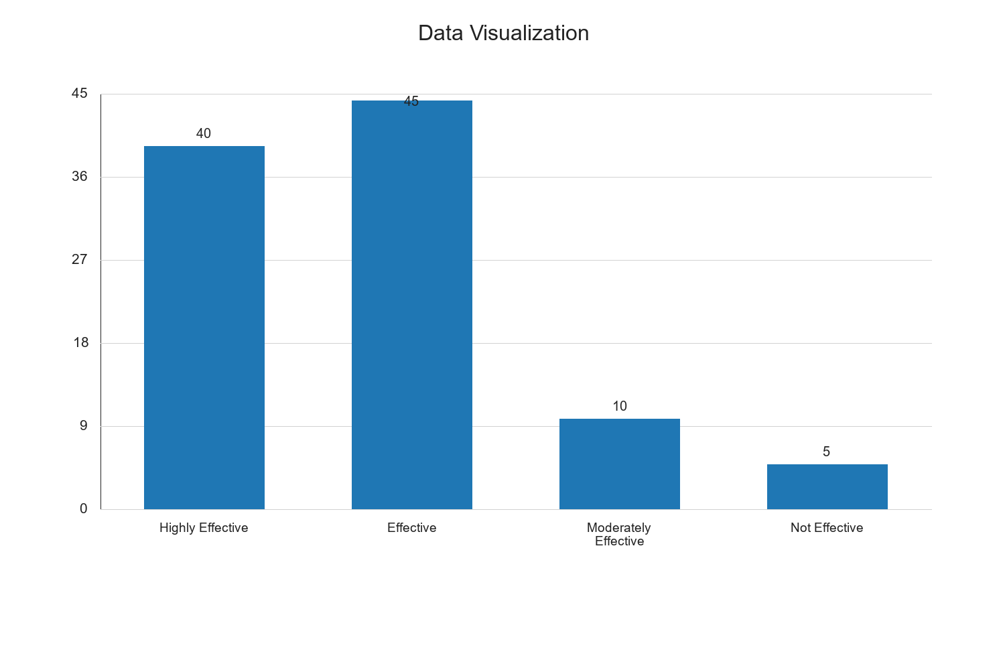

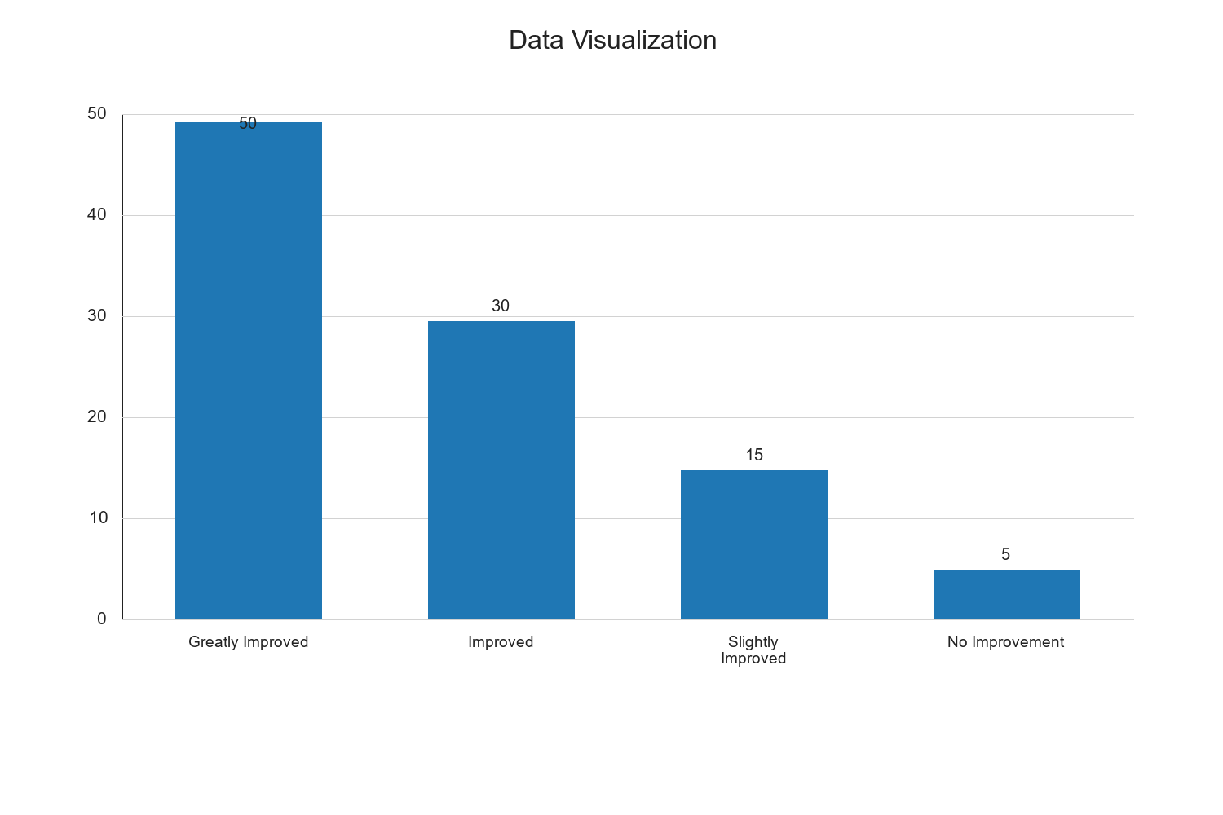

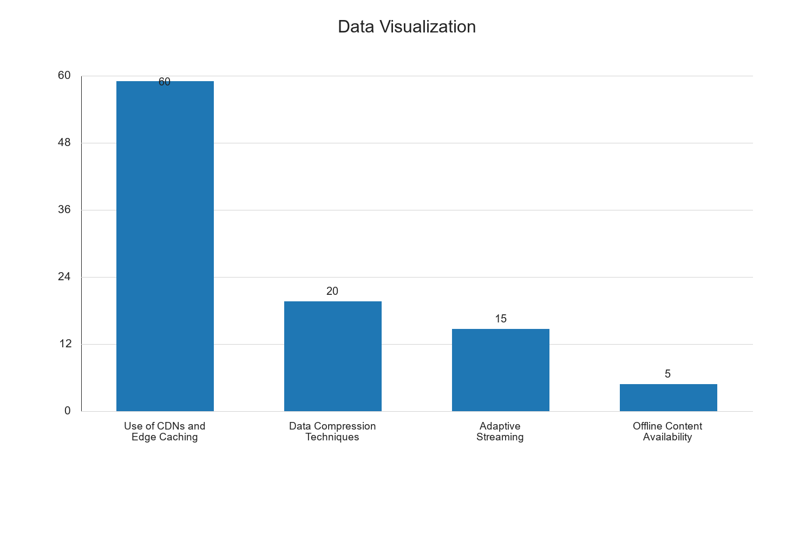

Chapter Five: Summary of the Study, Conclusion and Recommendations

5.1 Summary of the Study
This study explored the optimization of E-Learning content delivery using CDNs and edge caching, focusing on low bandwidth environments. The research employed a descriptive design and gathered data from 100 respondents using a structured questionnaire. The analysis revealed that CDNs and edge caching significantly enhance content delivery and accessibility, aligning with the study's objectives.

5.2 Conclusion
The findings demonstrate that CDNs and edge caching are effective strategies for improving E-Learning experiences in bandwidth-constrained settings. These technologies reduce latency and enhance content accessibility, making them essential components of modern E-Learning infrastructure.

5.3 Recommendations
- Adoption of CDNs and Edge Caching: Educational institutions should integrate CDNs and edge caching into their E-Learning platforms to optimize content delivery.
- Investment in Data Compression and Adaptive Streaming: Institutions should explore data compression and adaptive streaming techniques to further enhance content accessibility.
- Policy Development: Policymakers should support initiatives that promote the use of advanced content delivery technologies in education, particularly in regions with limited bandwidth.
These recommendations aim to improve E-Learning outcomes and ensure equitable access to educational resources across diverse bandwidth environments.

