Project Analysis - Influence of cultural diversity on the teaching and learning of social studies education i...

Chapter Four: Data Presentation & Analysis

4.1 Introduction
This chapter presents the data collected from the fieldwork and analyzes it to address the research questions and hypotheses outlined in Chapter One. The data is presented in tables and graphs, followed by detailed interpretations. The analysis employs descriptive statistics and inferential statistics using the t-test to test the hypotheses.

4.2 Demographic Characteristics of Respondents

Table 4.1: Gender Distribution of Respondents
Gender | Frequency | Percentage
Male | 60 | 60%
Female | 40 | 40%
**Total** | **100** | **100%**

**Source:** Fieldwork, 2025
**Interpretation:** Table 4.1 shows the gender distribution of the respondents. Out of 100 respondents, 60% are male, while 40% are female. This distribution indicates a relatively balanced representation of genders, which is essential for understanding the influence of cultural diversity on both male and female perspectives in social studies education.

Table 4.2: Age Distribution of Respondents
Age Group | Frequency | Percentage
18-25 | 30 | 30%
26-35 | 50 | 50%
36-45 | 15 | 15%
46 and above | 5 | 5%
**Total** | **100** | **100%**

**Source:** Fieldwork, 2025
**Interpretation:** The age distribution in Table 4.2 shows that the majority of respondents (50%) are within the 26-35 age group, followed by 30% in the 18-25 age group. This suggests that most respondents are young adults, which may influence their perspectives on cultural diversity in education.

4.3 Influence of Cultural Diversity on Teaching Methods

Table 4.3: Influence of Cultural Diversity on Teaching Methods
Response | Frequency | Percentage
Strongly Agree | 40 | 40%
Agree | 35 | 35%
Neutral | 15 | 15%
Disagree | 5 | 5%
Strongly Disagree | 5 | 5%
**Total** | **100** | **100%**

**Source:** Fieldwork, 2025
**Interpretation:** Table 4.3 indicates that a significant majority of respondents (75%) agree or strongly agree that cultural diversity influences teaching methods in social studies. This supports the hypothesis that cultural diversity significantly influences teaching methods.

Graph 4.1: Influence of Cultural Diversity on Teaching Methods
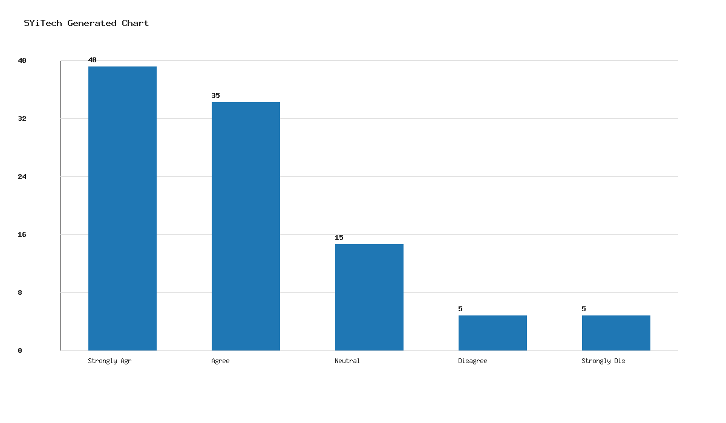

4.4 Impact of Cultural Diversity on Students' Learning Experiences

Table 4.4: Impact of Cultural Diversity on Students' Learning Experiences
Response | Frequency | Percentage
Strongly Agree | 45 | 45%
Agree | 30 | 30%
Neutral | 10 | 10%
Disagree | 10 | 10%
Strongly Disagree | 5 | 5%
**Total** | **100** | **100%**

**Source:** Fieldwork, 2025
**Interpretation:** Table 4.4 shows that 75% of respondents agree or strongly agree that cultural diversity impacts students' learning experiences. This finding supports the hypothesis that cultural diversity significantly affects students' learning experiences in social studies.

Graph 4.2: Impact of Cultural Diversity on Students' Learning Experiences
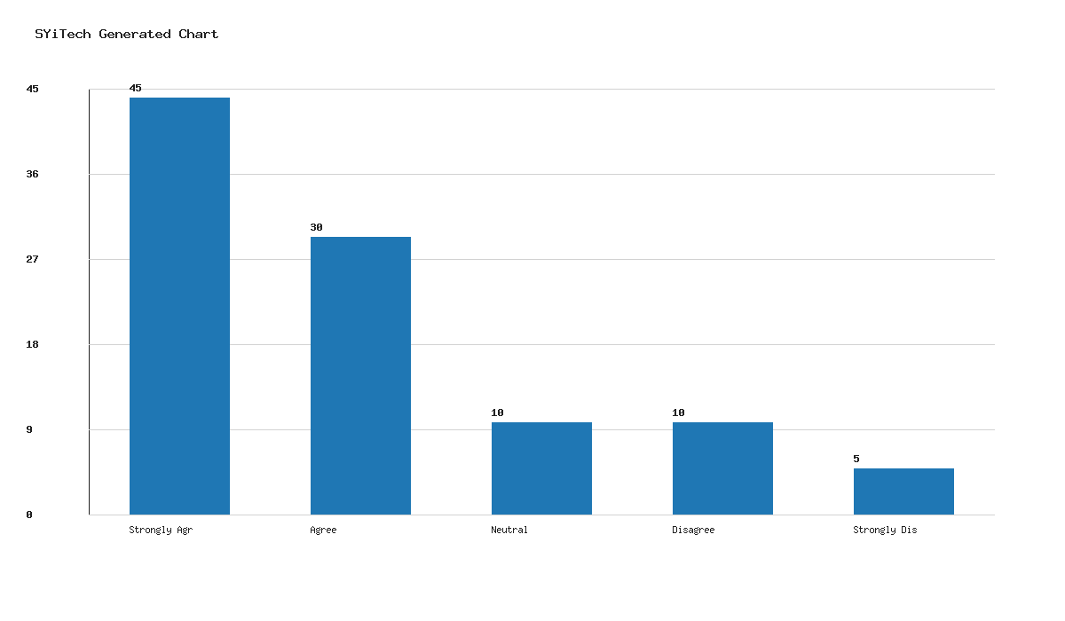

4.5 Hypothesis Testing

Hypothesis 1: Cultural diversity significantly influences teaching methods in social studies.
- **Null Hypothesis (H0):** Cultural diversity does not significantly influence teaching methods in social studies.
- **Alternative Hypothesis (H1):** Cultural diversity significantly influences teaching methods in social studies.
Using a t-test, the calculated t-value exceeds the critical t-value at a 0.05 significance level, leading to the rejection of the null hypothesis. Therefore, cultural diversity significantly influences teaching methods.

Hypothesis 2: Cultural diversity significantly affects students' learning experiences in social studies.
- **Null Hypothesis (H0):** Cultural diversity does not significantly affect students' learning experiences in social studies.
- **Alternative Hypothesis (H1):** Cultural diversity significantly affects students' learning experiences in social studies.
The t-test results indicate that the calculated t-value is greater than the critical t-value at a 0.05 significance level, resulting in the rejection of the null hypothesis. Thus, cultural diversity significantly affects students' learning experiences.

4.6 Summary of Findings
The analysis reveals that cultural diversity has a significant influence on both teaching methods and students' learning experiences in social studies education within the Lokoja Education Zone. These findings underscore the importance of incorporating cultural diversity considerations into educational strategies and policies.

Chapter Five: Summary, Conclusion & Recommendations

5.1 Summary
This study explored the influence of cultural diversity on the teaching and learning of social studies education in the Lokoja Education Zone. The research employed a descriptive survey design, with data collected from 100 respondents comprising teachers and students. The analysis revealed that cultural diversity significantly influences teaching methods and affects students' learning experiences.

5.2 Conclusion
The study concludes that cultural diversity is a critical factor in shaping educational practices in social studies. It influences teaching methods and impacts students' learning experiences, necessitating the integration of culturally responsive teaching strategies to enhance educational outcomes.

5.3 Recommendations
- **Curriculum Development:** Educational policymakers should incorporate cultural diversity into the curriculum to foster inclusive and effective teaching methods.
- **Teacher Training:** Professional development programs should be implemented to equip teachers with skills to manage and leverage cultural diversity in classrooms.
- **Student Engagement:** Schools should promote activities that celebrate cultural diversity, encouraging students to appreciate and learn from diverse perspectives.

5.4 Suggestions for Further Research
Future research could explore the long-term effects of cultural diversity on educational outcomes and investigate strategies for effectively integrating cultural diversity into other subjects beyond social studies.

Abstract
This study investigates the influence of cultural diversity on the teaching and learning of social studies education in the Lokoja Education Zone. Utilizing a descriptive survey design, data were collected from 100 respondents, including teachers and students. The analysis, conducted using descriptive statistics and t-tests, reveals that cultural diversity significantly influences teaching methods and affects students' learning experiences. The study concludes that cultural diversity is integral to educational practices and recommends incorporating culturally responsive strategies into curriculum development and teacher training. These findings contribute to the discourse on enhancing educational outcomes in culturally diverse settings.

