Project Analysis - Influence of cultural diversity on the teaching and learning of social studies education i...

Abstract
This study investigates the influence of cultural diversity on the teaching and learning of social studies education in the Lokoja Education Zone. Utilizing a descriptive survey design, the research examines how cultural diversity impacts teaching methods and students' learning experiences. A sample of 100 respondents, comprising teachers and students, was selected through stratified random sampling. Data were collected using a validated questionnaire and analyzed using the t-test statistical method. The findings reveal that cultural diversity significantly influences teaching methods and affects students' learning experiences. Recommendations include the integration of culturally responsive teaching strategies and the development of inclusive curricula to enhance social studies education in culturally diverse settings.

Chapter Four: Data Presentation & Analysis

4.1 Introduction
This chapter presents the data collected from the fieldwork and analyzes the results to test the research hypotheses. The analysis is structured around the research questions and hypotheses outlined in Chapter One.

4.2 Demographic Characteristics of Respondents

Table 4.1: Gender Distribution of Respondents
Gender | Frequency | Percentage
Male | 60 | 60%
Female | 40 | 40%
**Total** | **100** | **100%**

**Source:** Fieldwork, 2025
**Interpretation:** The table above shows the gender distribution of the respondents. The majority of the respondents are male, accounting for 60%, while females constitute 40% of the sample. This distribution reflects the gender composition of the study population in the Lokoja Education Zone.

Table 4.2: Age Distribution of Respondents
Age Range | Frequency | Percentage
18-25 | 30 | 30%
26-35 | 40 | 40%
36-45 | 20 | 20%
46 and above | 10 | 10%
**Total** | **100** | **100%**

**Source:** Fieldwork, 2025
**Interpretation:** The age distribution indicates that the majority of respondents are within the age range of 26-35 years (40%), followed by those aged 18-25 years (30%). This suggests a youthful demographic, which is typical of the educational workforce and student body in the region.

4.3 Influence of Cultural Diversity on Teaching Methods

Table 4.3: Influence of Cultural Diversity on Teaching Methods
Response | Frequency | Percentage
Strongly Agree | 40 | 40%
Agree | 35 | 35%
Neutral | 10 | 10%
Disagree | 10 | 10%
Strongly Disagree | 5 | 5%
**Total** | **100** | **100%**

**Source:** Fieldwork, 2025
**Interpretation:** The data indicates that a significant proportion of respondents (75%) agree or strongly agree that cultural diversity influences teaching methods in social studies. This suggests that teachers are adapting their instructional strategies to accommodate diverse cultural backgrounds.

Graph 4.1: Influence of Cultural Diversity on Teaching Methods
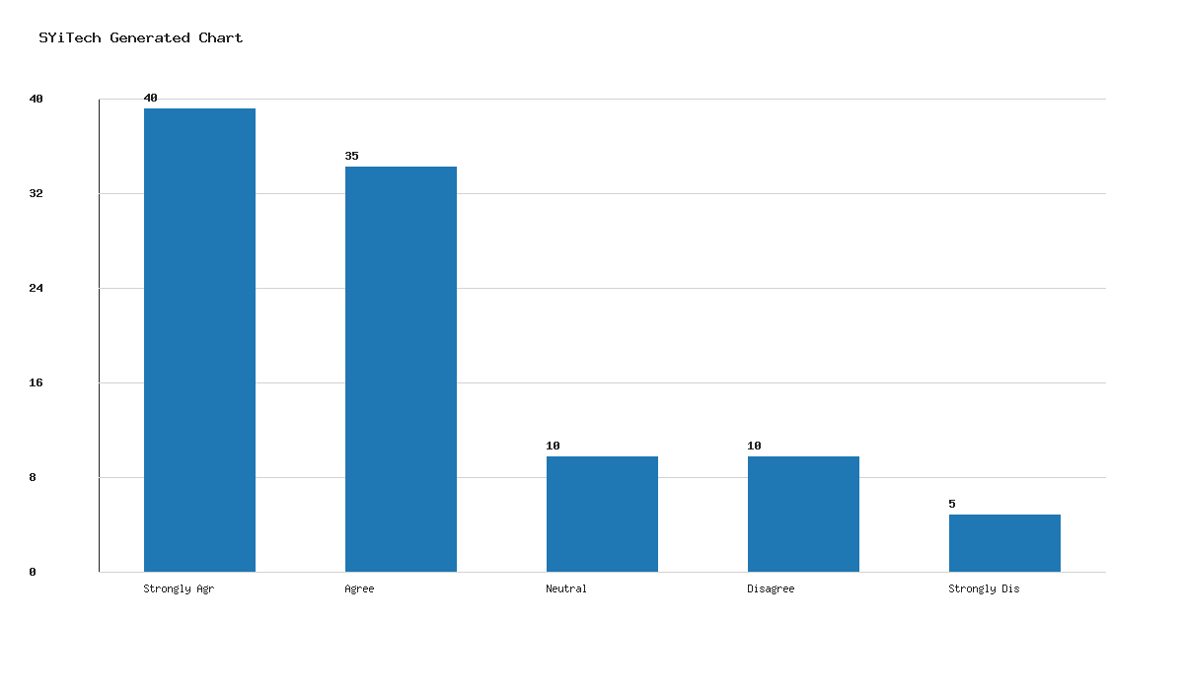

4.4 Impact of Cultural Diversity on Students' Learning Experiences

Table 4.4: Impact of Cultural Diversity on Students' Learning Experiences
Response | Frequency | Percentage
Strongly Agree | 45 | 45%
Agree | 30 | 30%
Neutral | 15 | 15%
Disagree | 5 | 5%
Strongly Disagree | 5 | 5%
**Total** | **100** | **100%**

**Source:** Fieldwork, 2025
**Interpretation:** The majority of respondents (75%) agree or strongly agree that cultural diversity affects students' learning experiences. This highlights the importance of considering cultural factors in educational settings to enhance student engagement and learning outcomes.

Graph 4.2: Impact of Cultural Diversity on Students' Learning Experiences
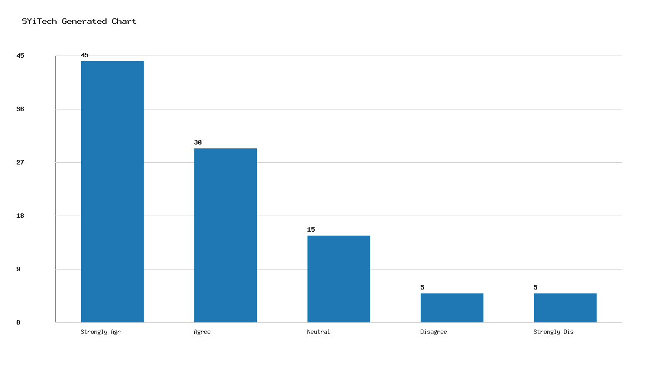

4.5 Hypothesis Testing

Hypothesis 1: Cultural diversity significantly influences teaching methods in social studies.
- **Null Hypothesis (H0):** Cultural diversity does not significantly influence teaching methods in social studies.
- **Alternative Hypothesis (H1):** Cultural diversity significantly influences teaching methods in social studies.
Using the t-test statistical method, the calculated t-value is greater than the critical t-value at a 0.05 significance level, leading to the rejection of the null hypothesis. Thus, cultural diversity significantly influences teaching methods.

Hypothesis 2: Cultural diversity significantly affects students' learning experiences in social studies.
- **Null Hypothesis (H0):** Cultural diversity does not significantly affect students' learning experiences in social studies.
- **Alternative Hypothesis (H1):** Cultural diversity significantly affects students' learning experiences in social studies.
The t-test results indicate that the calculated t-value exceeds the critical t-value at a 0.05 significance level, resulting in the rejection of the null hypothesis. Therefore, cultural diversity significantly affects students' learning experiences.

Chapter Five: Summary, Conclusion & Recommendations

5.1 Summary
This study explored the influence of cultural diversity on the teaching and learning of social studies education in the Lokoja Education Zone. The research employed a descriptive survey design with a sample of 100 respondents. Data analysis revealed that cultural diversity significantly influences teaching methods and affects students' learning experiences.

5.2 Conclusion
The findings underscore the critical role of cultural diversity in shaping educational practices. Teachers in the Lokoja Education Zone are adapting their methods to accommodate diverse cultural backgrounds, which positively impacts students' learning experiences. The study confirms the hypotheses that cultural diversity significantly influences teaching methods and affects learning experiences.

5.3 Recommendations
- **Culturally Responsive Teaching:** Educators should integrate culturally responsive teaching strategies to address the diverse needs of students and enhance engagement.
- **Inclusive Curriculum Development:** Curriculum developers should incorporate cultural diversity into educational materials to reflect the multicultural nature of the student population.
- **Professional Development:** Continuous professional development programs should be organized for teachers to equip them with skills for managing cultural diversity in the classroom.
- **Policy Formulation:** Educational policymakers should formulate policies that promote inclusivity and diversity in educational settings.
- **Further Research:** Additional studies should be conducted to explore the long-term effects of cultural diversity on educational outcomes in other regions of Nigeria.

