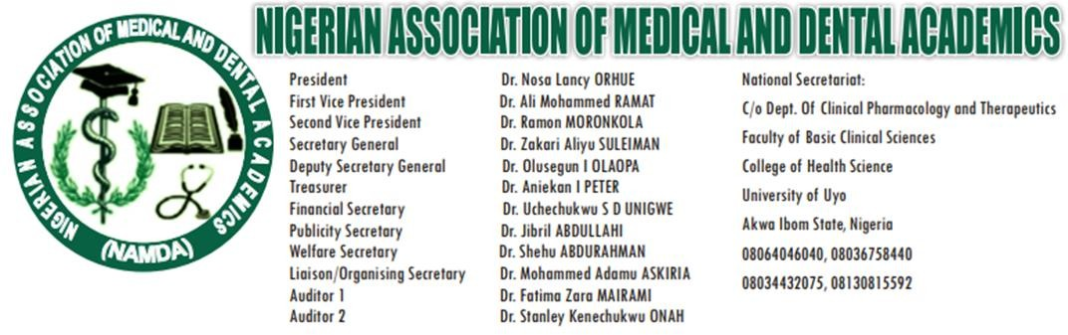
12th October, 2025

PRESS RELEASE
NAMDA Clarifies: We Are Not on Strike
The Nigerian Association of Medical and Dental Academics (NAMDA) wishes to inform all her members, medical students, and the general public that NAMDA is not on strike.

- Our members across all medical and dental colleges and faculties in Nigerian universities are hereby advised to continue their normal academic, clinical, and research activities without disruption.

- NAMDA remains committed to constructive engagement with relevant authorities toward the advancement of medical education, research, and healthcare delivery in Nigeria. We urge our members to disregard any misinformation suggesting otherwise and to continue to uphold the highest standards of professionalism and service.

- The NAMDA continues to stand firm in its struggles for improved welfare, conducive working environments, and the strengthening of Nigeria’s medical education system — all through the positive collaborative dialogue and practical commitments we have received from the current Minister of Education Dr. Maruf Olatunji Alausa who has kick started interactions on our demands. It is our belief that he will deliver on his commitment to NAMDA demands.
- We wish to use this opportunity to remind all Vice Chancellors that members of NAMDA will be on their duty post and therefore will NOT tolerate undue application of no work, no pay to her members. Vice Chancellors are reminded that it is their responsibility to ensure maintenance of law and order in the campuses inclusive of the Colleges of Medicine.

- Consequently, we expect Vice Chancellors to create the enabling work environment for our members.
Thank you.


Dr. Mohammed Askira
National Liaison Secretary, NAMDA For Mr. President

